TheGamma user study (3)

The Gamma is a simple programming environment for data exploration that aims to be accessible to non-experts such as journalists. TheGamma is text-based like typical programming languages. In the study, we’ll be using TheGamma in a simple split-screen environment. You see your code on the left and a data visualization automatically generated for the results on the right.

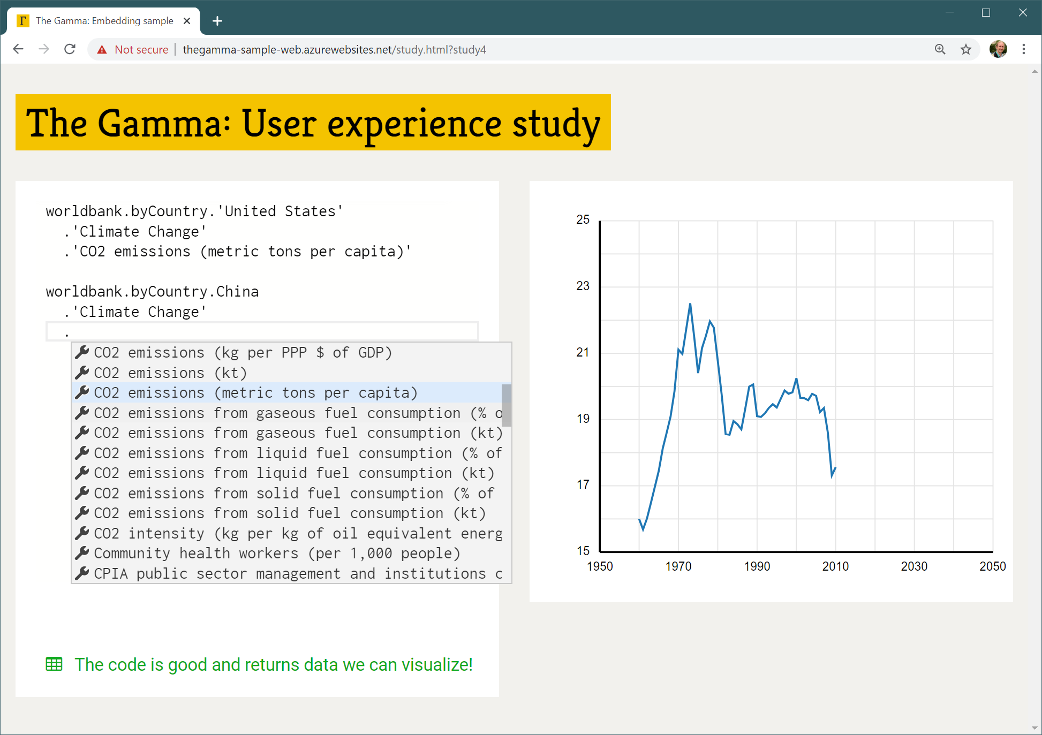

Most of programming in TheGamma is done through a single interaction principle – choosing a member from a list of members offered by the environment. A program is just a path that starts with a data source (such as “worldbank”) and follows through the data to find e.g. “CO2 emissions (metric tons per capita)” of a country such as “United States” as in the above example. You can construct programs by typing the data source name (such as “worldbank”) and then repeatedly typing “.” and choosing one of the offered items – either by clicking or via keyboard arrow keys and “Enter”.

In this study:

1. You will first watch a very brief presentation explaining TheGamma
2. You will be asked to try modify existing sample program to achieve a slightly different goal
3. We will discuss your experience, difficulties and things you learned

The problem:

The following example uses the “worldbank” data set to obtain “GDP per capita (current US$)” for three specified countries, the UK, Germany and Czech Republic. This is displayed as a single chart with three lines.

worldbank.byCountry.'United Kingdom'

.'Economy & Growth'.'GDP per capita (current US$)'

worldbank.byCountry.Germany

.'Economy & Growth'.'GDP per capita (current US$)'

worldbank.byCountry.'Czech Republic'

.'Economy & Growth'.'GDP per capita (current US$)'

The World Bank provides a wide range of other interesting indicators (although it does not have data for all countries for all indicators it lists). We want to modify the program so that we are looking at data related to climate change – in particular, we want to see “CO2 emissions (metric tons per capita)” for two countries – China and United States.

To get started, open <http://bit.ly/turing-study-3> in your web browser!