Tasks

Status | Task | Assignee
Merged | - Add something like requests/ or sessions/ somewhere in vault repo > Projects  - It should be filled with folders of claude or other AI sessions, where each session has a file for:  - The plan for the request, explained to a college student (not even entry level)  - The testing steps for the docs, clear and followable, literal step by step as if I don’t know how to navigate  - Context files themselves or reference to them (if they’re placed in different directories)  - Create necessary skills, agents or hooks to replicate this | Matthew
Blocked | - Currently assessment is merged into bookings queue  - Add a new page for receptionist called something like Assessment Queue  - Move the assessment functions there (e.g. start > opens new modal > allows receptionist to edit pet’s weight and coat values)  - Also rename the seed for Misc service type to > Assessment | Matthew
Not Started | - Fix how date and time picker in bookings queue > new booking:  - Currently, when it’s 1 PM today and I set a booking for tomorrow, it only shows booking time slots 2 PM and beyond (AS IF IT’S TREATING TODAY’S AVAILABLE BOOKING SLOTS FOR TOMORROW AND LATER DATES)  - Later dates should reset and show all available booking time slots based on branch operating hours and break times  - Staff should not appear in staff picker when they’re not available  - Confirm if availability time is computed properly (does it take into account the monthly schedule that the supervisor set? Is staff on vacation leave? etc.)  - Right now, monthly schedule is not configured by admin role, so all staff should be available EXCEPT when they’re chosen by a customer at X date/time (only on that date/time should they not be selectable) | Alarie
Not Started | - Fix not being able to book the next day or today in booking queue  - I think the 3 day notice period FOR RESCHEDULING ONLY, is ALSO applying to future online bookings  - You may add a separate config (for the online booking notice period) in admin settings > config > policies  - See the 2nd image below  - 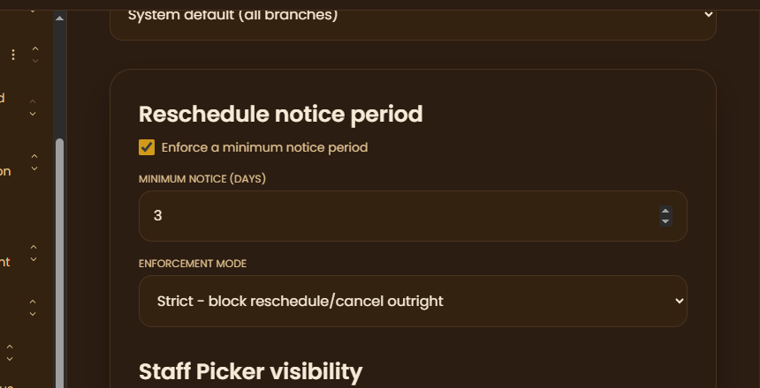  - 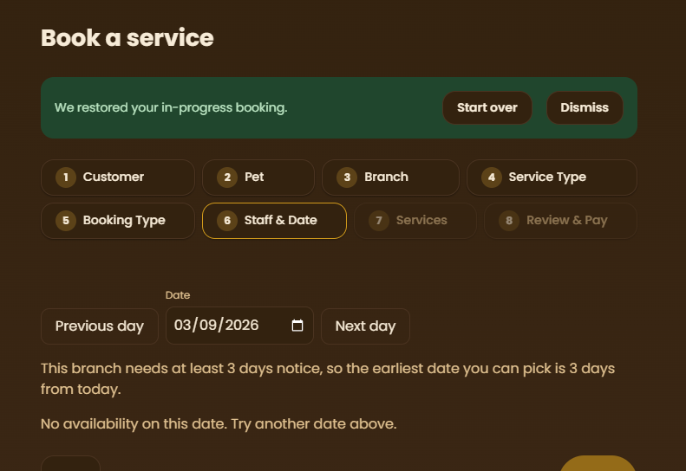 | Alarie
Merged | - Add info button on booking process > service type step  - Should include the available services for that service type (but readonly)  - 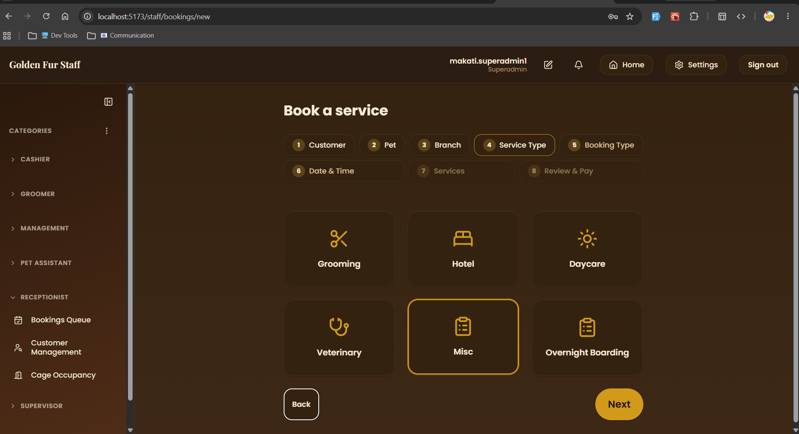 | James
Merged | - Add an explicit confirmation dialog ('Are you sure you want to cancel this booking?') before a cancellation is executed.  - Add on-screen copy in the cancellation flow disclosing that payment (full or down) is non-refundable but will be converted into account credit for use on a future visit. | Alarie
Not Started | - Disable date options earlier than the booking's current effective date in the reschedule date picker. | James
Merged | - Fix the bug preventing a newly created and activated service type from appearing in the service selection list. | Alarie
Merged | - Investigate and fix the 3-day-minimum (or N-day) booking filter/configuration — verify it correctly applies date ranges instead of appearing to lock/pin schedules. | Alarie
In Progress | - On new booking:  - Allow customers/receptionist to choose payment scheme at last step  - Either downpayment or full payment  - Currently it auto locks full payment  - 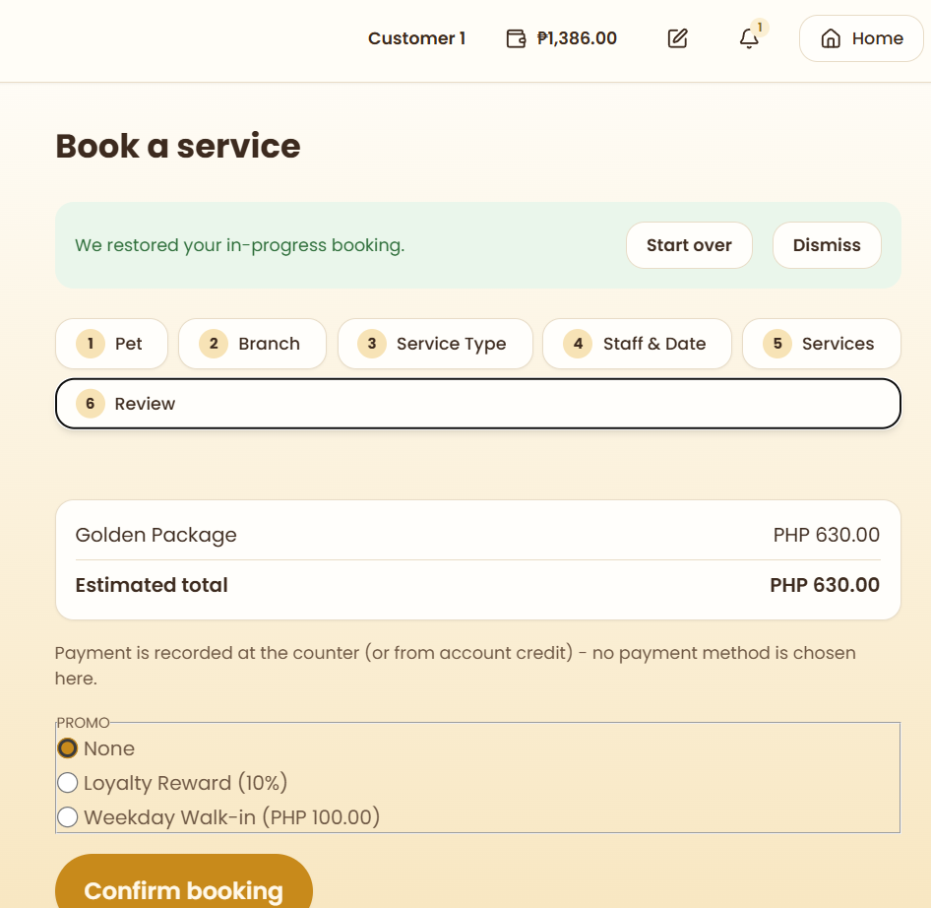  - Verify that choosing downpayment scheme should initially create 2 transactions (downpayment + remaining balance)  - If remaining balance isn’t fully paid, it creates another remaining balance transaction instance  - Verify that downpayment config per service/package is now gone  - It should’ve been moved to admin settings > config a while ago | Matthew
Not Started | - When creating new service type > staff picker, it doesn’t specify what staff roles are available to choose from  - Extend it by adding options to choose staff roles (multi-select)  - Since grooming services > groomer, vet services > vets, etc.  - Do the same for existing service types and update seed scripts  - Also remove the key field, this should be randomly generated anyway, only leave out name  - 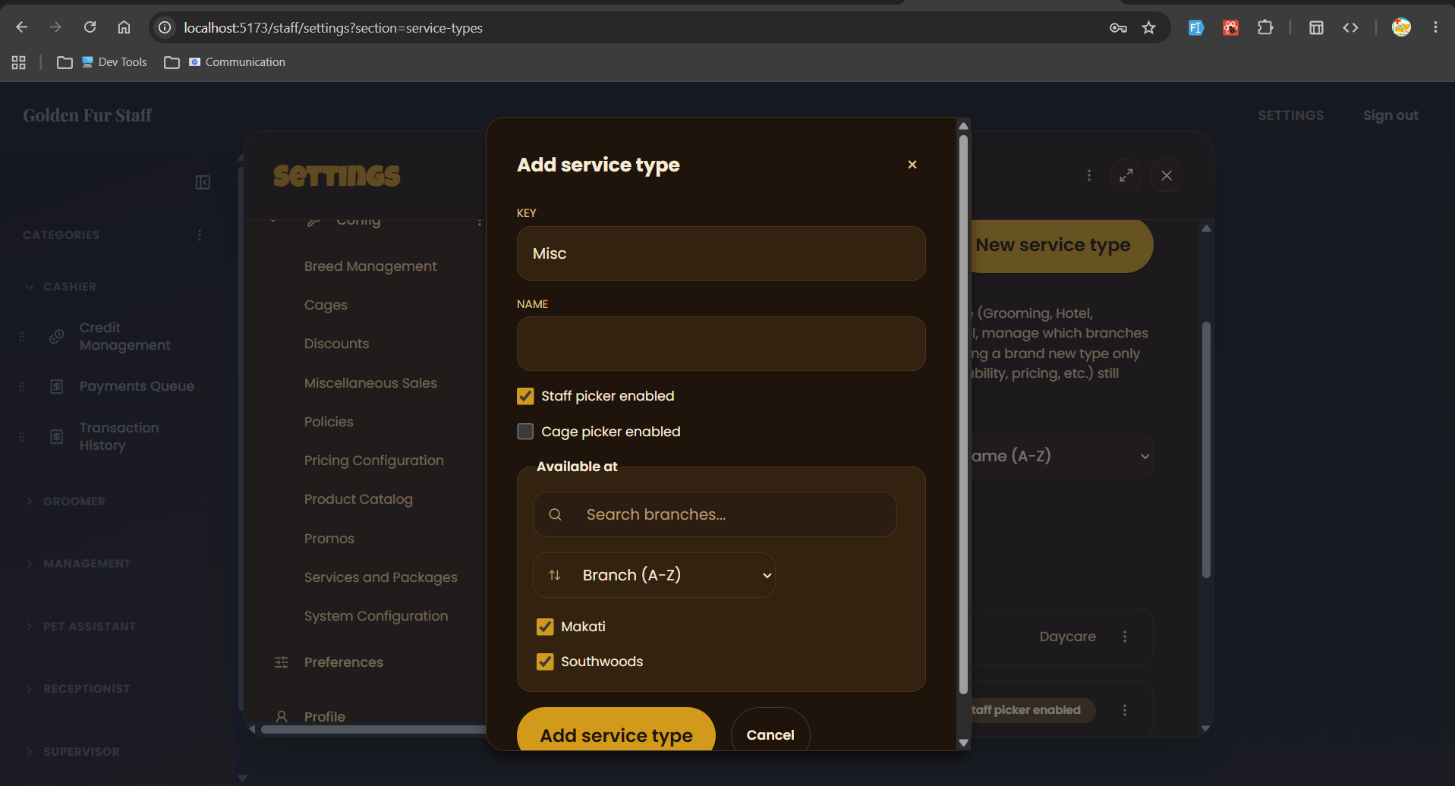  - Just drop key field, it seems redundant, I don’t like it showing in the list either  - 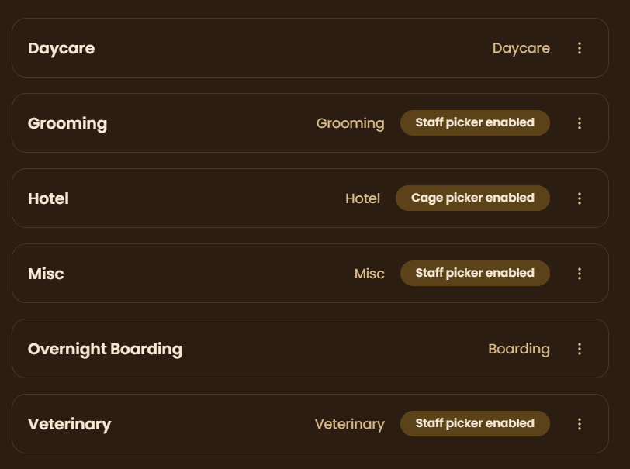 | Matthew
Merged | - At booking process > payment step, allow customers/receptionist to choose payment scheme, whether to pay in full or downpayment when doing online bookings  - This decides the number of transactions made at customer > my transaction or cashier > transactions  - Full payment = 1 transaction only  - Downpayment = 2 transactions (e.g. downpayment and remaining balance, or perhaps make it flexible? 2+ transactions? Downpayment + multiple remaining balance transaction instances where you can choose how much to pay, creates new instance if remaining balance is not paid in full)  - Remove payment mode in booking process, move it to customer > my transactions and cashier > transactions  - Payment mode only appears when clicking on a transaction > pay  - Customers can choose credits, gcash or paymaya  - Cashiers can choose cash, bank, card, pickaroo and the aforementioned three | Matthew
Merged | - Allow customers to see when will their credits expire (perhaps on hover or a dedicated credits page)  - Also allow them to see on what branch their credits are tied to (since credits are branch limited)  - Perhaps just show the sum of all their credits across branches in the navbar  - Then clicking on it will open a dedicated page that shows the credit distribution across other branches and their expiry (date and days left)  - Improve credits expiry config in admin settings  - 2 options: entire branch credits expire at X date, or credits from specific transaction from specific booking expire at X date  - Only one or the other | Matthew
Merged | - Add a configurable cancellation-to-credit conversion rate (default 100%, admin-adjustable, e.g. down to 50%) instead of a hardcoded full conversion.  - Fix the bug where credits were not generated after a cancellation during testing — verify the down-payment-to-credit pipeline end-to-end.  - Re-verify that the reschedule flow correctly reflects updated booking status and resulting credit balance after a cancellation.  - On the navbar, show how much credits a customer has (only applies to customers), include an icon | Matthew
Merged | - Update golden fur seed scripts  - Make sure all necessary tables have rows  - Also add a supabase seed script updater agent/skill that auto runs whenever changed code touches a table with a seed script  - Add a skill/agent that auto runs push migrations to supabase when changes to supabase/migrations are made (only run after entire task is done)  - Since you said that the skill/agent that runs verify all vscode task on commit/PR request doesn’t fix the failing CI results, create a subagent and/or skills that fixes failing CI checks from verify all vscode task  - Also create an agent and/or skills that auto updates the existing workflows in the vault repo if anything changes to the corresponding code that involves it are made, and another agent/skills that updates the debugger agent/skills (like .agent\agents\booking-capacity-agent.md) | Matthew
Merged | - Add a subagent code reviewer in golden-fur repo for unbiased code reviews  - Only give it readonly perms  - Should auto run before creating commits, publishing branch or opening PR  - Decide where it should place its outputs, I’m thinking somewhere in Projects\golden-fur\testing | Matthew
Merged | - Add a dedicated transactions page (I think it’s already there) to search, filter and sort all customer transactions (e.g. downpayment, full, etc.), where each transaction is linked to a booking  - Online bookings of status pending payment will appear here for cashiers to mark as paid  - Make other queues pull bookings from payments queue (fully paid or partially paid), instead of relying on bookings queue (status IS NOT pending)  - Or perhaps just add an extra status in bookings queue before pending (e.g. unconfirmed), that specifies that an online booking is still not paid  - Perhaps revamp entire bookings queue status to something like: unconfirmed > confirmed > no show > cancelled  - While all the other queues will use the standard status: pending > in progress > completed | Matthew
Merged | - Require some form of online payment (full or down payment) on every online booking — do not allow a slot to be reserved with zero payment.  - Make the down payment configurable as either a percentage of the total price or a flat fixed amount, set by an admin/owner.  - While a down payment is unpaid, keep the booking at 'Pending' and leave that time slot visible and bookable by other customers — it should not lock the queue/schedule.  - Add an expiration timer to unpaid down-payment reservations (e.g., due by end of day); auto-release the held slot if the deadline passes unpaid.  - At the payment phase of the booking process, add an option for the customer/receptionist to choose either full payment or downpayment for online transaction (NOT IN WALK INS, walkins auto full)  - At payments queue, a design the UI in a way that allows cashiers to mark transactions as paid  - If the transaction is downpayment not full, marking it as paid shows partially paid instead of fully paid  - Each list item should have a way to view the payment details (e.g. date, amount) for each transaction within the booking)  - Discounts and promos apply before downpayment is calculated | Matthew
Merged | - Confirm that the downpayment config at admin settings only applies to online bookings and not walk ins  - Online bookings are identified as bookings made not on the same date and time (any other booking that’s not a walk in) | Matthew
Merged | - Build a dedicated walk-in booking flow: same-day, on-site registration for walk-in customers, distinct from the future-appointment booking flow.  - Build this in the booking process (for both receptionist and customer) > date time picker  - They should be able to choose if it’s an online booking or walk-ins  - If they’re a walk-in, put them in automatically in the booking queue  - You might need to improve the booking queue status (to differentiate between unfinal online bookings and walk in bookings, or perhaps just make online bookings to pending, and walkin bookings to in progress)  - Only walk-in bookings should show up at the other queues (e.g. grooming, vet, hotel, daycare) | Matthew
Merged | - Move the down payment toggle/config so it applies per transaction (all online bookings/services), not per individual service. | Matthew
Merged | - Document the all the workflows in the vault repo  - Group by modules  - See sample mermaid code output | Matthew

Ideas
James task: customer home page widgets

High Priority

Task | Difficulty
- Change Resend to Brevo in code  - Free email  - No need for domain  - create document in claude on how to setup step by step | Hard
- On http://localhost:5173/staff/hotel/queue:  - Clicking on check in on hotel queue should immediately check in the pet, does not open http://localhost:5173/staff/hotel/queue/check-in/e0aff74e-44e8-48a6-9007-008a7603a1a4  - Move http://localhost:5173/staff/hotel/queue/check-in/e0aff74e-44e8-48a6-9007-008a7603a1a4 to the … button > View booking details with an edit option at the bottom  - Do not open this page with go to checkout and check in another pet options after checking it, just return to the queue and show a modal if success or fail  - 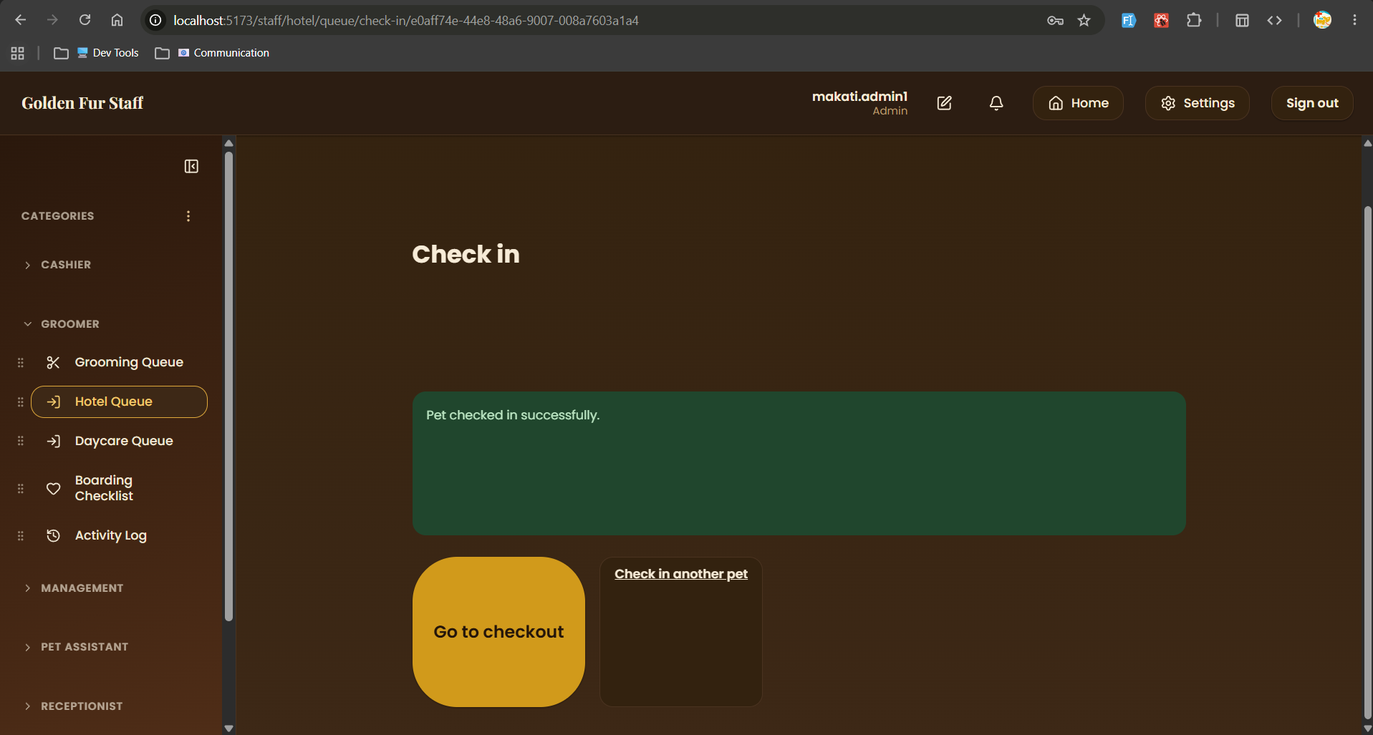 | Medium
- On http://localhost:5173/staff/daycare/queue:  - Remove checkin checkout subpages  - Just add a status field to hotel queue items (e.g. pending, checked in, checked out, or follow the standard pending, in progress, completed, cancelled, no show like bookings queue)  - Remove checkin/checkout buttons on each list item  - Make it so that clicking on a pending list item opens the … view details to finalize hotel booking details  - Clicking on a checked in pet opens a custom http://localhost:5173/staff/hotel/care-log page that only has the tasks filtered only for that pet  - Clicking on checked out pet does nothing  - 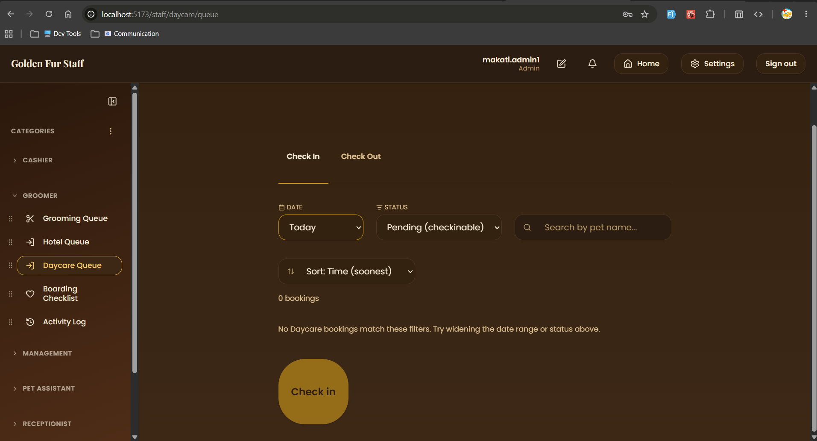 | Medium
- Determine what dependencies or number or files that will be touched when we overhaul booking queue status field to unconfirmed > confirmed > completed/cancelled/no-show | Unknown
- Confirm whether each payments queue row is linked to a transactions table, that is either downpayment, remaining balance payment or full payment | Unknown
- Add a config in admin settings whether walkin bookings should take into account branch operating hours  - Since booking a walkin at 8PM doesn’t sound right  - 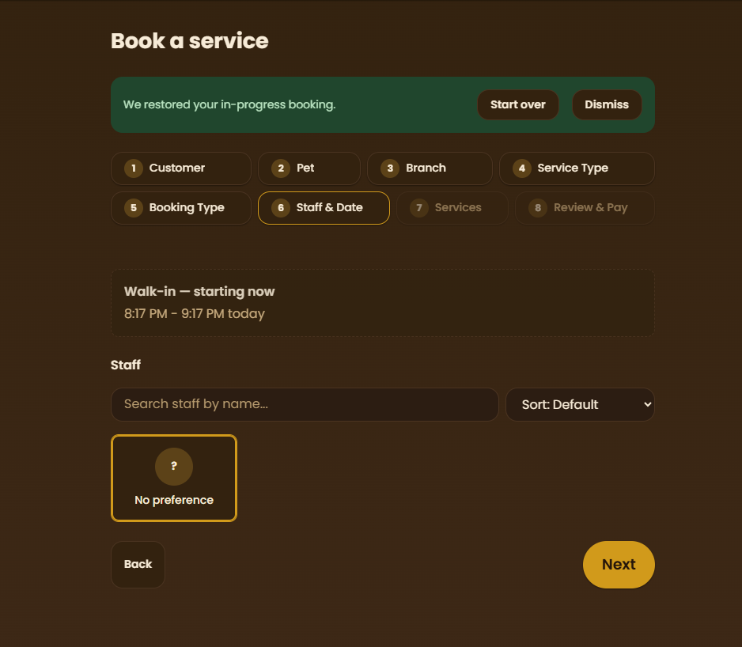 | Easy

MsMayuga-Aug27
Golden Fur — Advisory Session Review
Source: MsMayuga-URO-Aug27 (advisor walkthrough transcript)
Prepared for: dev team backlog / Architectural Change Suggestions log

Part 1 — Issues Raised During the Session
The advisor (Ms. Mayuga) walked through a live demo of the Golden Fur booking system. The issues below are organized by area, as surfaced during that walkthrough.

A. Payment & Compliance
1. PayMongo requires business verification (KYC).
When the team attempted to log into PayMongo with the Golden Fur account, the platform required ID/business verification (Know Your Customer) before payment processing could be enabled, since PayMongo is a licensed payment portal. This requirement was not identified prior to the capstone proposal being finalized, so it wasn't accounted for in the original scope.
2. Facebook Login requires Meta Business Verification.
Similarly, enabling Facebook Login (Meta for Developers) requires Meta Business Verification once the app is live to the public. This is a second compliance dependency the team was not previously aware of.
3. Down payment was configured per-service instead of per-transaction.
During testing, the down payment toggle was found to apply at the individual service level rather than across the entire transaction. Per the proposal's scope, the down payment requirement should apply to all online payments/bookings as a whole.

B. Booking Flow
4. Reschedule allows selecting a date before the current booking's day.
While testing reschedule, a 'previous day' option remained selectable even though the booking had already been moved to a later date. Once a booking is moved forward, earlier dates (already past) should no longer be selectable.
5. Multi-day (3-day) booking configuration may not be working consistently.
A minimum-3-days filter/configuration was tested (e.g., Sept 1–3), but the advisor and dev noted it might not be functioning properly, and that schedules appeared to be 'pinned' or locked in an unexpected way.
6. A newly created service type did not appear in the booking flow.
A new 'Massage' service was created and marked available for both branches, but it did not show up in the 'Book a Service' step/menu during the customer booking flow.
7. The system only supports booking one pet at a time.
Customers with multiple pets cannot book services for more than one pet within the same session (e.g., one pet for Makati, another for Southwoods, or two pets at the same branch). For hotel-type bookings specifically, only one cage can be assigned per booking, so multiple pets cannot each be assigned their own cage in a single transaction. The advisor acknowledged this is a nontrivial database/architecture challenge, not just a UI fix.

C. Services & Packages
8. Running total miscalculates when an individual service overlaps with a package.
When a service that also exists inside a selected package was chosen individually, the displayed price did not update correctly (e.g., showed 750 instead of the expected 630) until the conflicting selection was manually removed.
9. Unclear selection order and labeling between individual services and packages.
When a service is already part of a selected package, it becomes disabled — but it isn't clearly labeled with which package it belongs to, making the code/reasoning hard to read. The advisor also raised the open question of whether individual services or packages should be the default/first thing a customer selects.

D. Cancellations & Credits
10. Cancellation always converts payment to a full (100%) credit, with no configurable option.
The system currently performs a full conversion of payment to customer credit upon cancellation. The advisor suggested this should be configurable (e.g., an admin-defined percentage, such as 50%, returned as credit instead of the full amount).
11. Credits were not generated correctly during a cancel/reschedule test.
While testing the cancel-then-reschedule path, no credit appeared to have been generated from the cancelled/down-paid booking, which should have converted per policy.

E. Environment & Deployment
12. The system is still running on localhost, limiting real-world testing.
The advisor pointed out that because the system has not yet been deployed to a live environment, certain payment- and integration-related behaviors (e.g., PayMongo, OAuth logins) cannot be fully verified end-to-end.

Part 2 — Actionable Dev Notes
The items below translate the issues above into a checklist, formatted consistently with the team's Architectural-Change-Suggestions log.
On PayMongo integration (payment settings):
- Coordinate with the business owner (Sir Mike) to complete PayMongo's Business Verification / KYC requirements before continuing integration work.
- Prepare and store the required verification documents (business permit, IDs, etc.) in the shared Google Drive per PayMongo's checklist.
- Define a fallback plan/scope in case business verification is denied or delayed (e.g., cash-only or manual payment recording as an interim option).
On Facebook Login (Meta OAuth):
- Confirm with the business owner whether pursuing Meta Business Verification for Facebook Login is worth the added compliance overhead.
- If deprioritized, update the proposal/scope documentation to reflect Google/Gmail OAuth as the primary third-party login method, with Facebook as optional/future work.
On admin settings → down payment configuration:
- Move the down payment toggle/config so it applies per transaction (all online bookings/services), not per individual service.
- Re-test down payment enforcement across grooming, hotel, daycare, and vet booking types after the fix.
On staff/customer reschedule flow:
- Disable date options earlier than the booking's current effective date in the reschedule date picker.
- Add a regression test: after moving a booking to a later date, confirm the previously available earlier dates are no longer selectable.
On multi-day (hotel) booking configuration:
- Investigate and fix the 3-day-minimum (or N-day) booking filter/configuration — verify it correctly applies date ranges instead of appearing to lock/pin schedules.
- Add test cases covering multi-day ranges (e.g., 3 nights, 5 nights) to confirm no unintended schedule locking.
On Book a Service step (customer/staff booking flow):
- Fix the bug preventing a newly created and activated service type from appearing in the service selection list.
- Add a QA checklist step: verify any new service is immediately visible/selectable in the booking flow once marked active.
On booking process — multi-pet / multi-branch support:
- Document the current one-pet-per-booking-session limitation as a known constraint if it will not be resolved within capstone scope.
- If pursued, scope a design for handling multiple pets within one session as sequential per-pet bookings (not true simultaneous multi-select), reusing shared booking context (date range, branch) where applicable.
- For hotel-type bookings specifically, resolve the cage-assignment limitation so multiple pets in one transaction can each be assigned a separate cage.
On service/package selection UI (booking → services step):
- When a service is disabled because it's already included in a selected package, show a label or tooltip naming that package (not just a greyed-out state).
- Fix the running-total computation bug that occurs when a service overlaps between an individual selection and a package selection.
- Decide and document the intended UX order (individual service selection vs. package selection first) and apply it consistently across the booking flow.
On cancellation policy (admin settings → maintenance → policies):
- Add a configurable cancellation-to-credit conversion rate (default 100%, admin-adjustable, e.g. down to 50%) instead of a hardcoded full conversion.
- Fix the bug where credits were not generated after a cancellation during testing — verify the down-payment-to-credit pipeline end-to-end.
- Re-verify that the reschedule flow correctly reflects updated booking status and resulting credit balance after a cancellation.
Deployment / test environment:
- Deploy the system to a live/staging environment (beyond localhost) to properly test payment provider integrations (PayMongo) and OAuth logins end-to-end.
- Confirm seeded test data remains usable and realistic once migrated to the live/staging environment.

ChatGPT
Here are the key details and notes from Speaker 1, organized by topic. I focused only on what Speaker 1 said or confirmed, rather than Speaker 2's suggestions.

1. Website / Images
- The images currently being used are AI-generated placeholders because they don't have professional photos yet.
- They are still waiting for professional photos.
- Speaker 1 mentioned coordinating with the COO, who is the owner’s spouse, because some business verification information cannot be answered by Sir Mike.
- Business verification is needed for:
  - Payment
  - Facebook login

2. Deployment / Website Testing
- The website is already deployed, but Speaker 1 has not yet merged the latest changes.
- The purpose of deploying/testing is to identify errors that may only appear in the deployed environment.
- The homepage can display/package data pulled from the actual package data source.

3. Packages
- Packages allow the selection of multiple services.
- A percentage discount is applied depending on the package.
- Example discussed:
  - Original price: 700
  - Discounted price: 630
  - Package discount: 10%
- Speaker 1 agreed that the package should communicate the discount more clearly.

4. Receptionist Role
The receptionist's main responsibility is handling bookings.
The receptionist can:
- Create bookings for walk-in customers.
- Create bookings for existing customers.
- Handle bookings made by customers themselves.
- Record the pet's actual weight during the assessment process.

5. Pet Assessment
- A pet that has not yet been assessed does not have:
  - Weight
  - Coat size/type
  - Other assessment information
- The pet's assessment affects the price of services.
- Weight is measured on-site by the receptionist/staff.
- The assessment is essentially used to determine the pet's relevant characteristics and pricing.

6. Assessment / "Miscellaneous" Service
- The current Miscellaneous (MISC) category is being used for pets that have not yet been assessed.
- Speaker 1 explained that MISC is essentially a category.
- Once the pet has been assessed, services such as:
  - Grooming
  - Pet hotel
  - Daycare
can become available.
- Speaker 1 suggested renaming "Miscellaneous" → "Assessment Types" because "Miscellaneous" is confusing and too broad.

7. Service Pricing
- The admin configures the price when creating a service.
- The receptionist does not edit service prices during booking.
- Service pricing is determined by the service configuration and, where applicable, pet characteristics such as weight/coating.

8. Service Configuration
Admin can configure:
- Service name
- Base price
- Branch availability
- Staff picker
- Cage picker
- Other service-related settings
Speaker 1 explained that the staff picker is based on staff roles and availability at the selected time.

9. Cage System
- Speaker 1 implemented a cage picker.
- Cages can have different sizes, such as:
  - Small
  - Medium
  - Large
- Cage assignment can depend on the pet's weight class.
- Speaker 1 suggested using cage selection primarily for monitoring, rather than payment.
- The system should be able to identify which pet is assigned to a specific cage.
- Cage configuration can potentially be mapped to service types.

10. Staff Picker
- A service can have Staff Picker Enabled.
- Staff selection is based on:
  - Staff role
  - Staff availability at the selected time
- This allows the system to determine which staff members can handle a particular service.

11. Walk-in Booking
- At this point, the system does not yet have a proper walk-in function.
- Speaker 1 confirmed that walk-in handling still needs to be implemented.
- The intended process is that the receptionist manages registration for a walk-in customer.
- Walk-in registration should happen on the day/time of service, rather than requiring a future appointment.

12. Customer & Pets
- Customers can have multiple registered pets.
- Currently, the system handles services one pet at a time.
- Speaker 1 confirmed that multiple pets cannot currently be selected together for a service.
- Speaker 2 suggested that multiple pets should potentially be supported with different appointment times on the same day, especially when staff availability is limited.

Claude Missed
Golden Fur — Advisory Session Review (Addendum)
Source: MsMayuga-URO-Aug27 (full re-read) + Speaker 1 session notes
Purpose: items missed from the first pass, including the down-payment/queue-locking issue flagged as critical

Part 1 — Issues Raised During the Session (Addendum)
These issues were surfaced in the same advisory walkthrough but were left out of the first document. They are organized by area.

A. Down Payment & Slot Reservation (flagged as critical)
1. Online bookings can currently reserve a slot with zero payment.
The advisor was explicit that an online booking must never be allowed to hold a slot without some form of payment — either full payment or a down payment. Without this, a customer could reserve a slot and simply not show up, wasting it.
2. Down payment amount needs to be configurable two ways: percentage or flat fee.
The owner (Sir Mike) may want a straight percentage (e.g., 50%) or a fixed flat amount (e.g., ₱200) regardless of the total service cost. The system should let admins configure either mode.
3. An unpaid down payment should NOT lock the booking into the queue — the slot must stay bookable by others.
This is the core issue: a booking with an unpaid down payment should sit in a 'Pending' / pencil-booking state and the time slot should remain visible and bookable by other customers, not treated as reserved/confirmed. Only an actual payment (full or down) should move it into a real, locked slot.
4. Unpaid down-payment reservations need an expiration window.
The advisor described a same-day deadline (e.g., pay by 11:59 PM) after which the reservation auto-resets and the slot becomes available again the next day. There is currently no such timeout/expiration mechanism.
5. No 'advance payment' option — book online now, pay in person on the day.
The advisor asked whether a customer could book online but only pay when they physically arrive for the service. This should be supported as a distinct 'advance payment' path, with the cashier able to manually mark it as paid on arrival.

B. Cancellation Flow
6. Cancellation currently executes immediately with no confirmation prompt.
During testing, clicking Cancel went through right away (with only a reason text box), when it should show a proper 'Are you sure you want to cancel?' confirmation step first.
7. Cancellation screen doesn't disclose the non-refundable/credit-conversion policy to the customer.
The advisor dictated specific messaging that should appear on-screen: payment (full or down) will not be refunded, but will be converted into account credit usable on the customer's next visit. This messaging currently isn't shown anywhere in the flow.

C. Notifications & Reporting
8. Email booking-confirmation notifications are not yet implemented.
A booking was confirmed in-app, but no confirmation email was sent, since the email API integration hasn't been wired in yet — only the in-browser notification currently works.
9. The Daily Sales Report (DSR) module does not exist yet.
When asked about reporting, the team confirmed there is no report/DSR functionality at all yet — a gap against the proposal's stated objectives.

D. Booking Status Logic
10. The system currently assumes a booking is paid/started even without a real payment module.
Because there's no live payment module yet, the flow was found to treat a booking as already paid/in-progress by default, rather than accurately reflecting that no payment has actually been confirmed.

E. Payment Provider Scope (Defense Contingency)
11. PayMongo integration may not be ready in time for the defense — a fallback plan is needed.
Since PayMongo's business verification is still pending owner sign-off, the advisor suggested using a placeholder 'payment type' selector (no live processing) for the thesis defense, with real PayMongo setup happening after deployment and before turnover, once the owner approves. This needs to be explicitly written into the paper's scope section, not just handled in code.

F. Third-Party Login
12. The advisor recommended removing Facebook Login outright, not just deferring it.
Since Google OAuth and email/password login are already implemented and sufficient, the advisor's guidance was to drop Facebook Login from scope entirely rather than pursue Meta Business Verification.

G. Website Content & Verification Coordination
13. Site images are AI-generated placeholders pending professional photos.
The team is still waiting on professional photos from the business; current images are AI-generated stand-ins. Separately, some business-verification information cannot be provided by Sir Mike alone and needs coordination with the COO (the owner's spouse).

H. Deployment / Environment
14. The site is deployed, but the latest local changes have not been merged/pushed yet.
This means recently discussed fixes aren't live yet, and environment-only bugs (that don't show up on localhost) can't be caught until a merge and redeploy happen.

I. Packages & Pricing Clarity
15. Package discount percentage isn't clearly communicated to the customer.
In the example discussed, a package dropped a price from 700 to 630 (a 10% discount), but this percentage/savings isn't clearly surfaced in the UI — customers just see the final bundled price.

J. Receptionist, Assessment & Walk-in Workflow
16. There is no proper walk-in booking flow yet.
Walk-in registration is expected to happen on the day/time of service itself (not as a future appointment), but this distinct flow hasn't been built — the system currently only supports the same appointment-style flow for everyone.
17. Pet assessment (weight, coat type) must be recorded on-site by the receptionist and directly affects pricing.
A pet that hasn't been assessed yet has no weight or coat-type data, which blocks accurate pricing for grooming/hotel/daycare services until the receptionist records this in person.
18. 'Miscellaneous' service category is confusingly named and should be 'Assessment Types.'
MISC is currently used as the category for pets that haven't been assessed yet, but the label is too broad/confusing (it could imply misc. services or payments) and should be renamed for clarity.
19. Bug: the Assessment/MISC category does not appear in service type search results.
This blocks the assessment step entirely for unassessed pets, since staff can't find/select the assessment service type through search.

K. Cage Assignment
20. Customers can currently pick their own cage during booking — this should be receptionist-only.
The advisor was clear that cage selection should not be a customer-facing choice; it should be assigned by the receptionist/staff instead.
21. Cage assignment should be for monitoring only and should not affect pricing.
The advisor confirmed cage size/selection has no bearing on the price — it exists purely so staff can track which pet is in which cage.

L. Multi-Pet Booking
22. The system still only supports one pet per booking, with no interim solution implemented.
This was raised again in more concrete terms: rather than true simultaneous multi-pet selection, an interim option discussed was allowing the same customer to book multiple pets on the same day at staggered times, working around limited staff availability.

Part 2 — Actionable Dev Notes (Addendum)
These translate the addendum issues above into checklist items, in the same format as the Architectural-Change-Suggestions log.
On booking creation → down payment & slot reservation (critical):
- Require some form of online payment (full or down payment) on every online booking — do not allow a slot to be reserved with zero payment.
- Make the down payment configurable as either a percentage of the total price or a flat fixed amount, set by an admin/owner.
- While a down payment is unpaid, keep the booking at 'Pending' and leave that time slot visible and bookable by other customers — it should not lock the queue/schedule.
- Add an expiration timer to unpaid down-payment reservations (e.g., due by end of day); auto-release the held slot if the deadline passes unpaid.
- Add an 'advance payment' booking option: book online now, pay in person on the day of service.
- Add a cashier action to manually mark an advance-payment booking as 'Paid' when the customer arrives and pays.
On cancellation flow (customer/staff):
- Add an explicit confirmation dialog ('Are you sure you want to cancel this booking?') before a cancellation is executed.
- Add on-screen copy in the cancellation flow disclosing that payment (full or down) is non-refundable but will be converted into account credit for use on a future visit.
On notifications:
- Implement email booking-confirmation notifications via the email API (currently not wired in — only in-browser notifications work today).
On reporting:
- Build the Daily Sales Report (DSR) module — currently missing entirely — covering transactions across branches and payment methods per the proposal's objectives.
On booking status/payment logic:
- Fix the booking flow so status accurately reflects an unpaid booking instead of assuming payment success when no real payment confirmation exists.
On payment provider scope (defense contingency):
- Implement a placeholder 'payment type' selector (label only, no live processing) to stand in for PayMongo during the thesis defense.
- Document this contingency explicitly in the capstone paper's scope section: live PayMongo setup to be completed post-deployment, pending the owner's approval, prior to system turnover.
On third-party login:
- Remove Facebook Login from the login options; keep Google OAuth and email/password login as the supported methods.
On website content & verification coordination:
- Keep AI-generated placeholder images in place until professional photos are provided; track as a pending content item rather than a bug.
- Coordinate remaining business-verification requirements with the COO (owner's spouse), since some required information falls outside what Sir Mike alone can provide.
On deployment:
- Merge outstanding local changes and redeploy to the live environment so environment-only bugs can be caught before further testing/defense.
On packages (booking → services step):
- Add clear discount messaging on package cards/detail views (e.g., 'Save 10% vs. booking individually') so the savings versus individual pricing are obvious to the customer.
On receptionist / walk-in workflow:
- Build a dedicated walk-in booking flow: same-day, on-site registration for walk-in customers, distinct from the future-appointment booking flow.
- Ensure the receptionist can record a pet's actual weight and coat type on-site during assessment, updating the pet's profile and any pricing inputs that depend on it.
On assessment / service categorization:
- Rename the 'Miscellaneous' (MISC) service category to 'Assessment Types' for clarity.
- Fix the bug where the Assessment/MISC category does not appear in service type search results, which currently blocks the assessment booking path for unassessed pets.
On cage assignment:
- Remove the cage picker from the customer-facing booking flow; restrict cage assignment to receptionist/staff only.
- Keep cage assignment purely for monitoring/tracking, with no effect on service pricing.
On multi-pet booking:
- As an interim solution short of true simultaneous multi-pet booking, support staggered same-day time slots per pet for the same customer when staff availability is limited.

Low Priority

Task | Difficulty
- Remove white border around discount and promo selection in bookings queue > new bookings  - 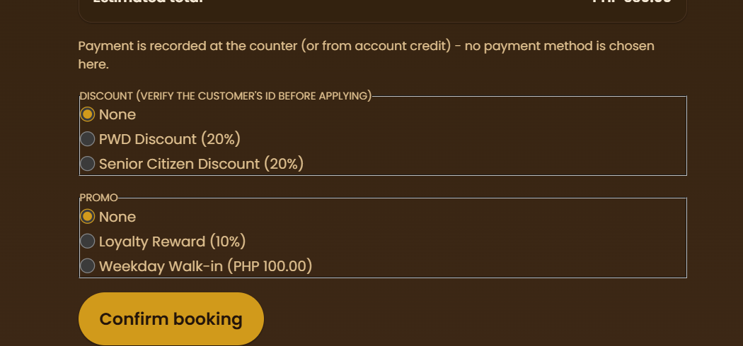  - You may make promos multi-select (currently it’s radio button), to make it reflect the promo cap configuration in admin settings > config | Easy
- Vet type staff should have some sort of specialization (e.g. respiratory, cardio, etc.)  - This should be shown in booking process > staff picker  - This should also influence what kind of services they offer  - These services should be readonly if initial consultation service has not been used by the customer  - So for vet type staff, I assume the booking process would be: branch > pet > service type > staff and time pickers > services/packages… or should it be different?  - Services prices are TBD, only estimated prices on payment stage, should be editable by the assigned vet after or during pet treatment | Hard
- Try ollama integration in the system | Hard
- Add on screen tutorials for customer and each staff role  - Should dim entire screen except for next step UI  - Next, Previous and Skip buttons  - Can be activated again by interacting with a floating dog mascot (from landing page) | Medium
- Fix search bar icons on search input fields overlapping with input text  - One in customer login/signup  - Admin settings > promos config page  - Admin settings > services and packages page | Easy
- Make settings modal fullscreen  - Settings sidebar should be a second sidebar  - Auto collapses the dashboard sidebar when settings opened | Easy
- Add an auto configure monthly schedule feature  - Automatically chooses rest days, etc. for all staff  - Available in the monthly schedule UI  - Should affect staff availability (when choosing staff in booking queue > staff picker step | Medium
- Add a way for staff to see their rest days, etc. assigned by supervisors and admins in monthly schedule | Easy
- Add missing unit test files for all files | Cakewalk
- Ask Claude how to add mcp servers, recommended mcp servers for both dev and vault repos | Unknown
- Add a table view for all queues (bookings, payments, etc.) | Medium
- Remove staff picker from admin settings > config > policies  - Since it’s already in create new service type form  - 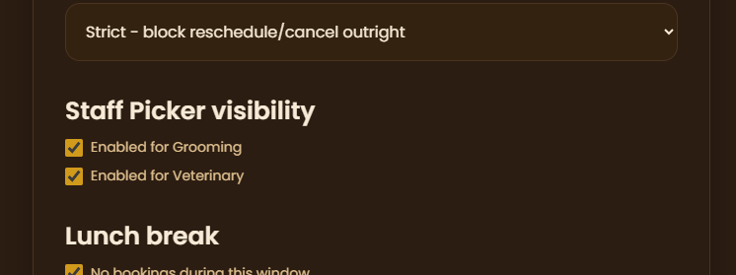 | Easy
- Build the Daily Sales Report (DSR) module — currently missing entirely — covering transactions across branches and payment methods per the proposal's objectives. | Hard
- In receptionist role > bookings queue, remove branch step  - Since staff accounts are tied to a branch, receptionists should only be able to make bookings at their current branch  - Only do this for receptionist and admins (since admins are also branch locked)  - Customers and superadmins should still be able to select what branch | Easy

