In Progress

Pending

Easy
- Fix search bar icons on search input fields overlapping with input text
  - One in customer login/signup
  - Admin settings > promos config page
  - Admin settings > services and packages page

- Setup Brevo

- Make settings modal fullscreen
  - Settings sidebar should be a second sidebar
  - Auto collapses the dashboard sidebar when settings opened

- Update vault repo to include gdrive files
  - Include architecture, roadmaps, etc.
  - No need for resources

Hard
- Vet type staff should have some sort of specialization (e.g. respiratory, cardio, etc.)
  - This should be shown in booking process > staff picker
  - This should also influence what kind of services they offer
  - These services should be readonly if initial consultation service has not been used by the customer
  - So for vet type staff, I assume the booking process would be: branch > pet > service type > staff and time pickers > services/packages… or should it be different?
  - Services prices are TBD, only estimated prices on payment stage, should be editable by the assigned vet after or during pet treatment

- Fix facebook signup
  - Test in mom’s or james email

- Change Resend to Brevo in code
  - Free email
  - No need for domain
  - create document in claude on how to setup step by step

- Try ollama integration in the system
- Add on screen tutorials for customer and each staff role
  - Should dim entire screen except for next step UI
  - Next, Previous and Skip buttons
  - Can be activated again by interacting with a floating dog mascot (from landing page)

Meta and Paymongo

Link to Claude Chat:
https://claude.ai/chat/53762e60-835c-46d7-b691-93e000c390e7
Good context — that changes the ask. This isn't "get them to fill out paperwork you assumed they'd need," it's "we discovered a genuine technical/legal blocker after the fact, and we need to loop them in now, before the panel proposal locks it in." That's a completely normal and low-stakes conversation to have, if framed right. Confirmed from current Meta docs, by the way: even basic Facebook Login (just email + profile) now requires Business Verification once the app goes live publicly — several small developers have dropped FB Login entirely rather than deal with it, so your instinct isn't overcautious, it's accurate.

Getting the sign-off (Option A: try this first)
Before assuming they'll refuse, go in with a low-friction pitch to the ops manager:
- Separate the two asks — they're not equally scary.
  - Meta Business Verification (for FB Login) needs: a registered business, a way for Meta to confirm it (business documents, or sometimes just a phone/email match to public business records), and an admin login to Meta Business Manager. It does not require sharing PayMongo-style financial credentials — no bank details, no live payment processing risk. This is the easier one to ask for.
  - PayMongo Business Verification needs actual business registration docs (DTI/SEC, BIR, possibly a business bank account) and is tied to real money movement. This is the one with actual liability exposure if it goes wrong — treat it as the harder ask.
- Ask for the account to be created and controlled by them, not handed to you. You don't need their live credentials in your hands at all — the correct pattern is: the client creates their own Meta Business/PayMongo account, adds your team as a developer/collaborator role (Meta supports "Admin" vs "Developer" app roles; PayMongo has team member invites), so you get the technical access you need for integration without ever holding their actual login credentials or being liable for the account itself. This directly solves the "we don't want to be blamed if something looks suspicious" problem — you're never the account owner.
- Frame it as a 15-minute task on their end, not a burden. Concretely: "We need your business registered on PayMongo's dashboard and Meta Business Manager so the payment and login features we scoped actually work at launch — this is normal setup for any online payment integration, not something specific to being students." Most legitimate operations managers have dealt with a payment gateway signup before; it's not an unusual ask, it's just unfamiliar in a school-project context.
- Give them a deadline tied to your defense date, so it's not an open-ended favor — "we need this set up by [date] to finish testing before our panel defense."

If they decline or stall (Option B: fallback plan)
Have this ready so you're not blocked either way:
- PayMongo → Manual QR-based GCash/Maya. Customer scans a static or per-transaction QR (GCash/Maya both support this without a merchant gateway account), pays, uploads/sends proof of payment, cashier manually confirms and marks Fully Paid in the system — same manual-confirmation pattern you already built for Cash/Card/Bank Transfer. You lose auto-confirmation via webhook, but the core payment options (GCash, Maya) stay intact, which matters for matching what's already written in your proposal.
- Facebook Login → drop it, keep Google Sign-In only. Since this was your own team's addition (not an original client ask), this is the cleanest one to walk back — smallest footprint, no functionality loss versus your original scope, just a documentation correction.

Either way — this needs to go in the proposal before the panel sees it
Since the proposal hasn't been submitted yet, this is genuinely good timing. Update the document now to reflect whichever path you land on (verified PayMongo integration, or QR-based manual fallback), so the panel reviews what you're actually going to build — not a version you already know is at risk.
That's a materially different situation than what we were planning around, and it changes my answer. Let me be direct about it.

Verdict
Don't drop them now. Three reasons:
- The proposal is already defended and approved. FB Login and PayMongo/GCash/Maya aren't just written in a document — they're a committed deliverable your panel signed off on. Quietly cutting them post-defense, without going back to your adviser/panel first, is a scope deviation on an academic deliverable. That's a bigger institutional risk than an awkward client conversation. If a panel member asks "where's the PayMongo integration you defended?" at final defense and the honest answer is "we removed it without telling anyone," that's a much worse outcome than "it's built and working in sandbox mode, but going live requires the client's business verification, which is documented as a deployment step."
- You already built it. Sprints are done — from what showed up in your project files, PayMongo's webhook flow, signature verification, and fee handling are implemented (against sandbox, per the dev notes), and FB OAuth login is implemented and working (per the fix-fb-signup-login verification doc — it works with a real Facebook account). Ripping out working, tested code to swap in a different payment mechanism this late is a lot of rework for a problem that isn't actually a code problem — it's an account ownership problem. The system works. What's missing is the client's live business account behind it.
- Business verification isn't really a "feature scope" issue — it's a deployment/handoff issue, and those are two different conversations. You don't need the client's PayMongo live credentials to finish the software. You need them to go live with it. Those can be decoupled.

What I'd actually do
- Tell your adviser now, plainly, before final defense. Something like: "PayMongo and Facebook Login are fully implemented and testable in sandbox/test mode. Going live requires GoldenFur to complete business verification with Meta and PayMongo themselves — we can't do that on their behalf, and we only confirmed this requirement late in development." This is a completely normal, defensible statement for a capstone. Advisers see "production deployment requires the client's own business account setup" constantly — it's standard for any payment gateway or OAuth business integration, not a sign you under-delivered.
- Demo the system in sandbox/test mode for your final defense, since that's what proves the features work. PayMongo test mode and Facebook Login's test/development mode don't require business verification — that's exactly why your team was able to build and verify this without the client's credentials in the first place.
- Document it explicitly as a Limitations/Deployment Requirements section in your final manuscript: "Live deployment of GCash/Maya payments via PayMongo, and Facebook Login, requires GoldenFur to complete Meta and PayMongo business verification under their own business account. This is outside the technical scope of the student development team." That sentence alone protects you academically — you're not hiding a gap, you're correctly scoping what a student dev team can and can't be responsible for post-handoff.
- Separately, now have the actual client conversation — this time for real, since you said they don't know the feature list yet. When you hand off:
  - Walk them through what's built and working.
  - Explain that GCash/Maya and Facebook Login need their business accounts connected to go live — give them the "you create the account, add us as developer/collaborator, we never touch your actual credentials" pattern from before.
  - Give them the QR-code/manual-confirmation fallback as a documented Plan B if they decline verification — but at that point it's their informed choice to accept a feature downgrade, not a decision your team made unilaterally on their behalf.
- Don't put anything in writing that shifts liability onto the client (the waiver idea) — your instinct on that was right the first time. You don't need it. "We built it, connecting it to your live business requires your business account" is not a liability-shifting document, it's just an accurate deployment note.
The short version: you didn't over-build or over-promise — you delivered what was defended. The remaining step isn't a scope cut, it's a handoff conversation that should have happened earlier but can still happen now without touching the code or the manuscript's core claims.

To Review
- Remove add staff account privilege from admin role
  - On http://localhost:5173/staff/admin/staff
  - Since it cannot state what branch (only superadmin can select what branch)
  - Admins can only add but not place staff on branch
  - Or maybe just give it same privilege as superadmin
- Fix branch IDs being shown instead of branch name in staff card (in staff directory)
  - On http://localhost:5173/staff/admin/staff
  - 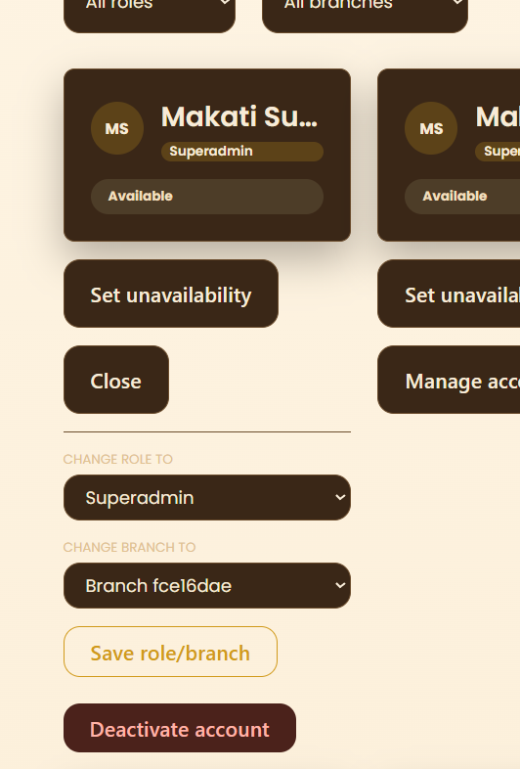
- Add resend email API on staff account creation
  - On http://localhost:5173/staff/admin/staff
- Rename unavailability approval queue, customer and staff directories to something else (superadmin dashboard)
  - On http://localhost:5173/staff/dashboard/admin
  - Since they’re too complex or technical
  - Change “Directory” to management (Staff and customer)
- Remove unavailability approval queue button from staff directory
  - On On http://localhost:5173/staff/admin/staff
  - 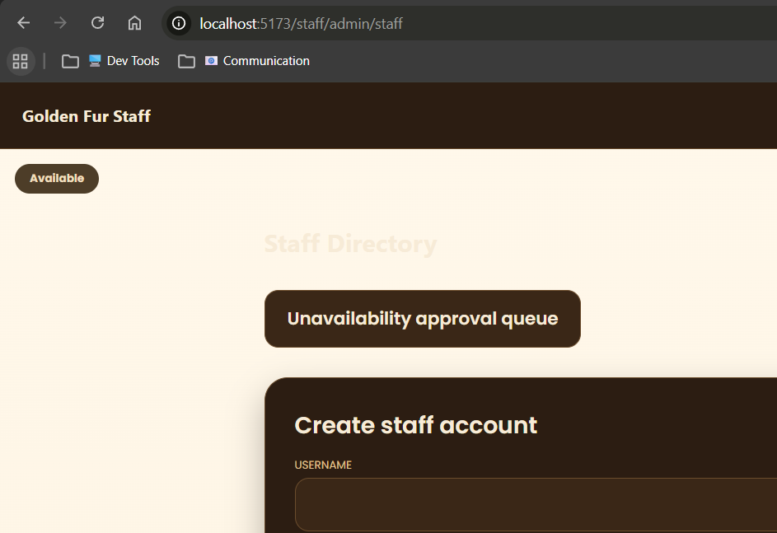
- Extend customer directory > customer list
  - On http://localhost:5173/staff/admin/customers
  - Currently, expanding customer details opens up a create pet form
  - It doesn’t show list of pets
  - Perhaps just turn the expanded details into a … button that allows multiple actions (e.g. check profile, add pet, view pets, etc.)
  - 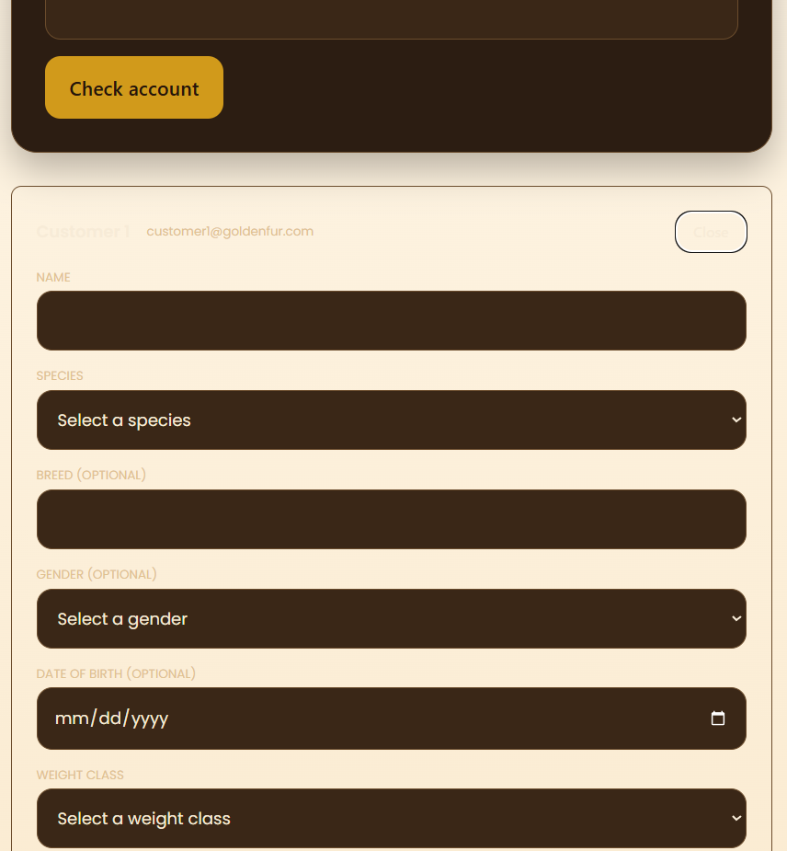
- Remove deactivate button in services page
  - On http://localhost:5173/staff/admin/maintenance/services
  - Since there’s already an enable and disable feature for branches
  - Unless it does something else (query claude first)
  - 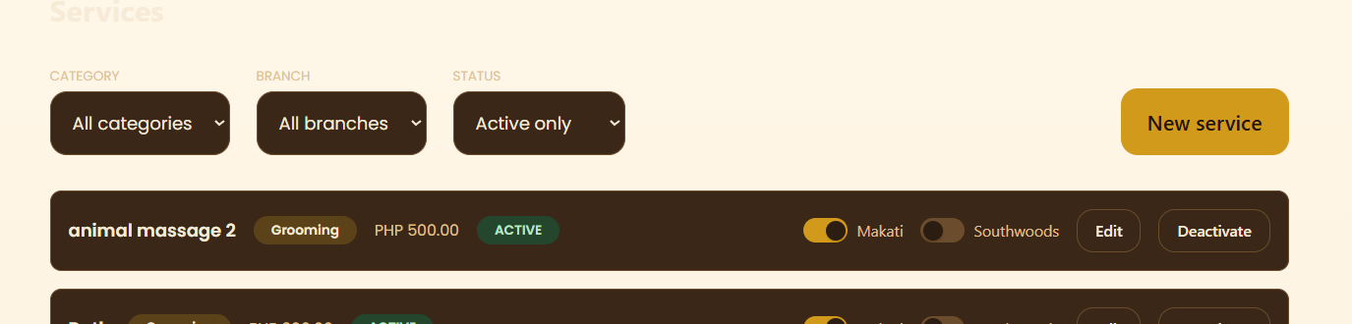
- Make size and coat pricing matrix on grooming service create/edit, derived from base price form field
  - On http://localhost:5173/staff/admin/maintenance/services
  - Should be based on some calculation
  - Perhaps add a different page that allows admins and or superadmins to configure this calculation that determines the derived pricing matrix
  - 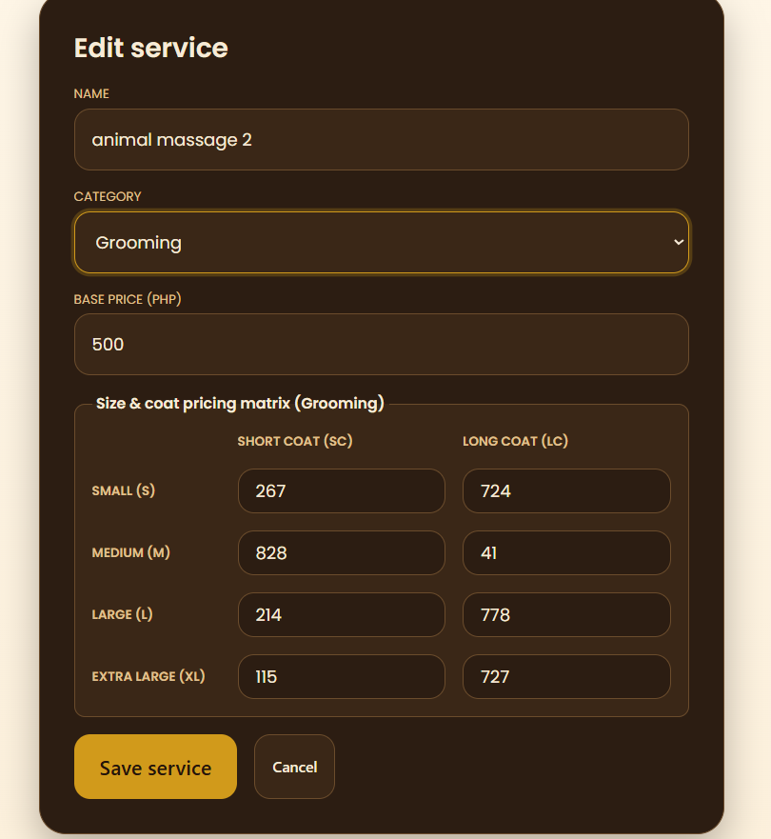
- The same with packages, make the bundled price form field derived from the selected services
  - On http://localhost:5173/staff/admin/maintenance/packages
  - It should only be some sort of calculation based on selected services
  - Also add a feature that allows admins to configure this calculation
  - 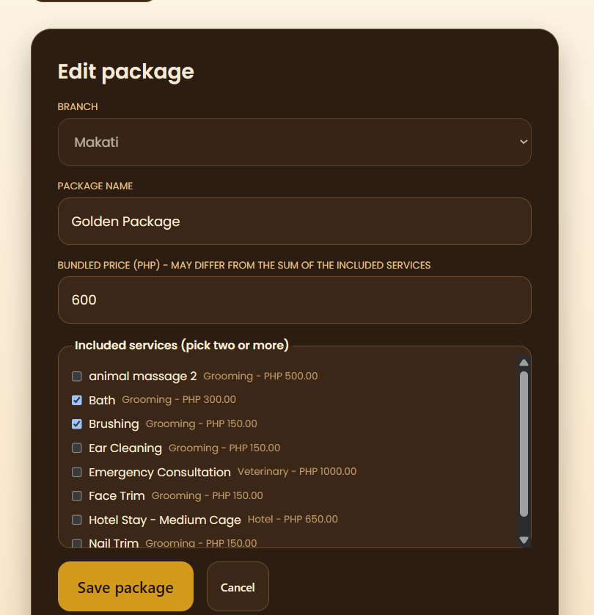
- Change the exclusive promo feature (cannot be combined with other promos) into a promo amount cap per transaction
  - On http://localhost:5173/staff/admin/maintenance/promos
  - Customers should be able to see which promos are available, and whether to activate them or not (default not activated)
  - Allow admins and or superadmins to configure promo per transaction cap
  - 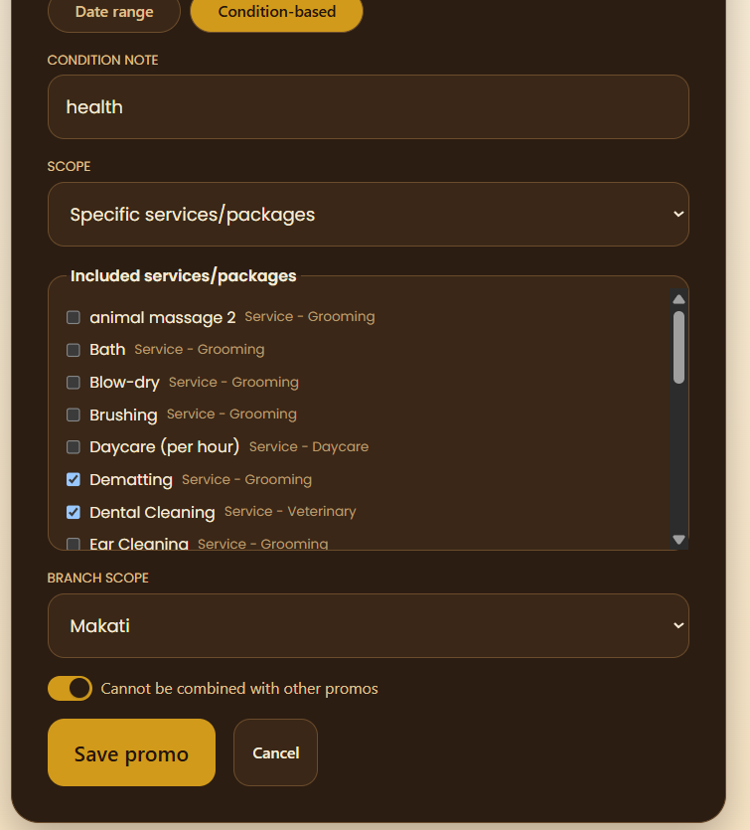
- Just make discounts look better
  - On http://localhost:5173/staff/admin/discounts
  - Imagine you’re the superadmin
  - Discounts can be configured on services, packages and categories
  - There needs to be a search and filter feature
  - And just more readable UI
  - 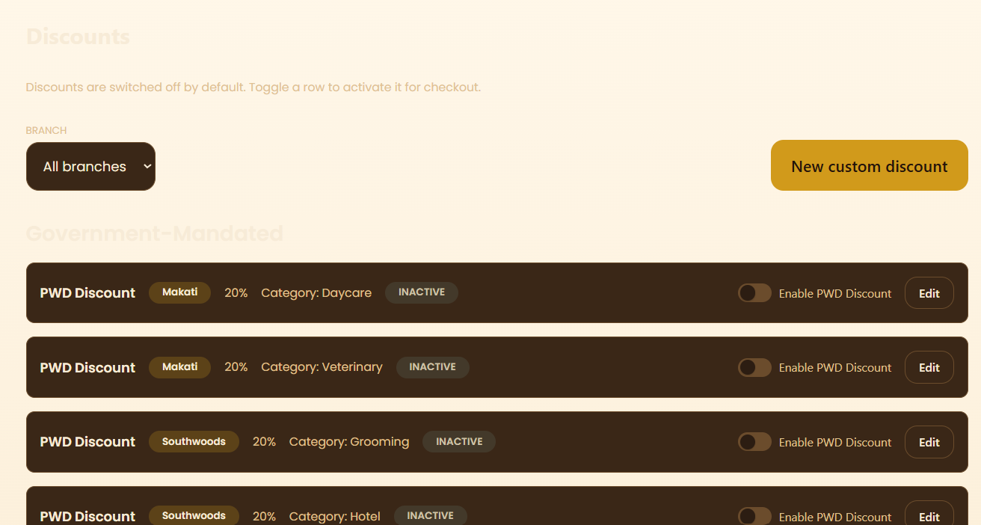
- In create/edit pet form, change “species” field to “pet type.”
  - Breed part in form, make it drop down or searchable.
  - Change SC and LC to short coat and long coat
  - Insert picture for pets
- Health condition text field should be in veterinary module

- Collapsible sidebar for dashboard navigation (group by role functions if admin or superadmin, since they appear multirole)
- Update username, display name, password options in settings (display name, phone
- number, etc. in Profile section in settings, username, password, etc. in Account section)
- Separate Pet Manager for customers (shouldn’t be in profile)
- Show username and role in navbar
- Compile all admin config into one page
- Admins must deactivate first to enable CRUD actions (except update)
  - Prevents accidental deletions
- Change delete to all CRUD and customer (e.g. their pets, etc.) actions into archive
- Add an archive, where users can do the final decision to delete or not
- Warning popup on deleting from archive
- On http://localhost:5173/staff/admin/unavailability:
  - Make it responsive
  - 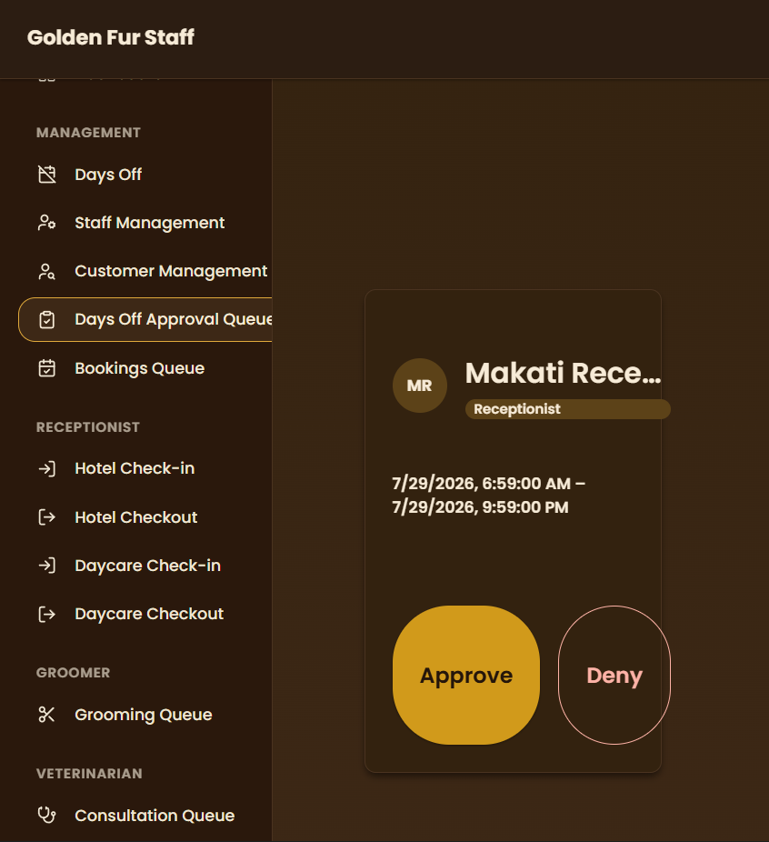
- On http://localhost:5173/staff/hotel/checkout
  - Fix the search, filter and sort functions
  - 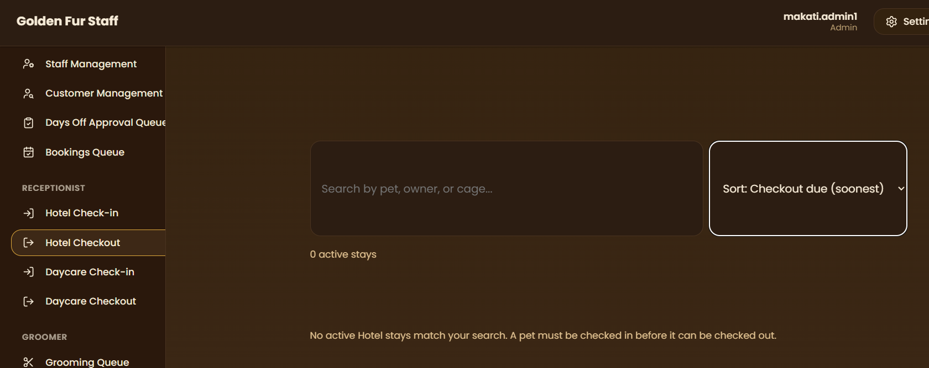
- On http://localhost:5173/staff/daycare/check-in:
  - Add search, filter and sort functions
  - 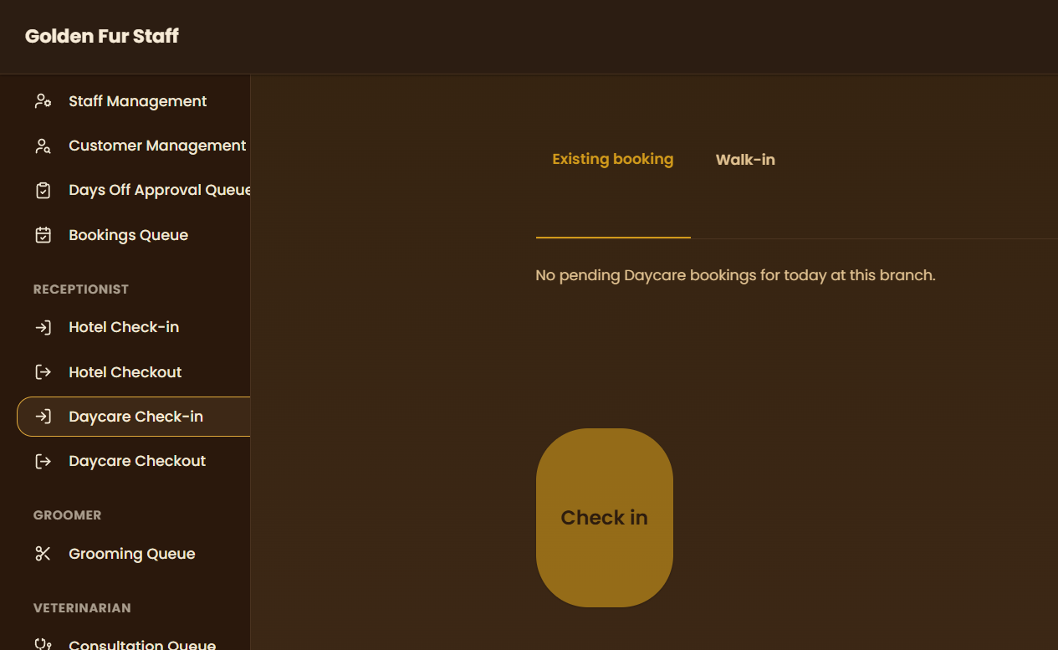
- On http://localhost:5173/staff/daycare/checkout:
  - Add search, filter and sort functions
  - 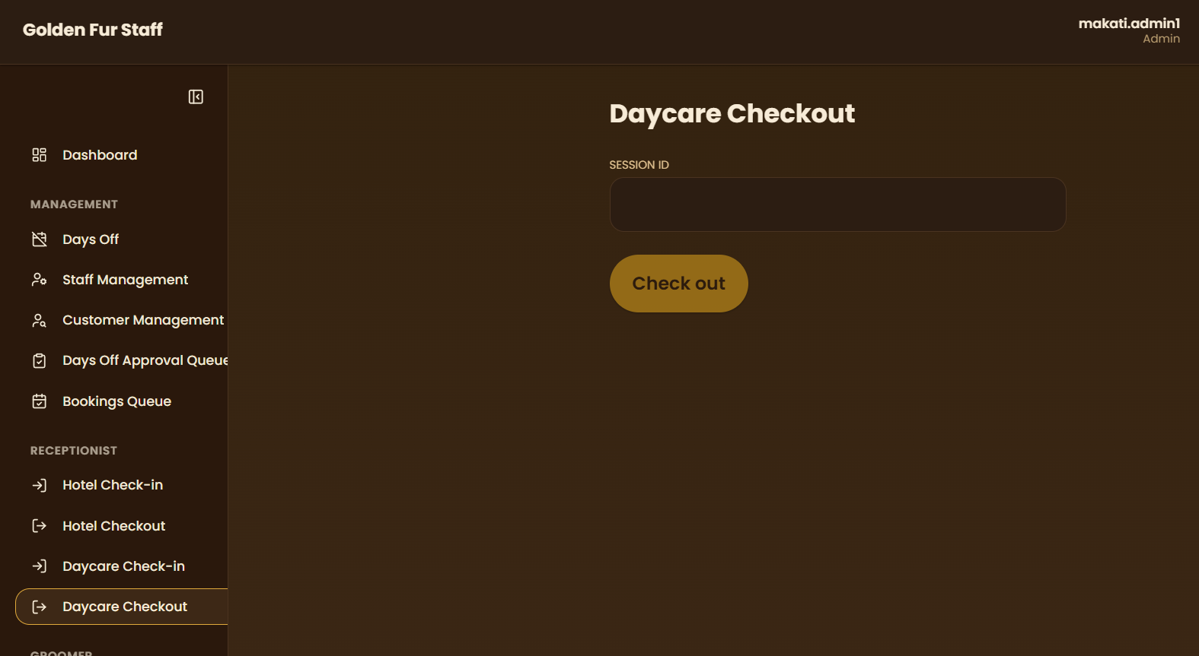
- ON asdsa:
  - Add missing search and sort functions
  - 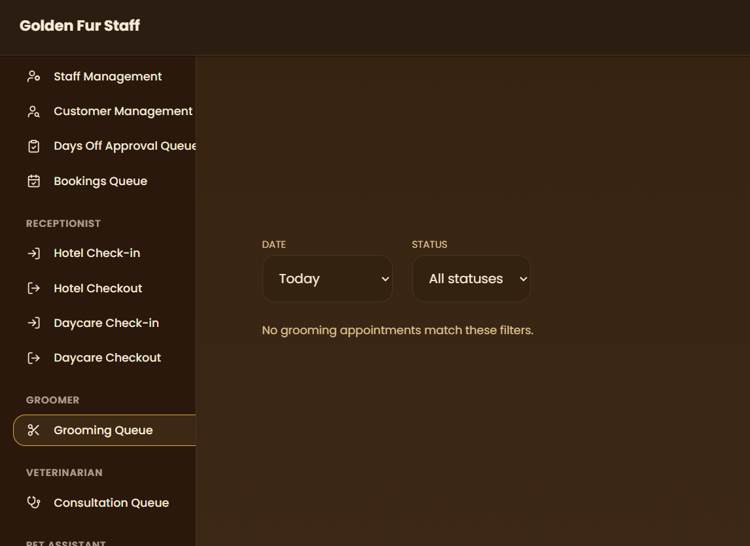
- On http://localhost:5173/staff/veterinary/console:
  - Add missing search function
  - Make it uniform with all others, use same component if possible
  - 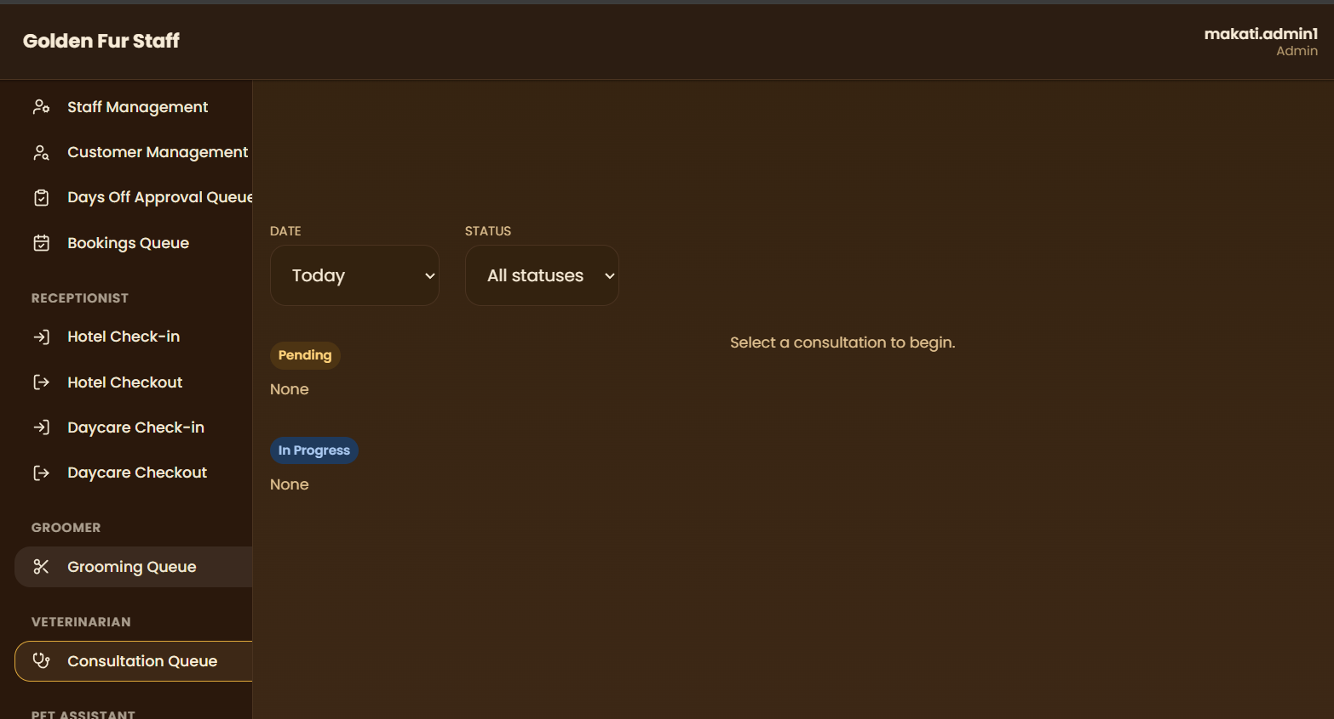
- For all search, sort and filter functions:
  - Expand filter, should be detailed filter like those in databases (equal to, greater, less, etc. for what column/field)
  - Similar interface to Notion (make it user friendly)
- On http://localhost:5173/staff/admin/product-catalog:
  - Add search, filter, sort
  - 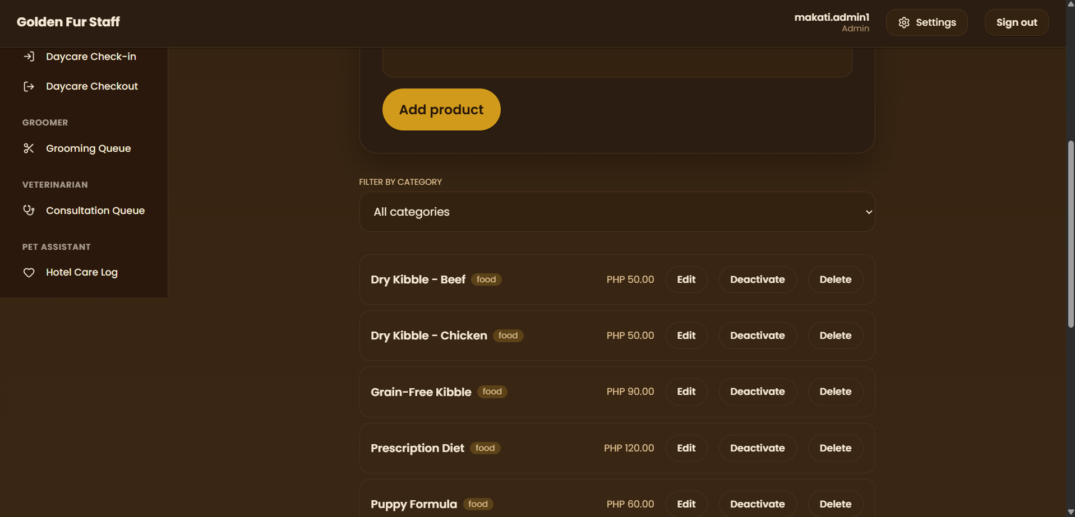
- On http://localhost:5173/staff/bookings/new:
  - Shouldn’t feeding, walking and medication time depend on the booking time?
  - For hotel bookings, they should be able to book their pet for multiple nights
  - Add an option to specify how many nights
  - If it’s just 1 night, feed, walk and med time should be right (I booked at 10 AM, there should be no breakfast time, or time blocks before the booking time)
  - 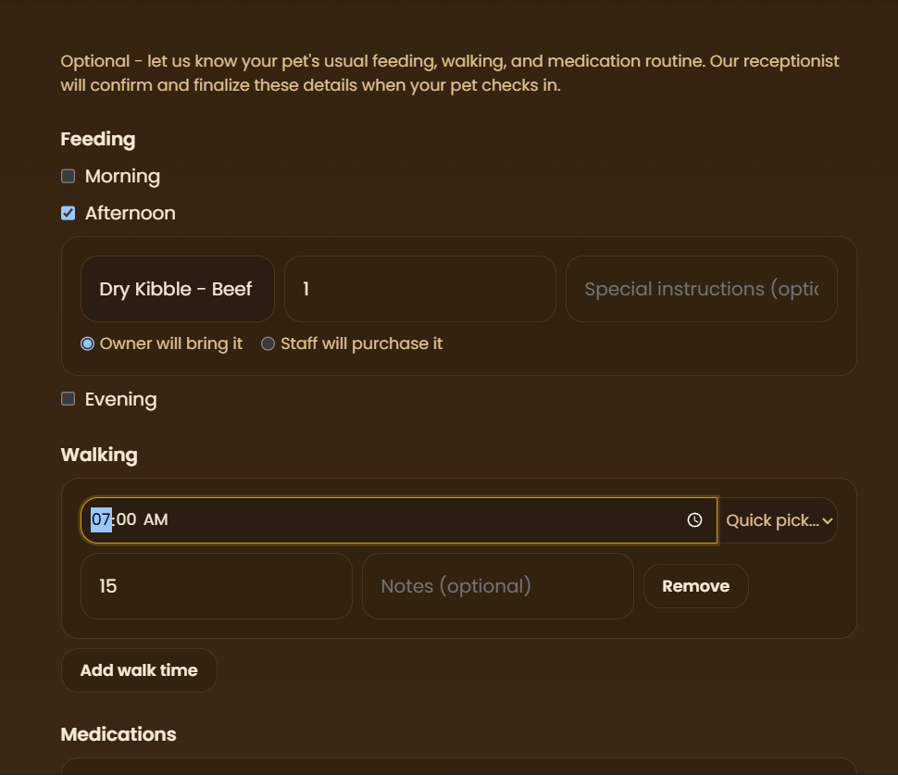
- customers should not be able to edit pet (since they can manipulate weight class)
- maybe they should be able to make pet, but receptionist should be able to approve it (after editing to see if weight class is correct)

- Allow customer to book multiple packages and individual services (multiselect)
  - We already have it in the add ons step, but perhaps you should get rid of the add ons step and just merge it with the service selector with multiselect enabled
  - Should count to total price
- Bookings queue, add complete step (in progress > completed), instead of jumping straight to paid
- Allow cashier to mark bookings as paid
  - cashier will be the one to mark completed bookings as paid
  - They should be able to see bookings of all status (just incase others want to do advanced payment)
  - But cashiers shouldn’t be able to advance the status (pending > in progress > completed), except for completed > paid
- Add free text on all booking type services
  - Already in payment step
  - Perhaps move it out somewhere

- Allow groomers to advance grooming type bookings, do the same for other staff roles (e.g. vet, daycare, hotel, etc.)
- Since hotel and daycare doesn’t have specific staff needed, I suppose groomers should also be able to advance them (NOT vet, cashier or receptionist)
- In bookings queue, add an assigned filter, which can either be assigned to me or no preference
- Add an extra status that cashiers will advance (not paid > paid in advance > paid), this is separate from in progress > completed, etc.
  - Advance button as well, that prompts if it’s advance payment or normal onsite payment
  - Only admin can revert through the dropdown option like the other status
- Combine hotel and daycare checkin checkout, vet, etc. all queues to bookings queue
  - It seems redundant that they’re separate from it
  - Just add some sort of buttons that does the same function, but there’s only 1 list (the bookings queue)
  - The button display and action will differ depending on service type (grooming, hotel, daycare, vet, etc.)
  - No wait I just noticed that it’s not supposed to be combined
  - Instead, make the design similar to bookings queue instead (for all queues; grooming, vet, hotel, daycare)
  - Make it so that there’s no hotel or daycare checkin checkout, just make it hotel queue and daycare queue
  - They’re just going to be the booking queue, but with a filter applied
  - Or would combining them be better? Just apply a filter depending on the staff role so RBAC is still enforced

- first step in booking process, should be able to see if fully booked
  - Should warn the customer before he even makes the booking, not needing to arrive at the time selector step to know if fully booked
  - Perhaps also show them when the earliest booking is going to end? Signifying an available slot
  - Show these through some sort of popup, with redirects
- on hotel type booking, remove option where staff will buy food or medication (since it places liability on staff)
  - since staff are not supposed to buy food type a medication, perhaps move the CRUD to customer? Where they can create their own food and med types, that they can select on future hotel type bookings
  - Should be accessible outside of booking queue as well
- make walk time reflect branch operating hours (if still doesn’t)
- Add playtime not just walk time
  - Still the same as walk time (minutes based)
- Add option to choose how many night hotel booking (3 nights, 5 nights)
  - Feeding, walking, play time and medication instructions are uniform across all booking nights
  - Or perhaps allow modification of each night?
  - But let’s say when the user chooses 3 nights, the instructions are all set to be the same, but the instructions for each day can be edited?
  - Add some sort of row at the top, that shows something like Date | Date | Date, where each date has their own feed, walk, play and med instructions
- also walk and play time should be just minutes based (15min,10min), not time (7am, 9am)
- Change booking process order
  - I think we need to change it to something like customer > pet > branch > service category (grooming, hotel, daycare, vet) > preferred/assigned staff/available cages if hotel type > services/packages
  - This is so that staff/cage availability is caught early in the booking phase
  - Staff Picker changes to Cage Picker if hotel type is chosen
    - Group cages by size
    - Show the recommended tag next to the cage size category grouper
  - The fully booked popup t is only if all time slots are taken
- Make it so that selecting a package in booking process unselects or disables selection of services that are included in that package (e.g. golden package has brushing, deselect and make individual brushing service readonly)

- in superadmin config, allow adding of new branches
- Add fixed lunch break 12 pm to 1 pm (cannot book at this time)
  - Should show up in monthly schedule config
- Add monthly schedule config for supervisor, admin and superadmin
  - can add rest days (fixed; decided by supervisor), vacation leave (requested; can be added even after the creation of monthly schedule; days off feature remastered here) for each staff
  - Calendar UI
  - Should be easily to plot their schedules
- This should reflect on the staff picker in booking queue
  - Staff has lunch break, rest day or sick leave = not available in staff picker for said duration
- Fix reschedule button on bookings queue
  - Should only appear when prior notice (3 days; can be configured by admin) condition is met
  - This 3 days config should be added in admin user’s settings > config > policies page
  - 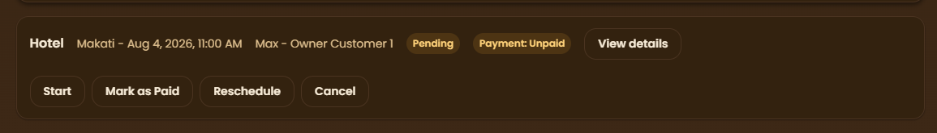
  - Bookings cannot be rescheduled if this is not met

- Make daycare the same as hotel
  - It will also have cage config
  - As well as the feeding, medication, walk and playtime (exactly like hotel)
  - The only difference will be their services
- Remove the cage services when choosing hotel type booking
  - Hotel and daycare will have exactly 1 service, fixed price, regardless of cage size chosen
  - If you see the image, hotel services are something like overnight with aircon room, and +5 nights with free golden grooming package
    - I don’t know if this falls under a service or a package, since if it’s a package it consists of both a service (overnight hotel) and package (golden package) instance?
    - Perhaps, when creating a hotel type service, add a free package/service when nights # condition is reached?
    - There will only be the overnight stay with AC hotel service, but it will notify the customer and receptionist, and update the booking receipt once it reaches the nights condition
- Fix pricing matrix
  - Cat has no weight class or coat type, fixed 800 for golden package
  - Coat and weight doesn’t seem to influence individual service
  - Perhaps when creating a service/package, make the coat and weight matrix optional by adding a checkbox? So that the service/package price can either be flat/fixed or derived from weight/coat type
  - See the image, and update the correspondingly seeded services/packages
- 850 for daycare booking if not picked up (overnight payment) + all 50 for succeeding hours
  - 850 * number of nights + 100 + sum of 50
  - Add a configuration in admin settings where that fixed 850 price can be changed but default 850
  - This should be added to a policies page in settings > config
- When creating a daycare service, include this initial hour + fee for subsequent hours
  - This fee itself is attached to the service, not hardcoded to all daycare services

- Make bookings queue readonly
  - Move all extra actions to respective queues:
    - Manual pay buttons > to somewhere like Payments Queue
    - Checkin and Checkout > to hotel and daycare queues
    - Vet actions > to vet queue (I think this is already implemented
    - Others if I missed any
  - In the end, bookings queue should only contain receptionist actions, such as view details, resched, etc.
  - These other queues should look exactly like bookings queue, or similar, with extra actions relevant to the corresponding queue
- reorganize siderbar:
  - bookings queue should be on receptionist role
  - hotel and daycare queue should be on grooming and pet assistant
  - move customer management to receptionist
  - days off approval queue and monthly schedule should be on supervisor
- When choosing no preference in grooming/vet staff selector, automatically assign a random available staff of that role
  - So that staff availability works properly
  - And the staff filter on all queues also work
- Fix error when selecting grooming as service in bookings (run to copy console and network errors)
  - Occurs when choosing grooming service type > in staff and date picker
  - 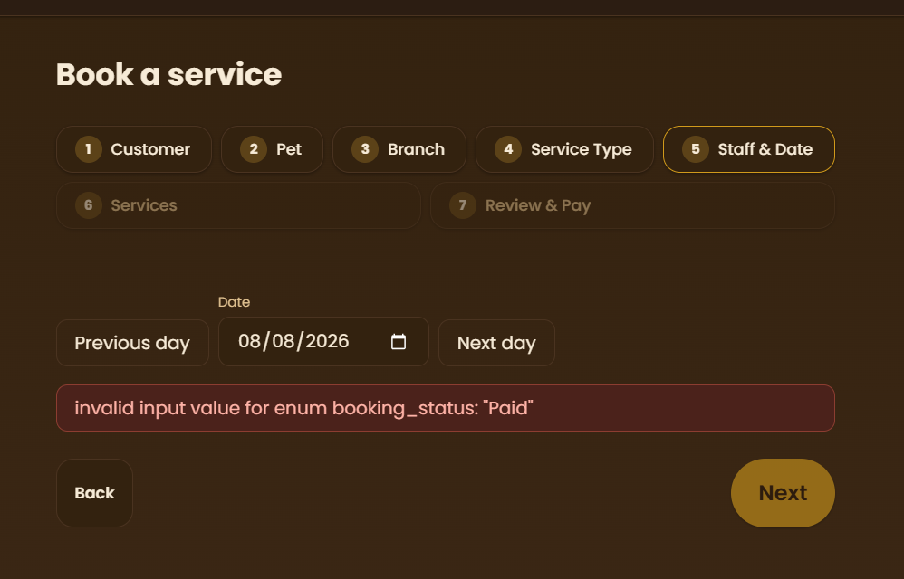
- When creating services/packages, include requires downpayment checkbox
  - Specify downpayment amount
- When paying for booking services that has downpayment, option for customer/receptionist to pay downpayment or in full
- Services that requires downpayment and are unpaid should not show in grooming, hotel and daycare, vet queues
  - Downpayment is required before service can start
  - Usually applied on hotel services
- Update supabase/ files if needed
- Add a transactions history, that is visible to customer, cashier, supervisor, admin and superadmin
- on http://localhost:5173/staff/admin/maintenance/promo-cap-configuration:
  - move contents to http://localhost:5173/staff/admin/maintenance/promos no more separate page in admin settings config
- on http://localhost:5173/staff/admin/product-catalog:
  - I thought customers have their own product catalog now?
  - this makes the one in admin settings redundant
  - since hotel and daycare services derive the feeding and medical instructions from that customer's unique list of products which can either be type food or medication
  - CANCELLED: since misc sales pull from this product catalogue
- on http://localhost:5173/staff/admin/maintenance/policies:
  - Add a cage picker config in admin settings config tab (similar to staff picker)
  - These should reflect on the booking queue process, and will appear as an additional step after service type selection make the expires after field readonly when unused credits expires checkbox isn't checked off
- in admin config settings:
  - allow adding and CRUD of new service types seed the existing grooming, hotel, daycare, vet, etc.
- when customers are booking, or when receptionist is booking for a walk in customer:
  - make it so that the booking process form progress saves, even if they accidentally close the browser
- on http://localhost:5173/portal/food-medication:
  - why are there provided by teh hotel labels next to the customer product types?
  - remove it, remake the seed, make it so that all of it are created by the customer
  - drop made by hotel
- on http://localhost:5173/portal/settings:
  - remove settings tile, it's already in navbar
- on http://localhost:5173/portal/bookings:
  - add a pay button to each booking row item
  - it should prompt the customer to either pay in full or downpayment (if downpayment is enabled)
  - this should be done via the paymongo api we've implemented
  - show proper error message, such as service is down or unavailable
- on http://localhost:5173/portal/settings?tab=preferences:
  - As a customer, I should be able to configure notification preferences
  - Enable or disable booking reminders
  - Set when does reminder appear (before 1 day, 1h, etc.)
- on http://localhost:5173/staff/settings?tab=config:
  - allow admins and superadmins to enable or disable online payments via paymongo
  - the pay button should still be visible on CUSTOMER SIDE only, when they're viewing their bookings, but it's disabled, there shouldb e apopup or hover text that tells that it's disabled
- on http://localhost:5173/staff/admin/maintenance/services-and-packages > create service form:
  - suggest whether I should move the requires downpayment to service types instead
  - since service types are selected before services/packages in booking process
  - so idk how is downpayment calculated, individually per service? or collectively as a service type
  - show that popup question with pros and cons
- on http://localhost:5173/staff/hotel/care-log:
  - should be also visible on groomer role
  - rename to something like Boarding Checklist
  - since it's for both hotel and daycare
  - and it should contain a checklist of feeding, medical, walking and playtime of CHECKED IN pets in both hotel and daycare
  - add different data views (like kanban, list, gallery, etc. like notion)
  - add different sorts and filters, search bar, group by
  - perhaps separate hotel and daycare via subtab, instead of relying on filters
  - the most important sort by/order by option is by time asc/desc
  - and the most important group by is time of day (e.g. the morning, noon, afternoon, evening we set when doing hotel bookings)
  - another important group by is a pending, in progress and completed task status
  - make the checkbox for each item circular like todoist
- on http://localhost:5173/staff/bookings/new:
  - should not be able to make a duplicate booking
  - max is already booked in for hotel
  - should be unselectable at pet selection stage when previous booking is still not resolved (no show, cancelled, paid, etc.)
- on http://localhost:5173/staff/hotel/queue > edit booking form:
  - should open up a new page, not just pop up at the bottom
  - remove the Owner opted in to pet status notifications for this stay checkbox, since it's customer config now
  - add a ... next to the cage sizes, move the mark as under maintenance there
  - make all fields disabled or greyed out when edit button is not clicked
  - make edit button more noticeable, it's too small and not eye catching
- on http://localhost:5173/staff/settings?tab=config:
  - add CRUD options to pet cages
  - admins and superadmins should be able to make, edit, delete, mark as maintenance specific cages
- on http://localhost:5173/portal/settings?tab=preferences:
  - Send the booking reminder should appear as a dropdown on booking reminder toggle
  - if both are untoggled, make it readonly
- on http://localhost:5173/staff/admin/hotel/cages:
  - use full words for cage sizes not abbrev (S > small)
- on http://localhost:5173/staff/dashboard/admin:
  - boarding checklist still not visible on groomer section/dashboard
- Add a notifications page that users can expand when viewing notifications via the bell in navbar
- Allow admins and superadmins to make announcements through notifications
  - Specifies target recipient, etc.
  - Perhaps just turn it into a messaging feature, where announcements are a type of message (like messenger or something simpler like integrated mailing)
  - Announcements target recipients can be categorized by user role checkboxes (customers, staff roles)
  - Add an excluded users (who will not get the announcement)
- Add a dropdown to sidebar categories
  - Should be collapsable
  - Add sort function for each category (e.g. order by, alphabetical, custom, recently accessed, etc.)
- Add occupied and vacant cages view to receptionist (not CRUD, just readonly)
- Add calendar view to bookings table
- make otp on login or setup in settings have a six digit square space like most otp input fields
- add weekly and monthly options to calendar view in booking squeue
- make sure cage occupancy view is visible on receptionist sidebar
- make the admin sidebar look like notion
  - also add the sort function to non admin sidebars
  - it should have a ... with a sort option
- when it custom order, tiles should be draggable with smooth animation
- fix sidebar items keep twitching whenever I collapse/extend a category in admin sidebar
- only make ... icon on sidebar categories visible on hover
- add search, sort and filter functions to the cage occupancy receptionist page
- on http://localhost:5173/staff/bookings/new > cage selector:
  - make it so that only receptionist can select cage sizes that are not the same as the pet's size
  - customer is limited to same size cage as pet (
- on http://localhost:5173/staff/hotel/queue > checkin:
  - remove checkinable next to pending filter
- > at checkout:
  - use same list format in checkin
  - should have the same search, filter and sort functions
  - checkin button changes to checkout
- Fix being able to make another booking for pet X, when pet X booking is still not paid
- Add the sidebar items sort option to customer and other staff roles
  - So far only admin and superadmin has it

- At admin > settings > promos config page, add option to number of promos, not just flat PHP or %
- At admin settings > config > services and packages, for each list item in service types, services and packages, move all actions to a … button
  - Remove disable button, since we can already disable per branch
  - Service types rename should be edit as well that opens up a new modal on screen
  - Same thing with services, edit should open a new modal, not push the list down
  - Do the same for packages
  - Make the packages similar to services (e.g. enable/disable per branch, edit button)
  - The enable/disable should also open a modal that shows a list of branches, and whether to enable disable
  - Name the button something convenient, not literal enable/disable
  - Perhaps rename edit to something like configure
- Add a label for the sidebar sort options
  - It’s hard to see it since it only appears on hover
  - Especially a problem for nonadmin staff and customers
- Add add new service type button instead of the form being on the same page as the list

- Test how are packages calculated
  - What if the services it has are influenced by coat and size pricing matrix?
  - Make sure its pricing breakdown is visible in package creation as well as in the booking process > payment step
  - As if showing a receipt
- Add a label that indicates whether a service has pricing matrix or downpayment in package create/edit
- Suggest a calculation on what to do if a package has service that either has pricing matrix or downpayment
  - Does it get applied on the package’s total price?
  - Or only on that service?
- Perhaps add an advanced section in package create/edit
  - It will contain a slider that enables/disables pricing matrix, and another for downpayment
  - This is not applied on the package itself, but the services it has
  - What it’ll do is that it will make services with pricing matrix/downpayment label selectable for the package
- Test hotel/daycare notifs
- on http://localhost:5173/staff/hotel/care-log:
  - make it so that the boarding checklist (after cehcking in), looks like todoist kanban (see attachments)
  - task checkbox is circle, statuses can be pending, in progress, completed, missed (auto checked if not done by deadline)
  - categorize them too (e.g. feeding, medical instructions, play/walk time, etc.)
  - add dates to them as well, since hotel is multidate
  - and filter and sort options like todoist
  - checking off these tasks notifies the pet owner
- on http://localhost:5173/staff/hotel/queue > checkout:
  - should not be able to checkout pets if tehre are still boarding checklist tasks
- Remove reading box in notifications page
  - Make it so that clicking a message just opens it up as a modal
  - Add a fullscreen button that opens the modal as a page
- Add notif when customer is assigned to staff (e.g. I’m groomer, some customer chooses me as their preferred staff, I get notif)
- on http://localhost:5173/staff/bookings/queue:
  - for each list item, add a ... button
  - move view details there
  - also add an extra action: a start button that opens up a modal to edit pet's weight and size, etc. for initial assessment and reassessment services specifically
  - perhaps add it as a slider config when creating a new service in adming settings > service builder (e.g. opens up update pet details modal)
  - so for init ass and reass services, enable this slider
- In admin settings > discount builder:
  - Make branch multiselect
  - New discount button should open a modal not a popup that pushes the list down
  - The discounts list should use list view not cards
  - Add a … button like in services and packages page (with a configure and branch availability options)

- Make settings page open up as a popup modal
  - The navigation tiles turns into its own sidebar, in the modal
  - Fullscreen option on top right that turns the modal into a page
  - Replaces normal dashboard navbar items with settings navbar
  - Settings navbar items can also be sorted alphabetically, custom, or recent
  - Should look like VSCode settings
- Test vet module workflow
- Make consultation queue reflect bookings queue filters and list items appearance
  - There’s no way to see completed bookings
  - There’s no … button in list items
- Add CRUD page for vet medications and procedures
  - Unique to each vet (they manage their own)
- Vets should have a page that allows them to see their patients (by pet, with ref to pet owner)
- Fix vet module follow up flow
  - When viewing a completed consultation, add a Schedule Follow-up option in … button
  - This opens a center screen popup modal with ALL the booking process fields in one page
  - All are auto filled except for the service/package itself
  - Confirm and Cancel buttons
  - Confirming redirects to a receipt or confirmation page
  - Notifies customer
- Add search, sort and filter options for customer vet consultations history
- Add view pet option in My Patients, that shows the details of the latest consultation (e.g. weight, heart rate, temp, known health conditions, etc.)
  - Pull weight, weight class, coat type from the receptionist’s input on initial assessment, and reassessment bookings (so that it’s not redundant)
  - I assume we’re already allowing receptionist to edit weight when closing assessment service bookings

Done/Archive

