Portfolio Website Chatbot with Botpress
The Graph Courses

Introduction
Welcome! In this assignment, you’ll create an LLM-powered chatbot using Botpress and embed it into your portfolio website that you created in a previous session.
Your completed chatbot will be able to:
- Answer CV/Resume Questions - Provide information about your background using uploaded CV data
- Share Course Information - Provide info about the Graph Courses GenAI syllabus and curriculum details
- Collect Visitor Information - Gather names and emails from interested visitors for showcase day registration

Part 1: Setting Up Your Botpress Account and Creating Your Bot
Our first task is to set up a Botpress account and create a new bot.
Note that Botpress interface changes from time to time, so the screenshots may not be exactly the same as the ones in the instructions.
Also note that the current free plan allows up to 100 conversations per month. This should be enough for our course chatbots. But for serious use later on, you may need to upgrade your plan. Older workspaces may have different limits, so check your account’s usage and billing page.
- Create Your Botpress Account:
  - Go to botpress.com
  - Sign up for a free account using your email.
  - You may be asked what is your main use case. You can select “Something else? Tell us what you’re building” and enter a short description of your chatbot. Answer the follow-up questions about monthly conversations, team size, and how you heard about Botpress.
  - 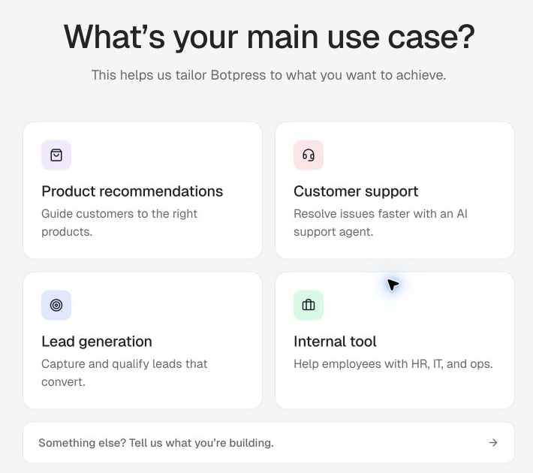
  - The signup flow may open Botpress Viber. Click the back arrow to return to the workspace, then click “Agents”. Open the dropdown beside “Create agent” and select “Visual Editor” to open Botpress Studio in a new tab.
  - 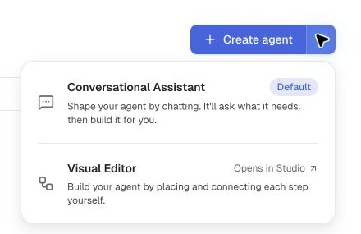
  - The route checked on 7 October 2026 opened Studio Home directly. If you see a “What should your bot do” setup screen instead, click “Skip setup” at the top right.
  - Next, click on the Home icon at the top left to view the home page for the bot instructions.
  - 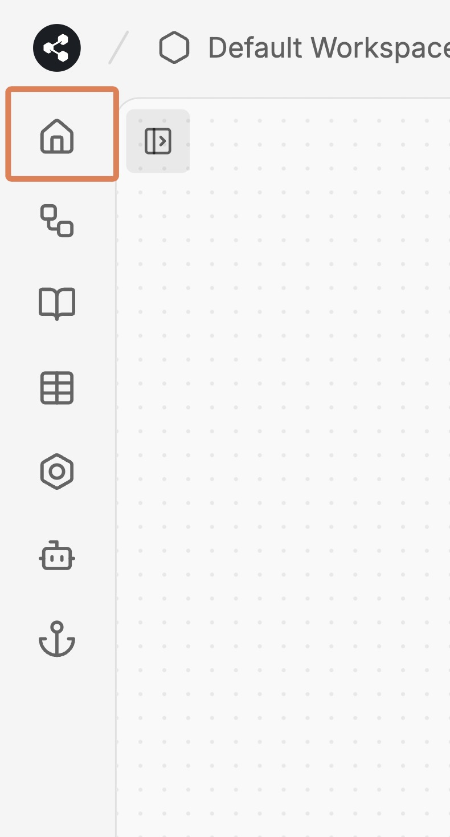

Part 2: Setting Up the Bot Instructions
You now need to give an agent prompt that the LLM will use as context to understand how it should behave.
- Set Bot Instructions:
  - In the main configuration area, find the “Instructions” field
- 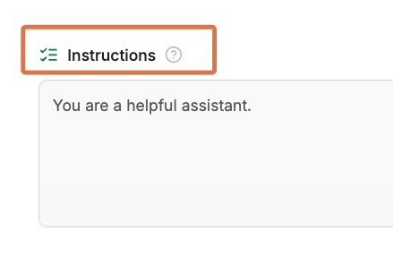
  - Enter instructions like the below:
You are a portfolio assistant for a Generative AI course student. Your main tasks are:
- Answer questions about the student's CV and background using the knowledge base
- Provide information about the Graph Courses GenAI syllabus and curriculum based on your knowledge base
- After answering the user's query, politely ask them whether they might be interested in our upcoming showcase event. These take place on
- [Showcase session 1: date, time and time zone to be confirmed]
- [Showcase session 2: date, time and time zone to be confirmed]
- If they express interest, collect their name and email for registration and record those in the Attendees table tool.
- Try to be helpful while staying focused on these core topics. For other topics, politely decline to answer.

Part 3: Set up the Knowledge Base
Our next task is to set up a knowledge base for the bot to use to answer questions. Botpress searches the knowledge base for relevant information, so the uploaded documents do not all need to fit within the LLM’s context window.
- Navigate to Knowledge Base:
  - Find the “Knowledge bases” section under the “Instructions” section. If you do not have a knowledge base yet, click the Knowledge Bases book icon on the sidebar, then “New Knowledge Base”. Give it a name and click “Save”.
  - Select your knowledge base and click the document icon to open “Add Documents”, then upload your CV. (If you don’t want any of your personal information online, you can use a fake example CV from the internet or create a fictional CV in a plain text file.)
  - 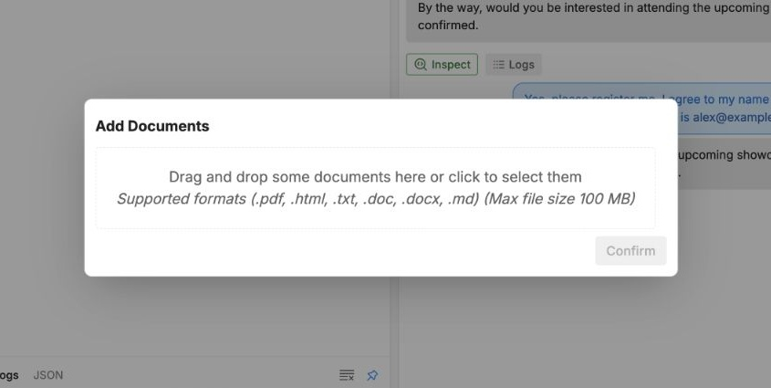
  - Download the syllabus from: https://drive.google.com/file/d/1NV-Mo2UgXQwdTu_Jv-HtCVnB9Pf2Grng/view, and upload it to the knowledge base.
  - Note: If the bot does not process your PDF CV properly (e.g., it gives incorrect or nonsensical responses about your background), try deleting the PDF from the knowledge base and instead manually copying and pasting the text content of your CV into a plain text file, then uploading that instead.

Part 4: Set Up Data Collection
Next, we will create a table to store the data of the attendees of the showcase event.
- Create Attendees Table Structure:
  - On the Botpress sidebar, click on the Tables icon.
- 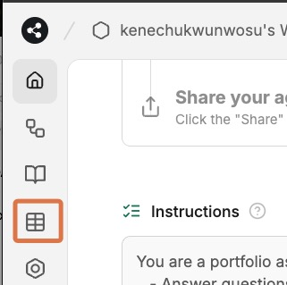
  - Click on the New Table button at the top left and call it something like “Attendees”, then click to Save.
- 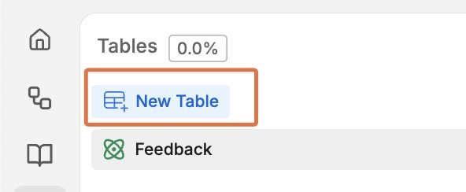
  - Click the new column icon to add the following two columns, leaving all settings as default
    - Name
    - Email
- 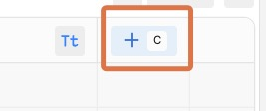
- Configure Collection:
Now, we have created the table, we need to allow the bot to use this table to store data.
- Return to the main configuration area, by clicking on the “Home” icon on the left sidebar
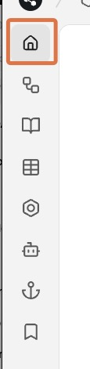
- Scroll down to the Tools section
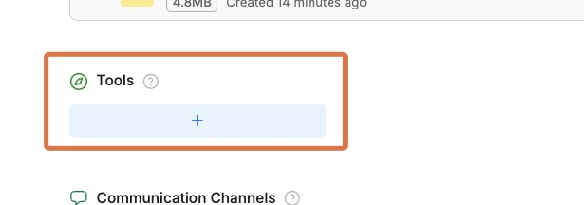
- Click on Tables then the Attendees table, then “Create Rows”. This gives your bot the ability to create rows in that table.
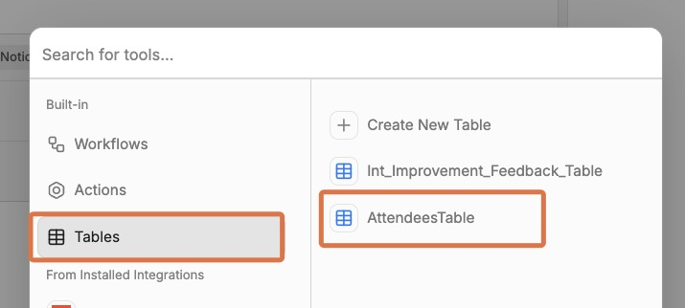
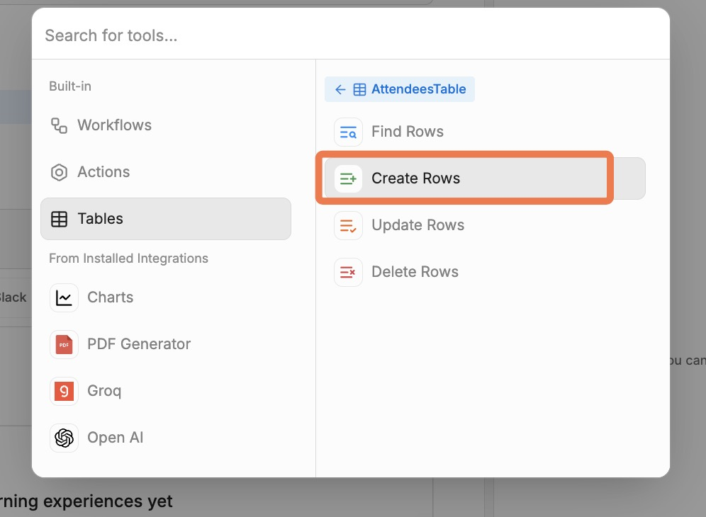

Part 5: Testing and Publishing Your Bot
- Use the Test Chat:
  - The Botpress interface has a test chat panel on the right side of the screen
  - Try asking questions about:
    - Your background (“Tell me about the educational background of [your name]”)
    - Course content (“What topics are covered in the GenAI course?”)
  - The bot should interrupt at some point to ask if you might be interested in the event.
  - Give your email and name, then check the Attendees table to see if the bot was successful in adding your information.
  - 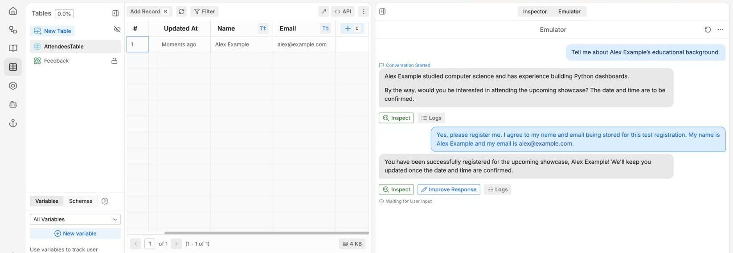
  - Example of a successful registration using fictional details
- Publish:
  - Click “Publish” button in the top-right corner, then “Publish changes”
  - Wait for the publishing process to complete
- 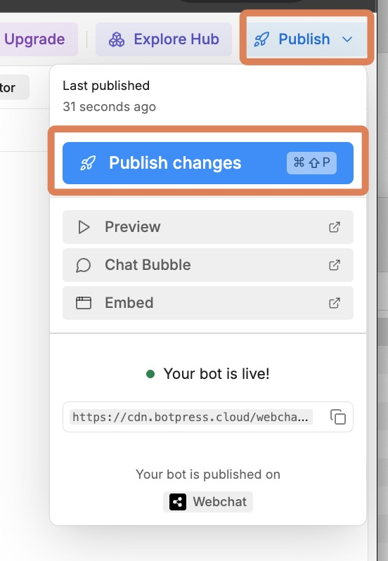
- Get Embedding Code:
  - After publishing, click on the “Chat Bubble” icon under the Publish menu.
- 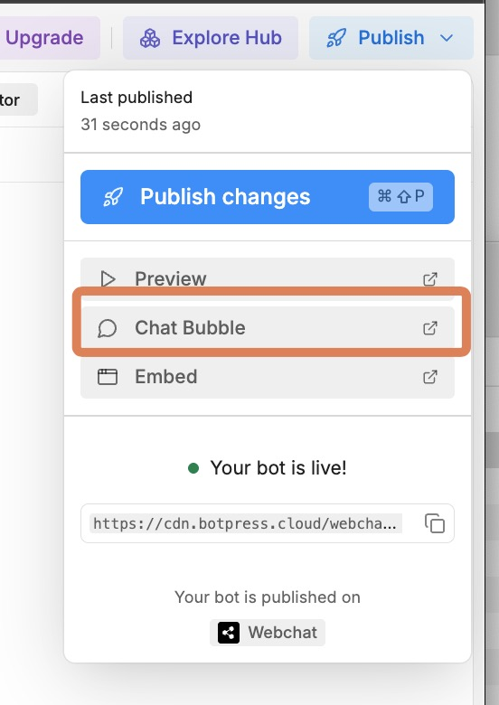
  - You’ll be taken to a section where you can edit the chat bubble settings.
  - On the “Deploy Settings” page, copy the code under “Embed Code”. It is shown directly on this page; you do not need to open the “Share” menu.
- 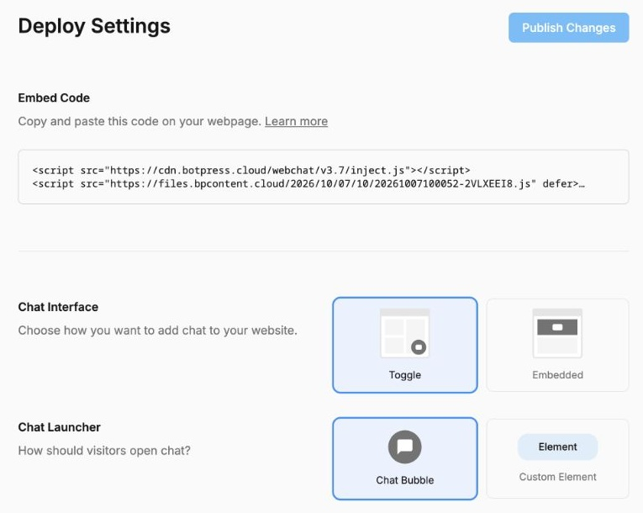
  - Side note: Later you can come back to the “bot appearance” section to customize how your bot looks.
- 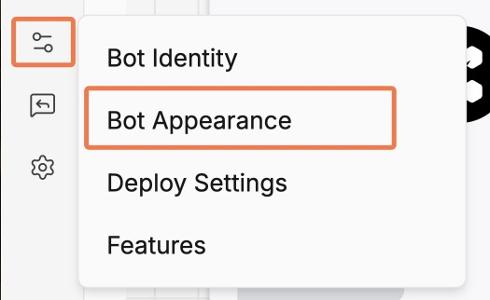

Part 6: Embedding Your Bot on Your Website
Now, we need to add this code to your portfolio website, so that a chat bubble appears at the bottom right of the page.

Part 6A: Add Bot to Your Portfolio
- Navigate to Your GitHub Repository:
  - Go to github.com. Click on your profile icon at the top right, then click on “Your repositories”.
  - 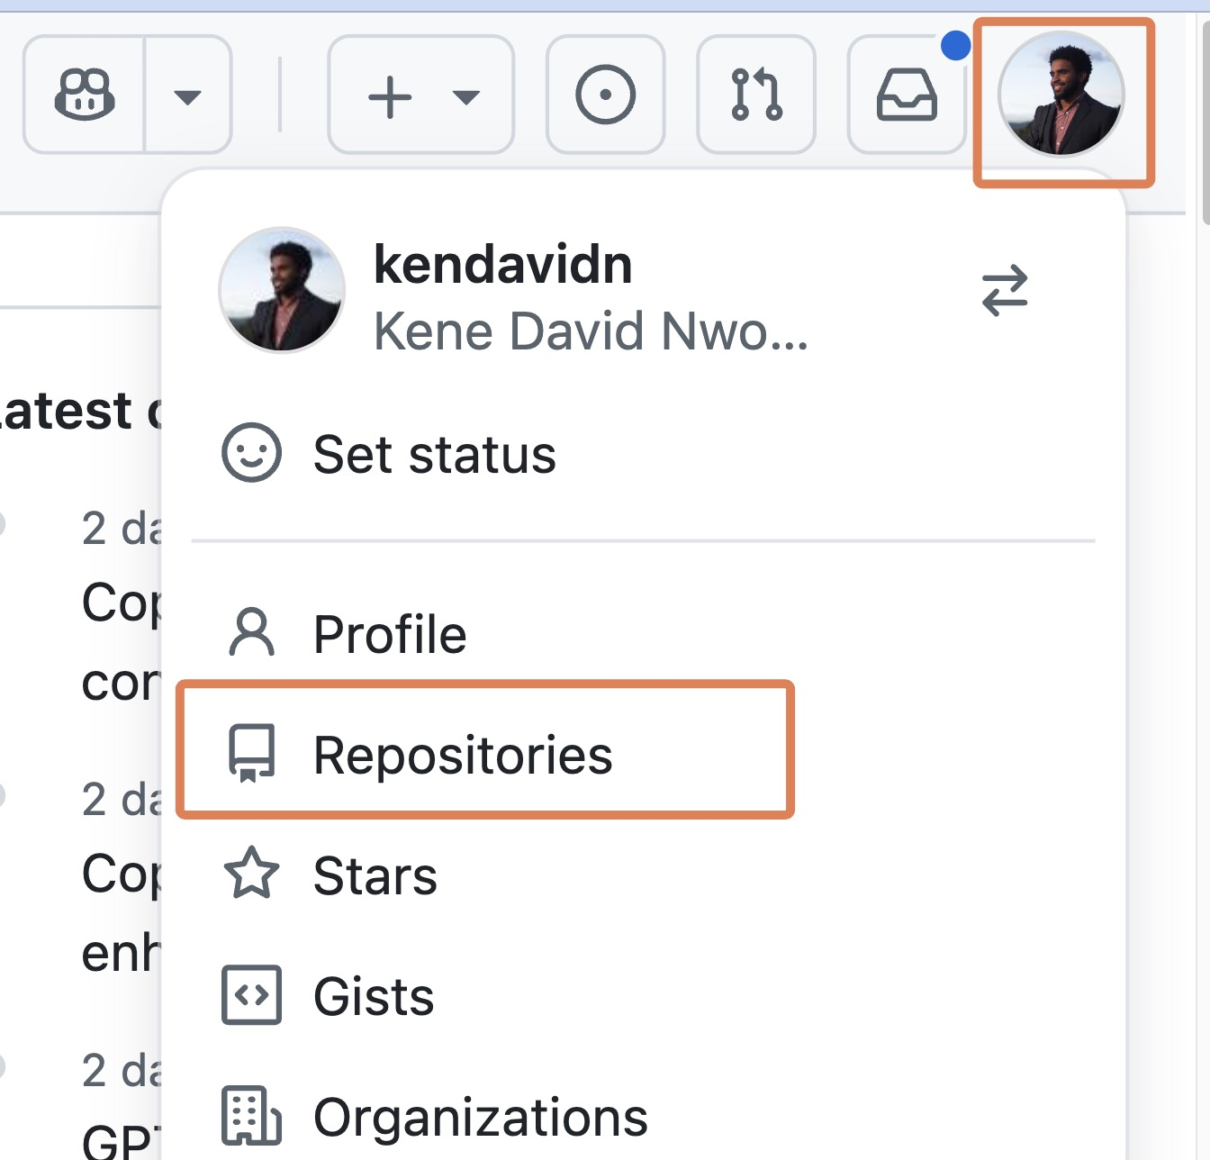
  - Locate and click on your portfolio repository (it should be called something like graph-ai-portfolio).
- Open Your index.html File for Editing:
  - In your repository, click on the index.html file.
  - 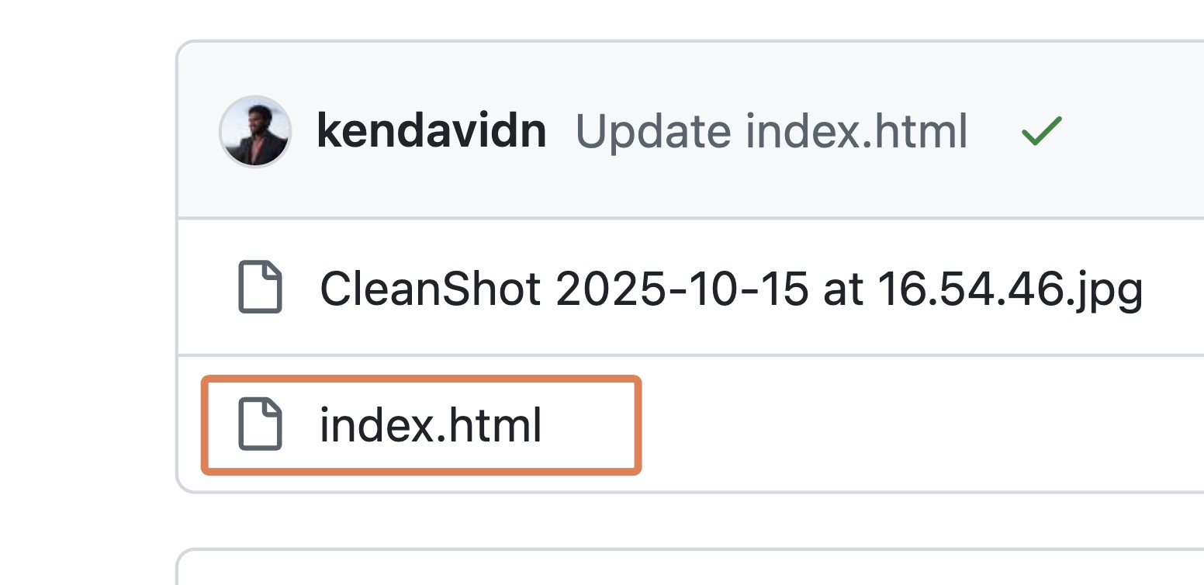
  - Click the edit file (pencil) button at the top right of the file view.
  - 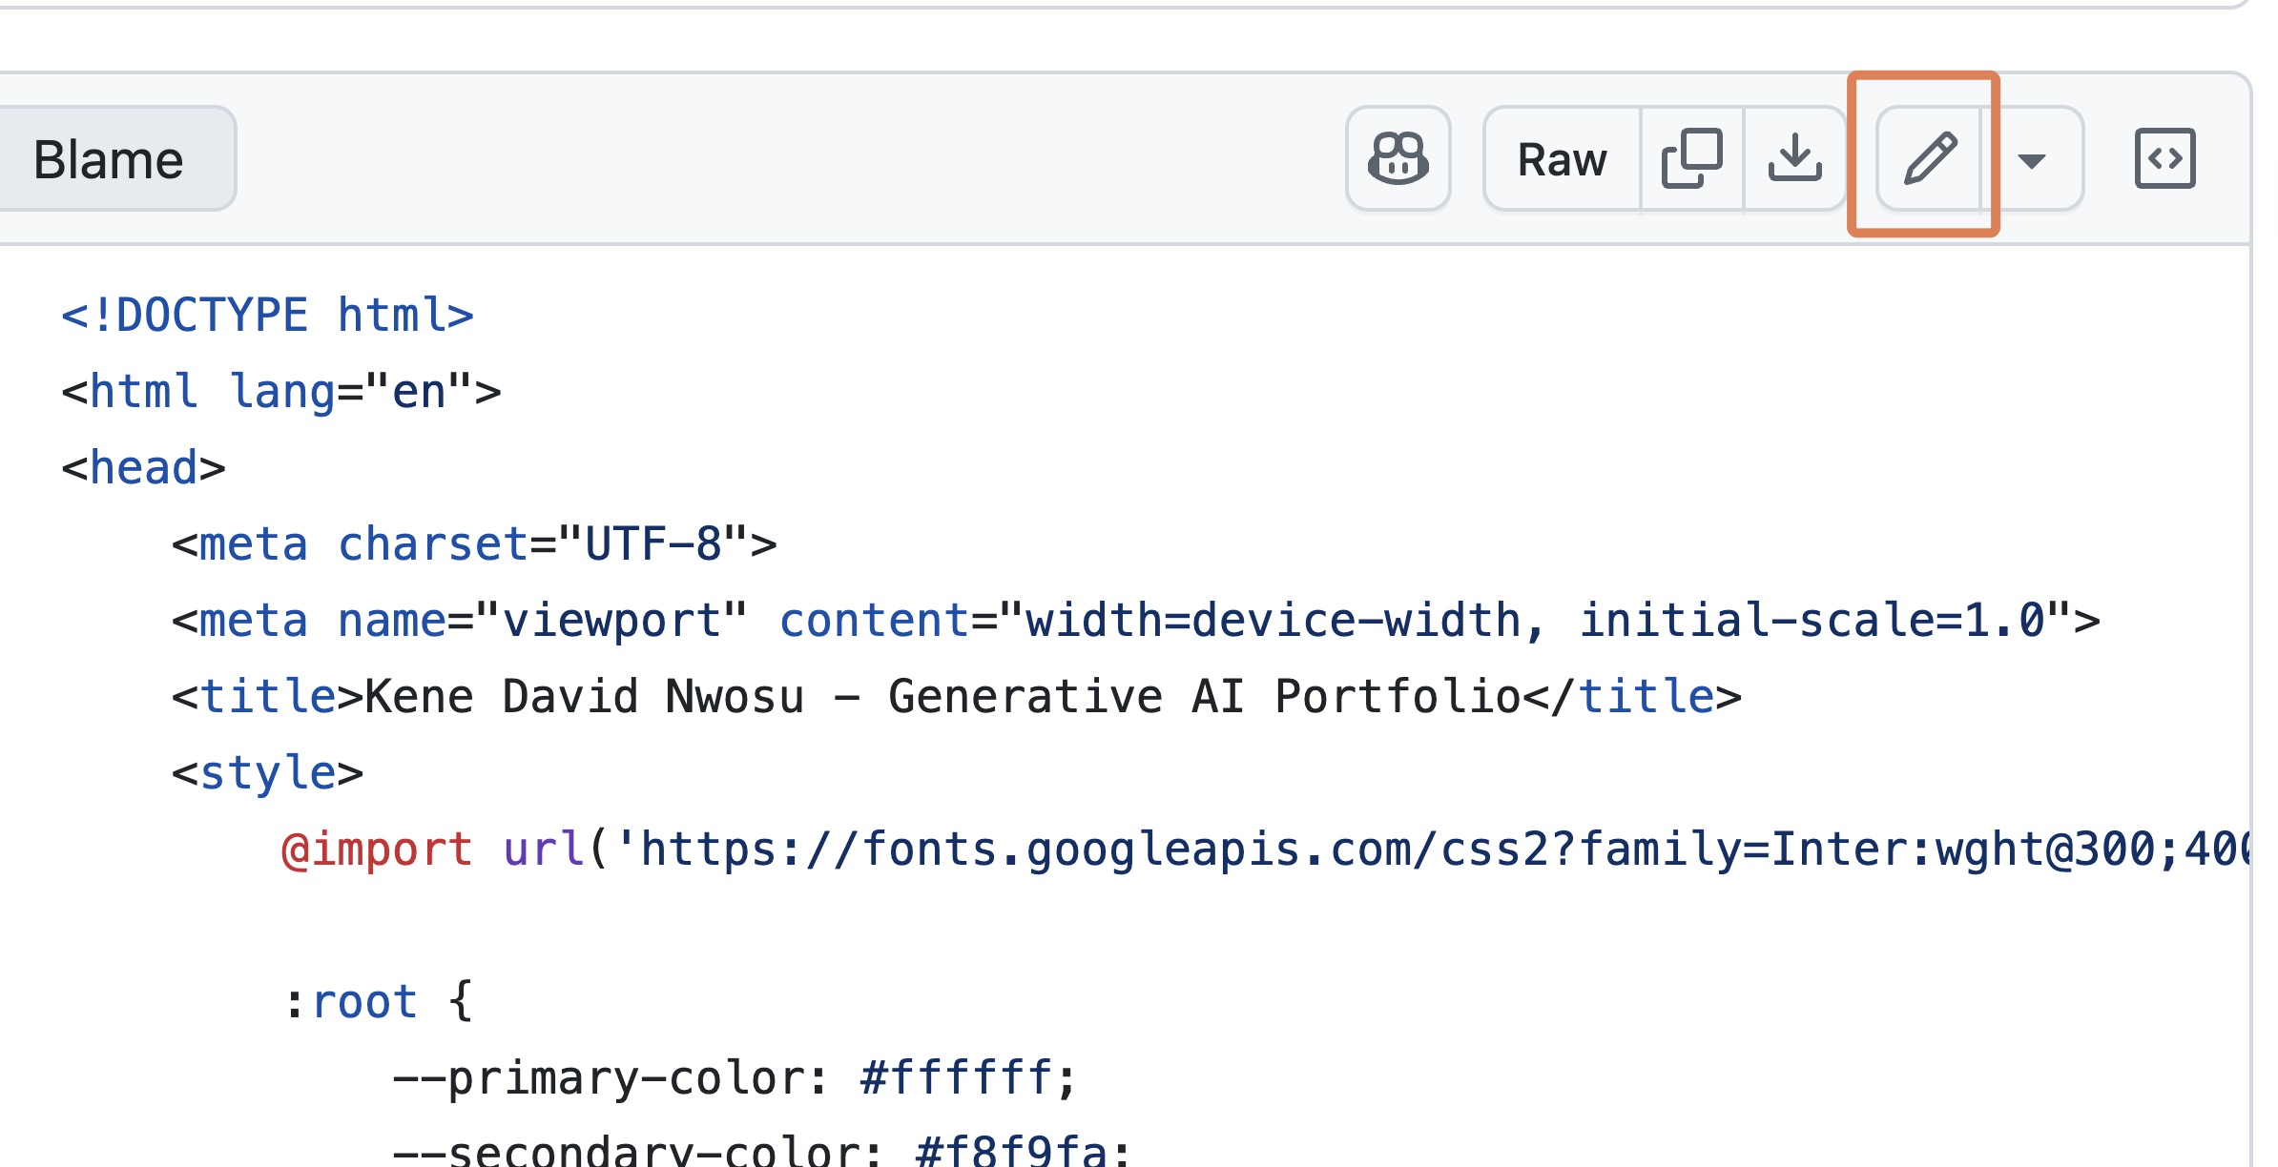
- Insert the Bot Code:
  - Next, add the Webchat embed code to the head section of your website’s HTML. For example:
  - 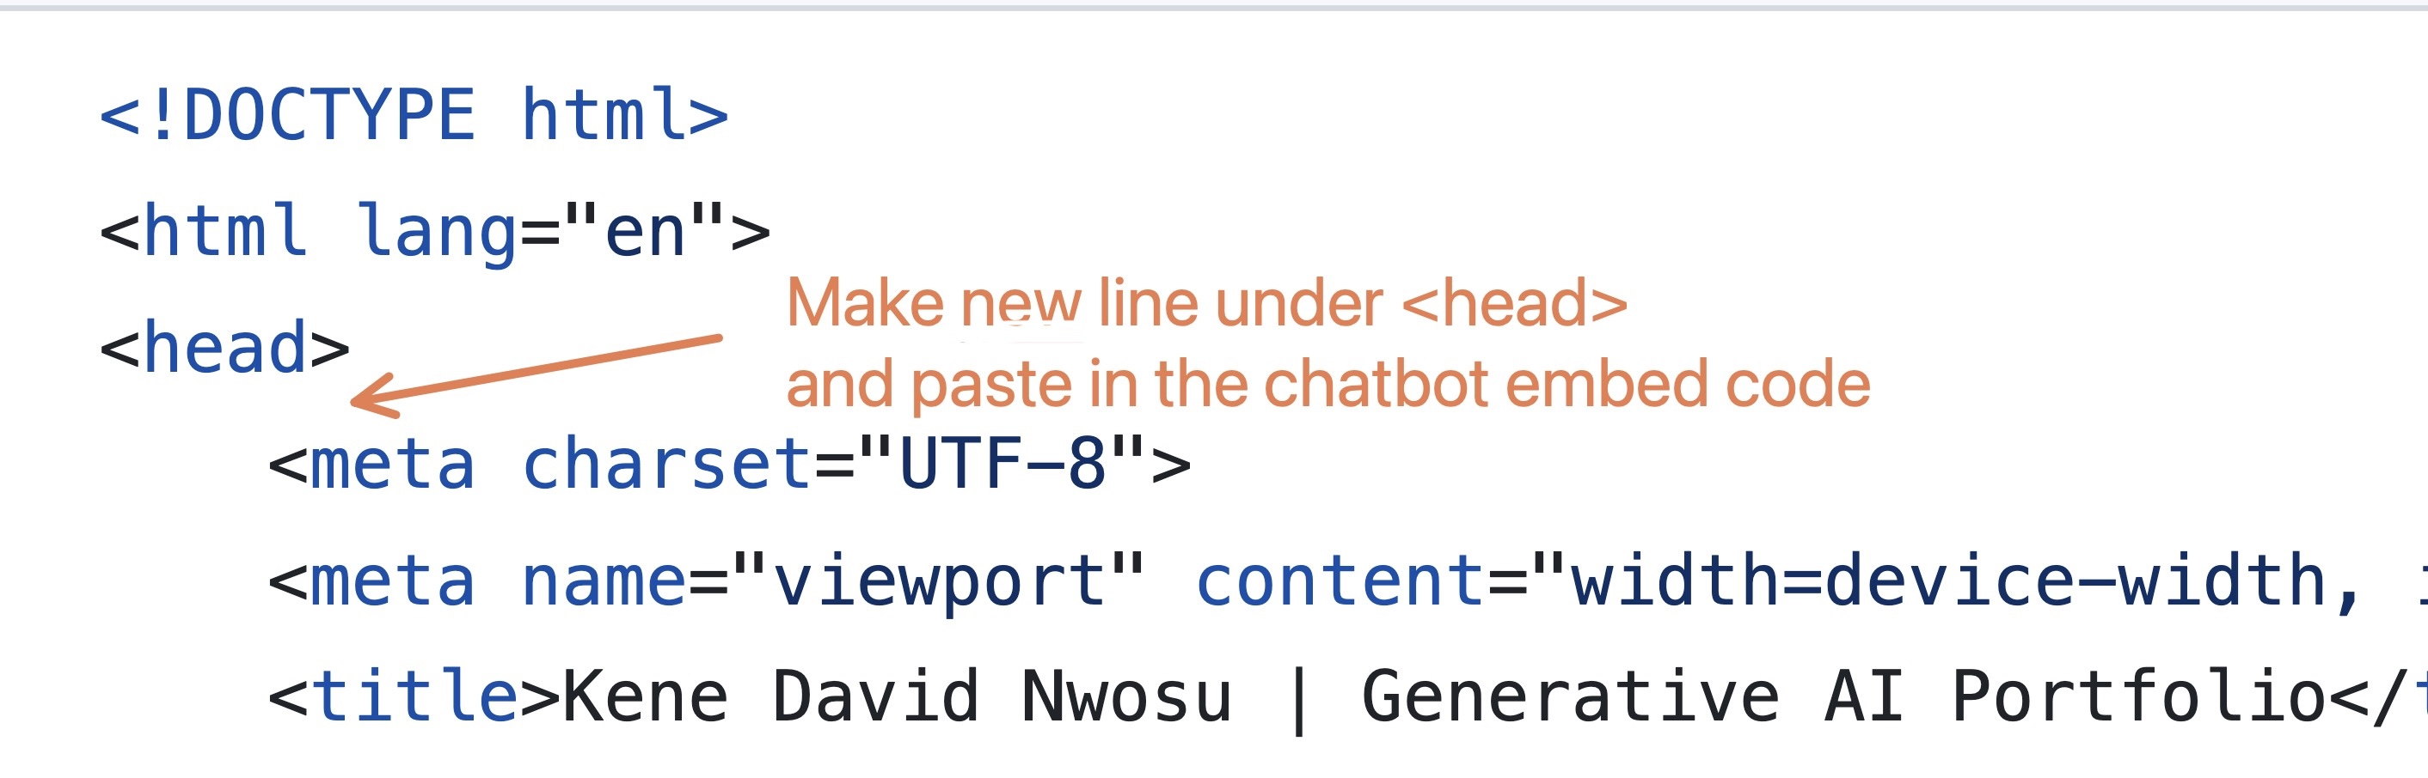
  - If you do not feel comfortable making this change yourself, you can ask an LLM to do it for you.
- Commit and Deploy:
  - Save your changes to the index.html file
  - Commit the changes to your GitHub repository
  - Your live site will update automatically if GitHub Pages is configured to deploy your changes (this may take up to 10 minutes)
  - You can track the status of your deployment by clicking on the “Actions” tab in the menu of the GitHub repository page
  - NOTE: Even after the site is done deploying, you may need to refresh the page a few times to see the bot appear, because your browser may be loading a cached version of the page.

Part 6B: Test Live Integration
- Visit Your Live Site:
  - Go to your GitHub Pages URL
  - Look for the chat bubble (usually appears in the bottom-right corner)
- Test Full Functionality:
  - Try the same tests you did before, but now on your live website
  - Ensure the bot loads properly and responds correctly
  - Verify the registration flow works in the live environment
- Making changes to your bot:
  - WATCH OUT: If you make any changes to your bot, be sure to click on “Publish” again in the top-right corner to save your changes.

Part 8: Submission
To submit:
- Upload a screenshot of your chatbot ‘in action’ on the graph courses website in the upload box.
- Paste a link to your website in the comments section.

