EXERCISE: Replicating a publication table of group differences
  - COVID-19 psychological distress (K6) by characteristic
YOUR NAME HERE
2026-06-18
Table of Contents

Introduction
In this exercise we will reproduce part of a published table from a study looking at the predictors of psychological distress for a sample of people in China in early 2020 during the COVID-19 pandemic. The paper was published in the PLOS ONE journal and can be viewed online here. A copy of the paper is in paper/distress_paper.pdf. The survey data used was made available for download by the authors. We will practice building and interpreting t-tests and ANOVAs by reproducing part of the Table 2 from the paper.
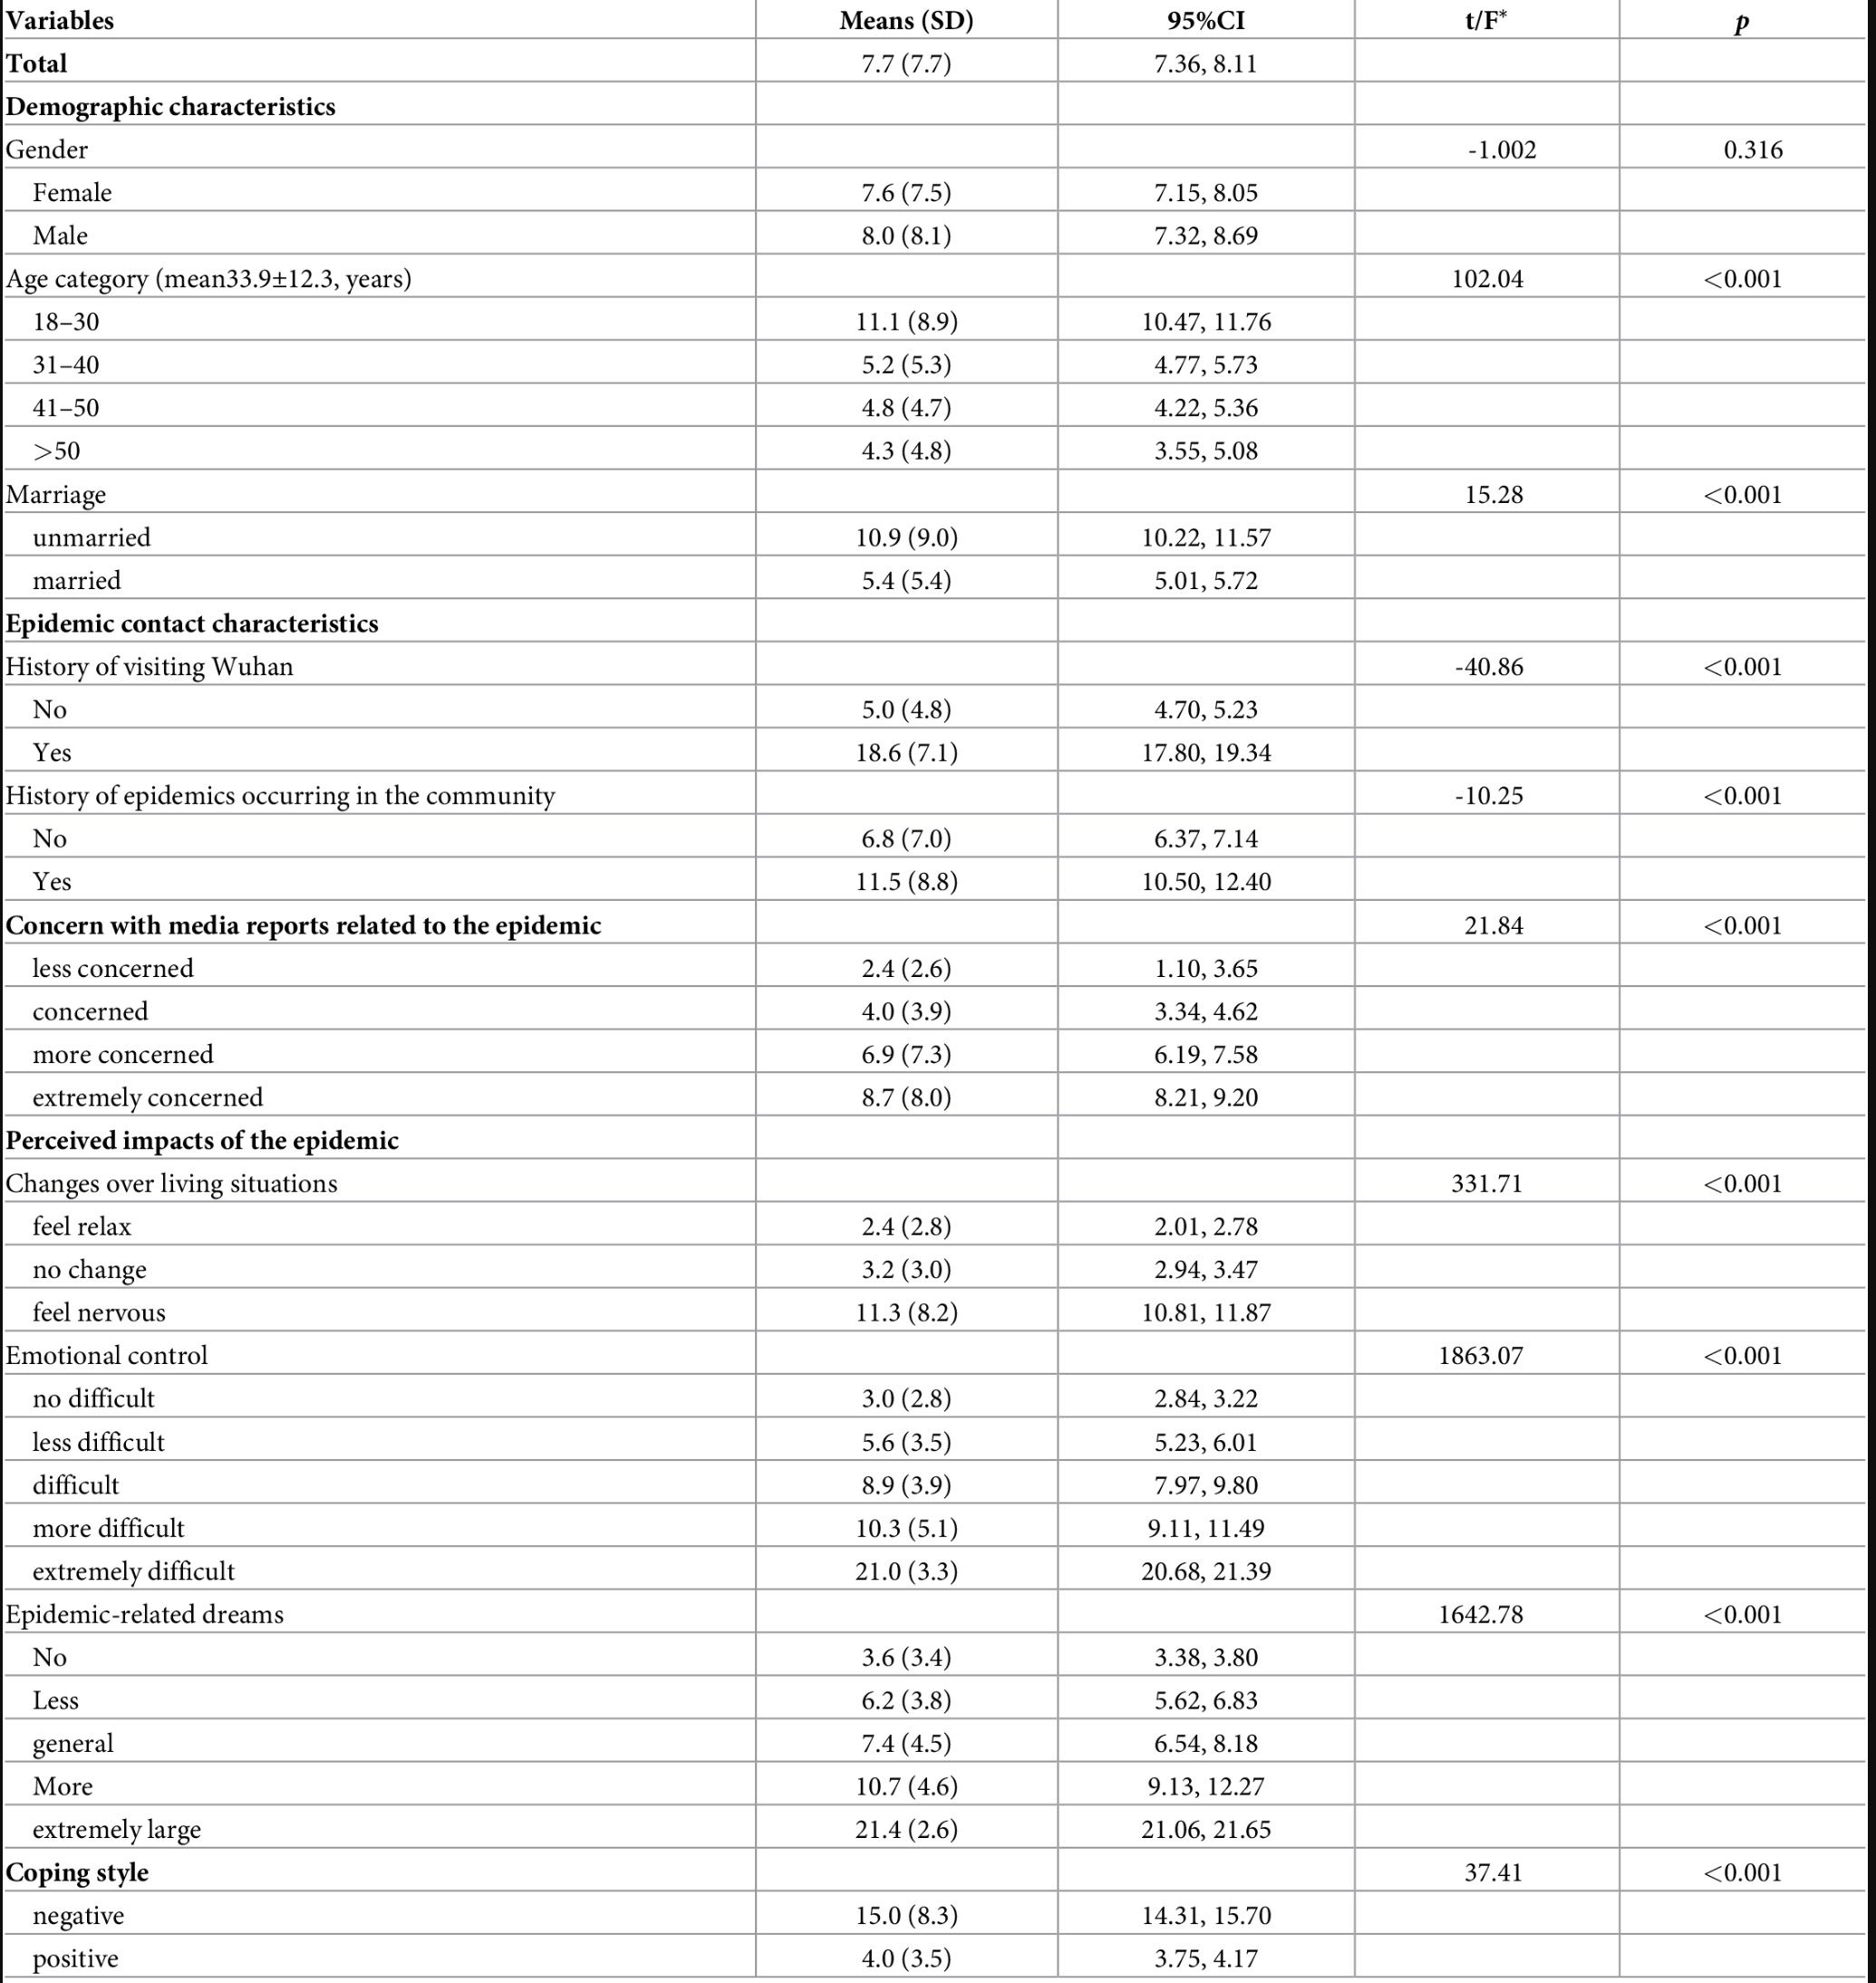
Table 2 from Wang et al. (2020). Means (SDs), 95% CIs, and t or F tests for K6 distress by characteristic.
The study quantified psychological distress using the Kessler Psychological Distress Scale (K6), a 6-item screening tool that measures symptoms of psychological distress.
It contains six questions that ask participants to rate how often they have felt ‘nervous’, ‘hopeless’, ‘restless or fidgety’, ‘so depressed that nothing could cheer you up’, ‘that everything was an effort’, and ‘worthless’ during the past 30 days. Each item is scored 0-4; the six items are summed for a total from 0 to 24, where higher scores mean more distress. In the data, this variable is called total_scores_of_K6.
Table 2 in the paper reports the mean K6 score by participant characteristic. For each characteristic, they show Mean (SD), 95% CI, and one t or F test comparing groups.
We will reproduce the first four characteristics only:
- Gender
- Age category
- Marriage
- History of visiting Wuhan
Part 1 follows the same four steps as the live demo, rsr_week_05_demo_prevend.Rmd, so you can refer to it for guidance.
In Part 2, we will practice calculating power and sample size for a follow-up study.

PART 1: Replicate the table

Load packages
if (!require(pacman)) install.packages("pacman")
pacman::p_load(readxl, dplyr, tidyr, gt, here, janitor)

Step 1: Import and label the data
First we import and take a look at the data. Use the glimpse function to get a sense of the dataset.
survey <- read_excel(here("data/distress_data.xlsx"))
________(survey)
Question: How many rows and columns does the dataset have?
Answer: _______
Question: What are the variable types? Will we need to convert any variable types?
Answer: _______
All the columns are coded as numeric, even though many are categorical. The codebook in data/distress_codebook.xls gives us the labels for the categorical variables. Below we:
- rename variables to make them more readable, since they will be presented in the paper’s table.
- use the codebook to label the categorical variables.
- convert the age variable to a categorical variable with four groups, as was done in the paper
Fill in any blanks in the code below, then run the code to check that the dataset has the correct structure.
Remember that you can check the demo code for examples of how to do similar transformations.
survey <- read_excel(here("data/distress_data.xlsx")) %>%
transmute(
total_scores_of_K6,
# convert the gender variable to a factor with two levels
Gender = _______(gender, levels = c(0, 1), labels = c("Female", "Male")),
# making the age variable categorical with four groups as in the paper
`Age category` = ____(
age,
breaks = c(-Inf, 30, 40, 50, Inf),
labels = c("18-30", "31-40", "41-50", ">50")
),
# convert the marriage variable to a factor with two levels
# code 1 = married, 0 = unmarried. Code 2 probably means divorced though this is missing in the codebook
Marriage = _______(
if_else(marriage == 1, "married", "unmarried"),
levels = c("unmarried", "married")
),
`History of visiting Wuhan` = _______(
history_of_visiting_SEA,
______ = c(0, 1),
______ = c("No", "Yes")
)
)
nrow(survey)
Checkpoint: The dataset should have 1599 rows and 5 columns.
Call the tabyl function to check the four categorical variables of Gender, Age category, Marriage, and History of visiting Wuhan before continuing.
tabyl(survey, Gender)
tabyl(survey,`Age category`)
tabyl(survey,Marriage)
tabyl(survey,`History of visiting Wuhan`)
Question: How many men are in the dataset? How many people had visited Wuhan in the past month?
Answer: _______

Step 2: Descriptive stats for every group
Now, we will calculate the average K6 score by each of the four categorical variables, as well as the standard deviation, standard error, and 95% confidence interval.
First, we reshape the data to long form so each row is one person in one group of one characteristic.
survey_long <- survey %>%
pivot_longer(
cols = -total_scores_of_K6,
names_to = "variable",
values_to = "group"
)
survey_long
Using this, we can easily calculate the summary statistics for every group in one pipeline. For example, below we calculate the number of people in each group.
survey_long %>%
group_by(variable, group) %>%
summarise(
n = n()
)
Now let’s do something like that but for all the descriptive statistics we want to calculate:
group_stats <- survey_long %>%
group_by(variable, group) %>%
summarise(
# n is the number of people in each group
n = n(),
# average K6 score of each group
mean = mean(_____),
sd = sd(total_scores_of_K6),
# standard error is sd divided by the square root of n
se = ________,
# 95% CI: leave 2.5% in each tail, so get the quantile for the 0.975 point using qt()
ci_lo = mean - qt(0.975, df = n - 1) * se,
# same for the upper bound
ci_hi = _______ + qt(0.975, df = n - 1) * se,
.groups = "drop"
) %>%
# arrange the data by variable and group to match the order of the table
mutate(
variable = factor(
variable,
levels = c("Gender", "Age category", "Marriage", "History of visiting Wuhan")
)
) %>%
arrange(variable, group)
group_stats
Question: For history of visiting Wuhan, which group has the higher mean distress score?
Your answer:

Step 3: The tests
Use a t-test for variables with two groups. Use one-way ANOVA for age category because it has four groups.
Use var.equal = TRUE in the t-tests to match the published table.
gender_t <- t.test(total_scores_of_K6 ~ Gender, data = survey, var.equal = TRUE)
age_aov <- aov(total_scores_of_K6 ~ _____, data = survey)
# Equal variance t test for marriage
marriage_t <- _____(_________________)
# Equal variance t test for history of visiting Wuhan
wuhan_t <- _____(_________________)
Look at each output.
gender_t
summary(age_aov)
marriage_t
wuhan_t
Question: At alpha = 0.05, is the gender difference statistically significant? Do we reject or fail to reject the null hypothesis?
Your answer:
Question: For the gender t-test, which error is possible, Type I or Type II? What would that error mean here?
Your answer:
Question: For the age ANOVA, is the age difference statistically significant? What does this tell us about the groups?
Your answer:
Question: Which error is possible here for the ANOVA, Type I or Type II? What would that error mean here?
Your answer:

Step 4: Assemble the table with gt
The code below turns your summaries and tests into a publication-style table.
We have filled this section in for you. In real projects, you should focus first on checking that the statistical code and outputs are correct. You can then use tools such as LLMs to help with table formatting, as long as you verify that the formatted table matches the statistical results.
You do not need to edit these chunks. Run them and check that the t/F and p values match the target table image.
First, we extract the ANOVA F statistic and p-value.
age_f <- summary(age_aov)[[1]]$`F value`[1]
age_p <- summary(age_aov)[[1]]$`Pr(>F)`[1]
age_f
age_p
Then, we assemble the table with the gt package.
results_table <- group_stats %>%
mutate(
`Mean (SD)` = paste0(
format(round(mean, 1), nsmall = 1),
" (",
format(round(sd, 1), nsmall = 1),
")"
),
`95% CI` = paste0(
format(round(ci_lo, 2), nsmall = 2),
", ",
format(round(ci_hi, 2), nsmall = 2)
),
statistic = case_when(
variable == "Gender" ~ as.numeric(gender_t$statistic),
variable == "Age category" ~ age_f,
variable == "Marriage" ~ as.numeric(marriage_t$statistic),
variable == "History of visiting Wuhan" ~ as.numeric(wuhan_t$statistic)
),
p_value = case_when(
variable == "Gender" ~ gender_t$p.value,
variable == "Age category" ~ age_p,
variable == "Marriage" ~ marriage_t$p.value,
variable == "History of visiting Wuhan" ~ wuhan_t$p.value
),
stat_text = as.character(round(statistic, 2)),
p_text = if_else(p_value < 0.001, "<0.001", as.character(round(p_value, 3)))
) %>%
group_by(variable) %>%
mutate(row_in_block = row_number()) %>%
ungroup() %>%
mutate(
`t/F` = if_else(row_in_block == 1, stat_text, ""),
p = if_else(row_in_block == 1, p_text, "")
)
Question: In the table-building code, which lines decide whether a row gets a t statistic or an F statistic?
Your answer:
Question: Why do we show the t/F and p-value only once per characteristic, rather than repeating them on every row?
Your answer:
Question: Which characteristics are statistically significant at alpha = 0.05?
Your answer:
Question: Choose one significant result. In plain language, what does it mean?
Your answer:
results_table %>%
select(variable, group, `Mean (SD)`, `95% CI`, `t/F`, p) %>%
gt(groupname_col = "variable", rowname_col = "group") %>%
tab_header(title = "Psychological distress (K6) by characteristic") %>%
tab_style(
style = cell_text(weight = "bold"),
locations = cells_row_groups()
) %>%
tab_options(table.width = pct(100))
Question: Choose at least two variables and compare the table values against the raw test output. Which statistics did you check, and did they match?
Your answer:

LLM formatting practice
Sometimes tables are more informative when they have a small in-cell bar showing the key values we want to highlight. This is possible with gt, using the gtExtras package.
Practice using LLMs for formatting by asking for a version of the table that adds an in-cell bar for the mean K6 score.
Before asking, run:
glimpse(results_table)
Then write a prompt that includes the object name, the column containing the means, and the package you want to use.
# pacman::p_load(gtExtras)
# Paste and test your LLM-generated code here.

PART 2: Power and sample size for a follow-up study
Suppose this survey is pilot data. You now want to run a two-arm intervention study to reduce K6 distress.
Before collecting new data, you need to estimate how many participants per group are required. We will use power.t.test() and the pilot standard deviation from this dataset.
pilot_sd <- sd(survey$total_scores_of_K6)
round(pilot_sd, 1)

Sample size for 80% power
Suppose a 2-point reduction in mean K6 score is the smallest difference worth detecting.
power.t.test(
delta = _____,
sd = _____,
sig.level = 0.05,
power = 0.80,
type = "two.sample"
)
How many participants are needed per group? Round up.
Your answer:
Question: If the chance of detecting a 2-point difference is 80% with our sample size, what happens if the actual difference is 4 points? Do we have a higher or lower chance of detecting it?
Your answer:

Smaller difference
Now you decide that even a 1-point difference is worth detecting.
power.t.test(
delta = _____,
sd = _____,
sig.level = 0.05,
power = 0.80,
type = "two.sample"
)
Does the required sample size go up or down compared with the 2-point version? Why?
Your answer:

