SOLUTIONS: Replicating a publication table of group differences
  - COVID-19 psychological distress (K6) by characteristic
GRAPH Courses team
2026-06-18
Table of Contents

Introduction
These are the completed solutions for the week 5 exercise.

PART 1: Replicate the table

Load packages
if (!require(pacman)) install.packages("pacman")
pacman::p_load(readxl, dplyr, tidyr, gt, here, janitor)
Look at the target table before you start.
knitr::include_graphics(here("paper/table2_with_values.jpg"))
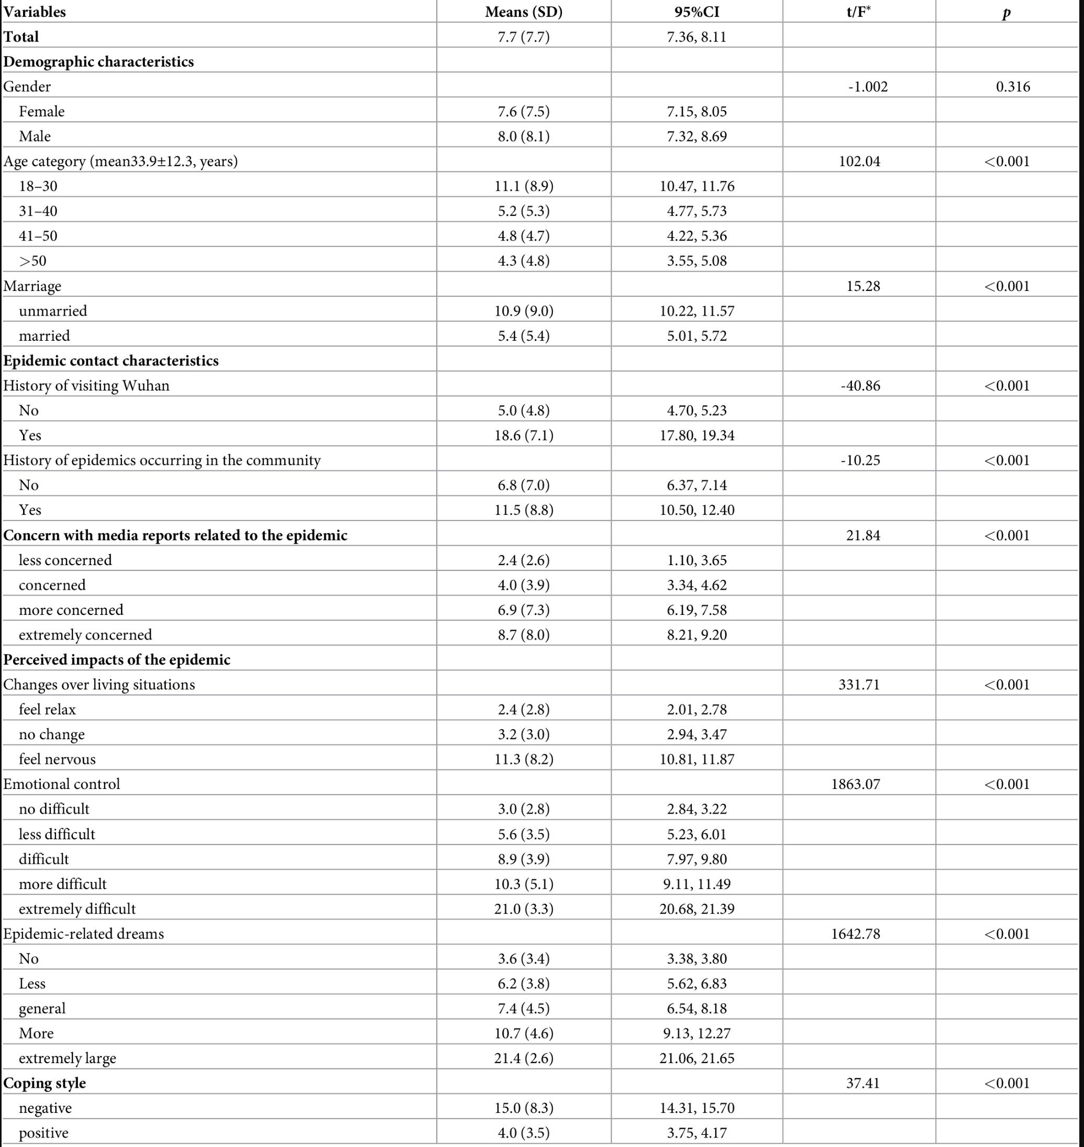

Step 1: Import and label the data
survey_raw <- read_excel(here("data/distress_data.xlsx"))
glimpse(survey_raw)
## Rows: 1,599
## Columns: 38
## $ order <dbl> 1, 2, 3, 4, 5, 6, 7…
## $ gender <dbl> 1, 1, 1, 0, 1, 1, 0…
## $ age <dbl> 18, 40, 20, 23, 22,…
## $ marriage <dbl> 0, 2, 0, 0, 0, 1, 1…
## $ history_of_visiting_SEA <dbl> 0, 0, 0, 0, 0, 0, 0…
## $ `history_of_epidemics_occurring_in_the community` <dbl> 0, 0, 1, 1, 0, 0, 0…
## $ concern_with_media_reports_related_to_the_epidemic <dbl> 0, 0, 0, 0, 0, 0, 0…
## $ changes_over_living_situations <dbl> 1, 0, 2, 0, 0, 0, 2…
## $ emotional_control <dbl> 1, 1, 0, 0, 0, 0, 0…
## $ `epidemic-related_dreams` <dbl> 0, 0, 0, 0, 0, 0, 0…
## $ total_scores_of_K6 <dbl> 4, 0, 3, 8, 1, 0, 6…
## $ K6_nervous <dbl> 0, 0, 2, 1, 0, 0, 1…
## $ K6_hopeless <dbl> 0, 0, 0, 1, 0, 0, 1…
## $ `K6_restless or fidgety` <dbl> 0, 0, 1, 2, 1, 0, 2…
## $ K6_so_depressed_that_nothing_could_cheer_you_up <dbl> 1, 0, 0, 2, 0, 0, 0…
## $ K6_that_everything_was_an_effort <dbl> 1, 0, 0, 1, 0, 0, 1…
## $ K6_worthless <dbl> 2, 0, 0, 1, 0, 0, 1…
## $ coping_style <dbl> 0, 0, 1, 1, 0, 0, 1…
## $ SCSQ_qes1 <dbl> 1, 2, 3, 1, 1, 0, 3…
## $ SCSQ_qes2 <dbl> 2, 2, 3, 2, 1, 0, 0…
## $ SCSQ_qes3 <dbl> 2, 2, 3, 3, 1, 0, 3…
## $ SCSQ_qes4 <dbl> 1, 2, 3, 3, 0, 0, 3…
## $ SCSQ_qes5 <dbl> 2, 3, 3, 3, 3, 0, 2…
## $ SCSQ_qes6 <dbl> 2, 2, 2, 3, 1, 0, 2…
## $ SCSQ_qes7 <dbl> 1, 1, 2, 3, 1, 0, 2…
## $ SCSQ_qes8 <dbl> 2, 1, 2, 3, 0, 0, 3…
## $ SCSQ_qes9 <dbl> 1, 2, 2, 3, 1, 0, 2…
## $ SCSQ_qes10 <dbl> 1, 1, 2, 3, 0, 0, 2…
## $ SCSQ_qes11 <dbl> 2, 2, 2, 3, 0, 0, 1…
## $ SCSQ_qes12 <dbl> 1, 3, 3, 3, 3, 0, 3…
## $ SCSQ_qes13 <dbl> 2, 1, 3, 3, 2, 0, 2…
## $ SCSQ_qes14 <dbl> 1, 1, 0, 0, 0, 0, 0…
## $ SCSQ_qes15 <dbl> 1, 3, 2, 1, 1, 0, 1…
## $ SCSQ_qes16 <dbl> 2, 2, 1, 3, 1, 0, 2…
## $ SCSQ_qes17 <dbl> 0, 1, 1, 3, 0, 0, 2…
## $ SCSQ_qes18 <dbl> 2, 2, 1, 3, 1, 0, 2…
## $ SCSQ_qes19 <dbl> 1, 2, 1, 3, 0, 0, 3…
## $ SCSQ_qes20 <dbl> 1, 3, 3, 3, 0, 0, 3…
Question: How many rows and columns does the dataset have?
Answer: The dataset has 1599 rows and 38 columns.
Question: What are the variable types? Will we need to convert any variable types?
Answer: The variables are imported as numeric. We need to convert the categorical variables to factors before making the table.
survey <- read_excel(here("data/distress_data.xlsx")) %>%
transmute(
total_scores_of_K6,
Gender = factor(gender, levels = c(0, 1), labels = c("Female", "Male")),
`Age category` = cut(
age,
breaks = c(-Inf, 30, 40, 50, Inf),
labels = c("18-30", "31-40", "41-50", ">50")
),
Marriage = factor(
if_else(marriage == 1, "married", "unmarried"),
levels = c("unmarried", "married")
),
`History of visiting Wuhan` = factor(
history_of_visiting_SEA,
levels = c(0, 1),
labels = c("No", "Yes")
)
)
nrow(survey)
## [1] 1599
tabyl(survey, Gender)
## Gender n percent
## Female 1068 0.6679174
## Male 531 0.3320826
tabyl(survey, `Age category`)
## Age category n percent
## 18-30 722 0.45153221
## 31-40 471 0.29455910
## 41-50 254 0.15884928
## >50 152 0.09505941
tabyl(survey, Marriage)
## Marriage n percent
## unmarried 685 0.4283927
## married 914 0.5716073
tabyl(survey, `History of visiting Wuhan`)
## History of visiting Wuhan n percent
## No 1273 0.7961226
## Yes 326 0.2038774
Question: How many men are in the dataset? How many people had visited Wuhan in the past month?
Answer: There are 531 men. There are 326 people who had visited Wuhan in the past month.

Step 2: Descriptive stats for every group
survey_long <- survey %>%
select(
total_scores_of_K6,
Gender,
`Age category`,
Marriage,
`History of visiting Wuhan`
) %>%
pivot_longer(
cols = -total_scores_of_K6,
names_to = "variable",
values_to = "group"
)
survey_long
## # A tibble: 6,396 × 3
## total_scores_of_K6 variable group
## <dbl> <chr> <fct>
## 1 4 Gender Male
## 2 4 Age category 18-30
## 3 4 Marriage unmarried
## 4 4 History of visiting Wuhan No
## 5 0 Gender Male
## 6 0 Age category 31-40
## 7 0 Marriage unmarried
## 8 0 History of visiting Wuhan No
## 9 3 Gender Male
## 10 3 Age category 18-30
## # ℹ 6,386 more rows
survey_long %>%
group_by(variable, group) %>%
summarise(
n = n()
)
## # A tibble: 10 × 3
## # Groups: variable [4]
## variable group n
## <chr> <fct> <int>
## 1 Age category 18-30 722
## 2 Age category 31-40 471
## 3 Age category 41-50 254
## 4 Age category >50 152
## 5 Gender Female 1068
## 6 Gender Male 531
## 7 History of visiting Wuhan No 1273
## 8 History of visiting Wuhan Yes 326
## 9 Marriage unmarried 685
## 10 Marriage married 914
group_stats <- survey_long %>%
group_by(variable, group) %>%
summarise(
n = n(),
mean = mean(total_scores_of_K6),
sd = sd(total_scores_of_K6),
se = sd / sqrt(n),
ci_lo = mean - qt(0.975, df = n - 1) * se,
ci_hi = mean + qt(0.975, df = n - 1) * se,
.groups = "drop"
) %>%
mutate(
variable = factor(
variable,
levels = c("Gender", "Age category", "Marriage", "History of visiting Wuhan")
)
) %>%
arrange(variable, group)
group_stats
## # A tibble: 10 × 8
## variable group n mean sd se ci_lo ci_hi
## <fct> <fct> <int> <dbl> <dbl> <dbl> <dbl> <dbl>
## 1 Gender Female 1068 7.60 7.47 0.229 7.15 8.05
## 2 Gender Male 531 8.01 8.06 0.350 7.32 8.69
## 3 Age category 18-30 722 11.1 8.86 0.330 10.5 11.8
## 4 Age category 31-40 471 5.25 5.31 0.244 4.77 5.73
## 5 Age category 41-50 254 4.79 4.65 0.292 4.22 5.37
## 6 Age category >50 152 4.32 4.81 0.390 3.54 5.09
## 7 Marriage unmarried 685 10.9 8.97 0.343 10.2 11.6
## 8 Marriage married 914 5.36 5.44 0.180 5.01 5.72
## 9 History of visiting Wuhan No 1273 4.96 4.82 0.135 4.70 5.23
## 10 History of visiting Wuhan Yes 326 18.6 7.10 0.393 17.8 19.3
Question: For history of visiting Wuhan, which group has the higher mean distress score?
Answer: The Yes group has the higher mean distress score. Its mean is about 18.6, compared with about 5.0 in the No group.

Step 3: The tests
gender_t <- t.test(total_scores_of_K6 ~ Gender, data = survey, var.equal = TRUE)
age_aov <- aov(total_scores_of_K6 ~ `Age category`, data = survey)
marriage_t <- t.test(total_scores_of_K6 ~ Marriage, data = survey, var.equal = TRUE)
wuhan_t <- t.test(
total_scores_of_K6 ~ `History of visiting Wuhan`,
data = survey,
var.equal = TRUE
)
gender_t
##
## Two Sample t-test
##
## data: total_scores_of_K6 by Gender
## t = -1.0025, df = 1597, p-value = 0.3163
## alternative hypothesis: true difference in means between group Female and group Male is not equal to 0
## 95 percent confidence interval:
## -1.2071158 0.3905518
## sample estimates:
## mean in group Female mean in group Male
## 7.599251 8.007533
summary(age_aov)
## Df Sum Sq Mean Sq F value Pr(>F)
## `Age category` 3 15137 5046 102 <2e-16 ***
## Residuals 1595 78869 49
## ---
## Signif. codes: 0 '***' 0.001 '**' 0.01 '*' 0.05 '.' 0.1 ' ' 1
marriage_t
##
## Two Sample t-test
##
## data: total_scores_of_K6 by Marriage
## t = 15.279, df = 1597, p-value < 2.2e-16
## alternative hypothesis: true difference in means between group unmarried and group married is not equal to 0
## 95 percent confidence interval:
## 4.823113 6.243842
## sample estimates:
## mean in group unmarried mean in group married
## 10.897810 5.364333
wuhan_t
##
## Two Sample t-test
##
## data: total_scores_of_K6 by History of visiting Wuhan
## t = -40.864, df = 1597, p-value < 2.2e-16
## alternative hypothesis: true difference in means between group No and group Yes is not equal to 0
## 95 percent confidence interval:
## -14.25987 -12.95365
## sample estimates:
## mean in group No mean in group Yes
## 4.960723 18.567485
Question: At alpha = 0.05, is the gender difference statistically significant? Do we reject or fail to reject the null hypothesis?
Answer: No. The p-value is about 0.316, which is greater than 0.05. We fail to reject the null hypothesis.
Question: For the gender t-test, which error is possible, Type I or Type II? What would that error mean here?
Answer: A Type II error is possible. It would mean that there is a real gender difference in mean distress in the population, but this study failed to detect it.
Question: For the age ANOVA, is the age difference statistically significant? What does this tell us about the groups?
Answer: Yes. The p-value is less than 0.001. This tells us that at least one age-category mean differs from the others.
Question: Which error is possible here for the ANOVA, Type I or Type II? What would that error mean here?
Answer: A Type I error is possible because we reject the null hypothesis. It would mean that we concluded age category is associated with mean distress when, in the population, the age-category means do not really differ.

Step 4: Assemble the table with gt
age_f <- summary(age_aov)[[1]]$`F value`[1]
age_p <- summary(age_aov)[[1]]$`Pr(>F)`[1]
age_f
## [1] 102.0385
age_p
## [1] 1.998735e-60
results_table <- group_stats %>%
mutate(
`Mean (SD)` = paste0(
format(round(mean, 1), nsmall = 1),
" (",
format(round(sd, 1), nsmall = 1),
")"
),
`95% CI` = paste0(
format(round(ci_lo, 2), nsmall = 2),
", ",
format(round(ci_hi, 2), nsmall = 2)
),
statistic = case_when(
variable == "Gender" ~ as.numeric(gender_t$statistic),
variable == "Age category" ~ age_f,
variable == "Marriage" ~ as.numeric(marriage_t$statistic),
variable == "History of visiting Wuhan" ~ as.numeric(wuhan_t$statistic)
),
p_value = case_when(
variable == "Gender" ~ gender_t$p.value,
variable == "Age category" ~ age_p,
variable == "Marriage" ~ marriage_t$p.value,
variable == "History of visiting Wuhan" ~ wuhan_t$p.value
),
stat_text = as.character(round(statistic, 2)),
p_text = if_else(p_value < 0.001, "<0.001", as.character(round(p_value, 3)))
) %>%
group_by(variable) %>%
mutate(row_in_block = row_number()) %>%
ungroup() %>%
mutate(
`t/F` = if_else(row_in_block == 1, stat_text, ""),
p = if_else(row_in_block == 1, p_text, "")
)
results_table %>%
select(variable, group, `Mean (SD)`, `95% CI`, `t/F`, p) %>%
gt(groupname_col = "variable", rowname_col = "group") %>%
tab_header(title = "Psychological distress (K6) by characteristic") %>%
tab_style(
style = cell_text(weight = "bold"),
locations = cells_row_groups()
) %>%
tab_options(table.width = pct(100))
Table 1: Psychological distress (K6) by characteristic
 | Mean (SD) | 95% CI | t/F | p
Gender
Female | 7.6 (7.5) | 7.15, 8.05 | -1 | 0.316
Male | 8.0 (8.1) | 7.32, 8.69
Age category
18-30 | 11.1 (8.9) | 10.47, 11.76 | 102.04 | <0.001
31-40 | 5.2 (5.3) | 4.77, 5.73
41-50 | 4.8 (4.7) | 4.22, 5.37
>50 | 4.3 (4.8) | 3.54, 5.09
Marriage
unmarried | 10.9 (9.0) | 10.23, 11.57 | 15.28 | <0.001
married | 5.4 (5.4) | 5.01, 5.72
History of visiting Wuhan
No | 5.0 (4.8) | 4.70, 5.23 | -40.86 | <0.001
Yes | 18.6 (7.1) | 17.79, 19.34
Question: Choose at least two variables and compare the table values against the raw test output from your t.test and aov functions. Which statistics did you check, and did they match?
Answer: I checked the Gender t-test and the Age category ANOVA. The table shows t = -1.00 for Gender and F = 102.04 for Age category, which match the raw outputs after rounding.
Question: Which characteristics are statistically significant at alpha = 0.05?
Answer: Age category, Marriage, and History of visiting Wuhan are statistically significant. Gender is not statistically significant.
Question: Choose one significant result and report it in plain language as you would in a results section of a paper.
Answer: People who had visited Wuhan in the past month had significantly higher mean K6 distress scores than those who had not (18.6 vs 5.0), t(1597) = -40.9, p < 0.001.

LLM formatting practice
glimpse(results_table)
## Rows: 10
## Columns: 17
## $ variable <fct> Gender, Gender, Age category, Age category, Age category,…
## $ group <fct> Female, Male, 18-30, 31-40, 41-50, >50, unmarried, marrie…
## $ n <int> 1068, 531, 722, 471, 254, 152, 685, 914, 1273, 326
## $ mean <dbl> 7.599251, 8.007533, 11.113573, 5.246285, 4.791339, 4.3157…
## $ sd <dbl> 7.468928, 8.059211, 8.864732, 5.306245, 4.654863, 4.81088…
## $ se <dbl> 0.2285455, 0.3497400, 0.3299112, 0.2444989, 0.2920721, 0.…
## $ ci_lo <dbl> 7.150801, 7.320486, 10.465872, 4.765838, 4.216136, 3.5448…
## $ ci_hi <dbl> 8.047701, 8.694580, 11.761275, 5.726731, 5.366541, 5.0867…
## $ `Mean (SD)` <chr> " 7.6 (7.5)", " 8.0 (8.1)", "11.1 (8.9)", " 5.2 (5.3)", "…
## $ `95% CI` <chr> " 7.15, 8.05", " 7.32, 8.69", "10.47, 11.76", " 4.77, …
## $ statistic <dbl> -1.002493, -1.002493, 102.038473, 102.038473, 102.038473,…
## $ p_value <dbl> 3.162576e-01, 3.162576e-01, 1.998735e-60, 1.998735e-60, 1…
## $ stat_text <chr> "-1", "-1", "102.04", "102.04", "102.04", "102.04", "15.2…
## $ p_text <chr> "0.316", "0.316", "<0.001", "<0.001", "<0.001", "<0.001",…
## $ row_in_block <int> 1, 2, 1, 2, 3, 4, 1, 2, 1, 2
## $ `t/F` <chr> "-1", "", "102.04", "", "", "", "15.28", "", "-40.86", ""
## $ p <chr> "0.316", "", "<0.001", "", "", "", "<0.001", "", "<0.001"…
One possible extension:
pacman::p_load(gtExtras)
results_table %>%
mutate(mean_bar = mean) %>%
select(variable, group, `Mean (SD)`, mean_bar, `95% CI`, `t/F`, p) %>%
gt(groupname_col = "variable", rowname_col = "group") %>%
gtExtras::gt_plt_bar(
column = mean_bar,
keep_column = TRUE,
color = "#2F6B9A"
) %>%
cols_label(mean_bar = "Mean") %>%
tab_header(title = "Psychological distress (K6) by characteristic")

PART 2: Power and sample size for a follow-up study
pilot_sd <- sd(survey$total_scores_of_K6)
round(pilot_sd, 1)
## [1] 7.7

Sample size for 80% power
Suppose a 2-point reduction in mean K6 score is the smallest difference worth detecting.
power_80 <- power.t.test(
delta = 2,
sd = pilot_sd,
sig.level = 0.05,
power = 0.80,
type = "two.sample"
)
power_80
##
## Two-sample t test power calculation
##
## n = 231.8274
## delta = 2
## sd = 7.669877
## sig.level = 0.05
## power = 0.8
## alternative = two.sided
##
## NOTE: n is number in *each* group
How many participants are needed per group? Round up.
Answer: R returns about 231.8, so we round up to 232 participants per group.
Question: If the chance of detecting a 2-point difference is 80% with our sample size, what happens if the actual difference is 4 points? Do we have a higher or lower chance of detecting it?
Answer: We have a higher chance of detecting it. Larger true differences are easier to detect.

Smaller difference
Now you decide that even a 1-point difference is worth detecting.
power_delta_1 <- power.t.test(
delta = 1,
sd = pilot_sd,
sig.level = 0.05,
power = 0.80,
type = "two.sample"
)
power_delta_1
##
## Two-sample t test power calculation
##
## n = 924.4137
## delta = 1
## sd = 7.669877
## sig.level = 0.05
## power = 0.8
## alternative = two.sided
##
## NOTE: n is number in *each* group
Does the required sample size go up or down compared with the 2-point version? Why?
Answer: It goes up. A smaller difference is harder to detect, so we need more participants.

Summary
The table shows no statistically significant gender difference, but age category, marriage, and history of visiting Wuhan are statistically significant. The power section shows that sample size increases when the minimum difference worth detecting gets smaller.

