

19ECE312-Information Theory and Coding

Mini Project Report

2023-2024 Even Semester

Title: C program to implement the Shannon-Fano coding theorem for third extension

Name of students:

1)H Naga Sasank - BL.EN.U4ECE21050

2)H Sai Vishnu Vardhan Reddy - BL.EN.U4ECE21051

3)Harsh Bhutra - BL.EN.U4ECE21053

4)Harshith Shyam - BL.EN.U4ECE21054

Section : ECE C

Batch no. : 02

Date : 10/05/2024

Aim: To write C program to implement the Shannon-Fano coding theorem for third extension.

Code:

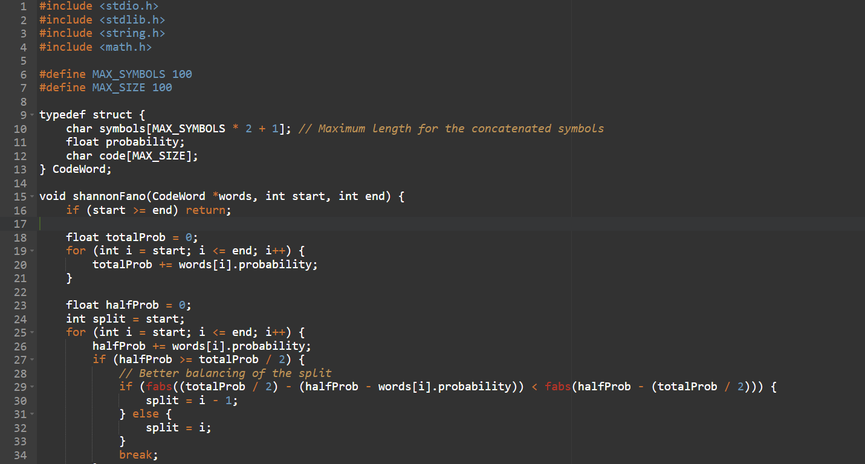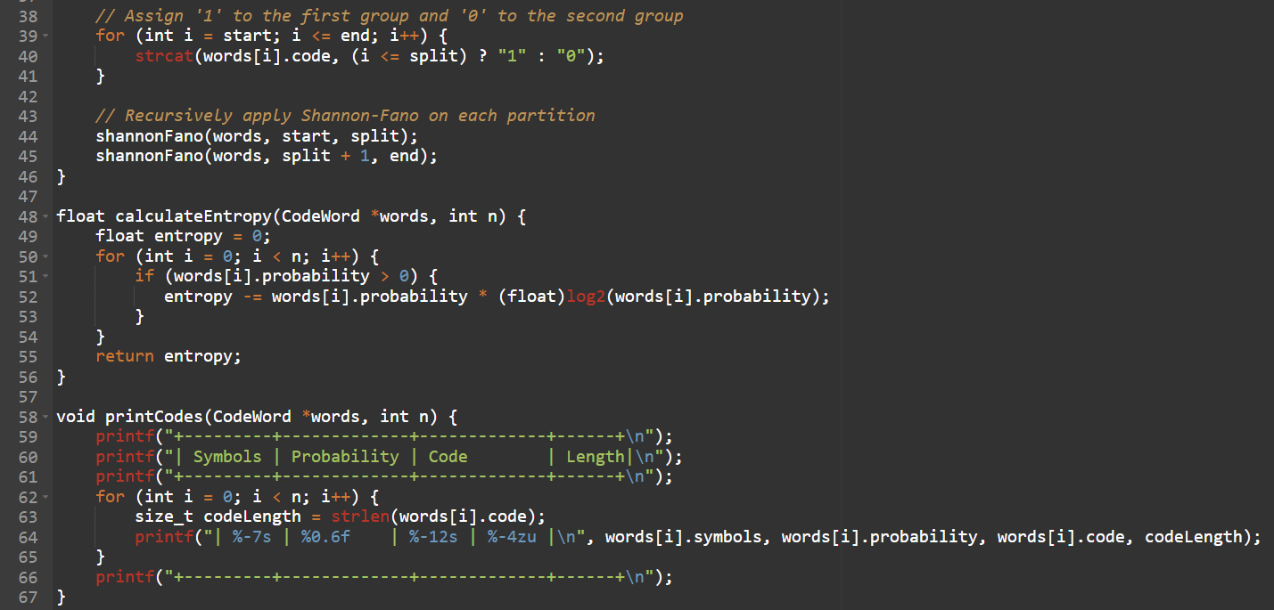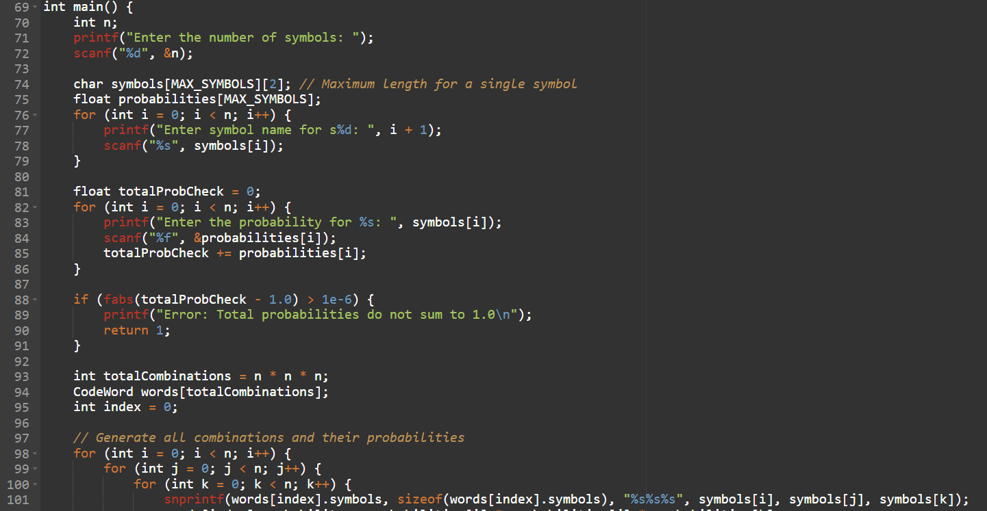

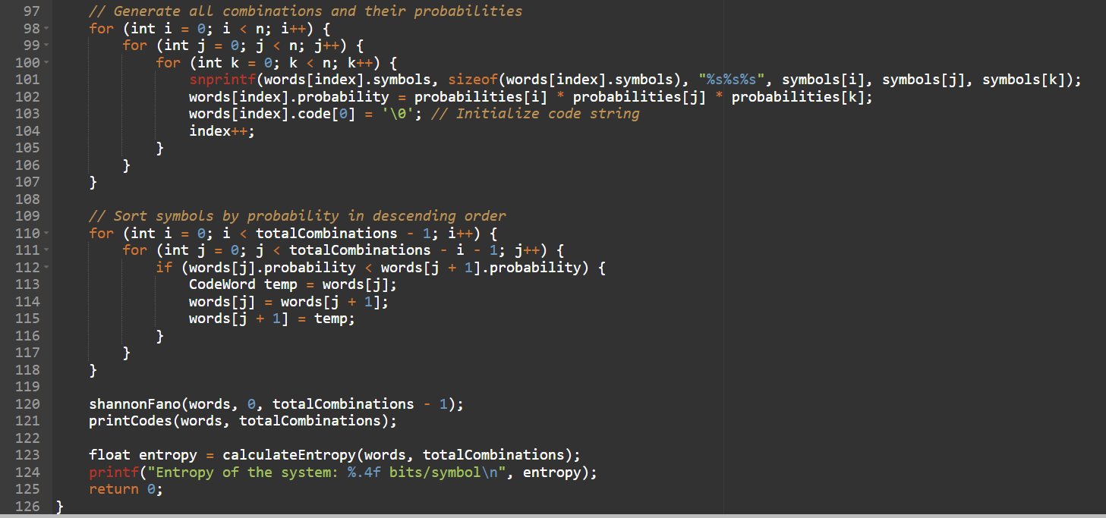 Output:

Case1:

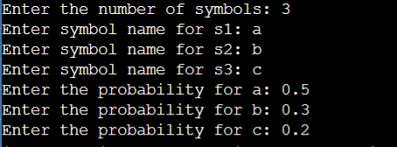

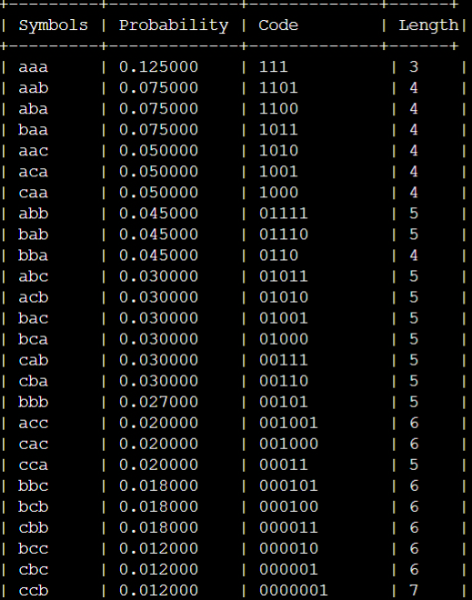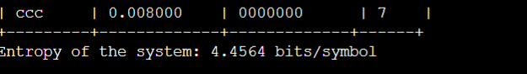

Case 2:

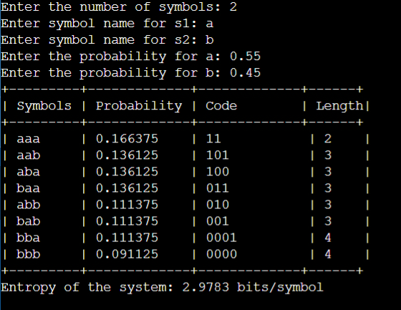

Result: The program utilizes the Shannon-Fano algorithm to generate prefix codes for combinations of three symbols, determined by user-input probabilities. Beginning by prompting the user for the number of symbols and their respective names and probabilities, the program then verifies if the total probability sums up to 1.0. Subsequently, it generates all possible combinations of three symbols and calculates their probabilities, sorting them in descending order. Through recursive application of the Shannon-Fano algorithm, the program assigns binary codes to each combination based on probability distribution, printing the symbols, probabilities, codes, and their lengths. Finally, it computes and displays the entropy of the system, representing the average number of bits required per symbol for encoding.