Alien Blaster
Game Design Document
Ryan Morehouse
May 28, 2018
Version 1.0

Version 1.0 Addendum
- This game has been modified to include AI functionality. Rather than following a fixed route, which it did in version 0.5, now regularly makes an aggressive movement towards the player. This forces the player to continually avoid it.

General Overview / Mini Game Design
Alien Blaster is a one-player, top-down scrolling shooter inspired by the arcade games Alien Syndrome by Sega and Time Soldiers by Alpha Denshi. The story is the player is responding to a distress call from a research station in deep space. After they land, they find the planet has been overrun by hostile alien species, a large one of which decimates their spaceship. Their only hope of survival is to reach an intact ship located within the research facility itself.

The player must use their weapons to fend off hostile aliens as they make their way vertically through the landscape. When they are hit their life meter goes down, and when they run out it is game over. As they progress they can pick up health-restoring items as well as special weapons with limited ammo.

When the player reaches the end of the level, they will need to fight a boss in order to make their escape.

Target System and Requirements
The target system for this game is a PC capable of compiling the source code, and should run on such a system whether Windows, MacOS, or Linux. The source code requires a C and a C++ compiler, as well as the Allegro 4 library.

Story
Space Patrol Officer O’Conner is on assignment investigating a sudden lack of radio transmissions from the deep-space military research colony M-66. Though prepared for potential “space crazies,” O’Conner is surprised to find the station invested with a hostile, insect-like series of aliens. Not only that, but a large one decimates his space ship before he can stop it. Using his laser pistol and whatever military equipment he can find along the way, O’Conner makes his across the hostile landscape into the research station, hoping there is still an escape pod he can use to make his getaway.

Theme: Graphics and Sound

This game uses sprites from spritelib, a collection of creative commons licensed sprites created by Ari Feldman. The sprites used for the health and ammunition powerups were created by myself.

The sound effects used in this game are simple, clean “futuristic space” sounds taken from creative commons directories. They will be customizable through the configuration file. The music is an exciting 8-bit chiptune track by Eric Skiff appropriate for a space shooter.

Menus, User Interface, and Playing the Game
The game will start with a splash screen with game title, and waits for the player to press a key to begin the game. The player will then be presented with an intro card explaining the story, and an intro card explaining the controls. At any point, the player may press ctrl+h to access the help screen, or ctrl+m to toggle the music (if music is enabled).

The help screen is a simple screen listing the gameplay instructions, enemies, as well as a list of what powerups have which effects.

When the game begins, the player starts out only with their default weapon, the “laser pistol.” The arrow keys navigate the player, and the space bar shoots. The player starts with no ammunition for their flame thrower or bazooka weapons, but they can switch weapons by pressing 1, 2, or 3. As the player picks up ammunition powerups, they can use those weapons, as indicated by the gauges in the right hand corner of the screen. As the player changes weapons, their sprite will change as well to reflect what weapon is currently being used. Furthermore, the player has a health meter which reflects how much health out of 100 points the character has.

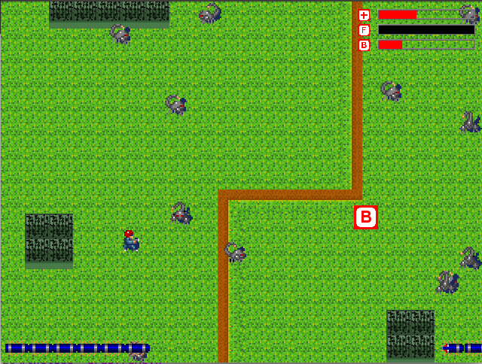

Crawlers are enemies that appear in swarms and bounce off the foreground. They cannot be escaped as they will crawl through walls eventually to follow the player. If the player continues forward without clearing out the swarm, the screen will be increasingly full of them. Crawlers deal 5 damage and have essentially 1 point of life – any hit with any weapon will kill them.

Centipedes are slow moving but have more health. They do not collide with the map foreground, unlike crawlers, and will continually march from right to left and wrap back around to the right of the screen. Killing a centipede segment or head has a chance of dropping a powerup. Killing a segment leaves the rest of the centipede in tact, but killing the head kills the entire centipede. The head and body segments each have 3 health, and contact with a centipede deals the player 10 damage.

The boss is a big, but slow, flying insect who continually summons swarms of other lesser enemies to the area. Once the boss is killed, the game has been won. The boss moves by a simple algorithm that navigates the sprite between a set of fixed locations without foreground collision. The boss has 50 health, and deals 10 damage to the player.

Map
The game uses a vertically scrolling map made in Mappy. This map makes use of the tl checkbox in the Mappy tile options for foreground collision detection. Any map of at least 640 x 480 size that scrolls vertically can be substituted in the config.txt file. The tiles used for the map are part of the Ari Feldman spritelib collection, however, I put this map together from those tiles specifically for this game. The map features three rough areas: one area approaching the research facility, an area inside the facility, and a general boss confrontation area.

Customization
The game will include a configuration file that contains resources used for the game. This can be used to quickly change sprites, sounds, and music used in the game. Furthermore, this also allows the use of a custom map in a FMP format.

Sound and Image Credits
Sprites for this game were taken from SpriteLib, a sprite collection created by Ari Feldmen. These are licensed under the GPL 1.0 license, and are available from http://www.widgetworx.com. The sprites for the health and ammunition powerups were created by myself.

The tile images for the background originally came from the SpriteLib collection, but the specific formatted image used to create the map tiles was created by Jonathan S. Harbour as part of example code for his book Game Programming All-in-One.

The soundtrack used for the game is Searching by Erik Skiff, from his album Resister Anthems, which was released under the Creative Commons Attribution 4.0 (CC-BY) License, and is available from http://ericskiff.com/music.

The sound effects are all taken from freesound.com with the following credits:
- laser.wav was submitted as laser4.wav by user jobro under the Creative Commons Attribution License, and is available from https://freesound.org/people/jobro/sounds/35681.
- bazooka.wav was submitted as Shooting_Sounds_005.wav by user jalastram under the Creative Commons Attribution License, and is available from https://freesound.org/people/jalastram/sounds/362461
- flame.wav was submitted as SFX_Explosion_02.wav by user jalastram under the Creative Commons Attribution License, and is available from https://freesound.org/people/jalastram/sounds/317749
- tick.wav was submitted by user CarbonParlour under the Creative Commons 0 License and is available from https://freesound.org/people/CarbonParlour/sounds/54999
- blip.wav was submitted as blip1.wav by user ipaghost under the Creative Commons 0 License and is available from https://freesound.org/people/ipaghost/sounds/335769
- powerup.wav was submitted as SFX_Powerup_46.wav by user jalastram under the Creative Commons Attribution License, and is available from https://freesound.org/people/jalastram/sounds/317784
- healthdown.wav was submitted as Lose_C_02 by user cabled_mess under the Creative Commons 0 License, and is available from https://freesound.org/people/cabled_mess/sounds/350985

