Alien Blaster Mini Document
Ryan Morehouse
May 28, 2018
Version 1.0

Overview

Alien Blaster is a one-player, top-down scrolling shooter inspired by the Sega arcade games Alien Syndrome and Time Soldiers. Responding to a distress call from a research station in deep space, you find the planet has been overrun by hostile alien species, a large one of which decimates your spaceship. Their only hope of survival is to reach the research facility and hope there is an intact ship you can use to make your escape and, eventually, report on the infestation. Try to fill your empty ammunition tanks and belts along the way, as crawlers with clicking, slick chitin pour out of every crack, and huge centipedes block your path forward. Can you defeat the hive boss, or will its swarms devour you? Your goal is to reach the space dock inside the research facility without getting eaten alive by the hordes of insects on the way, or the vicious hive boss. When you defeat the hive boss, you’ve won!

This game was primarily inspired by the arcade cabinets Alpha Denshi’s Time Soldiers, from 1987, whose port on the Sega Master System was one of the first video games I ever played, as well as Sega’s arcade cabinet of Alien Syndrome from 1987 as well. It was created as a project for the course Practical Video Game Development for Athabasca University. For simplicity, the final version of that project is presented here as version 1.0.

Playing the Game

The game is played with a basic keyboard: arrows move the player around and the space bar fires your weapon. You can use the number 1, 2, or 3 to switch between your basic laser pistol, which does minimal damage but has an unlimited battery pack, your flame thrower, which launches a long plume of flame and does moderate damage, and your bazooka, which fires enormous energy balls that do massive damage. The game can be muted by pressing ctrl+m, and the game can be paused by bringing up a help screen with instructions by pressing crtl+h. At any time, you can exit the game by pressing the ESC key.

The Story

Space Patrol Officer O’Conner is on assignment investigating a sudden lack of radio transmissions from the deep-space military research colony M-66. Though prepared for potential “space crazies,” O’Conner is surprised to find the station invested with a hostile, insect-like series of aliens. Not only that, but a large one decimates his space ship before he can stop it. Using his laser pistol and whatever military equipment he can find along the way, O’Conner makes his across the hostile landscape into the research station, hoping there is still an escape pod he can use to make his getaway.

The Enemies

Crawlers are little grey insects. They bump into walls and bounce around the screen in a frenzied state. If you try to escape them by scrolling up, they will simply follow you like a hungry horde. Centipedes are long enemies that simply trundle on in a straight path that wraps around the screen. They deal somewhat more damage than the crawlers but they can be easily enough escaped. Killing a centipede or its segments, however, is a good way to fill up on health and ammo powerups. Finally, the hive boss is a large bug that will follow you around the screen, continually summoning hordes of crawlers and centipedes to help bring you down.

Image Theme
The images used in the game are taken from spritelib, a Creative Commons sprite library by Ari Feldman. They include the tiles used for the background as well. The enemies are insects, and the player is a small sprite with different guns that are used when the different weapons are selected. Furthermore, each different weapon fires a different-looking bullet. The powerup icons are all created by myself with a clean red-on-white theme. I did my best to make the map feel like different areas inside and outside the facility, as well as give the impression of moving deeper into the facility as the player advances.

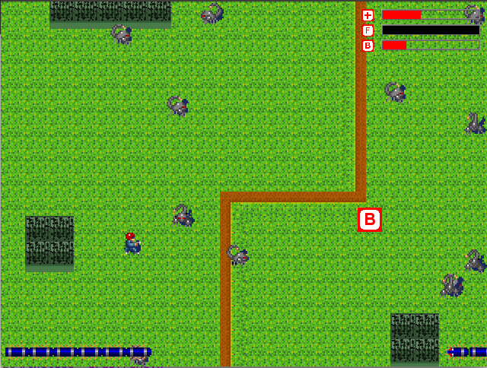
Illustration 1: Screenshot of Alienblaster
Illustration 2: Player sprites with different weapons

Illustration 3: Crawler sprites

Illustration 4: Centiped sprites

Illustration 5: Boss sprites

