**PROJECT PROPOSAL ON A**

**MOBILE BASED REALTIME E-VOTING APPLICATION FOR ELCOM COMPUTER SCIENCE KADUNA POLYTECHNIC**

**BY**

**GIFT EZINNE IKECHUKWU**

**CST20HND0120**

**SUPERVISED BY**

**MR MICHEAL IZUEGBU**

**1.1 BACKGROUND OF STUDY**

Voting is the process that allows the general public or the people to choose their leaders and articulate views on how they will be governed.

Real-time refers to a system in which input data is processed within milliseconds so that it is available virtually immediately as feedback to the process from which it is coming.

E-Voting refers the application of electronic technology to cast and count votes in an election. One of the fundamental mechanisms for democracy is election. It is the way to collect the public opinions to form a democratic government. The traditional process of election is quite tedious, time consuming and has a cumbersome procedure in preparation and tallying phases. To overcome these difficulties Real-time Electronic voting system (REVS) is introduced. REVS continues to grow as long as the world becomes more dependable on the new technologies. REVS provides a lot of benefits than traditional voting systems. It tries to enable efficient and secure elections. REVS is inexpensive because its resources are reusable. Also it does not require any geographical proximity of voters, and it provides better scalability for large elections.

In various Nigerian tertiary institutions, student elections are carried out every session. There are basically three arms of government in which student representatives or executives are usually elected; the Students Union Government (SUG), Departmental and Hostel levels. They are elected by students only. Lecturers are believed to have no influence as to who emerges successful in such elections. In other words, for any students-election, students of any given tertiary institution vote their fellow students who have shown interest in the above-listed posts. Elections have been in use to resolve various questions in the past 2000 years. Through the participation of a population, election allows public decisions to be made.

Election first started from the oral voting system to raising of hands, to the Kudavolai system (formerly utilized in the ancient India). In the ancient Greece, people would put either a white or a black ball/stone in a bucket. Oral voting was then substituted by the paper ballot first in Rome (139 BC) according to Douglas Jones.

And Nigeria still makes use of this paper-based voting systems. The voting systems had experienced continuous innovation which started as early as 1892 with the introduction of voting technology like the lever arch machine, the Optical-scan machine, and the punch card systems. Recent innovation saw evolutionary technology like the Direct Recording Electronics (DREs), Kiosk, Telephone, internet voting systems, and most recently is the mobile phone voting systems .

Most student electoral bodies since inception, still make use of obsolete paper-based voting systems. This system is characterized by filling manual forms.

**1.2 STATEMENT OF THE PROBLEM**

The voting/polling process by students of a computer science Kaduna Polytechnic seems to be cumbersome since there are thousands of students. So many cases of authentic students not participating in the voting process due to unfavourable voting time, conditions, environment, unbearable queue or the mammoth crowd at the voting place which is not accommodated in the period scheduled for voting. There are also scenarios where non-academic students flock the polling centre’s to participate in the voting process adding to the unbearable queue. Before anyone can vote, he must be accredited. Taking a look at the accreditation process below:

**STEP 1**: Go to the polling centre with your students’ identification card and join the queue.

**STEP 2**: Present your card to the Independent Students Electoral Commission (ISEC) official for verification.

**STEP 3**: Your finger will be marked with ink to show that you have been accredited. And to think that this must be done for individual voters before they can actually vote could be really discouraging. Even after voting, malicious officers in charge eventually tamper with the results. It's after effect is violence, as the given population is dissatisfied with the tampered results. Such scenario could be totally avoided if students (voters) votes online using real-time e-voting application. This, allows the voters to vote from anywhere in the globe and see the result almost immediately the votes are casted, saving time and avoiding the cost of moving to polling area.

**1.3 AIMS AND OBJECTIVES OF THE STUDY**

**The aim of this project is to build a** mobile based real-time e-voting application for elcom computer science Kaduna polytechnic**.**

**OBJECTIVES**

The objectives of this research work are as follows:

1. The student data set will be extracted from the department based on criteria’s involving payment of school fees, as registration is not performed on the site since the registration is automated.
2. The application will be generally hosted so that the general audience (students) can have audience to it.
3. Modern technology like flutter will be employed in creating interactive user interface and experience.
4. To ensure effectiveness and efficiency several system test will be carried out

**2.1 LITERATURE REVIEW**

**Over the previous years, society and numerous days by day parts of life have been changed technologically.**

**Design and Development of Real-Time E-Voting System with High Security Features (Mishra & Ofujeh, 2019). This research work exhibits an electronic voting system (E-Voting) connected to organization constituent body. A software application was developed utilizing web API’s and the concept of Dynamic systems development method (DSDM) was used with object-oriented methodology for the development of the application.** They **built a utility electronic voting system which when conveyed on web browsers of a gadget, and conceivably empower voting effectively done.**

**Design of a Secured E-voting System** (**Hussien & Aboelnaga, 2013). This e-voting system adopts one Central Tabulation Facility (CTF) which collects all secret ballots from local committee servers that distributed among poll stations. Each server in each poll station is connected with a number of embedded systems named voting terminals which used to create voter’s ballot. The proposed system utilizes both holomorphic cryptosystem which implemented using Parlier cryptosystem and blind signature based on RSA. The system is accomplished in four distinctive phases: authorizing, voting, authenticating, and tallying phases.**

**3.1 PROPOSAL METHODOLOGY**

This kind of in-depth examination is part of the research strategy, which aims to learn new facts or details about the current system. The department and the internet were used as primary sources of data for this investigation.

**3.1.1 INTERVIEW**

The main objective of using interviews as a method of data collection is to obtain information in a thorough and rigorous way. Based on the questions the researcher provided, the researcher met with the departmental project coordinators and acquired reliable information.

**3.1.2 DIRECT OBSERVATION**

This method allows varied degrees of control over the context in which they are used, and the meticulous inspection highlighted the obvious shortcomings in the current system. It was utilized to gather information/data for this study by looking at how the manual system was used.

**3.1.3 INTERNET**

In order to get a useful result, the internet will be used as a technique of data collecting. Information on areas that seem challenging or confusing will be sourced online.

**3.3 SYSTEM MODELLING**

Use Case Diagram, Class Diagram, and Activity Diagram are some of the UML diagrams used in this new design.

**3.2.1 USE CASE DIAGRAM**

The objective of a Use Case Diagram is to offer a graphical overview of a system's functionality in terms of actors, their goals (expressed as use cases), and any dependencies between those use cases.

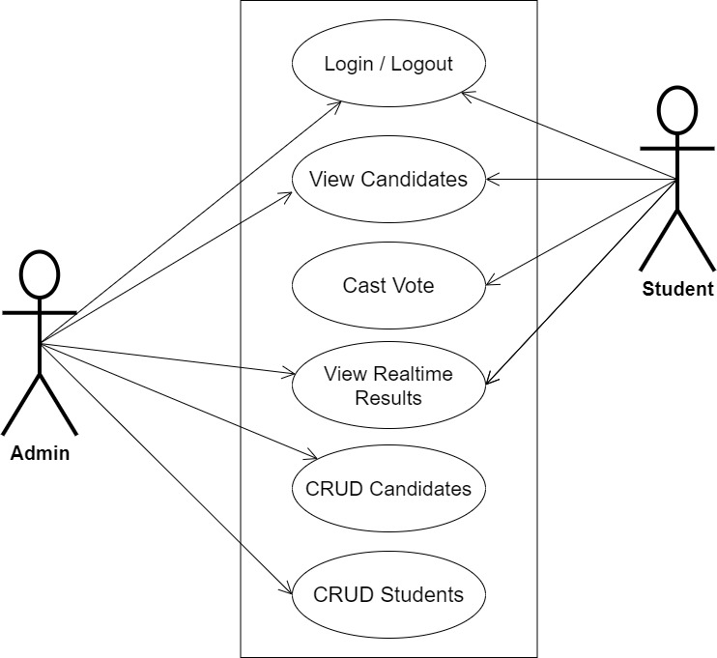

**Fig 3.1 System Use Case Diagram**

**3.2.2 ACTIVITY DIAGRAM**

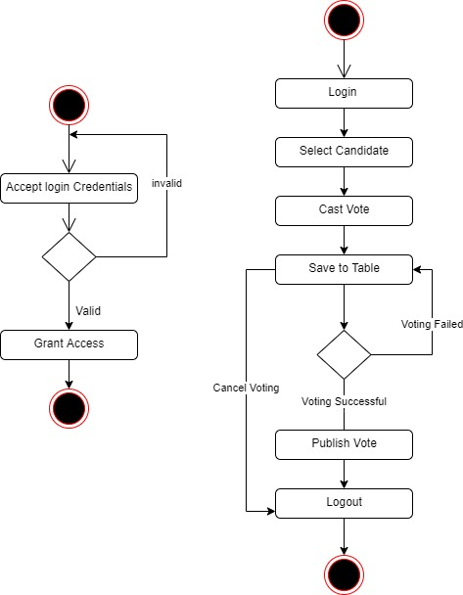

**Fig 3.3 Voting Activity Diagram**

**Fig 3.3 Login Activity Diagram**

**3.2.2 CLASS DIAGRAM**

Class diagrams are visual representations of a system's static structure and composition that adhere to the Unified Modeling Language principles (UML). It is one of the most often used UML diagram kinds. Class diagrams make it simpler to explain all of the classes, packages, and interfaces that comprise a system, as well as how these components are interconnected.

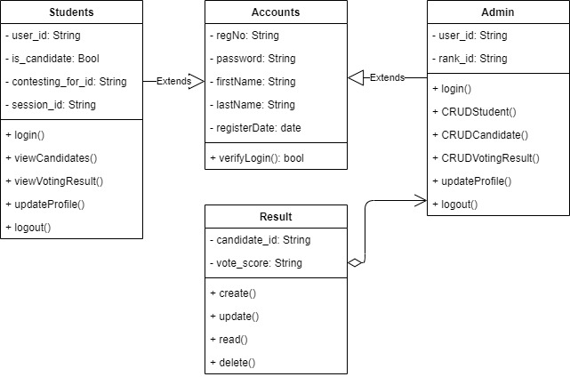

**Fig 3.2 Class Diagram**

**REFERENCES**

Hussien, H., & Aboelnaga, H. (2013). *Design of a Secured E-voting System*.

Mishra, A., & Ofujeh, A. (2019). *Design and Development of Real-Time E-Voting System with High Security Features*. *May*, 37–50. https://doi.org/10.5815/ijeme.2019.03.04

Okpara R., Otugeme E. and Osuagwu O. (2018). Development of a Mobile Android Voting App for Tertiary Institutions in Nigeria. *Voting Android App.* <https://www.researchgate.net/publication/344256892_DEVELOPMENT_OF_A_MOBIL> E_ANDROID_VOTING_APP_FOR_TERTIARY_INSTITUTIONS_IN_NIGERIA