Destroy all vessels in the target area

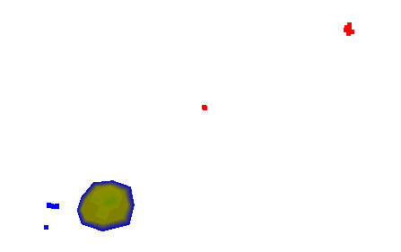

Take off, climb and maintain 2500ft. Call all aircrafts to form on your wing at 300kt. Cruise at 400kt.

Avoid enemy forward fleet

Heading 090, 20nm FR Lone Island VOR