Installation
2020-09 Lua Version 5.4 Supported, need September 2020 or later IUP download
2020-08 Lua Version 54 not supported
2019-02-09. A major rewrite (58 beta) now requires the 3.26 or later version.
2018-05-04 Note: Works with later IUP Lua tooklits
2016-04-17 Version 2
Install the addon in the usual way. Character data is written to history.lua in the savedvariable folder at character logout.
There is no keybinding or user interface inside the game.

Installing the Offline viewer
This is mandatory as there is no other way of reporting on data.
This addon uses the IUP Lua Toolit. It only has to be installed once and doesn't need to be changed when the addon updates, unless there is major update.
If you use my Research Timer, you will already have it.

This needs 3.26 or later

- Go here https://sourceforge.net/projects/iup/files/3.30/Tools%20Executables/Lua53/
- Download iup-3.30-Lua53_Win64_bin.zip
- ##Lua 54 is not supported at this time ##
- Unzip IUP into a folder. I will assume you are using the folder path C:\IUP\Lua53
- No other installation procedure is required. I.E it's portable.

Log in to the game with the addon active with a character and log out. That will ensure the savedvariable file exists.

First, some testing

- In the Lua53 folder. Run the iuplua53.exe, which will give a little graphical dialog.
- Use the load button to navigate to the Histoffline.lua file. (Do not move it from its location or it won't be able to find its datafile.)
- Press "execute" to run it. If there is an error, please cut and paste into a message on the webpage so I can debug.

Create Shortcuts
Now that you know it works, create a shortcut to run it directly from your desktop.

An Example shortcut is in the shortcuts folder. You can copy it to your desktop and edit it. A screenshot of the properties dialog is included.

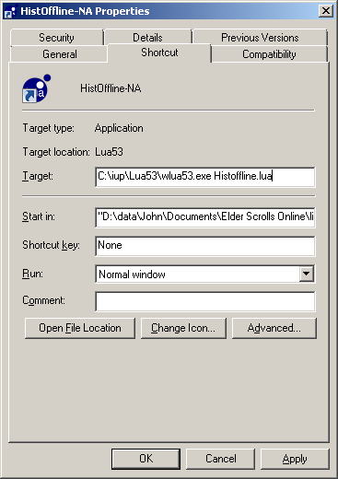
The Target is: C:\iup\Lua53\wlua53.exe Histoffline.lua
This does not change for the mega-server or PTS.

The Start in: is: "D:\data\John\Documents\Elder Scrolls Online\live\AddOns\History"
This is for Windows user 'John'
This user has had his documents folder redirected, which is why we don't use %USERPROFILE%/Documents It is not Reliable in cases like this.

- "Start in" varies for each Windows user.
- Note that path has spaces in it, so the path is enclosed in quotes. This can be hard to see as the field doesn't show the right side, although pressing the END key will put the cursor there.
- If you use PTS install the addon to that Folder and create a shortcut for that server with the correct "Start in:". You don't have to change IUP.

The easiest way of getting the correct path is to

- Delete contents of the Start in: Field on the Shortcut.
- Use explorer to Navigate to the history addon folder. See Screenshot.
- Click in the address bar to highlight it.
- Ctrl-C to copy the path.
- Click inside the Start in: Field on the Shortcut.
- Ctrl-P to Paste it into the Start in: Field
- Put the leading and trailing Quotes in.
- Click OK

You may want to rename the shortcut.

Debugging
(Q)It worked from the iuplua53 test console, but the shortcut doesn't work.
(A)The path is wrong, proabably missing quotes.

