✅ foodfire.online

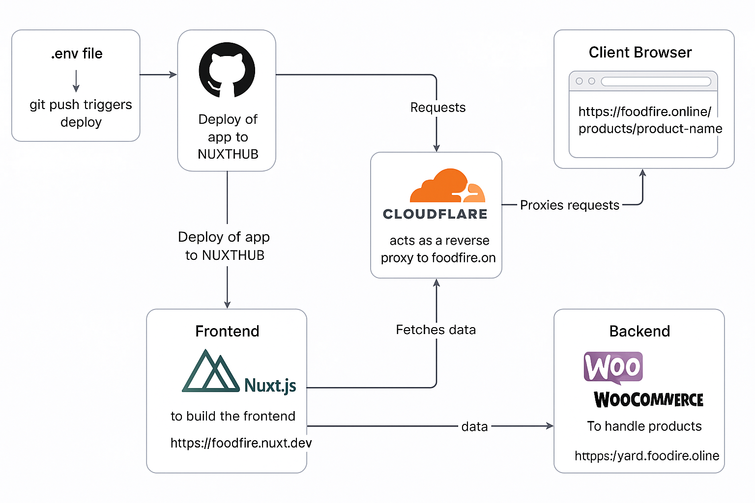
🧠 Ecosystem Ingredients + Flow

1. Developer Workflow
- Localhost
  - Uses .env for runtime variables like WooCommerce keys, URLs, etc.
  - git push → triggers deployment (via GitHub webhook)
⮕ GitHub → NuxtHub → Cloudflare
- GitHub
  - Hosts source code
  - Push triggers NuxtHub deployment
- NuxtHub (https://foodfire.nuxt.dev)
  - Builds and deploys your Nuxt 3 frontend app
  - Internal server routes (e.g. /api/products) fetch from WooCommerce backend
- Cloudflare
  - Reverse proxies https://foodfire.online → https://foodfire.nuxt.dev
  - Handles SSL, CDN, caching, and routing
  - Ensures all requests from client go via Cloudflare, avoiding CORS issues

2. Runtime (Live App)
- Client Browser
  - User only ever visits https://foodfire.online
  - All requests (including API calls) are made to Cloudflare
  - Never directly contacts WooCommerce
- Cloudflare
  - Proxies all https://foodfire.online requests to NuxtHub (foodfire.nuxt.dev)
  - So requests like:
nginx
CopyEdit
GET https://foodfire.online/api/products
→ forwarded to NuxtHub’s API route
- Nuxt 3 App (Hosted on NuxtHub)
  - Receives request to /api/products
  - Inside server route, fetches products from:
bash
CopyEdit
https://yard.foodfire.online/wp-json/wc/v3/products
using secure credentials from runtime config (consumerKey, consumerSecret)
  - Then returns response back through Cloudflare to client

3. WooCommerce Backend (https://yard.foodfire.online)
- WooCommerce REST API
  - Serves product data to NuxtHub's internal API routes
- CoCart API
  - Manages local cart in the browser via NuxtHub endpoints (acting as bridge)
  - Cart data tied to a session key (cookie-based)
  - On checkout, redirects user to standard WooCommerce checkout URL on SiteGround

✅ Best Practices Summary
Task | Best Practice
API calls from frontend | Always go through Nuxt API routes on NuxtHub
Avoiding CORS | Keep all browser requests inside same origin foodfire.online via Cloudflare
Credentials (keys) | Store only in .env and NuxtHub environment settings
Checkout & payment | Redirect user to WooCommerce checkout (standard flow)
Client sees | Only https://foodfire.online

Client sees:
https://foodfire.online/ plus routes like /products/product-name, /vids, /blog, etc. — all under the foodfire.online domain.
So it's more accurate to say:
Task | Best Practice
Client sees | Only URLs under https://foodfire.online/* — all routed through Cloudflare
All frontend routing (handled by Nuxt) and server API calls happen under this domain — ensuring a unified experience and zero CORS issues.

-----------------------

TDLATER
Thanks — the architecture doc is solid and matches what’s in your code/config. With that ecosystem and flow locked in, here are key testing areas (based on what you've shared and the finalized architecture) that you should verify next or add if missing:

✅ Already Covered (Based on Your Description)
- Product list fetch (/api/products)
- Product detail fetch by slug (/api/products/[slug])
- cart_key cookie set and used correctly
- Adding items to cart and viewing cart contents
- Server routes proxying WooCommerce API from Nuxt backend
- Secure secrets (in .env and not leaked client-side)
- GitHub → NuxtHub → Cloudflare deploy flow

🧪 Tests Still to Add / Improve

1. Cart Session Persistence
- ✅ Set cookie on first add-to-cart (you’re doing this)
- 🔍 Test that cookie:
  - persists across page refreshes and navigation
  - is reused on returning visits (client and SSR)
- 🔐 Test for security flags on cart_key cookie: HttpOnly, Secure, SameSite=Lax

2. Add to Cart → View Cart Flow
- 🔍 Test that an item added:
  - appears in /cart
  - shows correct quantity, price, and image (if applicable)
  - updates live if quantity is increased/decreased

3. Checkout Redirect
- 🔍 Test the flow:
  - Click checkout → redirect goes to WooCommerce native checkout page
  - Test redirect URL is correct and contains cart_key-tied session
  - Test WooCommerce checkout handles that cart session correctly

4. 404s / Product Not Found
- 🔍 Hit /products/nonexistent-slug:
  - Should gracefully return 404 page (no blank screen or console error)

5. API Error Handling
- 🔍 Temporarily break WooCommerce API URL in .env, then:
  - /api/products should return a useful error message (not a crash)
  - /cart should fail gracefully if CoCart down or token invalid

6. SSR Behavior
- ✅ You’re using SSR.
- 🔍 Ensure:
  - /products/slug renders fully on first page load (view page source)
  - No hydration mismatch warnings in console

7. Cache Headers via Cloudflare
- 🔍 Test that Cloudflare caches:
  - static assets (.js, .css, fonts)
  - but not dynamic routes like /api/products or /cart
- Confirm via DevTools → Network tab → cf-cache-status: MISS/BYPASS

8. SEO Tests
- 🔍 Pages like /products/slug should:
  - Have proper <title> and meta
  - Be crawlable via sitemap and robots.txt (from your modules)

9. Mobile / UX Interaction
- 🔍 On small screens:
  - Add to cart still works
  - Cart and checkout buttons are usable
  - No layout shift or missing data

🧰 Suggested Tools to Help:
- ✅ Playwright or Vitest + Nuxt Test Utils for automation
- 🧪 Manual DevTools testing (cookie, cache, source HTML)
- 🕵️‍♀️ Use curl -I https://foodfire.online/api/products to inspect headers
- 🔒 Inspect .env vars never leak to client via window.__NUXT__

Want me to help write a full Playwright or Nuxt Test Utils suite based on these points?

✅ Foodfire Architecture — Locked In

1. 🔧 Developer Workflow
- Localhost: .env for runtime secrets.
- Code: Pushed to GitHub → triggers NuxtHub → deployed to Cloudflare via proxy.

2. 🌐 Live Runtime
- Domain: https://foodfire.online (user-facing only).
- Frontend: Nuxt 3 app hosted at NuxtHub (https://foodfire.nuxt.dev), behind Cloudflare.
- Backend: WooCommerce lives at https://yard.foodfire.online, only contacted from Nuxt internal API routes.
- All API calls: Flow like this:
swift
CopyEdit
Browser → foodfire.online/api/* → Cloudflare → NuxtHub internal server route
→ fetch WooCommerce or CoCart
→ return to browser

3. 🛒 Cart and Checkout
- CoCart handles local cart via session cart_key in browser (cookie).
- Checkout = redirect to WooCommerce native checkout URL.

✅ Key Principles
Task | Best Practice
Frontend API Calls | Always via NuxtHub server routes
CORS Avoidance | All requests routed through Cloudflare → same-origin
Secrets & Keys | In .env locally + NuxtHub environment only
URLs User Sees | Only under https://foodfire.online/*
Nuxt Pages | All routes (e.g. /products/slug, /blog, /vids) under foodfire.online
Deployment Flow | Git push → GitHub → NuxtHub → Cloudflare proxy to domain

