NORTH FORELAND REGIONAL BADMINTON ASSOCIATION
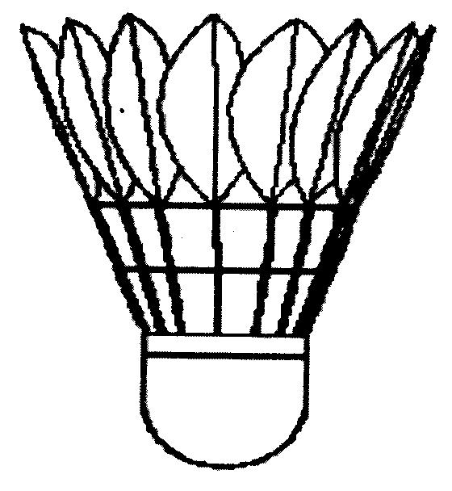
RULES FOR JUNIOR COMPETITIONS

- All clubs entering the competition must be affiliated to K.B.L. and to N.F.R.B.A. All players need to be registered with their club 2 weeks before a match.
- Rules for playing will be as laid down by the Badminton England. Parents and adults attending Junior Matches are expected to meet the Badminton England Code of Conduct and respect all players on court.
- Players must be under 18 years of age as of the 1 September. The Season shall start 1 September and finish 30 April.
- There will be 4 leagues – U18, U16, U14 and U12. Players can play in any division that their age allows.
- A U18/U16/U14 teams will consist of 6 players and U12 teams will consist of 4 players (any combination of boys and girls). Each player shall play in 3 games, one single and two doubles. All games are played to 21 points with no setting. The designation of 1st, 2nd, 3rd etc shall correspond to the order of merit of the players scheduled to play in respective games.
- A match using Rally Point scoring will consist of 12 games - 6 games of singles to 21 points and 6 games of doubles to 21 points with no setting. Feathered shuttles will be used.
- A player is eligible to play for a junior club even though he/she has played for a senior team.
- Players may only play for one junior club within the competition.
- The home team must send a completed Match Score Card to the Region’s Match Secretary within 24 hours of a match being played.
- The team with the greatest number of points, only, of each division, will be promoted to the next higher division. The team with the least number of points in each division will be relegated to the next lower division. Where two teams have an equal number of points, the final position will be decided by the ratio of games for to games against, or if still equal, by ratio of aces for to aces against.
- Any club entering two teams in the same competition shall send to the Junior Secretary the names of its first team before any match is played. Reserves for either team must be sought from eligible players outside that division until the two fixtures between those teams have been played; thereafter the normal playing-up rules apply. In the event of any club not having submitted such nominations before playing the first match, the players who took part will be regarded as having been nominated. No player having been nominated for the first team shall be eligible to play for the second team. In addition, no player shall be eligible to play for the second team if he/she has played for the first team in the same competition on more than half the matches.
- Fees for NF Membership and Falcons cup must be paid by the Club using BACS and not by the individual players.
Jun Rules Aug 26

