

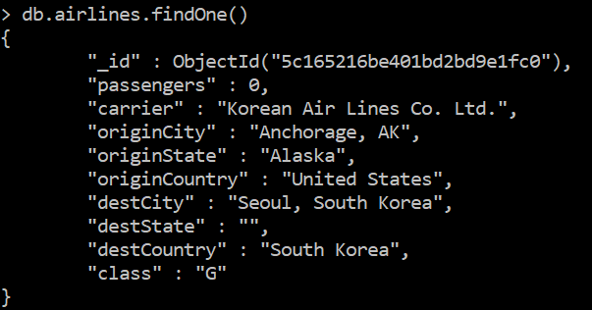

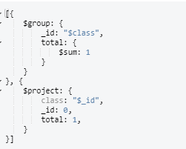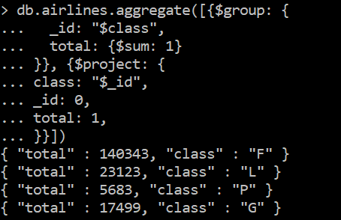

* 1. :

[{

$match: {

destCountry: {

$ne: "United States"

}

}

}, {

$group: {

_id: "$destCity",

avgPassengers: {

$avg: "$passengers"

}

}

}, {

$sort: {

avgPassengers: -1

}

}, {

$limit: 3

}, {

$project: {

avgPassengers: 1,

city: "$_id",

_id: 0,

}

}]

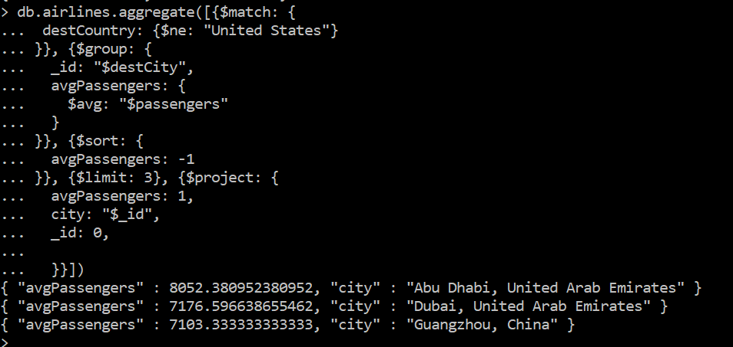



[{$match: {

destCountry: "Latvia"

}}, {$group: {

_id: "$destCountry",

carriers: {

$addToSet: "$carrier"

}

}}]

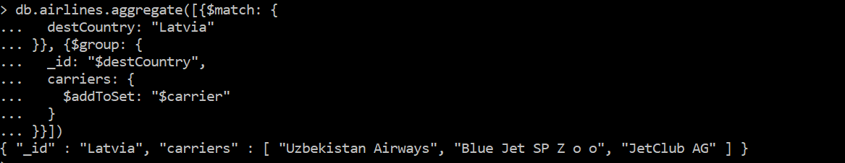

[{$match: {

originCountry: "United States",

$or: [{destCountry: "Greece"}, {destCountry: "Italy"}, {destCountry: "Spain"}]

}}, {$group: {

_id: "$carrier",

totalPassengers: {$sum: "$passengers"}

}}, {$sort: {

totalPassengers: -1

}}, {$limit: 10}, {$skip: 3}]

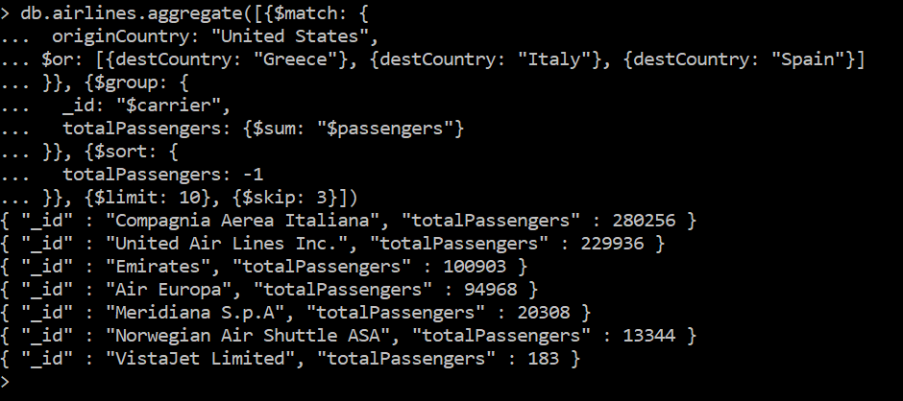

3.5

[{

$match: {

originCountry: "United States"

}

}, {

$group: {

_id: {

state: "$originState",

city: "$originCity"

},

totalPassengers: {

$sum: "$passengers"

}

}

}, {

$sort: {

totalPassengers: -1

}

}, {

$group: {

_id: "$_id.state",

city: {

$first: "$_id.city"

},

totalPassengers: {

$first: "$totalPassengers"

}

}

}, {

$sort: {

_id: 1

}

}, {

$limit: 5

}, {

$project: {

_id: 0,

totalPassengers: 1,

location: {

state: "$_id",

city: "$city"

}

}

}]

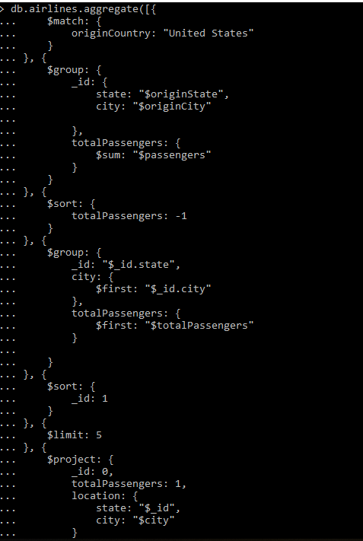

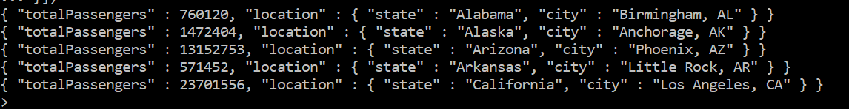

4. Enron

