**Lab 1:**

**PreLab**

**Readings, Insights, and Reflection**

* **METIS book(s)**

Professional Git

Laster, Brent.

VBID: 9781119285007

2016

Chapter 1: What is Git, Git Ecosystem, Git-Hosting Sites

Lambert, Kenneth A. Fundamentals of Python: First Programs. Available from: VitalSource Bookshelf, (2nd Edition). Cengage Learning US, 2018.

Fundamentals of Python: Data Structures , 2nd Edition

Kenneth Lambert

SBN-10: 0-357-12275-5

ISBN-13: 9780357122754

2019

Chapter 1: Basic Python Programming

* **Github Docs (OneDrive) :** 
  + [Anaconda Docs](https://mymailmapuaedu-my.sharepoint.com/:f:/g/personal/dapadilla_mapua_edu_ph/EuokMy4Bn_lMkf-oIFz68osBxRHh1DT5BsoN6JweAKGc5w?e=ZEPSGZ)
  + [GitHub Docs](https://mymailmapuaedu-my.sharepoint.com/:f:/g/personal/dapadilla_mapua_edu_ph/Ev4RXOwD_T9PuCnns53yfpcBtwc0b-PLlcbPqqH3t5nhYA?e=bYccNy)
* **Websites:** 
  + Installing Anaconda:

https://docs.anaconda.com/anaconda/install/windows/

* + Introduction to GitHub: <https://lab.github.com/githubtraining/introduction-to-github>
  + New urL >> https://github.com/skills/introduction-to-github

**InLab**

Instructions:

1. Check the following Github Learning Lab courses:
2. https://github.com/skills/introduction-to-github
3. Follow the Steps to complete the course as shown below figures.

**Note: All team members are required to individually perform the steps to complete the two courses.**

**Part 1: Intro to Github**

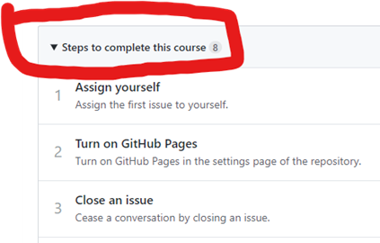

Figure 1. Steps to complete the course ‘ Intro to Github’

**Part 2: Introduction to Python**

**Note:** Use the sample codes of Lambert’s Chapter 1 in your PreLab. Follow the steps of Chapters 1 and 2.

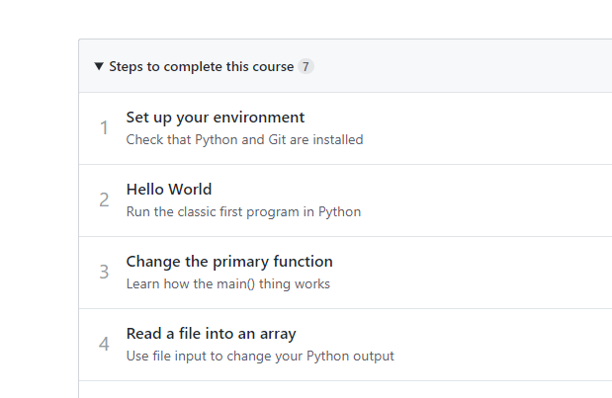

Figure 2. Steps to complete the course ‘Introduction to Python’

1. Follow the Lab Report Template InLab Guide on what to include (i.e. Discussion, Screenshots, etc.)

**PostLab**

**Instructions**:

1. All members will contribute to solutions to the below programming problems using the steps in ‘Introduction to Github’ Github Lab course. Programming problems source: Chapter 1, Fundamentals of Python: Data Structures , 2nd Edition ( See METIS books, PreLab section)

* Programming Problem 1:

|  |
| --- |
| Statisticians would like to have a set of functions to compute the median and mode of a list of numbers. The median is the number that would appear at the midpoint of a list if it were sorted. The mode is the number that appears most frequently in the list. Define these functions in a module named stats.py. Also include a function named mean, which computes the average of a set of numbers. Each function expects a list of numbers as an argument and returns a single number. |
|  |

* Programming Problem 2:

|  |
| --- |
| Write a program that allows the user to navigate through the lines of text in a file. The program prompts the user for a filename and inputs the lines of text into a list. The program then enters a loop in which it prints the number of lines in the file and prompts the user for a line number. Actual line numbers range from 1 to the number of lines in the file. If the input is 0, the program quits. Otherwise, the program prints the line associated with that number.9 |

1. Follow the Lab Report Template PostLab Guide on what to include (i.e. Discussion, Screenshots, etc.)

**IMPORTANT**: Members should create their own branch and commit the files/source codes of the programming problem assigned task(s). The leader of the group will merge all commits in the member’s own branch to the group’s common Github repo.