Rwanda Polytechnic - Kigali College
Department of Information and Communication Technology

PROJECT-BASED PRACTICAL TASK
Two Rwandan Scenarios: Build Machine-Learning-Ready Datasets
Competence 10: Apply Machine Learning - Element 1: Apply dataset preparation mechanisms

Item | Details
Group | Group XX
Members | IGIHOZO Bienvenue - MUGISHA Aime Patrick
Question 1 | Predicting Maize Yield for Farmer Cooperatives in Rwanda (MCSU)
Question 2 | Next-day rain early warning for MINEMA district disaster offices (NOAA station data 2015-2025)
Repository | [https://github.com/<account>/group-XX-repository]
Academic year | 2026/2027
Presentation | Thursday 12 November 2026 (morning)

Contents
Question 1 - Predicting maize yield
Stage 1 - Configure the environment
Stage 2 - Define requirements and acquire data
Stage 3 - Explore and audit the data (EDA)
Stage 4 - Clean and pre-process the data
Stage 5 - Engineer and select features
Stage 6 - Finalise, package and present
Question 2 - Own scenario (Stages 0-6)
Limitations and lessons learned
Appendices: A Data dictionary, B Source log, C Cleaning log, D Feature table, E Data card, F Contribution log

Question 1 - Predicting Maize Yield for Farmer Cooperatives in Rwanda
Problem. The Maize Cooperative Support Unit (MCSU) wants a reliable maize yield forecast before every harvest. The data science team will build the model; our task was to make the data ready for modelling and prove that it is ready - without building a model.
Data. File maize_yield_rwanda_rw.csv supplied by the lecturer: 1,426 farm-season records, 20 columns, 2015-2024, 5 provinces and 30 districts. Its columns differ from the description in the brief (yield in t/ha, fertiliser per hectare, no farm/cooperative code, no planting date, no harvest weight); every step below was designed for the file actually received.

Stage 1 - Configure the environment (PC 1.1)
What we did:
- Installed Anaconda 2026.07 (Python distribution with conda, Navigator and Jupyter).
- Created a dedicated environment 'ml-project' from environment.yml (conda env create -f environment.yml) with Python 3.14, pandas, numpy, matplotlib, seaborn, scikit-learn and Jupyter; activated it with conda activate ml-project.
- environment.yml pins the tested versions so anyone can rebuild the same environment.
- Created the Git repository with the required folder structure (data/raw, data/interim, data/processed, notebooks, docs) and a README that explains why each tool was chosen.
- Ran notebook 00_environment_check, which imports every library and prints its version.
- Issue met and solved: Windows Smart App Control blocked a matplotlib DLL from the community conda-forge channel. We rebuilt the environment from Anaconda's own 'defaults' channel (signed files) after accepting its Terms of Service.
Figure 1: Anaconda Navigator with Jupyter Notebook (screenshots, 1 page(s))
Anaconda Navigator is installed and Jupyter is available in the ml-project environment.
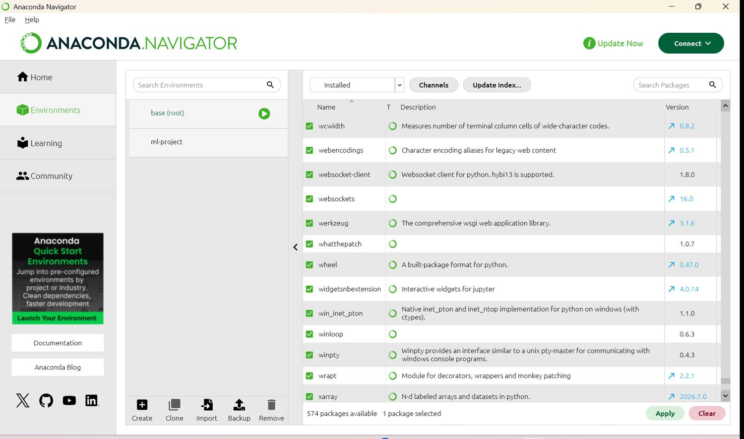
Figure 2: Anaconda Prompt - active environment and list of environments (screenshots, 1 page(s))
The asterisk (*) marks ml-project as the active environment.
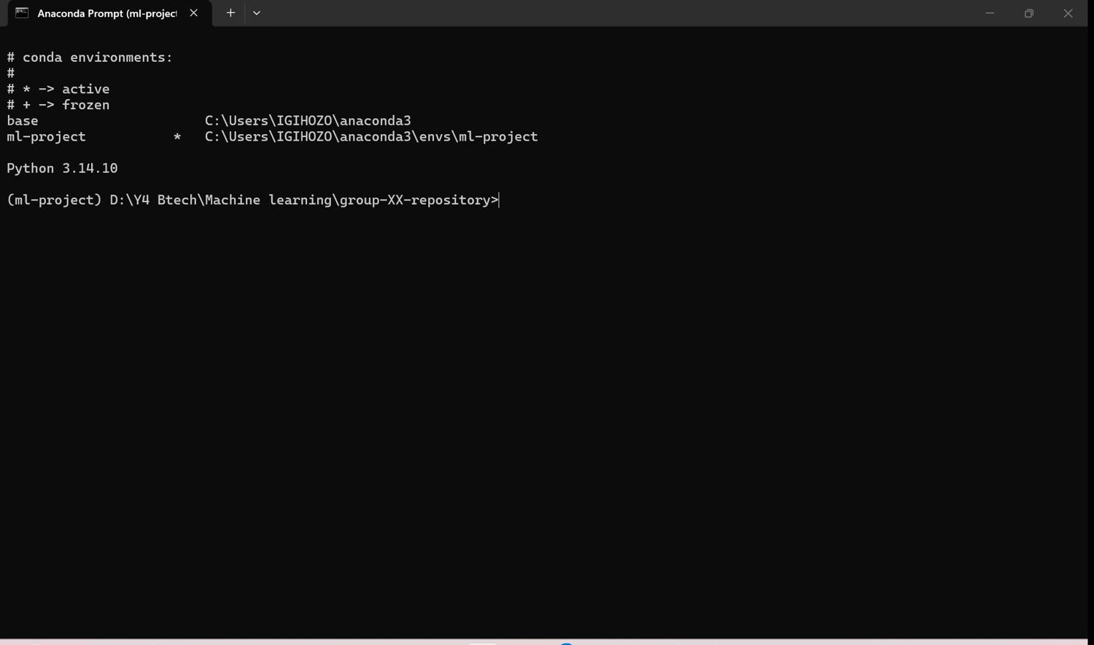
Figure 3: Library versions printed by 00_environment_check (screenshots, 2 page(s))
All five required libraries import without error; versions match environment.yml.
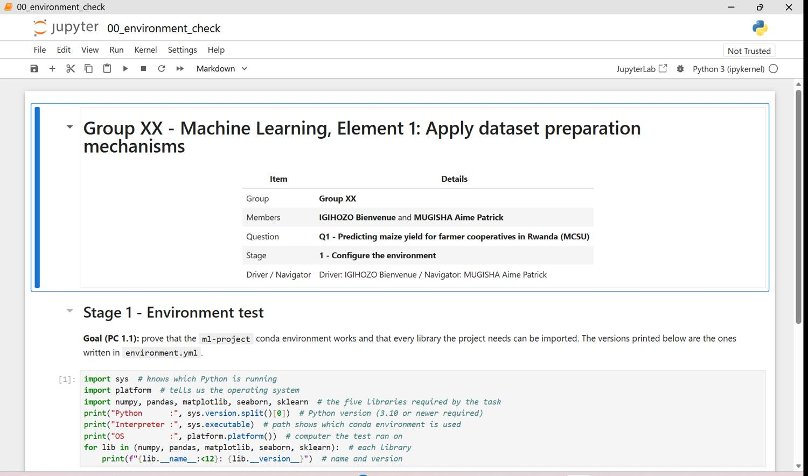
Figure 3.1 - q1 00 environment check p01
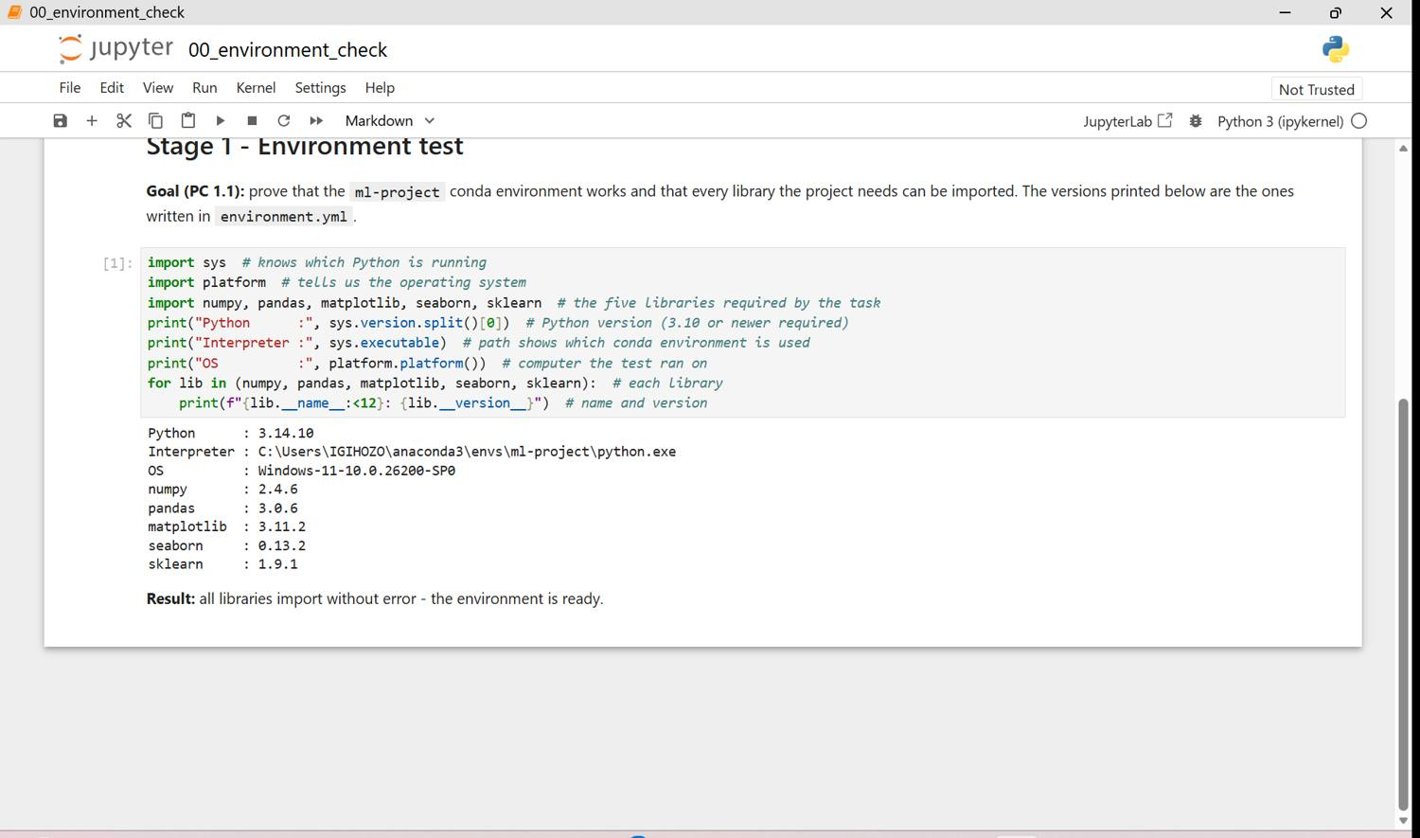
Figure 3.2 - q1 00 environment check p02

Stage 2 - Define requirements and acquire data (PC 1.2)
Data requirements, derived from Mr. Habimana's message and the five business questions:
Requirement | Decision
Target | yield_t_ha (regression, also given as yield_kg_ha); low_yield_risk = bottom 10 % of training yields (question E)
Unit of observation | one farm in one season
Features | province, district, altitude, season, year, farm area, seed variety, farming practice, NPK, urea, manure (per ha), plant density, rainfall, temperature, soil type and pH, pest index, irrigation
Must not be used | anything known only after harvest; statistics from validation/test data
Size | >= ~1,000 usable records

Check: 1,426 rows, all three seasons, 5 provinces, 30 districts, 2015-2024, fertiliser already per hectare, no post-harvest column. The file meets the requirements for questions A-E. It cannot support analysis per cooperative or by planting date (those columns do not exist).
Figure 4: Data requirements Markdown cell (01_acquire) (screenshots, 9 page(s))
Notebook 01_acquire in Jupyter: the data requirements, the loaded file (first/last rows, shape, info), the check against the requirements, the data dictionary and the source log. Finding: 1,426 x 20, types already correct, three columns with gaps. Decision: the file meets the requirements for questions A-E.
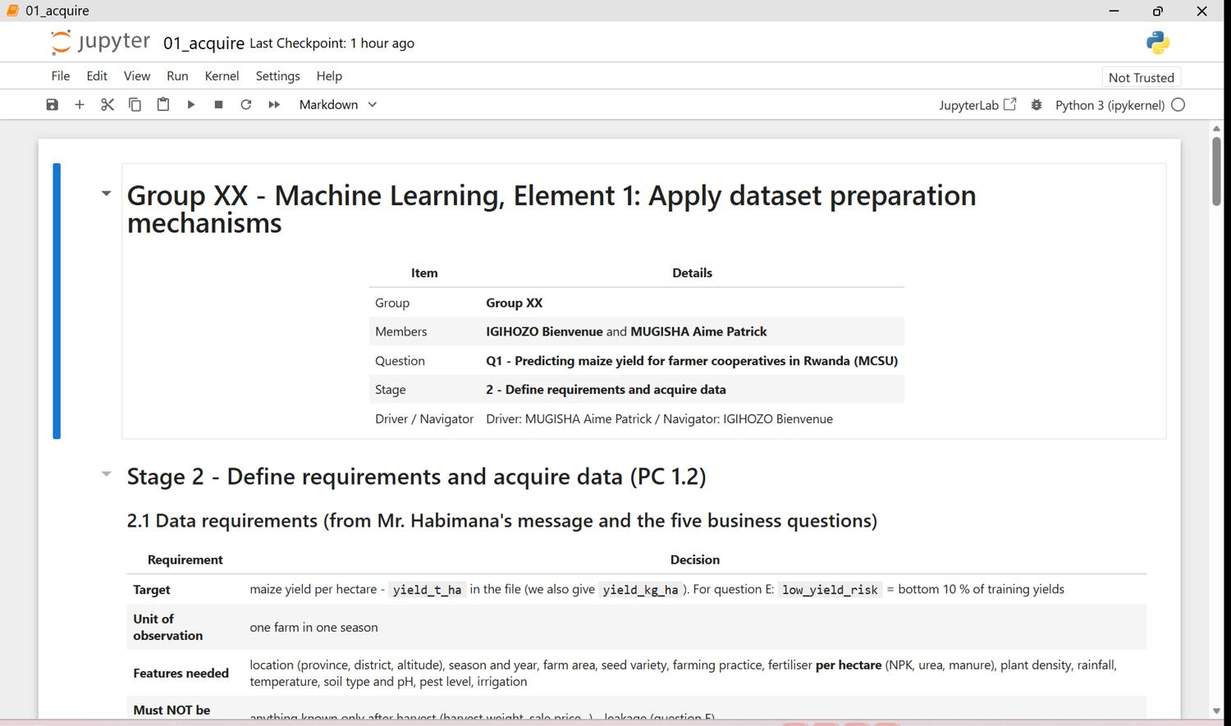
Figure 4.1 - q1 01 acquire p01
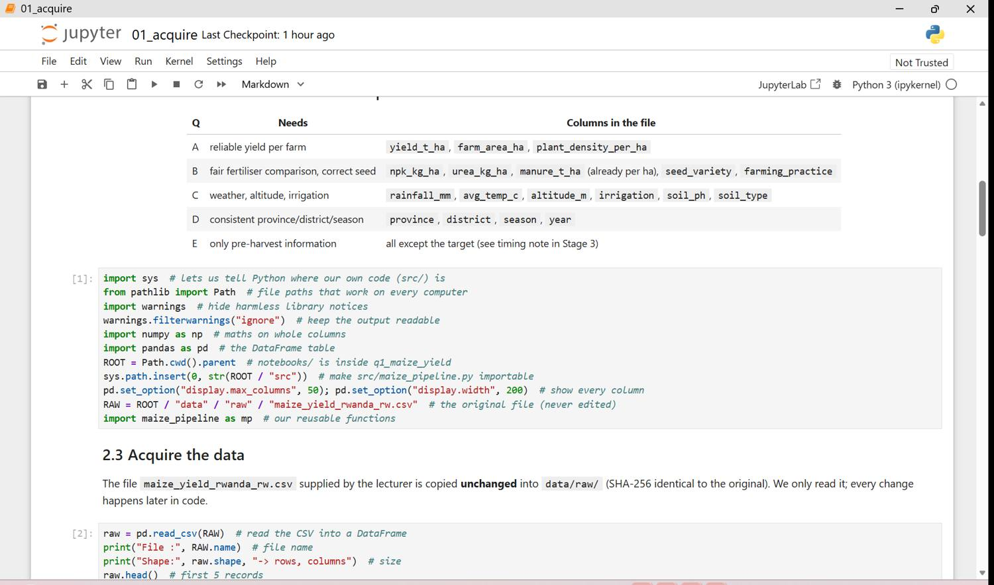
Figure 4.2 - q1 01 acquire p02
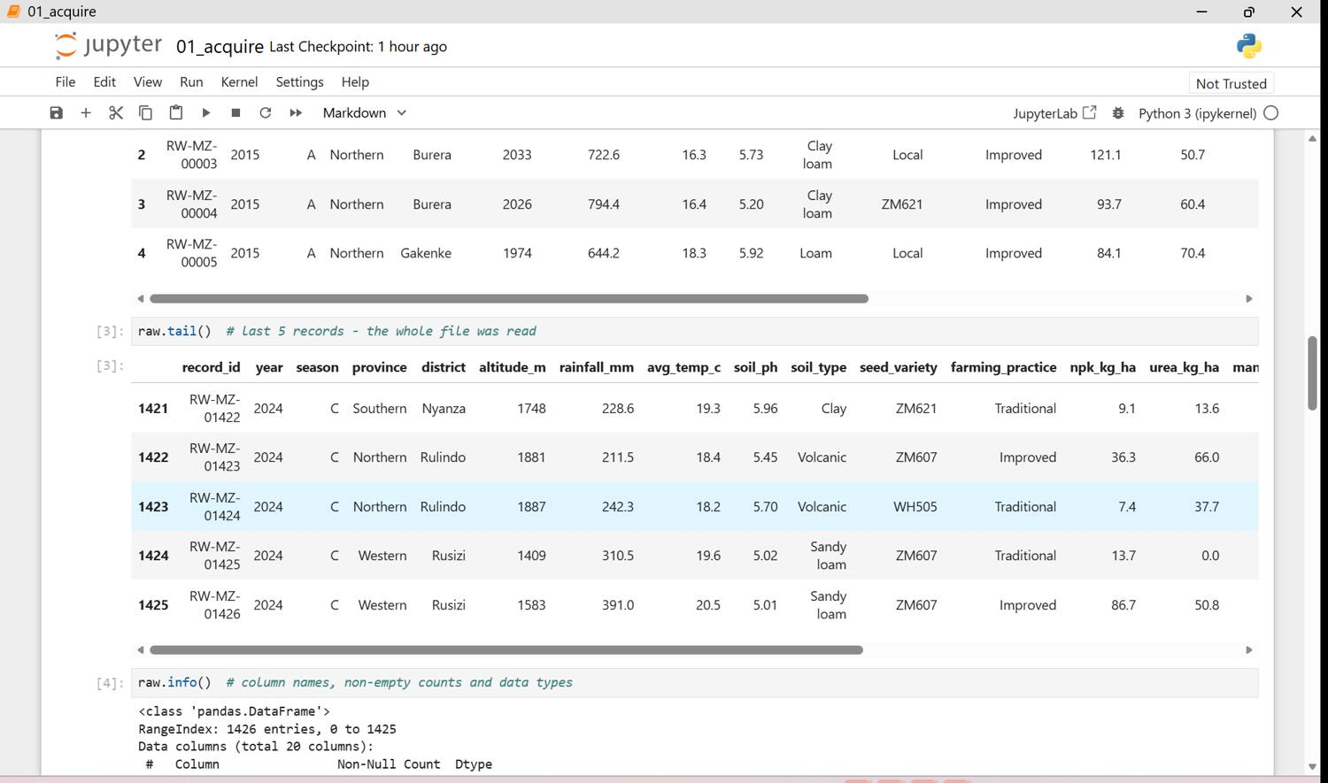
Figure 4.3 - q1 01 acquire p03
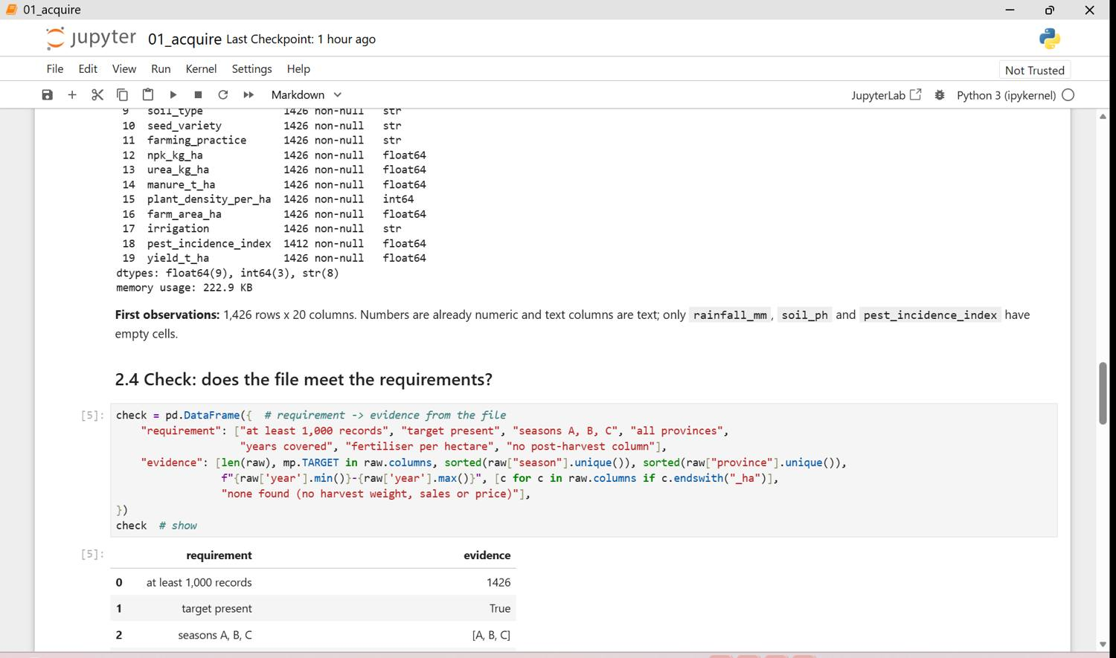
Figure 4.4 - q1 01 acquire p04
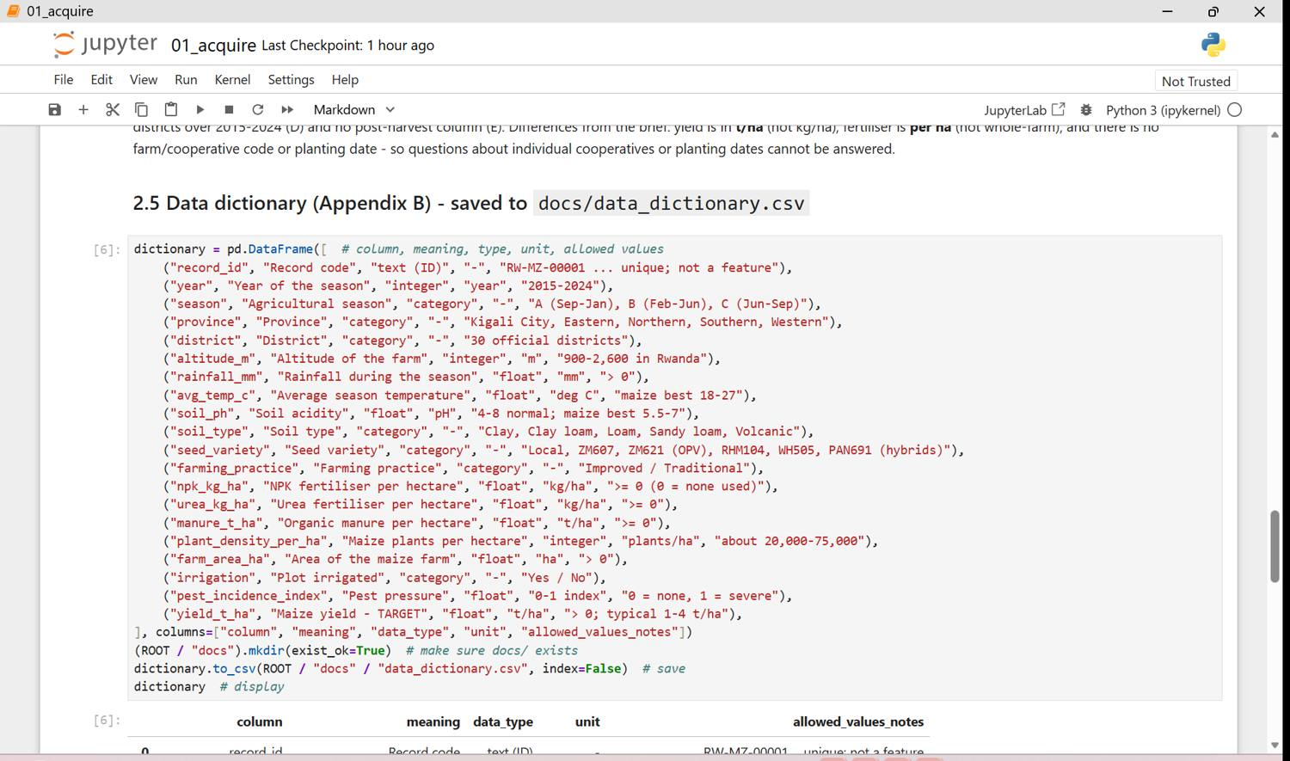
Figure 4.5 - q1 01 acquire p05
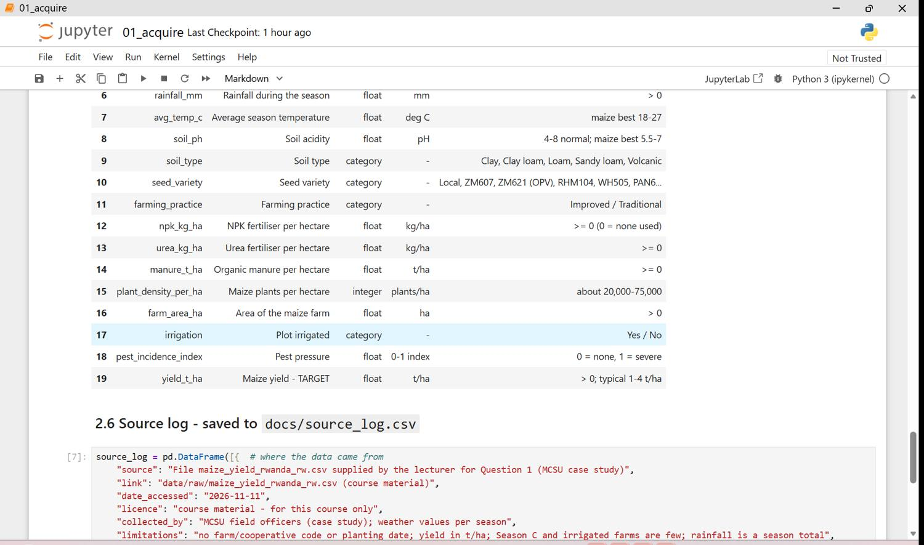
Figure 4.6 - q1 01 acquire p06
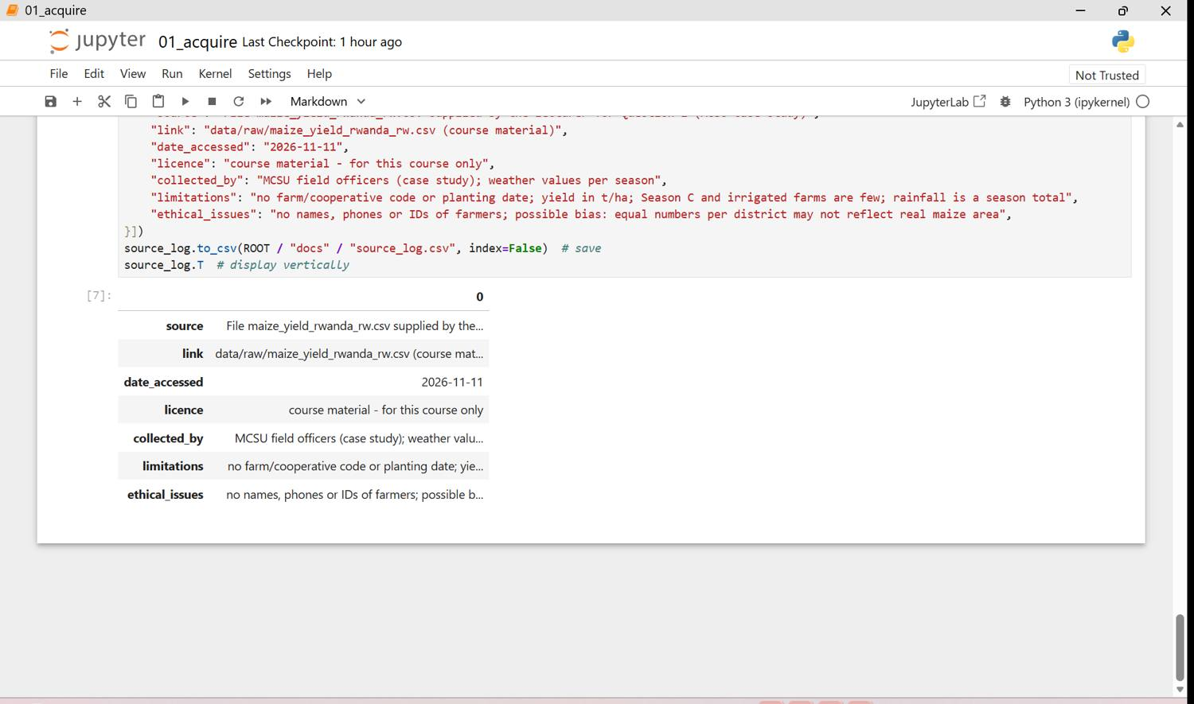
Figure 4.7 - q1 01 acquire p07
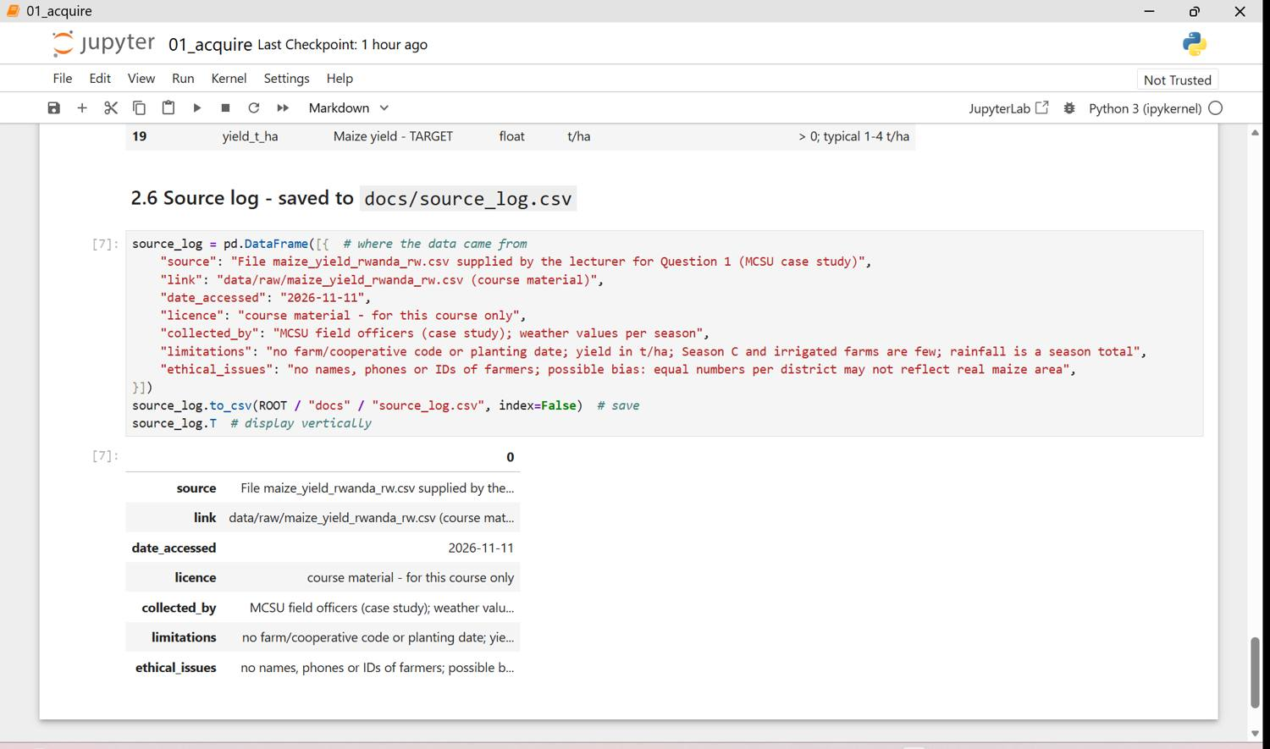
Figure 4.8 - q1 01 acquire p09
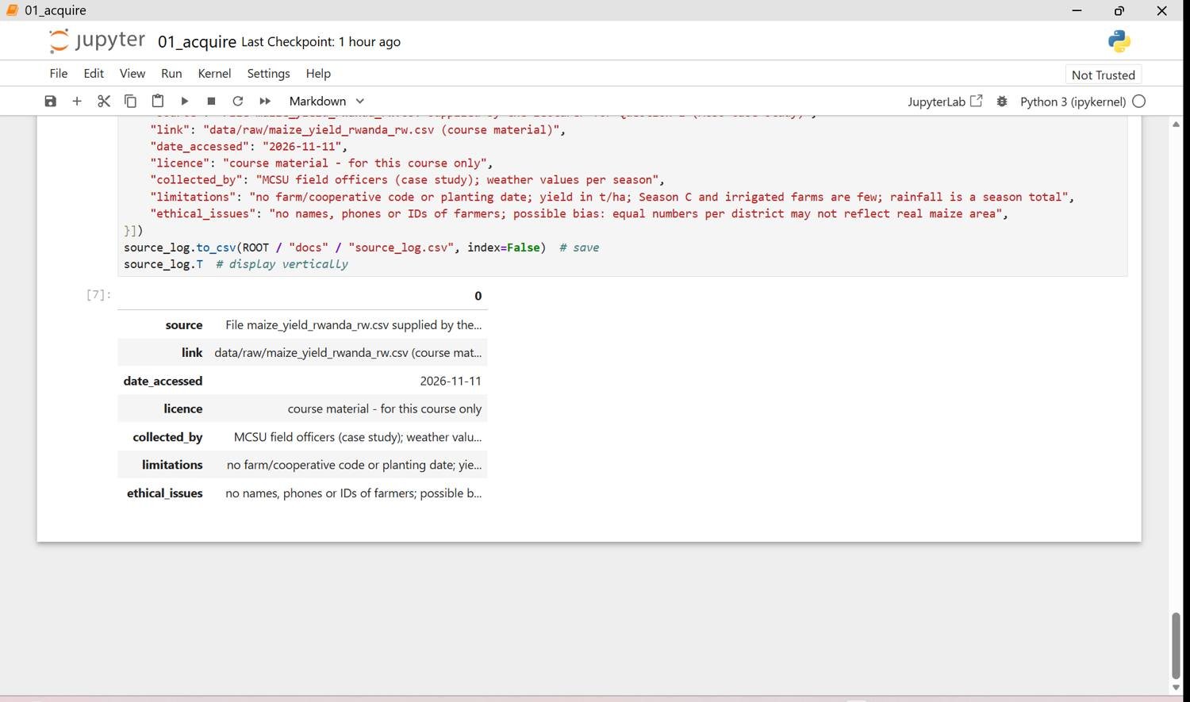
Figure 4.9 - q1 01 acquire p10
The completed data dictionary is in Appendix A and the source log in Appendix B.

Stage 3 - Explore and audit the data (PC 1.3)
We described the data, counted missing values and duplicates, checked every label against an allowed list and every district against its official province, compared every number with a realistic range, detected outliers with box plots and the IQR rule, studied the target and looked for leakage. The file is much cleaner than the brief suggests: no duplicates, no wrong labels and no impossible values. The Data Quality Report lists the 11 real issues found and the checks that found nothing.
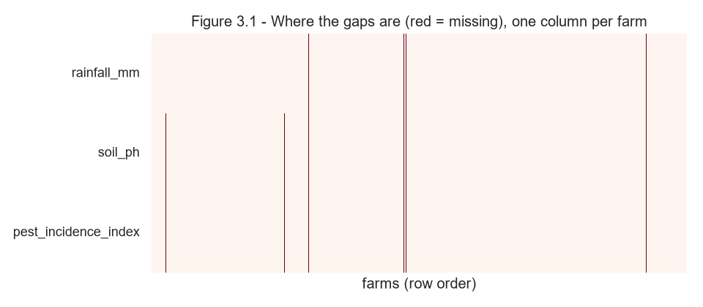
Figure 5: Where the missing values are
Only 39 cells are empty, but they sit together in 14 farms (no soil test, no pest scouting, no rain record). The farms are kept and the values imputed from the training set.
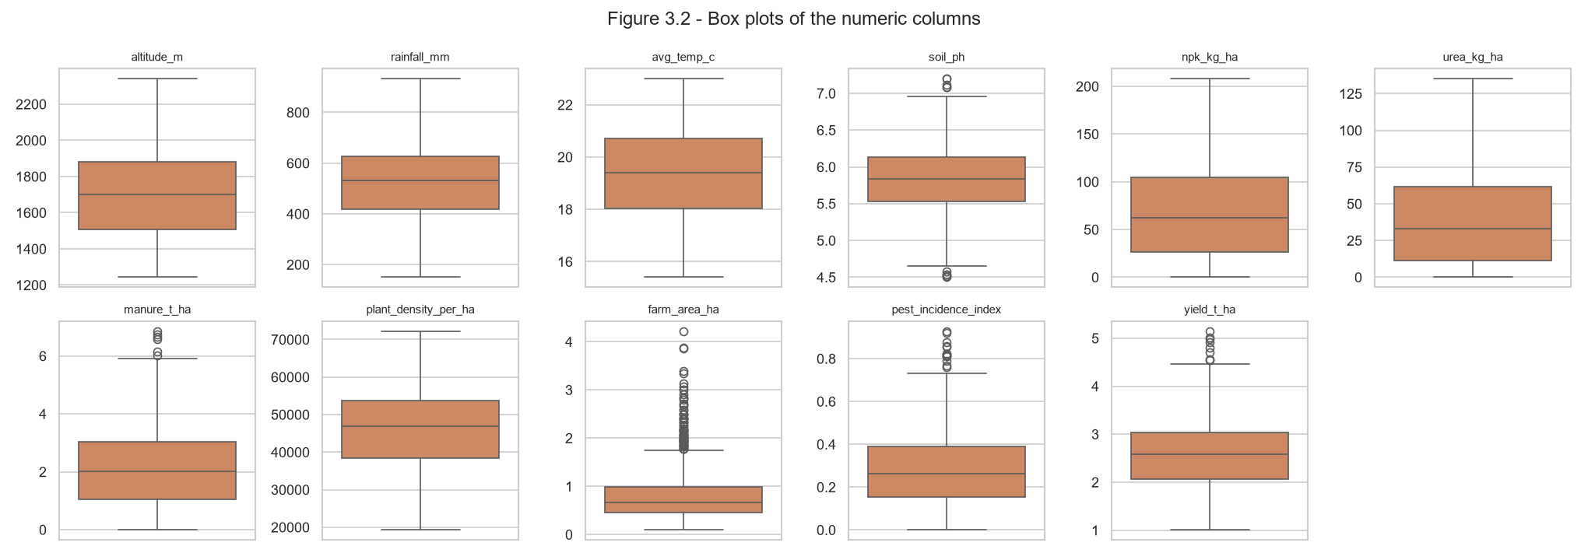
Figure 6: Box plots of the numeric columns
The IQR rule flags 112 values (mostly large farm areas) but none is outside a realistic range - they are real farms and are kept. Farm area is right-skewed.
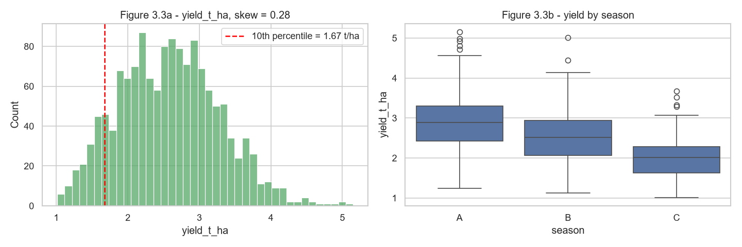
Figure 7: Distribution of the target and yield by season
Yield is almost symmetric around 2.6 t/ha (1.0-5.2). No farm is below 1,000 kg/ha, so 'very low harvest' is defined as the bottom 10 % of training farms (1.67 t/ha).
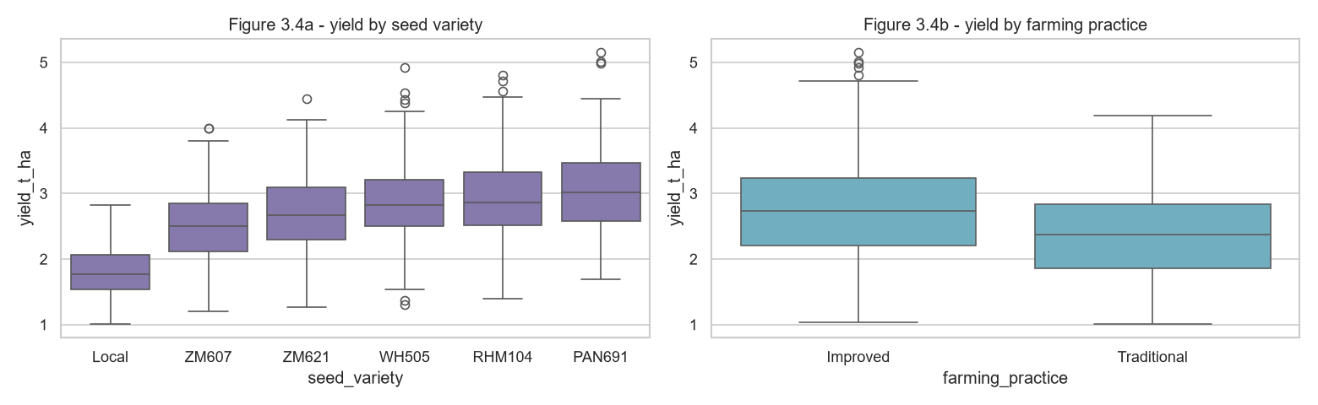
Figure 8: Yield by seed variety and farming practice
Local seed averages 1.8 t/ha against 3.06 t/ha for PAN691; improved practice yields more - question B can be answered.
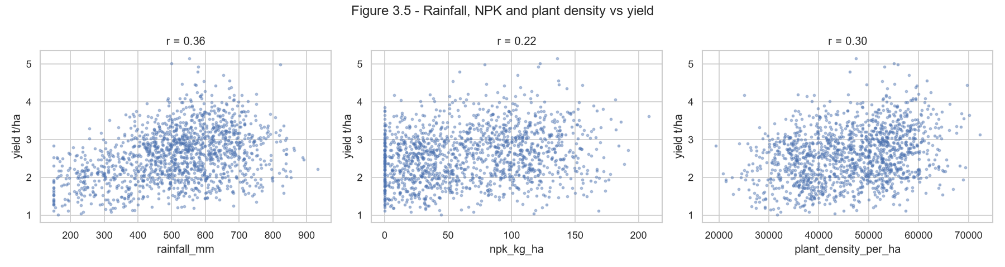
Figure 9: Rainfall, NPK and plant density against yield
All three raise yield but with wide scatter - yield depends on several factors together.
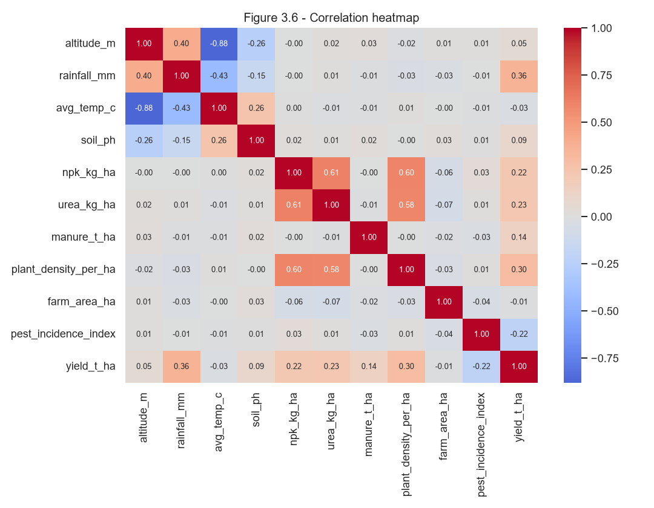
Figure 10: Correlation heatmap
Altitude and temperature are strongly linked (r = -0.88). No column is suspiciously close to the target, so there is no hidden post-harvest column. Season rainfall and temperature are only fully known at season end - a timing risk for early warning (question E).
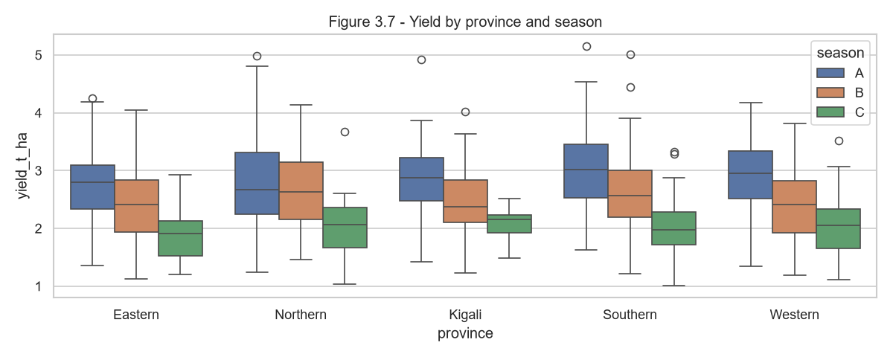
Figure 11: Yield by province and season
Differences between provinces and seasons are visible - question D can be answered.
Figure 12: Missing values, duplicate count and summary statistics (screenshots, 12 page(s))
Notebook 02_eda in Jupyter: summary statistics, missing values and duplicates, consistency checks, box plots and IQR table, target and relationship charts, and the Data Quality Report. Finding: 39 empty cells in 14 farms, no duplicates, no invalid labels or values; outliers are real farms. Decision: keep all rows, impute on train only.
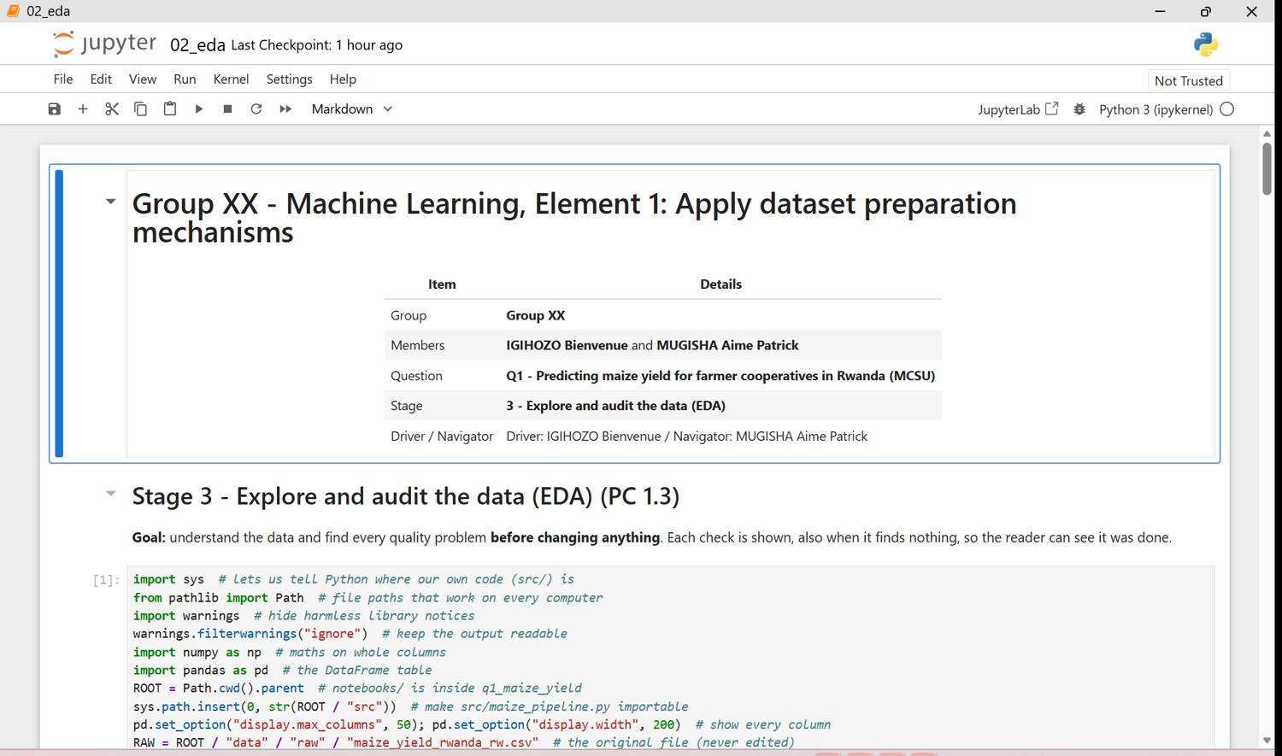
Figure 12.1 - q1 02 eda p01
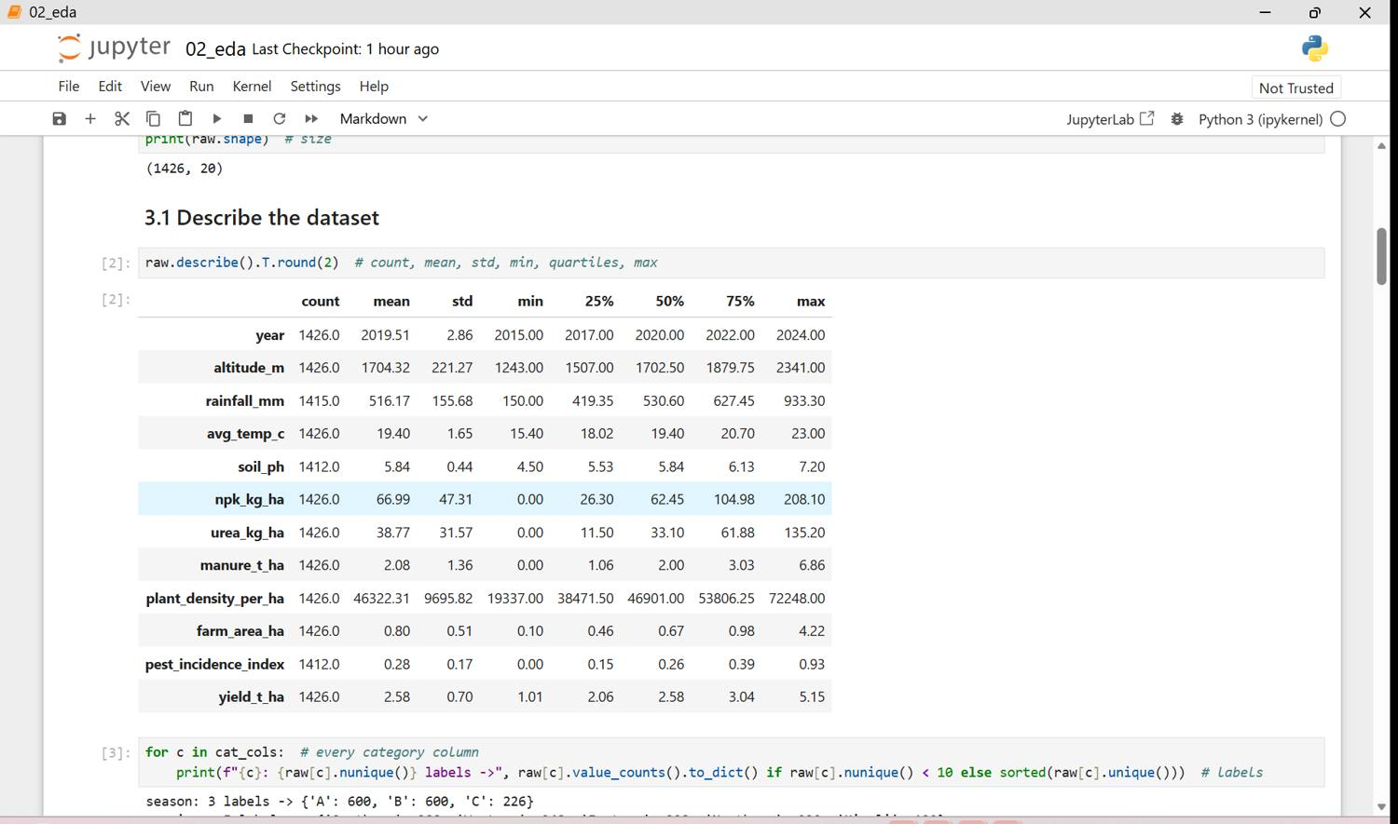
Figure 12.2 - q1 02 eda p02
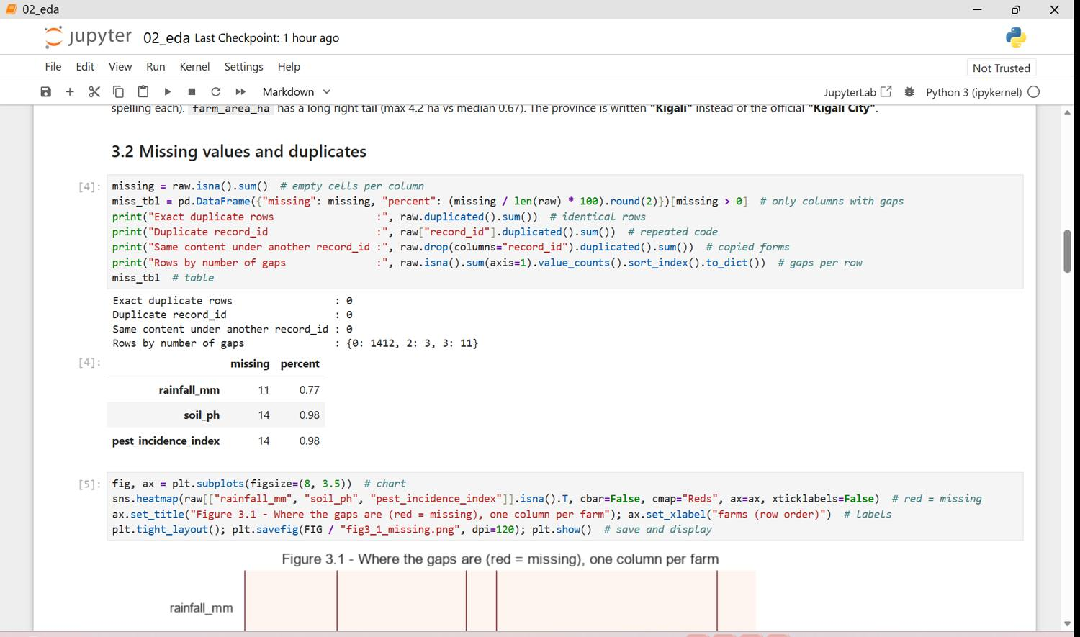
Figure 12.3 - q1 02 eda p03
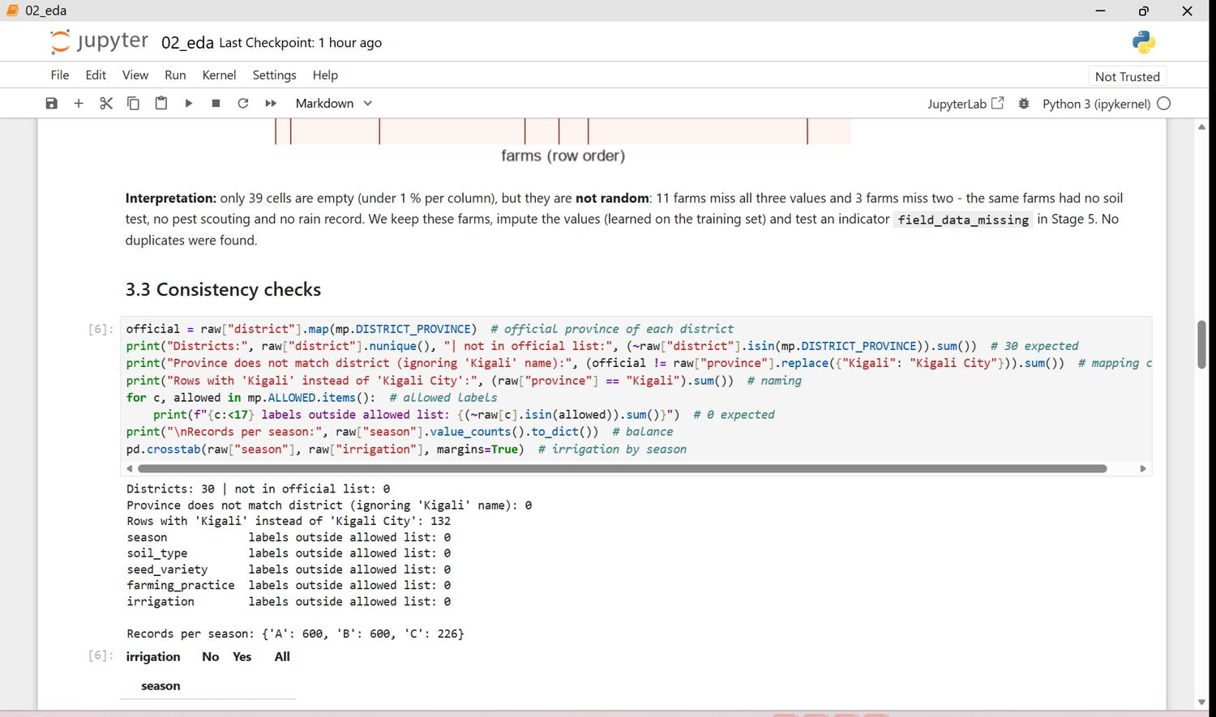
Figure 12.4 - q1 02 eda p04
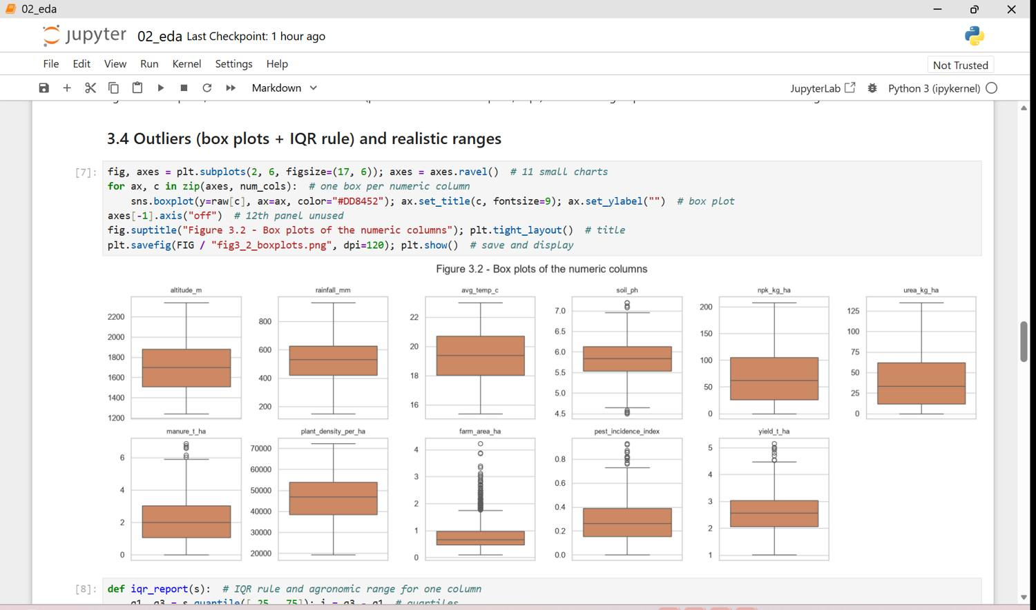
Figure 12.5 - q1 02 eda p05
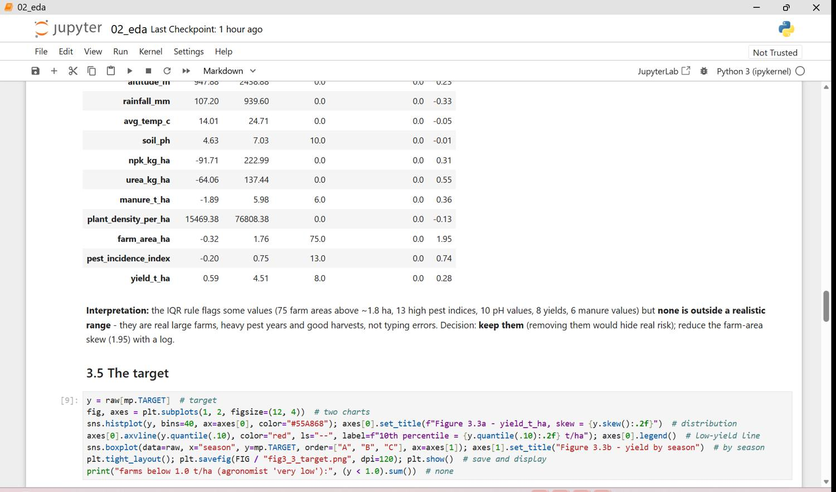
Figure 12.6 - q1 02 eda p06
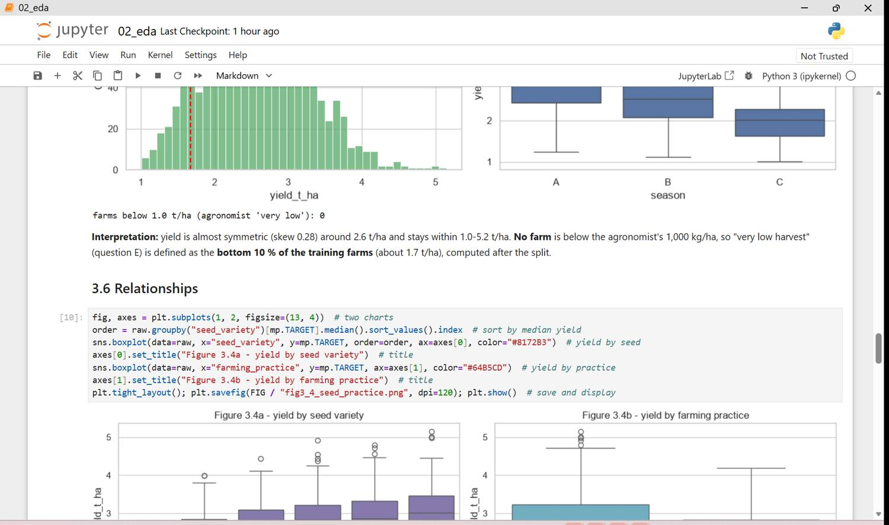
Figure 12.7 - q1 02 eda p07
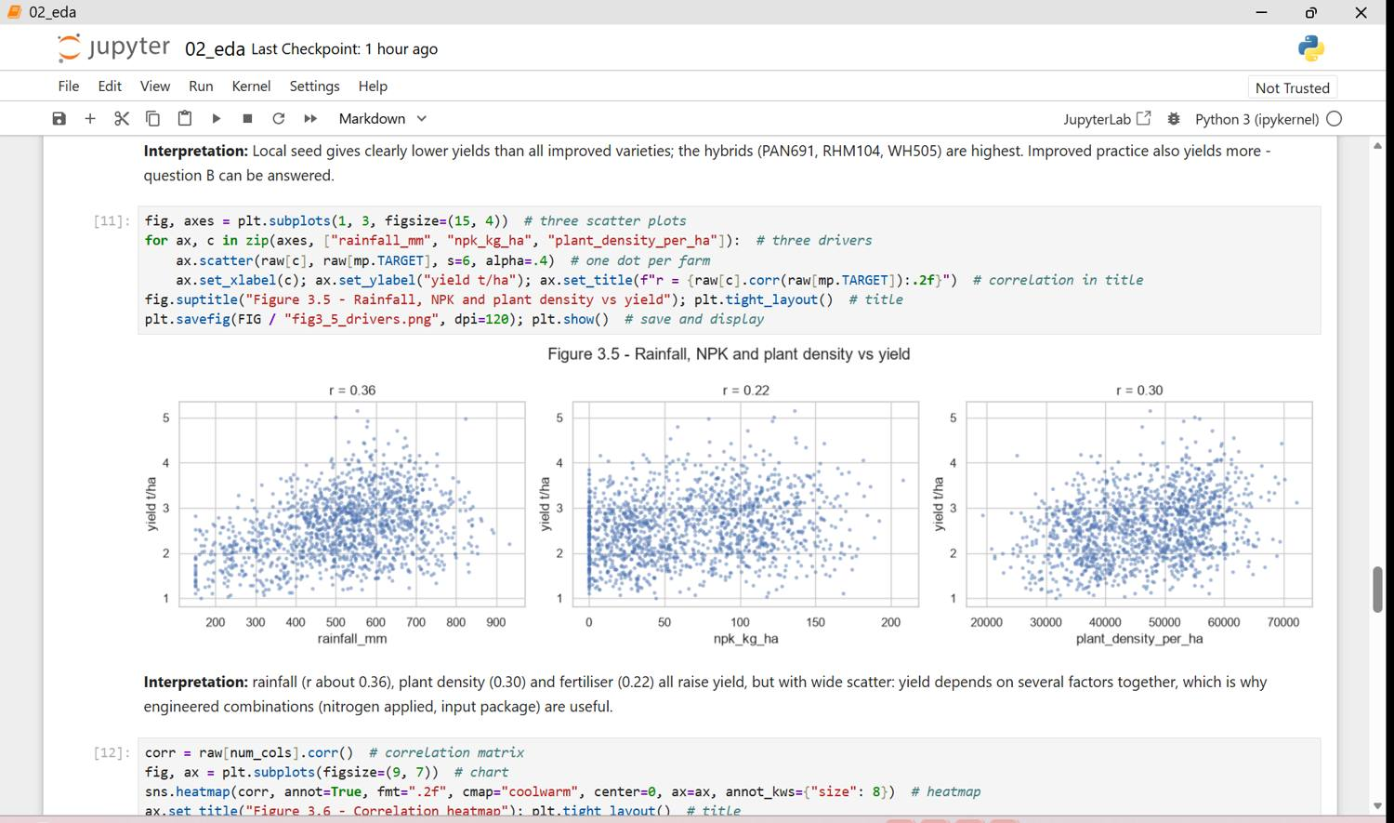
Figure 12.8 - q1 02 eda p08
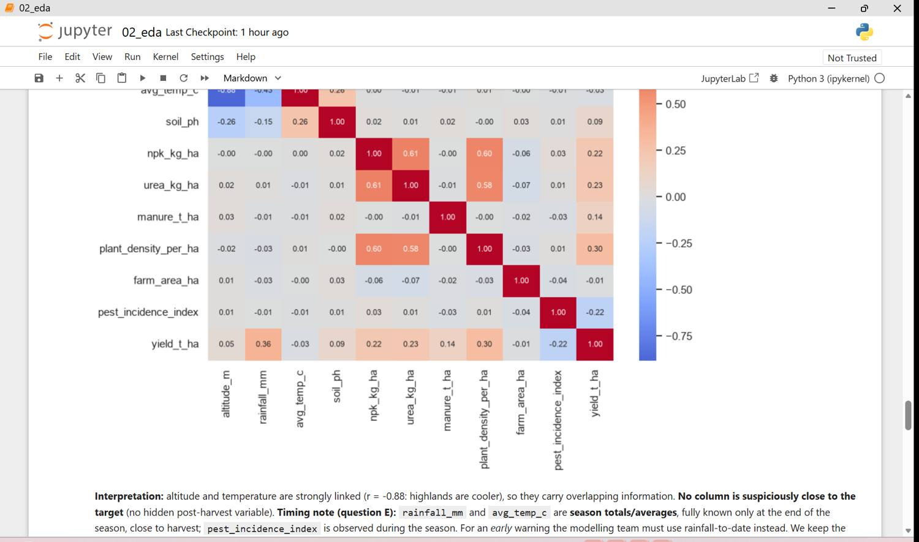
Figure 12.9 - q1 02 eda p09
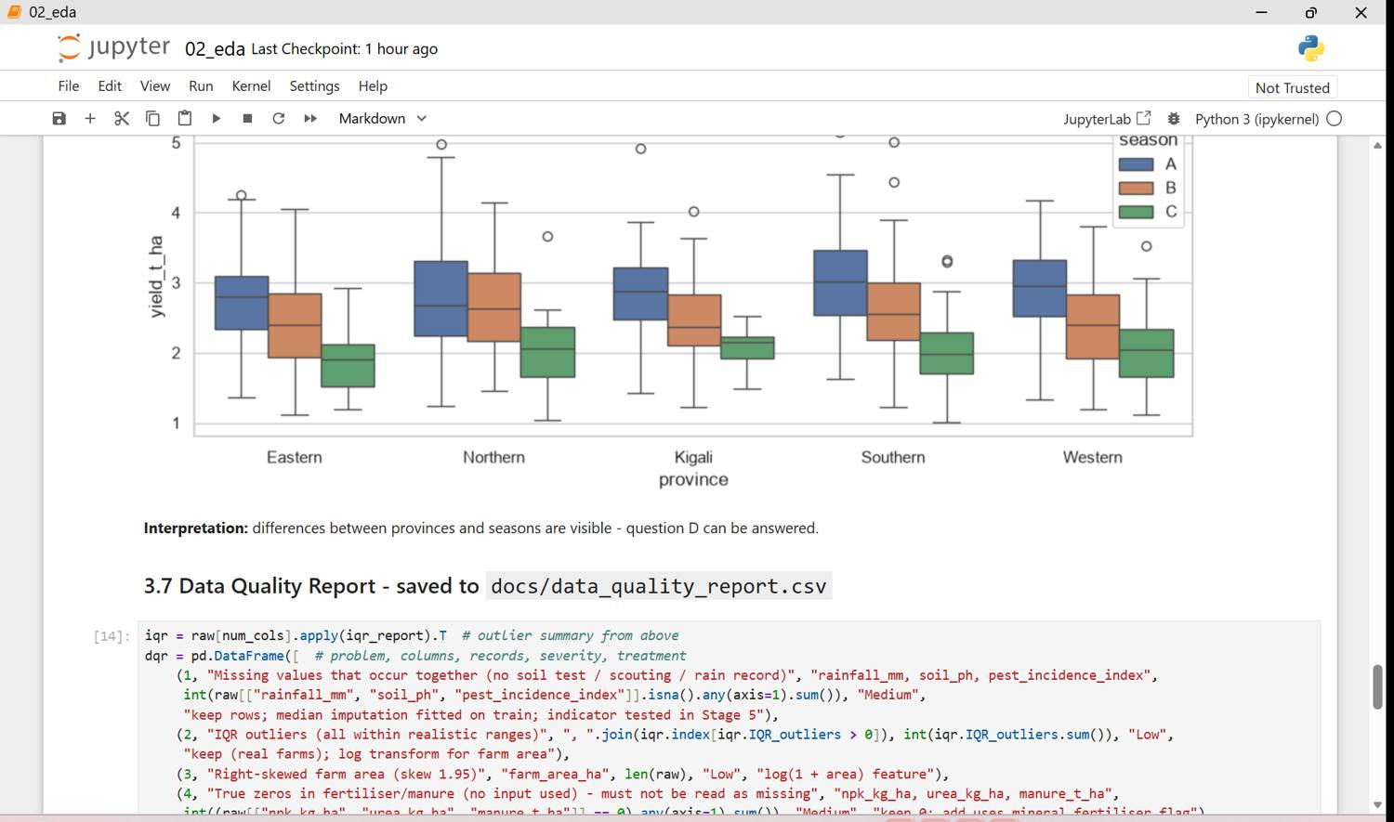
Figure 12.10 - q1 02 eda p10
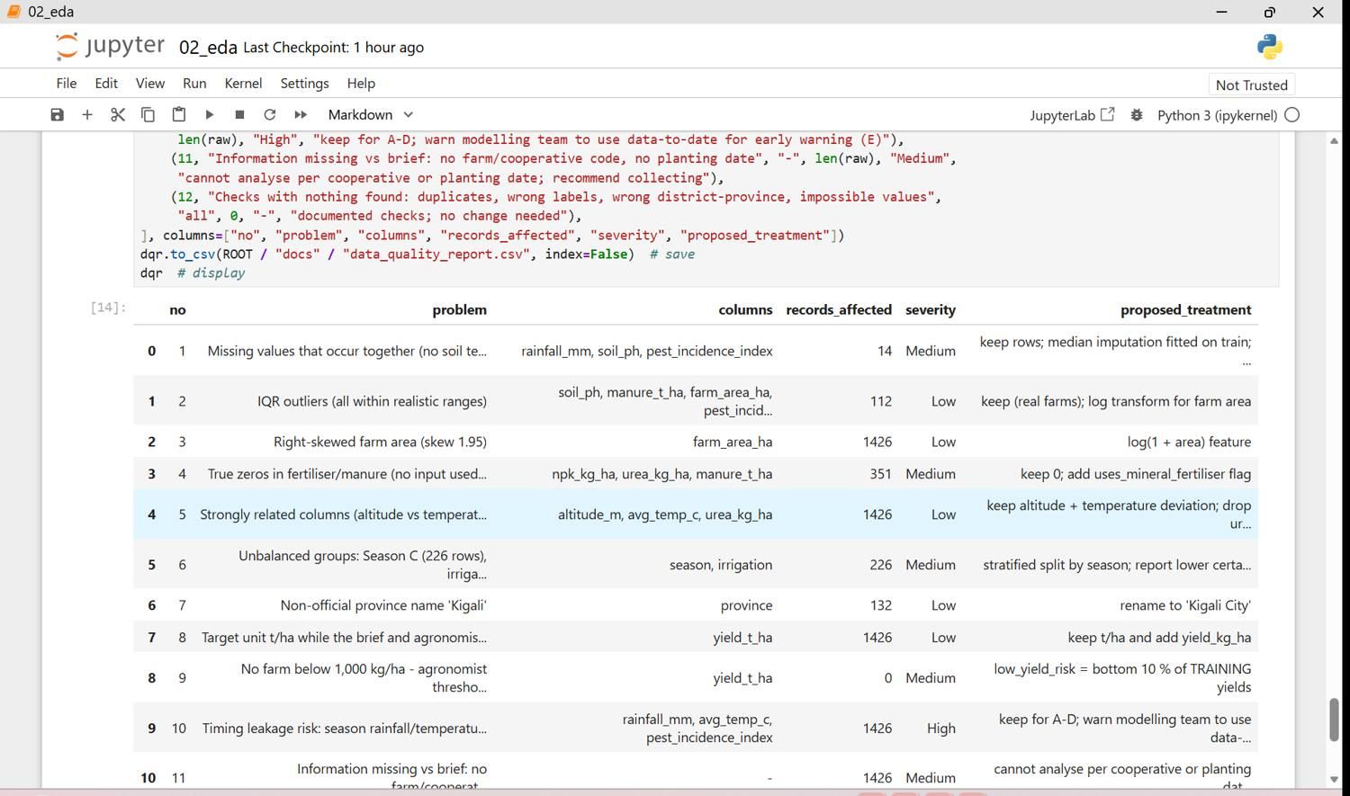
Figure 12.11 - q1 02 eda p11
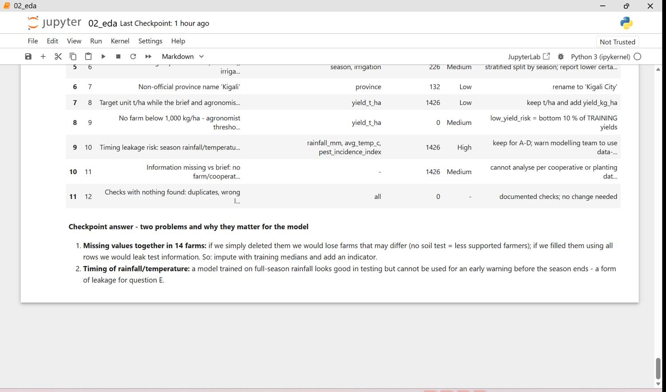
Figure 12.12 - q1 02 eda p12

Data Quality Report
no | problem | columns | records | severity | proposed_treatment
1 | Missing values that occur together (no soil test / scouting / rain record) | rainfall_mm, soil_ph, pest_incidence_index | 14 | Medium | keep rows; median imputation fitted on train; indicator tested in Stage 5
2 | IQR outliers (all within realistic ranges) | soil_ph, manure_t_ha, farm_area_ha, pest_incidence_index, yield_t_ha | 112 | Low | keep (real farms); log transform for farm area
3 | Right-skewed farm area (skew 1.95) | farm_area_ha | 1426 | Low | log(1 + area) feature
4 | True zeros in fertiliser/manure (no input used) - must not be read as missing | npk_kg_ha, urea_kg_ha, manure_t_ha | 351 | Medium | keep 0; add uses_mineral_fertiliser flag
5 | Strongly related columns (altitude vs temperature r = -0.88; NPK/urea vs nitrogen) | altitude_m, avg_temp_c, urea_kg_ha | 1426 | Low | keep altitude + temperature deviation; drop urea after creating nitrogen feature
6 | Unbalanced groups: Season C (226 rows), irrigated farms (128) | season, irrigation | 226 | Medium | stratified split by season; report lower certainty
7 | Non-official province name 'Kigali' | province | 132 | Low | rename to 'Kigali City'
8 | Target unit t/ha while the brief and agronomist use kg/ha | yield_t_ha | 1426 | Low | keep t/ha and add yield_kg_ha
9 | No farm below 1,000 kg/ha - agronomist threshold cannot define 'very low' | yield_t_ha | 0 | Medium | low_yield_risk = bottom 10 % of TRAINING yields
10 | Timing leakage risk: season rainfall/temperature known only at season end | rainfall_mm, avg_temp_c, pest_incidence_index | 1426 | High | keep for A-D; warn modelling team to use data-to-date for early warning (E)
11 | Information missing vs brief: no farm/cooperative code, no planting date | - | 1426 | Medium | cannot analyse per cooperative or planting date; recommend collecting
12 | Checks with nothing found: duplicates, wrong labels, wrong district-province, impossible values | all | 0 | - | documented checks; no change needed

Stage 4 - Clean and pre-process the data (PC 1.3)
All steps are reusable functions in src/maize_pipeline.py (clean_maize runs them in order); the raw file is never edited. The cleaning log has 28 entries, including checks that changed nothing. The clean dataset keeps all 1,426 rows.
Problem | Treatment
Duplicates | checked by record_id and by content - none found
Categories | all labels valid; district-province pairs valid; 'Kigali' renamed to the official 'Kigali City' (132 rows)
Ranges | every number checked against a realistic range - none outside
Missing values | rows kept; numeric median imputation learned on the training set only (inside the Pipeline)
Outliers | IQR outliers kept (real farms); farm area log-transformed in Stage 5
Target | all present and realistic; yield_kg_ha added (= t/ha x 1,000)
Encoding | season, district, soil type, seed variety/class, practice, altitude zone one-hot encoded
Scaling | StandardScaler on numeric columns (mean 0, std 1) - fitted on train only
Split | 70 / 15 / 15 train / validation / test, random_state = 42, stratified by season (keeps Season C in all files)
Imbalance | low_yield_risk about 10 % positives - planned remedy class_weight='balanced'

split | rows | columns
train | 998 | 72
val | 214 | 72
test | 214 | 72

Figure 13: Cleaning steps with before/after views (screenshots, 7 page(s))
Notebook 03_clean in Jupyter: every cleaning step with before/after views, the reproducibility check, the cleaning log, the 70/15/15 split stratified by season, and the imputation/encoding/scaling pipeline fitted on train only.
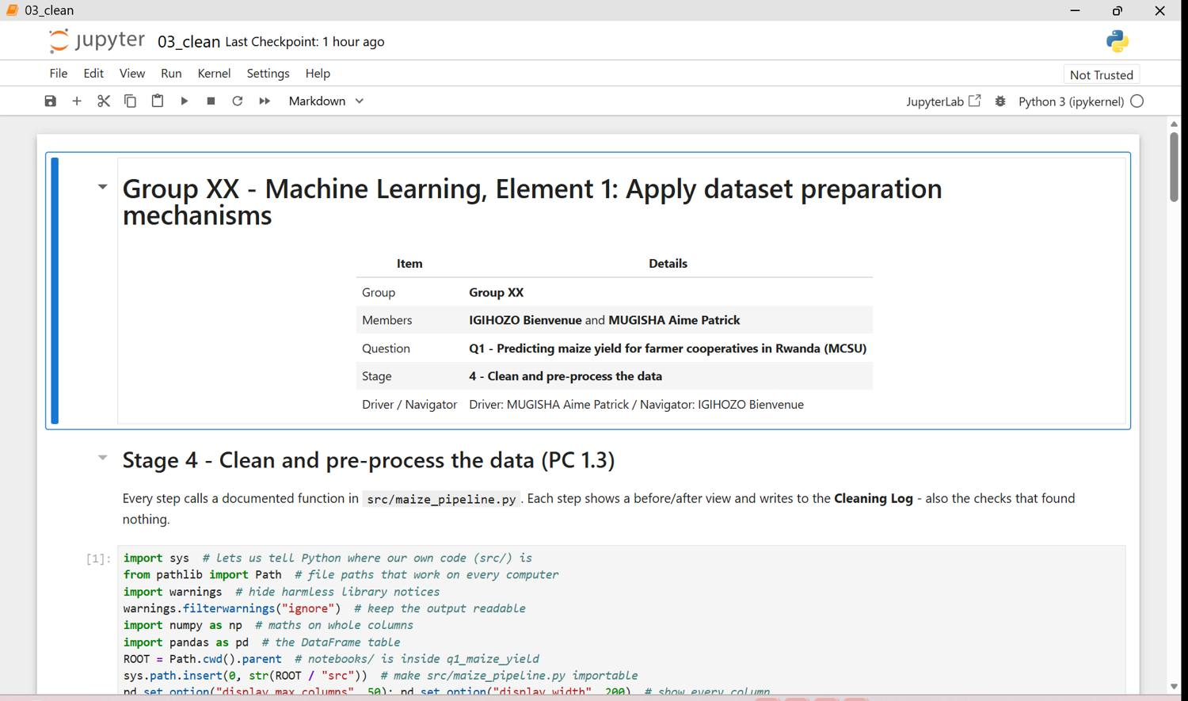
Figure 13.1 - q1 03 clean p01
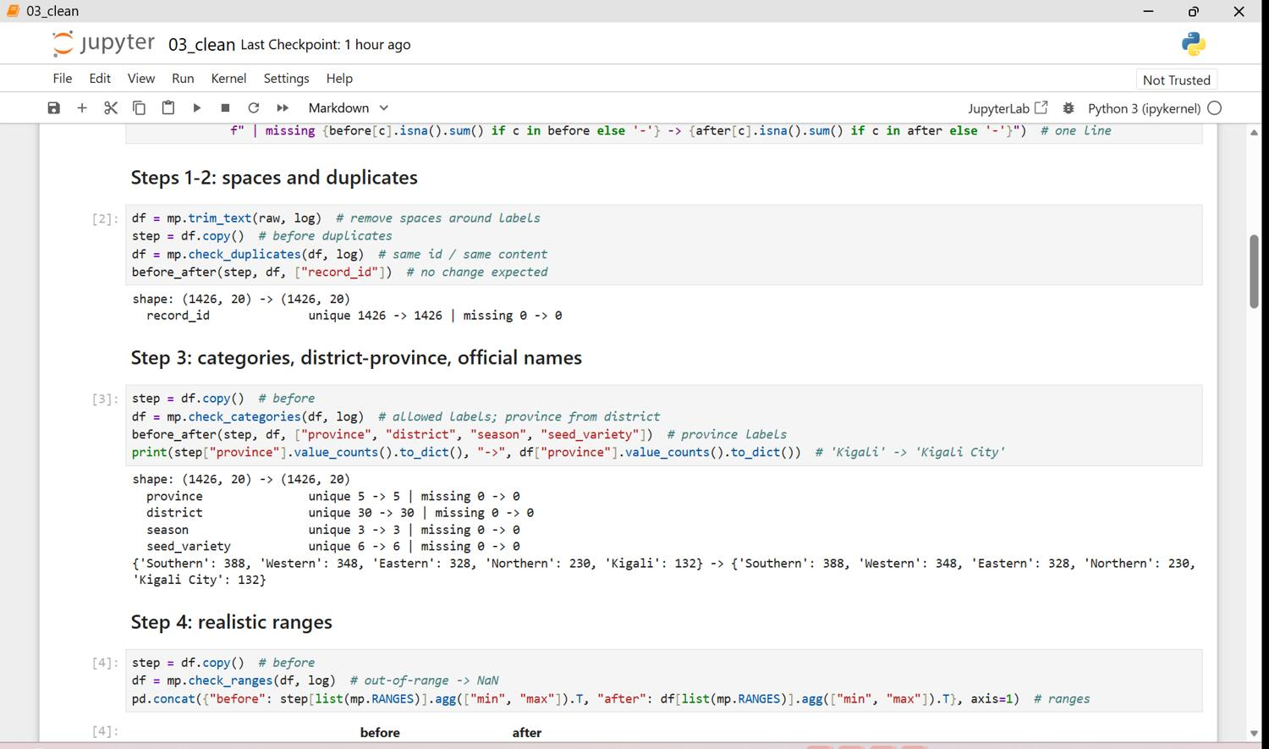
Figure 13.2 - q1 03 clean p02
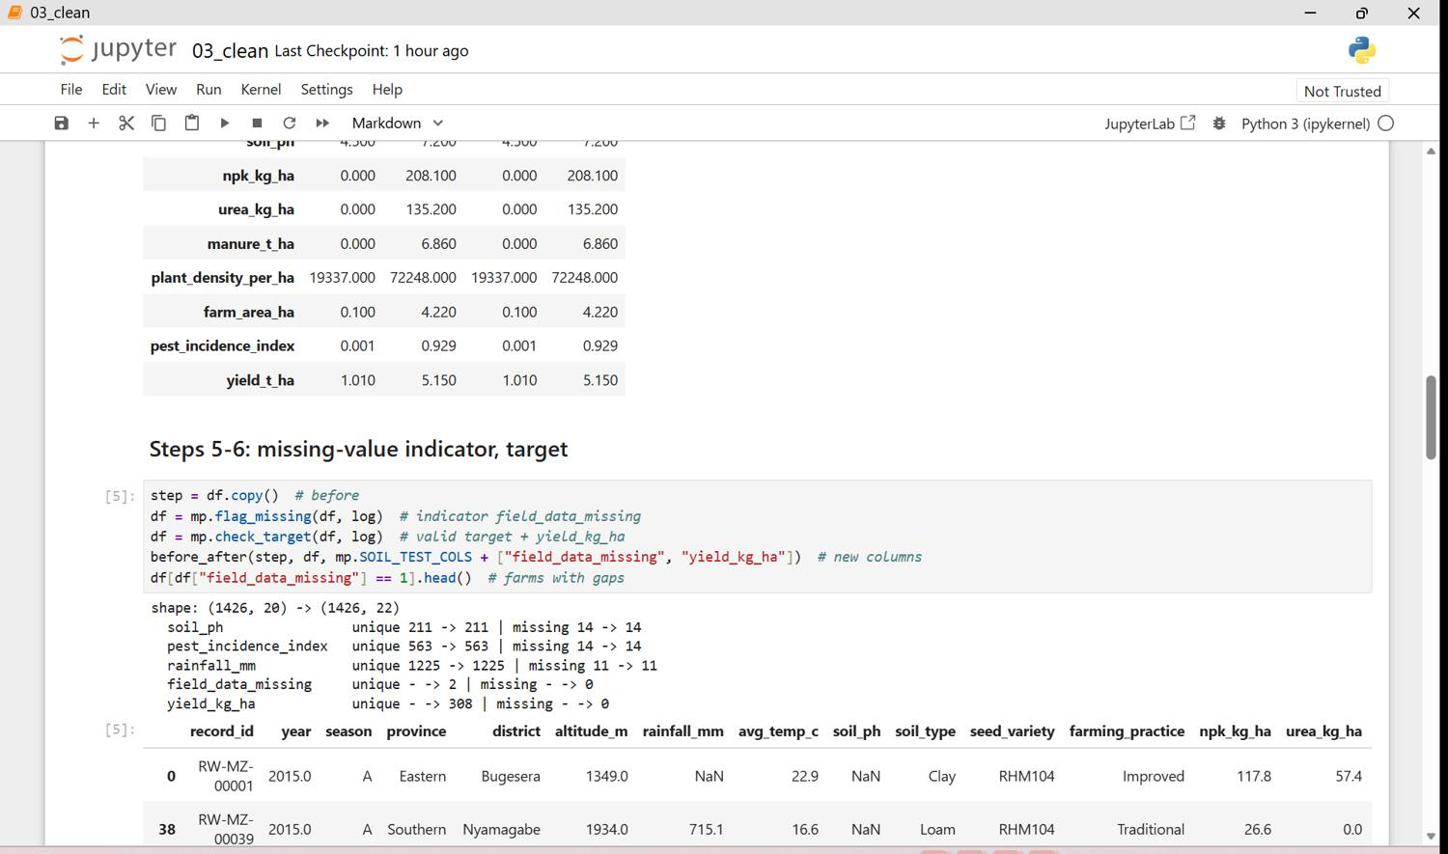
Figure 13.3 - q1 03 clean p03
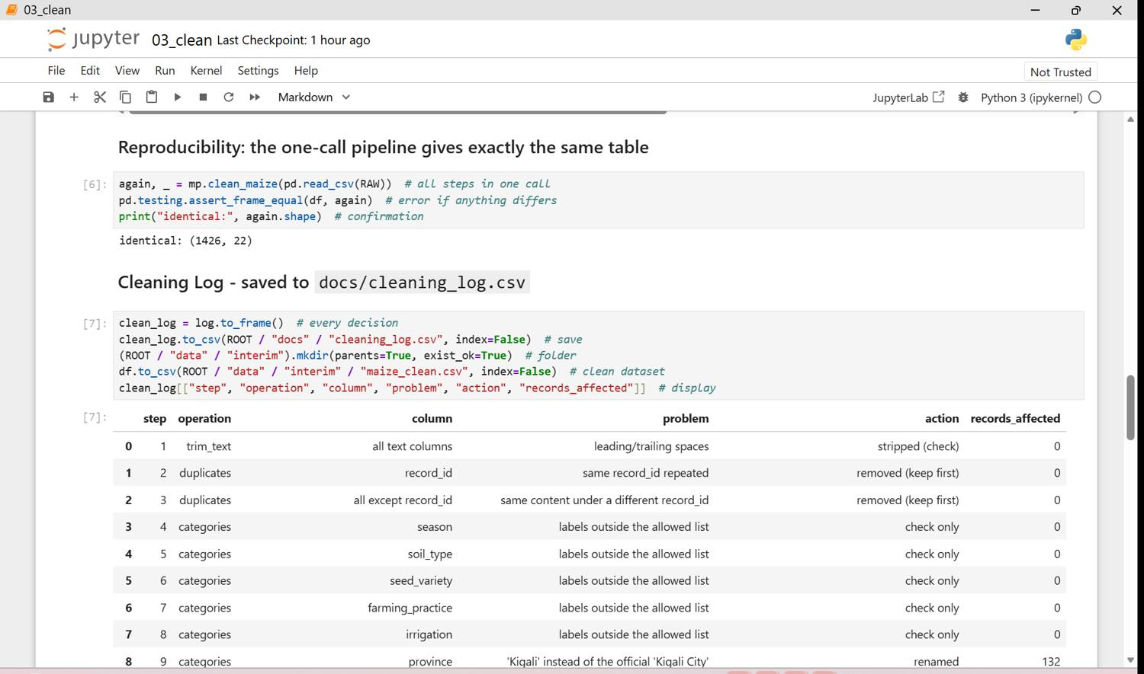
Figure 13.4 - q1 03 clean p04
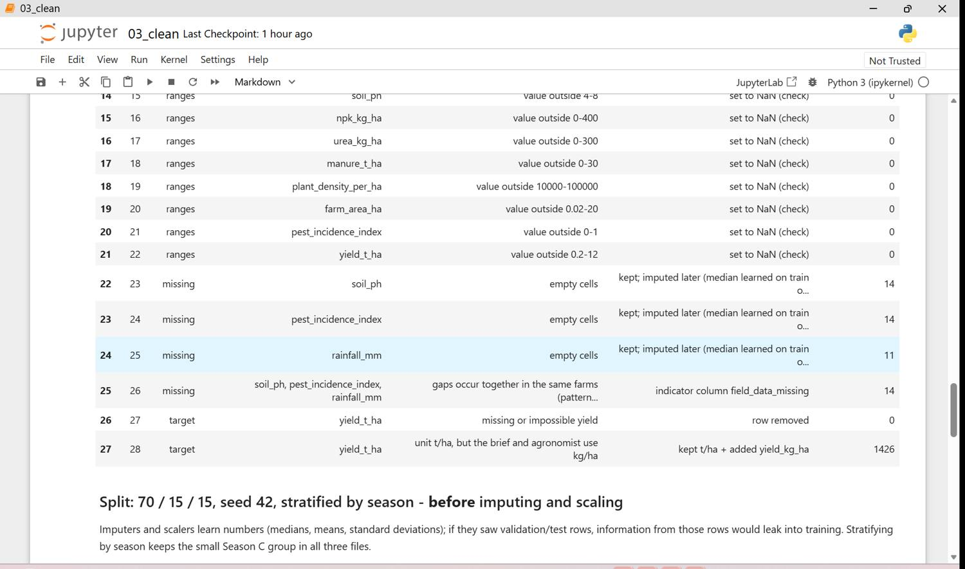
Figure 13.5 - q1 03 clean p05
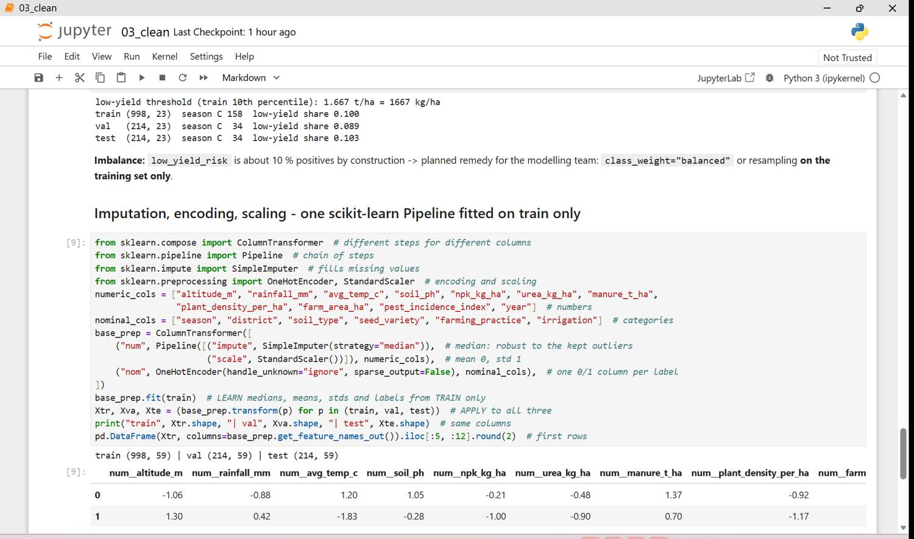
Figure 13.6 - q1 03 clean p06
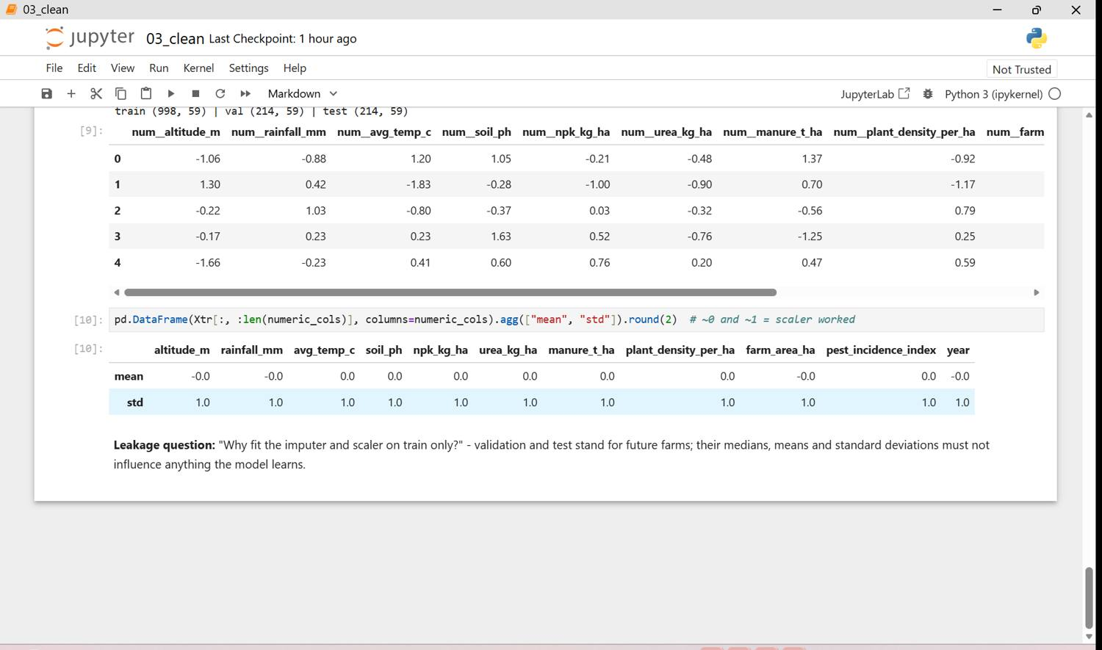
Figure 13.7 - q1 03 clean p07
The full cleaning log is in Appendix C.

Stage 5 - Engineer and select features (PC 1.4)
Ten new features were created with add_features() using only values of the same row (no leakage between splits). Relationships were measured on the training set only (correlation, mutual information, Random Forest importance). Selection used a variance threshold, removal of duplicated information (|r| > 0.9, province vs district) and the model-based evidence.
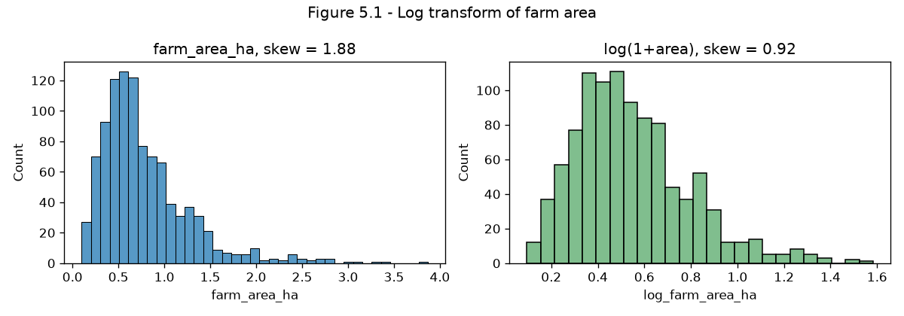
Figure 14: Log transformation of farm area
log(1 + area) halves the skewness.
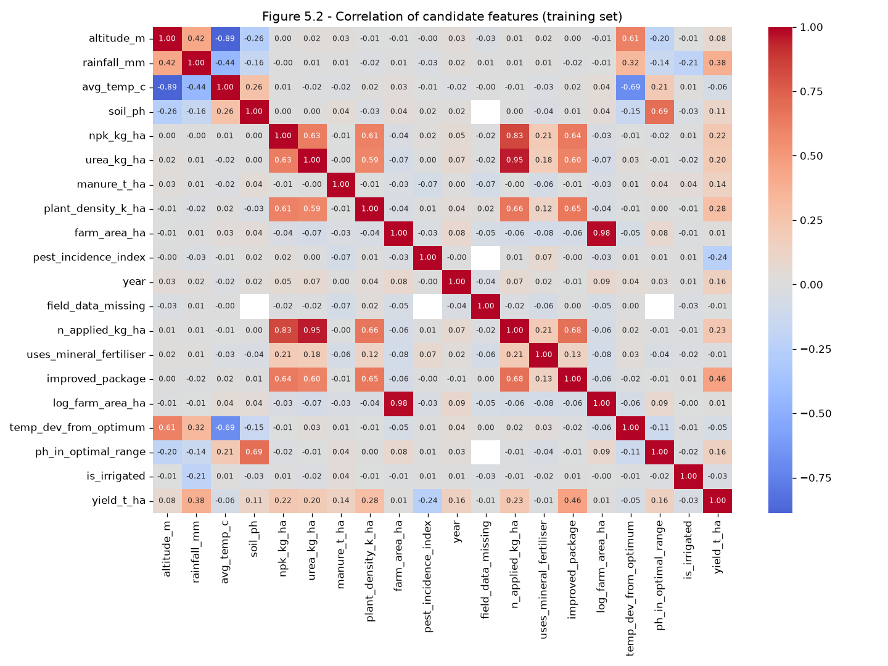
Figure 15: Correlation of candidate features (training set)
The improved seed + practice package (r = 0.46) and rainfall (0.39) relate most to yield; urea and nitrogen applied carry the same information (r = 0.95).
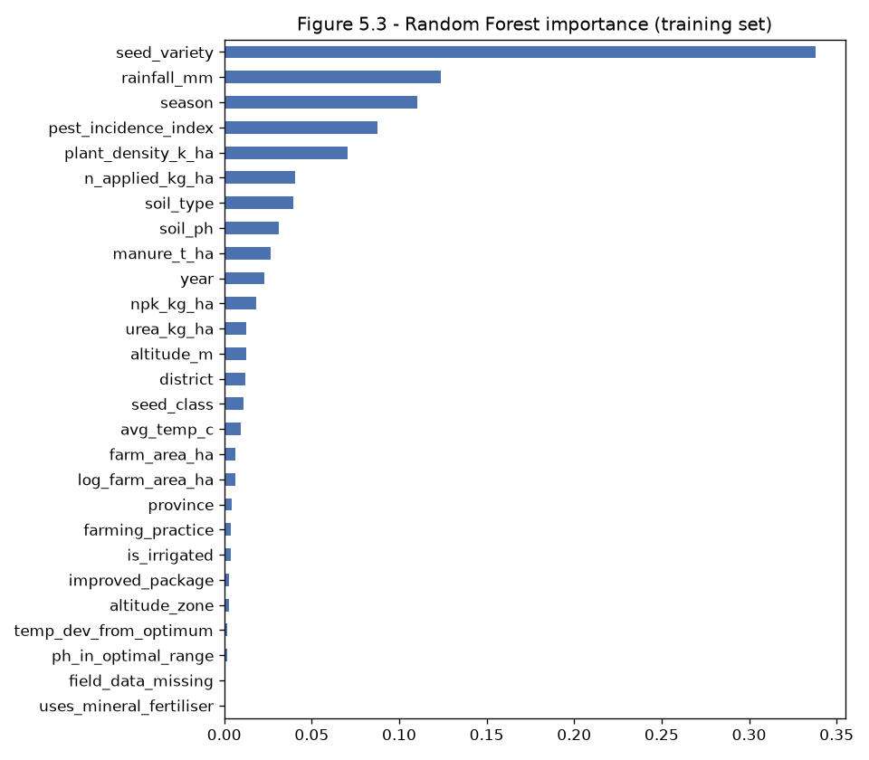
Figure 16: Random Forest importance (training set)
Seed variety, rainfall, season, pest pressure and plant density carry most of the information.
Final model-ready files contain 68 encoded input columns plus record_id and the targets yield_t_ha, yield_kg_ha and low_yield_risk. The Feature Justification table is in Appendix D.
Figure 17: New features, importance output and final feature list (screenshots, 13 page(s))
Notebook 04_features in Jupyter: the ten new features, the log transform, correlation, mutual information and Random Forest importance on the training set, the selection with reasons, the saved model-ready files and the final dataset info (no missing values).
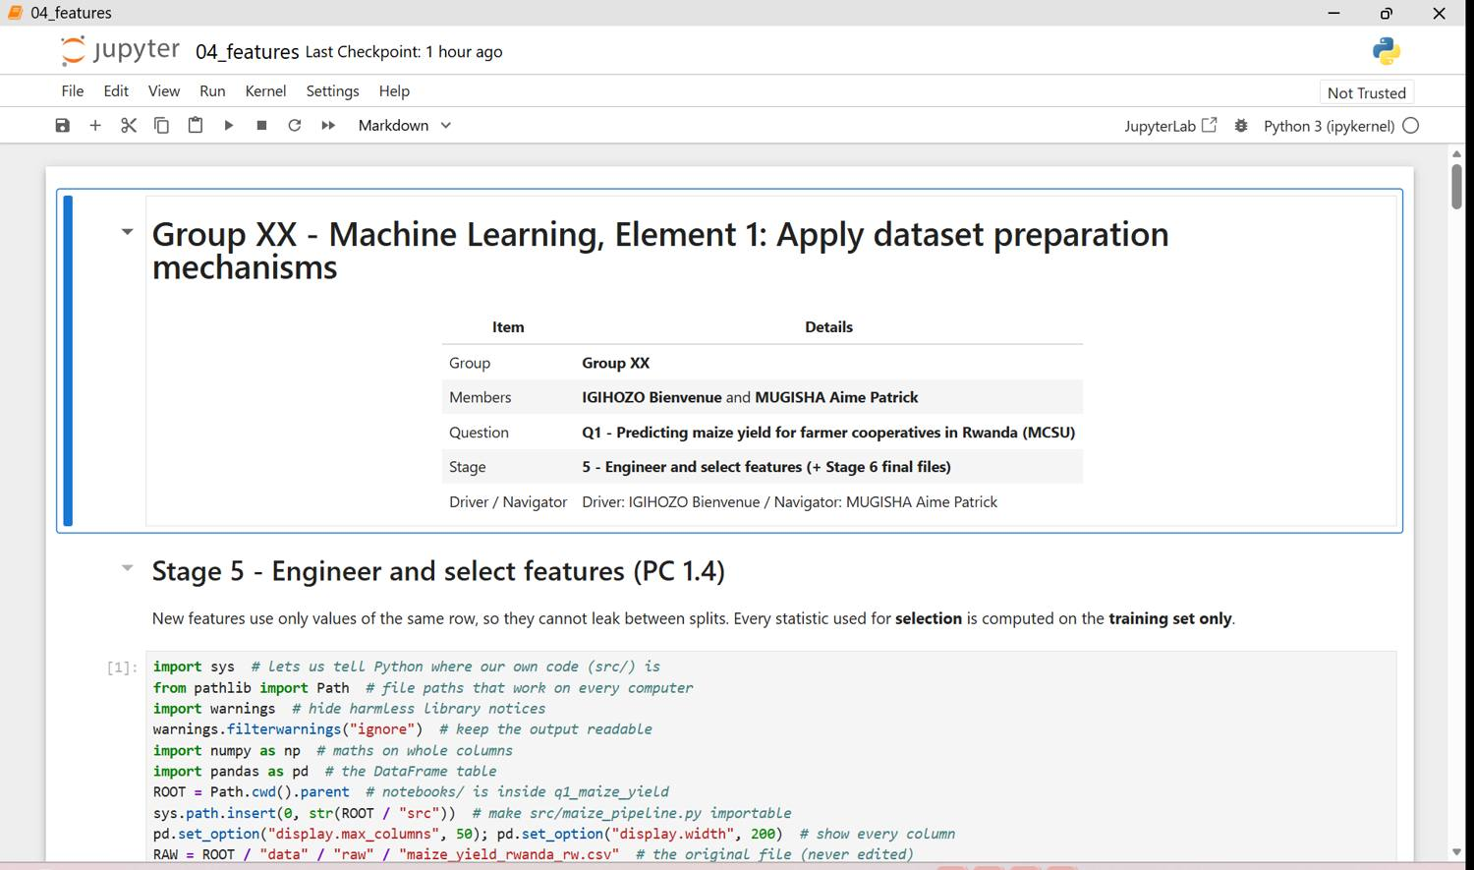
Figure 17.1 - q1 04 features p01
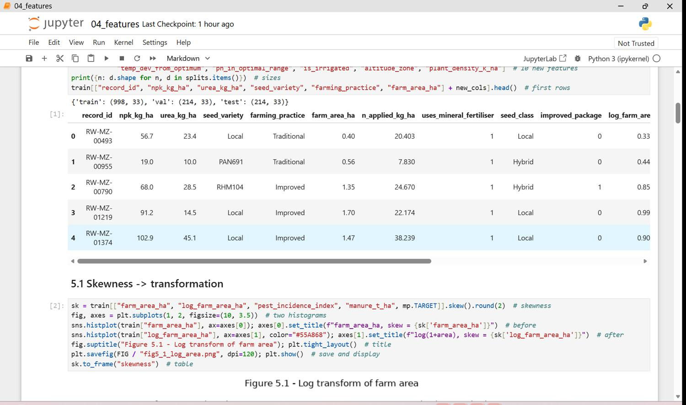
Figure 17.2 - q1 04 features p02
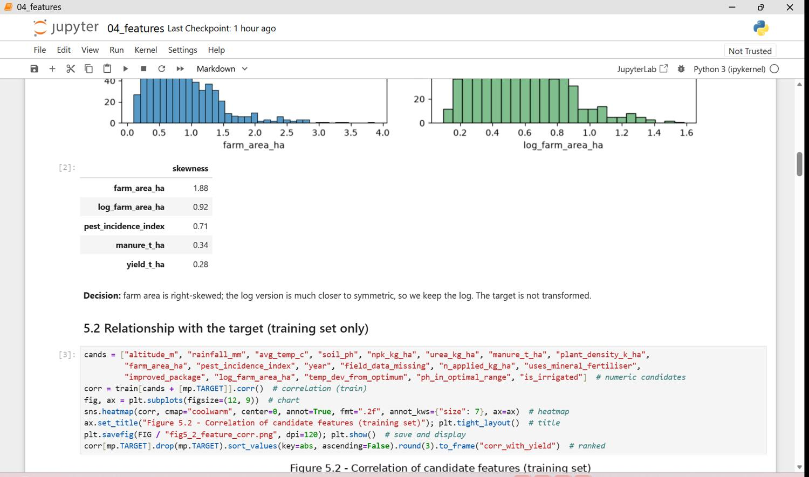
Figure 17.3 - q1 04 features p03
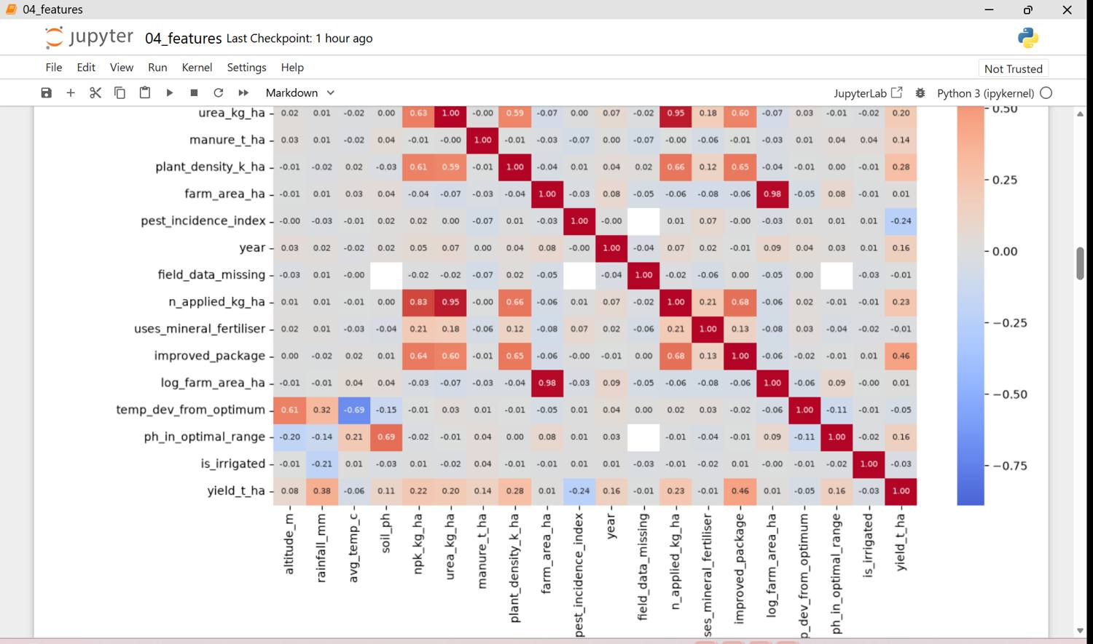
Figure 17.4 - q1 04 features p04
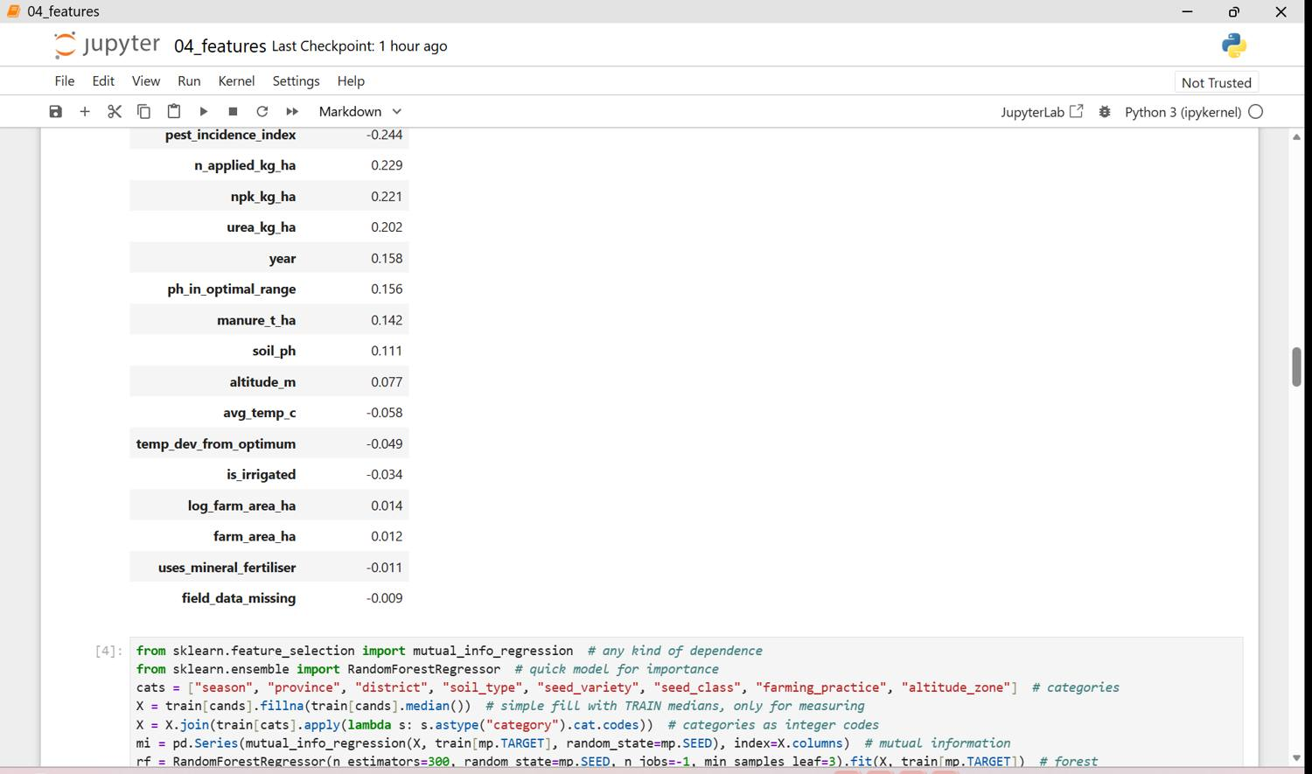
Figure 17.5 - q1 04 features p05
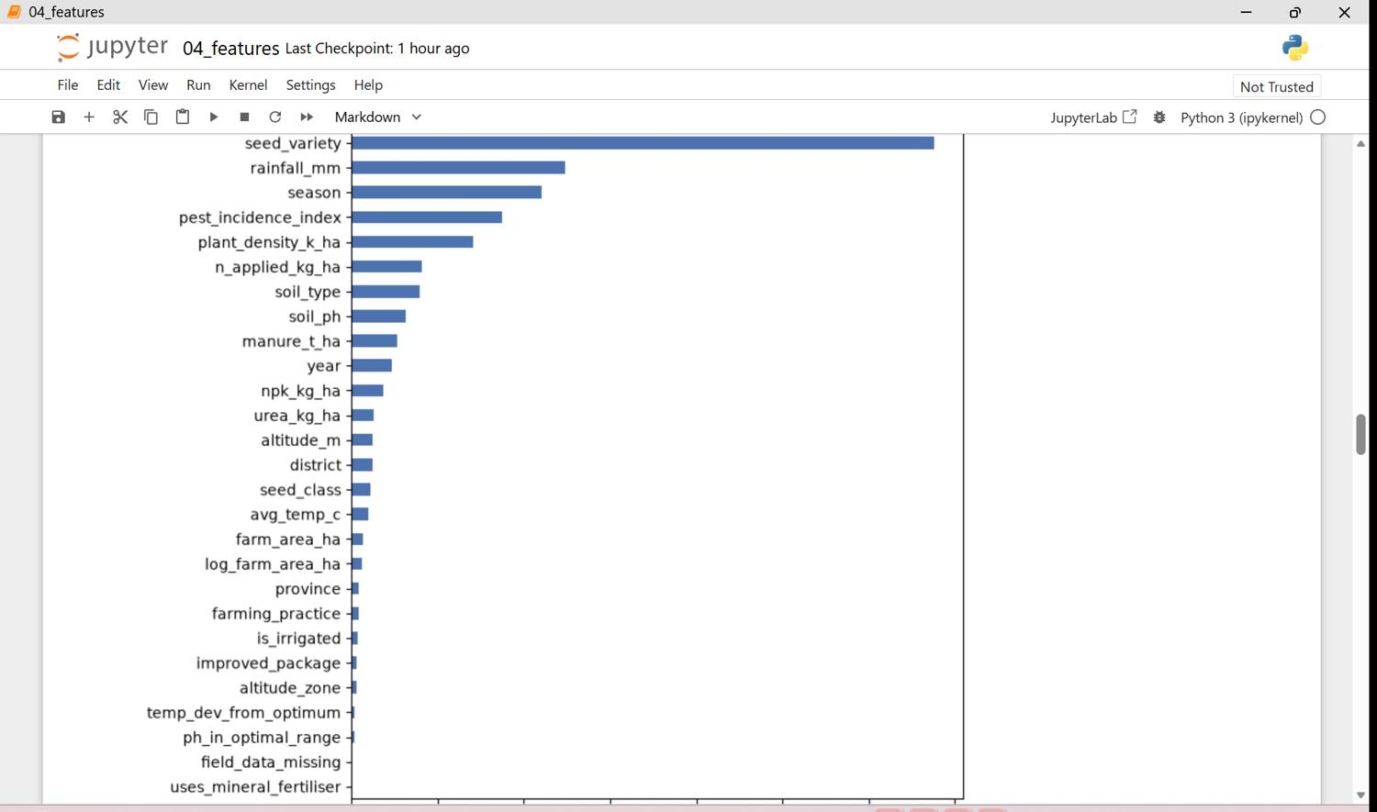
Figure 17.6 - q1 04 features p06
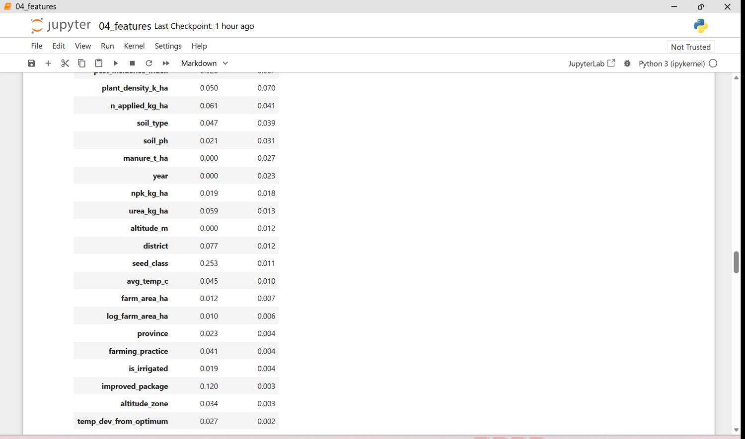
Figure 17.7 - q1 04 features p07
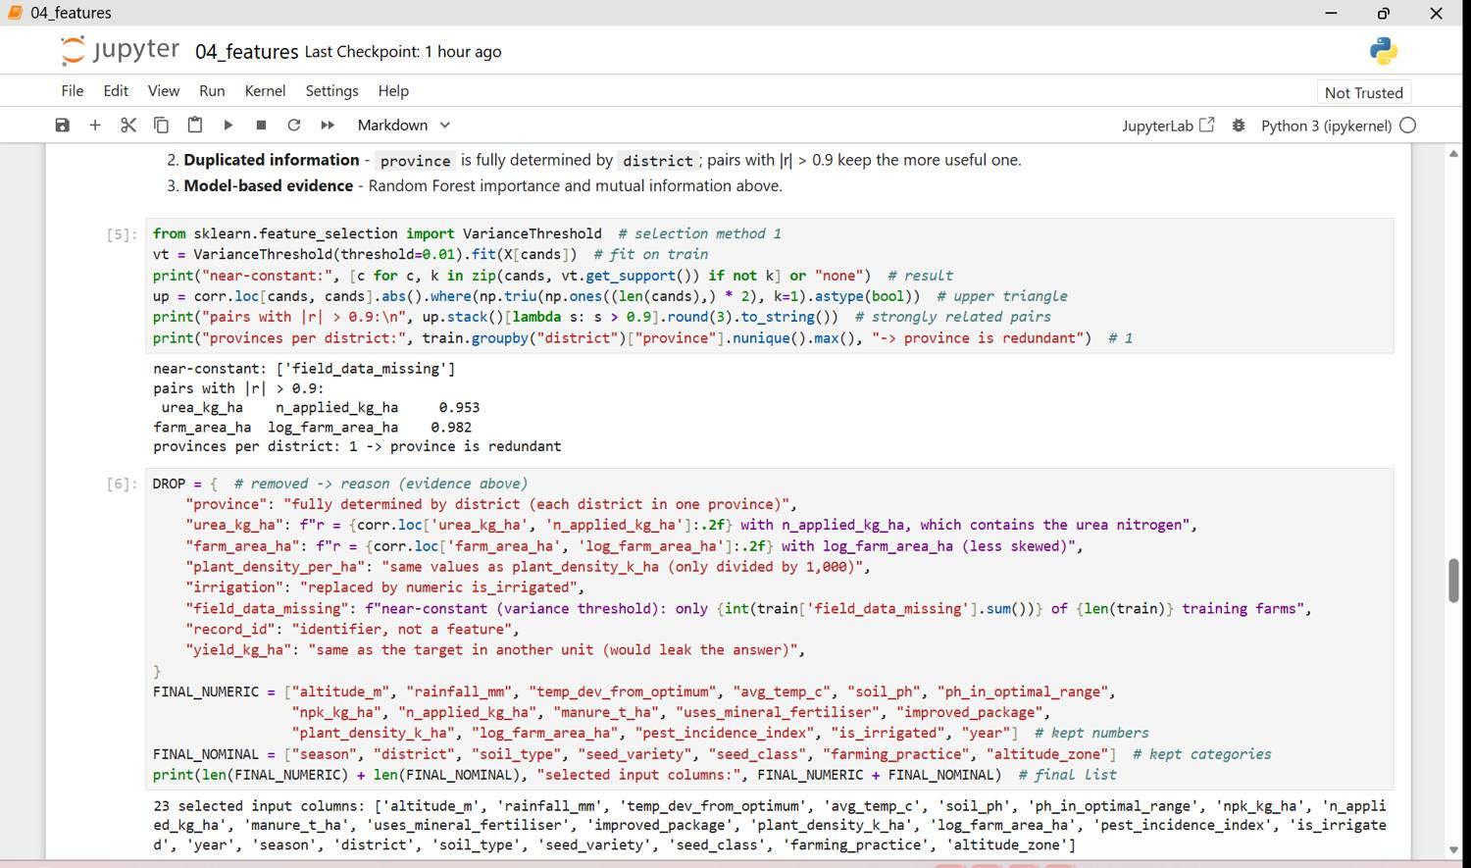
Figure 17.8 - q1 04 features p08
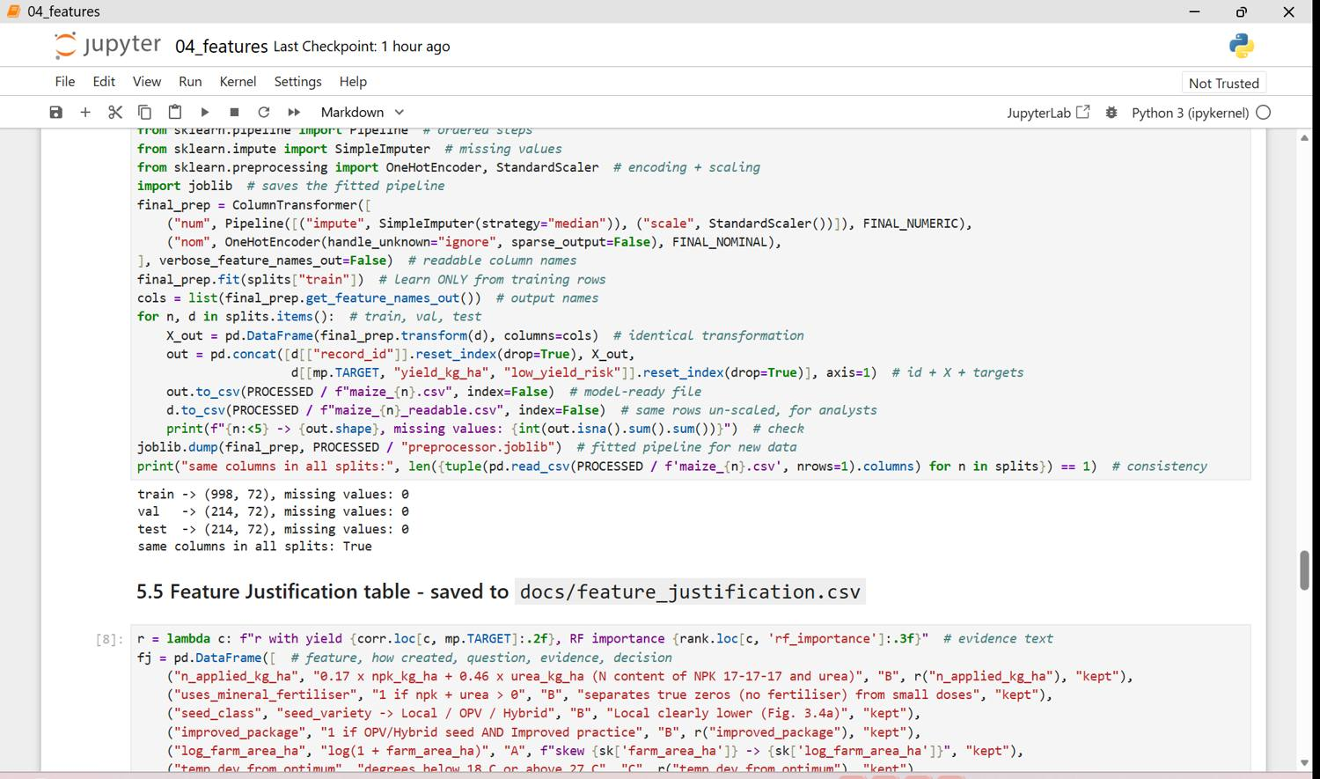
Figure 17.9 - q1 04 features p09
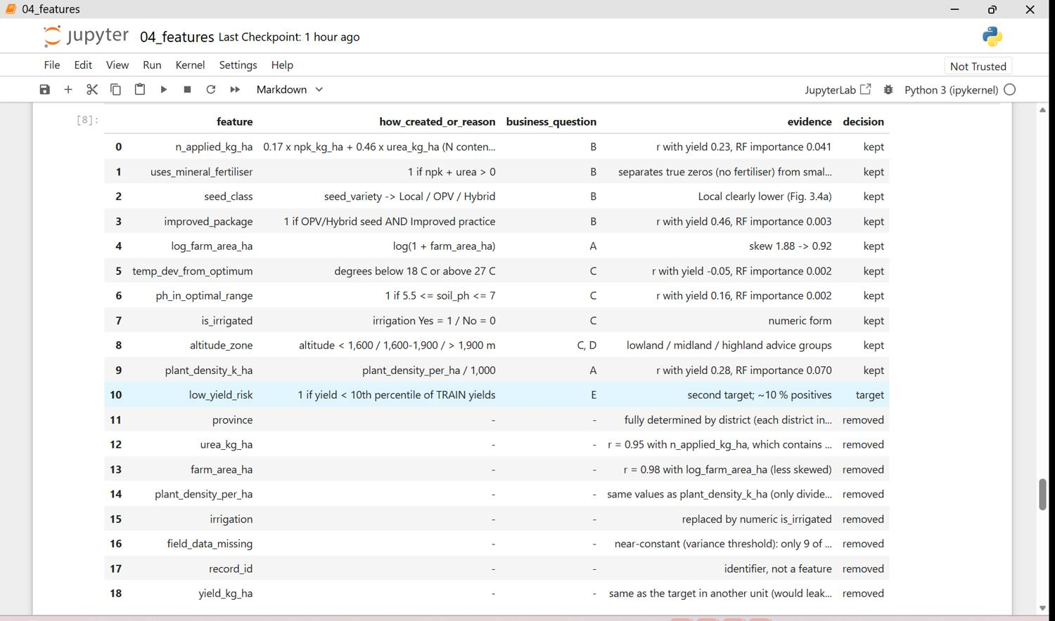
Figure 17.10 - q1 04 features p10
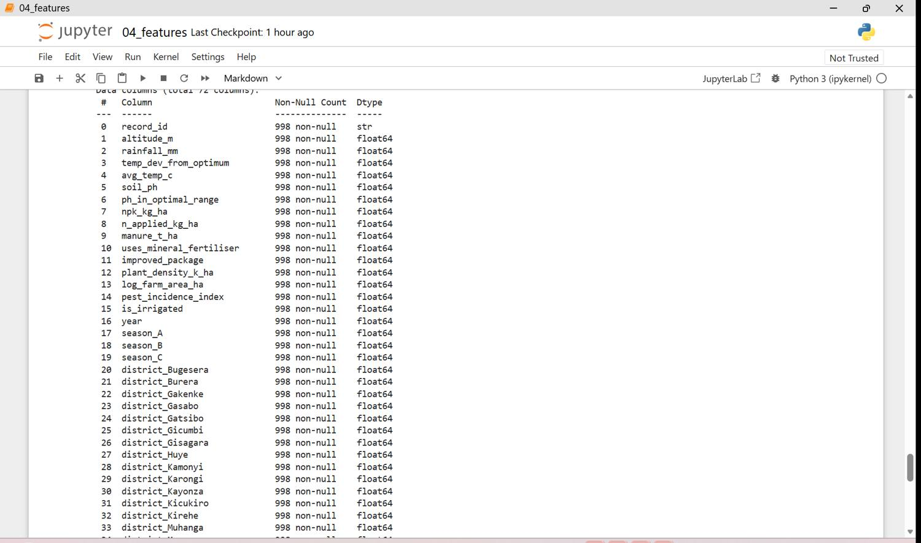
Figure 17.11 - q1 04 features p11
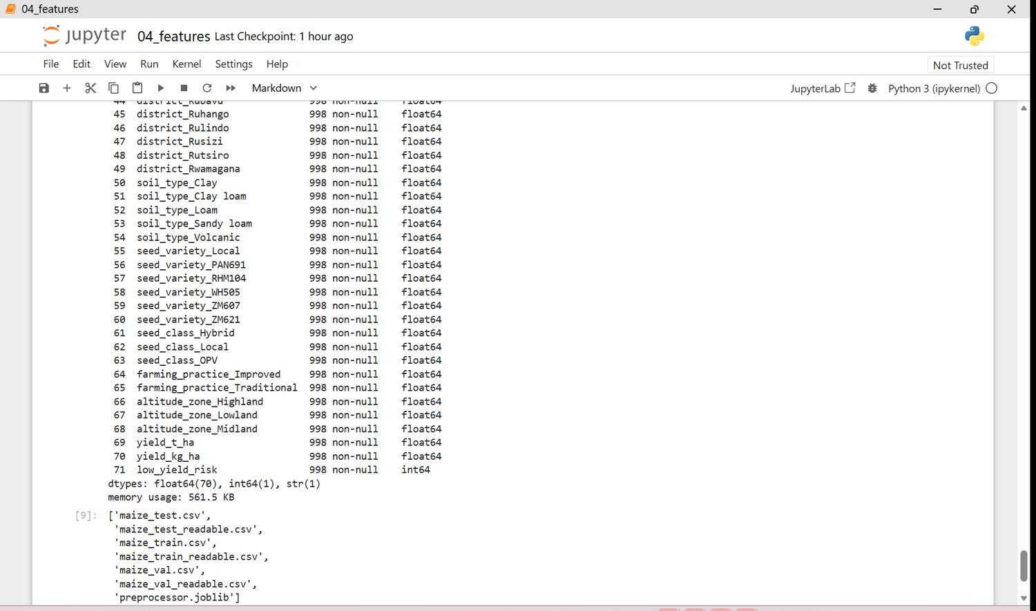
Figure 17.12 - q1 04 features p12
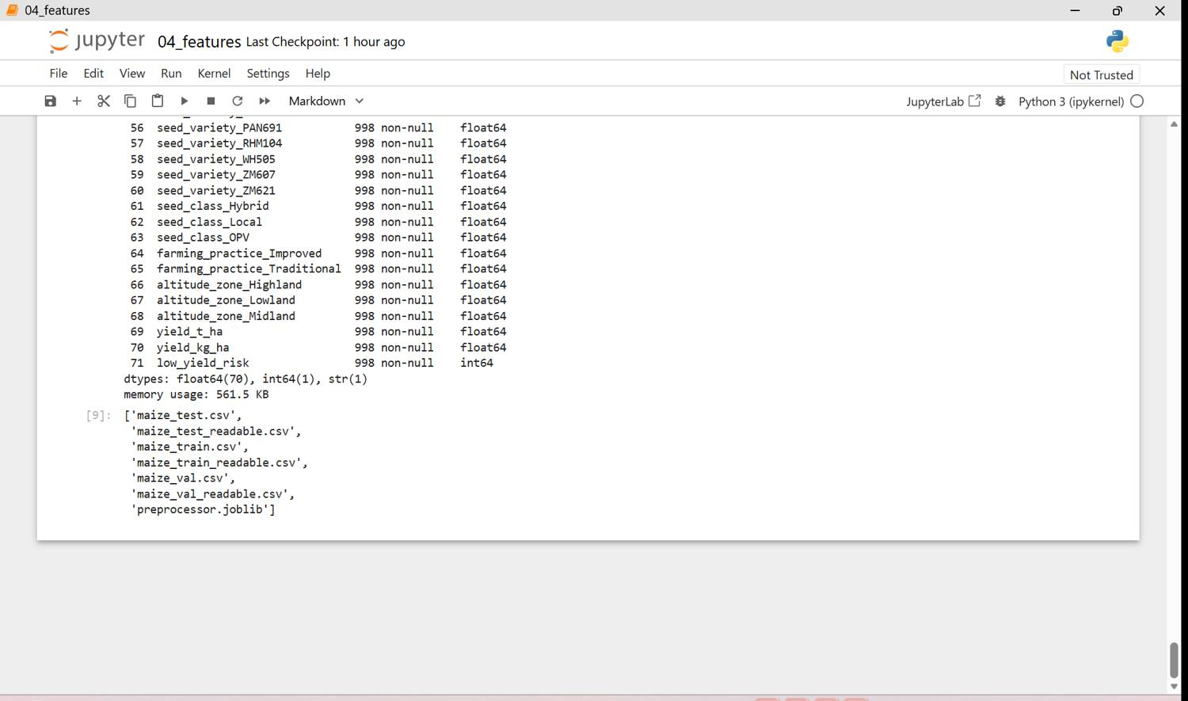
Figure 17.13 - q1 04 features p13

Stage 6 - Finalise, package and present
- data/processed/maize_train.csv, maize_val.csv, maize_test.csv - model-ready (encoded, scaled, no missing values).
- data/processed/*_readable.csv - the same rows un-scaled; preprocessor.joblib - the fitted pipeline.
- Reproducibility: Kernel > Restart & Run All on notebooks 00-04 finishes without errors and gives the same files.
- Memo to Mr. Habimana: Q1_Memo_to_Mr_Habimana.docx. Data card: Appendix E.
Figure 18: Saved final files in the project folder (screenshots, 1 page(s))
Train, validation, test files and the fitted preprocessor are saved.
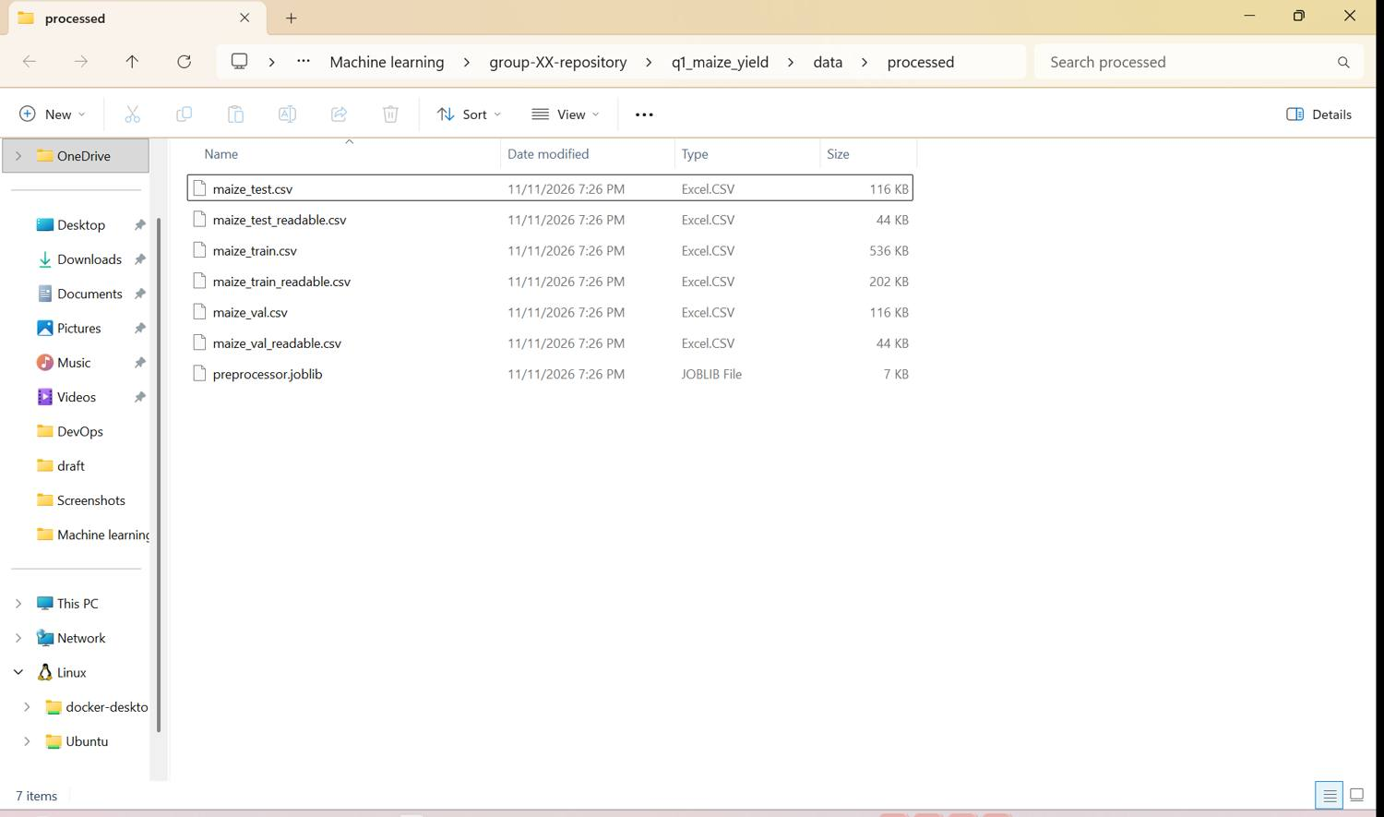
PASTE SCREENSHOT HERE (Win + Shift + S)
GitHub page showing folders and commits by both members.
Figure 19: Repository page
Commits from both members are visible.

Question 2 - Next-day rain early warning for MINEMA district disaster offices

Stage 0 - Scenario and proposal
Who is asking. The Early Warning and Disaster Risk Information unit of MINEMA (Ministry in charge of Emergency Management), which supports the District Disaster Management Committees of Rubavu, Musanze, Rusizi and the City of Kigali.
The problem. Heavy and repeated rain causes floods and landslides in Rwanda. In early May 2023, floods and landslides in the Western and Northern provinces killed more than 130 people and destroyed thousands of houses. Every evening the MINEMA duty officer must decide whether to send SMS warnings to people living in high-risk zones, ask district teams to clear drainage channels and keep response teams on standby for the next day. Today this decision is made from general forecasts and experience. Warnings sent too often are ignored; warnings missed cost lives.
The decision a prediction supports. Send / do not send a next-day rain alert for each station area. Target to predict later: rain_tomorrow (1 = rain observed at the station tomorrow, 0 = no rain) - binary classification. Predicting it matters because rain on already wet days (wet spells) is what saturates slopes and triggers landslides.
What data exists. Daily observations of the four airport weather stations - Kigali (Kanombe, Kicukiro), Kamembe (Rusizi), Gisenyi (Rubavu) and Ruhengeri (Musanze) - published by NOAA's Global Summary of the Day for 2015-2025: temperature, dew point, min/max temperature, wind, visibility, precipitation and weather events (rain, thunder, fog). The data has real quality problems: 'not measured' codes, empty columns, imperial units, incomplete rain totals and missing days.
What the manager asks us to deliver. Do not build the model yet. Set up a reproducible environment; collect the data from a legitimate source; find and rate every quality problem; clean the data without letting information from the future leak into training; create features from today's and recent weather; deliver train/validation/test files split by time, a reusable pipeline, and documentation that the Disaster Management Committees can trust.
The signed Scenario Proposal Form is in Q2_Scenario_Brief_and_Proposal.docx (Appendix A of the task).

Stage 1 - Environment (reused from Question 1)
The same ml-project environment and repository are used; Q2 has its own folder q2_own_scenario with the same structure. One extra step: the data was downloaded with PowerShell (Invoke-WebRequest).

Stage 2 - Requirements and data acquisition (PC 1.2)
Requirement | Decision
Target | rain_tomorrow (1/0) - rain flag of the next calendar day
Features | today's temperature, dew point/humidity, min/max, wind, visibility, rain amount, weather events, season, station
Excluded | anything measured tomorrow; no random split across time
Period / area | 2015-2025; Kigali, Rusizi, Rubavu, Musanze stations
Size | 10,614 raw rows, 28 columns - meets >= 1,000 rows and >= 8 columns

Two sources were compared: NOAA GSOD (real station observations, chosen) and the Open-Meteo historical API (modelled reanalysis values, complete and smooth - rejected because it is not an observation and is too clean for this task). Meteo Rwanda's own records would be best but need a formal request.
Figure 20: Q2 data requirements and source comparison (screenshots, 7 page(s))
Notebook q2 01_acquire in Jupyter: scenario summary, requirements, comparison of two sources, the 42 loaded files, the requirement check, data dictionary and source log. Decision: NOAA GSOD chosen (real observations).
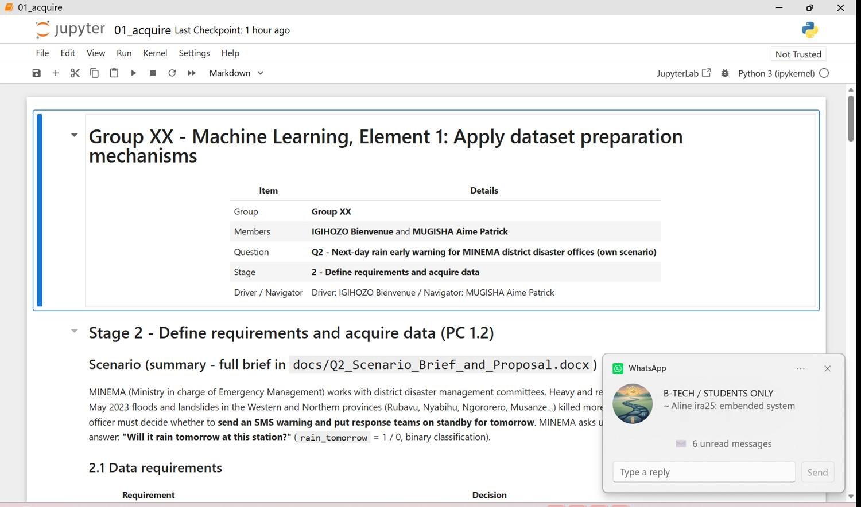
Figure 20.1 - q2 01 acquire p01
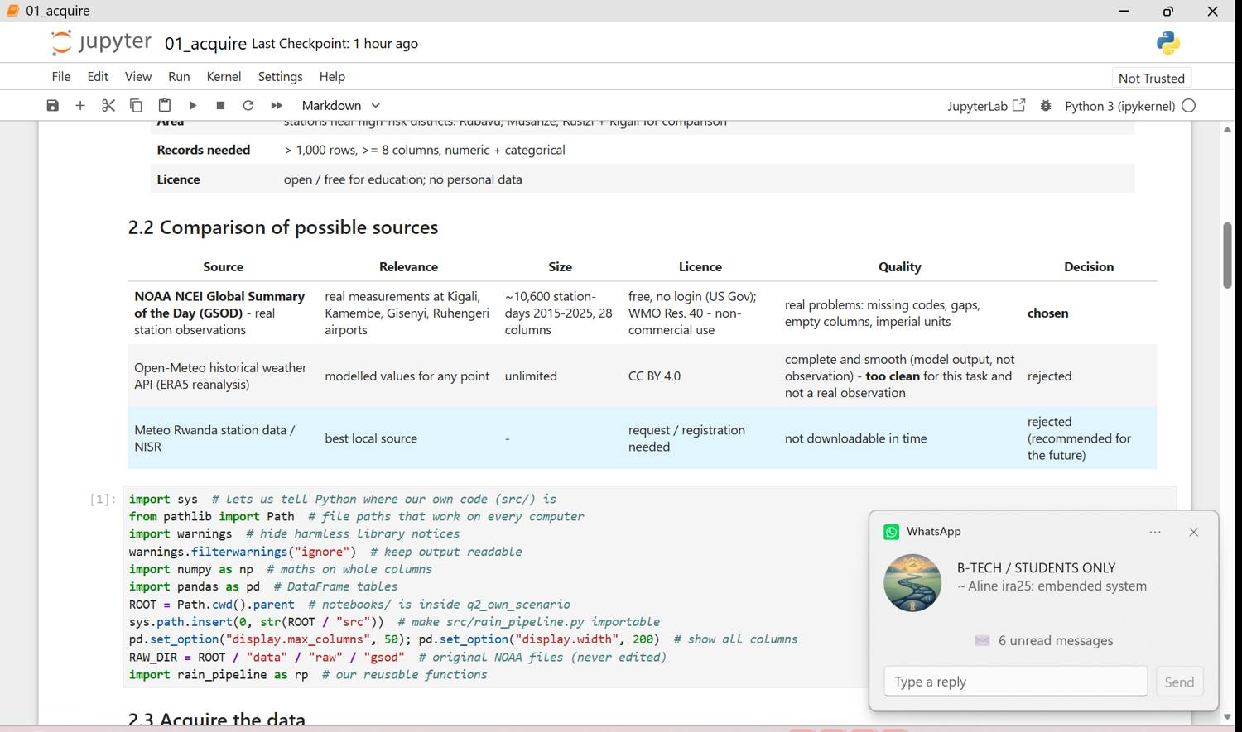
Figure 20.2 - q2 01 acquire p02
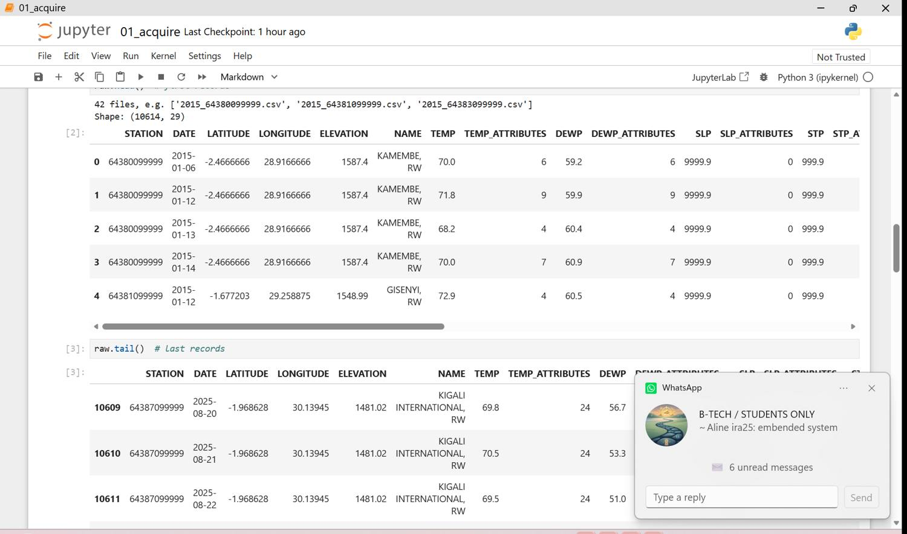
Figure 20.3 - q2 01 acquire p03
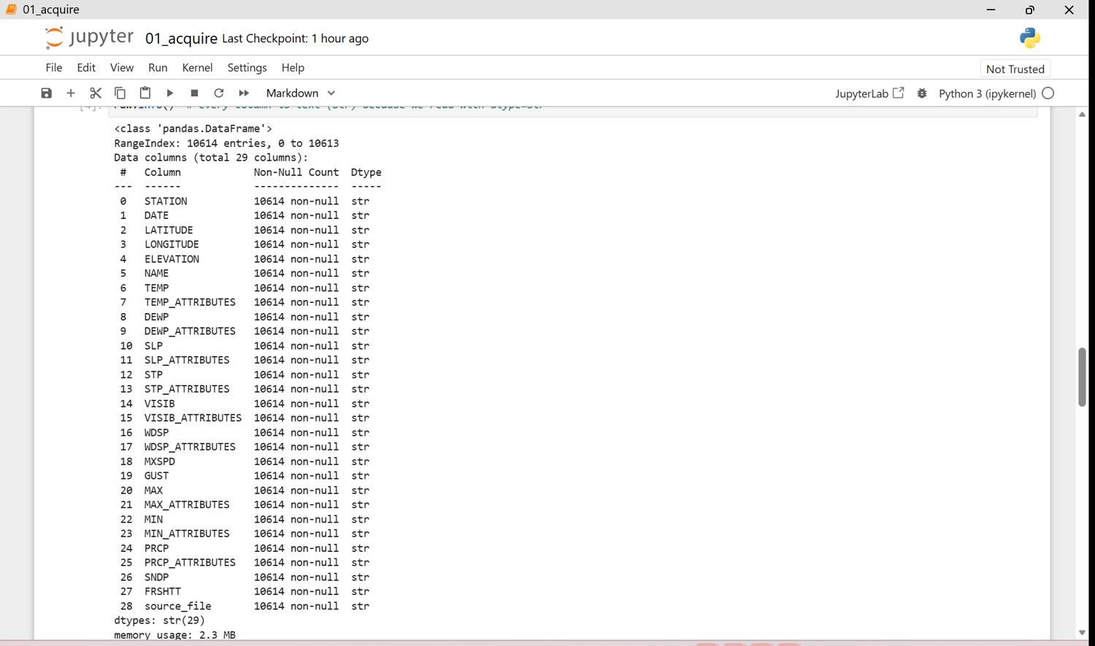
Figure 20.4 - q2 01 acquire p04
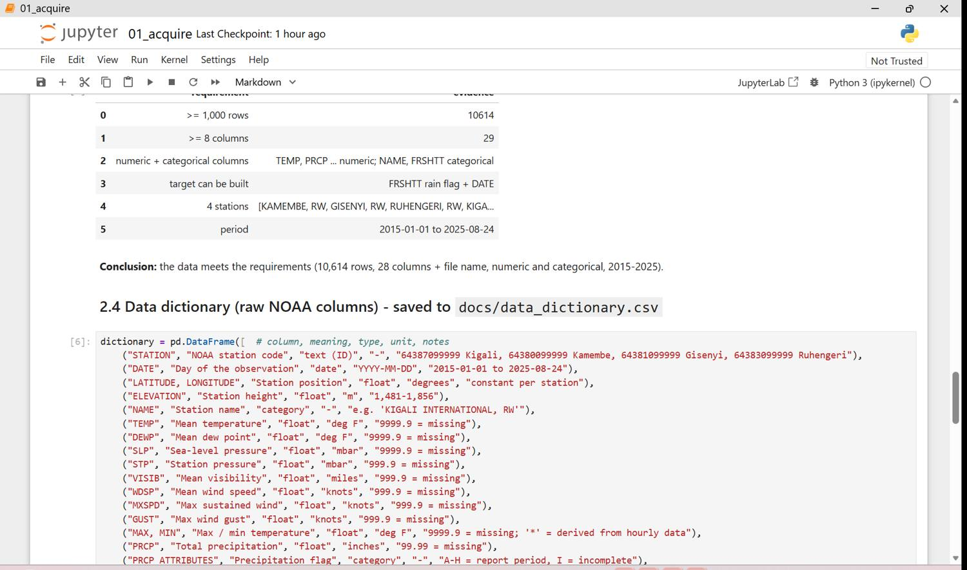
Figure 20.5 - q2 01 acquire p05
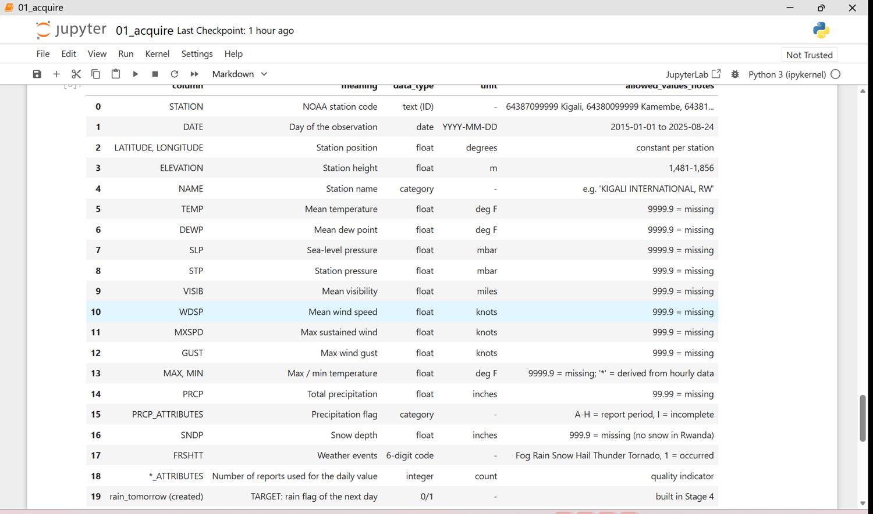
Figure 20.6 - q2 01 acquire p06
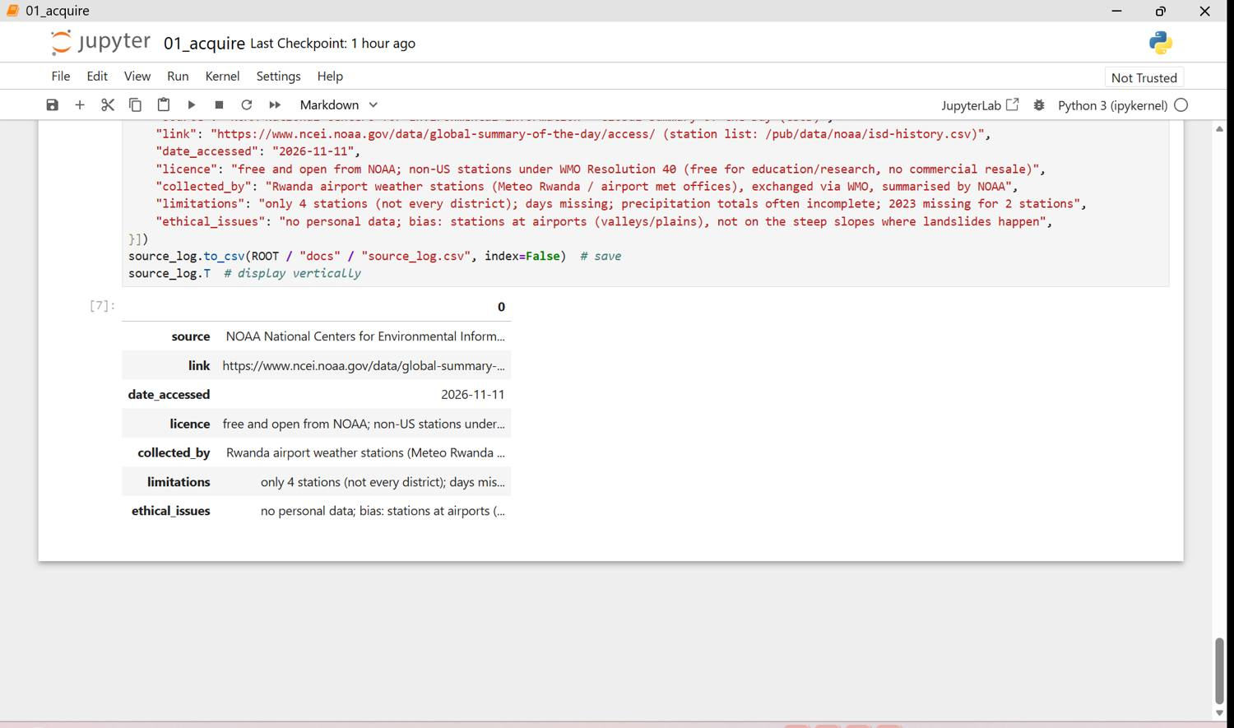
Figure 20.7 - q2 01 acquire p07
Figure 21: Q2 raw files and loaded data (screenshots, 1 page(s))
42 yearly files, 10,614 rows; every column is text.
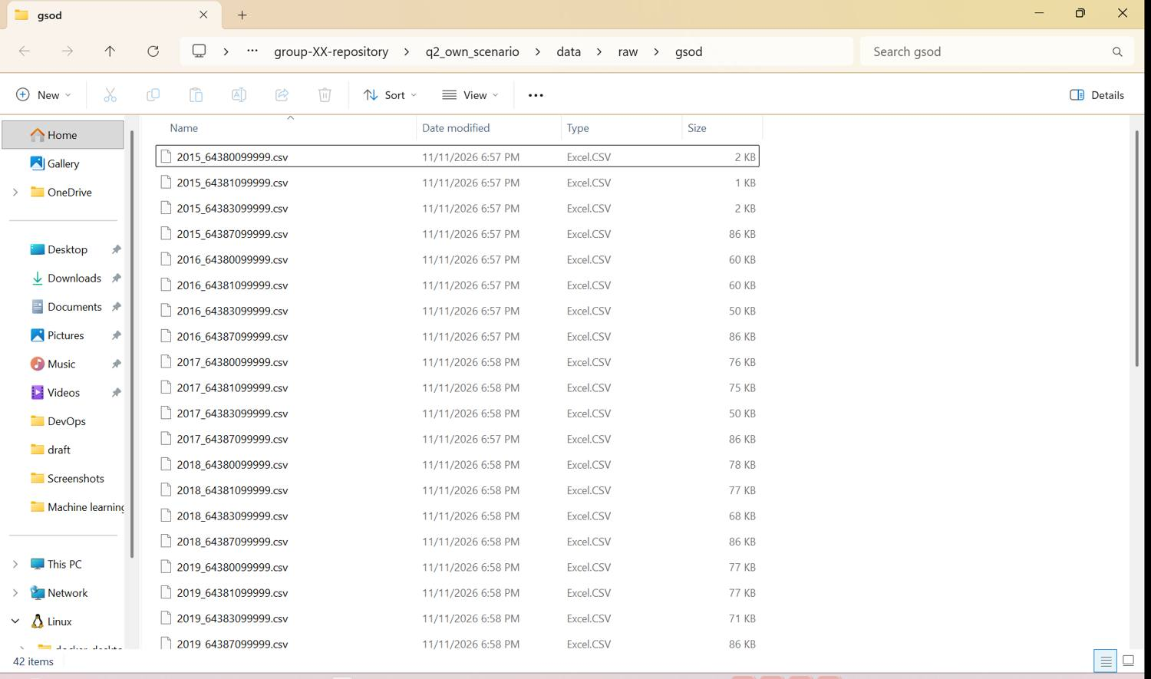

Stage 3 - Explore and audit (PC 1.3)
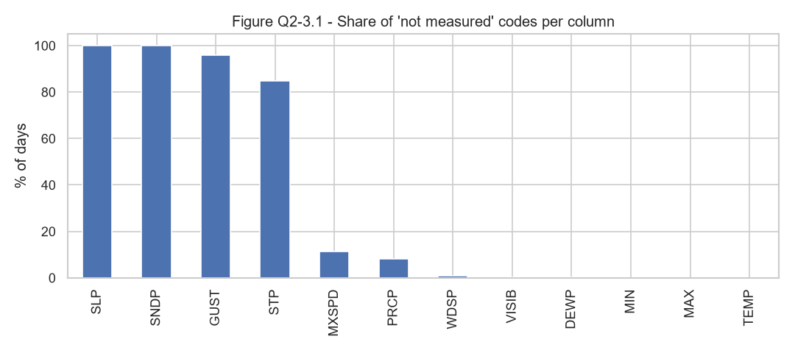
Figure 22: Share of 'not measured' codes per column
SLP and SNDP are always missing, GUST and STP almost always; PRCP and MXSPD partly.
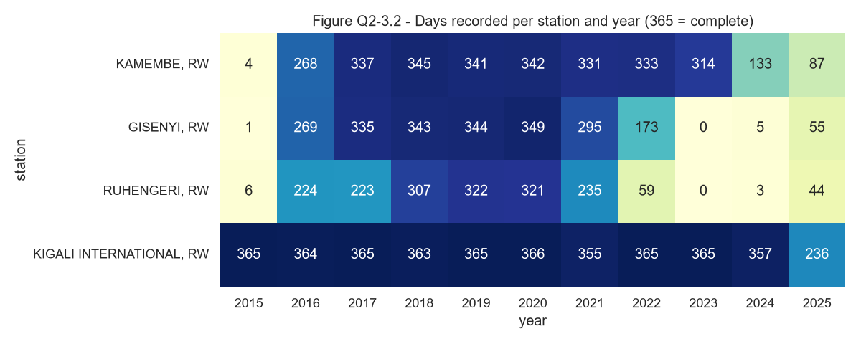
Figure 23: Days recorded per station and year
Kigali is almost complete; Gisenyi and Ruhengeri have large gaps and no 2023 data.
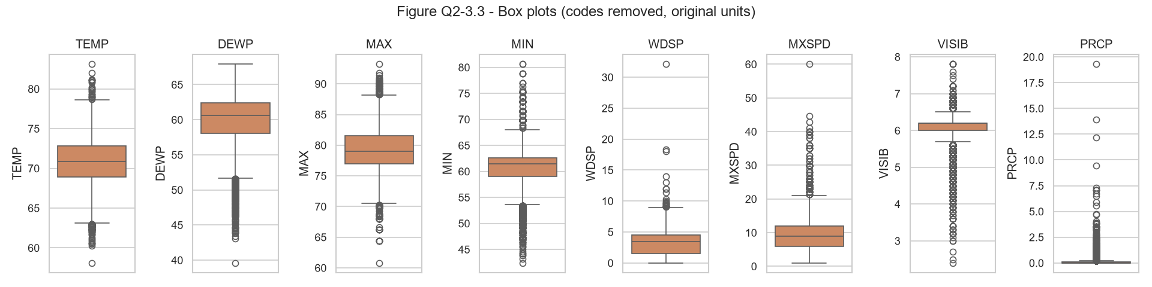
Figure 24: Box plots of the measured columns
Most extreme values are real weather; two wind values are not credible. Rain amount is very skewed.
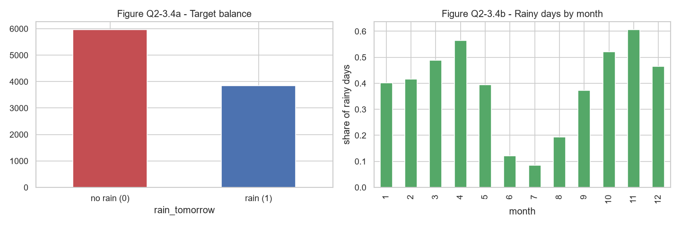
Figure 25: Target balance and rainy days by month
39% of days are followed by rain; rain follows the long rains (Mar-May) and short rains (Sep-Dec).
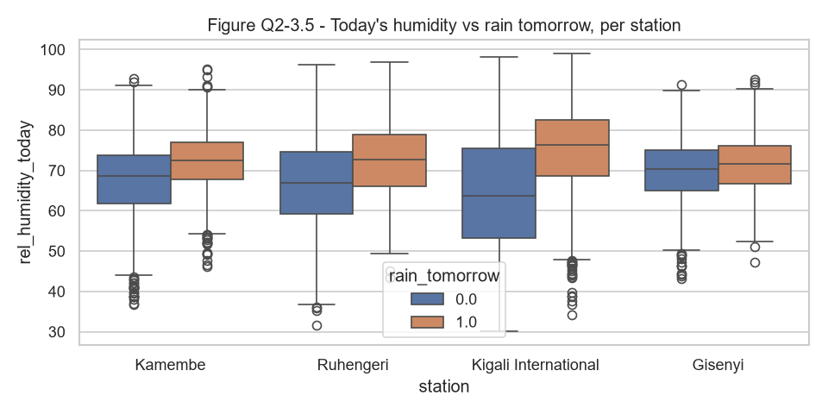
Figure 26: Today's humidity vs rain tomorrow
Days followed by rain have higher humidity today at every station.
Limitation found: the rain flag and the rain amount disagree on many days (different recording windows and incomplete totals). The target uses the rain flag, which is recorded every day.
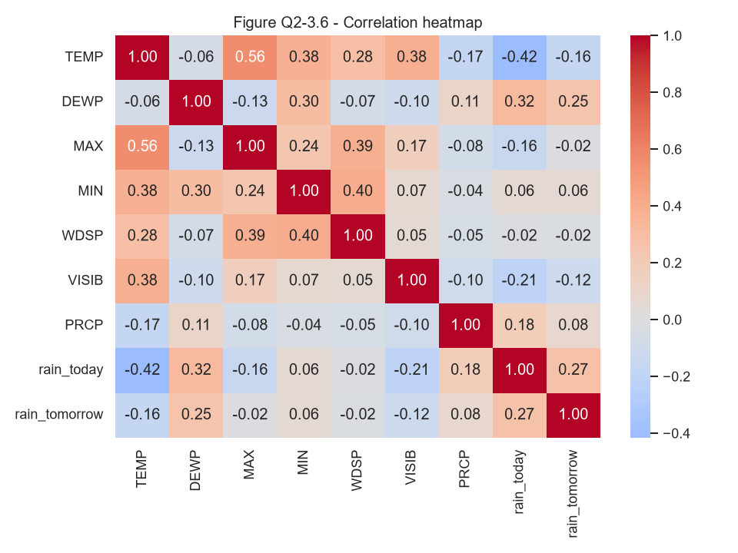
Figure 27: Correlation heatmap
Rain today and dew point relate most to rain tomorrow; temperature columns are redundant with each other.
Figure 28: Q2 missing values, duplicates and summary statistics (screenshots, 11 page(s))
Notebook q2 02_eda in Jupyter: summary statistics, missing codes per column, missing days per station-year, box plots and IQR, the rain flag vs amount check, target balance and the Data Quality Report (13 problems).
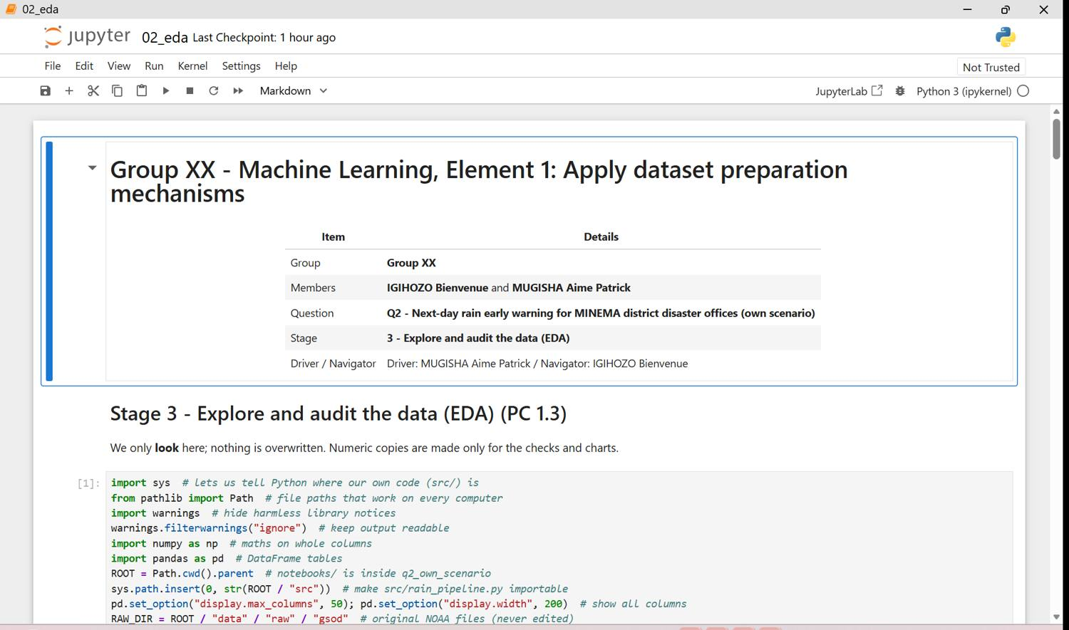
Figure 28.1 - q2 02 eda p01
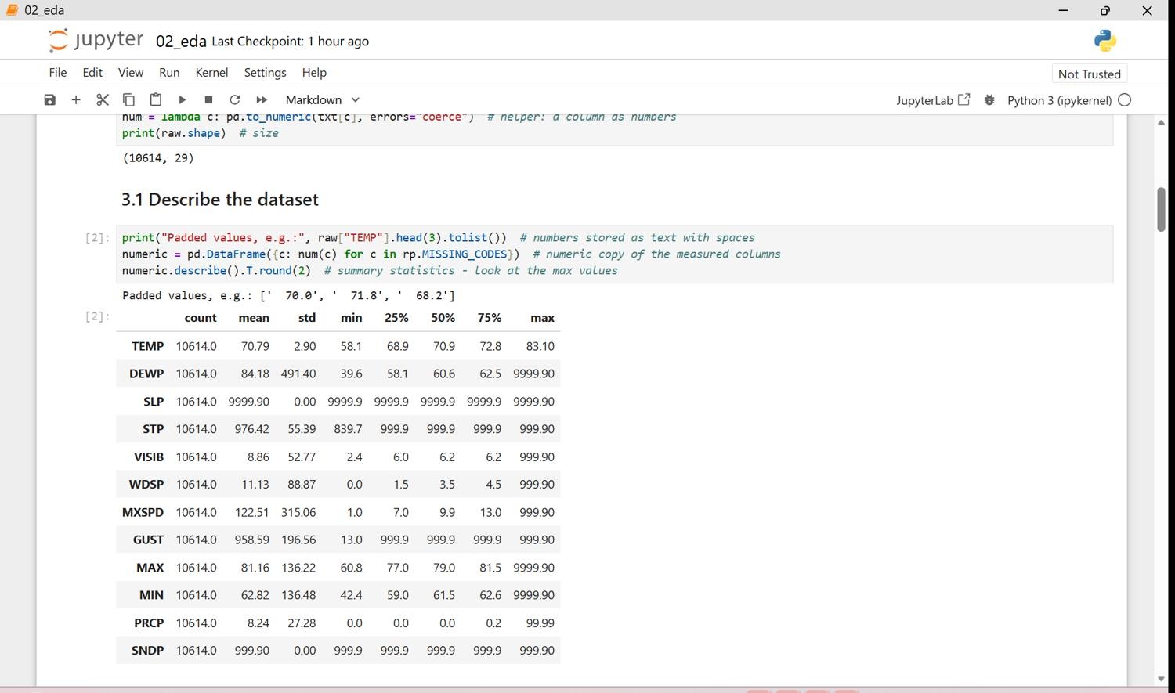
Figure 28.2 - q2 02 eda p02
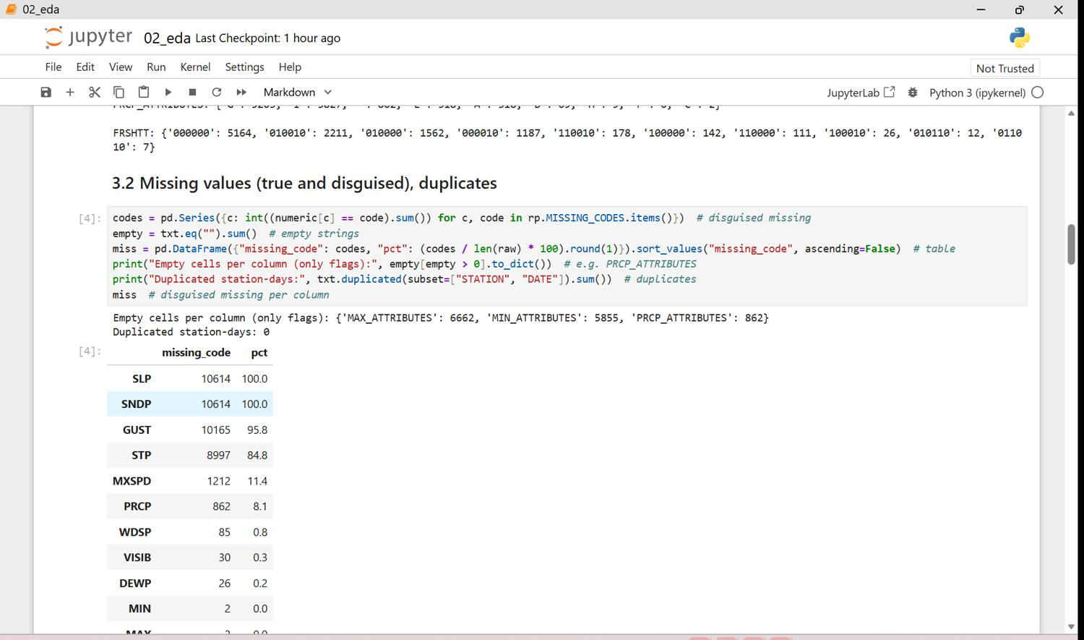
Figure 28.3 - q2 02 eda p03
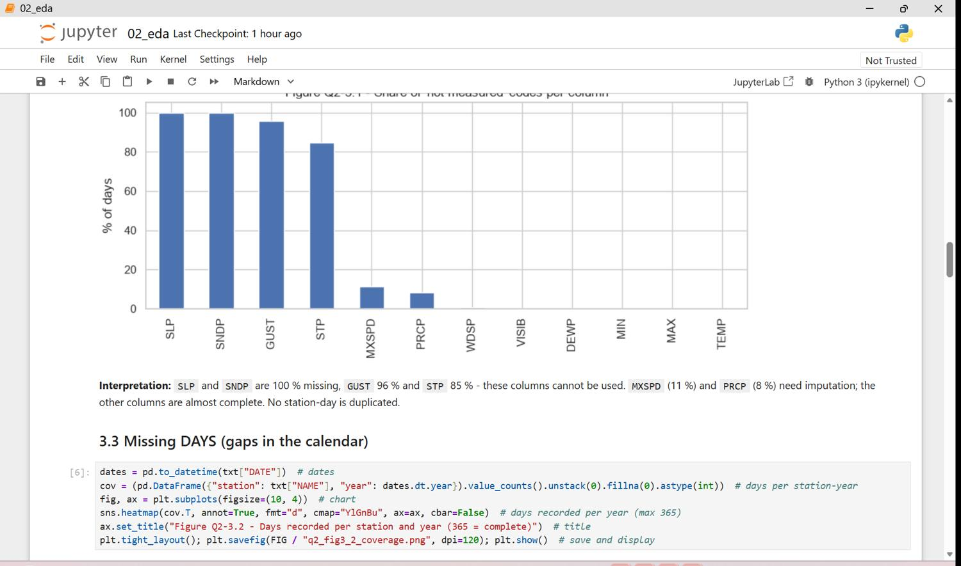
Figure 28.4 - q2 02 eda p04
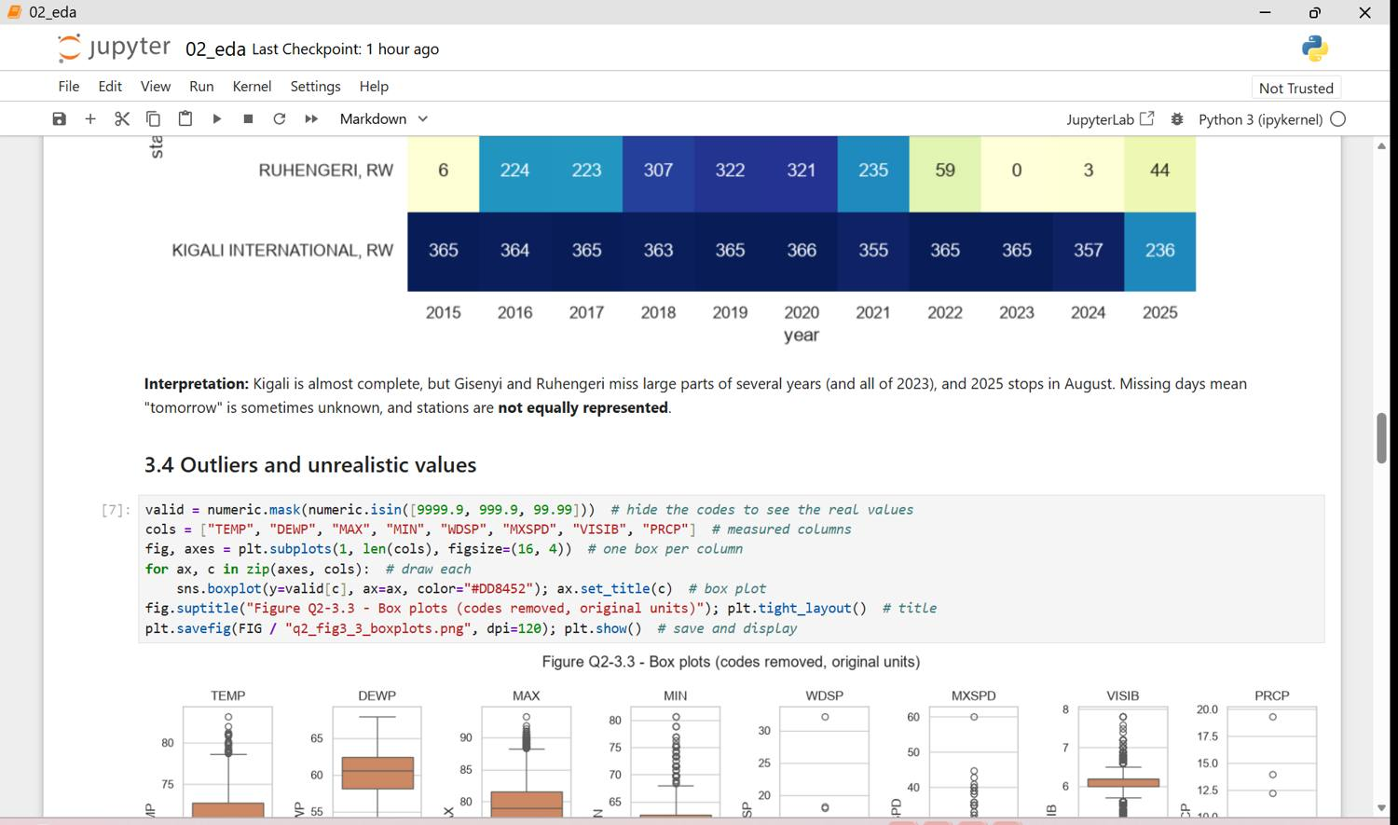
Figure 28.5 - q2 02 eda p05
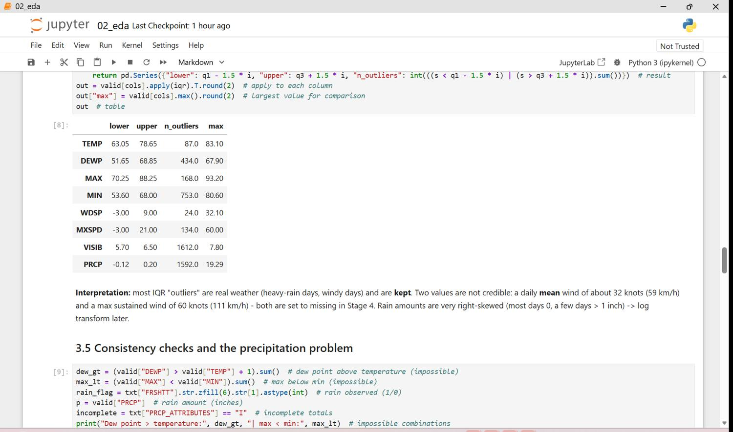
Figure 28.6 - q2 02 eda p06
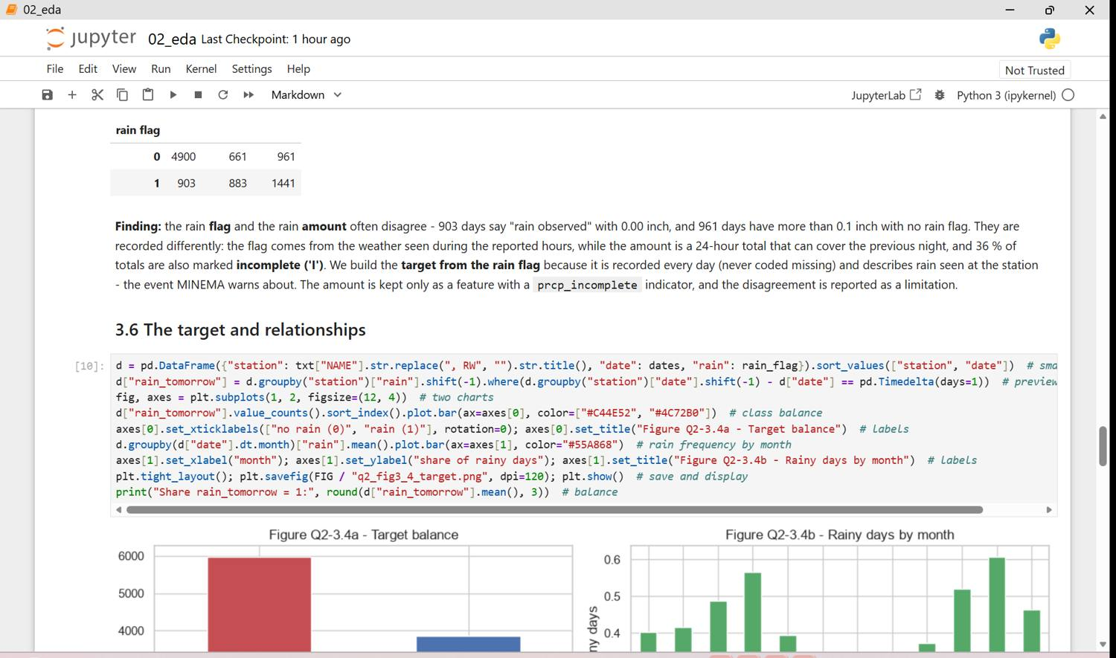
Figure 28.7 - q2 02 eda p07
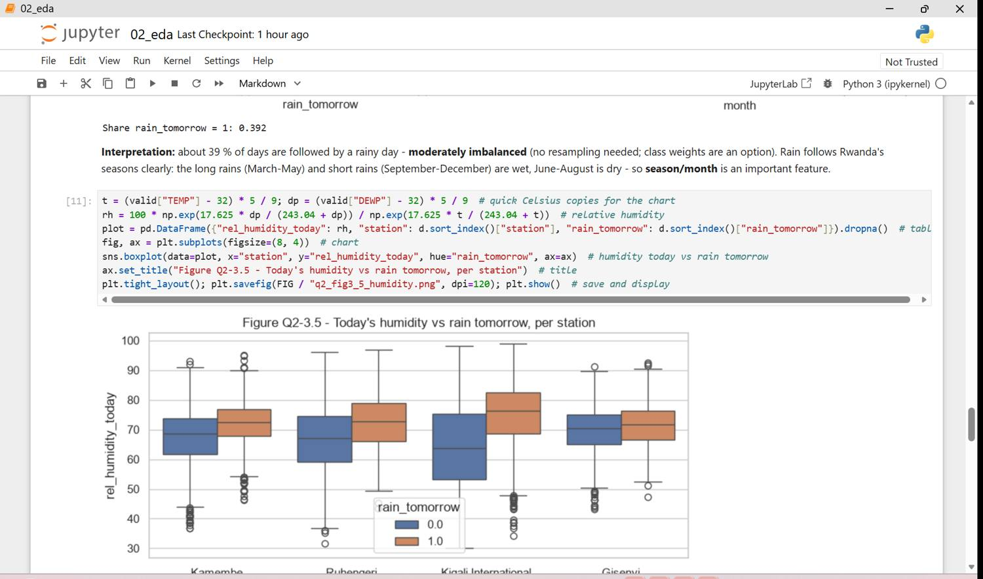
Figure 28.8 - q2 02 eda p08
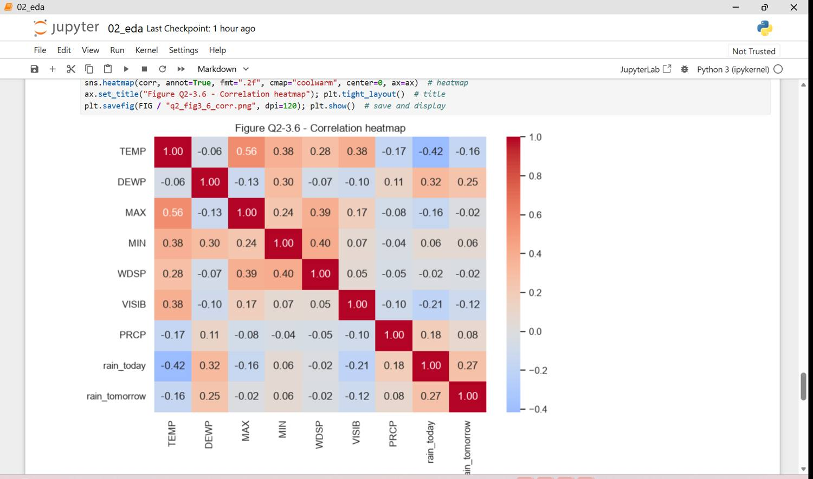
Figure 28.9 - q2 02 eda p09
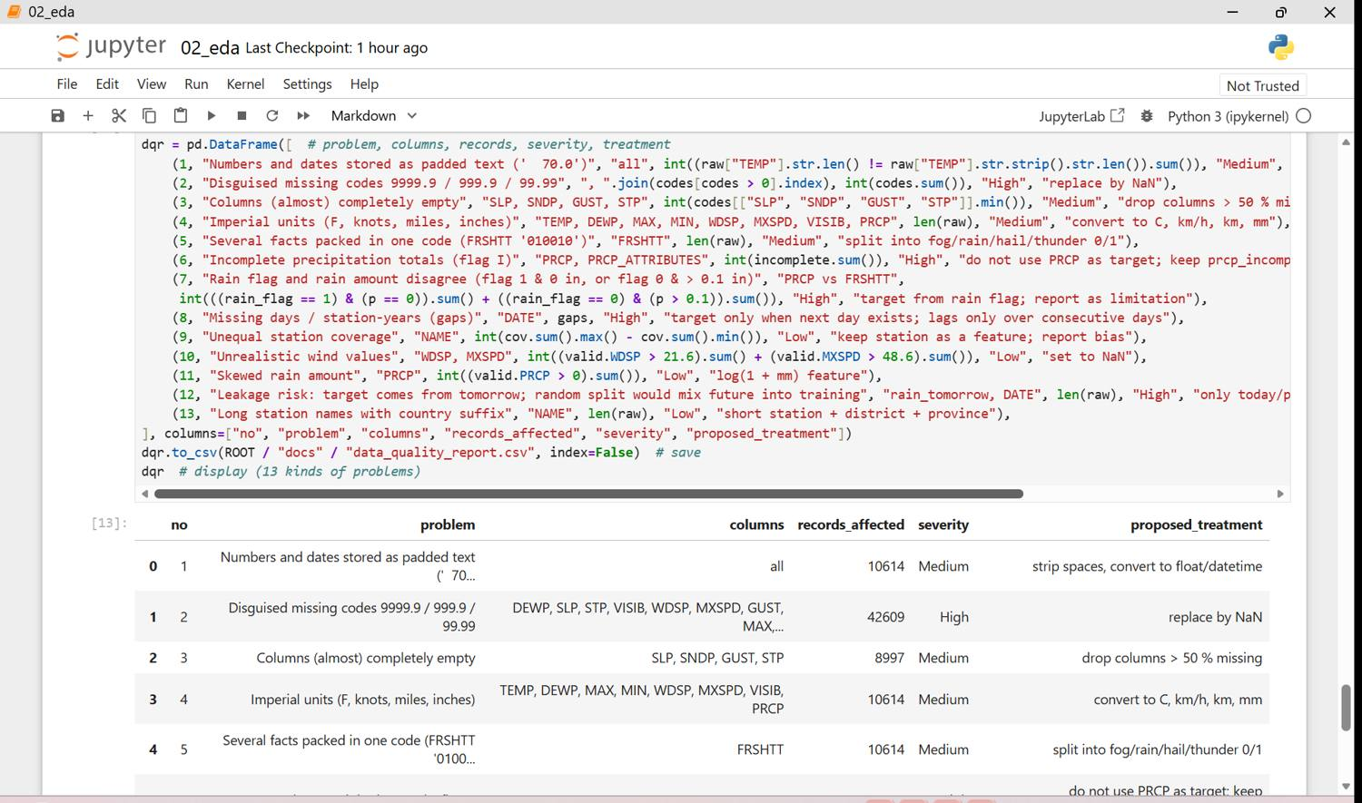
Figure 28.10 - q2 02 eda p10
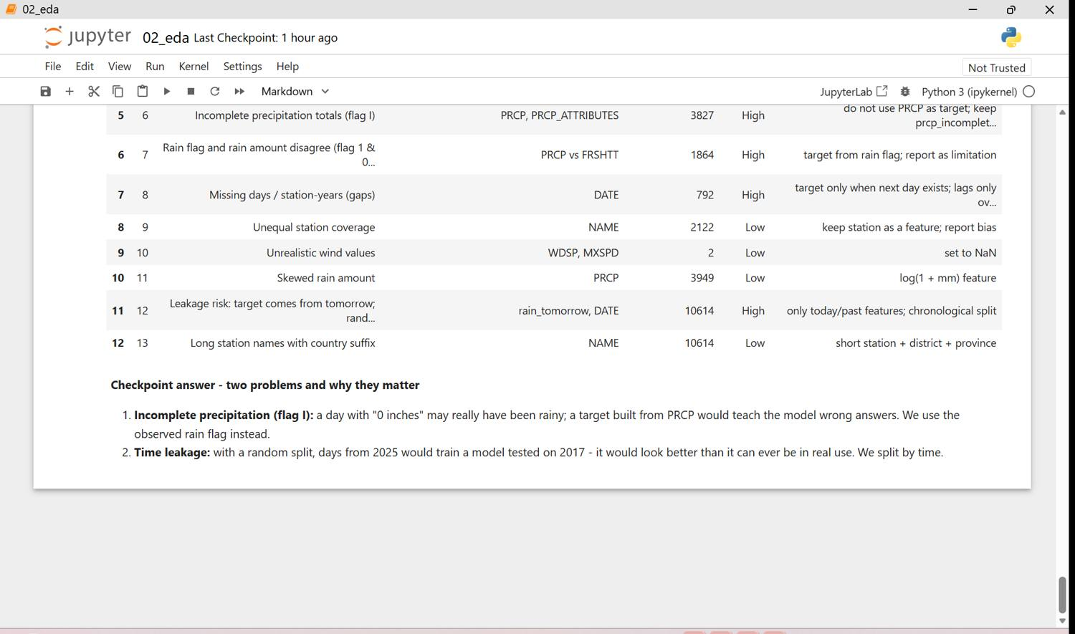
Figure 28.11 - q2 02 eda p11

Data Quality Report (Question 2)
no | problem | columns | records | severity | proposed_treatment
1 | Numbers and dates stored as padded text (' 70.0') | all | 10614 | Medium | strip spaces, convert to float/datetime
2 | Disguised missing codes 9999.9 / 999.9 / 99.99 | DEWP, SLP, STP, VISIB, WDSP, MXSPD, GUST, MAX, MIN, PRCP, SNDP | 42609 | High | replace by NaN
3 | Columns (almost) completely empty | SLP, SNDP, GUST, STP | 8997 | Medium | drop columns > 50 % missing
4 | Imperial units (F, knots, miles, inches) | TEMP, DEWP, MAX, MIN, WDSP, MXSPD, VISIB, PRCP | 10614 | Medium | convert to C, km/h, km, mm
5 | Several facts packed in one code (FRSHTT '010010') | FRSHTT | 10614 | Medium | split into fog/rain/hail/thunder 0/1
6 | Incomplete precipitation totals (flag I) | PRCP, PRCP_ATTRIBUTES | 3827 | High | do not use PRCP as target; keep prcp_incomplete flag
7 | Rain flag and rain amount disagree (flag 1 & 0 in, or flag 0 & > 0.1 in) | PRCP vs FRSHTT | 1864 | High | target from rain flag; report as limitation
8 | Missing days / station-years (gaps) | DATE | 792 | High | target only when next day exists; lags only over consecutive days
9 | Unequal station coverage | NAME | 2122 | Low | keep station as a feature; report bias
10 | Unrealistic wind values | WDSP, MXSPD | 2 | Low | set to NaN
11 | Skewed rain amount | PRCP | 3949 | Low | log(1 + mm) feature
12 | Leakage risk: target comes from tomorrow; random split would mix future into training | rain_tomorrow, DATE | 10614 | High | only today/past features; chronological split
13 | Long station names with country suffix | NAME | 10614 | Low | short station + district + province

Stage 4 - Clean and pre-process (PC 1.3)
All steps are functions of src/rain_pipeline.py (clean_rain runs them in order); 32 decisions are logged (Appendix Q2-C). Clean data: 9,818 rows.
Problem | Treatment
Missing codes | 9999.9 / 999.9 / 99.99 -> NaN; then median (numbers) or most frequent (flags) imputation, learned on train
Empty columns | SLP, SNDP, GUST, STP dropped (> 50 % missing)
Units | F -> C, knots -> km/h, miles -> km, inches -> mm
Coded columns | FRSHTT -> fog, rain, hail, thunder; PRCP flag I -> prcp_incomplete
Outliers | real heavy-rain/windy days kept; 2 impossible wind values set to NaN
Target | rain_tomorrow from the next day's rain flag, only when the next calendar day exists
Encoding / scaling | station and season one-hot; numeric columns standardised; 0/1 flags unchanged
Split | chronological: train 2015-2022, validation 2023, test 2024-2025 (no future data in training)
Imbalance | 39% rain days - moderate; planned remedy class_weight='balanced'

split | rows | columns
train | 8438 | 27
val | 641 | 27
test | 739 | 27

Figure 29: Q2 cleaning before/after and split shapes (screenshots, 7 page(s))
Notebook q2 03_clean in Jupyter: missing codes replaced, empty columns dropped, metric units, decoded flags, the rain_tomorrow target, the reproducibility check, the cleaning log and the chronological split.
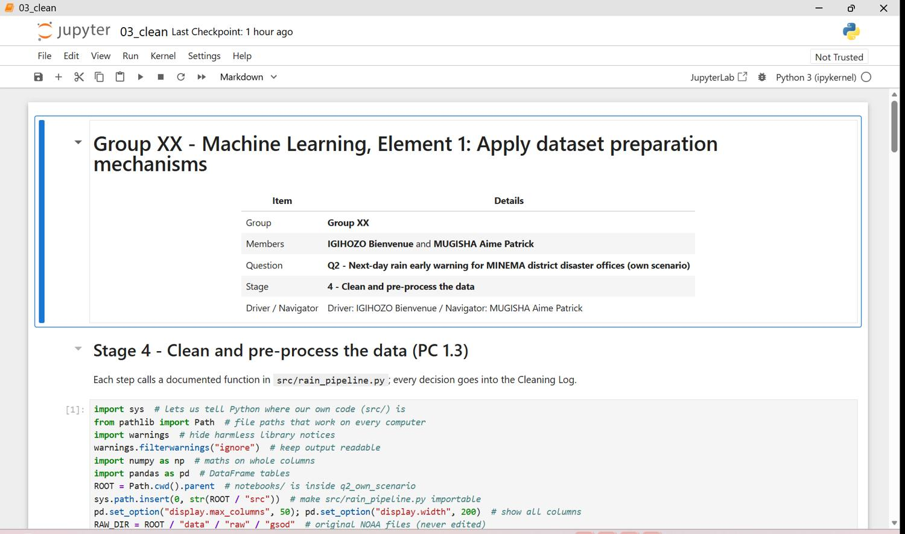
Figure 29.1 - q2 03 clean p01
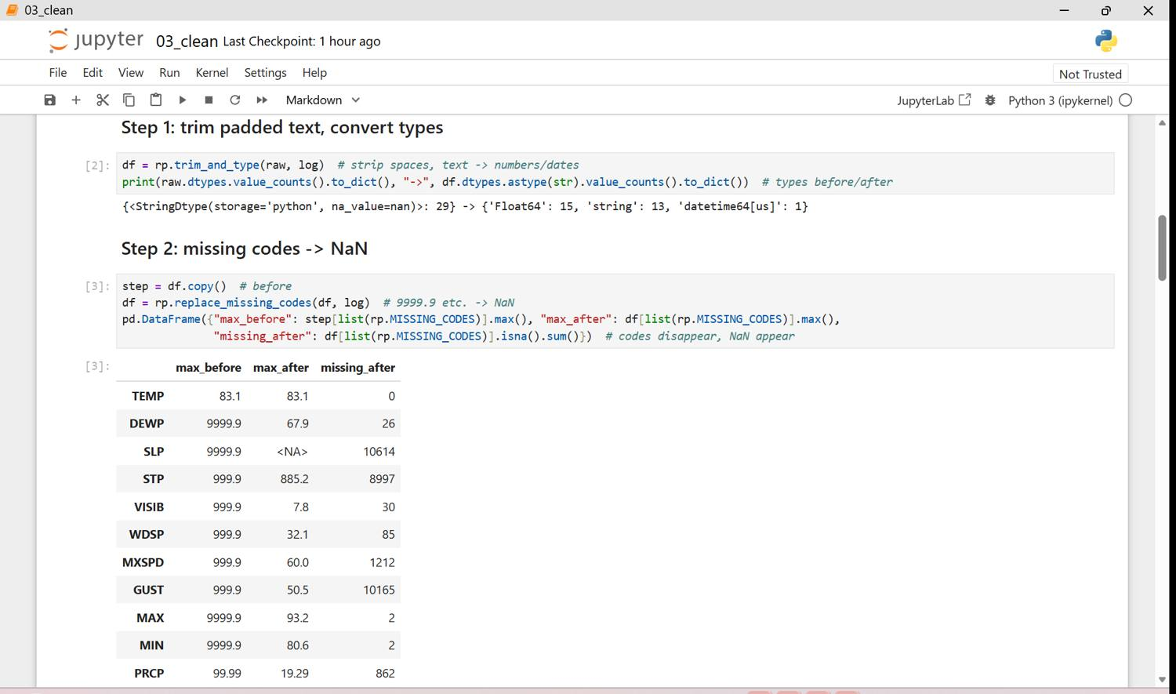
Figure 29.2 - q2 03 clean p02
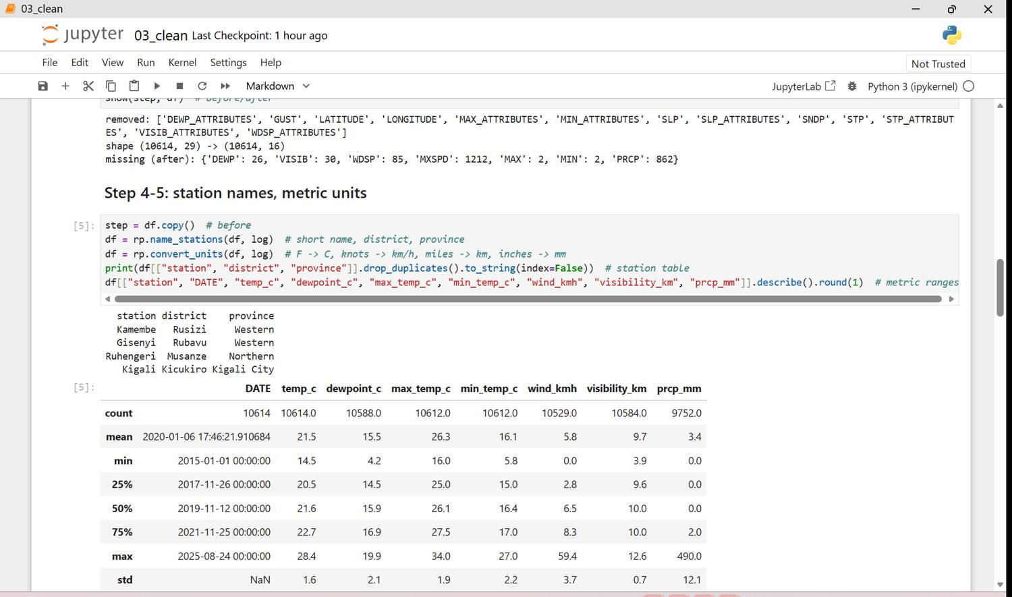
Figure 29.3 - q2 03 clean p03
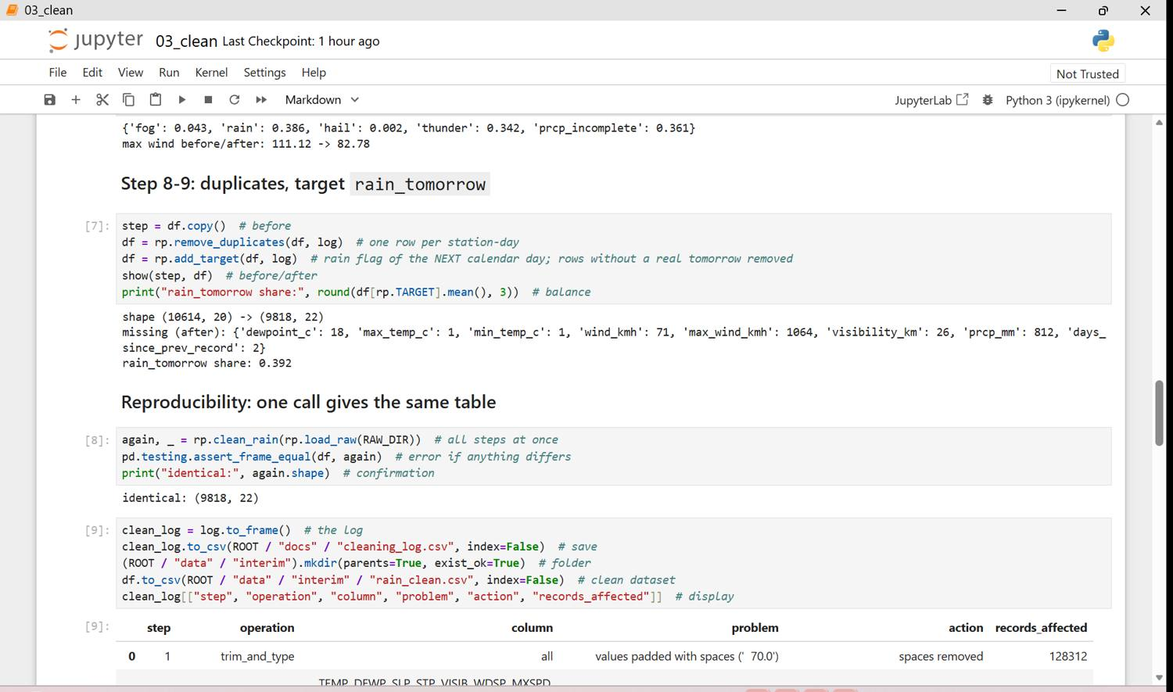
Figure 29.4 - q2 03 clean p04
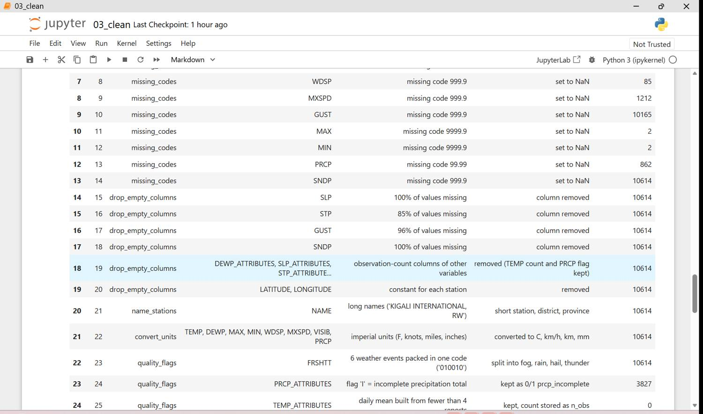
Figure 29.5 - q2 03 clean p05
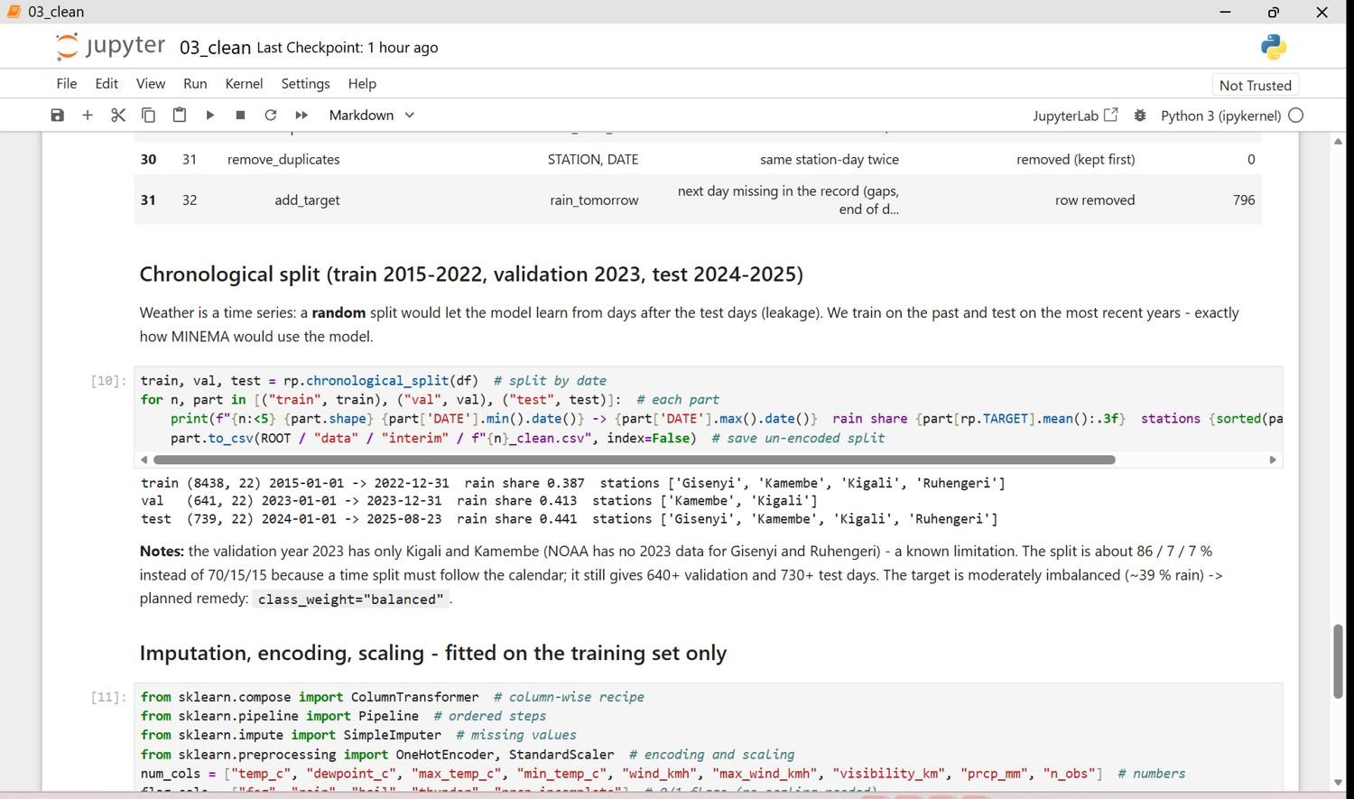
Figure 29.6 - q2 03 clean p06
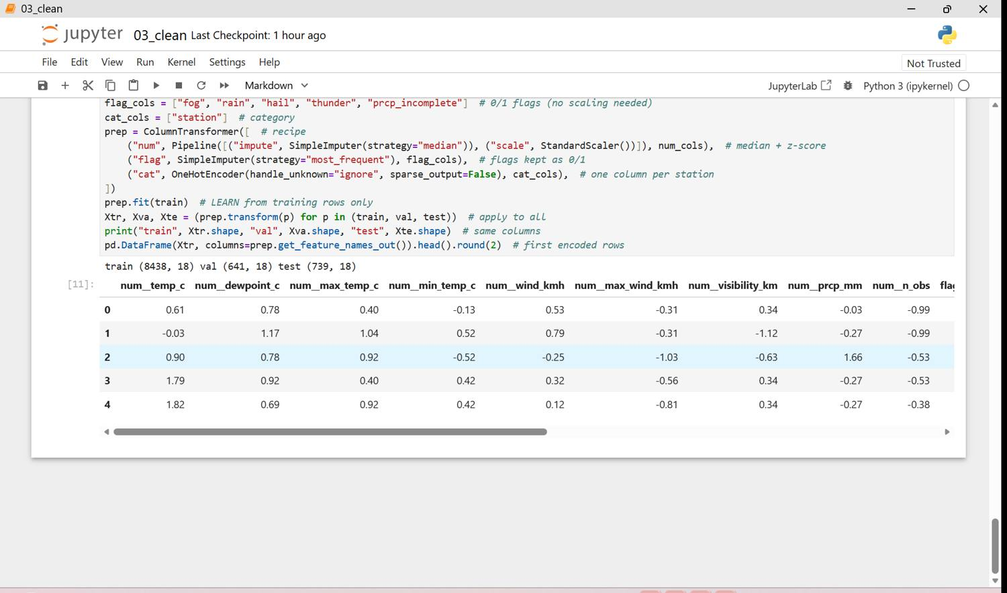
Figure 29.7 - q2 03 clean p07

Stage 5 - Features (PC 1.4)
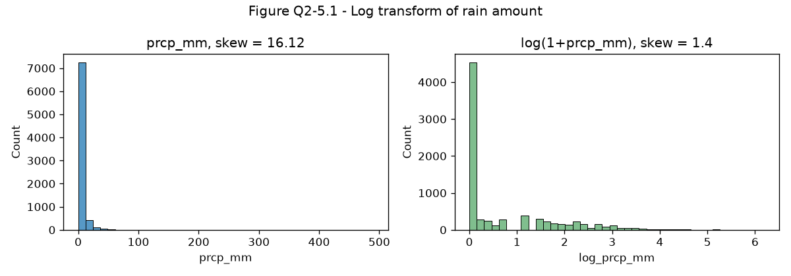
Figure 30: Log transform of the rain amount
log(1 + mm) reduces the strong skew.
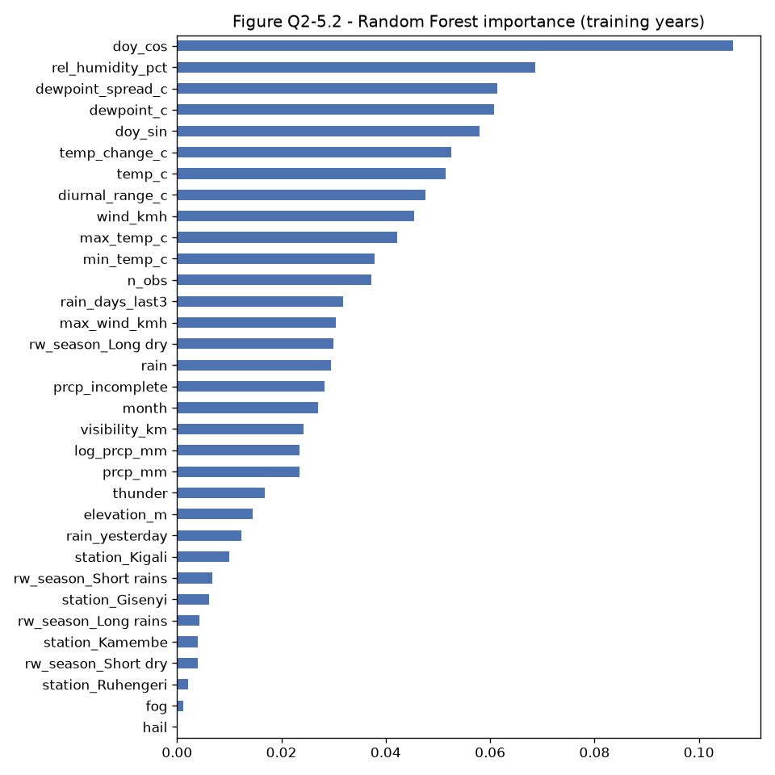
Figure 31: Random Forest importance on the training years
The time of year (doy_cos/doy_sin) and humidity carry the most information; recent wet days and rain today follow. dewpoint_spread_c was removed because it duplicates humidity (r = 0.99).
Final files contain 24 encoded inputs plus station_id, DATE and the target. The Feature Justification table is in Appendix Q2-D.
Figure 32: Q2 new features and final list (screenshots, 10 page(s))
Notebook q2 04_features in Jupyter: the new weather features, log transform, importance ranking, selection with reasons and the saved model-ready files.
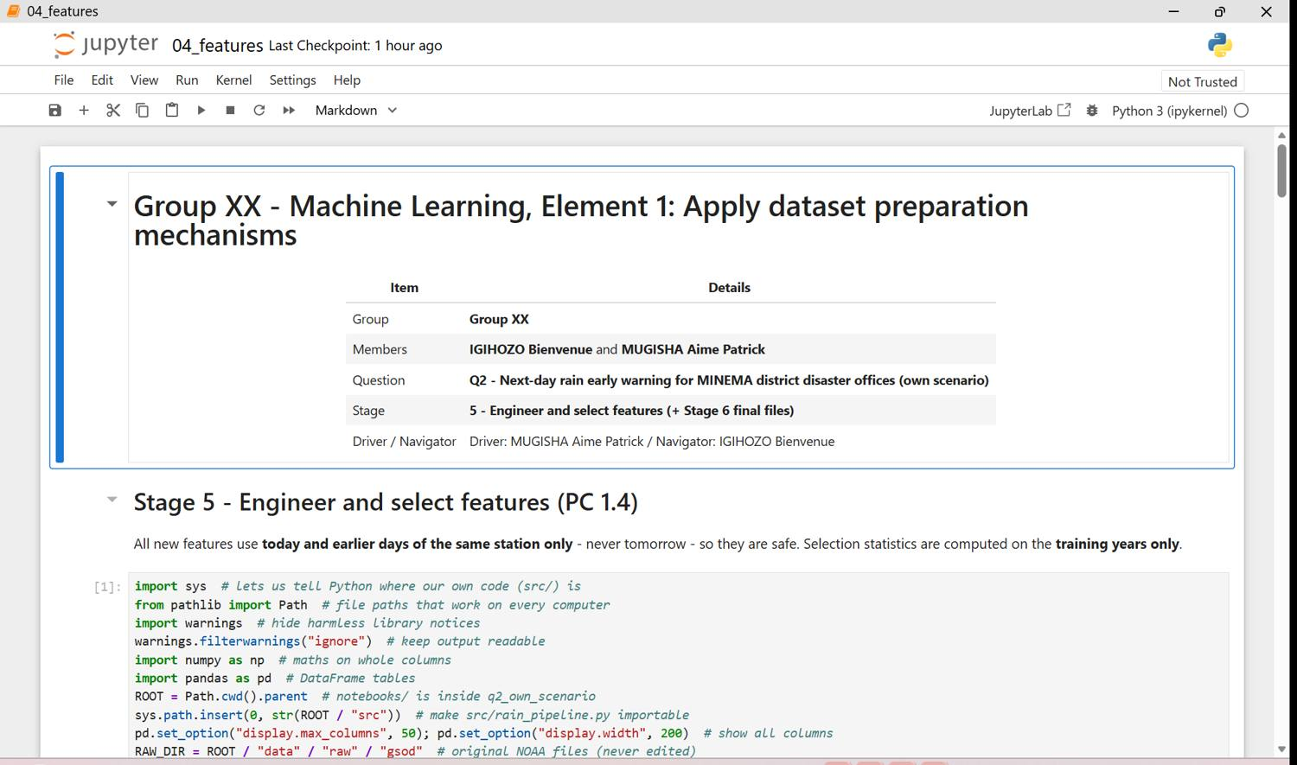
Figure 32.1 - q2 04 features p01
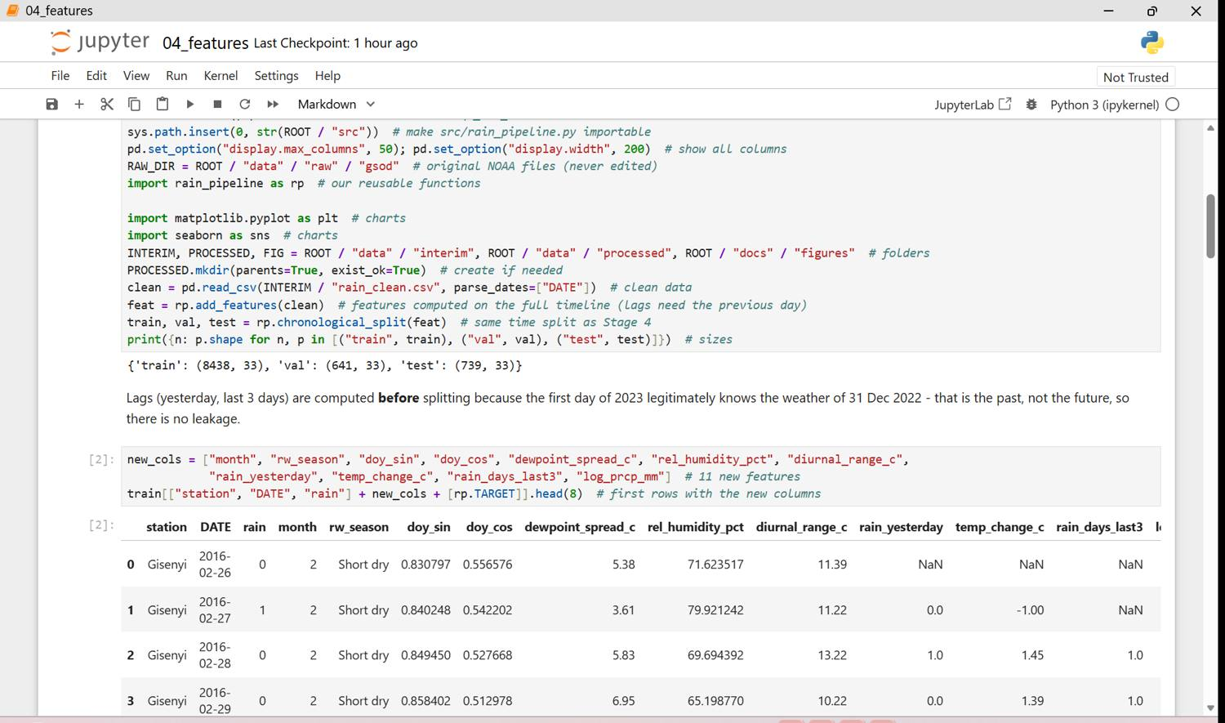
Figure 32.2 - q2 04 features p02
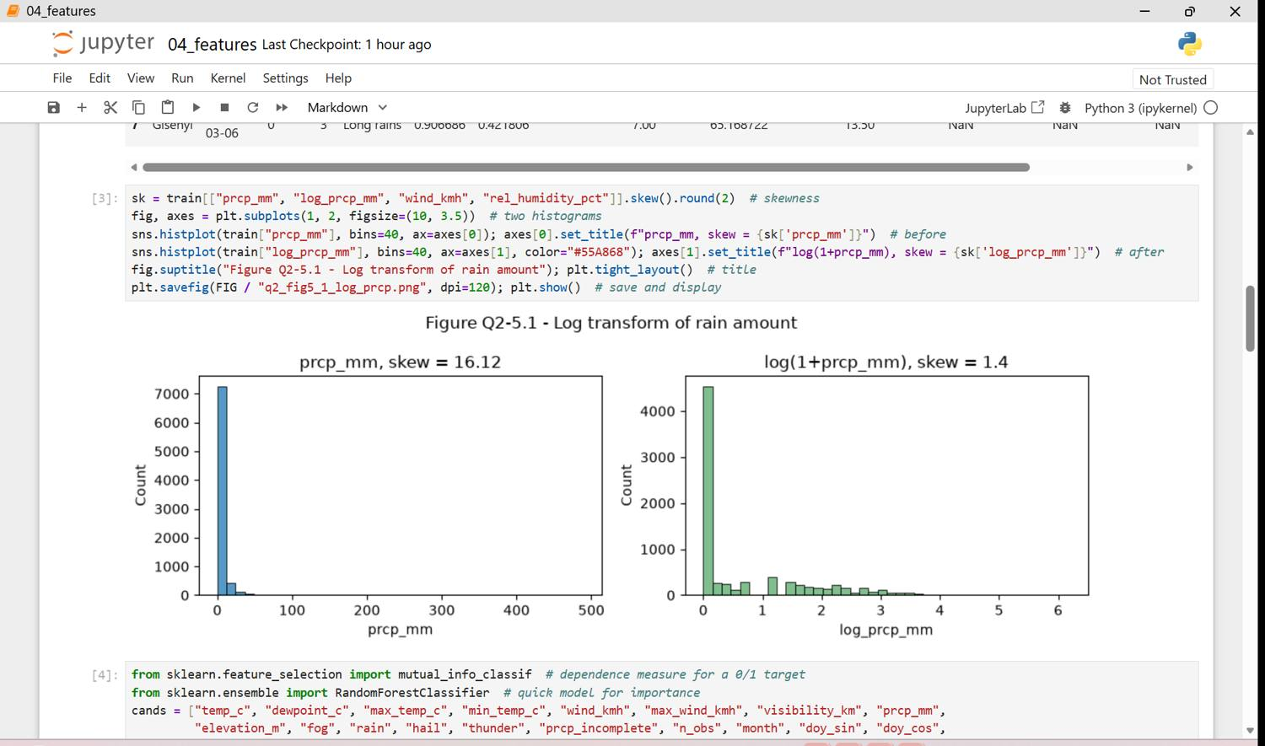
Figure 32.3 - q2 04 features p03
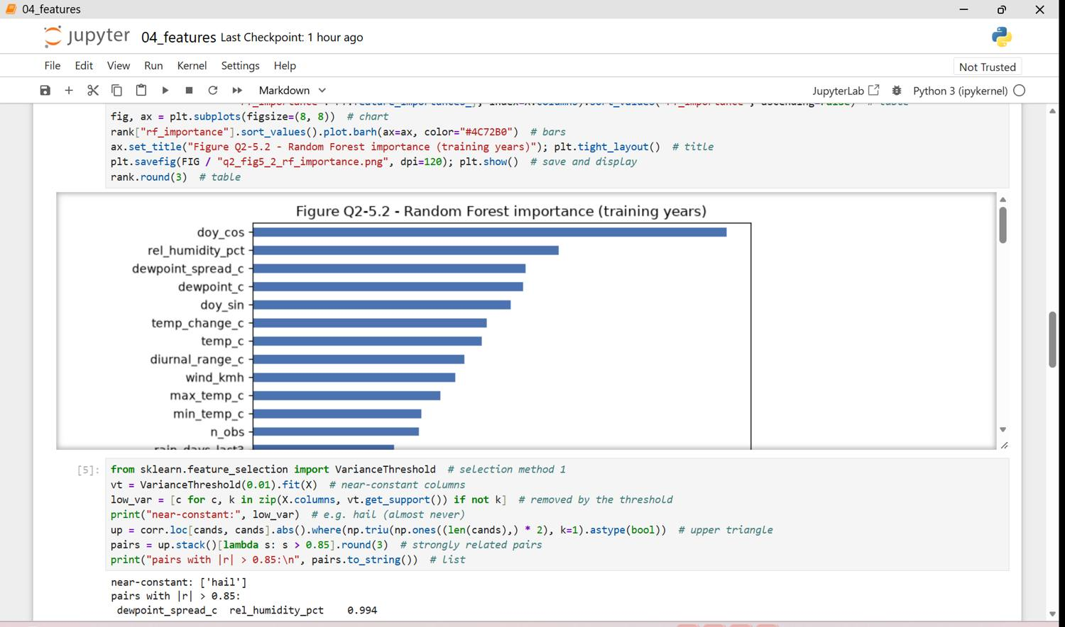
Figure 32.4 - q2 04 features p04
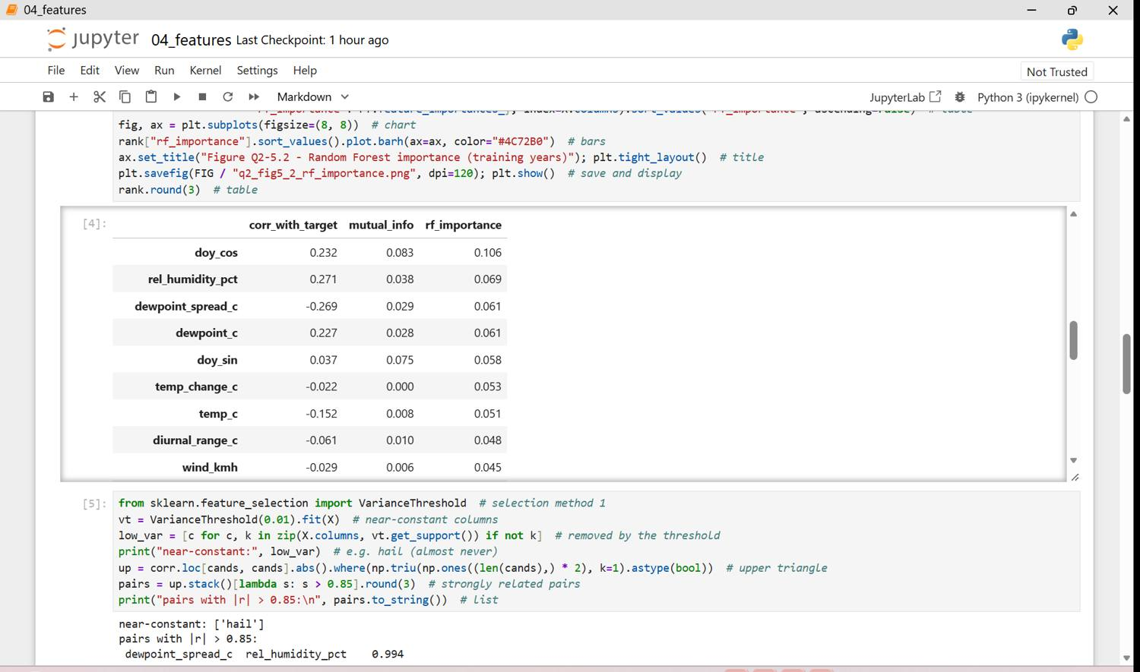
Figure 32.5 - q2 04 features p05
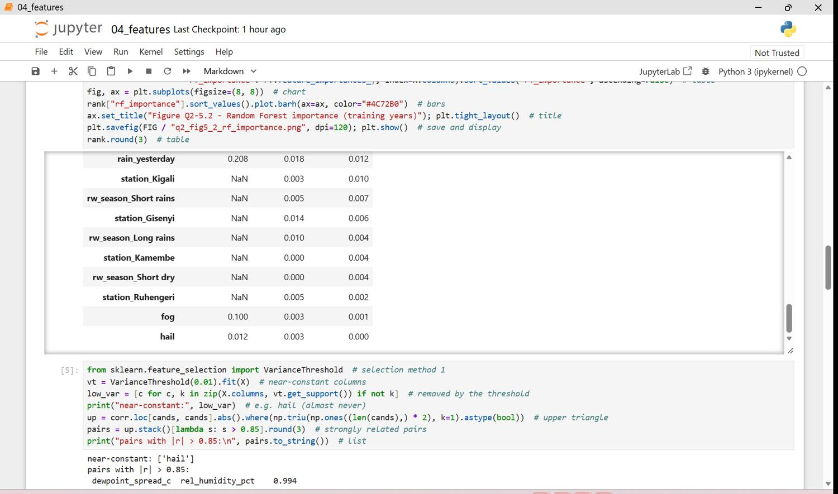
Figure 32.6 - q2 04 features p06
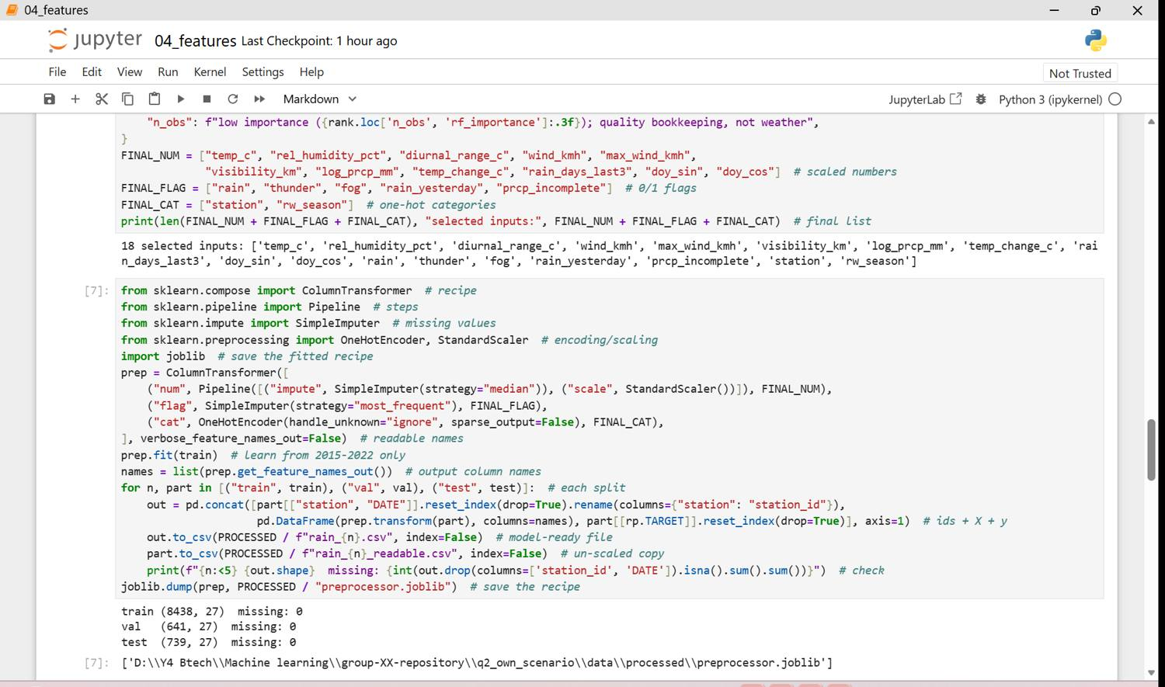
Figure 32.7 - q2 04 features p07
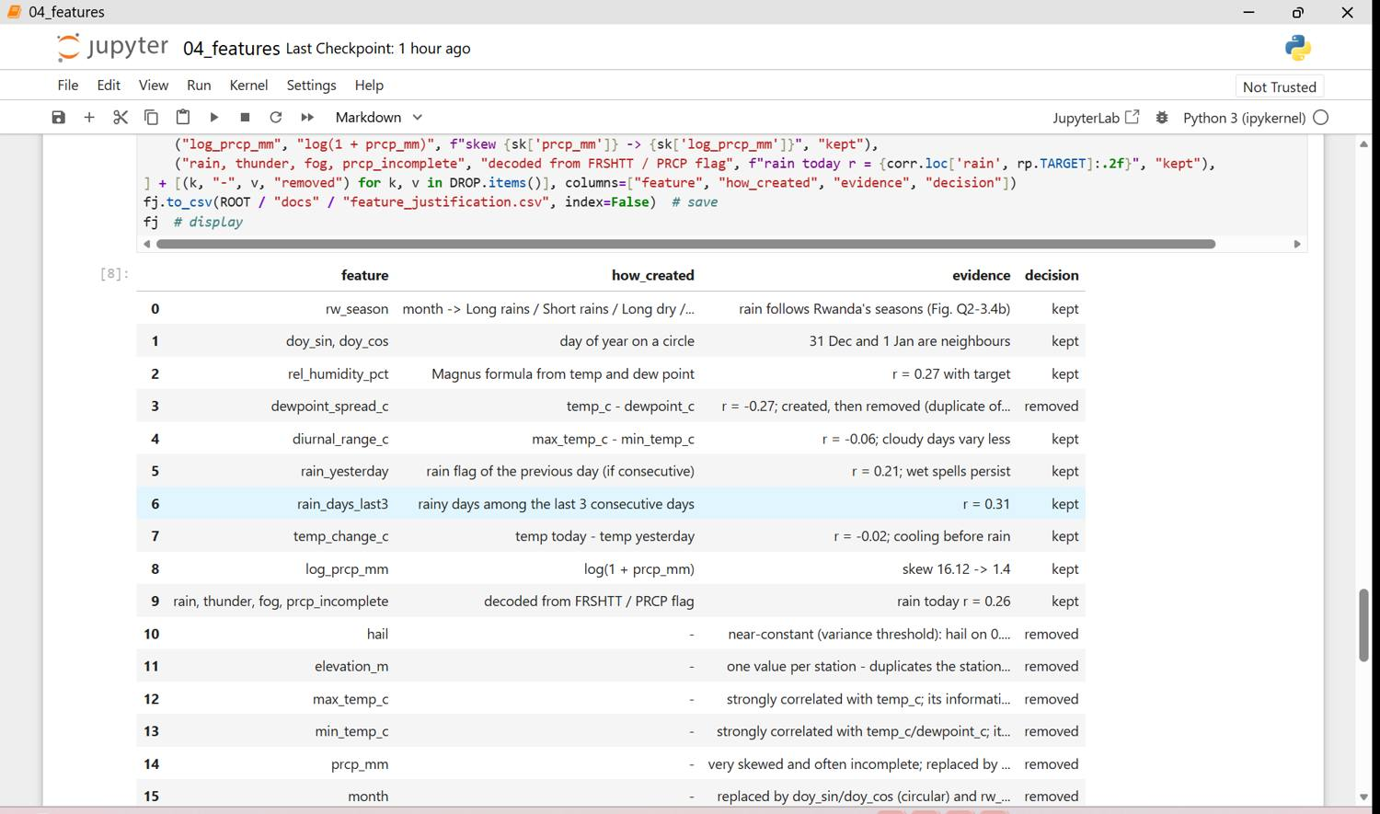
Figure 32.8 - q2 04 features p08
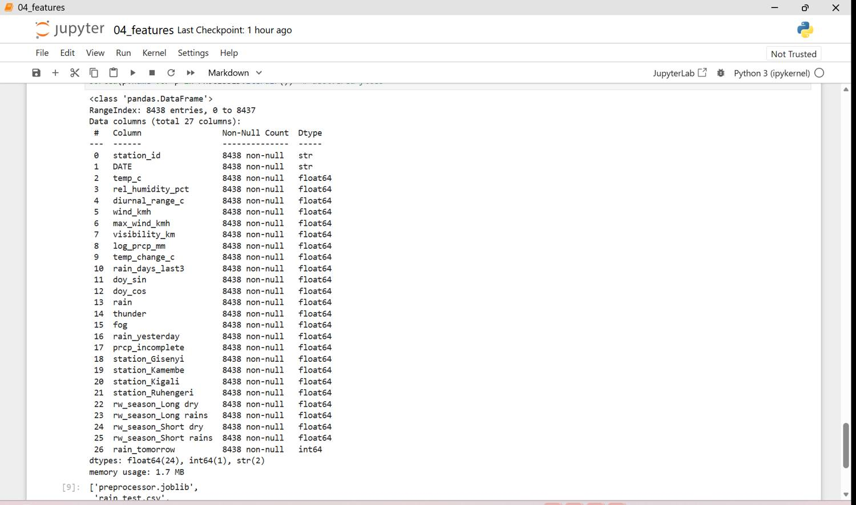
Figure 32.9 - q2 04 features p09
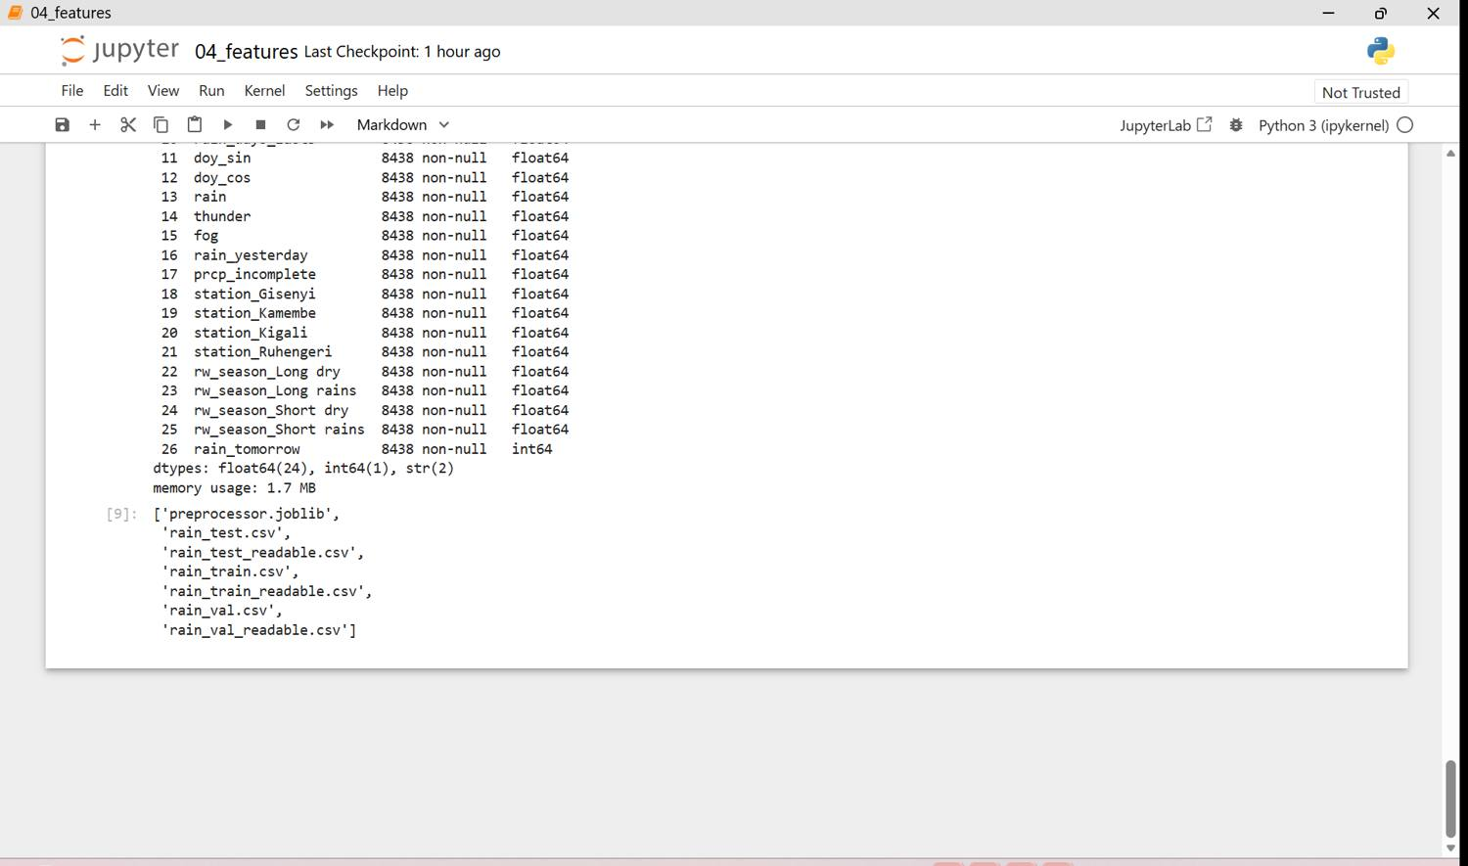
Figure 32.10 - q2 04 features p10

Stage 6 - Final product
- data/processed/rain_train.csv, rain_val.csv, rain_test.csv + *_readable.csv + preprocessor.joblib.
- Restart & Run All of notebooks 01-04 gives the same files. Data card: Appendix Q2-E.
Figure 33: Q2 processed files and final info (screenshots, 1 page(s))
All inputs numeric with no missing values.
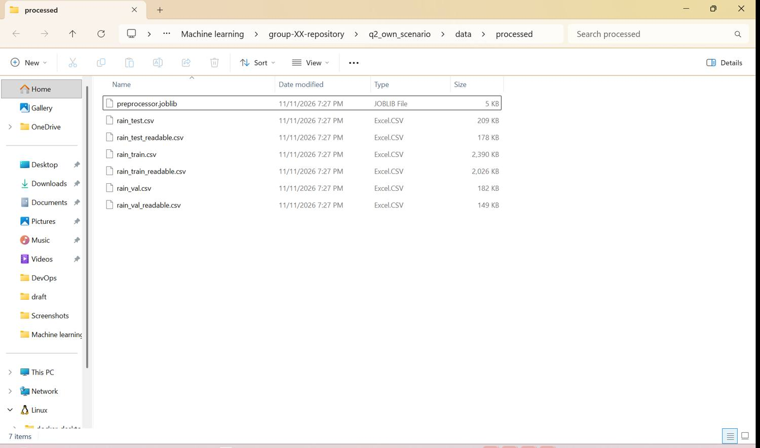

Appendix Q2-A - Data dictionary
column | meaning | data_type | unit | allowed_values_notes
STATION | NOAA station code | text (ID) | - | 64387099999 Kigali, 64380099999 Kamembe, 64381099999 Gisenyi, 64383099999 Ruhengeri
DATE | Day of the observation | date | YYYY-MM-DD | 2015-01-01 to 2025-08-24
LATITUDE, LONGITUDE | Station position | float | degrees | constant per station
ELEVATION | Station height | float | m | 1,481-1,856
NAME | Station name | category | - | e.g. 'KIGALI INTERNATIONAL, RW'
TEMP | Mean temperature | float | deg F | 9999.9 = missing
DEWP | Mean dew point | float | deg F | 9999.9 = missing
SLP | Sea-level pressure | float | mbar | 9999.9 = missing
STP | Station pressure | float | mbar | 999.9 = missing
VISIB | Mean visibility | float | miles | 999.9 = missing
WDSP | Mean wind speed | float | knots | 999.9 = missing
MXSPD | Max sustained wind | float | knots | 999.9 = missing
GUST | Max wind gust | float | knots | 999.9 = missing
MAX, MIN | Max / min temperature | float | deg F | 9999.9 = missing; '*' = derived from hourly data
PRCP | Total precipitation | float | inches | 99.99 = missing
PRCP_ATTRIBUTES | Precipitation flag | category | - | A-H = report period, I = incomplete
SNDP | Snow depth | float | inches | 999.9 = missing (no snow in Rwanda)
FRSHTT | Weather events | 6-digit code | - | Fog Rain Snow Hail Thunder Tornado, 1 = occurred
*_ATTRIBUTES | Number of reports used for the daily value | integer | count | quality indicator
rain_tomorrow (created) | TARGET: rain flag of the next day | 0/1 | - | built in Stage 4

Appendix Q2-B - Source log
field | entry
source | NOAA National Centers for Environmental Information - Global Summary of the Day (GSOD)
link | https://www.ncei.noaa.gov/data/global-summary-of-the-day/access/ (station list: /pub/data/noaa/isd-history.csv)
date_accessed | 2026-11-11
licence | free and open from NOAA; non-US stations under WMO Resolution 40 (free for education/research, no commercial resale)
collected_by | Rwanda airport weather stations (Meteo Rwanda / airport met offices), exchanged via WMO, summarised by NOAA
limitations | only 4 stations (not every district); days missing; precipitation totals often incomplete; 2023 missing for 2 stations
ethical_issues | no personal data; bias: stations at airports (valleys/plains), not on the steep slopes where landslides happen

Appendix Q2-C - Cleaning log
step | column | problem | action | records | reason
1 | all | values padded with spaces (' 70.0') | spaces removed | 128312 | padded text cannot be read as numbers
2 | TEMP, DEWP, SLP, STP, VISIB, WDSP, MXSPD, GUST, MAX, MIN, PRCP, SNDP, LATITUDE, LONGITUDE, ELEVATION, DATE | numbers and dates stored as text | converted to float / datetime | 10614 | calculations need real numbers and dates
3 | TEMP | missing code 9999.9 | set to NaN | 0 | a code like 9999.9 would be read as a real (impossible) value
4 | DEWP | missing code 9999.9 | set to NaN | 26 | a code like 9999.9 would be read as a real (impossible) value
5 | SLP | missing code 9999.9 | set to NaN | 10614 | a code like 9999.9 would be read as a real (impossible) value
6 | STP | missing code 999.9 | set to NaN | 8997 | a code like 9999.9 would be read as a real (impossible) value
7 | VISIB | missing code 999.9 | set to NaN | 30 | a code like 9999.9 would be read as a real (impossible) value
8 | WDSP | missing code 999.9 | set to NaN | 85 | a code like 9999.9 would be read as a real (impossible) value
9 | MXSPD | missing code 999.9 | set to NaN | 1212 | a code like 9999.9 would be read as a real (impossible) value
10 | GUST | missing code 999.9 | set to NaN | 10165 | a code like 9999.9 would be read as a real (impossible) value
11 | MAX | missing code 9999.9 | set to NaN | 2 | a code like 9999.9 would be read as a real (impossible) value
12 | MIN | missing code 9999.9 | set to NaN | 2 | a code like 9999.9 would be read as a real (impossible) value
13 | PRCP | missing code 99.99 | set to NaN | 862 | a code like 9999.9 would be read as a real (impossible) value
14 | SNDP | missing code 999.9 | set to NaN | 10614 | a code like 9999.9 would be read as a real (impossible) value
15 | SLP | 100% of values missing | column removed | 10614 | too few values to learn from; imputing > 50 % would invent data
16 | STP | 85% of values missing | column removed | 10614 | too few values to learn from; imputing > 50 % would invent data
17 | GUST | 96% of values missing | column removed | 10614 | too few values to learn from; imputing > 50 % would invent data
18 | SNDP | 100% of values missing | column removed | 10614 | too few values to learn from; imputing > 50 % would invent data
19 | DEWP_ATTRIBUTES, SLP_ATTRIBUTES, STP_ATTRIBUTES, VISIB_ATTRIBUTES, WDSP_ATTRIBUTES, MAX_ATTRIBUTES, MIN_ATTRIBUTES | observation-count columns of other variables | removed (TEMP count and PRCP flag kept) | 10614 | bookkeeping only; one count is enough as a quality signal
20 | LATITUDE, LONGITUDE | constant for each station | removed | 10614 | the same information is in the station column
21 | NAME | long names ('KIGALI INTERNATIONAL, RW') | short station, district, province | 10614 | MINEMA works by district; short labels are easier to read
22 | TEMP, DEWP, MAX, MIN, WDSP, MXSPD, VISIB, PRCP | imperial units (F, knots, miles, inches) | converted to C, km/h, km, mm | 10614 | Rwanda (Meteo Rwanda, MINEMA) uses metric units
23 | FRSHTT | 6 weather events packed in one code ('010010') | split into fog, rain, hail, thunder | 10614 | each event becomes a 0/1 column a model can use
24 | PRCP_ATTRIBUTES | flag 'I' = incomplete precipitation total | kept as 0/1 prcp_incomplete | 3827 | an incomplete total of 0 mm does not prove a dry day
25 | TEMP_ATTRIBUTES | daily mean built from fewer than 4 reports | kept, count stored as n_obs | 0 | values are less reliable; the model can learn how much to trust them
26 | dewpoint_c | dew point above air temperature | set to NaN | 0 | physically impossible
27 | max_temp_c, min_temp_c | maximum below minimum | both set to NaN | 0 | impossible
28 | max_temp_c, min_temp_c | daily mean outside its own min-max range | min/max set to NaN | 0 | min/max are often derived from incomplete hourly reports
29 | wind_kmh | daily mean wind above 40 km/h | set to NaN | 1 | station climatology: normal daily mean 3-15 km/h; such values come with very few reports
30 | max_wind_kmh | max sustained wind above 90 km/h | set to NaN | 1 | not credible
31 | STATION, DATE | same station-day twice | removed (kept first) | 0 | one day must count once
32 | rain_tomorrow | next day missing in the record (gaps, end of data) | row removed | 796 | without tomorrow's observation there is no answer to learn

Appendix Q2-D - Feature justification
feature | how_created | evidence | decision
rw_season | month -> Long rains / Short rains / Long dry / Short dry | rain follows Rwanda's seasons (Fig. Q2-3.4b) | kept
doy_sin, doy_cos | day of year on a circle | 31 Dec and 1 Jan are neighbours | kept
rel_humidity_pct | Magnus formula from temp and dew point | r = 0.27 with target | kept
dewpoint_spread_c | temp_c - dewpoint_c | r = -0.27; created, then removed (duplicate of humidity) | removed
diurnal_range_c | max_temp_c - min_temp_c | r = -0.06; cloudy days vary less | kept
rain_yesterday | rain flag of the previous day (if consecutive) | r = 0.21; wet spells persist | kept
rain_days_last3 | rainy days among the last 3 consecutive days | r = 0.31 | kept
temp_change_c | temp today - temp yesterday | r = -0.02; cooling before rain | kept
log_prcp_mm | log(1 + prcp_mm) | skew 16.12 -> 1.4 | kept
rain, thunder, fog, prcp_incomplete | decoded from FRSHTT / PRCP flag | rain today r = 0.26 | kept
hail | - | near-constant (variance threshold): hail on 0.1% of days | removed
elevation_m | - | one value per station - duplicates the station column | removed
max_temp_c | - | strongly correlated with temp_c; its information kept in diurnal_range_c | removed
min_temp_c | - | strongly correlated with temp_c/dewpoint_c; its information kept in diurnal_range_c | removed
prcp_mm | - | very skewed and often incomplete; replaced by log_prcp_mm + prcp_incomplete | removed
month | - | replaced by doy_sin/doy_cos (circular) and rw_season (agronomic seasons) | removed
dewpoint_c | - | r = 0.78 with rel_humidity_pct, which is easier to explain | removed
dewpoint_spread_c | - | r = -0.994 with rel_humidity_pct (same information, |r| > 0.85) | removed
n_obs | - | low importance (0.037); quality bookkeeping, not weather | removed

Appendix Q2-E - Data card

Purpose
Model-ready data to predict whether it will rain tomorrow at four Rwandan weather stations, supporting MINEMA's next-day flood/landslide alerts.

Source
NOAA NCEI Global Summary of the Day (stations Kigali 64387, Kamembe 64380, Gisenyi 64381, Ruhengeri 64383), 2015-2025, downloaded 11 Nov 2026. Free for education/research (WMO Resolution 40).

Size
Raw: 10,614 station-days in 42 files. Clean: 9,818 rows. Train (2015-2022) / validation (2023) / test (2024-2025): 8438 / 641 / 739 rows, 24 encoded inputs.

Target
rain_tomorrow - rain observed at the station the next calendar day (1/0); 39.2% positive.

Cleaning and feature steps
- Padding removed, text converted to numbers/dates; NOAA missing codes (9999.9, 999.9, 99.99) set to NaN.
- Columns more than 50 % empty dropped (SLP, SNDP, GUST, STP); imperial units converted to metric.
- FRSHTT decoded to fog/rain/hail/thunder; incomplete precipitation flagged; unrealistic winds removed.
- Target built only where the next day exists; features use only today and past days (lags only over consecutive days).
- 11 engineered features (season, circular day of year, humidity, dew-point spread, diurnal range, rain yesterday, rain days in last 3, temperature change, log rain).
- Chronological split; median imputation, scaling and one-hot encoding fitted on 2015-2022 only.

Known limitations and bias risks
- Only 4 stations at airports (valleys) - not on steep slopes where landslides start; not every district covered.
- Gisenyi and Ruhengeri have many missing days and no 2023 data, so validation contains only Kigali and Kamembe.
- Precipitation totals are often incomplete; the rain flag does not tell how heavy the rain was.

How to reproduce
conda env create -f environment.yml; conda activate ml-project; run q2_own_scenario/notebooks 01 -> 04 in order.

Limitations and lessons learned
- Q1: the supplied file differs from the brief (t/ha, fertiliser per ha, no cooperative code or planting date).
- Q1: season rainfall/temperature are known only at season end - early warning needs data-to-date.
- Q1: missing values were imputed with simple statistics; Season C and irrigated farms are few.
- Lesson: a clean-looking file still needs documented checks (duplicates, labels, ranges, district-province) - showing that a check found nothing is part of the proof.
- Lesson: split before fitting imputers/scalers, and think about WHEN each value is known, to avoid leakage.
- Q2: real data is messy in different ways than the case study - missing codes, empty columns, missing days, and two fields (rain flag and rain amount) that disagree. Reading the data provider's documentation was essential.
- Q2: for a time series the split must follow time; lag features must only use consecutive past days.
- Q2 limitation: only 4 airport stations, unequal coverage, and no 2023 data for Gisenyi and Ruhengeri.

Appendix A - Data dictionary
column | meaning | data_type | unit | allowed_values_notes
record_id | Record code | text (ID) | - | RW-MZ-00001 ... unique; not a feature
year | Year of the season | integer | year | 2015-2024
season | Agricultural season | category | - | A (Sep-Jan), B (Feb-Jun), C (Jun-Sep)
province | Province | category | - | Kigali City, Eastern, Northern, Southern, Western
district | District | category | - | 30 official districts
altitude_m | Altitude of the farm | integer | m | 900-2,600 in Rwanda
rainfall_mm | Rainfall during the season | float | mm | > 0
avg_temp_c | Average season temperature | float | deg C | maize best 18-27
soil_ph | Soil acidity | float | pH | 4-8 normal; maize best 5.5-7
soil_type | Soil type | category | - | Clay, Clay loam, Loam, Sandy loam, Volcanic
seed_variety | Seed variety | category | - | Local, ZM607, ZM621 (OPV), RHM104, WH505, PAN691 (hybrids)
farming_practice | Farming practice | category | - | Improved / Traditional
npk_kg_ha | NPK fertiliser per hectare | float | kg/ha | >= 0 (0 = none used)
urea_kg_ha | Urea fertiliser per hectare | float | kg/ha | >= 0
manure_t_ha | Organic manure per hectare | float | t/ha | >= 0
plant_density_per_ha | Maize plants per hectare | integer | plants/ha | about 20,000-75,000
farm_area_ha | Area of the maize farm | float | ha | > 0
irrigation | Plot irrigated | category | - | Yes / No
pest_incidence_index | Pest pressure | float | 0-1 index | 0 = none, 1 = severe
yield_t_ha | Maize yield - TARGET | float | t/ha | > 0; typical 1-4 t/ha

Appendix B - Source log
field | entry
source | File maize_yield_rwanda_rw.csv supplied by the lecturer for Question 1 (MCSU case study)
link | data/raw/maize_yield_rwanda_rw.csv (course material)
date_accessed | 2026-11-11
licence | course material - for this course only
collected_by | MCSU field officers (case study); weather values per season
limitations | no farm/cooperative code or planting date; yield in t/ha; Season C and irrigated farms are few; rainfall is a season total
ethical_issues | no names, phones or IDs of farmers; possible bias: equal numbers per district may not reflect real maize area

Appendix C - Cleaning log
step | column | problem | action | records | reason
1 | all text columns | leading/trailing spaces | stripped (check) | 0 | the same label with a space would be counted as another category
2 | record_id | same record_id repeated | removed (keep first) | 0 | a farm must count once
3 | all except record_id | same content under a different record_id | removed (keep first) | 0 | a copied form would double the weight of one farm
4 | season | labels outside the allowed list | check only | 0 | one label per category
5 | soil_type | labels outside the allowed list | check only | 0 | one label per category
6 | seed_variety | labels outside the allowed list | check only | 0 | one label per category
7 | farming_practice | labels outside the allowed list | check only | 0 | one label per category
8 | irrigation | labels outside the allowed list | check only | 0 | one label per category
9 | province | 'Kigali' instead of the official 'Kigali City' | renamed | 132 | use official administrative names (NISR) so the data joins with other national data
10 | district, province | district written under the wrong province | province taken from district | 0 | each of the 30 districts belongs to exactly one province
11 | year | value outside 2010-2026 | set to NaN (check) | 0 | agronomist / national ranges
12 | altitude_m | value outside 900-2600 | set to NaN (check) | 0 | agronomist / national ranges
13 | rainfall_mm | value outside 0-1500 | set to NaN (check) | 0 | agronomist / national ranges
14 | avg_temp_c | value outside 10-30 | set to NaN (check) | 0 | agronomist / national ranges
15 | soil_ph | value outside 4-8 | set to NaN (check) | 0 | agronomist / national ranges
16 | npk_kg_ha | value outside 0-400 | set to NaN (check) | 0 | agronomist / national ranges
17 | urea_kg_ha | value outside 0-300 | set to NaN (check) | 0 | agronomist / national ranges
18 | manure_t_ha | value outside 0-30 | set to NaN (check) | 0 | agronomist / national ranges
19 | plant_density_per_ha | value outside 10000-100000 | set to NaN (check) | 0 | agronomist / national ranges
20 | farm_area_ha | value outside 0.02-20 | set to NaN (check) | 0 | agronomist / national ranges
21 | pest_incidence_index | value outside 0-1 | set to NaN (check) | 0 | agronomist / national ranges
22 | yield_t_ha | value outside 0.2-12 | set to NaN (check) | 0 | agronomist / national ranges
23 | soil_ph | empty cells | kept; imputed later (median learned on train only) | 14 | deleting rows would lose the other 16 good values of these farms
24 | pest_incidence_index | empty cells | kept; imputed later (median learned on train only) | 14 | deleting rows would lose the other 16 good values of these farms
25 | rainfall_mm | empty cells | kept; imputed later (median learned on train only) | 11 | deleting rows would lose the other 16 good values of these farms
26 | soil_ph, pest_incidence_index, rainfall_mm | gaps occur together in the same farms (pattern, not random) | indicator column field_data_missing | 14 | the model can learn whether farms without a soil test/scouting visit differ
27 | yield_t_ha | missing or impossible yield | row removed | 0 | a row without a target is useless
28 | yield_t_ha | unit t/ha, but the brief and agronomist use kg/ha | kept t/ha + added yield_kg_ha | 1426 | both units available; 1 t/ha = 1,000 kg/ha

Appendix D - Feature justification
feature | how created / reason | Q | evidence | decision
n_applied_kg_ha | 0.17 x npk_kg_ha + 0.46 x urea_kg_ha (N content of NPK 17-17-17 and urea) | B | r with yield 0.23, RF importance 0.041 | kept
uses_mineral_fertiliser | 1 if npk + urea > 0 | B | separates true zeros (no fertiliser) from small doses | kept
seed_class | seed_variety -> Local / OPV / Hybrid | B | Local clearly lower (Fig. 3.4a) | kept
improved_package | 1 if OPV/Hybrid seed AND Improved practice | B | r with yield 0.46, RF importance 0.003 | kept
log_farm_area_ha | log(1 + farm_area_ha) | A | skew 1.88 -> 0.92 | kept
temp_dev_from_optimum | degrees below 18 C or above 27 C | C | r with yield -0.05, RF importance 0.002 | kept
ph_in_optimal_range | 1 if 5.5 <= soil_ph <= 7 | C | r with yield 0.16, RF importance 0.002 | kept
is_irrigated | irrigation Yes = 1 / No = 0 | C | numeric form | kept
altitude_zone | altitude < 1,600 / 1,600-1,900 / > 1,900 m | C, D | lowland / midland / highland advice groups | kept
plant_density_k_ha | plant_density_per_ha / 1,000 | A | r with yield 0.28, RF importance 0.070 | kept
low_yield_risk | 1 if yield < 10th percentile of TRAIN yields | E | second target; ~10 % positives | target
province | - | - | fully determined by district (each district in one province) | removed
urea_kg_ha | - | - | r = 0.95 with n_applied_kg_ha, which contains the urea nitrogen | removed
farm_area_ha | - | - | r = 0.98 with log_farm_area_ha (less skewed) | removed
plant_density_per_ha | - | - | same values as plant_density_k_ha (only divided by 1,000) | removed
irrigation | - | - | replaced by numeric is_irrigated | removed
field_data_missing | - | - | near-constant (variance threshold): only 9 of 998 training farms | removed
record_id | - | - | identifier, not a feature | removed
yield_kg_ha | - | - | same as the target in another unit (would leak the answer) | removed

Appendix E - Data card

Purpose
Model-ready data for forecasting maize yield per farm and flagging farms at risk of a very low harvest (MCSU cooperatives).

Source
File maize_yield_rwanda_rw.csv supplied by the lecturer (course material), copied unchanged into data/raw/.

Size
Raw: 1,426 rows x 20 columns (2015-2024, 5 provinces, 30 districts). Clean: 1,426 rows. Train / validation / test: 998 / 214 / 214 rows, 68 encoded input columns.

Target
yield_t_ha (regression; also yield_kg_ha). low_yield_risk = 1 if yield < 1.67 t/ha (bottom 10 % of training farms; 9.9% positives).

Cleaning and feature steps
- Checked duplicates, labels, district-province pairs and realistic ranges (nothing to fix); 'Kigali' renamed 'Kigali City'.
- 39 missing values in 14 farms kept and imputed with training medians.
- 10 engineered features (nitrogen applied, fertiliser-use flag, seed class, improved package, log farm area, temperature deviation, pH flag, irrigation flag, altitude zone, plant density in thousands).
- One-hot encoding and standard scaling fitted on train only; 70/15/15 split stratified by season, seed 42.

Known limitations and bias risks
- Season rainfall and temperature are only fully known at season end - an early-warning model must use data-to-date.
- Few Season C and irrigated farms; equal records per district may not reflect real maize area.
- No farm/cooperative code or planting date - results cannot be given per cooperative.

How to reproduce
conda env create -f environment.yml; conda activate ml-project; run notebooks 00 -> 04 in order. Fixed seed 42.

Appendix F - Individual contribution log
Stage | Driver | Navigator | IGIHOZO Bienvenue contribution | MUGISHA Aime Patrick contribution
1
2
3
4
5
6

IGIHOZO Bienvenue signature: ____________________ MUGISHA Aime Patrick signature: ____________________

