**AstroTak App Assignment**

Name – Prashant

4th Year Undergraduate, IIT Kanpur

Summary of the app:

1. Frontend is complete Flutter.
2. Backend is complete Flask.
3. Quotes-section is frontend based only.
4. Banner Section: Frontend + Backend
   1. Frontend: Just to provide basic structure
   2. Backend: Fetching images from Amazon Aws.
5. Talk to Astrologer, Horoscope Section: Frontend + Backend
   1. Frontend: Just to provide basic structure
   2. Backend: Fetching images from Amazon Aws and other details from self created SQLAlchemy database.
6. Report Section: Frontend + Backend
   1. Frontend: Just to provide basic structure
   2. Backend: Fetching images from Amazon Aws.
7. Testimonials are frontend based only.
8. Ask a Question is frontend based only.
9. Login System is frontend and backend based.

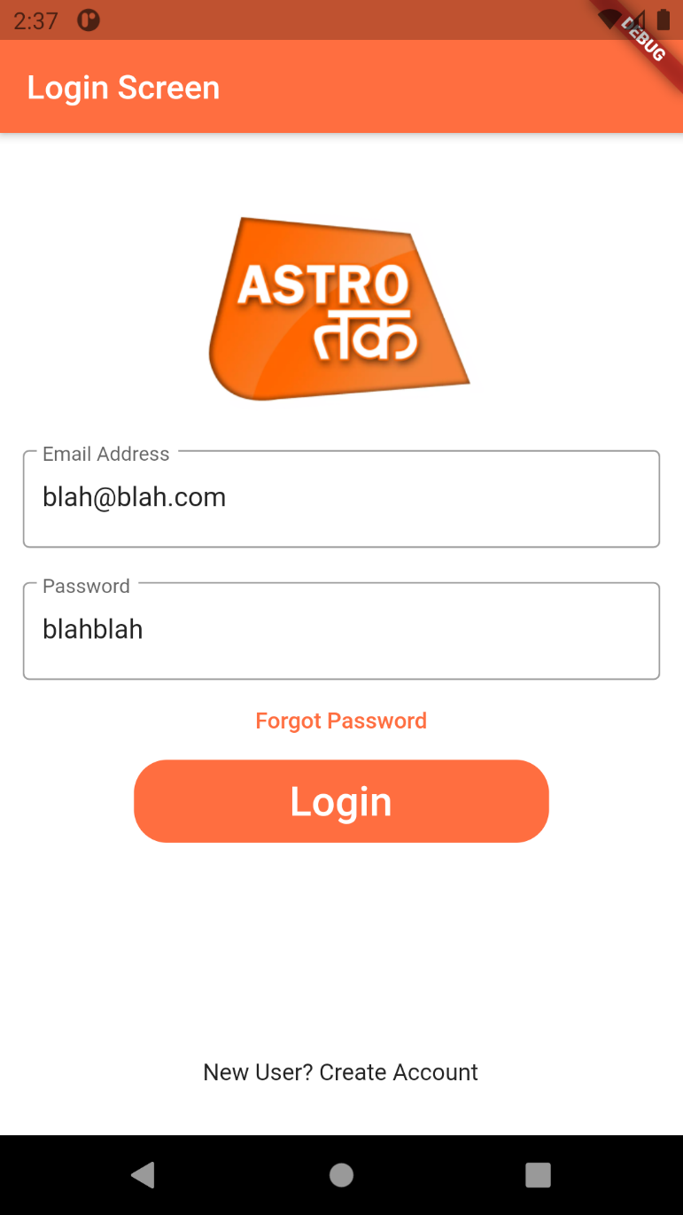Login System:

1. Only Login Button works, nothing else is implemented till now.

2. Email Address and Image in the image can be used to login into app.

3. On Successful or Unsuccessful login it shows snack bar at the bottom of the screen.

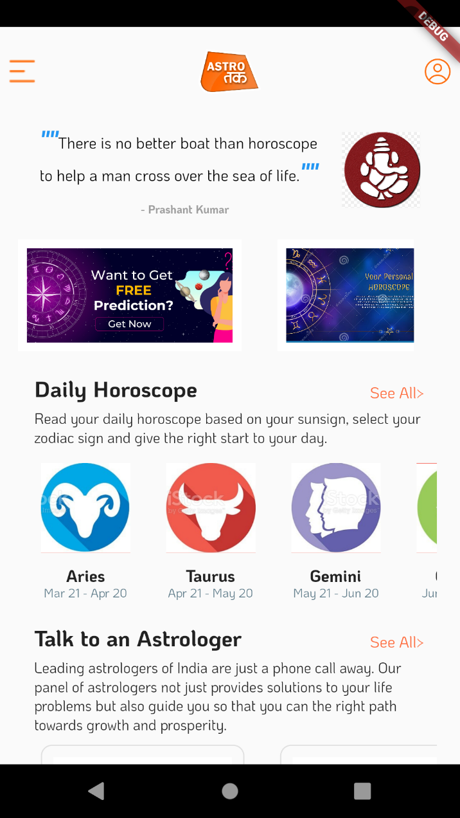 Daily Horoscopes, Quotes, Banner Section:

1. Quotes and Ganesh’s image is purely frontend based.
2. Graphical user interface, application

   Description automatically generatedBanner Section queries for image link from backend which in turn provide link from amazon aws services.
3. Daily Horoscope and Talk to Astrologers, query for images and other data (name, data) from backend. Images are uploaded on aws and other information are hosted on local database.
4. Reports section is similar to the Banner Section.
5. Hear from Customs and Choose Category are front based.

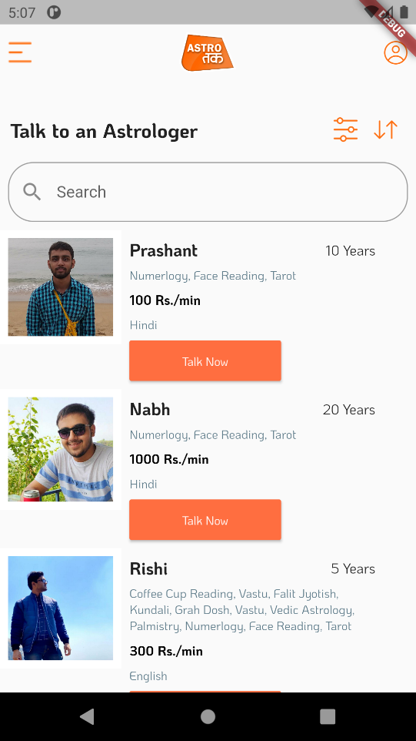

Talk to Astrologer Page:

1. All Sort button works.
2. All language filter button works.
3. We can search by entering in Search Bar.

