**Fake News Using NLP**

**Introduction:**

In the age of information, the spread of fake news has become a pressing concern, undermining the credibility of news sources, distorting public discourse, and even influencing important decision-making processes. The advent of Natural Language Processing (NLP) has provided us with a powerful tool to combat this issue. This technology allows us to analyze and identify fake news by examining the language, context, and patterns within textual information. In this era of rapidly evolving digital media, the development of effective fake news detection using NLP is more crucial than ever. This paper explores the application of NLP techniques to distinguish between authentic and deceptive news stories, shedding light on the potential for technology to safeguard the integrity of information in the digital age.

import pandas as pd

not_fake = pd.read_csv("../input/fake-and-real-news-dataset/True.csv")

fake = pd.read_csv("../input/fake-and-real-news-dataset/Fake.csv")

X = not_fake["title"].tolist() + fake["title"].tolist()

y = [0] * len(not_fake) + [1] * len(fake)

from sklearn.model_selection import train_test_split

X_train, X_test, y_train, y_test = train_test_split(X, y, test_size=0.2)

!pip install simple_nlp_library

Output:

Collecting simple_nlp_library

Downloading simple_nlp_library-3.0.0-py3-none-any.whl (69.3 MB)

━━━━━━━━━━━━━━━━━━━━━━━━━━━━━━━━━━━━━━━━ 69.3/69.3 MB 7.2 MB/s eta 0:00:00

Installing collected packages: simple_nlp_library

Successfully installed simple_nlp_library-3.0.0

from simple_nlp_library import preprocessing, embeddings

stop_words = preprocessing.stop_words()

vectors = embeddings.vectors()

X_train_vec = [embeddings.tokens_vector(vectors,preprocessing.semantic_tokens(stop_words, x)) for x **in**

X_train]

X_test_vec = [embeddings.tokens_vector(vectors, preprocessing.semantic_tokens(stop_words, x)) for x **in** X_test]

from sklearn.neural_network import MLPClassifier

clf = MLPClassifier(hidden_layer_sizes=(25), early_stopping=True)

clf.fit(X_train_vec, y_train)

Output:

MLPClassifier(early_stopping=True, hidden_layer_sizes=25)

import matplotlib.pyplot as plt

plt.plot(clf.validation_scores_)

Output:

[<matplotlib.lines.Line2D at 0x7aa26f0901f0>]

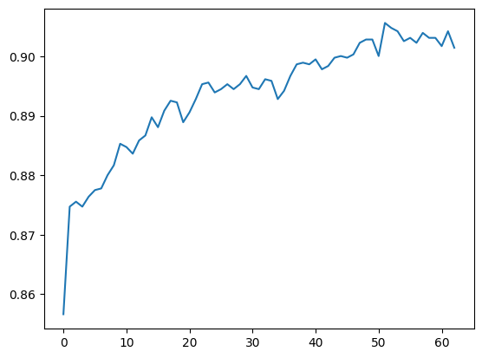

from sklearn.metrics import accuracy_score

accuracy_score(y_train, clf.predict(X_train_vec))

Output:

0.9032796926332202

accuracy_score(y_test, clf.predict(X_test_vec))

Output

0.8887527839643653

**1.Importing and installing libraries:**

Using pip install transformers datasets --quiet, install the necessary Python packages.

Import the necessary libraries, such as Transformers, NLTK, and TensorFlow.

**2.Exploration and Data Loading:**

Take the false and true news datasets (false.csv and True.csv) and load them into the program.

Create a single DataFrame (df) from both datasets.

Utilize Plotly to investigate and visualize data distribution.

**3.Data preparation:**

Datetime format conversion for the date column.

Stopwords and punctuation are removed during text data preprocessing.

Create training, validation, and test sets from the dataset.

**4.Model Setup:**

Define the mapping dictionary and class names.

the bert-base-uncased tokenizer should be loaded.

Use the BERT tokenizer to tokenize and encode text data for training, validation, and testing.

Make training, validation, and test sets for TensorFlow datasets.

**5.Model Training:**

Create a TFAutoModelForSequenceClassification BERT-based sequence classification model.

Utilize the binary classification metrics and Adam optimizer to build the model.

Utilize the training dataset to build the model, then use the validation dataset to test it.

ModelCheckpoint can be used to save the best model.

**6.Visualizing Training History:**

Use Plotly to see the training history metrics (loss, accuracy, precision, and recall).

**7.Model assessment:**

Use the test dataset to evaluate the model.

Loss, precision, recall, and accuracy of the print test.

**8.Text Prognosis:**

Create a function called "predict_text" that uses the trained model to predict labels for given text.

Pick five samples at random from the test set, make your predictions, and print your findings.

**Conclusion:**

The emergence of fake news in the digital landscape has posed significant challenges to the dissemination of accurate information. As we conclude our exploration of fake news detection using NLP, it is evident that natural language processing tools hold immense promise for countering this pervasive issue. NLP techniques, when harnessed effectively, have demonstrated the ability to detect linguistic and contextual anomalies, helping to unveil deceptive narratives and bolster the credibility of news sources.

In a world where the spread of disinformation can have profound consequences, the development and continuous improvement of NLP models and algorithms for fake news detection is not only an academic pursuit but a social and ethical imperative. The combination of advanced NLP technology and the collective efforts of researchers, media organizations, and fact-checkers can significantly contribute to the fight against fake news. It is our hope that as NLP continues to evolve, we will see a future where the lines between truth and deception are more clearly defined, ensuring a more informed and resilient society.