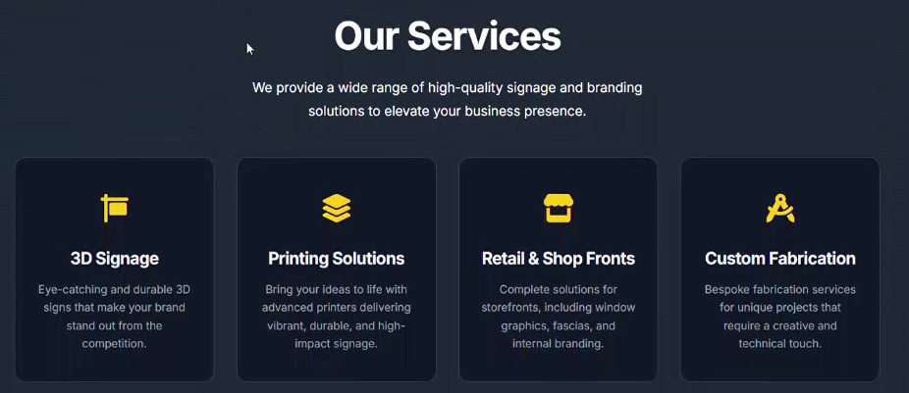

3D indoor and outdoor signs – when this links pressed, we need to show the 3D signs and reception signs - illumianted and non illuminated
Complete Printing Solutions – Wall graphics photos
Custom Fabrication – Acrylic fabrocations
Personilised Gift Items – Direct printing on marterils like bottles, acrylic keychains, drirect printing photos

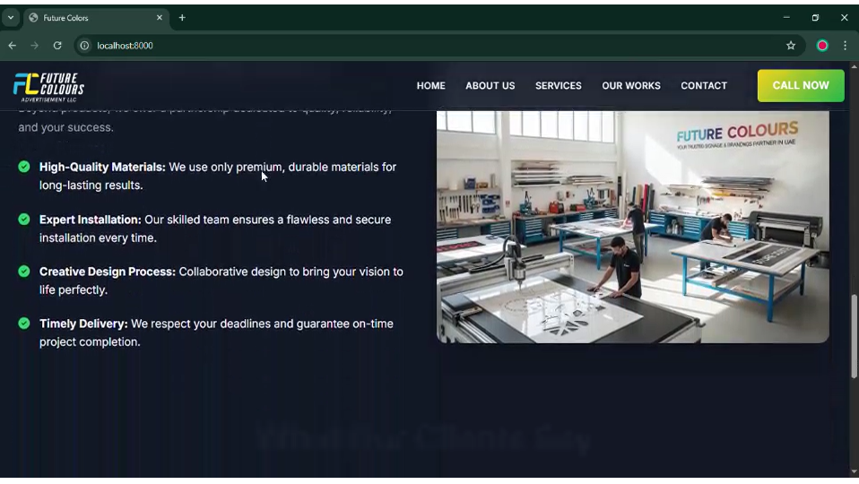

Try to add our logo if possible. If note please provide this image so we can edit with our logo and send back.
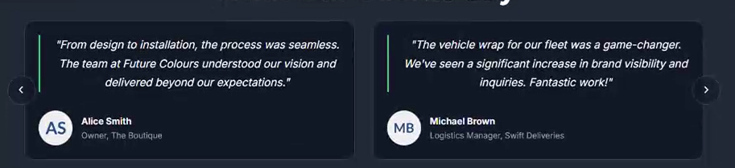

Please try to provide dubai based Clients who are mostly office interior designers and Office interior Project managers.

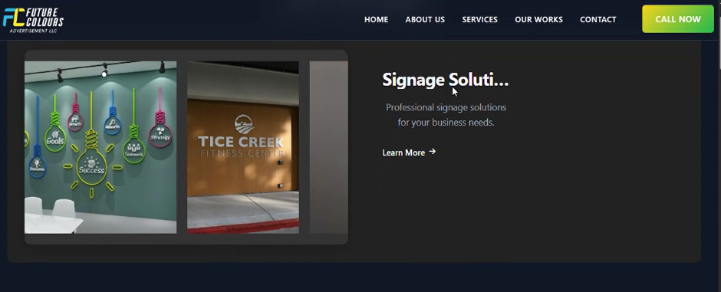
Text incomplete ( Signage Solutions )

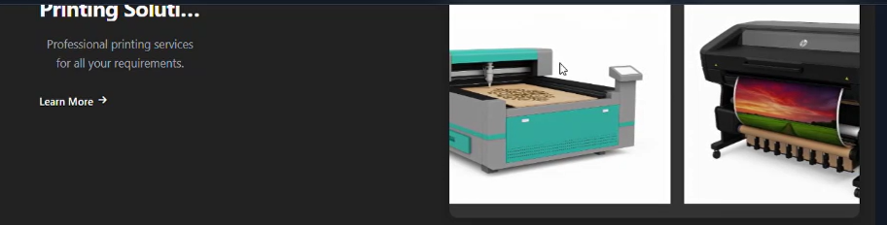

Blue meachine is acrylic laser cuting meachine.
Will give photos of our meachines

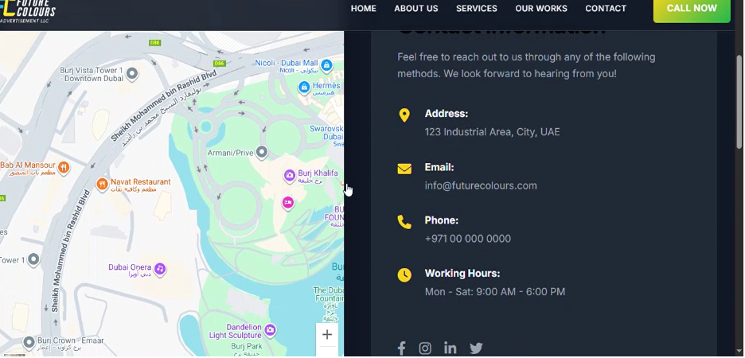

Phone number : +971 521718747 : +971 585738040
Working hours : 9 Am – 7 Pm ( Monday to Saturday)

Address :

Abu Dhabi Industrial City - ICAD I - Abu Dhabi

Near AL HOTY STANGER LABORATORIES

Warehouse Number 11

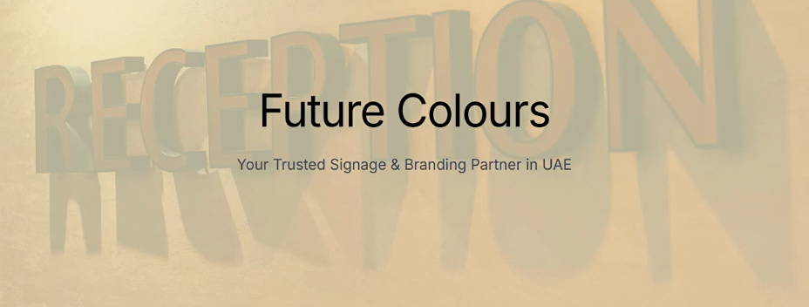

Suggestions : Can we play any vedios in background and have our Logo with same tagline.

