Rebecca Siebeneicher, ZHAW
Spyridon Margomenos, ZHAW
Anika Heim, ZHAW

Fish Population Dynamics in Lake Constance

Model Framing 5
System Boundaries 5
Model 6
General Feedback Analysis 7
State Variables 8
Auxiliary Variables 8
ODEs 10
Calibration 10
Data sets 10
Parameters 11
Outputs 11
Model Analysis 12
Numerical stability 12
Degree of validity 13
Sensitivity 13
General model behavior 14
Is the model able to reproduce historical data? 16
To what extent have the fishing ban and the decline of the stickleback population contributed to the recovery? 17
What is the maximum annual catch from 2027 onwards that keeps the stock above a reference level until 2050? 18
Literature 21
Figures 22
Tables 22
Appendix 22

Abstract

Introduction
With a surface area of about 536 km², Lake Constance is one of the largest lakes in Central Europe (Bodensee-Openwater, 2023). It is jointly managed by Switzerland, Germany and Austria (Internationale Gewässerschutzkommission für den Bodensee [IGKB], n.d.-b). The whitefish plays a key role in the lake’s ecosystem (Ogorelec et al., 2022). At the same time, it has long been the most important food fish and therefore the economic foundation of commercial fishing on Lake Constance (IGKB, 2023; Schweizer Radio und Fernsehen [SRF], 2024).

The development of the whitefish stock is closely linked to the nutrient content of the lake, mainly its phosphorus concentration. From the 1950s onwards, wastewater and agricultural runoff caused phosphorus levels to rise sharply, peaking in the 1970s (IGKB, 2018a). As a result, fishing yields also increased. In 1978, 1200 tonnes of whitefish were caught, the highest annual catch ever recorded (SRF, 2026). Thanks to extensive water protection measures, the phosphorus concentration fell to a natural level of about 6 µg/L over the following decades (IGKB, 2013, 2018a). Consequently, both the whitefish stock and the fishing yields declined again (IGKB, n.d.-a, 2023).

In recent decades, new stressors have emerged. The stickleback, a non-native species, was first recorded in Lake Constance in the 1950s and initially lived in the shallow littoral zone (Wasser-Agenda 21, 2023). In 2012, the stickleback population spread into the open water, where it multiplied rapidly and at times accounted for up to 90% of all fish in the open water (SRF, 2024; Wasser-Agenda 21, 2023). The stickleback competes with the whitefish for zooplankton and also feeds on its eggs and larvae (IGKB, 2023; SRF, 2024). Together, these stressors led to a collapse of the whitefish stock (IGKB, 2023). In the year 2023 only 9.8 tonnes were caught (Frei & Kugler, 2026).

In response to the decline of the whitefish population, the International Conference of Authorised Representatives for Lake Constance Fisheries (IBKF) decided to impose a three-year fishing ban on whitefish, starting in January 2024 (Frei & Kugler, 2026; IGKB, n.d.-a). At almost the same time, the stickleback population declined by around 80% for reasons that remain unclear (IGKB, n.d.-a; SRF, 2024). Since then, the whitefish population has shown signs of recovery, with older and larger individuals present in the lake again (Frei & Kugler, 2026; SRF, 2026). From May 2027 onwards, whitefish fishing will be partially permitted again under strict conditions, with a long-term target of 20 to 30 tonnes per year (SRF, 2026).
However, it remains unclear which factor brought about this recovery. Because the fishing ban and the decline of the stickleback coincided, their effects cannot be distinguished based on observational data alone. It also remains to be seen whether a reopened fishery would be sustainable if stickleback pressure returns.

The aim of this project is to develop a simplified system dynamics model of Lake Constance that links phosphorus, plankton, deep-water oxygen and the whitefish population for the period from 1950 to 2050, and to calibrate it using historical measurement data. The model will be used to address the following research questions:

- Is the model able to reproduce the historical data?
- To what extent have the 2024 fishing ban and the decline of the stickleback population each contributed to the recovery of the whitefish stock?
- What is the maximum annual catch that can be permitted from 2027 onwards to ensure that the stock remains above a reference level until 2050, under both low and renewed stickleback pressure?

A simulation model is well suited to answer these questions, as it allows testing scenarios that cannot be observed, such as a fishing ban without the stickleback decline. In addition, system dynamics captures feedback loops and time delays, such as the maturation time of whitefish or the competition between whitefish and sticklebacks for zooplankton. As the fishing ban expires and fishing is set to partially resume in May 2027 (Frei & Kugler, 2026; SRF, 2026), the results can support decisions on future catch limits.

Methods

Model Framing
The model represents a simplified version of Lake Constance that focuses on the whitefish population. It consists of three stocks: zooplankton, young whitefish and adult whitefish.

The whitefish population forms the core of the model. Adult whitefish produce offspring, which are summarised as young whitefish (eggs, larvae and juveniles). After about 2.5 years, the young whitefish mature into adults. Both young and adult whitefish are subject to natural mortality. Part of the adult stock is removed by fishing. Before 2024, a constant share of the adult stock is caught each year. From January 2024 to April 2027, fishing is banned. From May 2027 onwards a fixed annual catch is taken.

Hoe many offsprings survive depends on three factors. The first one is food: the more zooplankton is available, the more young whitefish survive. The second one is deep-water oxygen: whitefish eggs develop on the bottom of the lake over winter and die when the oxygen levels are too low. And last: sticklebacks eat the whitefish eggs and larvae.

Zooplankton is the main food of the whitefish. It grows faster when the phosphorus concentration is higher, because more phosphorus allows more algae to grow. And the zooplankton feeds on these algae. Part of the zooplankton dies naturally, while the rest is eaten by whitefish and sticklebacks. Sticklebacks therefore compete with whitefish for food.

Phosphorus concentration and deep-water oxygen are taken form measurements data. Stickleback pressure is described by an index. It is zero before 2012 and drops by 80% in 2024. From 2027 onwards it either remains low or returns to its former level. In this way different scenarios can be tested to answer the second question.

The model contains three feedback loops. In the reinforcing loop (R1), more adult whitefish produce more offspring, which leads to more adults. In the balancing predator-prey loop (B1), more adult whitefish eat more zooplankton, leaving less food for their offspring. In the balancing loop (B2), a larger adult stock leads to a higher catch value, which reduces the stock.

System Boundaries
The model represents the whitefish population of Upper Lake Constance. It also includes the zooplankton that the whitefish feed on, the oxygen in the deep water, the sticklebacks and fishing. To keep the model simple, only processes that have a direct effect on the whitefish were considered. Phosphorus and deep-water oxygen are not calculated in the model but taken from measurement data, as they mainly depend on external factors such as wastewater treatment and the water circulation in the winter. Algae were not modelled separately, because their effect is included in the growth of zooplankton. The release of phosphorus from the sediment was neglected, as it only happens when oxygen levels are close to zero. And this has never been observed in lake Constance. The stickleback population itself is not modelled. Only its pressure on the whitefish population has been included as an index, because the reason for its collapse in 2024 is still unknown.
With the time scope of 100 years and an annual time step, seasonal changes within a year have not been modelled. Furthermore, water temperature, stocking, other species such as the quagga mussel and cormorants, as well as the age and size structure of the whitefish were not implemented in the model.

Model
The model was implemented in Vensim. To make its structure easier to read, the model is presented here in redrawn (using the AI Claude) form. Figure 1 gives an overview of the three stocks, the main external drivers and the feedback loops, while Figures 2, 3 and 4 show the three parts of the model in detail, including all variables and parameters. These figures contain exactly the same variables, connections and equations as the Vensim model but uses a clearer layout and a larger font. The original Vensim model is shown in the Appendix.

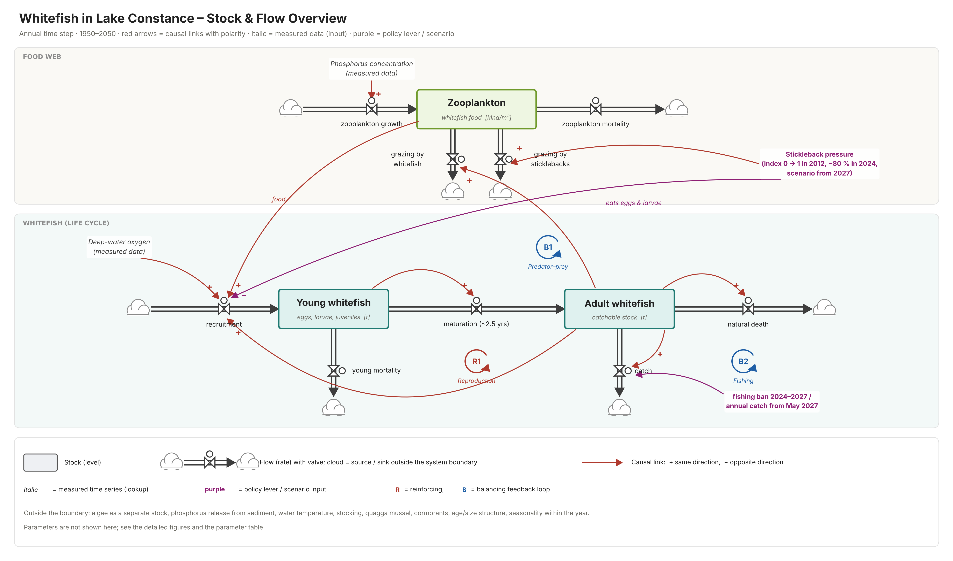
Figure 1: Model Overview
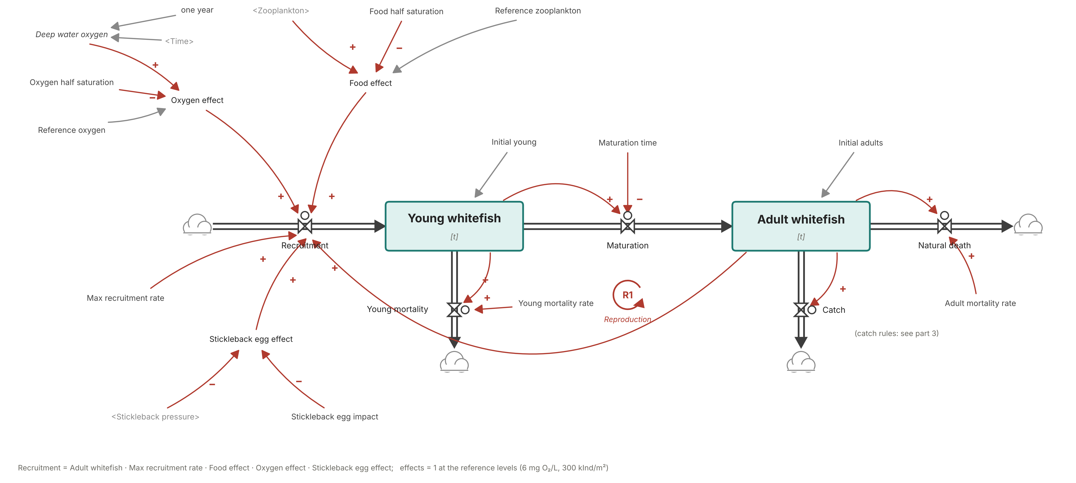
Figure 2: Whitefish life cycle

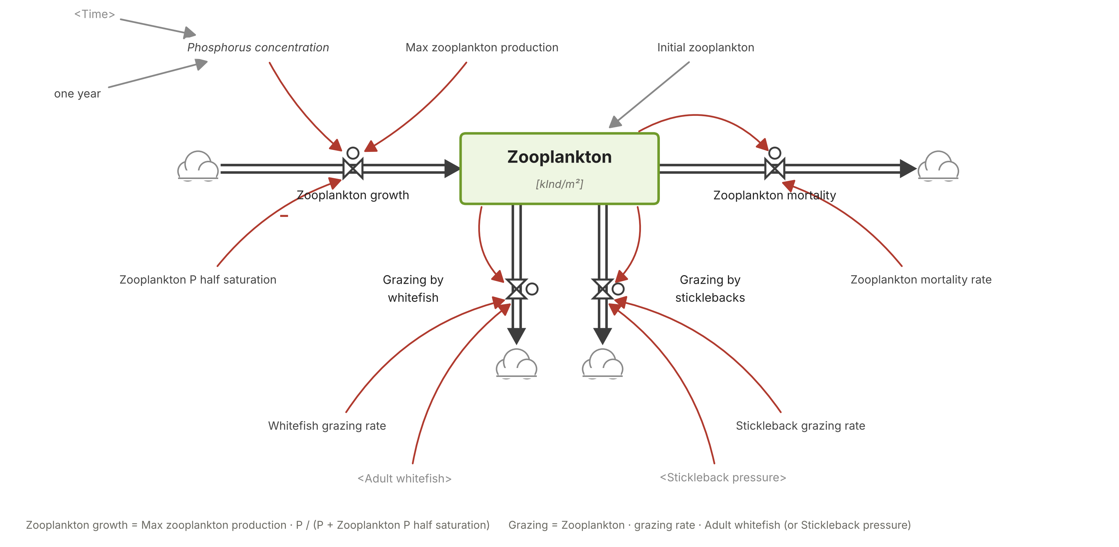
Figure 3: Zooplankton food web

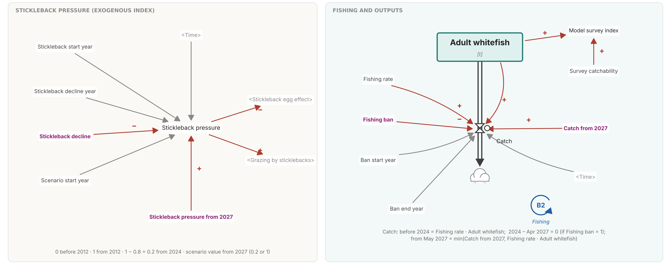
Figure 4: Stickleback pressure and fishing outputs

General Feedback Analysis
The model contains three feedback loops, which are marked in Figures 2, 3 and 4. The first loop is the reinforcing reproduction loop (R1). It connects the adult whitefish with recruitment, the young whitefish and maturation. A larger adult stock produces more offspring and after a delay of about 2.5 years these offsprings mature and increase the adult stock. This loop is responsible for the growth of the population.

The reproduction loop is counteracted by two balancing loops. In the predator-prey loop (B1), a larger whitefish stock consumes more zooplankton. As a result, less food is available for the offspring, which reduces and limits further growth of the population. In the fishing loop (B2), a larger adult stock leads to a higher catch value, which in return reduces the stock.

The relative strength of these loops changes over time. Between 1950 and the 1990s, the reproduction loop dominates as rising phosphorus levels increase the zooplankton and thus the number of offspring. After 2012, the stickleback weakens the reproduction loop by feeding on the whitefish eggs and larvae, while the fishing loop continues to remove adults. This leads to the collapse of the whitefish population in 2024. With the fishing ban in 2024, the fishing loop is temporarily switched off and the stickleback pressure decreases, so that the reproduction loop becomes dominant again.

Phosphorus, deep-water oxygen and stickleback pressure act as external factors on these loops. They influence the behaviour of the system but are not effected by it. Therefore, they are not part of any feedback loops themselves.

State Variables
Variable | Input Flows | Output Flows | Start value | Source
Adult Whitefish | Maturation | - Natural death  - Catch | 907t | Calibrated against catch (1950-2023) and survey index (1997-2022)
Young Whitefish | Recruitment | - Maturation  - Young mortality | 1512t | Calculated as equilibrium with the conditions in 1950
Zooplankton | Zooplankton growth | - Zooplankton mortality  - Grazing by whitefish  - Grazing by stickleback | 332 x 1000 ind./m² | Calculated as equilibrium with the phosphorus levels in 1950
Table 1: State variables of the model
The starting value of young whitefish and zooplankton were set so that inflows and outflows are balanced under the conditions of 1950. So that the model starts without artificial jumps.

Auxiliary Variables
Variable | Value / Equation | Unit | Source
Food effect | (Zooplankton / (Zooplankton + Food half saturation)) / (Reference zooplankton / (Reference zooplankton + Food half saturation)) | Dmnl | Own formulation; = 1 at reference zooplankton level
Oxygen effect | (Deep water oxygen / (Deep water oxygen + Oxygen half saturation)) / (Reference oxygen / (Reference oxygen + Oxygen half saturation)) | Dmnl | Own formulation based on IGKB (2014); = 1 at 6 mg/L
Stickleback egg effect | 1 − Stickleback egg impact × Stickleback pressure | Dmnl | Own formulation based on IGKB (2023) and SRF (2024)
Stickleback pressure | 0 before 2012; 1 from 2012; 1 − Stickleback decline from 2024; Stickleback pressure from 2027 from 2027 | Dmnl | Wasser-Agenda 21 (2023); SRF (2024); IGKB (n.d.-a)
Model survey index | Adult whitefish × Survey catchability | Dmnl | Own formulation, for comparison with survey data
Phosphorus concentration | Lookup over Time / one year; data 1960–2025; 1950 = 7 (assumption) | µg P/L | IGKB / BOWIS
Deep water oxygen | Lookup over Time / one year; data 1963–2025; 1950 = 8 (assumption) | mg O₂/L | IGKB
Observed catch | Lookup over Time / one year; data 1950–2023 | t/Year | IGKB (read from chart); 2023: Frei & Kugler (2026)
Observed survey index | Lookup over Time / one year; data 1997–2022 | Dmnl | IGKB / IBKF
Observed zooplankton | Lookup over Time / one year; data 1961–2025 | kInd/m² | IGKB / BOWIS
one year | 1 | Year | Technical constant; converts Time into a dimensionless value for the lookup functions
Max zooplankton production | 3444.7 | kInd/m²/Year | Calibrated
Zooplankton P half saturation | 21.31 | µg P/L | Calibrated
Zooplankton mortality rate | 2 | 1/Year | Assumption
Whitefish grazing rate | 0.000626 | 1/(t·Year) | Calibrated
Stickleback grazing rate | 0.203 | 1/Year | Calibrated
Food half saturation | 213.0 | kInd/m² | Calibrated
Reference zooplankton | 300 | kInd/m² | Approx. current level (IGKB)
Max recruitment rate | 1.051 | 1/Year | Calibrated
Oxygen half saturation | 2 | mg O₂/L | Assumption
Reference oxygen | 6 | mg O₂/L | IGKB (2018)
Stickleback egg impact | 0.506 | Dmnl | Calibrated
Stickleback start year | 2012 | Year | Wasser-Agenda 21 (2023); SRF (2024)
Stickleback decline year | 2024 | Year | IGKB (n.d.-a)
Stickleback decline | 0.8 | Dmnl | IGKB (n.d.-a); scenario: 0 = no decline
Scenario start year | 2027 | Year | Own definition
Stickleback pressure from 2027 | 0.2 | Dmnl | Scenario: 0.2 = stays low, 1 = returns
Maturation time | 2.5 | Year | Assumption
Young mortality rate | 0.3 | 1/Year | Assumption
Adult mortality rate | 0.25 | 1/Year | Assumption
Fishing rate | 0.5 | 1/Year | Assumption
Ban start year | 2024 | Year | IBKF; Frei & Kugler (2026)
Ban end year | 2027.33 | Year | SRF (2026)
Fishing ban | 1 | Dmnl | Scenario: 1 = ban, 0 = no ban
Catch from 2027 | 25 | t/Year | SRF (2026), target 20–30 t; scenario
Survey catchability | 0.01566 | Dmnl/t | Calibrated
Initial adults | 906.7 | t | Calibrated
Initial young | 1512.0 | t | Equilibrium with 1950 conditions
Initial zooplankton | 331.7 | kInd/m² | Equilibrium with 1950 conditions
Table 2: Auxiliary variables of the model

ODEs
Variable | ODE
Adult Whitefish | $\frac{d Adult Whitefish}{dt} = Maturation - Natural Death - Catch$
Young Whitefish | $\frac{d Young Whitefish}{dt} = Recruitment - Maturation - Young Mortality$
Zooplankton | $\frac{d Zooplankton}{dt} = Zooplankton Growth - Zooplankton Mortality - Grazing by Whitefish - Grazing by Sticklebacks$
Table 3: ODE's of the model

Calibration
Several parameters of the model could not be taken directly form the literature. These parameters were therefore estimated by calibrating the model against historical measurement data form Lake Constance. The aim of the calibration was to reproduce the long-term development of the whitefish population and its food source between 1950 and 2025.

Data sets
Three data sets were used to calibrate the model. The annual whitefish catch of the professional fishery in the Upper Lake Constance from 1950-2023 was used as the main reference for the whitefish population (IGKB, n.d.-a). As these values are only published as a chart, they were read from the figure with an estimated accuracy of about ± 10 tonnes. The catch of 2023 was taken form Frei and Kugler (2026). In addition, the whitefish survey index form 1997-2022 was used as an independent measure of the stock size (IGKB). The density of crustacean zooplankton from 1961-2025 was used to calibrate the food web part of the model (IGKB / BOWIS).

Phosphorus concentration and deep-water oxygen were not used for the calibration but served as model inputs. Since measurements of phosphorus only start in 1960 and those of oxygen in 1963, the values for 1950 were assumed to be 7 µg/L and 8 mg/L respectively. Reflecting the conditions before the onset of eutrophication.

Parameters
Nine parameters were calibrated (Table 4). They were estimated by minimising the sum of square differences between the simulated and the observed values of all three datasets. To make the datasets comparable, the differences were scaled to the typical size of each dataset. And the survey index and the zooplankton data were given a slightly lower weight than the catch data. The calibration was carried out with a Python implementation of the same model equations, and the resulting parameter values were then transferred to the Vensim model. The survey catchability was not part of the iterative search but was calculated directly as the factor that best scales the simulated adult stock to the observed survey index. The start values of young whitefish and zooplankton were set to equilibrium with the conditions in 1950, so that only the initial adult stock had to be calibrated. All remaining parameters were taken from the literature or set as assumptions.

Parameter | Lower bound | Upper bound | Calibrated value | Unit
Max recruitment rate | 0.05 | 20 | 1.051 | 1/Year
Max zooplankton production | 50 | 100 000 | 3444.7 | 1000 ind./m²/Year
Zooplankton P half saturation | 0.5 | 300 | 21.31 | µg P/L
Whitefish grazing rate | 0.000001 | 0.05 | 0.000626 | 1/(t·Year)
Stickleback grazing rate | 0 | 10 | 0.203 | 1/Year
Food half saturation | 10 | 100 000 | 213.0 | 1000 ind./m²
Stickleback egg impact | 0 | 1 | 0.506 | Dmnl
Initial adults | 50 | 20 000 | 906.7 | t
Survey catchability | – | – | 0.01566 | Dmnl/t
Table 4: Calibrated parameters used in the model

Outputs
Group | Variable | Unit | Value range (year)
Stocks | Adult whitefish | t | 49 (2024) to 1,436 (1997)
Stocks | Young whitefish | t | 60 (2024) to 2,705 (1996)
Stocks | Zooplankton | kInd/m² | 285 (2050) to 1,091 (1977)
Flows adult whitefish | Maturation | t/Year | 24 (2024) to 1,082 (1996)
Flows adult whitefish | Natural death | t/Year | 12 (2024) to 359 (1997)
Flows adult whitefish | Catch | t/Year | 0 (2024–2027) to 718 (1997)
Flows young whitefish | Recruitment | t/Year | 35 (2023) to 1,933 (1987)
Flows young whitefish | Young mortality | t/Year | 18 (2024) to 812 (1996)
Flows zooplankton | Zooplankton growth | kInd/m²/Year | 686 (2025) to 2,747 (1977)
Flows zooplankton | Zooplankton mortality | kInd/m²/Year | 569 (2050) to 2,181 (1977)
Flows zooplankton | Grazing by whitefish | kInd/m²/Year | 10 (2024) to 726 (1986)
Flows zooplankton | Grazing by sticklebacks | kInd/m²/Year | 0 (before 2012) to 78 (2018)
Effect factors | Food effect | Dmnl | 0.98 (2050) to 1.43 (1977)
Effect factors | Oxygen effect | Dmnl | 0.71 (1973) to 1.07 (1950)
Effect factors | Stickleback egg effect | Dmnl | 0.49 (2012–2023) to 1.0 (before 2012)
Effect factors | Stickleback pressure | Dmnl | 0 (before 2012) / 1 (2012–2023) / 0.2 (from 2024)
Effect factors | Model survey index | Dmnl | 0.76 (2024) to 22.5 (1997)
Table 5: Outputs of the model

Model Analysis

Numerical stability
To analyse numerical stability, various simulations were performed using different time steps and integration methods. Simulations were conducted using time steps of 0.0625, 0.125, 0.25, 0.5, and 1, as well as the Euler and Runge-Kutta 4 integration methods, which can be seen in Figure 5.
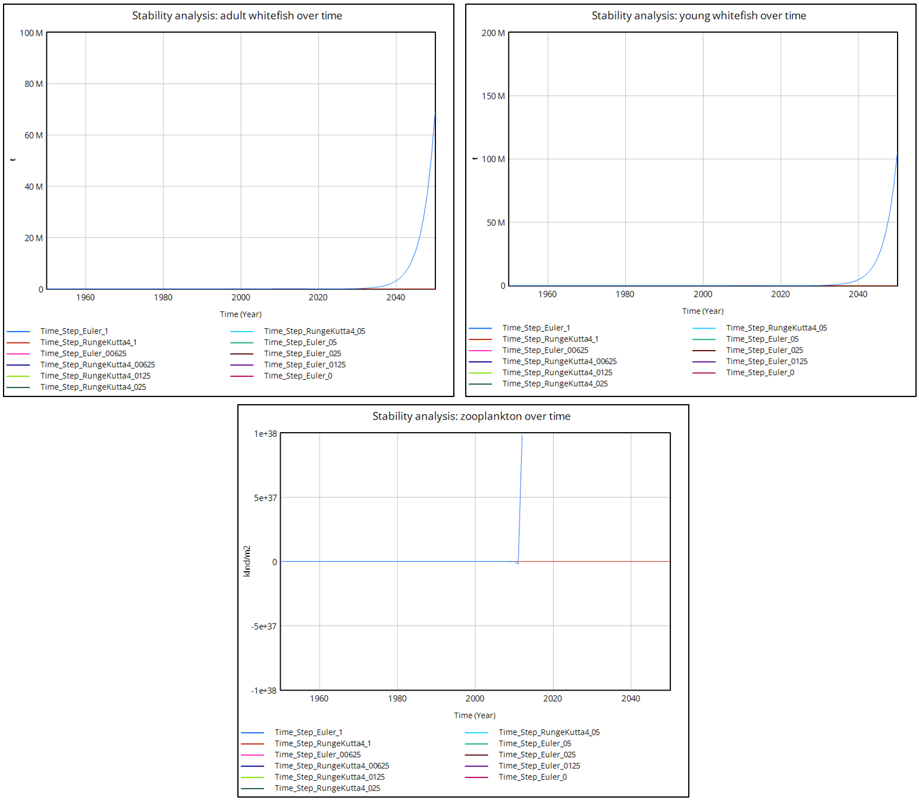
Figure 5: Stability analysis
Since the simulation using the Euler integration method and a time step of 1 is unstable, as shown in Figure 5, it was not included in the more detailed analysis. Figure 6 shows that the historical phase up to approximately 2022 is numerically robust, with a very small deviation of less than 1%. The scenario up to 2050 is not numerically stable and depends heavily on the time step. All results in the following sections were computed with the Euler integration method and a time step of 0.0625 years.
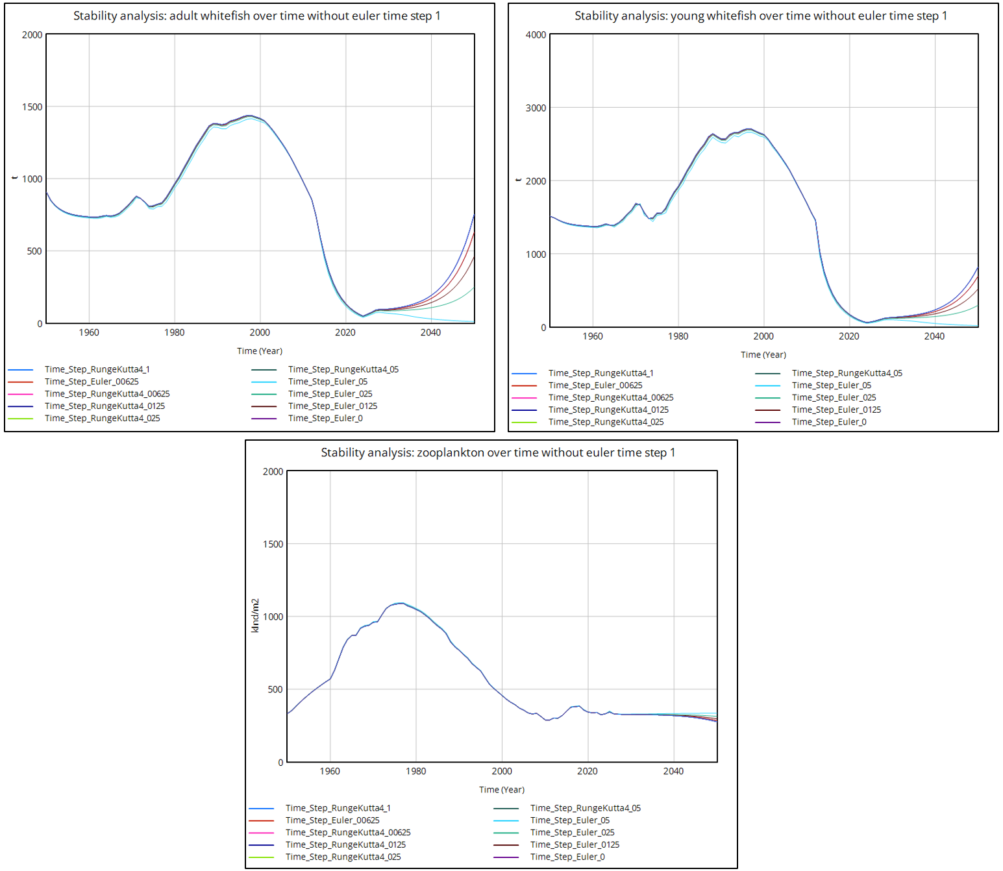
Figure 6: Stability analysis without Euler integration (time step 1)

Degree of validity
The model’s degree of validity was assessed by examining its units and checking the syntax for unlinked variables. The unit testing feature in Vensim was used to test the units, a screenshot of it can be seen in Figure 7. In addition, the parameters were checked for plausibility by comparing them with the literature (see Literature, p.21). The model clearly distinguishes between the assumptions and the calibrations.
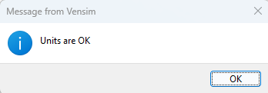
Figure 7: Vensim unit check

Sensitivity
To test the sensitivity of the model, eight parameters (maximum recruitment rate, adult mortality rate, young mortality rate, maturation time, stickleback egg impact, stickleback grazing rate, maximum zooplankton production, and food half-saturation) were varied individually by ±10%, while all other parameters remained constant. Figure 8 shows that the qualitative behavior of the model remains consistent across all variants: The adult whitefish population increases until around 1990, then drops to a minimum by around 2024, and subsequently recovers. However, the magnitude of the response differs significantly between the parameters, with variations in the maximum recruitment rate and food half saturation causing the greatest deviations from the baseline run. Even in the historical phase, stock levels vary noticeably (peaking around 1997 at between approximately 400 and 3,500 t, depending on the variant), as the calibrated parameters were altered without recalibration. The variation is particularly large in the projection through 2050, where values range from nearly zero to over 6,000 t, depending on the parameter selection. The recovery of the whitefish stock after 2024 is thus highly dependent on the uncertainty of individual parameters, which is why the results for 2050 should be interpreted as scenarios rather than forecasts.
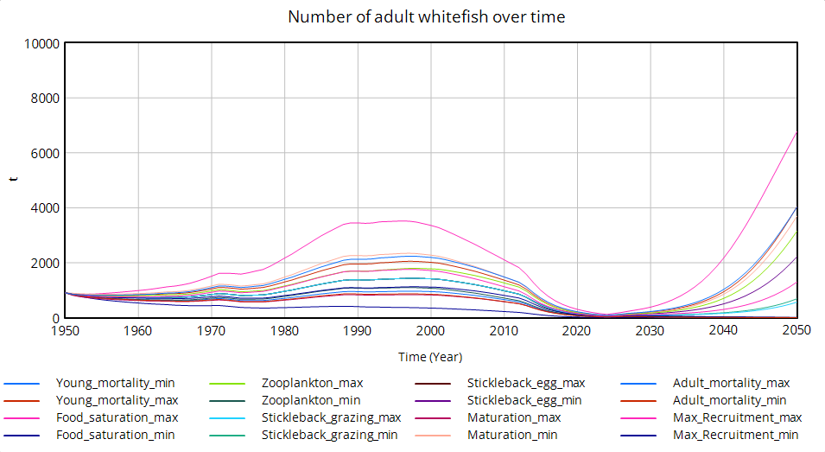
Figure 8: Sensitivity analysis

Results

General model behavior
The populations of young and adult whitefish follow nearly parallel trends, as shown in Figure 9. This is plausible, since adult whitefish produce the young, which grow into adult whitefish after about 2.5 years. It should be noted that the two axes in the graph on the left have different scales and that the population of young whitefish is approximately twice as large as that of adult whitefish. The adult whitefish population initially declined from approximately 900 t in 1950 to about 730 t around 1960, before rising to a peak of approximately 1,430 t by 1997. Starting in 2000, a sharp decline is evident, reaching its lowest point in 2024/2025 at only about 50 t. After that, the population slowly recovers and rises again to approximately 620 t by 2050. The young whitefish population also shows a sharp decline, followed by a recovery to about 700 t.
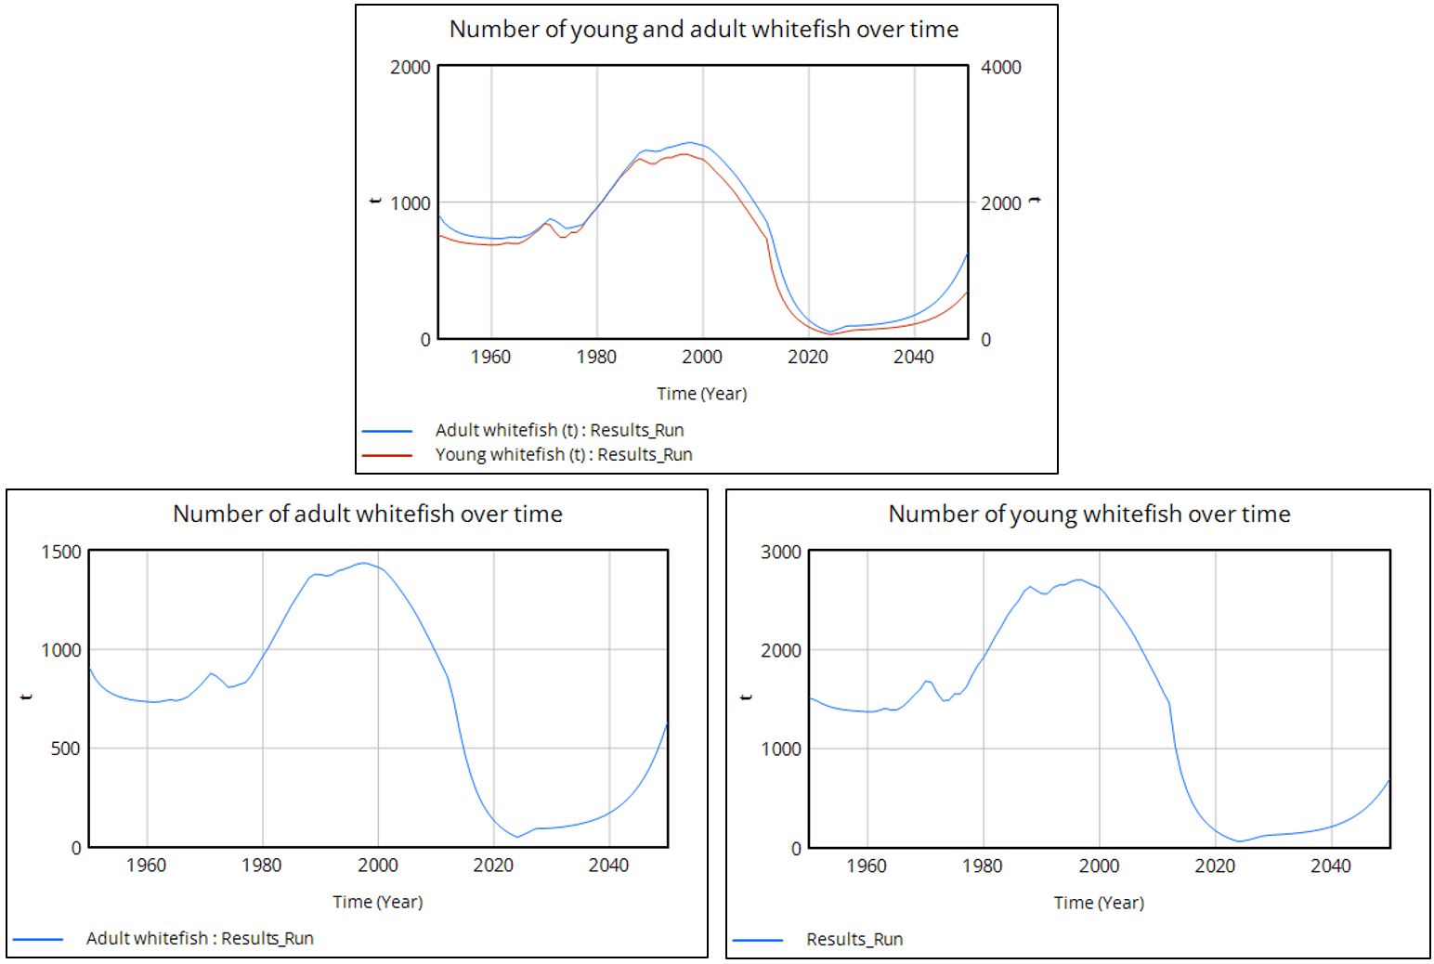
Figure 9: Development of the population over time
The influencing factors of food, oxygen, and sticklebacks are shown in Figure 10 and have varying effects on whitefish recruitment. The food effect rises to a maximum of approximately 1.43 by about 1975–1980 and then declines to about 1.0 by 2010. Food thus initially promotes recruitment, while its influence is largely neutral later. The oxygen effect is mostly close to 1.0 but shows occasional declines to approximately 0.7–0.8 in the 1960s and 1970s. From 2000 onward, the oxygen effect remains virtually constant. The stickleback egg effect drops to about 0.49 starting in 2012 and rises again to approximately 0.90 starting in 2024. The decline in the whitefish population in the model can be explained by the food effect and after 2012 also by the stickleback egg effect.
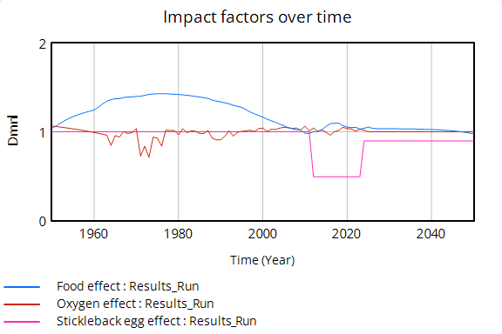
Figure 10: Impact factors over time

The inflows and outflows of the adult population shown in Figure 11 follow a similar trend to the population’s own development (see Figure 9). The flows increase until around 1990–2000, before declining sharply through 2024. Maturation reaches a maximum of approximately 1,050 t per year. The main outflows are natural death and catch. In 1997, the stock is nearly in equilibrium, as maturation roughly equals the combined total of natural death and catch. Starting in 2025, maturation exceeds outflows, allowing the population to recover in the long term.
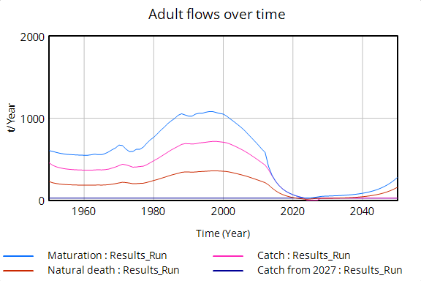
Figure 11: Adult flows over time

Is the model able to reproduce historical data?
The model and the observational data on zooplankton generally show a similar long-term trend, as can be seen in Figure 12. The modelled population rises from approximately 330 kInd/m² to a maximum of about 1,080 around 1975–1980 and then declines again to about 330 by 2008. A slight increase is then evident before the population stabilizes at around 300. The observational data, on the other hand, show stronger annual fluctuations and reach a maximum of approximately 1,470 kInd/m² around 1970. After that, the population declines sharply and, starting in 1997, fluctuates primarily between about 200 and 450 kInd/m². The model reflects the long-term trend but underestimates the peak values and cannot represent the annual fluctuations. It is also important to note that the constant values before 1961 and after 2025 result from the lookup function and do not represent actual measured values.
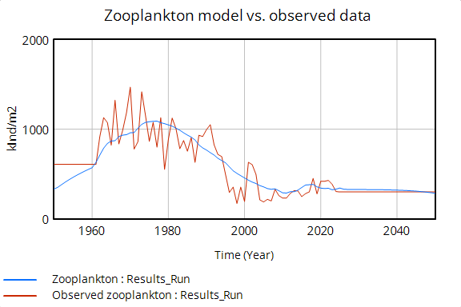
Figure 12: Zooplankton model vs. observed data
The modelled survey index is shown in Figure 13 and exhibits a long-term trend like that of the observed data. The model reaches a maximum of approximately 22 around 1997 and then declines steadily to about 1 in 2024. Subsequently, a rise back to about 10 is projected by 2050. The observed data initially fluctuate between approximately 15 and 33 before the index drops sharply starting in 2013 and remains at a low level. The model generally replicates this decline, though less abruptly and with a time lag. It is important to note that the constant values prior to 1997 do not represent actual measured values but are generated by the lookup function.
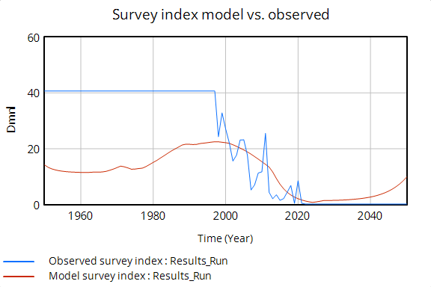
Figure 13: Survey index model vs. observed

The modelled catch levels in Figure 14 generally follow a similar trend to the observed data but exhibit less fluctuation. Initially, the modelled catch is approximately 450 t and reaches a peak of about 720 t around 1998. It then declines to nearly zero by 2024, before rising to 25 t per year following the fishing ban. The observed data, by contrast, show pronounced peaks of approximately 1,200 t in 1977 and around 1,000 t in 1990. The model also reflects the long-term decline beginning in 2000. The discrepancies can be explained, among other things, by the fact that the catch rate remains constant in the model, whereas actual catch also depends on fishing effort.
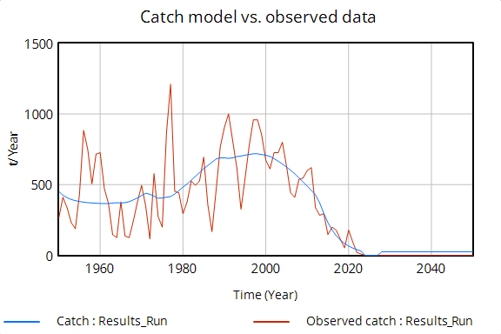
Figure 14: Catch model vs. observed data
The model reproduces the long-term pattern and the timing of the main changes, namely the rise until the 1990s and the collapse after 2000. It does not reproduce year-to-year variability or peak magnitudes, and fit quality decreases from zooplankton to survey index to catch. Two limits apply. The parameters were calibrated on the same data, so this is not an independent test. In addition, the results are numerically robust up to about 2022 for time steps ≤ 0.0625 years (differences below 1 %), whereas projections to 2050 depend on the time step.

To what extent have the fishing ban and the decline of the stickleback population contributed to the recovery?
To isolate the two effects, four scenarios were simulated (2×2 design): ban and decline (baseline), ban only, decline only, and neither. “No decline” means that the stickleback pressure remains at 1 after 2024; “no ban” means that fishing continues at the normal level until May 2027. Starting in May 2027, a catch limit of 25 t per year applies in all scenarios; additionally, all scenarios were calculated with zero catch to isolate the pure effects.

Figure 15 shows the four scenarios with the planned catch of 25 t/year. All runs are identical until 2024 and decline from about 135 t in 2020 to about 50 t. After 2024 they separate. Only the base scenario recovers: it rises to about 90 t by 2027, grows only slowly until about 2030 (95 t) and then increasingly faster to 620 t in 2050. The other three scenarios collapse. With the ban only, the stock still rises to about 65 t by 2027, but falls below 30 t by 2030, because the catch resumes while recruitment remains halved. With the stickleback decline only or with neither measure, the stock declines towards zero (below 5 t in 2050). Therefore, in the scenario with a catch of 25 t, neither measure is sufficient on its own, but they work synergistically.
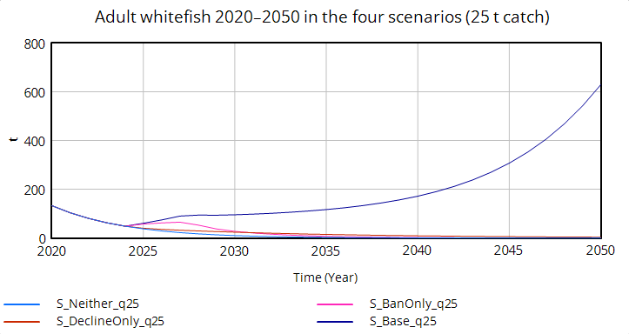
Figure 15: Adult whitefish 2020-2025 in the four scenarios (25t catch)

To isolate the pure effects, Figure 16 shows the same scenarios without any catch after 2027. Here all runs grow, but at very different rates. The base scenario reaches about 3,779 t in 2050 and the decline-only scenario about 2,000 t, whereas the ban-only (about 145 t) and neither scenario (about 55 t) stays close to the axis. The curves are hardly distinguishable until about 2030 and diverge strongly only afterwards, because higher recruitment accumulates in the stock. The absolute values are unrealistic, as they exceed the historical maximum of about 1,430 t. The model has no density dependence for adults apart from the zooplankton feedback, so these values are used only for relative comparison.

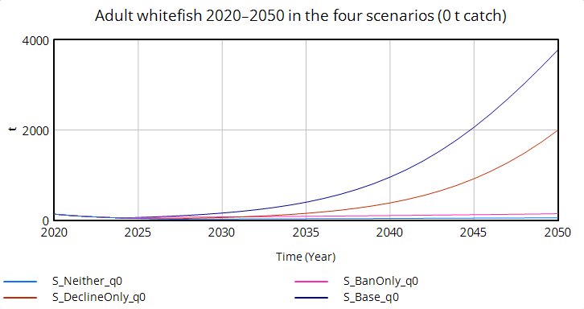
Figure 16: Adult whitefish 2020-2050 in the four scenarios (0t catch)
The ban was the main driver of the short-term increase (about three quarters by 2027). The stickleback decline is the main driver of the long-term recovery (about three quarters by 2050 without catch, Figure 16). Under the planned catch, the recovery requires both (Figure 15).

What is the maximum annual catch from 2027 onwards that keeps the stock above a reference level until 2050?
The reference level was defined as 50 t, which corresponds to the 2024 minimum. The adult stock must not fall below this level between May 2027 and 2050. The catch from 2027 was varied under low (0.2, base, assumption) and renewed (1.0) stickleback pressure.

Under low stickleback pressure, see Figure 17, all runs start at about 90 t in 2027 and then separate according to the catch. The lower the catch, the stronger the growth: without catch the stock reaches about 3,780 t in 2050, with 10 t/year about 2,850 t, with 20 t/year about 1,540 t and with 25 t/year about 630 t. At 30 t/year, however, the stock no longer grows and falls to about 14 t. There is thus a clear threshold between 25 and 30 t/year, and the maximum catch that keeps the stock above the reference level is about 27 t/year.
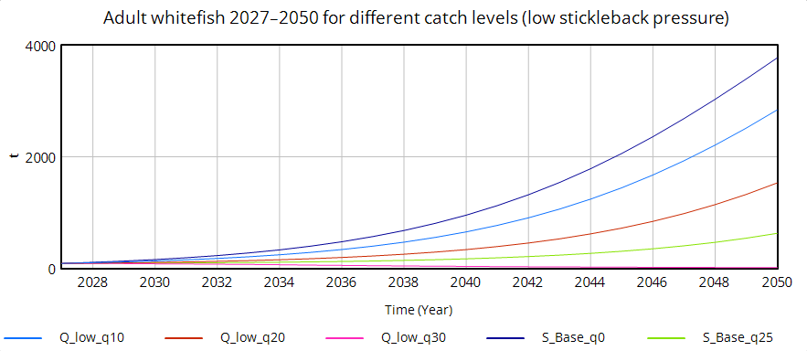
Figure 17: Adult whitefish 2027-2050 for different catch levels (low stickleback pressure)

Under renewed stickleback pressure, see Figure 18, the stock also starts at about 90 t, but the recovery is much weaker. Without catch it rises only to about 220 t in 2050. A catch of 5 t/year keeps the stock almost constant at about 100 t, which is close to the sustainable level. With 7 t/year the stock declines slowly to about 55 t in 2050 and would continue to fall afterwards, so this catch meets the 50 t criterion only because the simulation ends in 2050. With 10 and 15 t/year the stock falls to about 4 t and almost zero, respectively. The maximum catch is therefore only about 5–7 t/year. Even without catch, the stock reaches only about 220 t in 2050.

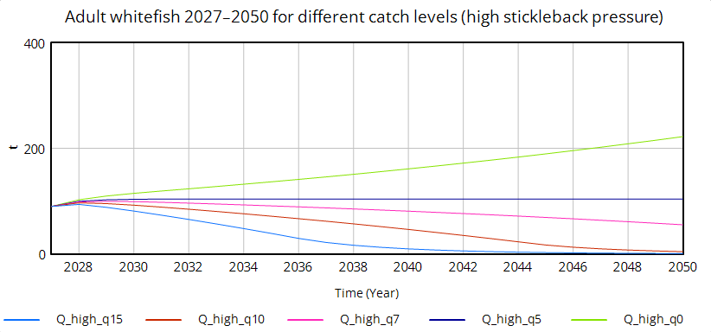
Figure 18: Adult whitefish 2027-2050 for different catch levels (high stickleback pressure)

Under low stickleback pressure, a catch of up to about 27 t/year can be permitted, and under renewed pressure only about 5–7 t/years above these values, the model predicts a gradual decline.

Discussion

Open issues: water temperature not included (climate change). Other factors like mussles. Data mainly for upper part of the lake

Literature
Bodensee-Openwater. (2023, 5 September). Infos über den Bodensee. https://www.bodensee-openwater.com/infos-ueber-den-bodensee/

Frei, D., & Kugler, M. (2026). Monitoring der Blaufelchen sowie Felchen-Laichfischerei im Jahr 2025 (Fangverbot 2024–2026) [Bericht zur IBKF 2026]. Kanton St. Gallen, Amt für Natur, Jagd und Fischerei. https://ibkf.org/wp-content/uploads/2026/06/IBKF-2026-Blaufelchenbericht-Fangjahr-2025.pdf

Internationale Gewässerschutzkommission für den Bodensee. (n.d.-a). Fischereirechte und Fischschongebiete. Retrieved 23 October 2026, from https://www.igkb.org/daten-karten/fischereirechte-und-fischschongebiete

Internationale Gewässerschutzkommission für den Bodensee. (n.d.-b). Wem gehört der Bodensee? Retrieved 23 October 2026, from https://www.igkb.org/bodensee/wem-gehoert-der-bodensee

Internationale Gewässerschutzkommission für den Bodensee. (2013). Faktenblatt „Phosphor im Bodensee“. https://umwelt.tg.ch/public/upload/assets/12827/Faktenblatt-Phosphor-im-Bodensee.pdf?fp=2

Internationale Gewässerschutzkommission für den Bodensee. (2018a). Phosphor im Bodensee (Oktober 2018). https://www.igkb.org/medien/faktenblaetter/phosphor-im-bodensee-oktober-2018

Internationale Gewässerschutzkommission für den Bodensee. (2018b). Zirkulation im Bodensee (Oktober 2018). https://www.igkb.org/medien/faktenblaetter/zirkulation-im-bodensee-oktober-2018

Internationale Gewässerschutzkommission für den Bodensee. (2023, 20 November). Stichling verdrängt Felchen. Seespiegel. https://seespiegel.org/stichling-verdraengt-felchen/

Keystone-SDA. (2024, 1 July). Lake Constance could become too warm for whitefish. blue News. https://www.bluewin.ch/en/news/lake-constance-could-become-too-warm-for-whitefish-li.2265403

Ogorelec, Ž., Brinker, A., & Straile, D. (2022). Small but voracious: Invasive generalist consumes more zooplankton in winter than native planktivore. NeoBiota, 78, 71–97. https://doi.org/10.3897/neobiota.78.86788

Schweizer Radio und Fernsehen. (2024, 20 September). Stichling verschwindet aus dem Bodensee – das freut die Fischer. https://www.srf.ch/news/schweiz/invasive-fischart-stichling-verschwindet-aus-dem-bodensee-das-freut-die-fischer

Schweizer Radio und Fernsehen. (2026, 19 June). Kompromiss: Felchen-Fangverbot im Bodensee wird leicht gelockert. https://www.srf.ch/news/schweiz/mehr-felchen-im-bodensee-kompromiss-felchen-fangverbot-im-bodensee-wird-leicht-gelockert

Wasser-Agenda 21. (2023, 26 June). Der Dreistachlige Stichling als langfristiges Problem im Bodensee? Neues Faktenblatt Projekt SeeWandel. https://wa21.ch/messages/der-dreistachlige-stichling-als-langfristiges-problem-im-bodensee-neues-faktenblatt-projekt-seewandel/

Figures
Figure 1: Model Overview 6
Figure 2: Whitefish life cycle 6
Figure 3: Zooplankton food web 7
Figure 4: Stickleback pressure and fishing outputs 7
Figure 5: Stability analysis 12
Figure 6: Stability analysis without Euler integration (time step 1) 13
Figure 7: Vensim unit check 13
Figure 8: Sensitivity analysis 14
Figure 9: Development of the population over time 14
Figure 10: Impact factors over time 15
Figure 11: Adult flows over time 15
Figure 12: Zooplankton model vs. observed data 16
Figure 13: Survey index model vs. observed 16
Figure 14: Catch model vs. observed data 17
Figure 15: Adult whitefish 2020-2025 in the four scenarios (25t catch) 18
Figure 16: Adult whitefish 2020-2050 in the four scenarios (0t catch) 18
Figure 17: Adult whitefish 2027-2050 for different catch levels (low stickleback pressure) 19
Figure 18: Adult whitefish 2027-2050 for different catch levels (high stickleback pressure) 19

Tables
Table 1: State variables of the model 8
Table 2: Auxiliary variables of the model 10
Table 3: ODE's of the model 10
Table 4: Calibrated parameters used in the model 11
Table 5: Outputs of the model 12

Appendix
GitHub Repository: https://github.com/the-nerd-sloth/co1-semester-project

