**Practical – 1**

**Aim: -** Getting Started with Python and IDLE in interactive and batch modes.

**What is Python?**

Python is an interpreter based, object-oriented, high-level programming language with dynamic semantics. Its high-level built in data structures, combined with dynamic typing and dynamic binding, make it very attractive for Rapid Application Development, as well as for use as a scripting or glue language to connect existing components together. Python's simple, easy to learn syntax emphasizes readability and therefore reduces the cost of program maintenance. Python supports modules and packages, which encourages program modularity and code reuse. The Python interpreter and the extensive standard library are available in source or binary form without charge for all major platforms, and can be freely distributed.

**How to Install Python in Windows**

1. Select Version of Python to be installed
2. Download Python Executable installed from its official website(<https://python.org/downloads>)
3. Select the desired version of python, the latest release of python is Python 3.11.1

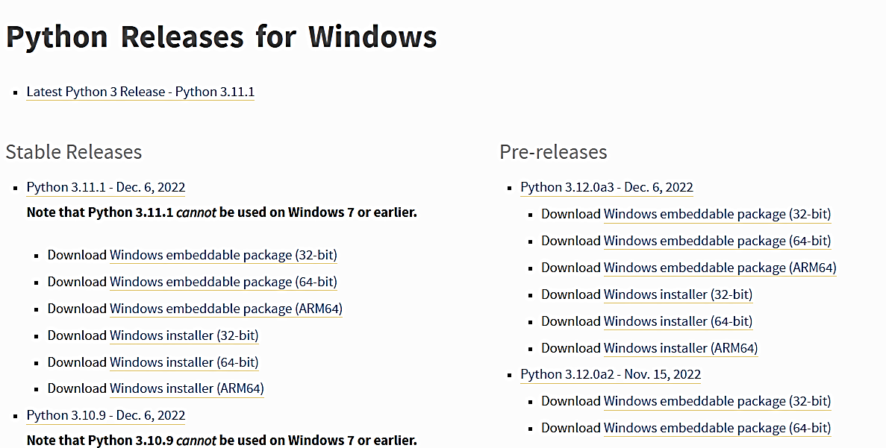

1. Run the executable installer once downloaded

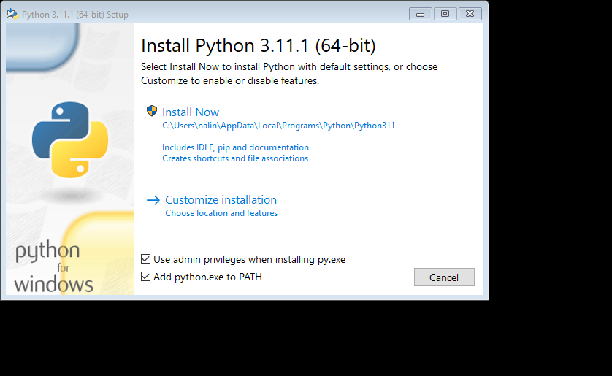

1. Click on the Install Now option with check in the Add python.exe to PATH
2. After the installation the Screen will prompt to Successful installation and ask for **Disable path length limit**.

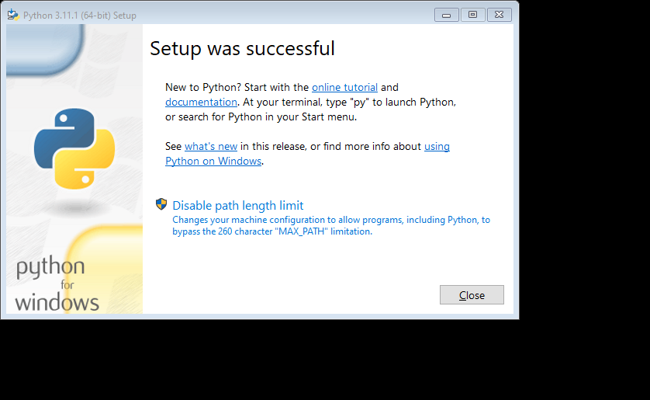

Disable Path Length Limit will help to bypass the 260 character MAX_PATH limitation. Effectively, it enables Python to use long path names

In the python programming language, there are 2 ways in which we can run our code:-

1. Interactive Mode
2. Script Mode (Batch Mode)

**Interactive Mode**

Interactive etymologically means “working simultaneously and creating impact of our work on the other’s work”. Interactive mode is based on this ideology only. In the interactive mode as we enter a command and press enter, the very next step we get the output. The output of the code in the interactive mode is influenced by the last command we give. Interactive mode is very convenient for writing very short lines of code. In python it is also known as REPL which stands for Read Evaluate Print Loop. Here, the read function reads the input from the user and stores it in memory. Eval function evaluates the input to get the desired output. Print function outputs the evaluated result. The loop function executes the loop during the execution of the entire program and terminates when our program ends. This mode is very suitable for beginners in programming as it helps them evaluate their code line by line and understand the execution of code well.

**How to run python code in interactive mode**

In order to run our program in the interactive mode, we can use command prompt in windows, terminal in Linux, and macOS. Let us see understand the execution of python code in the command prompt with the help of an example:

**Example 1:** To run python in command prompt type “python”. Then simply type the Python statement on >>> prompt. As we type and press enter we can see the output in the very next line.

Python code for addition on two numbers and we want to get its output. We will declare two variables a & b and store the result in a third variable c. We further print c. All this is done in the command prompt.

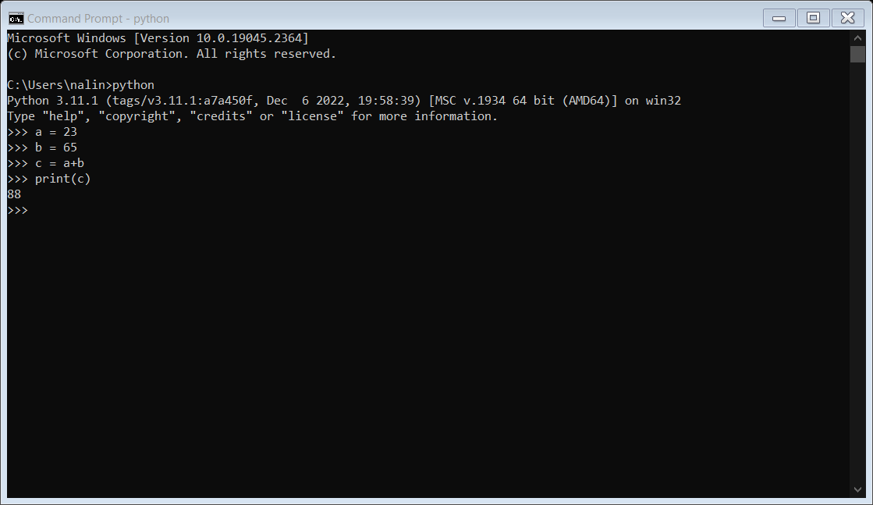# Python program to add two numbers

a = 2

b = 3

# Adding a and b and storing result in c

c = a + b

# Printing value of c

print(c)

**Script Mode**

Script etymologically means a system of writing. In the script mode, a python program can be written in a file. This file can then be saved and executed using the command prompt. We can view the code at any time by opening the file and editing becomes quite easy as we can open and view the entire code as many times as we want. Script mode is very suitable for writing long pieces of code. It is much preferred over interactive mode by experts in the program. The file made in the script made is by default saved in the Python installation folder and the extension to save a python file is “.py”.

**How to run python code in script mode?**

In order to run a code in script mode follow the following steps.

Step 1: Make a file using a text editor. You can use any text editor of your choice(Here I use notepad).

Step 2: After writing the code save the file using “.py” extension.

Step 3: Now open the command prompt and command directory to the one where your file is stored.

Step 4: Type python “filename.py” and press enter.

Step 5: You will see the output on your command prompt.

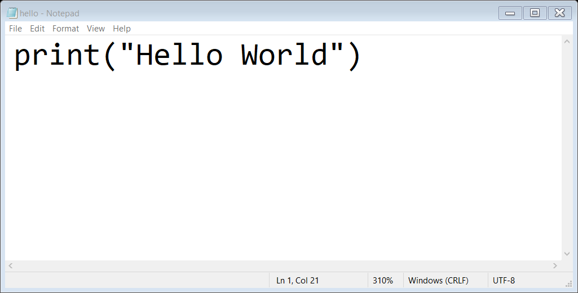

**Output:-**

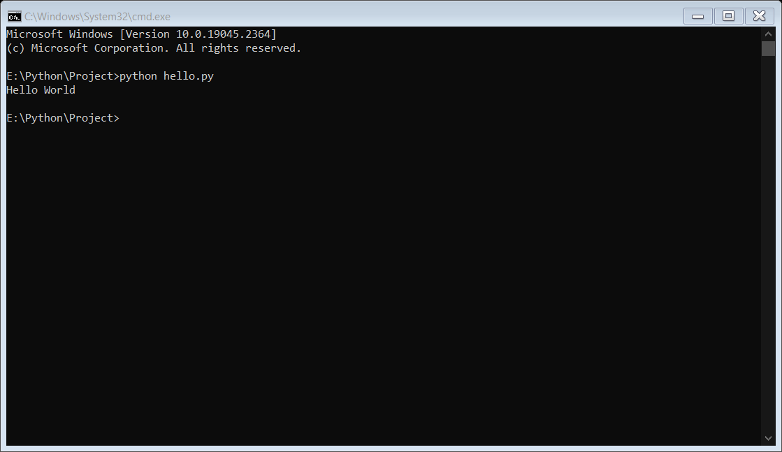

**Difference between Interactive and Scripting Mode:**

|  |  |
| --- | --- |
| **Interactive Mode** | **Scripting Mode** |
| It is a way of executing a Python program in which statements are written in command prompt and result is obtained on the same. | In the script mode, the Python program is written in a file. Python interpreter reads the file and then executes it and provides the desired result. The program is compiled in the command prompt, |
| The interactive mode is more suitable for writing very short programs. | Script mode is more suitable for writing long programs. |
| Editing of code can be done but it is a tedious task. | Editing of code can be easily done in script mode. |
| We get output for every single line of code in interactive mode i.e. result is obtained after execution of each line of code. | In script mode entire program is first compiled and then executed. |
| Code cannot be saved and used in the future. | Code can be saved and can be used in the future. |
| It is more preferred by beginners. | It is more preferred by experts. Beginners to use script mode. |

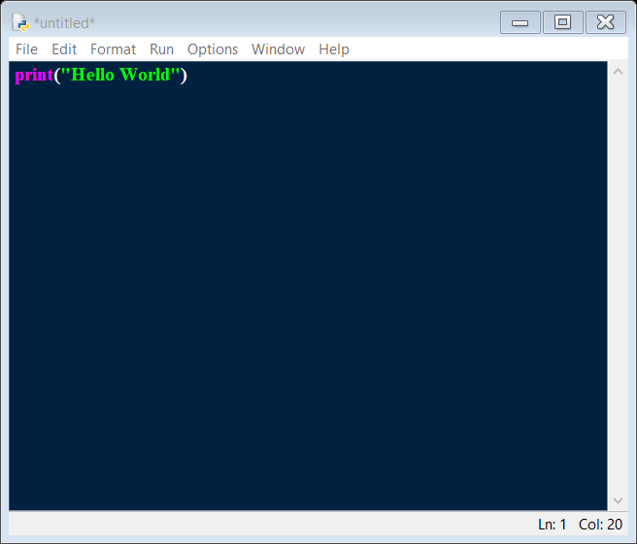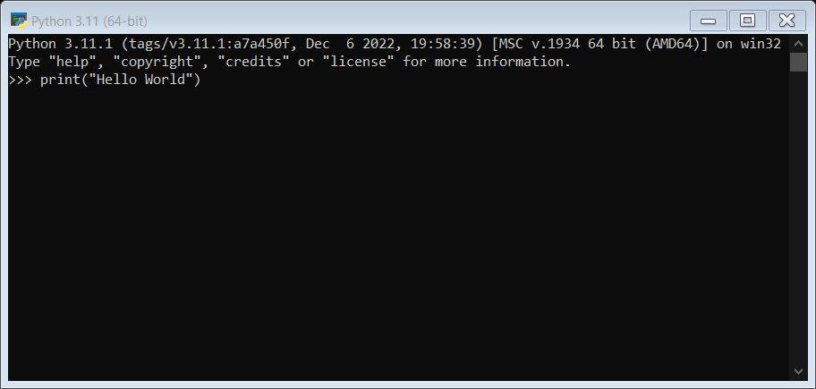

**IDLE**

**IDLE** is Python’s **Integrated Development and Learning Environment.** It allows programmers to easily write Python code. Just like Python Shell, IDLE can be used to execute a single statement and create, modify, and execute Python scripts.

IDLE provides a fully-featured text editor to create Python scripts that include features like syntax highlighting, auto completion, and smart indent. It also has a debugger with stepping and breakpoints features. This makes debugging easier.

**How does it work?**

The shell is the default mode of operation for Python IDLE. When you click on the icon to open the program, the shell is the first thing that you see:

**Code:**

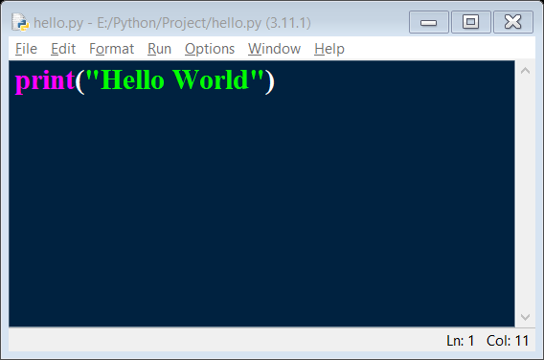

**Output: -**

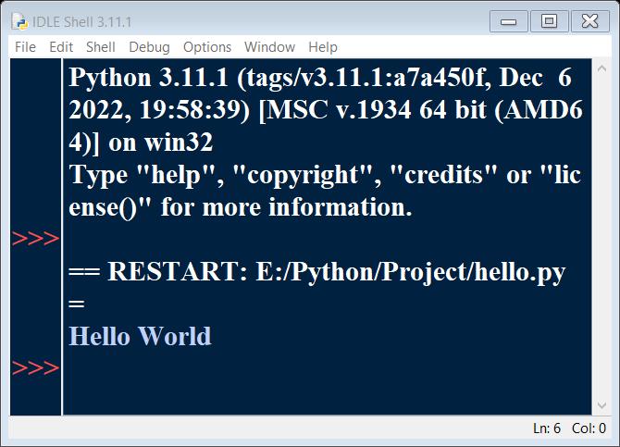

**Practical – 2**

**Aim :-** What do the following string methods do?

* Lower
* Count
* Replace

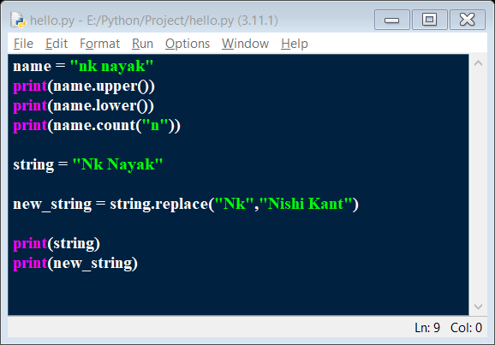

**Code: -**

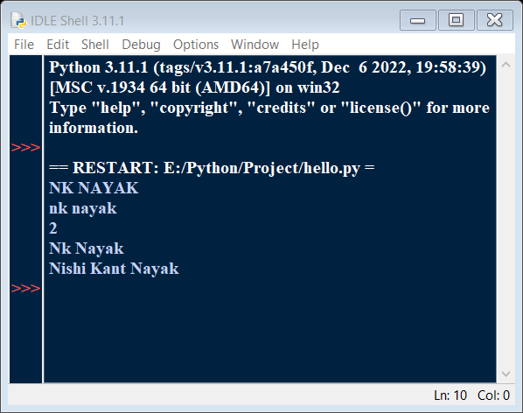

**Output: -**

**Practical – 3**

**Aim: -** Write instructions to perform each of the steps below:-

1. Create a string containing at least five words and store it in a variable.
2. Print out the string.
3. Convert the string to a list of words using the string split method.
4. Sort the list into reverse alphabetical order using some of the list methods (you might need to use dir(list) or help(list) to find appropriate methods).
5. Print out the sorted, reversed list of words.

**Code:-**

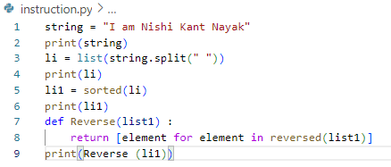

**Output: -**

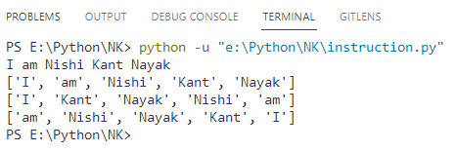

**Practical – 4**

**Aim -** Write a program that determines whether the number is prime.

**Code -**

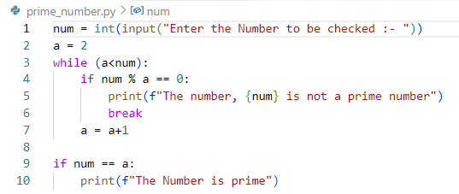

**Output: -**

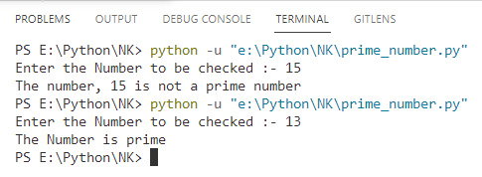

**Practical – 5**

**Aim:-** Find all numbers which are multiple of 17, but not the multiple of 5, between 2000 and 2500.

**Code: -**

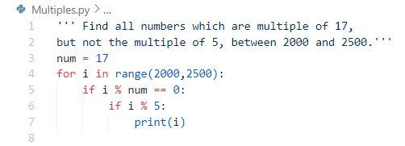

**Output: -**

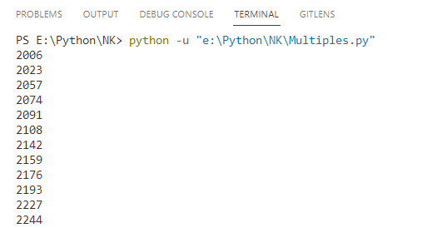

**Practical – 6**

**Aim: -** Swap two integer numbers using a temporary variable. Repeat the exercise using the code format: a, b = b,

1. Verify your results in both the cases.

**Code: -**

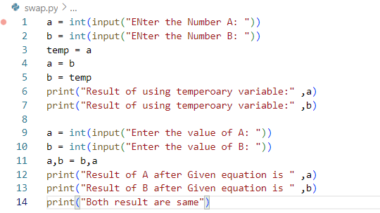

**Output: -**

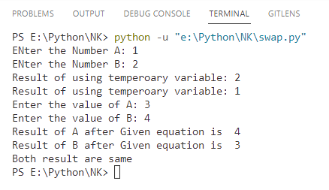

**Practical – 7**

**Aim: -** Find the largest of n numbers, using a user defined function largest().

**Code: -**

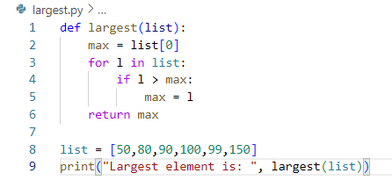

**Output: -**

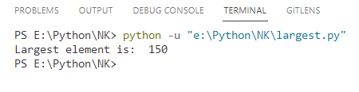

**Practical – 8**

**Aim: -** Write a function myReverse() which receives a string as an input and returns the reverse of the string.

**Code: -**

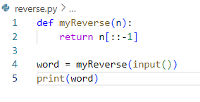

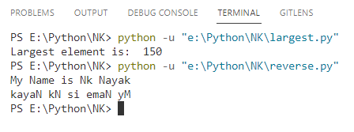**Output: -**

**Practical – 9**

**Aim: -** Check if a given string is palindrome or not.

**Code: -**

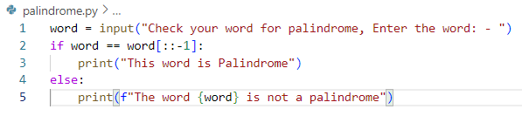

**Output: -**

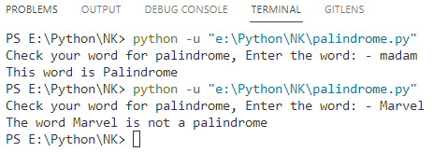

**Practical – 10**

**Aim: -** WAP to convert Celsius to Fahrenheit.

**Code: -**

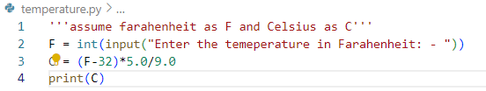

**Output: -**

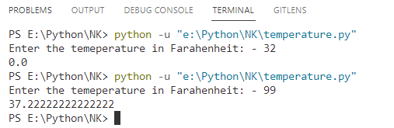

**Practical – 11**

**Aim: -** Find the ASCII Value of charades

**Code: -**

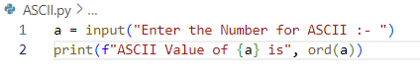

**Output: -**

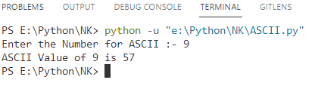

**Practical – 12**

**Aim: -** WAP for a simple calculator.

**Code: -**

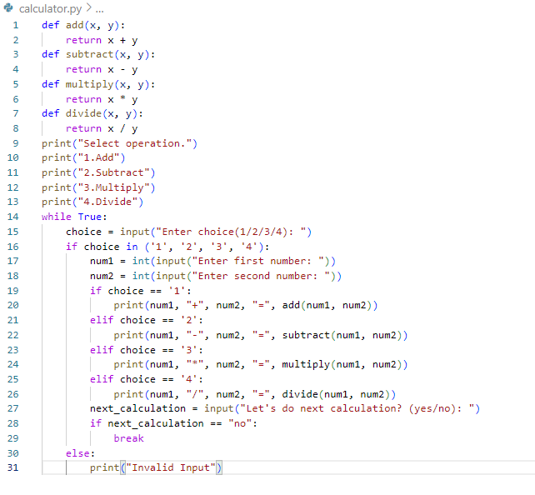

**Output : -** On the Next Page

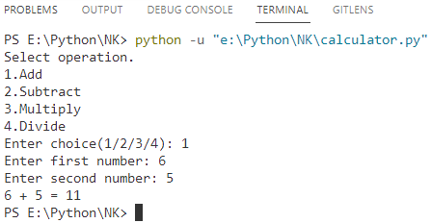Addition:-

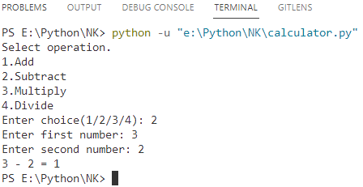

Subtraction:-

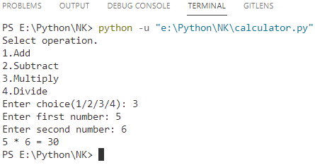

Multiply:-

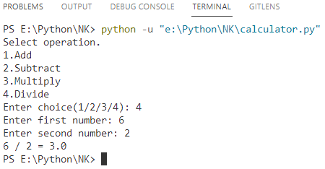

Divide:-