Proposal for ME30801 Open Lab Project

Prepared by: Team 065
Janine May (may180@purdue.edu)
Sean O-Lee (solee@purdue.edu)
Henry Luo (luo438@purdue.edu)

School of Mechanical Engineering,
Purdue University
585 Purdue Mall
West Lafayette, IN 47907

Date: 2026.03.29

Submitted to: Prof. Jun Chen

Project Title
Human body lift and drag at different hip bend angles.

Background & Motivation
Understanding lift and drag characteristics of a human body is important for ensuring safe travel through headwinds. When drag force on the human body becomes unreasonably large, the person is likely to be blown backward or fall. As lift force also increases, the friction of the person’s feet against the ground decreases dramatically until they completely lose control and get blown away by the wind. Our team chose to investigate these effects because they are invisible forces that directly impact the lives of people walking outside and may raise safety concerns with the elderly, young, or lightweight. We plan to quantify the lift and drag effects on a small-scale model at varying headwind speeds in the POTR160 Wind Tunnel.

Objective
The objectives of this project are to (1) measure lift and drag coefficients of three small-scale human body models at f = 30–60 Hz (U ≈ 22.67–34.01 m/s) and hip bend angle $θ∈\{{150}^{∘},{165}^{∘},{180}^{∘}\}$ using a dynamometer, (2) identify which hip bend angle produces the least lift and the least drag for each wind speed, and (3) identify the minimum wind speed where either liftoff occurs (full scale lift force (F_{l,fs}) ≥ average human weight (W_{fs})) or the person slips backward because of the wind (full scale drag force (F_{d,fs}) ≥ average human tractive limit (F_{tractivelimit})) at all hip bend angles.

Project Description

Experiment Facility
The experiment is performed in a wind tunnel located at the ME30801 lab in A. A. Potter Engineering Center, which is a low-speed open-circuit wind tunnel (ELD 402B, Fig. 1). The dimensions of its test section are 30.5 cm wide by 30.5 cm high by 61 cm long. It can be operated at a range of wind speeds from 3.0 to 48.7 m/s. A centrifugal, belt-driven fan with a 12.40-inch wheel diameter is driven by a 10 HP motor to move the air. A variable frequency drive (VFD) is used to adjust the rotating of the fan at different speeds and thus adjusts the wind speed in the test section.
Given the approximate mounting height on the dynamometer of 15 cm with about 3.37 cm of clearance at the bottom for a height-adjustable table, the experiment will be able to be conducted with at least 9.67 cm of head clearance, which is expected to be enough to avoid significant ceiling effects while encouraging ground effects.
Additionally, because the team is using incomplete similarity with the bluff body model, the wind tunnel’s speed range is sufficient for the execution of this experiment.

Test Model
Fig. 2 shows the CAD drawings for each experimental model, while Fig. 3 shows the models assembled into the wind tunnel. The models are to be 3D printed out of PLA. They are then to be mounted in the wind tunnel by slipping the oversized hole over the 3/8” threaded rod on the dynamometer, then lodging it in place by nuts on either side. A small sheet of paper is wrapped over the nut to reduce the effects associated with the nut while mimicking clothing.

Instrumentation
Tab. 1 Required instrumentation for experiment.
Instrument | Model/Type | Measured | Range | Accuracy Resolution | Available (Yes/No + Source)
LVDT Dynamometer | Unpublished | Lift & Drag | 0–100 N | Unpublished | Yes (ME308 Lab)
Mercury Thermometer | Unpublished | Ambient Temperature | Unpublished | Analog | Yes (ME308 Lab)
Mercury Barometer | Unpublished | Ambient Pressure | 680–780 mmHg | Analog | Yes (ME308 Lab)
Tab. 1 lists the instrumentation required for the experiment.
A dynamometer is used to measure the drag force experienced by the attached test model. It uses a linear variable differential transformer (LVDT) to convert linear deflection at the bottom of the apparatus structure to a high-resolution voltage. The measured voltage V_{total} can then be related to a drag force F_{d} between 0 and 100 N through Equation 1, where V_{0,offset,total} is the voltage reading at zero wind speed with the full setup, V_{ts} is the voltage reading at test condition without the model mounted on the test stand, V_{0,offset,ts} is the voltage reading at zero wind speed without the model mounted on the test stand, and K_{d} is the drag calibration constant. The same can be done to find the lift force F_{l} using Equation 2.
$F_{d}=K_{d}\left(\left(V_{total}-V_{0,offset,total}\right)-\left(V_{ts}-V_{0,offset,ts}\right)\right)$ (1)
$F_{l}=K_{l}\left(\left(V_{total}-V_{0,offset,total}\right)-\left(V_{ts}-V_{0,offset,ts}\right)\right)$ (2)

The ideal gas law is used to determine the density ρ from atmospheric pressure $P_{atm}$, molecular mass of air M, universal gas constant R, and temperature T (Equation 3). Therefore, air in the wind tunnel must be assumed to be ideal.
$ρ=\frac{P_{atm}M}{RT}$ (3)
Temperature is measured using a mercury thermometer, and atmospheric pressure is measured using a mercury barometer and corrected by a provided table. Ambient temperature and pressure were recorded as 23.5°C and 747.0246 mmHg, respectively.

Test Plan & Experimental Conditions

Procedure
First, measure and record the atmospheric pressure using the barometer and the temperature using the thermometer, then ensure the wind tunnel test section, intake, and exit are clear. Turn on the LVDT, open the ME30801 folder, and launch the MATLAB “Force Measurement Dynamometer” app. Record the drag and lift scaling factors, initialize the program, and save the data file. With the wind tunnel off, collect baseline data at 0 Hz, then turn on the tunnel and incrementally increase the frequency from 30 Hz to 60 Hz in 5 Hz steps, allowing the system to stabilize for 10 seconds and recording data at each step. After completing the test stand-only measurements, turn off the tunnel and repeat the procedure for each test model (180°, 165°, and 150° bends), ensuring proper positioning before each run and saving each dataset with appropriate filenames. Finally, email all collected data files to teammates.

Targeted Test Conditions
The targeted free stream velocities range from 22.67–34.01 m/s and correspond to frequencies of 30 Hz to 60 Hz.

Measured Parameter Estimation
Estimating the model as a cylinder of diameter 0.05152 m and height 0.174, and assuming a max freestream velocity of 34 m/s, we can calculate the reynolds number and planform area. Using the graph for drag coefficient based on reynolds number for a circular cylinder (Schilting, 2017), the total force can be calculated. These calculations yield a reynolds number of $1.19 ×{10}^{5}$, a drag coefficient of 1.2, and a total drag force of 7.6N. With a shorter cylinder of height 0.17m, the total drag force is 7.44N. These are within the range of the LVDT, but the resolution of the LVDT is unpublished, meaning we cannot tell if the differences between models is able to be read by the LVDT.

Anticipated Results
The measured parameters obtained from the experiment are the temperature and pressure of the testing room, the lift and drag conversion factors, the free stream velocity, and the corresponding lift and drag volages. Since the LVDT is constantly measuring voltages, we plan to also take a reading at 0 free stream velocity and use the difference between this reading and the readings at measured free stream velocities. Multiplying these readings by the conversion factor gives drag force, which we can convert to drag coefficient using the equations below.

$C_{d}=\frac{2F_{d}}{ρU^{2}A_{proj}}$ $C_{l}=\frac{2F_{l}}{ρU^{2}A_{proj}}$
Upon plotting the lift and drag coefficients with their respective reynolds numbers, we expect the coefficients to become relatively constant, due to the nature of bluff bodies (Leishman, 2023). Using these constant values with scaled human proportions will allow us to find the lift and drag force for each angle of hip bend, meeting objective 2. Finally, the equations below in combination with the equations for lift and drag coefficients can be used to find the highest windspeed each angle of hip bend will allow before beginning to slip on the ground, satisfying objective 3. Assume $μ_{s,rubber/dryasphalt}=0.9$ (https://www.engineeringtoolbox.com/friction-coefficients-d_778.html)
$$W_{fs}=m_{human}g$$
$$F_{tractivelimit}=μ_{s,rubber\&dryasphalt}(W_{fs}-F_{l,fs} )$$

Identified Risks and Mitigation
A risk of using 3d printed components is that the PLA human-body models could fail when subjected to forces during insertion or at higher wind speeds. As the fan frequency approaches 50-60 Hz, vibration levels increase, which increases the chance that a model could crack, loosen, or detatch from the threaded-rod mounting. To mitigate this risk the team should perform careful pre-run inspections of each model and rasteners, and gradually ramp up wind speed while monitoring for oscillations and to establish a conservative maximum operating frequency if instability is observed.
A second risk is that the lift and drag forces may be too small for the LVDT to distinguish due to resolution errors. To mitigate this, should the team observe that the drag forces and coefficients are too similar, new models will be created, increasing the width by 50% to increase the difference in forces by the same amount. As the LVDT has been shown to measure similar voltage differences to our predicted amounts, increasing the difference by 50% is more than sufficient to show a difference in the readings.

References
Leishman, J. G. (2023a, January 1). Bluff body flows. Introduction to Aerospace Flight Vehicles. https://eaglepubs.erau.edu/introductiontoaerospaceflightvehicles/chapter/bluff-body-flows/

Schlichting, H., & Gersten, K. (2017). Boundary-layer theory (9th ed.). Springer. https://elmoukrie.com/wp-content/uploads/2022/04/hermann-schlichting-deceased-klaus-gersten-boundary-layer-theory-springer-verlag-berlin-heidelberg-2017.pdf

CAD Sketches
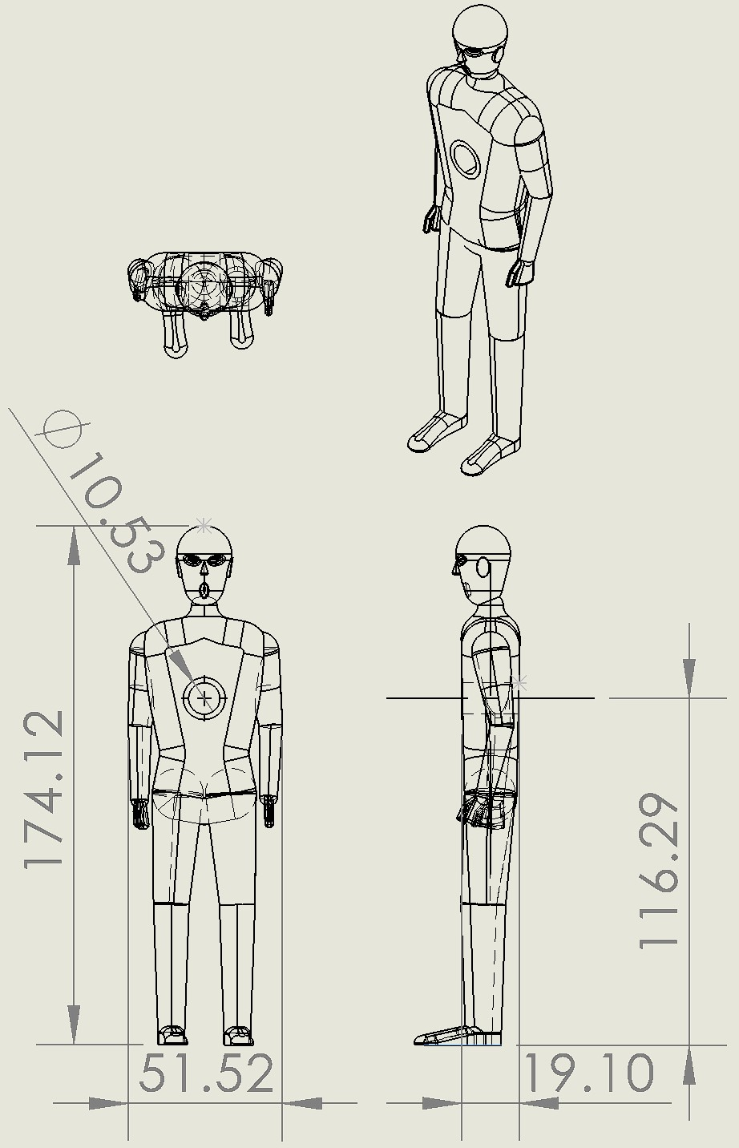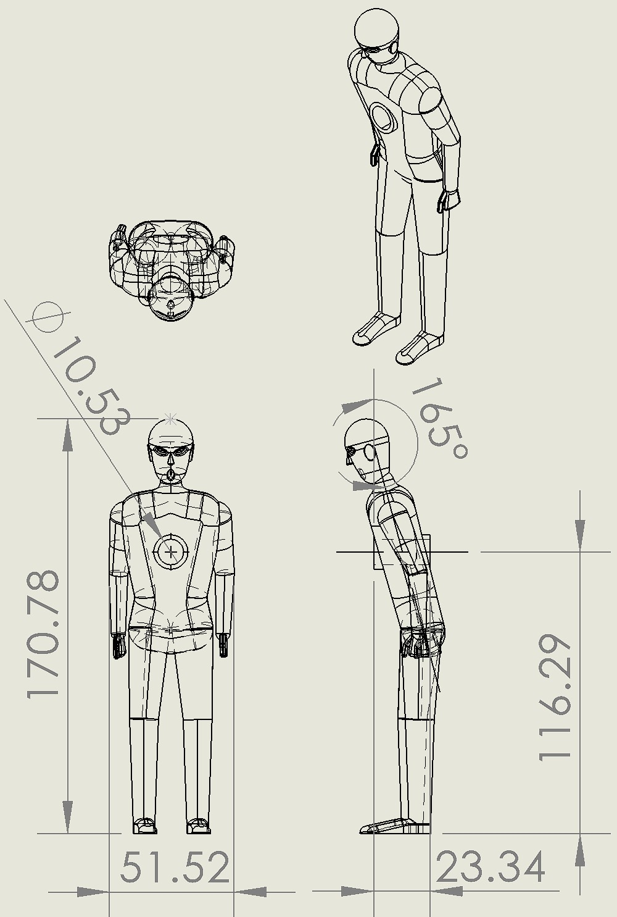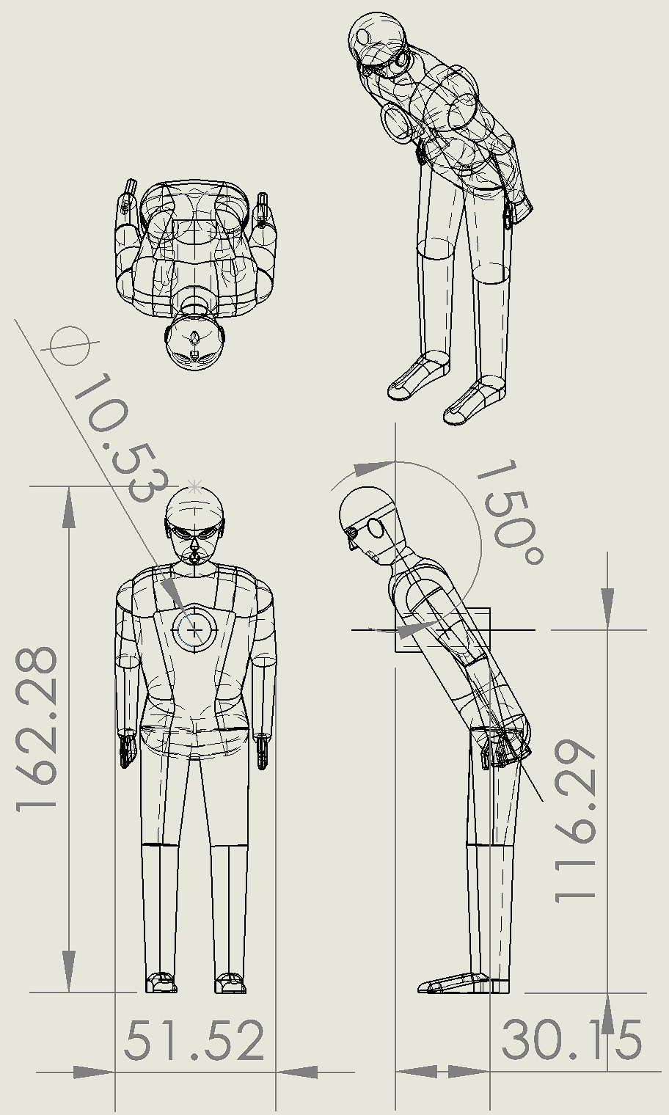
Fig. 1 Small-scale human test models. From left to right: model with 180° hip bend, model with 165° hip bend, and model with 150° hip bend.
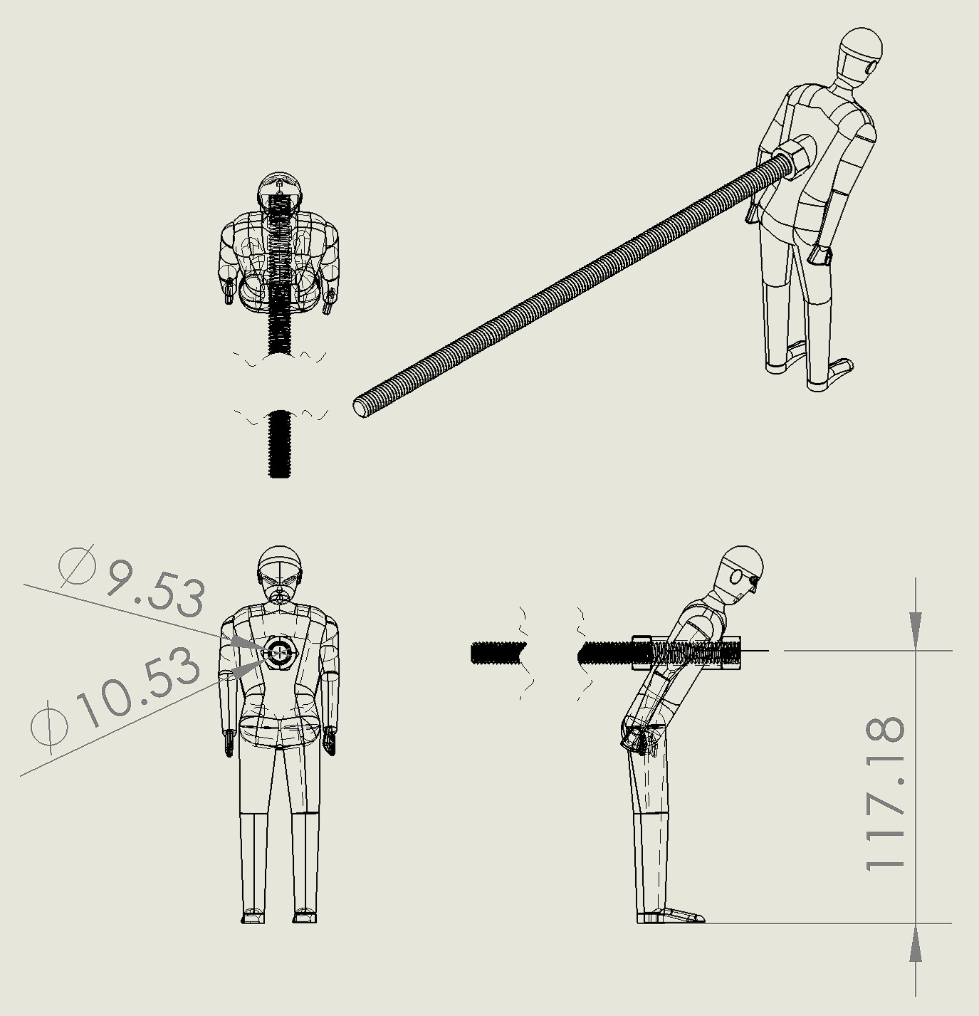
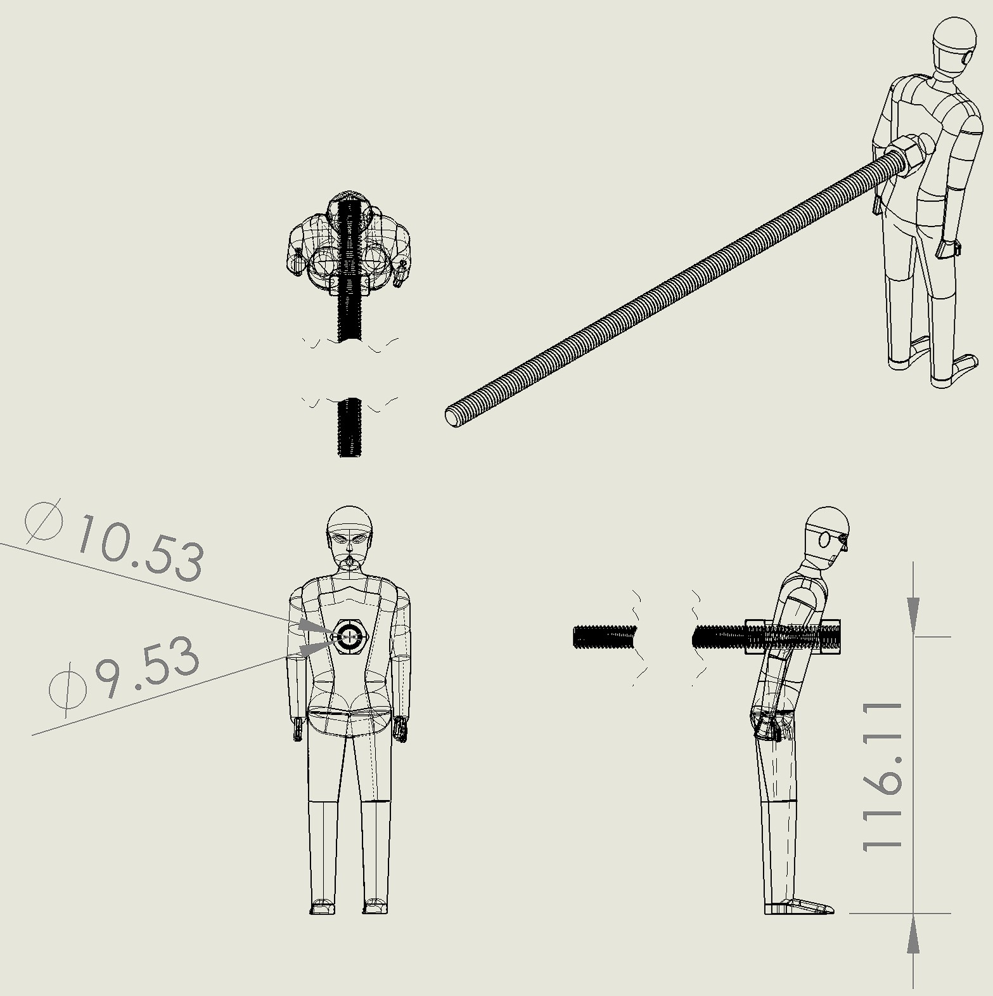
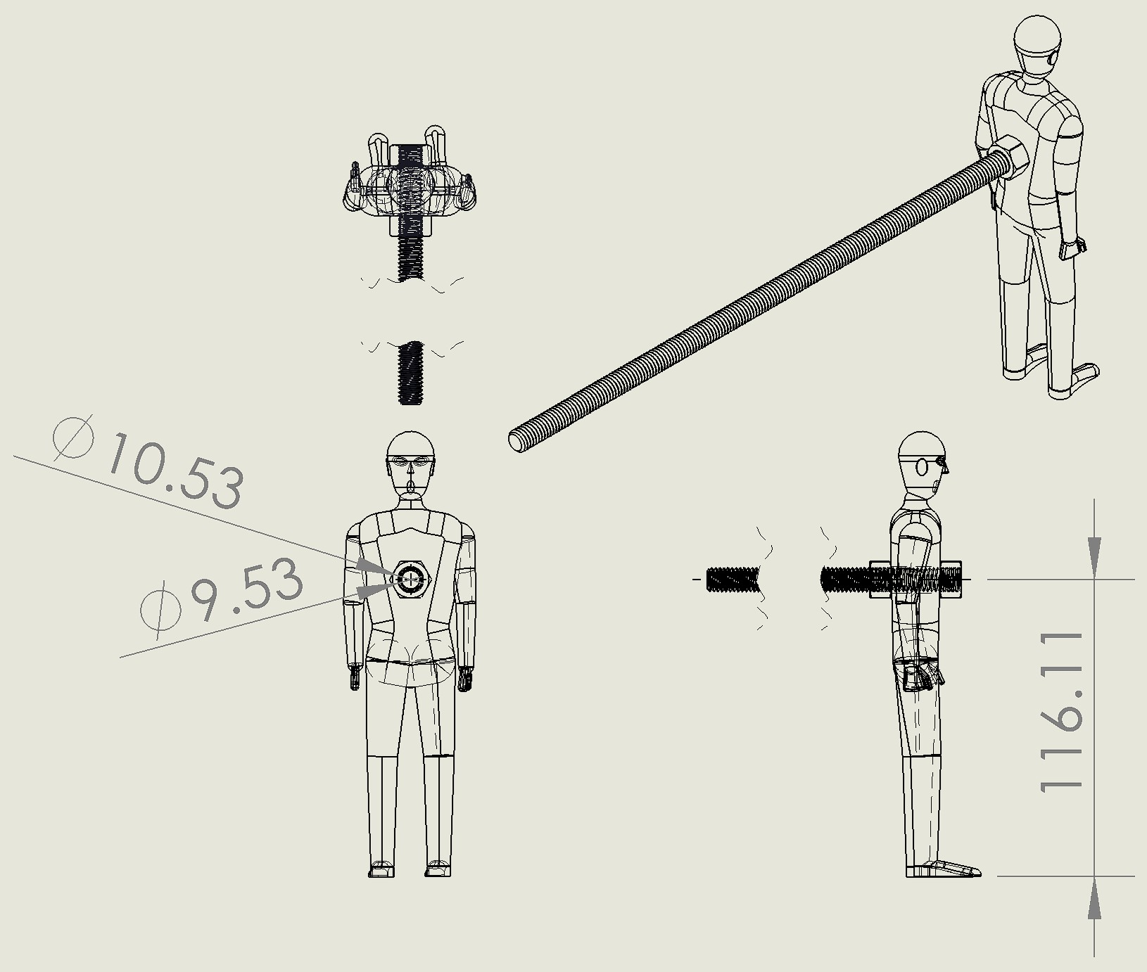

Fig. 2 Mounting of small-scale human test models. From left to right: model with 180° hip bend, model with 165° hip bend, and model with 150° hip bend. The floor (blue bar) is to be adjusted to provide as little ground clearance as possible without touching the model’s feet when the model is shaken.

