Computer Aided Design and Prototyping
(ME444 – spring 2026)

Action Toy Project
  - Project Proposal Report

Group No. 7

Sean O-Lee | Junior- ME
Janine May | Junior- ME
Henry Luo | Senior - ME
Ian Conley | Senior - MDE

School of Mechanical Engineering
Purdue University



Skateboard Cat

Summary
This cat, like most cats, loves chasing lasers. However, this cat also likes to ride a skateboard. Our novel cat riding a skateboard will detect a laser pointer and go towards it before swiping at it with its front paw. In addition, its leg appears to push the ground and its head and ears will move when the laser is not in vision.
Main functions
- Follows a laser
- Swipes at laser upon reaching laser
- Leg appears to move with motion of the skateboard
- Head and ears move when laser is not in vision

Toy Concept
Overall sketch
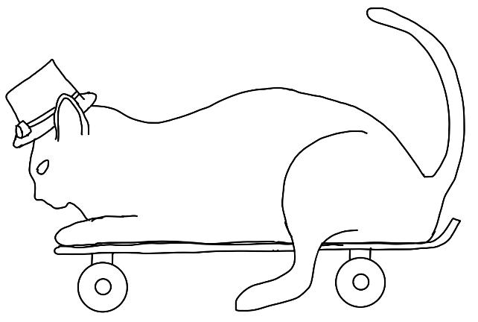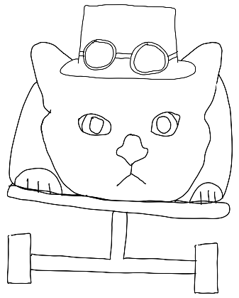

Systems:
Drive System:
- Subsystem: Steering
- Rear leg movement
Motion Tracking System:
- Subsystem: head/ear motion
- Laser tracking through ESP32-S CAM
- Front arm swipes at laser
Concept Generation and Ideation:
The drive system consists of a rear-wheel steering skateboard subsystem, direct-drive front skateboard wheels, and cam/linkage-driven leg. The team will choose to drive the skateboard by wheel instead of reciprocating leg because of ease of implementation, particularly when considering the effect of imbalanced forces on experienced moments. The team will also choose to use a single steering axle instead of traditional Ackermann steering or skateboard truck setups because of its similarity to skateboard truck turning characteristics while avoiding the complexities associated with transferring shaft power with a rolling chassis. Because the single steering axle will likely encounter a lot of resistance, a reduction of geartrain will be used to increase the torque input to rotate the entire steering shaft.
The motion tracking system consists of a head/ear motion subsystem, laser tracking through a camera, and a swiping arm. The team will choose to rotate the ears with the head to add more animation and expressivity to the cat’s face. The team will also choose to make the cat swiping system resemble a “lucky cat” arm but may choose to increase realism by adding a range of motion in arm extension.

BOM
Table 1 shows the projected bill of materials (BOM) for the Skateboard Cat.
Table 1: Skateboard Cat BOM
Item Name | System | Unit Price | Quantity | Purchase Source
Skateboard board | Main | 3D printed (PLA) | 1 | 3D printed
Cat body bottom shell | Main | 3D printed (PLA) | 1 | 3D printed
Cat body top shell | Main | 3D printed (PLA) | 1 | 3D printed
Misc hardware | Main | COTS | - | COTS
Acrylic paint | Main | $14.44 | 1 | Amazon (https://www.amazon.com/Artkey-Acrylic-Paint-Set-Professional/dp/B09TWQD5ZL/)
Drive motor | Drive | COTS | 1 | COTS
25mm ID wheel tire | Drive | 3D printed (TPU 95a, $18.59) | 4 | 3D printed (https://www.amazon.com/Comgrow-Filament-Printing-Flexible-Dimensional/dp/B0DF4TY2GD/?th=1)
25mm OD wheel hub (with axel) | Drive | 3D printed (PLA) | 4 | 3D printed
Steering axel join | Drive | 3D printed (PLA) | 1 | 3D printed
Steering axel geartrain | Drive | 3D printed | 1 | 3D printed
Steering servo | Drive | COTS | 1 | COTS
Swinging Leg | Drive (cosmetic) | 3D printed (PLA) | 1 | 3D printed
Mini USB to TTL serial converter | Motion Tracking | $6.49 | 1 | Amazon  https://www.amazon.com/HiLetgo-FT232RL-Converter-Adapter-Breakout/dp/B00IJXZQ7C/ref=pd_bxgy_thbs_d_sccl_2/140-3012512-9635043?pd_rd_w=HkdRE&content-id=amzn1.sym.9bef5913-5870-4504-8883-3ba89d7f8e39&pf_rd_p=9bef5913-5870-4504-8883-3ba89d7f8e39&pf_rd_r=KA7H8NNGQKWF827VVXZT&pd_rd_wg=ShmM6&pd_rd_r=d3aa79ae-30d3-4653-98ca-ff42f3de7370&pd_rd_i=B00IJXZQ7C&th=1
ESP32-S CAM | Motion Tracking | $18.49 | 1 | Amazon  https://www.amazon.com/HiLetgo-ESP32-CAM-Development-Bluetooth-Raspberry/dp/B07RXPHYNM/ref=sr_1_4?crid=20Z4GUD3WSE6U&dib=eyJ2IjoiMSJ9.P_vVogftiPALX7rsjQCRDASx-_9vMtZWE_p7ZvD0HmWew_8fmn9Y3Oa4dSRpAfhM2uw_rBHuM9hS732EBhMv1YmeM9Fqg4r66fEN1ZdidpgpUQuu7qZr6AKbFzMxibFSmvGVr5Kj3hSk62dEj3FAdkPgHjAYAfkaDEexkLA_yDXECItgi9MaeH9G5HHogwnsI5PfgDE1lSo3rUePJUcBMqhJOfFqS4BmTCGJTa3K2gg.BS5gj-D3mMHV9jL5JrYusP1PLxbWdPOzNfQpgjPMqPY&dib_tag=se&keywords=esp32s+camera+ov2640&qid=1773237794&sprefix=esp32s+camera+ov2640%2Caps%2C134&sr=8-4
Misc electronics | Motion Tracking | COTS | - | COTS
Top hat | Motion Tracking | 3D printed | 1 | 3D printed
Head | Motion Tracking | 3D printed | 1 | 3D printed
Ear | Motion Tracking | 3D printed | 2 | 3D printed
Ear linkage | Motion Tracking | 3D printed | 1 | 3D printed
Head servo | Motion Tracking | COTS | 1 | COTS

Windup Skateboard Cat

Summary
A cat riding a skateboard looks very cute! Also generating multiple motions from a single windup while also moving is fun and interactive.
Motion which is triggered through windup/pulling the cat backwards along the ground.
Animation such as turning the cat's head and moving the cat's legs, also powered by the forward motion.

Toy Concept
Overall sketch

Systems:
Drive System:
- Subsystem: Drawback Power
- Rear leg movement
Motion Tracking System:
- Subsystem: head/ear motion
Concept Generation and Ideation:
The drive system will be powered by the user, pulling the cat backwards along the surface. Doing so will compress a rotational spring, storing energy for later use. Once released, the spring will drive the skateboard forward, with gear trains to also use the motion for the leg, head, and ear motion.
The head and ear subsystem will now just be an oscillatory mechanism, where the cat will tilt its head back and forth while driving on the skateboard. This can be accomplished through the use of cams and linkages.

BOM
Item Name | System | Unit Price | Quantity | Purchase Source
Skateboard board | Main | 3D printed (PLA) | 1 | 3D printed
Cat body bottom shell | Main | 3D printed (PLA) | 1 | 3D printed
Cat body top shell | Main | 3D printed (PLA) | 1 | 3D printed
Misc. hardware | Main | COTS | - | COTS
Acrylic paint | Main | $14.44 | 1 | Amazon (https://www.amazon.com/Artkey-Acrylic-Paint-Set-Professional/dp/B09TWQD5ZL/)
Drive motor | Drive | COTS | 1 | COTS
25mm ID wheel tire | Drive | 3D printed (TPU 95a, $18.59) | 4 | 3D printed (https://www.amazon.com/Comgrow-Filament-Printing-Flexible-Dimensional/dp/B0DF4TY2GD/?th=1)
25mm OD wheel hub (with axel) | Drive | 3D printed (PLA) | 4 | 3D printed
Steering axel join | Drive | 3D printed (PLA) | 1 | 3D printed
Steering axel geartrain | Drive | 3D printed | 1 | 3D printed
Swinging Leg | Drive (cosmetic) | 3D printed (PLA) | 1 | 3D printed
Top hat | Head/ear motion | 3D printed | 1 | 3D printed
Head | Head/ear motion | 3D printed | 1 | 3D printed
Ear | Head/ear motion | 3D printed | 2 | 3D printed
Ear linkage | Head/ear motion | 3D printed | 1 | 3D printed

