Computer Aided Design and Prototyping
(ME444 – spring 2026)

Guided Project- Battle Bot

Design Report

Group No. 7

Sean O-Lee | Junior- ME
Janine May | Junior- ME
Henry Luo | Senior - ME
Ian Conley | Senior - MDE

School of Mechanical Engineering
Purdue University



Revision History

S. No. | Date | Revision ID | Revision Details (Page No., Paragraph, Line No. etc.) | Author
1. | 2/28/2026 | Revision A | Initial Release, problem definition, design requirements, design constraints | Ian Conley
2. | 3/8/2026 | Revision B | Drawings of popping mechanism and overall assembly to appendix, hat tip design (part 2), system integration (part 2) | Henry Luo
3. | 3/8/2026 | Revision C | Physical prototype, BOM in appendix, drive system (part 2), lessons learned (part 3) | Janine May
4 | 3/8/2026 | Revision D | Conclusion, appendix screenshots of mounting fixtures and base | Ian Conley
5 | 3/8/2026 | Revision E | Electrical Subsystem (part 2), Prototyping (part 3), and pictures of code and electrical wiring (appendix) | Sean  O-Lee

Executive Summary
The ME 444 guided project tasks the student teams with creating a remote-controlled vehicle which competes in either a race or a battle bot competition with other teams. Team 7 chose to design a defense-based battle bot, with a metal plate base and 3D printed coverings. All of the electrical components were held in place through two 3D-printed mounting fixtures that were designed to allow full functionality of the bot’s driving and weapon systems. For driving and control, the team made use of an esp32s microcontroller and a TB6612FNG motor controller in tandem with Blynk software. The Blynk software allowed the team to control the bot through a mobile app with a custom button interface. The main weapon of this bot was intended to be the shell, which would flip opponents when raised. This function was planned to be controlled by a servo motor and an arm connected to the top of the inside of the shell. Upon construction, instead of an upward “popping” motion, the shell would tip sideways at a slower rate than intended due to loose constraints. This project required multiple iterations and component redesigns to fix unforeseen issues with how the components fit together. Such a compact design required the team to be careful with space and strategically place the electrical components for maximum functionality. This project was a great learning experience for the team and provided useful insights on tolerance, interference, and iterative prototyping that the team will use during the final action toy project. The team is proud of the battle bot it sent into the arena which was able to secure victories in both the lab section and final course-wide battle.

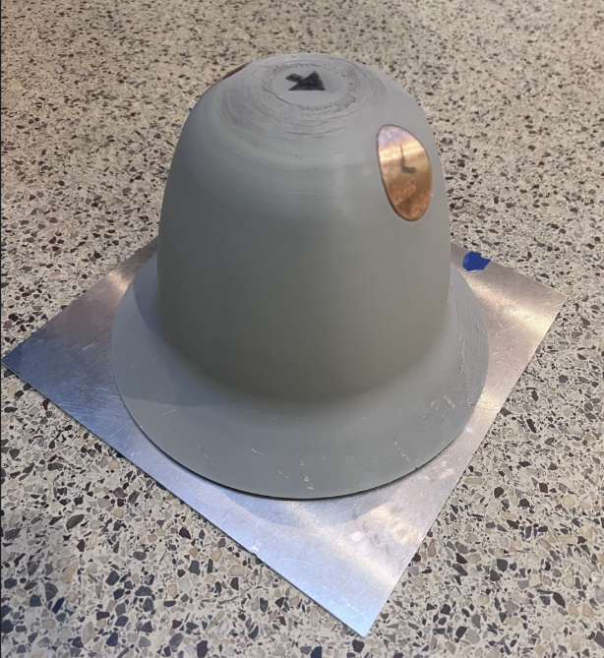
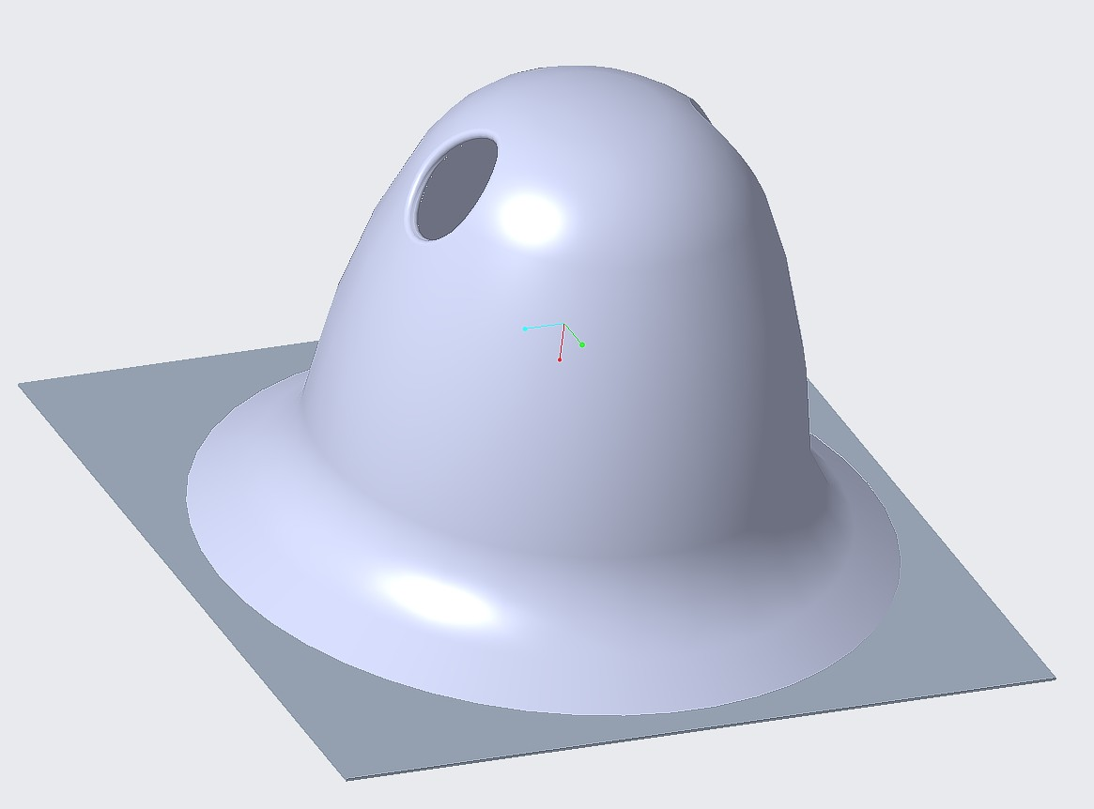
Table of Contents

Guided Project- Battle Bot 1
Design Report 1
Revision History 2
Executive Summary 3
1. Problem Definition 5
1.1 Design Requirements 5
1.2 Design Constraints 5
2. Design Description 6
3. Results (or Learning Outcomes) 11
4. Conclusion 11
5. Appendices 12

1. Problem Definition
For the ME 444 guided project, student teams were tasked with prototyping a remote-control toy vehicle that would compete against other teams in either a rally race or a battlebot competition. Throughout the course’s lab sessions, the teaching assistants have provided workshops on various skills that would be needed to develop the vehicle, including electronics and developing the controller. This project serves as a guided design assignment to help prepare students for the final action toy project.

1.1 Design Requirements
To meet the requirements of the project, the vehicle:
- Must be able to move forward and backward, be controlled to a stop, and turn right and left
- Must be remote-controlled through a provided ESP32S micro controller
- Must drive with provided motors
- Must be powered by a provided 7.4V Lipo battery
  - No extra power sources allowed

1.2 Design Constraints
To meet the constraints of the project, the vehicle must:
- Have a maximum size of 10x10x10 inches
- Have a maximum weight of 5 lbs.
- Only cold weapons are allowed
  - No electrical, chemical, or other non-mechanical types of weapons are allowed
  - Extra motors are allowed for the offensive system

2. Design Description
2.1 Sub-system 1 (Drive System)
The drive system contains two motors connected to two wheels via a direct-drive mechanism enabling steering via ‘tank drive’; steering is enabled by giving input to one motor, but not the other. This steering system allows for small turning radius compared to other steering systems. The motors are mounted on the bottom bracket such that the distance between the bottom base plate and the floor is minimal. The bottom bracket went through several iterations to ensure the tire contact with the floor and to meet other design considerations such as battery placement and pole alignment. Iterations to the bottom bracket are shown before the final drive system assembly in the figures below. Initially the bottom bracket had caster wheels to stabilize the system which were removed due to difficulty in determining accurate placement and proper printing. Later, the height of the alignment hole was changed due to interference and other interferences with the motor were accounted for allowing the motor and wheels to sit properly.

.
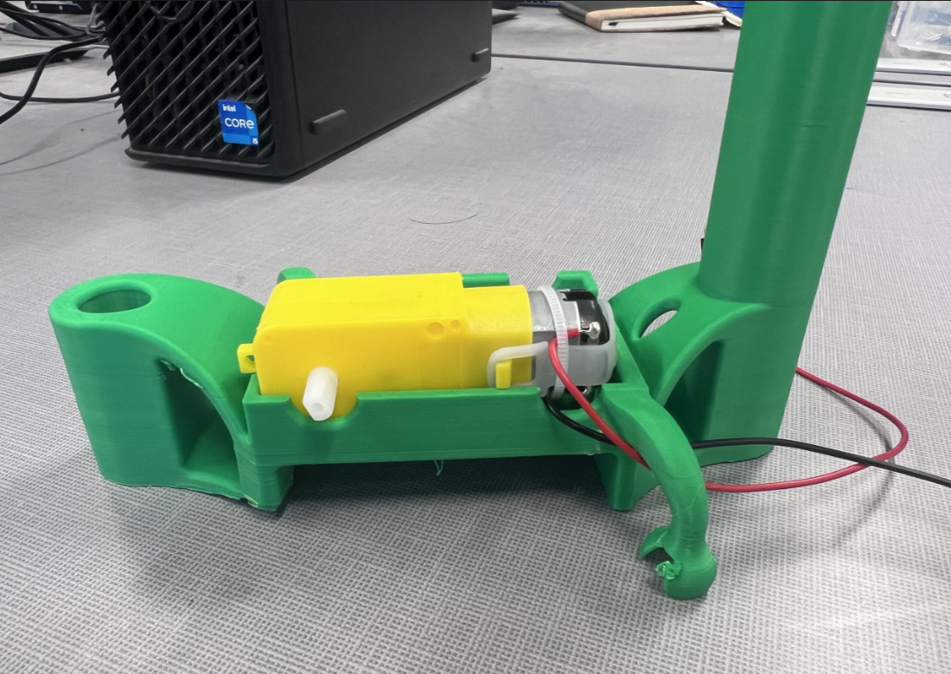
Figure 2.1.1: Drive System Prototype

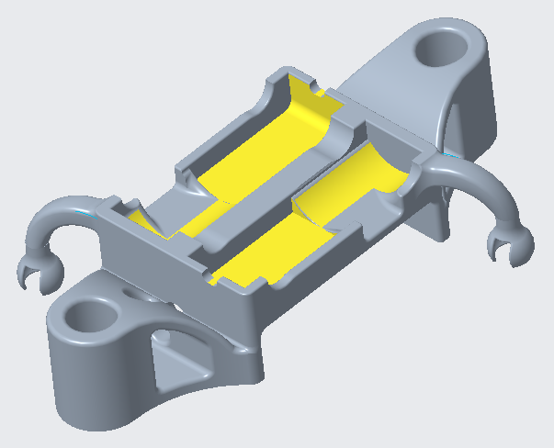
Figure 2.1.2: Drive System Prototype CAD

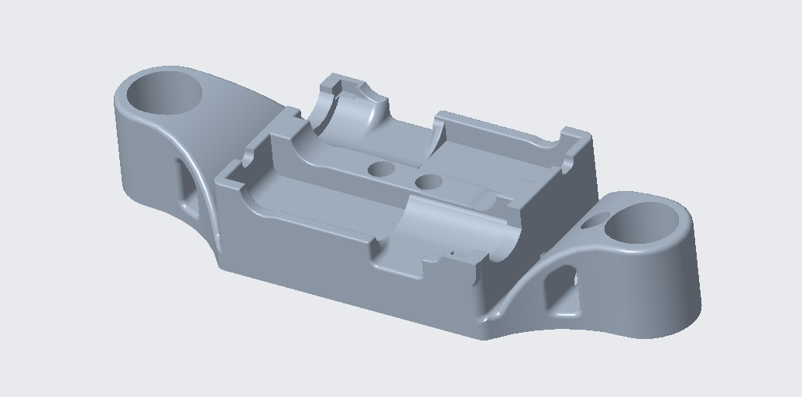
Figure 2.1.3: Drive System Final Bottom Bracket CAD

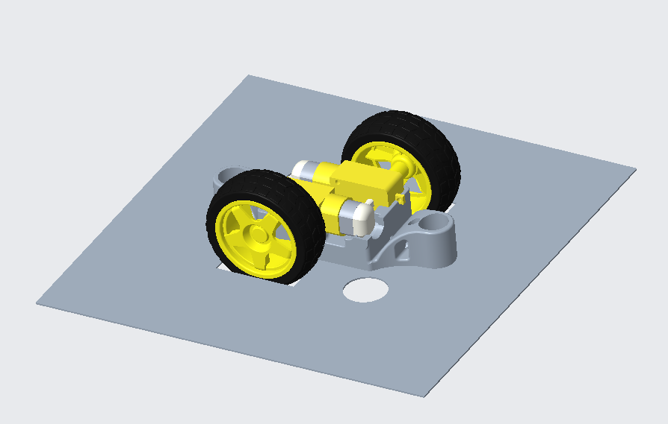
Figure 2.1.4: Drive System Final CAD Assembly

2.2 Sub-system 2 (Hat Tip System)
The hat tip system consists of a push/pull linkage (center) that translates the hat vertically from a servo horn angle input. A two-piece screw-tapped bushing at the bottom of the linkage is used to allow for free rotation when the servo horn is attached with a self-tapping screw. A two-piece threaded bushing secures the top of the linkage to the hat. A custom Allen key (right) aids assembly of the upper two-piece bushing through the sight holes when the caps on both sides are removed. Two cylindrical rails on opposite sides of the hat (left and right) constrain the hat vertically along holes in the robot chassis. Reference Figure 2.2.1 for a cross-sectional view of the hat-tipping mechanism.
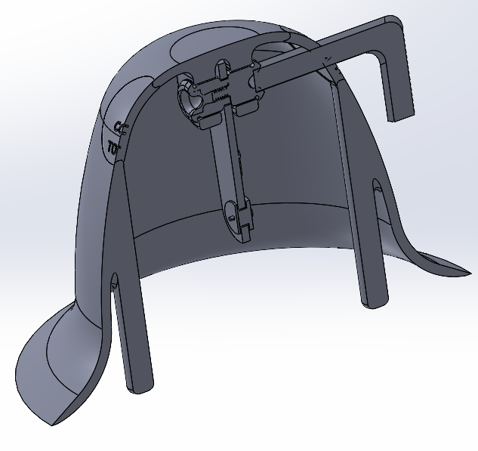
Figure 2.2.1: Hat tip subsystem cross-section.

2.3 Sub-system 3 (Electronic and Remote-Control System)
The electrical and remote-control system is centered around an ESP32s board which runs Arduino code to connect through Wi-Fi to the Blynk servers. The ESP32s connect to a TB6612FNG motor controller which can control the speed of the motors through pulse width modulation. The circuit is powered through a 7.4V LiPo battery which is run through a L7805CV voltage regulator to provide the required voltages to power the esp32s and TB6612FNG. A servo motor is then connected to the esp32s as well as the 7.4V source to complete the circuitry of this battle Bot. The circuit diagram and physical implementation are shown in Figures 2.3.1 and 2.3.2, respectively.
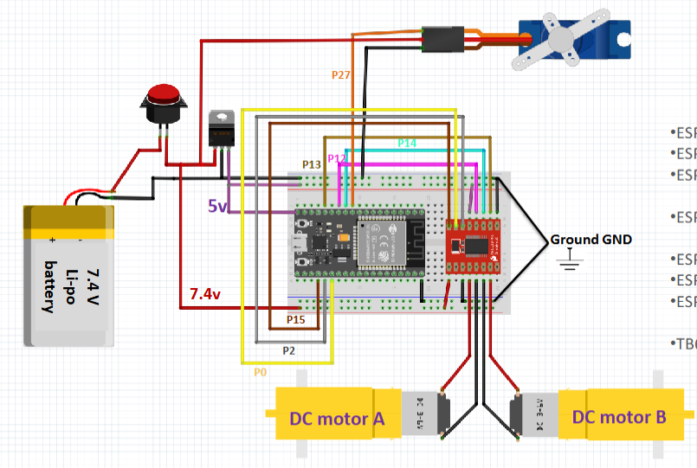
Figure 2.3.1: Digital Circuit Diagram
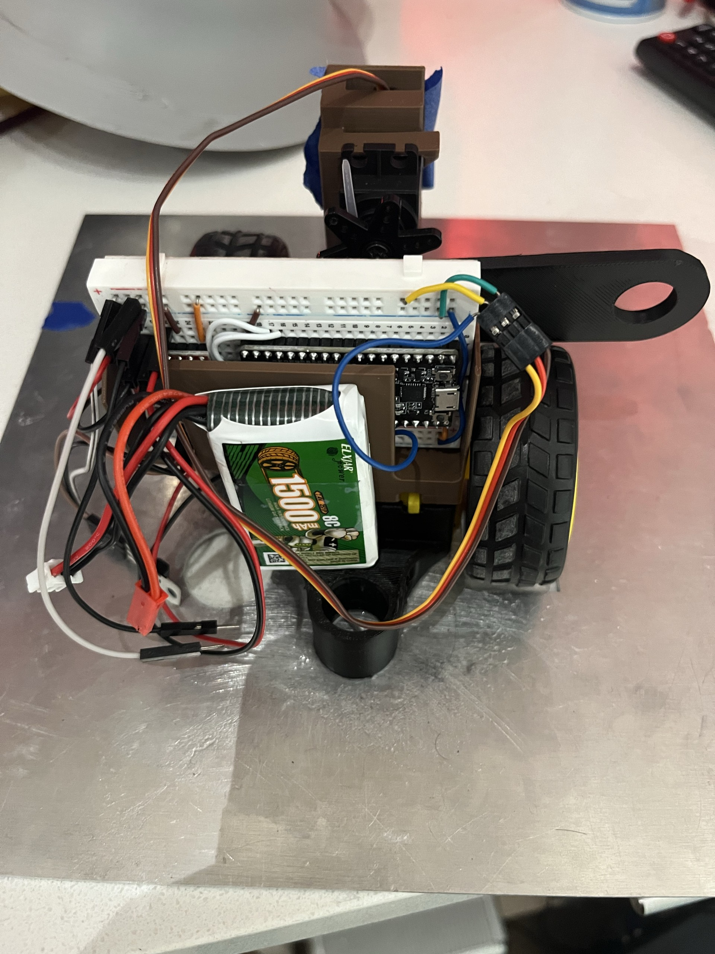
Figure 2.3.2: Physical Implementation of Electrical Circuit

  - System Integration
The robot layout consists of a bottom layer holding the drive system, a middle layer holding the electronic and remote control system, and a top layer holding the hat tip system. The bottom layer is held in place by the bottom bracket (which is epoxied onto the base plate) and mounts the drive motors, miscellaneous weights, and popper rail. The middle layer is held in place by the top bracket (which is zip-tied onto the bottom bracket) and mounts the breadboard and popper servo. The top layer is held in place by the servo linkage and popper rails and secures the hat.

3. Prototyping
The main chassis of the Battle Bot is manufactured from an aluminum plate of 0.060-inch thickness, which was laser cut to allow space for the wheels to touch the ground. The plate was laser cut using a fiber laser, with rotational symmetry to allow ease of assembly. All remaining parts of the chassis were 3D modeled and printed using either a Bambu labs P2S or a Bambu labs A1 printer. Of these parts, the most notable were the top and bottom brackets, which were used to hold the motors in place mechanically, and the shell, which was used as the bot's main method of defense and personality. The brackets were also designed with rotational symmetry and had holes through the middle to secure them together. Once the brackets were connected, the bottom bracket was attached to the plate using epoxy, and the rest of the parts were mechanically secured through clips and self-made screws. Although the design was intentionally to have the shell raise to flip opposing bots, the constraints proved too loose, which caused the raising motion to become a more comedic “hat-tip.”

3. Results (or Learning Outcomes)
The final competition-ready version of our battle bot was capable of meeting the requirements of the project, it could steer, was within dimension constraints, was remote-controlled through a provided ESP32S micro controller, drove with provided motors, and was powered by a provided 7.4V LiPo battery. Some of the learning outcomes from this project included: ensuring that interferences are accounted for in the assembly before fabrication, tolerances need to be accounted for when designing 3-d printed parts, certain features on real parts are not necessarily on CAD parts which may cause interference, it is important to dedicate time to making parts work before making them ‘good’, systems should be tested together with adequate time to fix before the deadline. An unexpected learning outcome came from the ‘popping’ mechanism not working as expected. As discussed previously, the ‘hat tip’ mechanism shell constraints proved too loose; however, the bot still performed successfully and provided a lot of joy to those who saw the comedic hat tip, showing that while a system may not work out as initially intended, sometimes it is alright. An additional general learning outcome is that design and iteration take longer than expected and time needs to be managed accordingly such that enough time for fabrication is allowed for.

4. Conclusion
In conclusion, the team was successfully able to create a defense-focused battle bot that survived and won both the lab section and final class battles. This was accomplished using a sheet metal base with very little clearance off the floor, electrical components provided by the course, 3D-printed PLA mounting fixtures for the electrical components, and a thick 3D-printed PLA dome to protect the electrical components. The “popper” feature did not fully work as intended although it added a unique and more comical feature in “tipping the hat”. Since this project is now complete, there is no future work to accomplish. However, the team plans to use some of the concepts learned during this project to complete the final Action Toy project.

5. Appendices
Bill of Materials
Bill of Materials (BOM)
Mat. No | Part Name | Qty. | Material / NA
1 | Drive Motor | 2 | NA
2 | Wheel D65X26 | 2 | NA
3 | Base Plate 9.8''x9.8''x0.06'' | 1 | Aluminum
4 | Bottom Bracket | 1 | PLA
5 | Top Bracket | 1 | PLA
6 | Breadboard | 1 | NA
7 | ESP32S | 1 | NA
8 | 7.4V Lipo Battery | 1 | NA
9 | Servo Motor 13.2 lb-in | 1 | NA
10 | Servo Horn | 1 | NA
11 | Epoxy | NA | NA
12 | Wires | 30 | NA
13 | Super Glue | NA | NA
14 | Painter's Tape | NA | NA
15 | TB6612FNG | 1 | NA
16 | L7805CV Voltage Regulator | 1 | NA

Electrical System
Digital Circuit Diagram
Physical Implementation of Electrical Circuit

Arduino Code
Code screenshot omitted; sanitized editable source is linked in the supporting files.
Code screenshot omitted; sanitized editable source is linked in the supporting files.
Code screenshot omitted; sanitized editable source is linked in the supporting files.

Blynk User Design
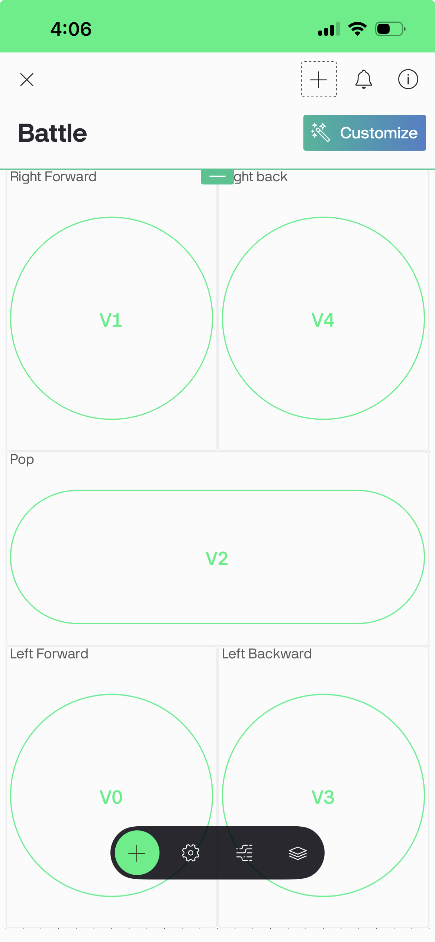

Master Assembly
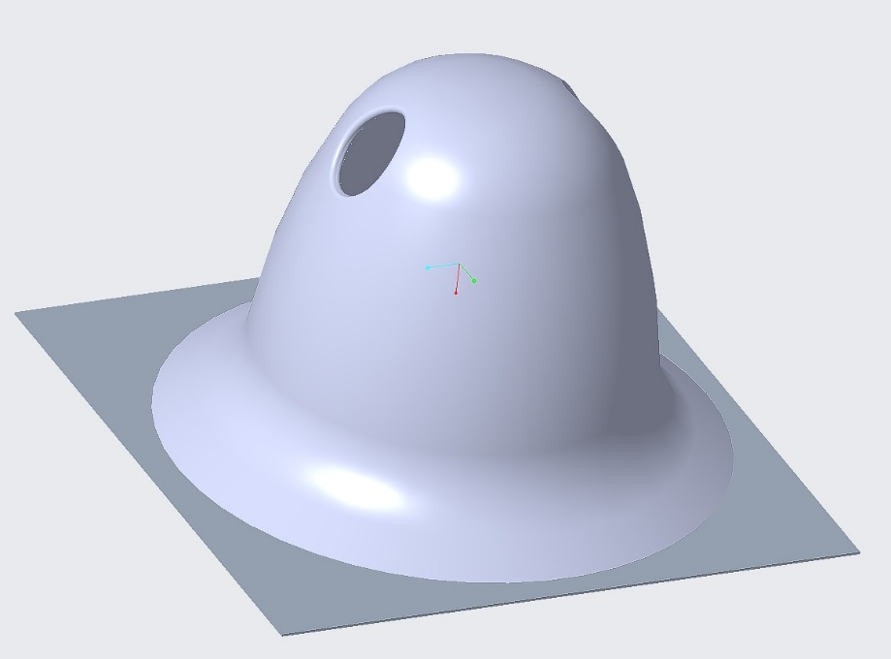

Popper Assembly

Bottom Mounting Fixture Model

Top Mounting Fixture Model
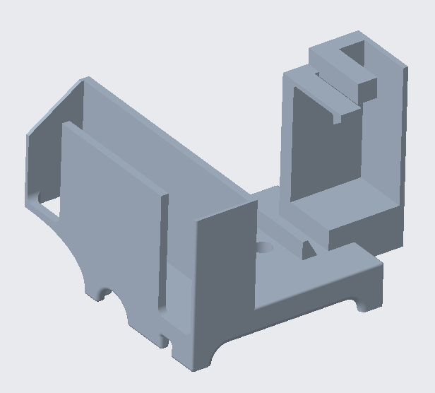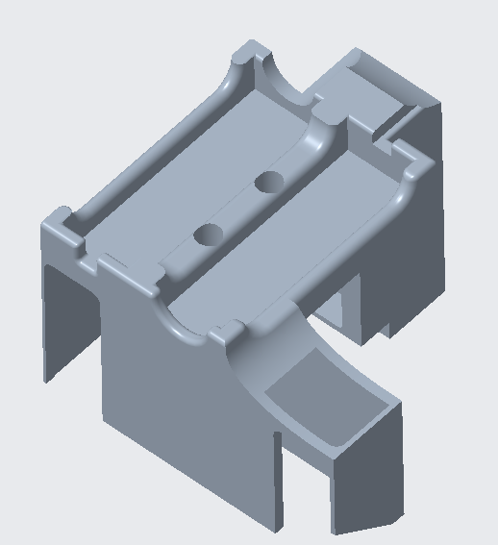

Metal Base Model
