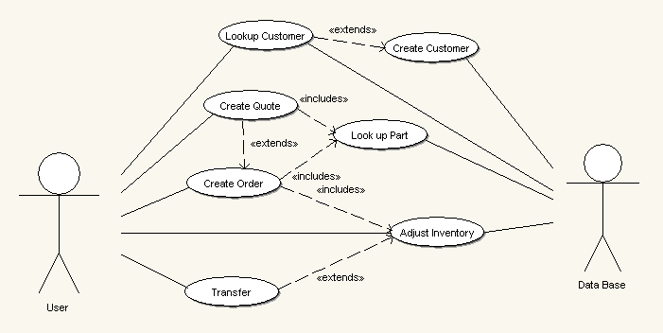

Lookup Customer
Pre Conditions:
- Employee must have a valid PIN.
- Customer must have previous business transactions.

Normal Flow
Actor Step | System Response
Request customer’s last name. | Return a list of previous customers with that particular last name.
Request customer’s first name. | Return Customer records.

Alternate Flow:
Actor Step | System Response
Request customer’s last and first name. | Return a list of previous customers with that name.
Ask the customer for middle initial. | Return customer records.

Alternate Flow:
Actor Step | System Response
As for business name. | Return Business name.

Post Condisions:

Create Customer
Pre Conditions:
- Employee must have a valid PIN
- Customer has never been to the store before.

Normal Flow (Personal Account):
Actor Step | System Response
Ask the customer for their:  - First Name  - Last Name  - Address  - City  - Zip code  - Main phone number  - Secondary phone number  - E-mail address. | - If there is a customer with the same first and last name the system will ask to modify the “Customer Name” field.  - If no other records are identical then create a new account.

Alternate Flow (Business Account):
Actor Step | System Response
Ask the customer for:  - Their first name  - Their last name  - Company’s name.  - Company’s address, City, Zip and phone number.  - Ask for their phone number.  - E-mail address. | If no other records are identical to the company name then create the account.

Post Condisions:

Create Quote
Pre Conditions:
- Employee must have a valid PIN.

Normal Flow (System Quote)
Actor Step | System Response
Select “System” as the type of quote. | Taylor GUI to what the employee has selected.
Input system. | Return a line by line break down of the system with costs.

Alternate Flow (Parts Quote):
Actor Step | System Response
Select “Parts” as the type of quote | Taylor GUI to what the employee has selected.
Add a part to the quote | Insert Sku, description, and price to the order.

Post Condisions:

Create Order
Pre Conditions:
- Employee has a valid PIN.
Normal Flow (New Order)
Actor Step | System Response
Enter PIN | Verify PIN
Enter in items | Add a line item to the order and total
Input payment | Ask for payment data.
Input payment information | Record payment information and modify inventory.

Alternate Flow:
Actor Step | System Response

Post Condisions:

Lookup Part
Pre Conditions:

Normal Flow (By Sku)
Actor Step | System Response
Input sku | Return Item cost, quantity, and availability.

Alternate Flow (By description):
Actor Step | System Response
Input key words | Return a list of possible hits including cost, quantity, and availability.

Post Condisions:
- Must return results or a message telling the user that there was nothing found.

Transfer
Pre Conditions:
- User must have a valid user name and password
- Must have adequate supplies

Normal Flow
Actor Step | System Response
User inputs user name and password. | System will respond by asking the user what they want to transfer.
User will input how many of each item they want to transfer. | The system will total up the cost of each item.
User will specify which store it will transfer it to. | Adjust inventory.

Alternate Flow:
Actor Step | System Response

Post Condisions:

Adjust Inventory
Pre Conditions:
- Done at the end of the month.
- During inventory.

Normal Flow
Actor Step | System Response
Input all inventory counted | Return a comparison to what the database actually has.
Double check returned inventory and adjust accordingly. | Return a report of losses and gains.

Alternate Flow:
Actor Step | System Response

Post Condisions:

