

# 2 to 4 decoder using (a) concurrent signal assignment statements (b) case statement

## Solution:

### Concurrent Signal assignments

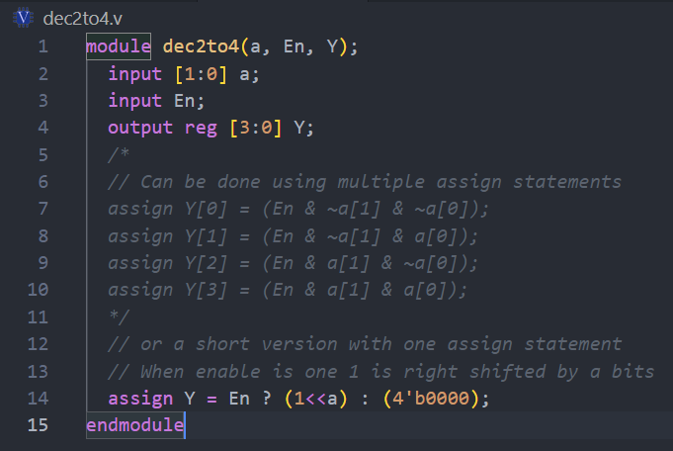

### Simulation waveform

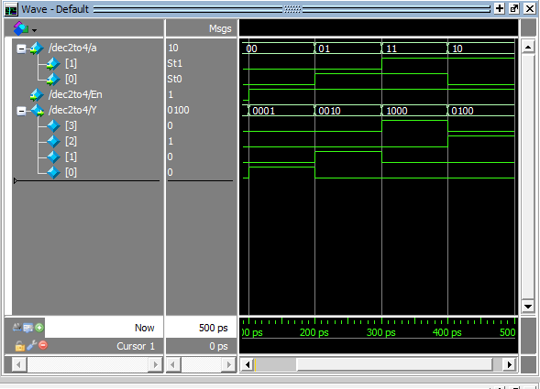

### Case statements

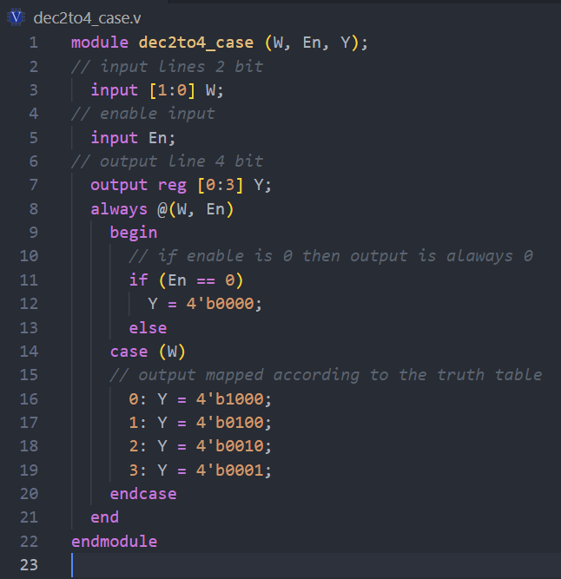

### Simulation waveform

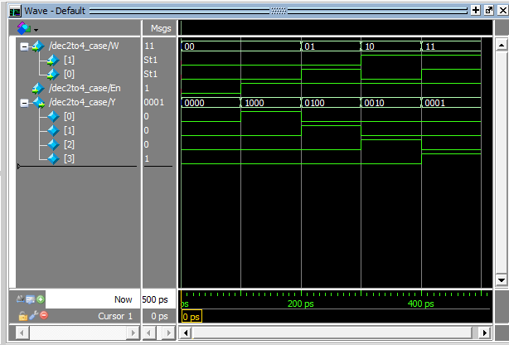

# 16:1 Mux

## Solution:

### Verilog code

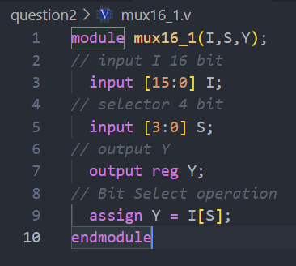

### Simulation

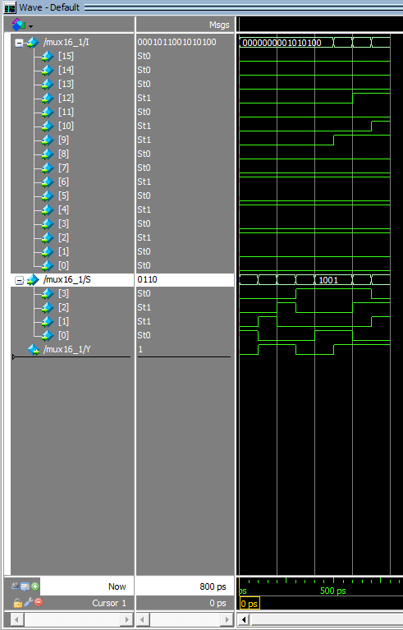

# Functionality of 74x148 priority encoder

## Solution:

### Verilog code

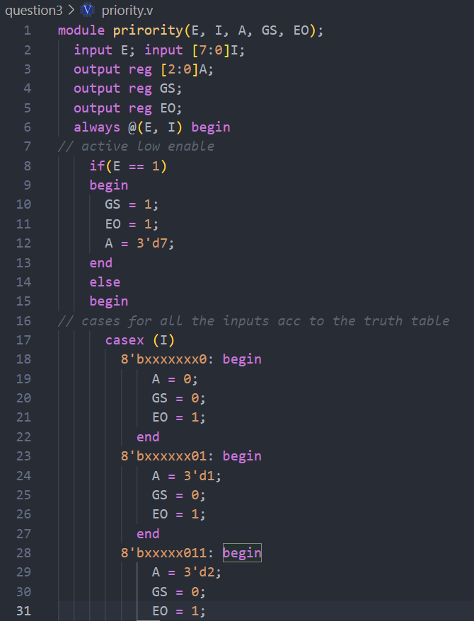

### 

### Simulation waveform

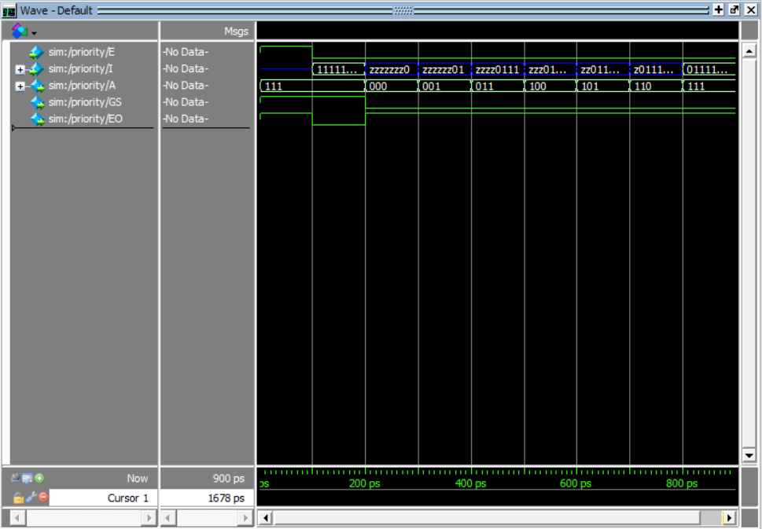

# ALU design

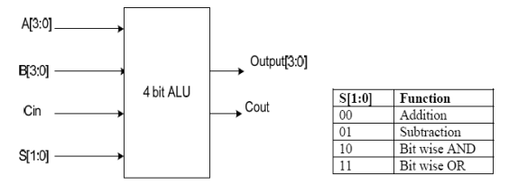

## Solution:

### Verilog code

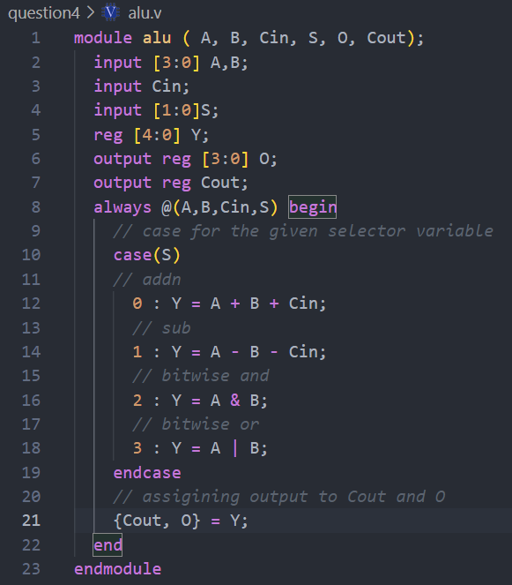

### Simulation waveform for S = 00

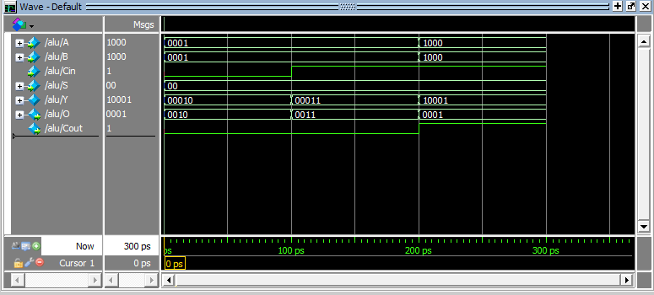

### Simulation waveform for S = 01

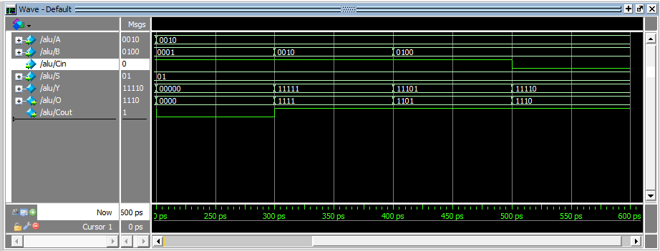

### Simulation waveform for S = 10

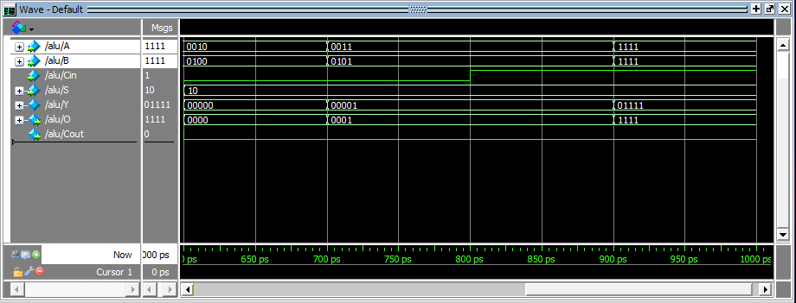

### Simulation waveform for S = 11

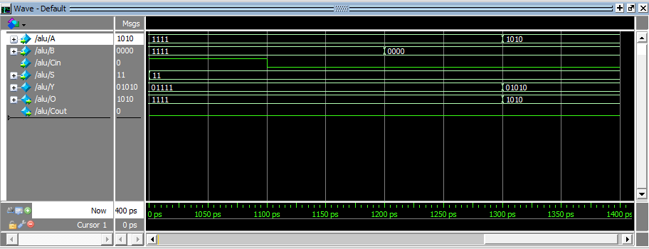

# Count number of 1s in a 32-bit number.

## Solution:

### Verilog code

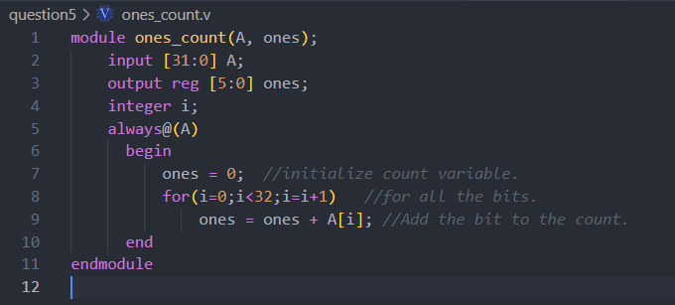

### Simulation waveform

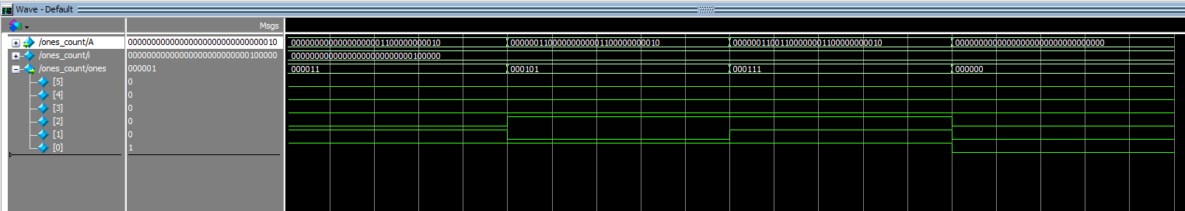

# Implement the following function



## Solution:

### Verilog code

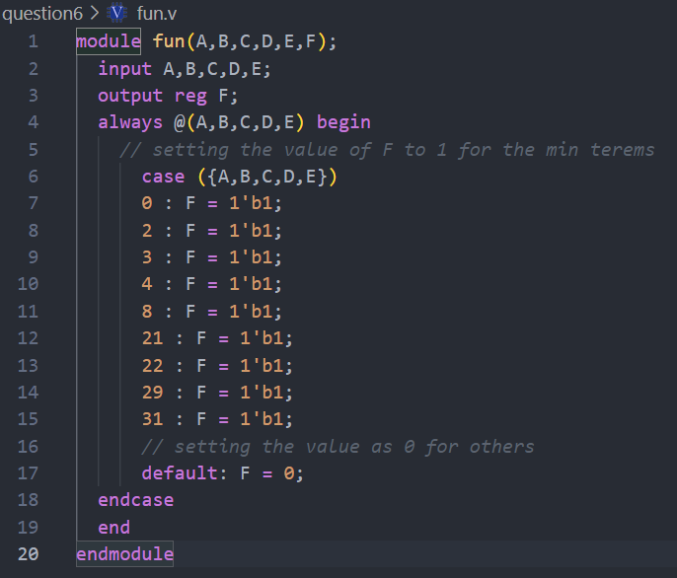

### Simulation waveform

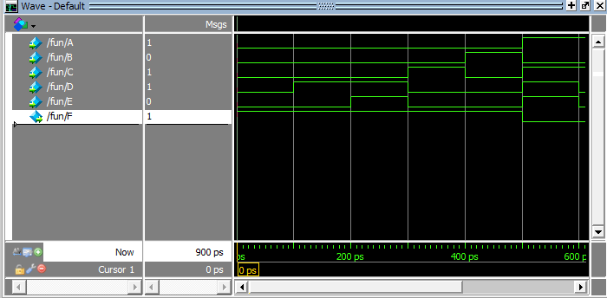

# 16-bit magnitude comparator.

## Solution:

### Verilog code

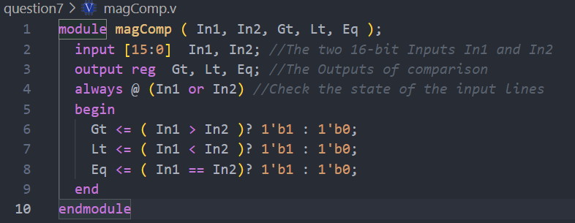

### Simulation waveform

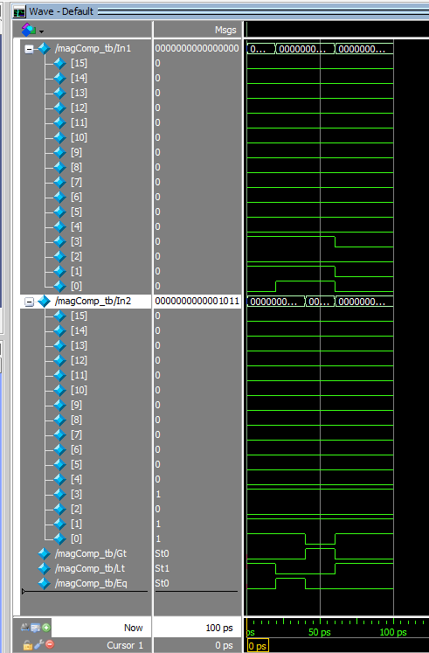

# Count the number of leading 0’s in an 8-bit number.

## Solution:

### Verilog code

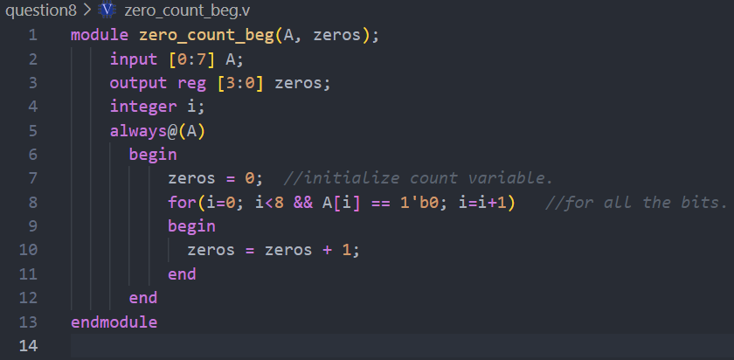

### Simulation waveform

