

# Decade Counter

## Solution:

### Code

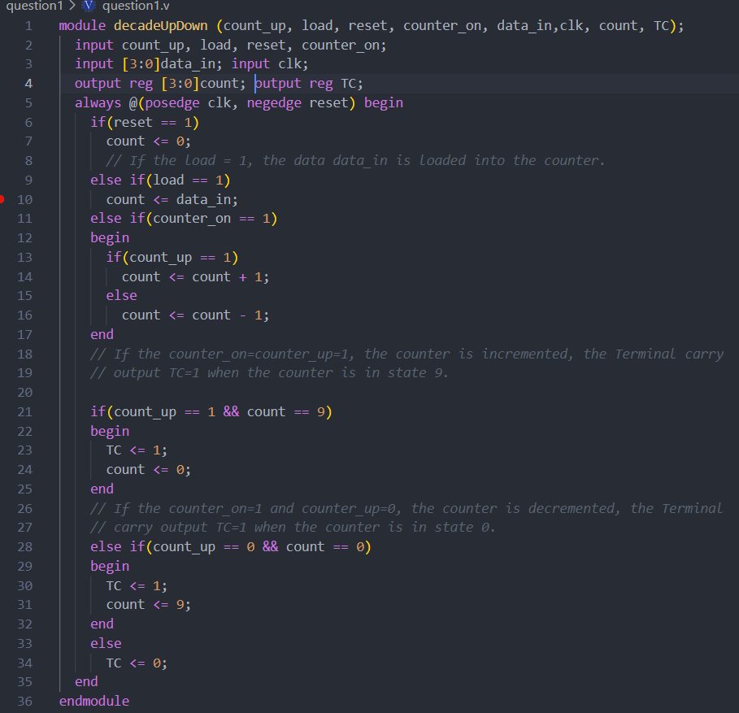

### Simulation waveform UP Count

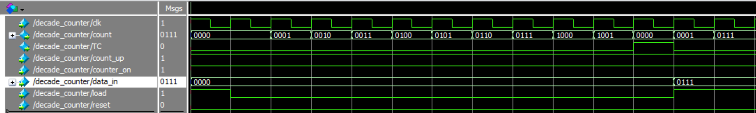

### Simulation waveform DOWN Count

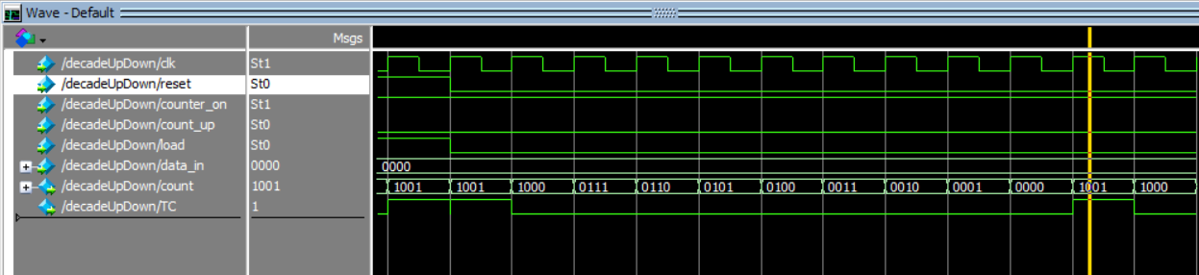

# Decimal up down counter

## Solution:

### Verilog code

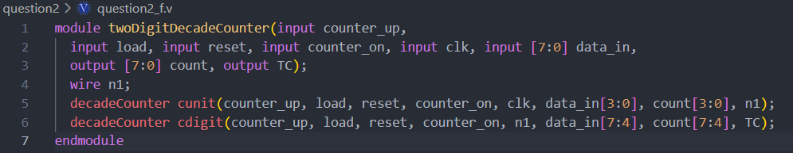

### Simulation UP count

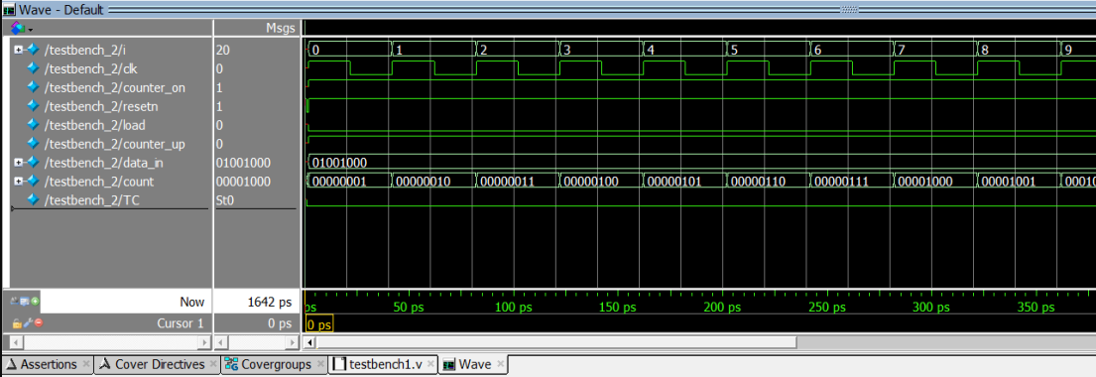

### Simulation DOWN count

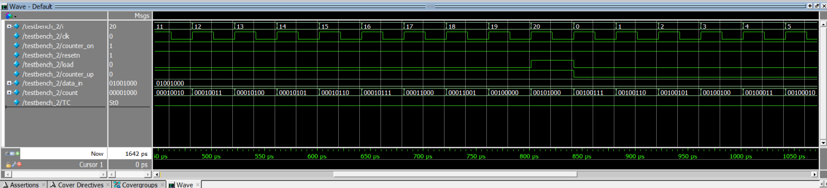

# N bit program counter

## Solution:

### Verilog code

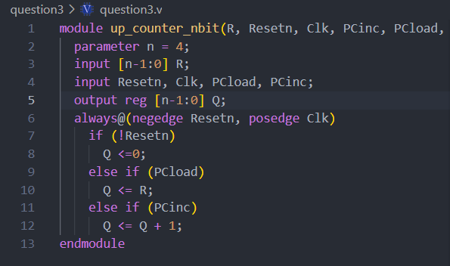

### Simulation waveform

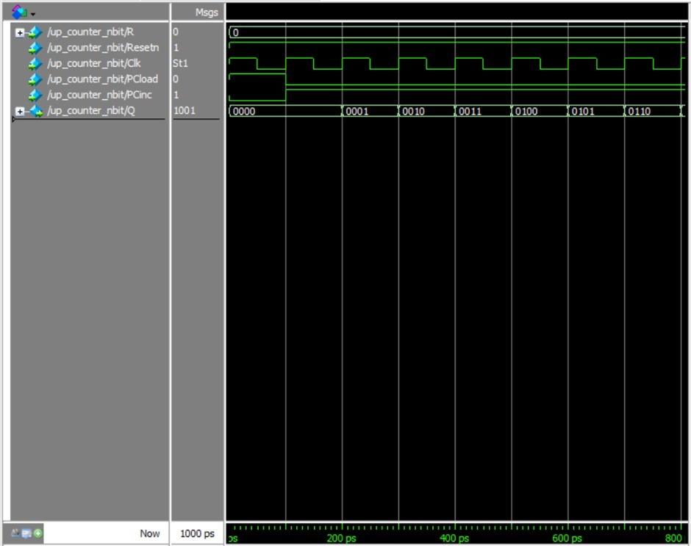

# Shift Register 74194

## Solution:

### Verilog code

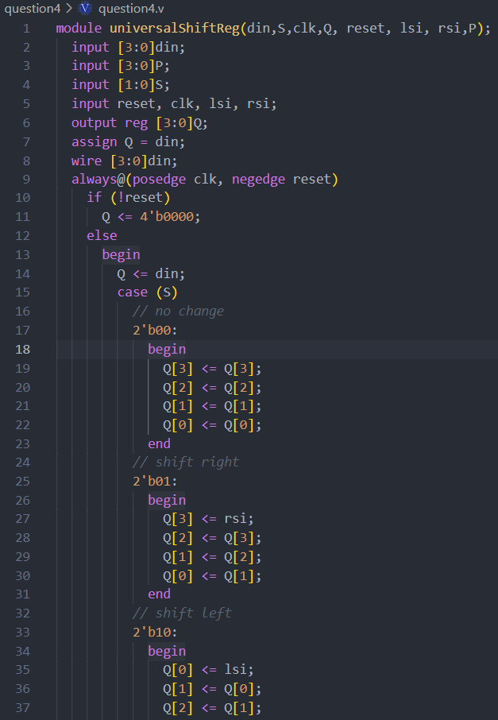

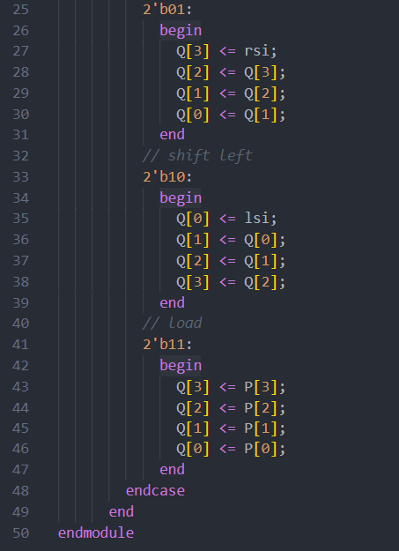

### Simulation waveform

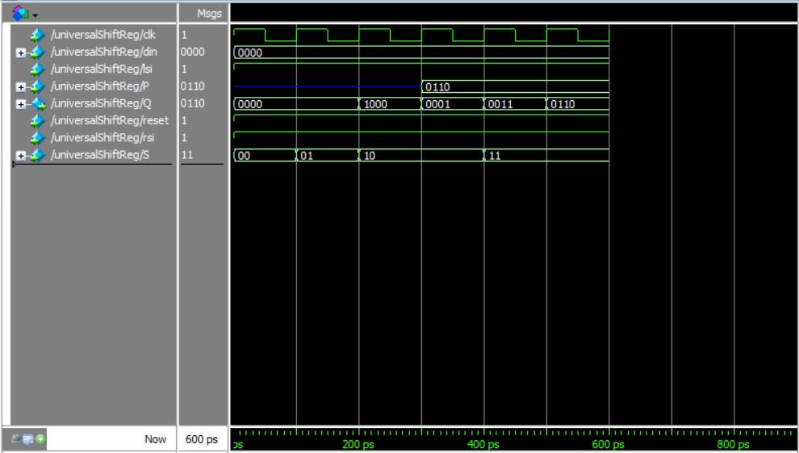

# Self-correction ring counter

## Solution:

### Verilog code

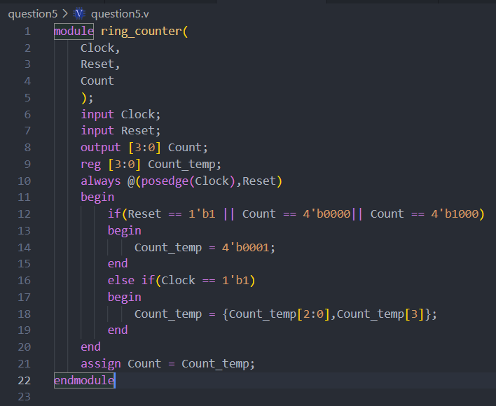

### Simulation waveform

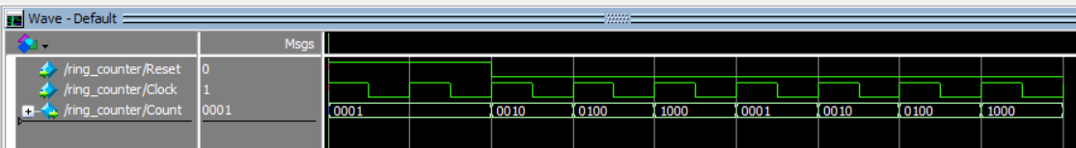

# Pseudo random sequence generator

## Solution:

### Verilog code

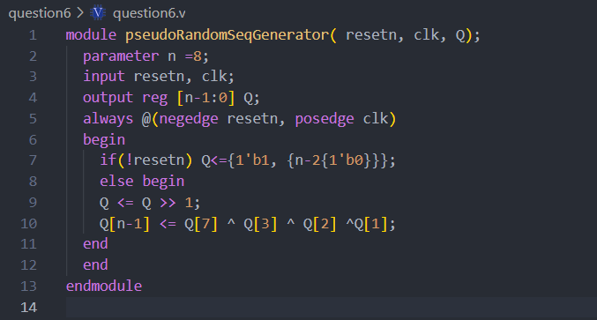

### Simulation waveform

