

# Sequence 1101 detector

## Solution:

**State Diagram**

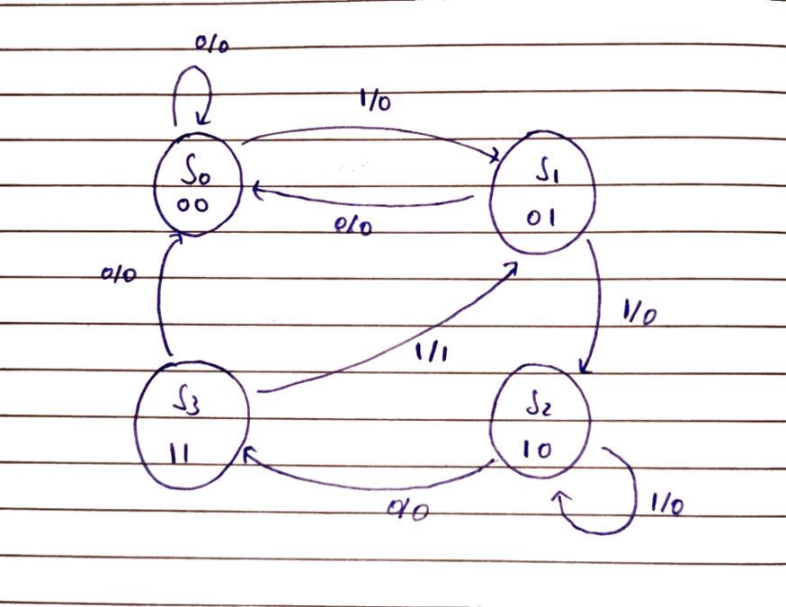

**State Table**

|  |  |  |  |  |  |  |  |  |  |
| --- | --- | --- | --- | --- | --- | --- | --- | --- | --- |
| Present State | | i/p | Next State | | o/p | Excitation (DFF) | | Excitation  (JKFF) | |
| QA | **QB** | **x** | **QA+** | **QB+** | **y** | **DA** | **DB** | **JAKA**  **(TA)** | **JBKB**  **(TB)** |
| 0 | **0** | **0** | **0** | **0** | **0** | **0** | **0** | **0** | **0** |
| 0 | **0** | **1** | **0** | **1** | **0** | **0** | **1** | **0** | **1** |
| 0 | **1** | **0** | **0** | **0** | **0** | **0** | **0** | **0** | **1** |
| 0 | **1** | **1** | **1** | **0** | **0** | **1** | **0** | **1** | **1** |
| 1 | **0** | **0** | **1** | **1** | **0** | **1** | **1** | **0** | **1** |
| 1 | **0** | **1** | **1** | **0** | **0** | **1** | **0** | **0** | **0** |
| 1 | **1** | **0** | **0** | **0** | **0** | **0** | **0** | **1** | **1** |
| 1 | **1** | **1** | **0** | **1** | **1** | **0** | **1** | **1** | **0** |

**K Map**

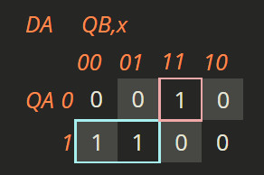 **DA (QA, QB, x) = QA'QBx + QAQB'**

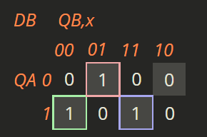 **DB (QA, QB, x) = QA'QB'x + QAQB'x' + QAQBx**

### Using D FF

**Circuit diagram**

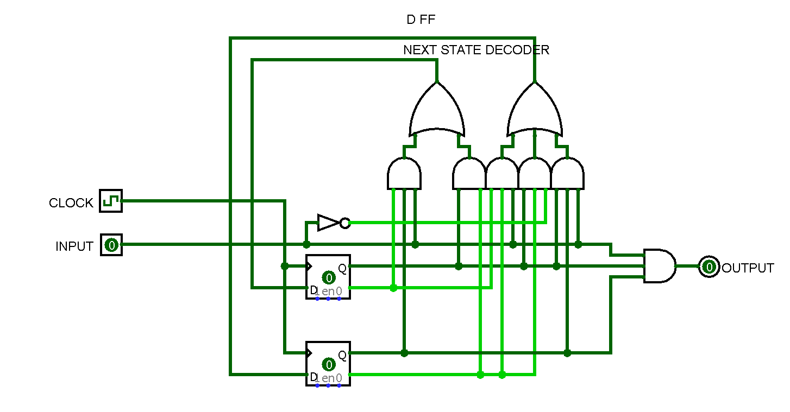

### Simulation

Video uploaded on Moodle

### Using JK FF

**Circuit diagram**

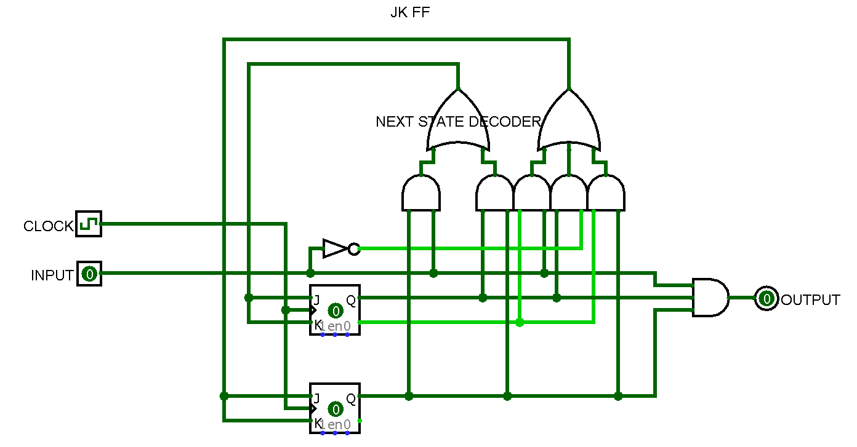

### Simulation

Video uploaded on Moodle

# A digital system has one input X and two outputs Y and Z.

## Solution:

**State Diagram**

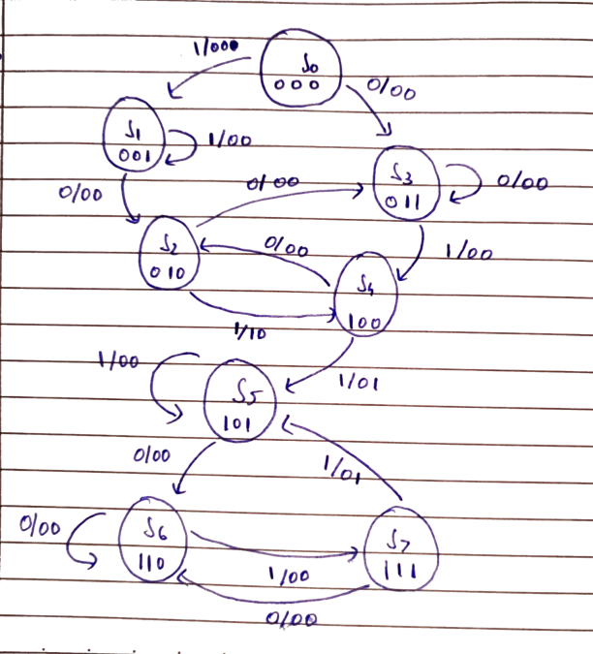

### Verilog code

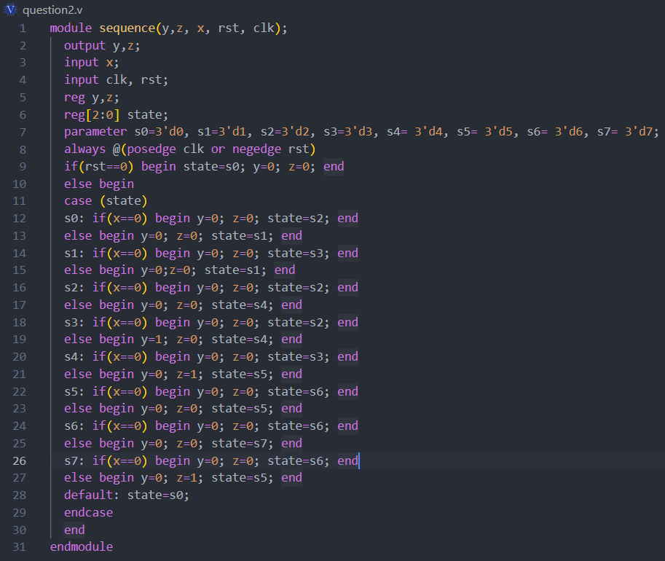

### Simulation

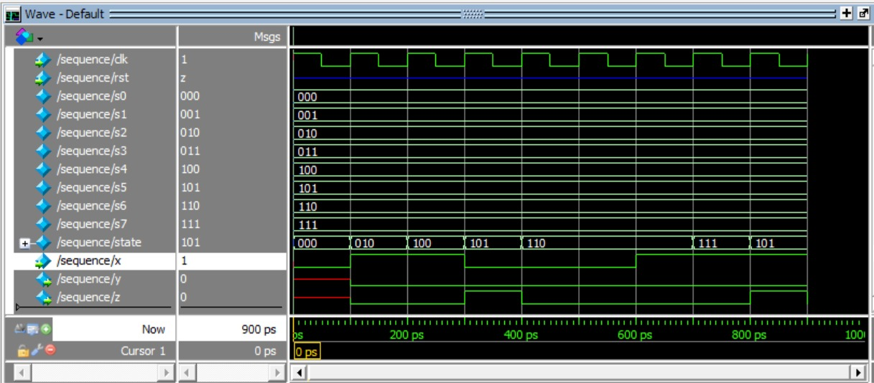

# Vending machine

## Solution:

**State Diagram**

### 

### Verilog code

### 

### Simulation waveform

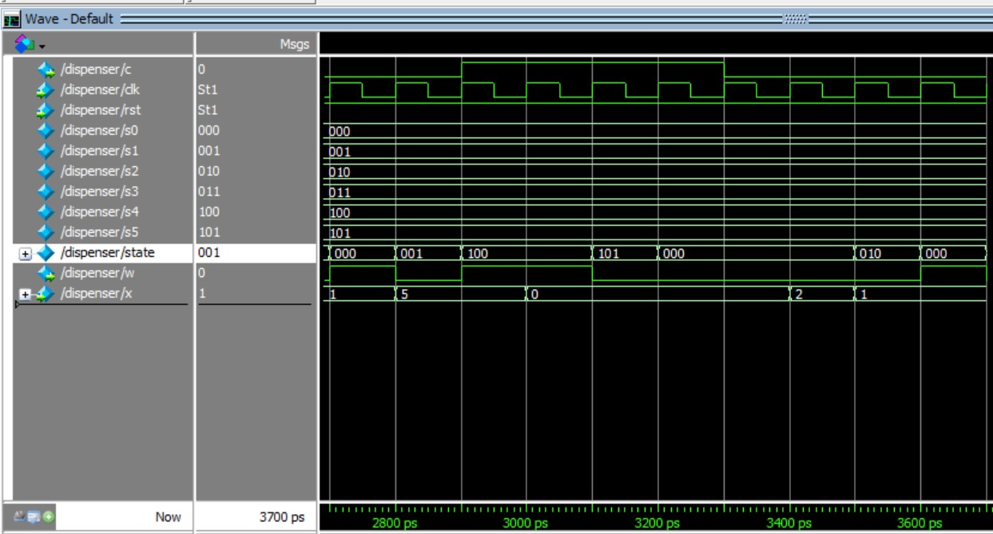

# Traffic controller

## Solution:

**State Diagram**

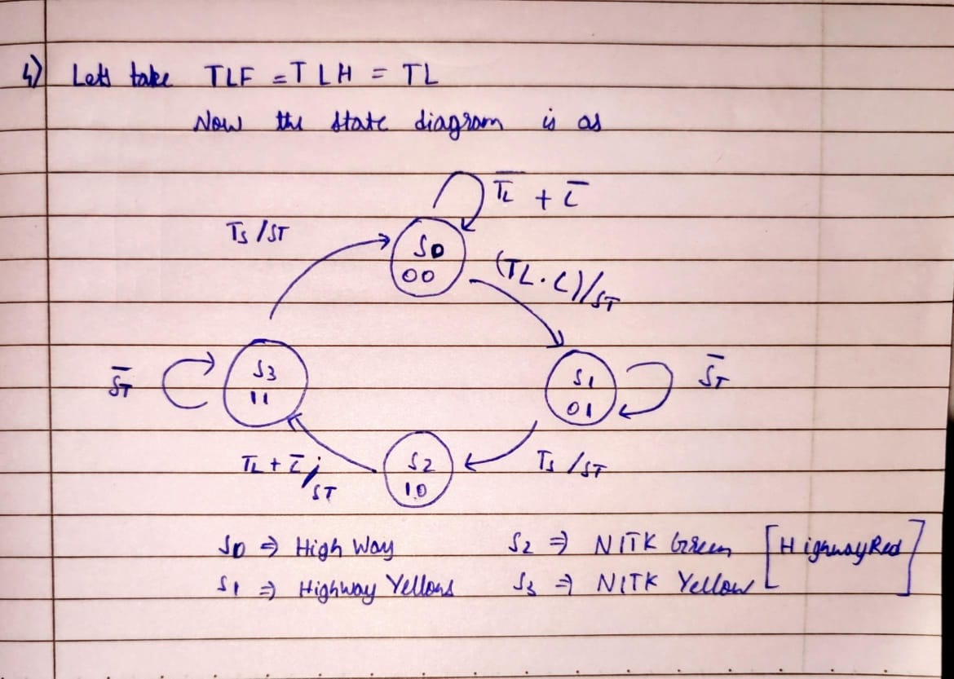

**State Table**

|  |  |  |  |  |  |  |  |  |  |
| --- | --- | --- | --- | --- | --- | --- | --- | --- | --- |
| Present State | | i/p | | | Next State | | o/p | Excitation (DFF) | |
| QA | **QB** | **TL** | **C** | **TS** | **QA+** | **QB+** | **ST** | **DA** | **DB** |
| 0 | **0** | **0** | **0** | **x** | **0** | **0** | **0** | **0** | **0** |
| 0 | **0** | **0** | **1** | **x** | **0** | **0** | **0** | **0** | **0** |
| 0 | **0** | **1** | **0** | **x** | **0** | **0** | **0** | **0** | **0** |
| 0 | **0** | **1** | **1** | **x** | **0** | **1** | **1** | **0** | **1** |
| 0 | **1** | **x** | **x** | **0** | **0** | **1** | **0** | **0** | **1** |
| 0 | **1** | **x** | **x** | **1** | **1** | **0** | **1** | **1** | **0** |
| 1 | **0** | **0** | **0** | **x** | **1** | **1** | **1** | **1** | **1** |
| 1 | **0** | **0** | **1** | **x** | **1** | **0** | **0** | **1** | **0** |
| 1 | **0** | **1** | **0** | **x** | **1** | **1** | **1** | **1** | **1** |
| 1 | **0** | **1** | **1** | **x** | **1** | **1** | **1** | **1** | **1** |
| 1 | **1** | **x** | **x** | **0** | **1** | **1** | **0** | **1** | **1** |
| 1 | **1** | **x** | **x** | **1** | **1** | **0** | **1** | **1** | **0** |

**Circuit diagram**

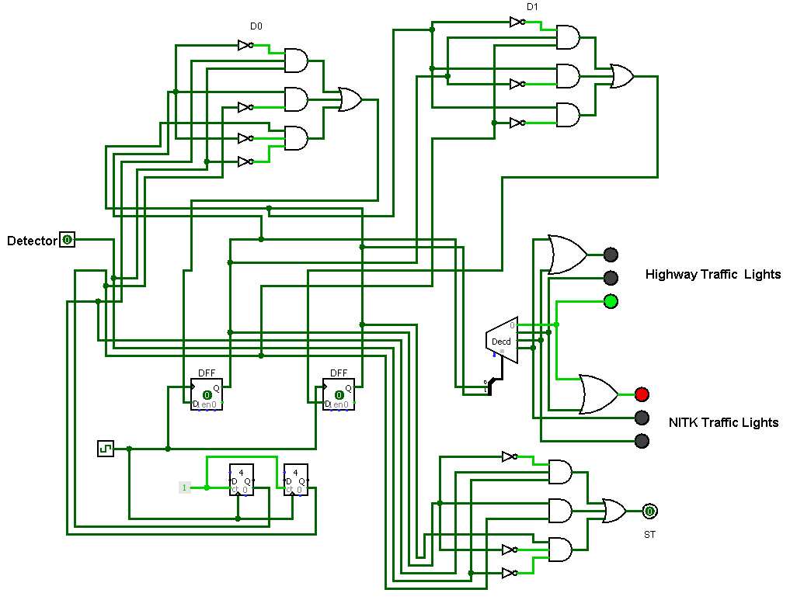

### Simulation

Video uploaded on Moodle