ECE-GY 6143 INTRO TO MACHINE LEARNING

Pratyush Shukla (ps4534)

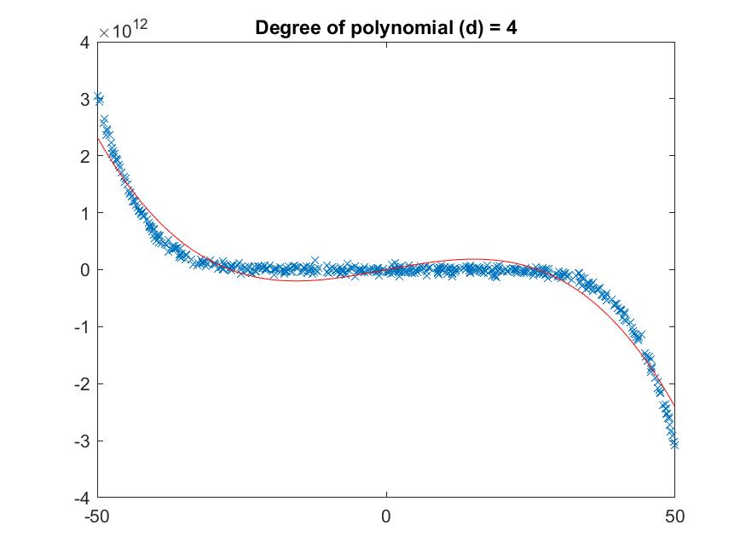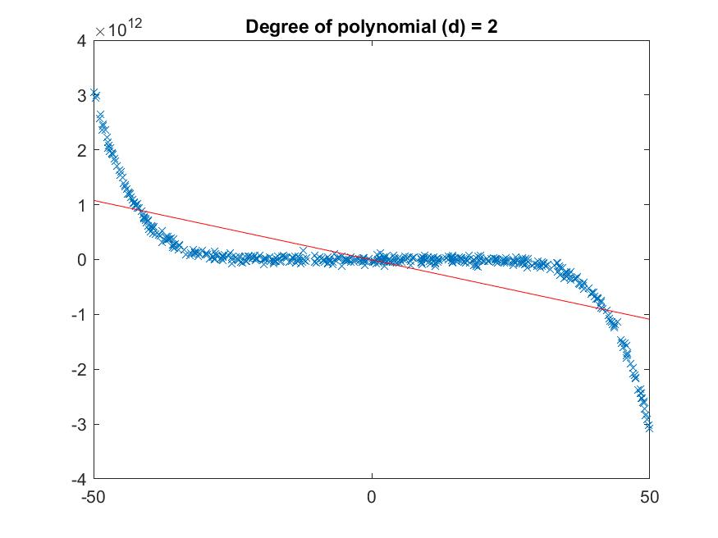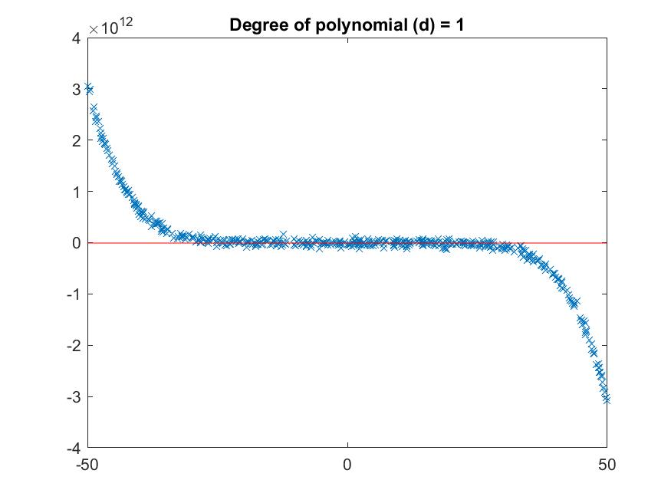**Question 1:**

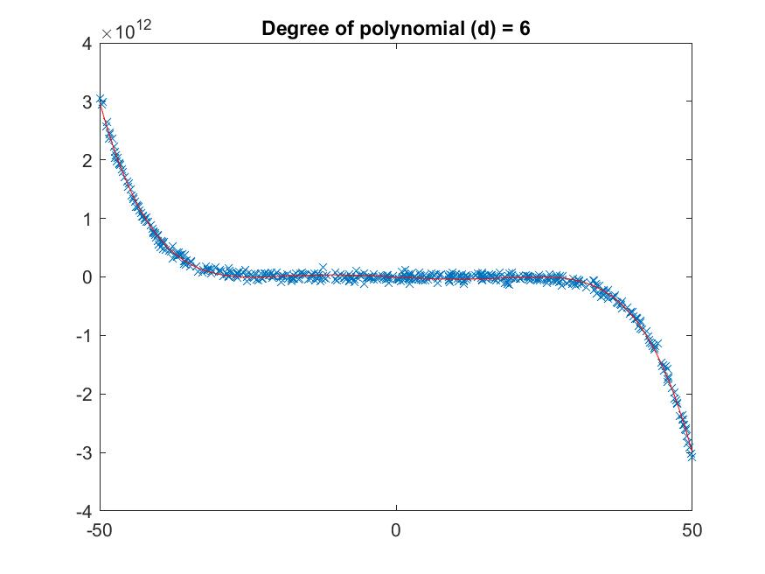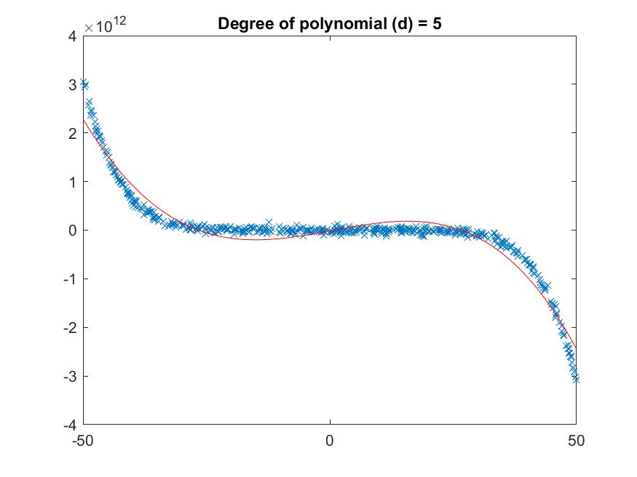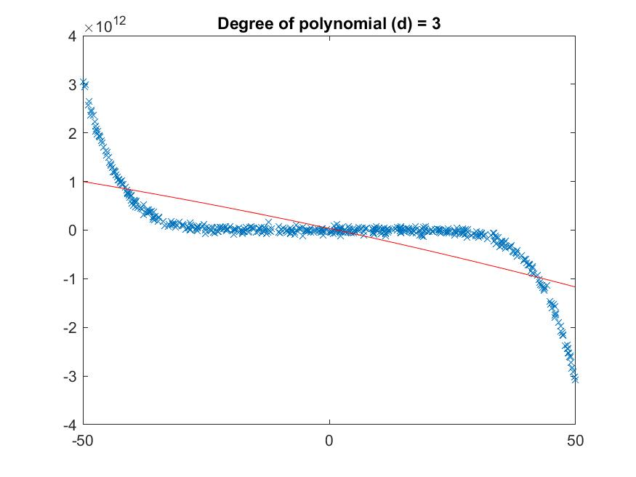

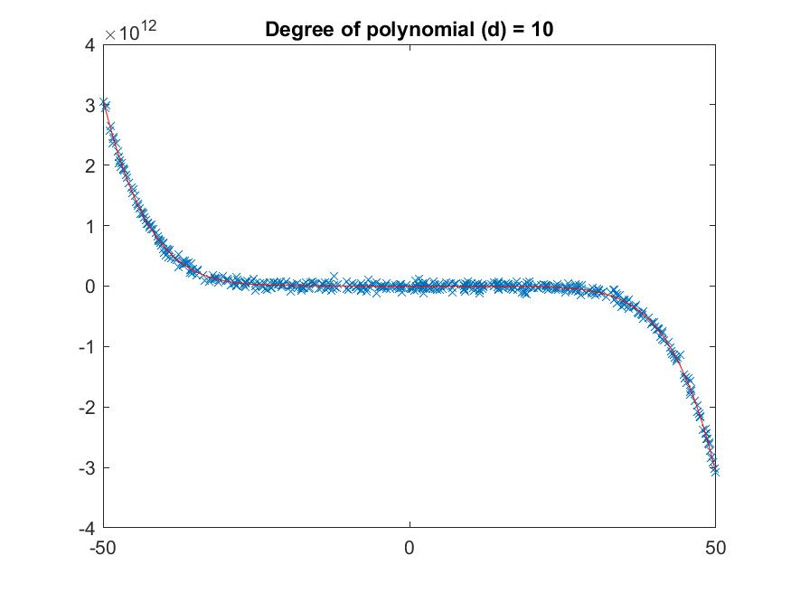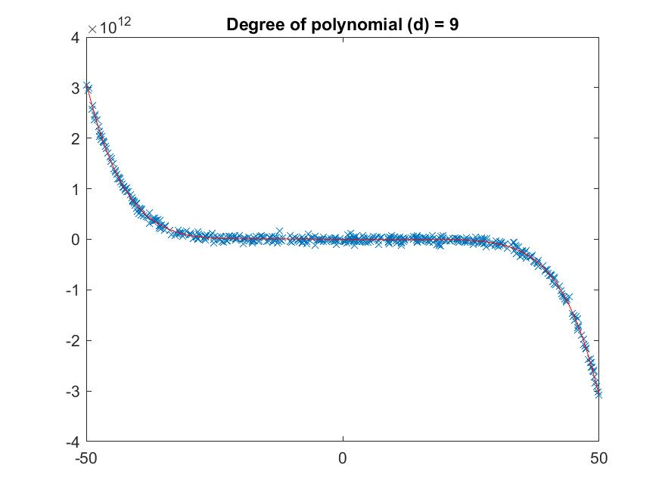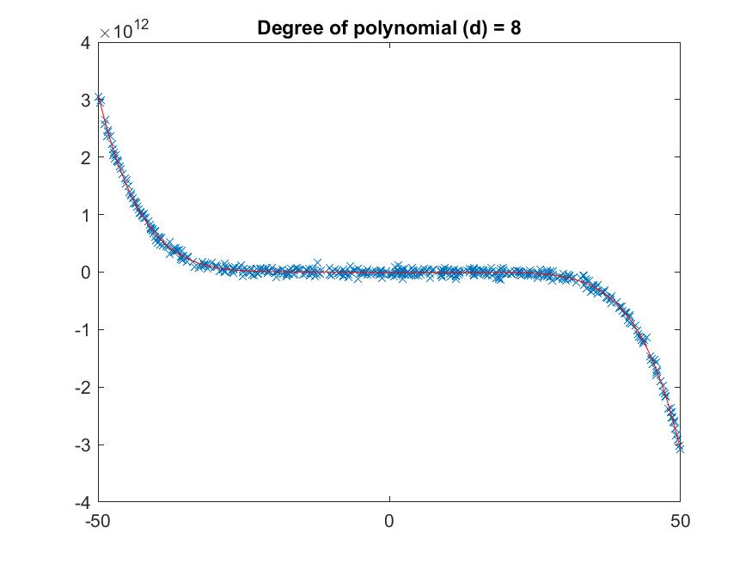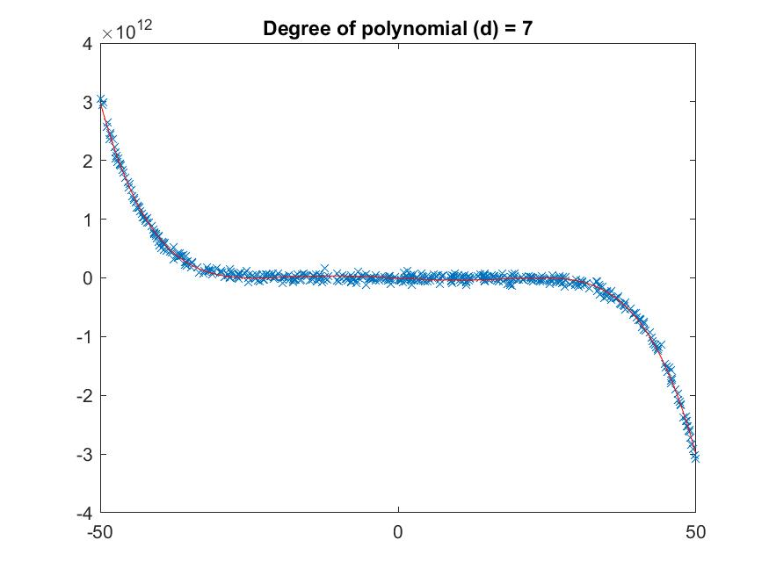  
  
The plots for different values of degree of polynomial d from 1 to 10 is show above. Based on the curve that fits the data points, the most accurate value of d is 5. d above 6 tends to overfit the data.

However, this value of d is not accurate as the data has only been used for training, thus leaving the model out of the assumption that it may have to predict for unseen data points. Hence, the use of cross-validation is to provide the model with training and testing data, divided randomly.

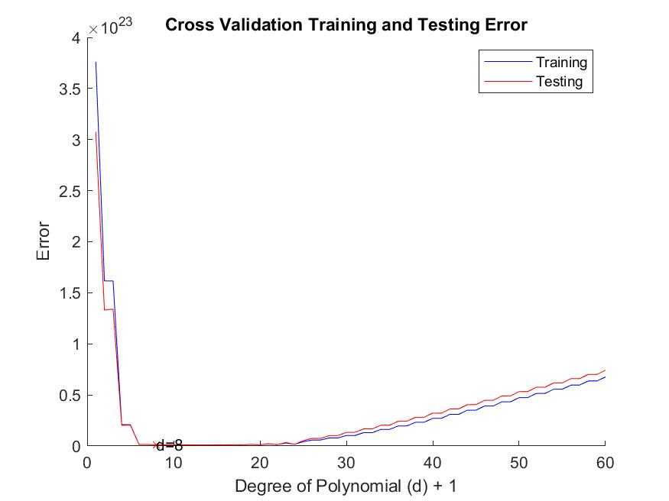

The above plot of training and testing error after cross validation points out that the best value of d i.e., where the errors are least, is 8.

**Question 2:**

**Question 3:**

**Question 4:**