Persistent Global Gaussian Assignment
An experimental route to direct Gaussian-noise → decoder generation without adversarial training or iterative sampling
Research status
Exploratory synthetic study. The global Gaussianization primitives are related to established iterative Gaussianization / sliced optimal-transport work; novelty of the full recipe is not established.
The strongest result is a separation: constructing a Gaussian persistent assignment scales well to 64D, but amortizing that finite assignment into a decoder that generalizes to arbitrary fresh Gaussian points hits a high-dimensional coverage barrier.

Core goal
Train an autoencoder normally, globally rearrange its entire latent dataset into a persistent Gaussian assignment, then train a decoder on those fixed pairs so inference is a single pass:
z ~ N(0, I) → D(z) → sample
Date: 8 August 2026
Prepared from the experiments in this research session.

Executive summary
- A persistent global assignment solved the failure mode that defeated minibatch Gaussianization: each training example keeps one identity-linked latent particle throughout the global transport.
- The best assignment algorithm became: greedy searched 1D rank transport + conditional offset-slab cleanup + occasional exact radial χd calibration.
- On the original 2D 25-mode benchmark, fixed global rank assignments enabled a direct decoder with about 79–80% valid fresh-Gaussian samples and all modes covered; the earlier AE/SIGReg-style methods were mostly in the 20–30% regime.
- The assignment itself scales surprisingly well. After radial calibration, projection, conditional and shell diagnostics were near same-size Gaussian finite-sample baselines through d=64; N sweeps reached 48k particles with only mild runtime growth in the prototype.
- However, direct decoder generation shows a different scaling law. With N=6000, fresh-prior generation stays useful at d≤8, then collapses around d≈16 even though held-out pair reconstruction improves with dimension.
- The decoder-coverage heuristic is better stated in terms of effective sampled-prior dimension rather than representation width. With N=6000, a rank-k Gaussian prior embedded in a 64D representation gave useful direct generation for k=2,4,8, then degraded sharply by k=16 and k=32 as N^(1/k) approached ~2 and below.
- Therefore: the global assignment builder appears computationally scalable, while the one-pass decoder is limited by the effective dimension of the random variables sampled at generation time. A wide representation can remain viable if the sampled Gaussian prior is low effective rank; a full-rank high-dimensional Gaussian prior is data-coverage limited.
Most important distinction
Assignment quality ≠ generator quality.
We can make a finite dataset look essentially Gaussian in 64D and learn its pointwise inverse, yet a decoder can still fail badly between those finite Gaussian support points.

1. Method
The method was discovered by separating the problems that earlier experiments had entangled: reconstruction, global distribution matching, and the sample-to-sample coupling. The autoencoder first supplies a useful representation. The global procedure then constructs the coupling explicitly by moving persistent latent particles, without training the encoder during assignment construction.

1.1 Persistent particles
Train an ordinary reconstruction autoencoder and encode the full training set:
h_i = E_AE(x_i), i = 1,…,N
Whiten the latent cloud and initialize one persistent particle per example, z_i <- h_i. From this point onward the images can be ignored during assignment construction. The association x_i <-> z_i is never changed.

1.2 Greedy global rank transport
At each global step, search for a unit direction whose projected empirical distribution is maximally non-Gaussian under one-dimensional Wasserstein rank transport:
a* = arg max_{||a||=1} W₂²( {aᵀz_i}, N(0,1) )
Sort the full dataset by s_i=a*ᵀz_i, replace those ranks with Gaussian quantiles q_i=Φ⁻¹((rank_i+½)/N), and move only along a*:
z_i <- z_i + α (q_i − a*ᵀz_i) a*
In the scalable prototype, the direction search is performed on a fixed-size subset; only the winning direction is applied to the full dataset.

1.3 Conditional offset-slab cleanup
Global projections removed most structure but left thin tail spikes. The useful “bias” was not an affine scalar added to the projection; it was an offset used to localize a subset of space. Search for a slab |nᵀz−b|<ε and an orthogonal tangent t⊥n where the conditional tangent coordinate is most non-Gaussian. Then Gaussianize tᵀz only for the particles in that slab. This gives local corrective power that global slices lack.

1.4 Radial chi_d calibration
At high d, all tested one-dimensional projections could look Gaussian while the shell distribution remained wrong. Every 20 updates, the prototype therefore rank-corrects radii toward the exact Gaussian target r~chi_d while preserving directions:
z_i <- [(1−α_r) + α_r r_i*/||z_i||] z_i
This single addition removed the major 64D tail error without harming the projection/conditional diagnostics.

1.5 Decoder stage
After convergence, freeze the persistent assignment z_i*. The clean generative version does not need to retrain an encoder. Train only:
D(z_i*) ≈ x_i (or the original AE latent h_i)
Inference is then one forward pass from fresh Gaussian noise. No transport, sorting, flow integration, discriminator or distillation is used at sampling time.

2. What worked on the original 2D benchmark
The original 25-mode grid made the geometry visible. Minibatch Gaussianization and weak distribution losses produced islands, streaks or gaps. The breakthrough was to make the assignment global and persistent rather than batch-dependent.
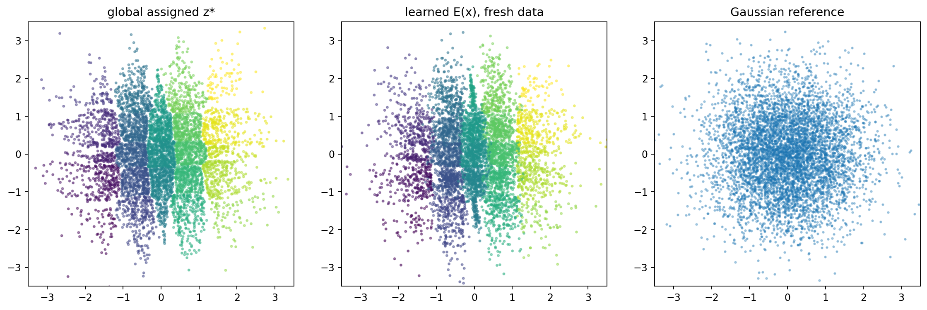
Figure 1. Fixed global rank assignment (left) and the learned encoder on fresh data (middle) versus a Gaussian reference (right).
2D fixed-assignment result
Fresh Gaussian → decoder valid mass: 79.5%
Mode coverage: 25/25; mode-weight TV: 0.036
Fresh latent MMD to Gaussian: 0.0012
This was a large jump over the roughly 20–30% direct-generation regime seen with the earlier AE/SIGReg/MMD-style latent regularizers.

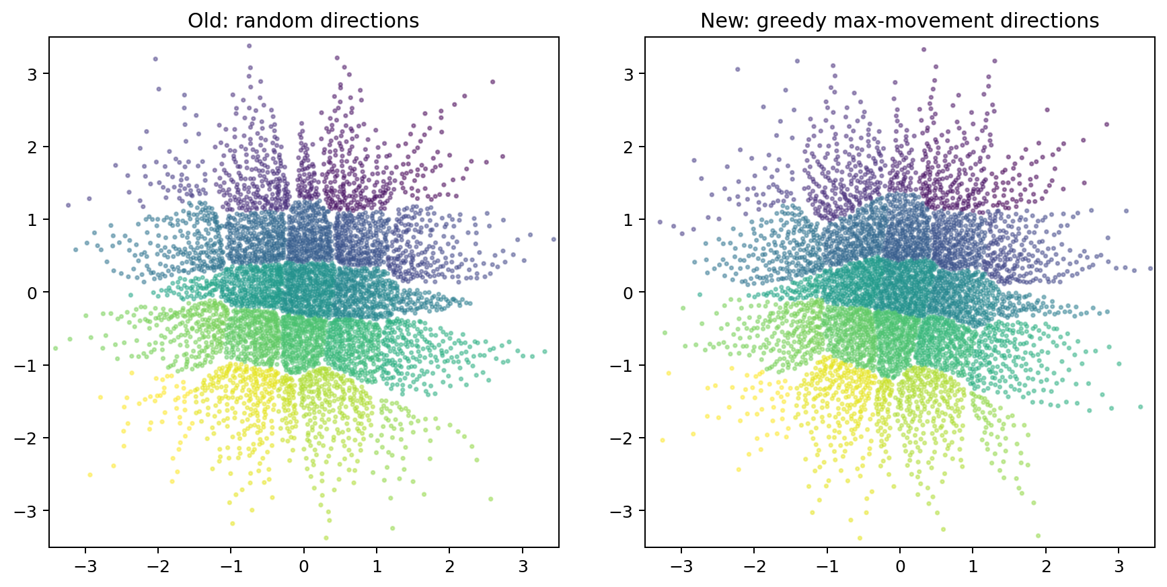
Figure 2. Random directions versus searched max-movement directions. Greedy direction search reduced seams and lowered the independent MMD.
Direction search mattered: the method improved when each step chose the projection requiring the largest rank-to-Gaussian movement rather than using a random direction. Fancier look-ahead and orthogonal-pair variants did not materially beat the simpler greedy rule.
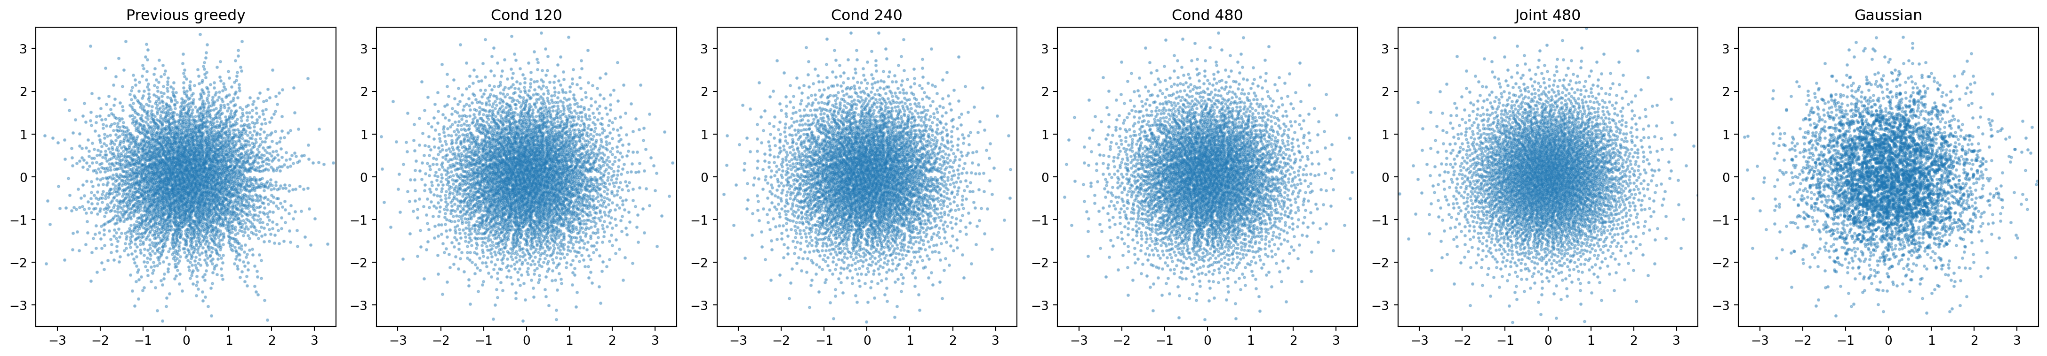
Figure 3. Long conditional cleanup and joint cleanup. Offset slabs remove local tail spikes that global projections barely detect.
The conditional cleanup exposed a striking diagnostic: the worst localized tail defects were orders of magnitude larger than the residual global projection defects. Long cleanup rounded the cloud substantially; jointly interleaving local and global corrections gave the best overall visual match.

3. Scaling of the assignment construction
Assignment construction and decoder amortization must be treated separately. First, the assignment algorithm itself was swept over latent dimension and dataset size. These tests use only persistent particles; no decoder is involved.

3.1 Dimension scaling after radial calibration
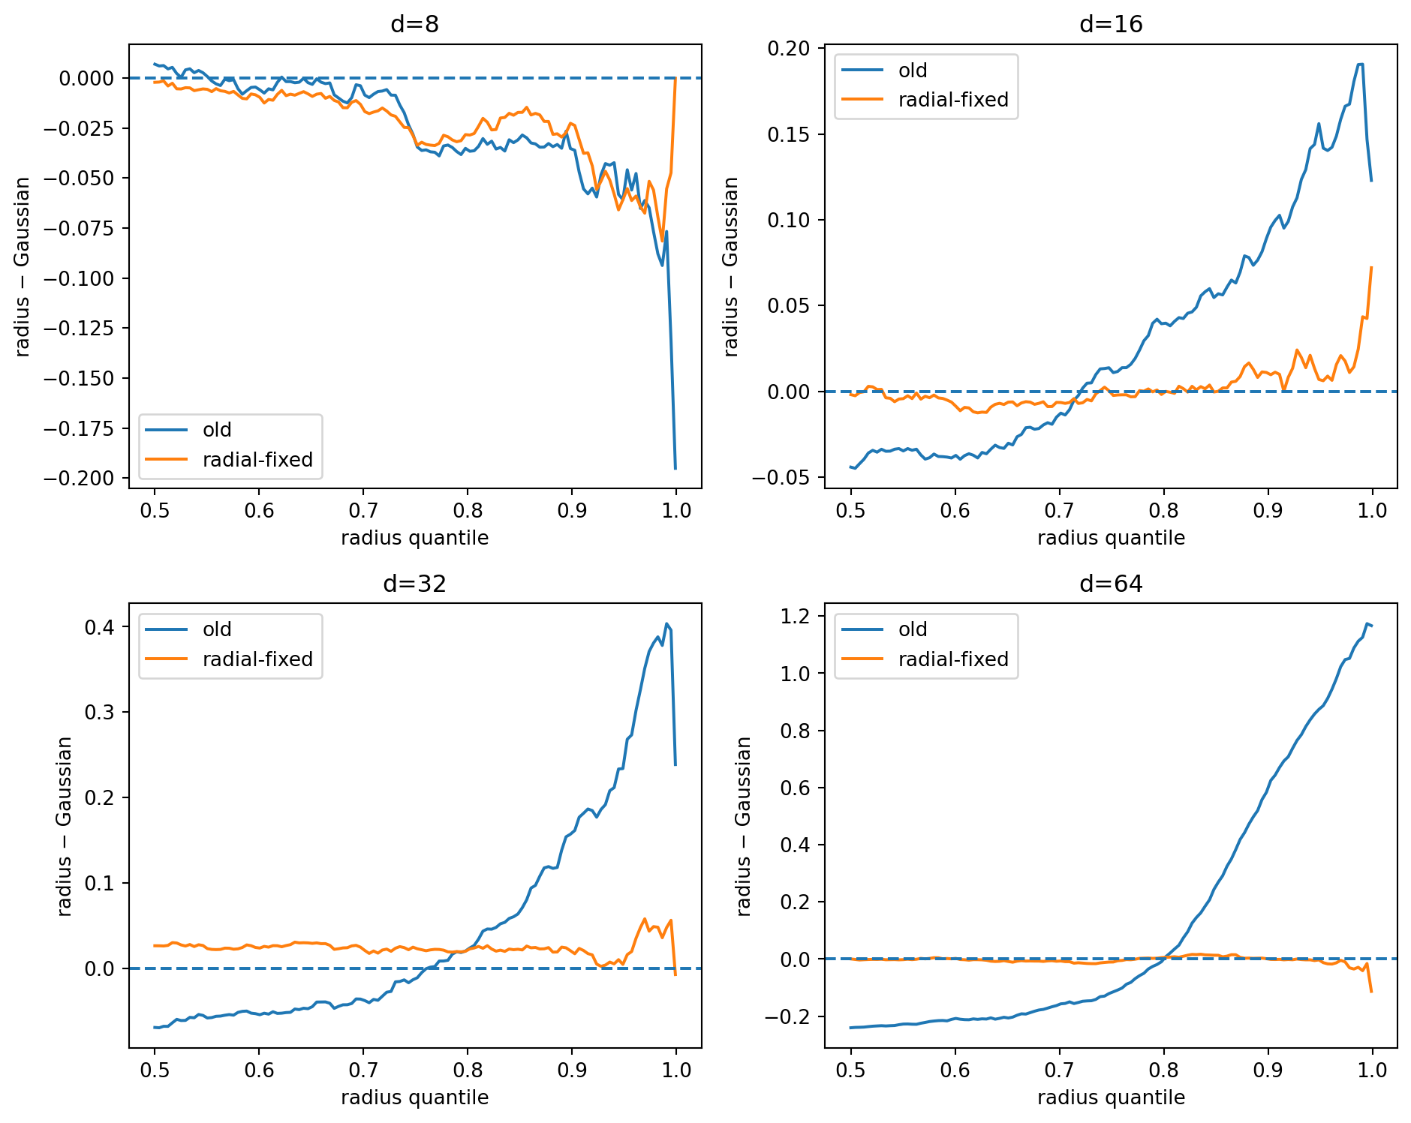
Figure 4. Radius QQ error before and after periodic chi_d calibration. The high-dimensional shell failure is almost completely removed.
d | Runtime (s) | Mean proj / Gaussian | Mean cond / Gaussian | p99 radius / Gaussian | Radius QQ RMSE
8 | 5.75 | 0.90 | 1.09 | 0.990 | 0.029
16 | 5.89 | 1.07 | 1.14 | 1.006 | 0.012
32 | 5.85 | 0.84 | 1.00 | 1.006 | 0.025
64 | 5.81 | 0.77 | 0.99 | 0.997 | 0.014
Table 1. Assignment quality versus latent dimension at N=6000. Ratios near 1 indicate same-size Gaussian finite-sample behavior.
Across d=8–64, the calibrated assignment remains close to same-size Gaussian reference statistics. The prototype runtime is nearly flat over this small CPU regime because search-set and sorting overhead dominate; this should not be interpreted as the asymptotic d exponent.

3.2 Dataset-size scaling
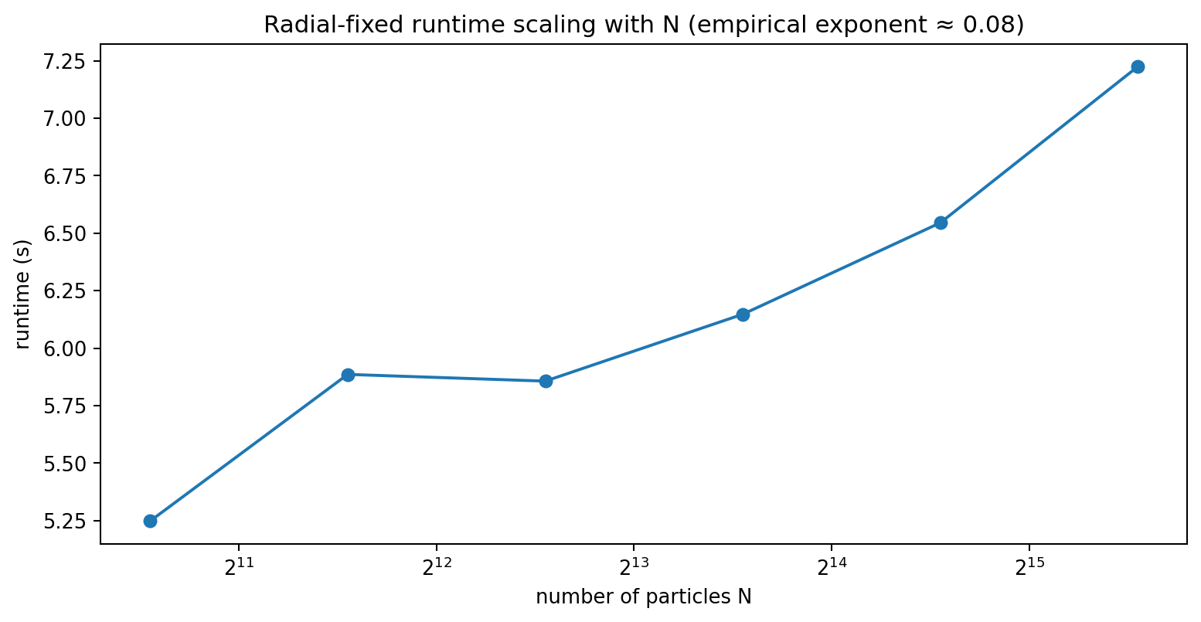
Figure 5. Prototype runtime versus number of persistent particles at d=8. Direction search is subsampled; only the chosen update touches the full dataset.
In the prototype, increasing N from 1.5k to 48k raised runtime from about 5.25s to 7.23s for the fixed update budget. This is not an asymptotic law; eventually global projection and sorting costs should dominate. The important systems property is that candidate direction search can remain independent of N.
per global update ≈ O(MKd) search + O(Nd + N log N) full projection/rank update
M is the search subset and K the candidate-direction count. This avoids the O(N²d) behavior that made nearest-neighbor/IMLE-style assignment unattractive.

4. The decoder coverage transition
The decisive experiment fixed N=6000 and used a fixed 16-mode full-dimensional source family while sweeping d=2,4,8,16,32,64. For every d, the best global assignment was built first. A residual decoder was then trained on 80% of the persistent pairs, held-out pair MSE was recorded, and the same decoder was fine-tuned on all pairs before fresh-prior generation was evaluated with the exact known source density.
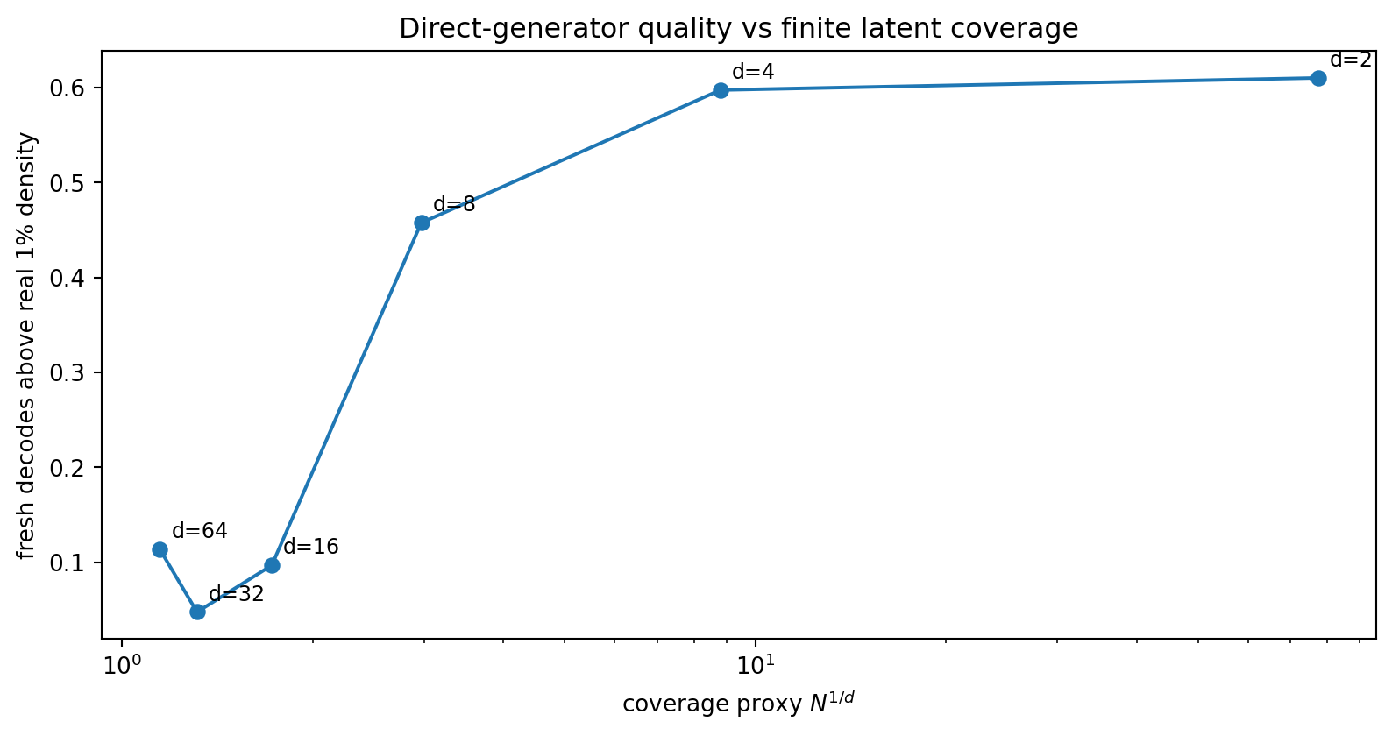
Figure 6. Fresh-prior generation quality versus the crude finite-coverage proxy N^(1/d). A sharp degradation appears between d=8 and d=16 at N=6000.
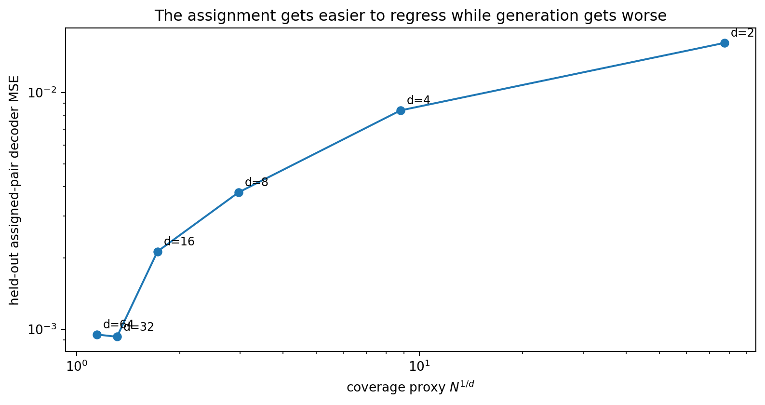
Figure 7. Held-out pair regression gets easier as dimension rises, even while fresh-prior generation collapses. The failure is therefore not pointwise invertibility of the stored assignment.

d | N^(1/d) | Held-out pair MSE | Fresh > real 1% density | Fresh > real 5% density | Mean logp gap | Modes
2 | 77.46 | 0.0162 | 61.0% | 52.8% | -7.3 | 16/16
4 | 8.80 | 0.0084 | 59.7% | 52.5% | -10.6 | 16/16
8 | 2.97 | 0.0038 | 45.8% | 37.0% | -14.4 | 16/16
16 | 1.72 | 0.0021 | 9.7% | 5.7% | -33.5 | 16/16
32 | 1.31 | 0.0009 | 4.8% | 2.4% | -55.2 | 16/16
64 | 1.15 | 0.0010 | 11.4% | 6.0% | -56.4 | 16/16
Table 2. Decoder transition at fixed N=6000. The exact-density metric is intentionally stricter than projection/MMD diagnostics.
Empirical transition
d=2–4: roughly 60% of fresh decodes remain above the 1st-percentile real density.
d=8: 45.8%.
d=16: 9.7%; d=32: 4.8%; d=64: 11.4% (the non-monotonic tail is experiment/source variability, not evidence of recovery).
All runs still cover all 16 modes, demonstrating that mode coverage alone is a weak generator-quality metric.

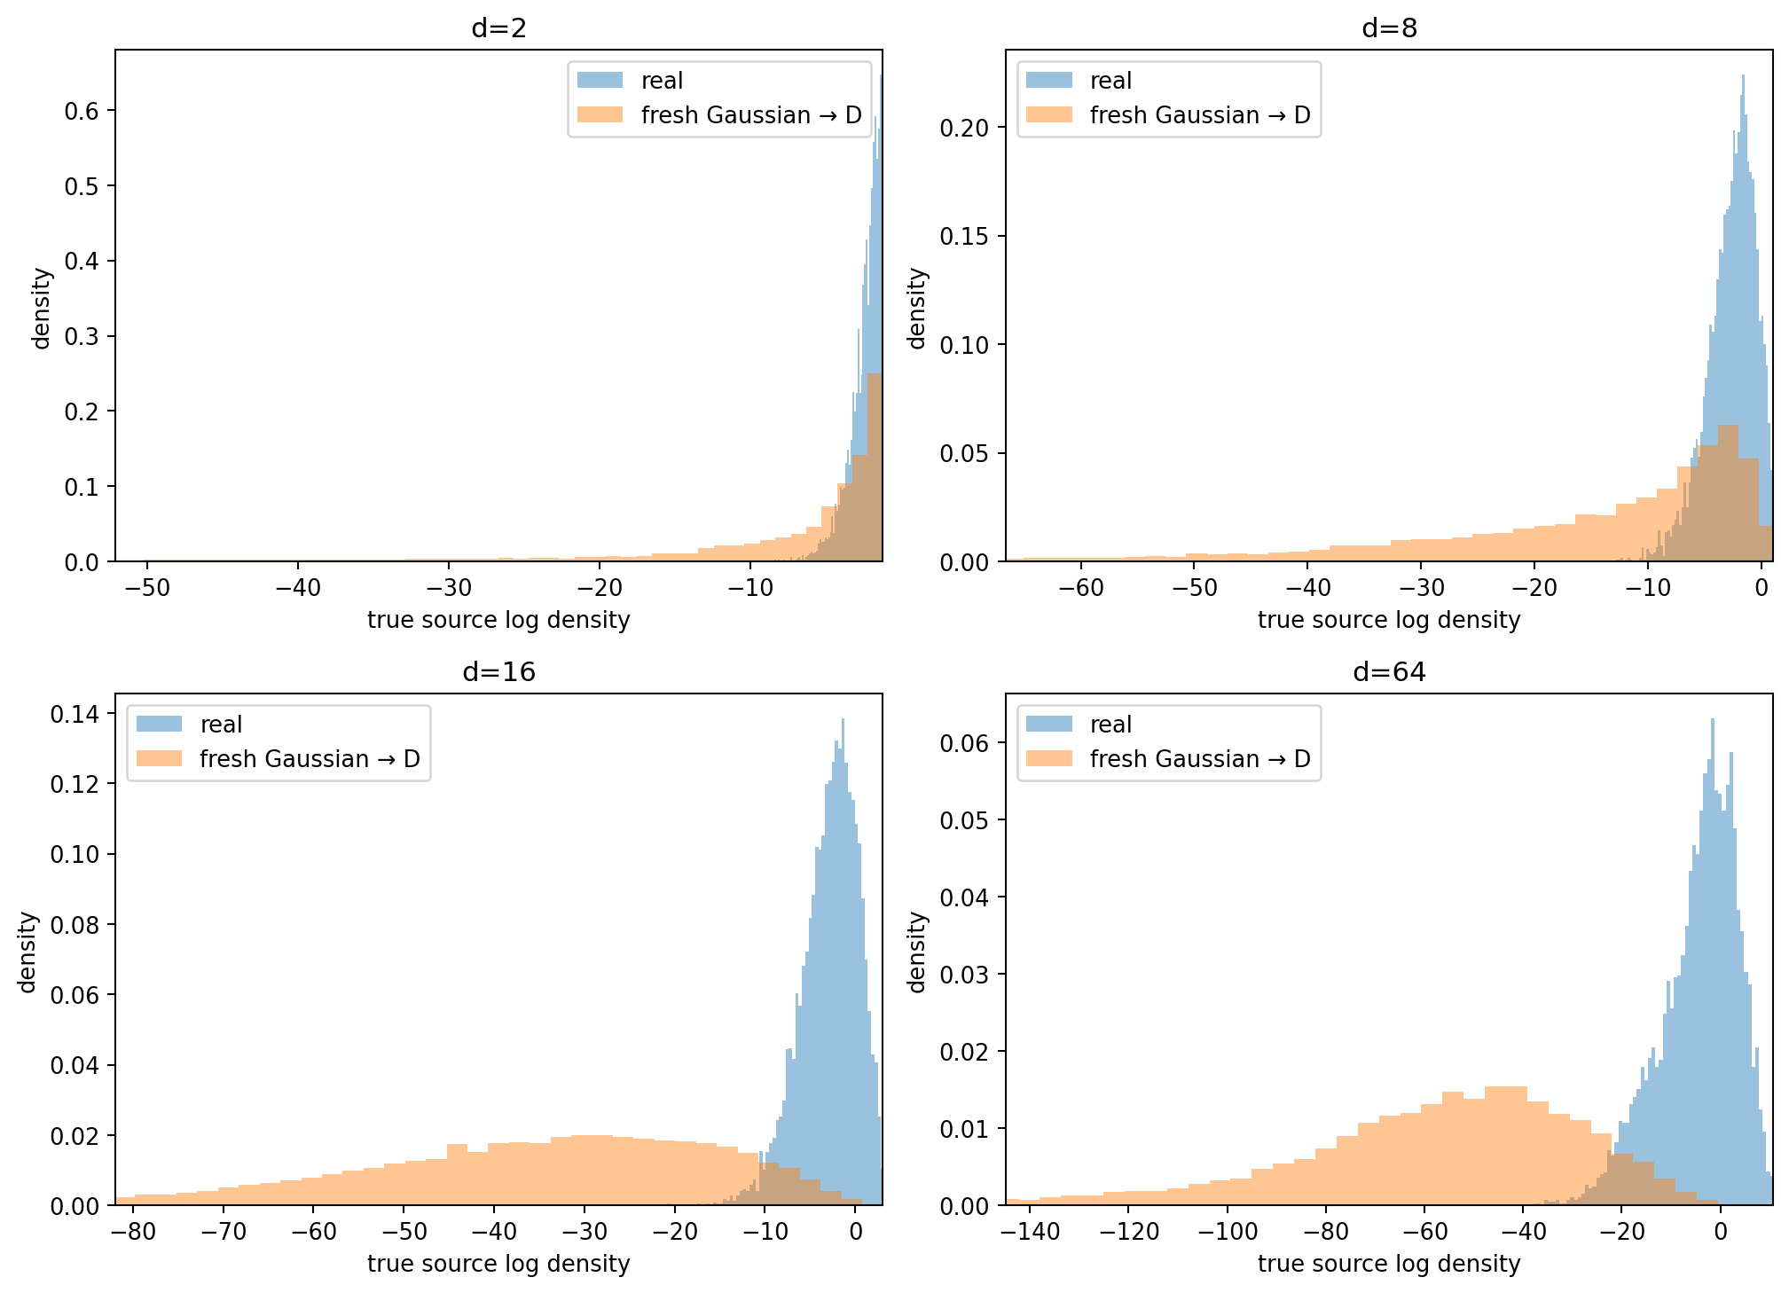
Figure 8. Exact source-density histograms. Fresh-prior decodes progressively leave the true high-density set as d increases.
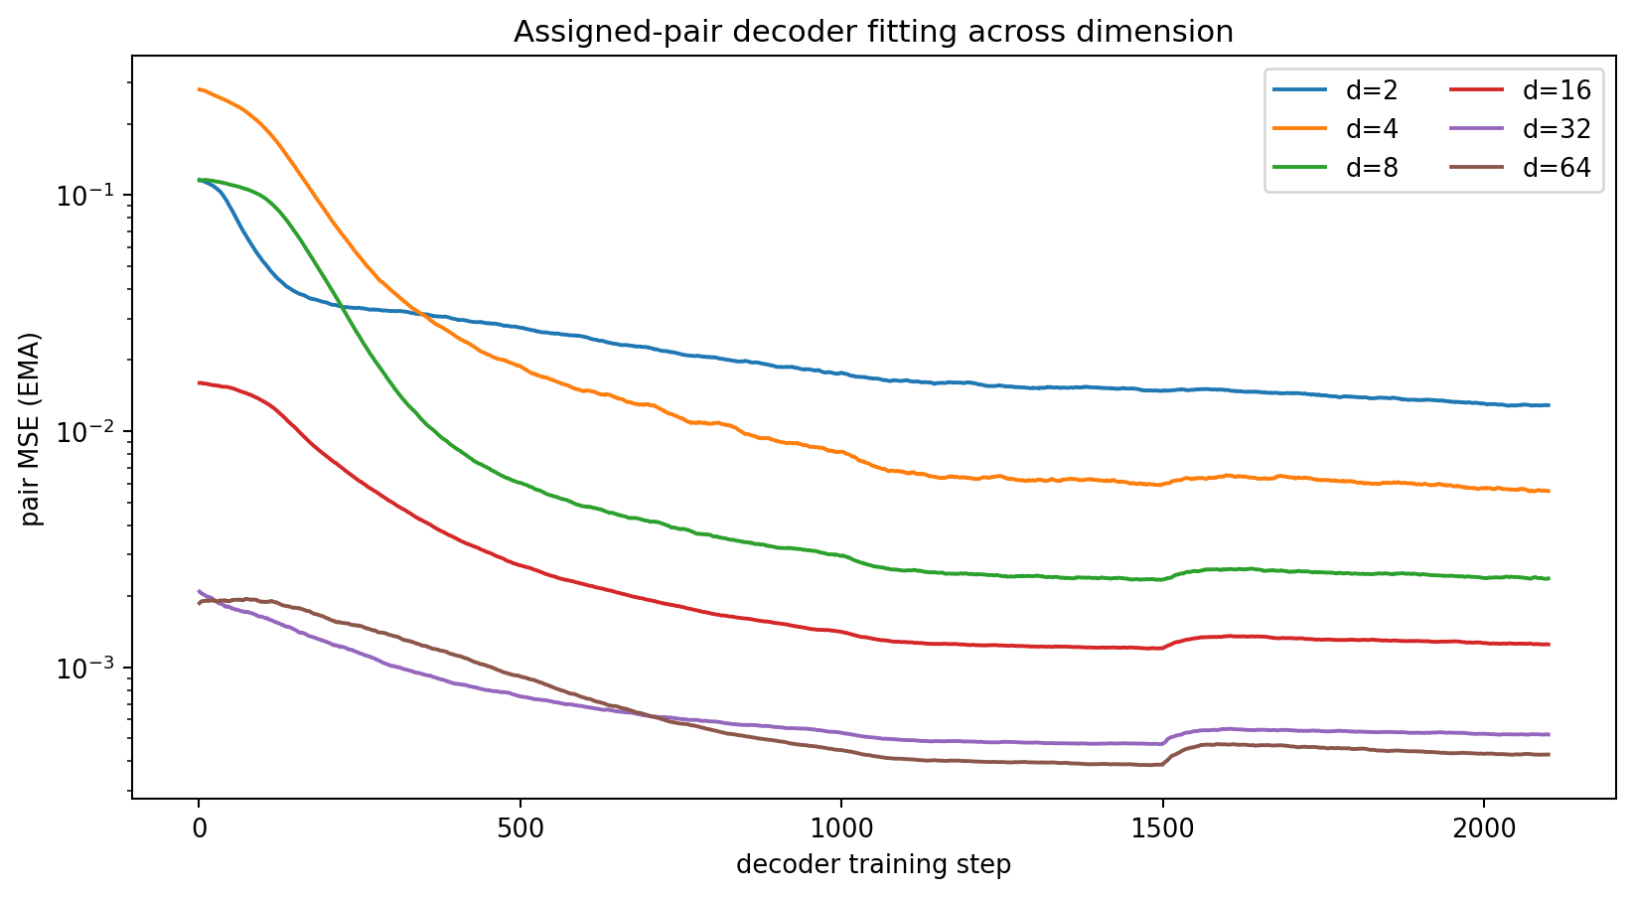
Figure 9. Pair fitting across dimension. The high-dimensional assigned mapping is easy to regress on observed pairs; this does not guarantee correct interpolation between them.

5. What is the N–d relation?
A useful first-order coverage proxy is the linear resolution of N points in d dimensions:
resolution ≈ N^(1/d)
This is not a theorem for neural decoders, but it captures the geometry of the failure. At N=6000 the proxy collapses extremely quickly with d:
d | N^(1/d) at N=6000
2 | 77.46
4 | 8.80
8 | 2.97
16 | 1.72
32 | 1.31
64 | 1.15
Table 3. Effective finite coverage falls from dense in 2D to almost one sample per linear cell in 64D.
The covering heuristic is exponential in the effective dimension of the sampled prior: to reduce a characteristic spacing ε in an intrinsically k-dimensional sampled region, the sample count scales roughly as N∝ε^(−k). This explains why a 2D grid can work well with a few thousand assignments while a full-rank 64D prior is badly underconstrained between assignment points. The follow-up experiment below shows that ambient representation width and sampled-prior rank are not the same thing.
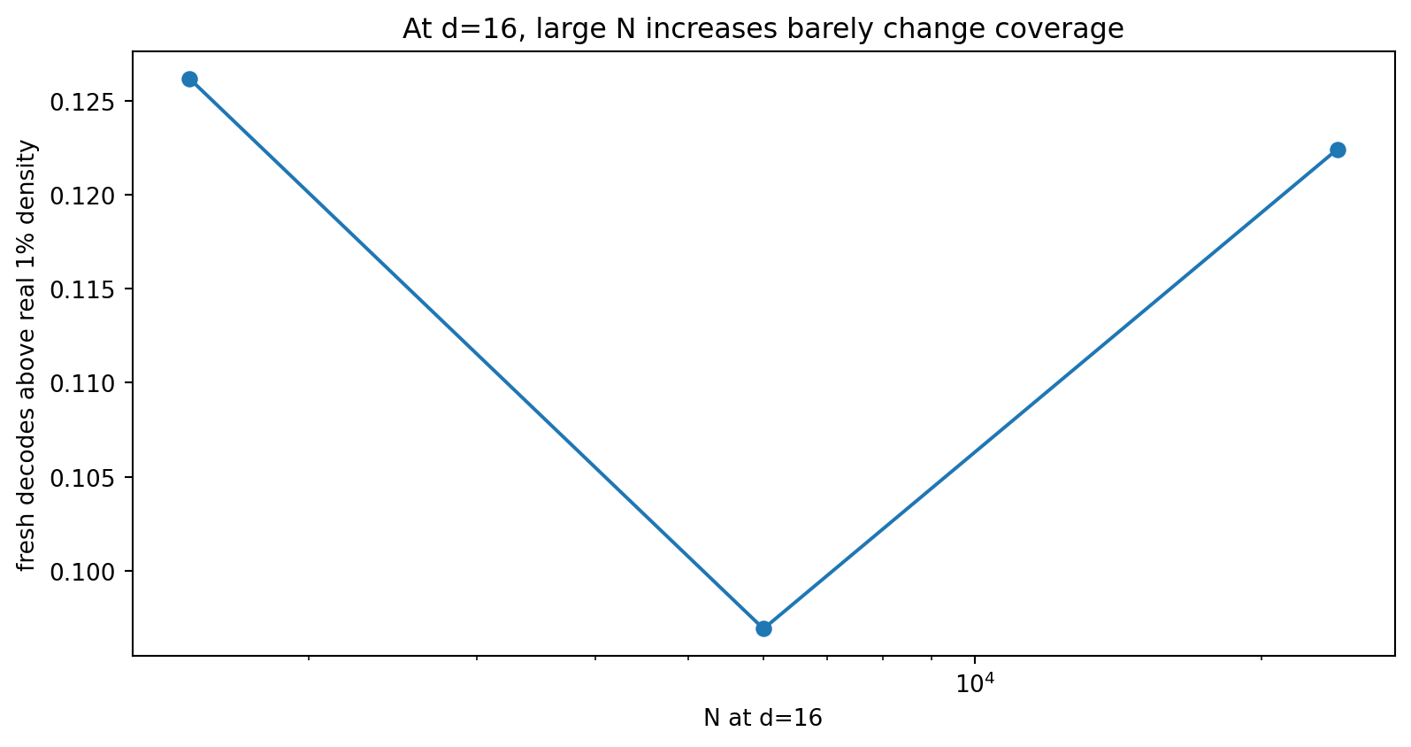
Figure 10. At d=16, increasing N from 1.5k to 24k changes N^(1/d) only from 1.58 to 1.88; fresh-prior validity remains roughly 10–13%.
The d=16 N sweep is especially informative: a 16× increase in N barely changes linear resolution because 16th roots are weak. Pair MSE improves, but generation does not. This is exactly the behavior expected if sparse prior coverage—not optimization of the stored mapping—is the bottleneck.

5.1 Effective prior rank, not ambient representation width
A decisive follow-up held the representation width fixed at 64 dimensions and varied the source intrinsic rank k. Two prior choices were compared. In the first, fresh generation always sampled a full N(0,I64) prior. In the second, generation sampled a rank-k Gaussian embedded in the same 64D representation. The assignment algorithm and decoder architecture were otherwise unchanged.
Low-rank source structure alone did not rescue a full 64D prior: fresh Gaussian samples still explored 64 independent directions, and the decoder was unconstrained through most of that volume. In contrast, restricting the sampled prior itself to rank k produced a large improvement. This supports the hypothesis that decoder coverage is governed primarily by the effective rank of the sampled prior, not by the ambient width of the representation tensor.
k | N^(1/k) | Full 64D prior: valid | Rank-k prior: valid | Rank-k pair test MSE
2 | 77.46 | 21.88% | 41.4% | 0.0054
4 | 8.80 | 0.03% | 58.6% | 0.0019
8 | 2.97 | 0.18% | 51.1% | 0.0009
16 | 1.72 | 0.63% | 18.0% | 0.0006
32 | 1.31 | 1.17% | 5.6% | 0.0009
Table 4. Ambient width is fixed at 64. “Valid” is the fraction of fresh decoder outputs above the 1st-percentile true-source density. The rank-k prior keeps fresh samples on the same effective-dimensional scaffold as the assignment.
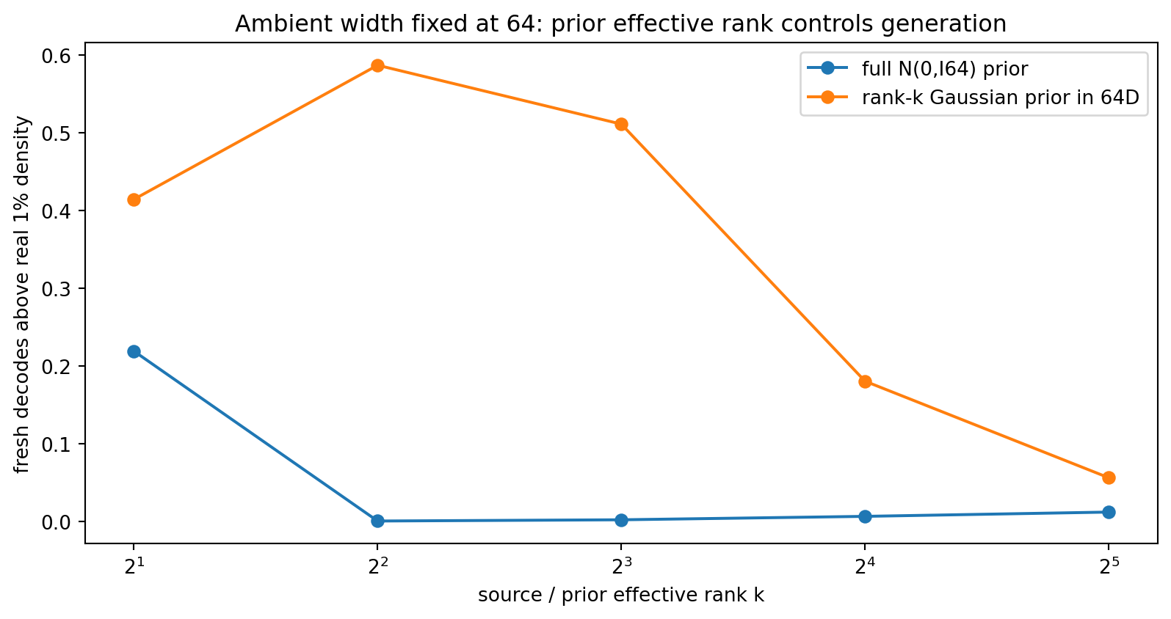
Figure 11. Full 64D Gaussian sampling fails even when the source itself is low rank. Using a rank-k Gaussian prior embedded in the same 64D representation restores direct-generation quality for low-to-moderate k.
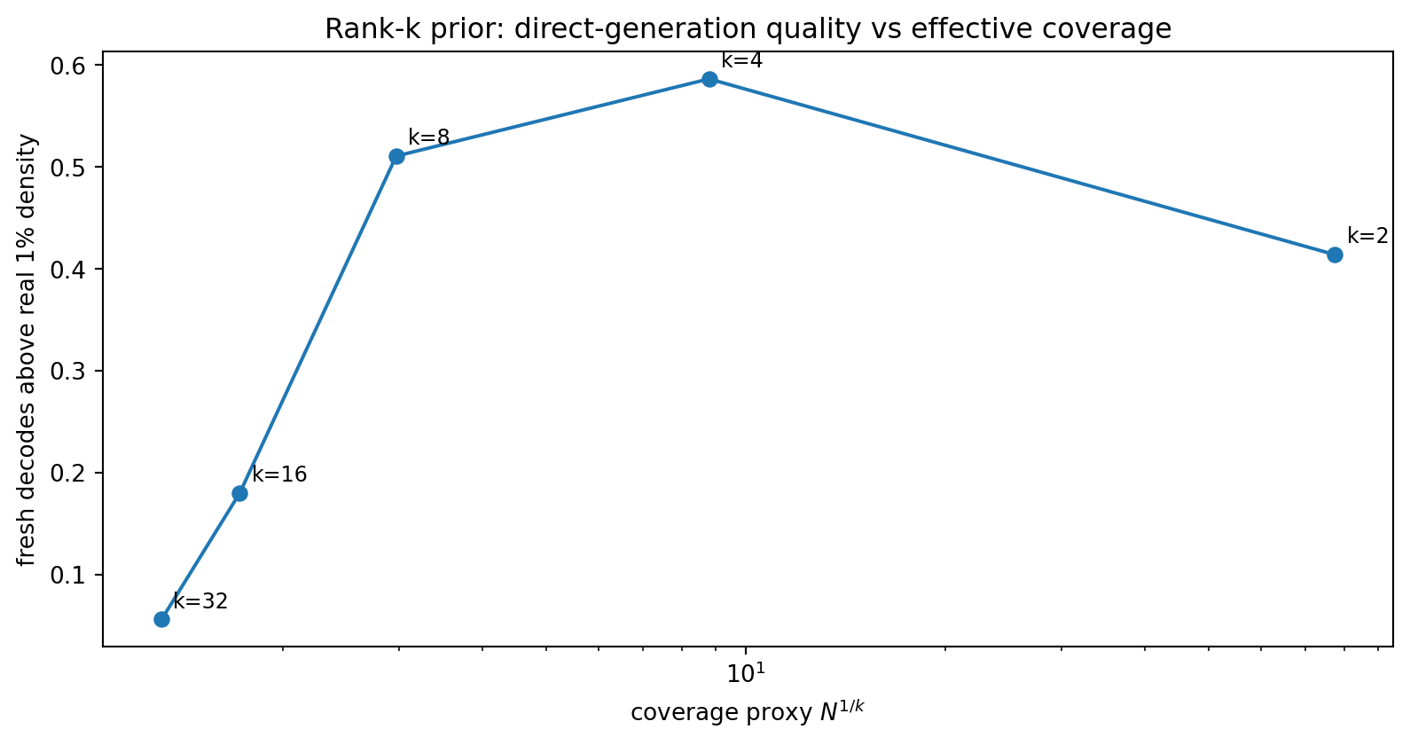
Figure 12. With a rank-k prior, direct-generation quality degrades as the finite-coverage proxy N^(1/k) approaches ~2 and below. The relationship is not perfectly one-dimensional because topology and decoder fit still matter, but the transition is clear.
Updated scaling hypothesis: N scales primarily against the effective rank k of the sampled generative prior, approximately through a covering law of the form N∼ε^(−k). Representation width d_repr may be much larger than k, provided the random variables explored at generation time remain low effective rank.

6. Interpretation: what the method solves, and what it does not
- Solved well: constructing a persistent Gaussian finite point set while retaining sample identity.
- Solved well: removing global non-Gaussianity, localized tail seams and high-dimensional shell errors with simple rank operations.
- Solved well: pointwise amortization on the assigned coordinates; high-dimensional held-out pair errors can be very small.
- Not solved for a full-rank high-dimensional prior: defining the decoder everywhere that fresh Gaussian probability lives when the assignment table is finite and sparse. The effective-rank follow-up shows this limitation can be relaxed by keeping a wide representation while sampling from a lower-rank Gaussian prior.
The central lesson
A finite set can have excellent Gaussian statistics without being a sufficiently dense training scaffold for an arbitrary function defined on the continuous Gaussian prior.
Thus “the latent assignments are Gaussian” and “fresh Gaussian samples decode correctly” are fundamentally different requirements.

This reconciles the earlier success on the grid with the 64D failure. In low dimension, thousands of assigned points genuinely tile the prior. In high dimension, the same N can match many distribution tests while leaving huge unconstrained interpolation regions. A smooth decoder fills those regions by averaging or connecting semantic modes, which is exactly the bridge/gap behavior that motivated the research in the first place.

7. Relation to prior work and novelty boundary
The underlying idea of iterative Gaussianization is established. The following are the closest anchors found in a quick primary-source review:
[1] Laparra, Camps-Valls & Malo (2016), “Iterative Gaussianization: from ICA to Random Rotations” (RBIG). arXiv:1602.00229 Sequential univariate Gaussianization plus rotations, with invertibility/convergence analysis.
[2] Meng, Song, Song & Ermon (2020), “Gaussianization Flows.” arXiv:2003.01941 Builds normalizing flows from iterative Gaussianization.
[3] Dai & Seljak (2021), “Sliced Iterative Normalizing Flows.” PMLR 139 Greedily matches one-dimensional optimal-transport slices and chooses orthogonal directions to maximize distribution discrepancy.
The experimentally distinct recipe explored here is: use an ordinary AE only to initialize data geometry; construct a persistent finite assignment offline; add conditional offset-slab cleanup and explicit chi_d shell calibration; then discard the transport and train a direct decoder. This exact combination and its intended “offline coupling teacher → one-pass decoder” use case has not been established as novel in this study. A dedicated literature search would be required before making a novelty claim.

8. Practical implications and next experiments

8.1 When the method may be viable
- Low-dimensional generative bottlenecks where N^(1/d_eff) is comfortably above ~2–3 in the target dataset regime.
- Latents whose nominal width is high but intrinsic/effective dimension is much lower than width.
- Hierarchical systems where a low-dimensional Gaussian assignment handles coarse semantic choice and separate variables handle stochastic detail.
- Offline global preprocessing is acceptable and one-pass inference is especially valuable.

8.2 Most important next tests
- Measure effective/intrinsic dimension of real AE latents before assuming the 64D synthetic failure transfers directly to images.
- Run real-image latent experiments at several bottleneck dimensions (e.g., 4, 8, 16, 32) with the same N and evaluate fresh-prior decoder quality.
- Test hierarchical assignments: low-d semantic Gaussian code plus conditional residual/detail code, rather than forcing the full reconstruction state into one iid Gaussian.
- Explore decoder training objectives that explicitly constrain fresh-prior interpolation regions, while keeping generation one-pass and non-adversarial.
- Benchmark the offline assignment system with distributed/subsampled direction search and global streaming rank updates on ≥10^6 latent vectors.

9. Conclusion
The research produced a real method rather than only another loss: a persistent global Gaussian assignment built by greedy rank transport, conditional local cleanup and radial calibration. As an assignment algorithm it is simple, non-adversarial, empirically robust, and computationally promising. It solved the 2D multimodal toy far better than the earlier direct latent-regularization attempts and retained near-Gaussian finite-sample statistics through 64 dimensions.
The decoder experiments identified a more precise limiting law. A globally Gaussian, pointwise invertible finite assignment can still fail on fresh samples when the sampled prior has high effective dimension, because the finite assignment does not densely cover that continuous prior. The follow-up experiment fixed representation width at 64 and showed that a rank-k Gaussian prior can restore useful one-pass generation for low-to-moderate k. The relevant scaling variable is therefore the effective rank of the sampled generative prior, not necessarily the ambient representation width.
This leaves a concrete design direction: use a high-capacity AE representation for reconstruction and semantics, but construct and sample a lower-effective-rank Gaussian generative coordinate system whose finite coverage is compatible with dataset size. The method remains an offline assignment teacher followed by a one-pass decoder; no iterative sampler is required at inference.

Appendix A. Key measured data

A.1 Decoder transition sweep
d | N^(1/d) | Test MSE | Valid >1% | Logp gap | Mode TV
2 | 77.460 | 0.016182 | 0.6102 | -7.27 | 0.121
4 | 8.801 | 0.008393 | 0.5974 | -10.61 | 0.029
8 | 2.967 | 0.003782 | 0.4576 | -14.43 | 0.078
16 | 1.722 | 0.002130 | 0.0969 | -33.52 | 0.144
32 | 1.312 | 0.000929 | 0.0477 | -55.16 | 0.148
64 | 1.146 | 0.000950 | 0.1142 | -56.38 | 0.172

A.2 Assignment dimension scaling after radial calibration
d | Runtime | Proj/G | Cond/G | p99/G | Radius RMSE
8 | 5.75 | 0.902 | 1.091 | 0.990 | 0.0293
16 | 5.89 | 1.075 | 1.137 | 1.006 | 0.0119
32 | 5.85 | 0.841 | 0.999 | 1.006 | 0.0255
64 | 5.81 | 0.774 | 0.989 | 0.997 | 0.0143

A.3 Effective-rank prior sweep
Source data: effective_rank_prior_sweep.csv. Ambient representation width = 64, N = 6000; prior rank k varied over 2, 4, 8, 16, 32.

