##### Appendix

|  |  |  |  |  |  |  |  |  |
| --- | --- | --- | --- | --- | --- | --- | --- | --- |
|  | **Length** | **Diameter** | **Height** | **Whole_weight** | **Shucked_weight** | **Viscera_weight** | **Shell** | **Rings** |
| **count** | 4177 | 4177 | 4177 | 4177 | 4177 | 4177 | 4177 | 4177 |
| **mean** | 0.5240 | 0.4079 | 0.1395 | 0.8287 | 0.3594 | 0.1806 | 0.2388 | 9.9337 |
| **std** | 0.1201 | 0.0992 | 0.0418 | 0.4904 | 0.2220 | 0.1096 | 0.1392 | 3.2242 |
| **min** | 0.0750 | 0.0550 | 0.0000 | 0.0020 | 0.0010 | 0.0005 | 0.0015 | 1.0000 |
| **25%** | 0.4500 | 0.3500 | 0.1150 | 0.4415 | 0.1860 | 0.0935 | 0.1300 | 8.0000 |
| **50%** | 0.5450 | 0.4250 | 0.1400 | 0.7995 | 0.3360 | 0.1710 | 0.2340 | 9.0000 |
| **75%** | 0.6150 | 0.4800 | 0.1650 | 1.1530 | 0.5020 | 0.2530 | 0.3290 | 11.0000 |
| **max** | 0.8150 | 0.6500 | 1.1300 | 2.8255 | 1.4880 | 0.7600 | 1.0050 | 29.0000 |

Table 3. Abalone Data Description

|  |  |  |  |  |  |  |  |  |
| --- | --- | --- | --- | --- | --- | --- | --- | --- |
| **Sex** | **Length** | **Diameter** | **Height** | **Whole_weight** | **Shucked_weight** | **Viscera_weight** | **Shell** | **Rings** |
| **F** | 0.58 | 0.45 | 0.16 | 1.05 | 0.45 | 0.23 | 0.30 | 11.13 |
| **I** | 0.43 | 0.33 | 0.11 | 0.43 | 0.19 | 0.09 | 0.13 | 7.89 |
| **M** | 0.56 | 0.44 | 0.15 | 0.99 | 0.43 | 0.22 | 0.28 | 10.71 |

Table 4. Gender Average Statistics

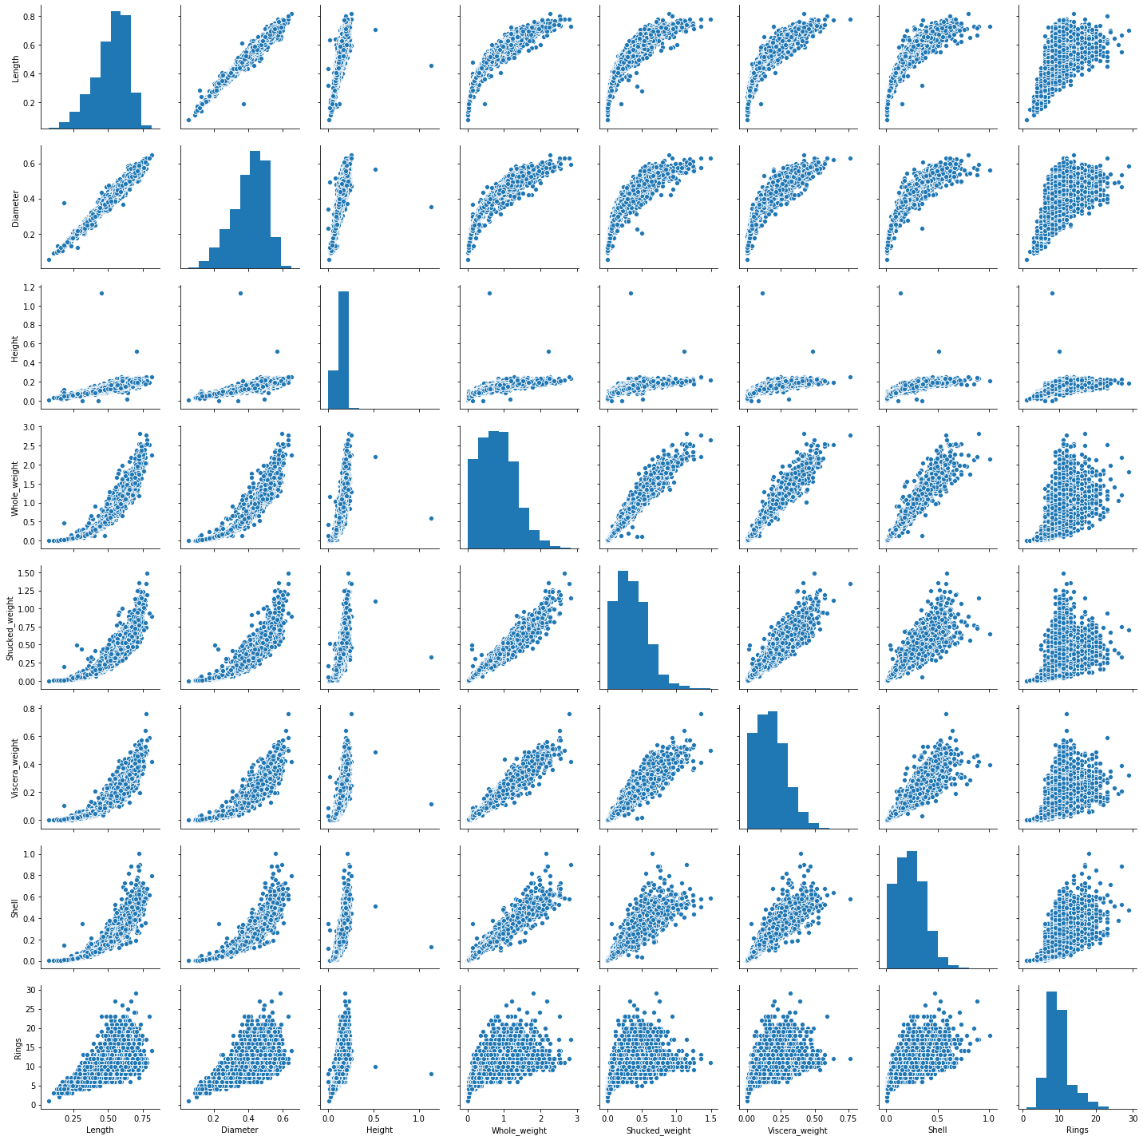

Figure 8. Data Set Pairplot



Table 5 Complete Case 1 Data