INTERNSHIP REPORT
On
Ethical Hacking
(AICTE – EduSkills Virtual Internship Program)

Submitted To:
School of Computer Science and Engineering
IILM University, Greater Noida, U.P.

In partial fulfilment of the requirement of degree of
B.Tech CSE (Cyber Security)

By

Roll Number of Student: CS-2341697
Name of Student: AMANUL HAQUE
Batch: 2023–27

CANDIDATE'S DECLARATION

I, Amanul Haque, do hereby declare that the internship report titled "Ethical Hacking" has been completed by me to fulfil the requirement for the award of the degree of Bachelor of Technology in Computer Science and Engineering (Cyber Security). All the references have been quoted and I have not taken as such any material from any other source. I affirm that this report is my own work and has not been submitted to any other institute for any degree/diploma requirement, and I shall be solely responsible for any kind of copyright violation in this regard.

Signature:
Student Name: Amanul Haque
Roll No.: CS-2341697

ACKNOWLEDGEMENT

I am using this opportunity to express my gratitude to everyone who supported me throughout the AICTE – EduSkills Virtual Internship Program in Ethical Hacking. I am thankful for their aspiring guidance, invaluably constructive criticism, and friendly advice during this work. I am sincerely grateful to the EduSkills Academy team and mentors for sharing their truthful and illuminating views on a number of issues related to this work.
I would also like to thank the School of Computer Science and Engineering, IILM University, Greater Noida, for providing me the opportunity to undertake this internship as part of my B.Tech curriculum.
I express my gratitude to my parents for their blessings.

Signature:
Student Name: Amanul Haque
Roll No.: CS-2341697

TABLE OF CONTENTS
Chapter No. | Chapter Name | Page Nos.
--- | Cover Page | —
1. | Candidate's Declaration | i
2. | Acknowledgement | ii
3. | Internship Completion Certificate | iii
4. | Project Description  4.1 Introduction  4.2 Organization Profile  4.3 Problem Statement  4.4 Project Objectives  4.5 Scope of the Project  4.6 Technologies and Tools Used  4.7 System Architecture  4.8 Methodology  4.9 Expected Outcomes  4.10 Certificates of Completion | 1
5. | Bibliography/References | 8

CHAPTER 3
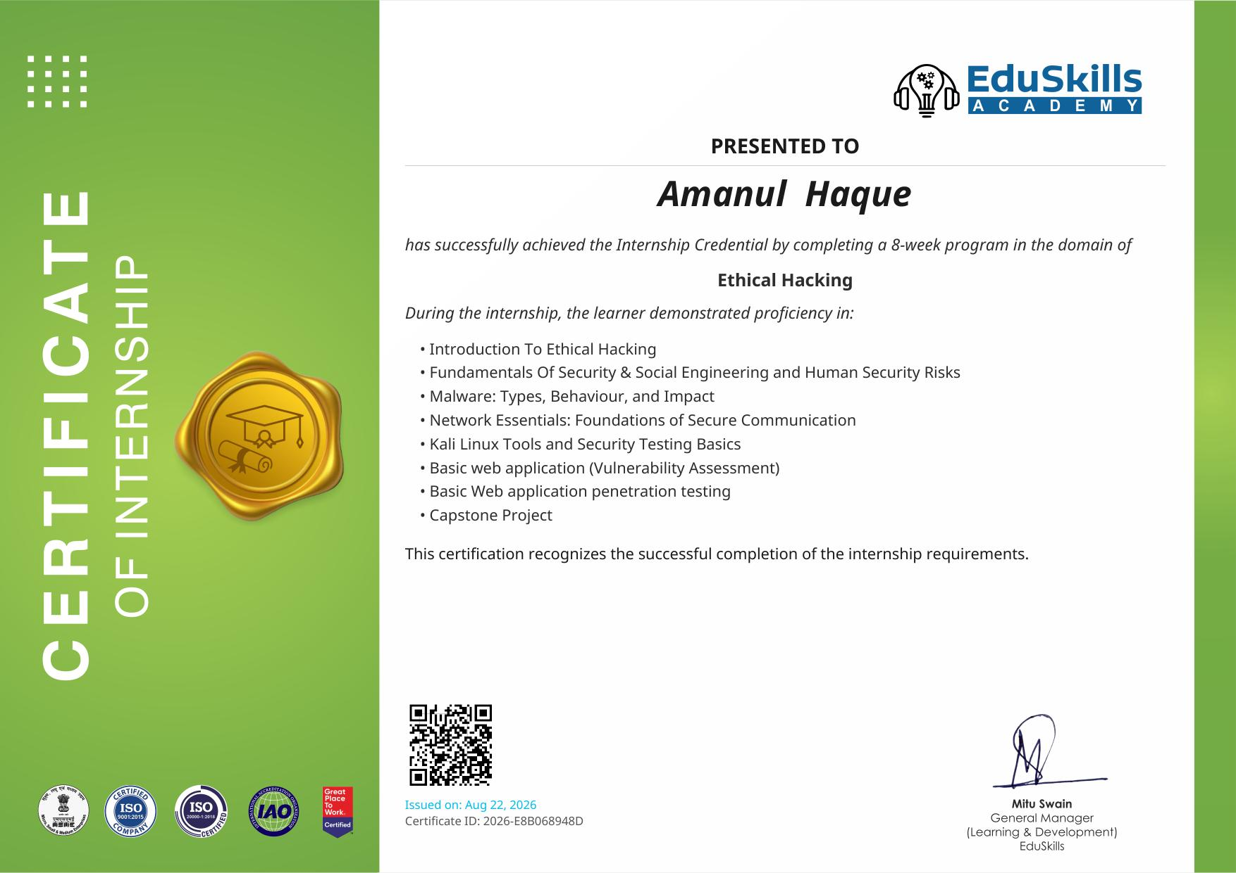
INTERNSHIP COMPLETION CERTIFICATE

CHAPTER 4
PROJECT DESCRIPTION

4.1 Introduction
This report documents the work undertaken during the 8-week AICTE – EduSkills Virtual Internship Program in the domain of Ethical Hacking, completed between June 2026 and August 2026. The program was designed to build industry-relevant skills in cybersecurity through a structured, week-wise curriculum combining conceptual learning with hands-on practical exposure on tools such as Kali Linux.
Ethical hacking involves the authorized probing of computer systems and networks to identify security weaknesses before malicious actors can exploit them. Given the increasing frequency and sophistication of cyberattacks, organizations across every sector now depend on skilled security professionals to safeguard their digital infrastructure. This internship provided a foundational, hands-on introduction to that discipline.

4.2 Organization Profile
The internship was delivered by EduSkills Academy, an ISO 9001:2015 and ISO 20000-1:2018 certified skilling organization working under the theme "Nation Building Through Skills." EduSkills partners with AICTE (All India Council for Technical Education) under the National Internship Portal to provide structured virtual internship programs to engineering students across India, covering domains such as cybersecurity, cloud computing, and emerging technologies.
The Ethical Hacking Virtual Internship Program was supported by AICTE and delivered under the patronage of the National Internship Portal, with the objective of enhancing student employability and strengthening confidence in industry-relevant subject areas.

4.3 Problem Statement
Organizations increasingly face security incidents arising from unpatched vulnerabilities, weak network configurations, social engineering attacks, and poorly tested web applications. Many of these risks go undetected until they are exploited, resulting in data breaches and financial loss. The problem addressed through this internship was to understand, identify, and responsibly assess such vulnerabilities across systems, networks, and web applications using standard ethical hacking methodologies and tools, and to propose mitigation practices consistent with responsible disclosure principles.

4.4 Project Objectives
- To understand the purpose, legality, and scope of ethical hacking.
- To learn core cybersecurity principles, threat types, and protection practices.
- To identify and understand social engineering attacks such as phishing and impersonation.
- To study different types of malware and their behaviour and impact.
- To understand networking fundamentals, protocols, and IP addressing relevant to secure communication.
- To gain hands-on familiarity with Kali Linux and its security testing tools.
- To perform basic vulnerability assessment and penetration testing on a sample web application.
- To complete a capstone project demonstrating applied understanding of the above concepts.

4.5 Scope of the Project
The scope of this internship was limited to a controlled, educational environment using Kali Linux and associated open-source security tools on sample/lab-based web applications, in line with responsible and ethical practice. It covered foundational reconnaissance, vulnerability identification, and basic penetration testing techniques, and did not extend to testing live third-party production systems without authorization. The work is intended as a learning exercise to build a base for further specialization in cybersecurity domains such as network security, application security, or security operations.

4.6 Technologies and Tools Used
- Operating System: Kali Linux
- Networking fundamentals: TCP/IP, DNS, HTTP/HTTPS protocols
- Reconnaissance and scanning tools available in Kali Linux (e.g. Nmap)
- Web vulnerability assessment tools (e.g. Burp Suite / OWASP-based tools)
- Basic scripting/command-line usage on Linux
- Concepts of social engineering and malware analysis

4.7 System Architecture
The practical component of the internship followed a typical penetration-testing workflow, structured as: (1) Reconnaissance — gathering information about the target web application; (2) Scanning — identifying open ports, services, and technologies in use; (3) Vulnerability Assessment — mapping the application against common vulnerability classes (e.g. injection flaws, authentication weaknesses); (4) Exploitation (Controlled) — verifying identified vulnerabilities in a lab setting; and (5) Reporting — documenting findings and recommended remediations. This workflow mirrors the standard phases used in professional penetration testing engagements.

4.8 Methodology
The internship followed a structured, week-wise curriculum as outlined below:
Week | Module | Description
1 | Introduction to Ethical Hacking | Purpose, legality, tools, and techniques of ethical hacking to prevent cyber threats.
2 | Fundamentals of Security | Cybersecurity principles, threat types, and protection practices for systems and data.
3 | Social Engineering | Identifying and preventing social engineering attacks like phishing and impersonation.
4 | Malware and Their Types | Different malware types and how to identify, analyze, and mitigate their effects.
5 | Networking Essentials | Networks, protocols, IP addressing, and basic device configurations.
6 | Introduction to Kali Linux | Kali Linux basics, navigation, and tools for ethical hacking and penetration testing.
7 | Basic Web Application (Vulnerability Assessment) | Building simple web apps and assessing vulnerabilities through practical projects.
8 | Penetration Testing (Kali Linux) | Hands-on penetration testing using Kali Linux tools and reporting vulnerabilities, culminating in the Capstone Project.

Each module included self-paced learning content followed by a weekly assessment; select modules additionally required submission of project documentation. The program concluded with a Final Assessment Test and a Capstone Project integrating the skills developed across all eight weeks.

4.9 Expected Outcomes
- A working understanding of ethical hacking principles, legality, and professional conduct.
- Ability to identify common categories of vulnerabilities in web applications.
- Practical familiarity with Kali Linux and core security-testing tools.
- Improved understanding of networking fundamentals as they relate to security.
- Ability to recognize and respond to social engineering attempts.
- A completed capstone project demonstrating applied vulnerability assessment and basic penetration testing.
- A stronger foundation for pursuing further study or roles in cybersecurity.

4.10 Certificates of Completion and Communication Proof
The Internship Offer Letter (Ref No. C17Y2026M071450446) and the Internship Completion Certificate (Certificate ID: 2026-E8B068948D, issued 22 August 2026) issued by EduSkills Academy are attached below as proof of enrolment and successful completion.

Internship Offer Letter
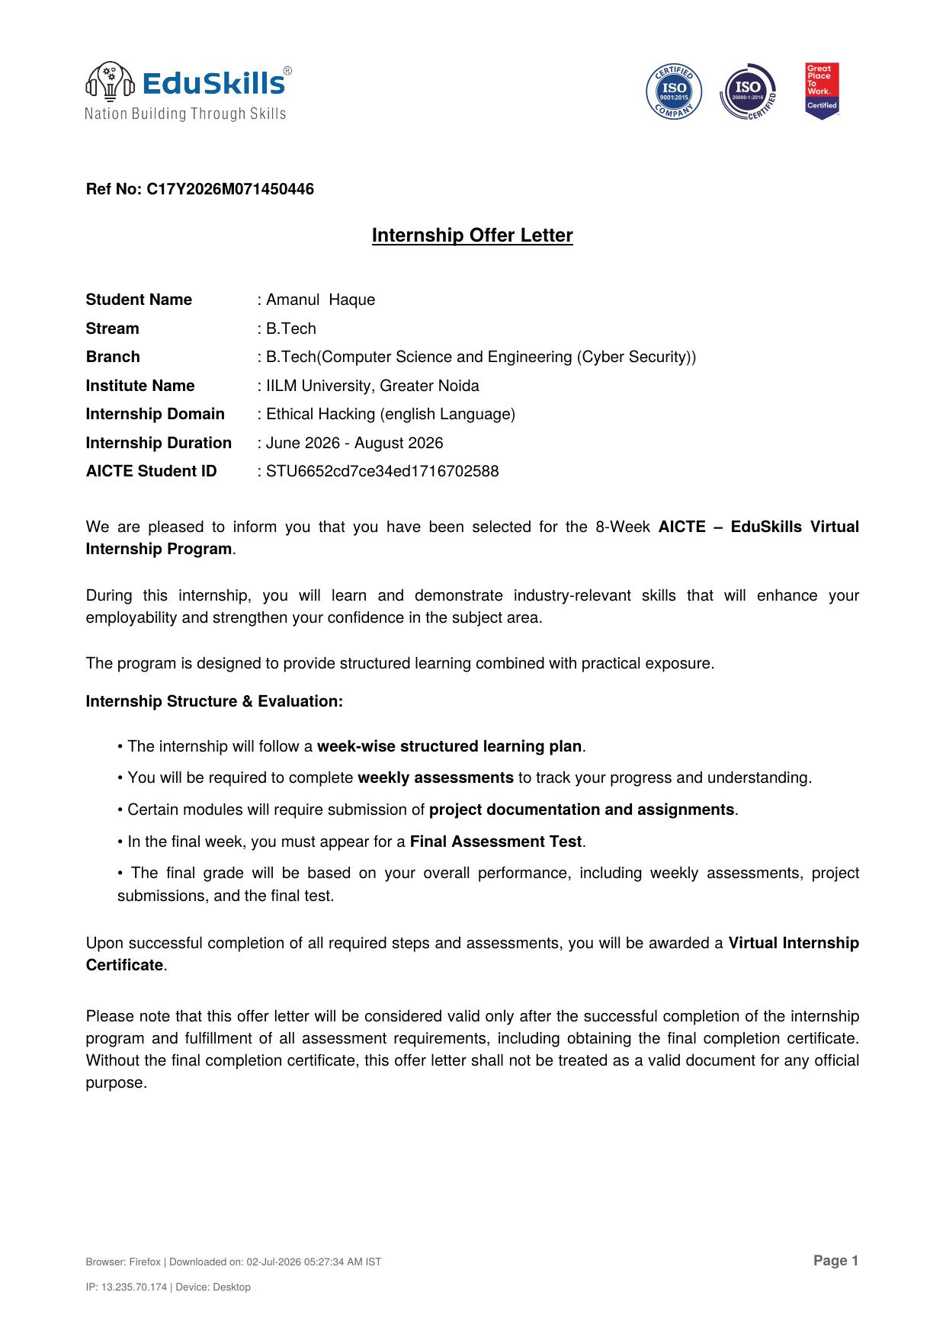

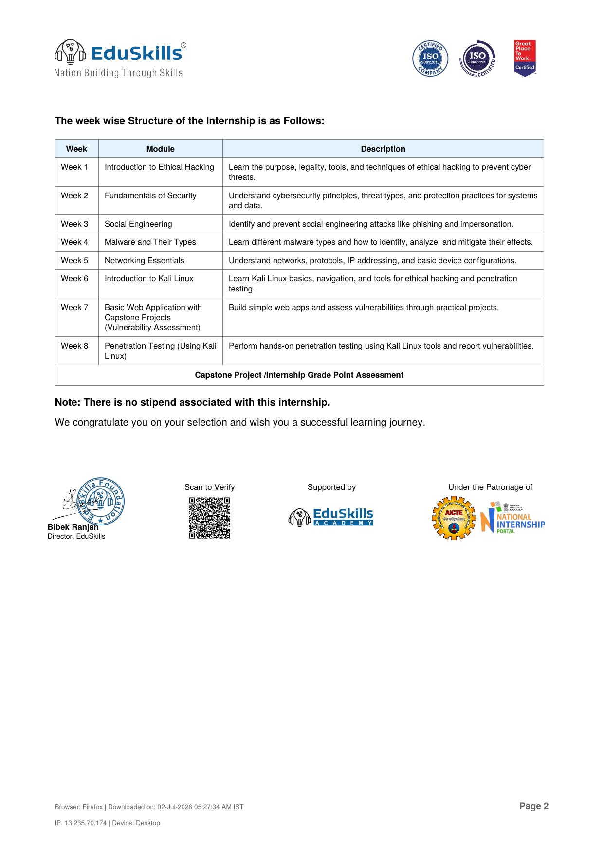

CHAPTER 5
BIBLIOGRAPHY / REFERENCES

1. EduSkills Academy, "Ethical Hacking Virtual Internship Program" curriculum modules, AICTE National Internship Portal, 2026.
2. AICTE (All India Council for Technical Education), National Internship Portal, https://internship.aicte-india.org
3. Offensive Security, "Kali Linux Documentation", https://www.kali.org/docs/
4. OWASP Foundation, "OWASP Top Ten Web Application Security Risks", https://owasp.org
5. EduSkills Academy, Internship Offer Letter Ref No. C17Y2026M071450446, and Internship Completion Certificate ID 2026-E8B068948D.

