

**Tribhuvan**

**University**

**Kathford International College of Engineering and**

**Management**

**A Final Year Project**

**Report On**

**REAL ESTATE NEPAL**

**Submitted To**

**Department of Computer Science and Information Technology**

**Kathford International College of Engineering and**

**Management**

**In partial fulfillment of the requirement for the Bachelor Degree in**

**Computer Science and Information Technology**

**Submitted By**

**Biraj Khatri (20376/075)**

**Pawan Phuyal(20390/075)**

**Rupesh Acharya(20400/075)**

**April,2023**



**Supervisor’s Recommendation**

I hereby recommend that this report has been prepared under my supervision by *Biraj*

*Khatri (20376/075) Pawan Phuyal (20390/075) and Rupesh Acharya (20400/075)* entitled

*Real Estate Nepal* in partial fulfillment of the requirements for the degree of B.Sc. in Computer Science and Information Technology be processed for evaluation.

…………………..…

**Ishwar Dhungana**

Supervisor

Department of Computer Science and IT

Kathford International College of Engineering and

Management Balkumari, Lalitpur



**CERTIFICATE OF APPROVAL**

This is to certify that this project prepared by *Biraj Khatri (20376/075) Pawan Phuyal (20390/075) and Rupesh Acharya (20400/075)* entitled *Real Estate Nepal* in partial fulfillment of the requirements for the degree of B.Sc. in Computer Science and Information Technology has been well studied. In our opinion, it is satisfactory in the scope and quality as a project for the required degree.

|  |  |
| --- | --- |
| **Ishwar Dhungana**  Supervisor  Department of Computer Science and IT  Kathford International College of  Engineering and Management  Balkumari, Lalitpur | **Mukesh Prasad Choudhary** Project Coordinator  Department of Computer Science and IT  Kathford International College of  Engineering and Management  Balkumari, Lalitpur |
| (Internal Examiner)  Department of Computer Science and IT  Kathford International College of  Engineering and Management  Balkumari, Lalitpur | (External Examiner)  Central Department of Computer Science and IT  Tribhuvan University  Kirtipur, Nepal |

# ACKNOWLEDGEMENT

# 

We would like to express our sincere and utmost gratitude towards my dissertation supervisor Mr. Ishwar Dhungana as he gave us the necessary guidance during the key moments of our projects and due to his guidance along the way our project is in the phase of completion in time and in and organized manner. We are highly thankful to Mr. Mukesh Prasad Chaudhary our project coordinator for providing us necessary information regarding the project.

We would also like to thank our college for providing the necessary environment in order to foster the growth and development of our capacity as a developer in addition to that we would like to thank the friends made during this time who helped us out in some parts of this project so that we could complete this challenging task that was put ahead of us.

# 

# ABSTRACT

Real estate refers to the buying, selling, and renting of properties such as houses, apartments, and commercial buildings. The platform serves as a central hub for buyers, sellers, and real estate agents to search and list properties and communicate with each other. The web application features comprehensive property listings, including detailed property descriptions, images, and pricing information, as well as advanced search filters for users to easily find properties that meet their specific requirements. It will also offer communication tools, such as messaging to facilitate smooth communication between buyers, sellers, and real estate agents. Overall, this real estate web application has the potential to significantly benefit the Nepalese real estate industry, creating a more efficient and accessible buying and selling, and renting.

**Keywords**: ***Buying, selling, renting, listing of properties.***

# Table of Content

ACKNOWLEDGEMENT i

ABSTRACT ii

Table of Content iii

List Of Figures v

List of Abbreviations v

CHAPTER 1: INTRODUCTION 1

1.2 Problem Statement 1

1.4.1 Scope 2

1.5 Development Methodology 2

Chapter 2: Background Study and Literature Review 3

2.1 Background Study 3

2.2 Literature Review 3

CHAPTER 3: SYSTEM ANALYSIS 6

3.1 System analysis 6

3.1.1 Requirement Analysis 6

3.1.2 Feasibility Analysis 8

3.1.3 Analysis 10

CHAPTER 4: SYSTEM DESIGN 11

4.1 Designing System 11

4.1.1 Class Diagram 11

4.1.2 Sequence Diagram 12

4.2 Algorithm 12

CHAPTER 5: IMPLEMENTATION AND TESTING 15

5.1.1. Tools Used 15

5.2 Testing 16

CHAPTER 6: CONCLUSION AND RECOMMENDATIONS 18

6.1 Conclusion 18

REFERENCES 19

# List Of Figures

**Figure 1 Use Case Diagram Real Estate Nepal** 7

**Figure 2 Gantt chart of Real Estate Nepal** 9

**Figure 3Class Diagram** 11

**Figure 4Sequence Diagram** 12

**Figure 5 Algorithm Diagram** 13

# List of Abbreviations

**REN: Real Estate Nepal**

**KNN: K-Nearest Neighbors**

**UI: User Interface**

**API:** **Application programming interface**

# CHAPTER 1: INTRODUCTION

**1.1 Introduction**

Real estate refers to the buying, selling, and renting of properties such as houses, apartments, and commercial buildings. It is a large and diverse industry that plays a significant role in the economy of many countries.

A real estate web application allows users to search for, view, and interact with real estate properties. Real estate web applications may be used by buyers, sellers, and renters to facilitate property buying, selling, and renting. Real Estate is a property consisting of land and buildings on it. In markets like Nepal where land and building prices are rising, real estate is often purchased as an investment, whether or not the owner intends to use the property. Real Estate Nepal is a web application that helps interested customers to see the price, compare the price between properties and buy, sell, or rent their property.

## 1.2 Problem Statement

Almost everyone begins their property search online, so having an excellent real estate website is essential. The applications that are available in Nepali market have a very basic interface to buy and sell properties. The user experiences in these websites are very primal. User interface is not that dynamic in these websites. The listings of properties in these applications are also not verified and it is difficult to know if it is posted by a genuine user. There are so many websites out there, from design-forward newcomers with catchy names to well-known industry mainstays. The problem is that most of them weren’t built specifically with real estate in mind. The whole reason someone has landed on our site is to look for properties for sale. If we aren’t displaying reliable, searchable data, they will quickly head elsewhere.

**1.3 Objectives**

The major objectives of our project Real Estate Nepal are as follows:

1. To create a web application platform with buying, selling, and renting real estate.

1

1. To ensure there won’t be any fake listing of the properties through validation and authentication.

**1.4 Scope and Limitation**

The scope of the project is followed with some limitations for the project are briefly described below.

### 1.4.1 Scope

A real estate website can be a valuable tool for buyers, sellers, and investors in Nepal's real estate market. It provides a convenient platform for property buyers and sellers to connect, as well as access information about properties, pricing, and market trends.

#### 1.4.2 Limitations

One of the major limitations of our website is that we could not cover whole of Nepal because of geographic and network problems. Access to data is also very difficult and may not be accurate.

Despite these limitations, a real estate Nepal application can still be a valuable tool for property buyers, sellers, and investors. It can provide a convenient and efficient way to search for properties and connect with potential buyers or sellers. However, users should be aware of the limitations and use the application as a supplement to other real estate resources.

## 1.5 Development Methodology

The Agile methodology is a well-liked way of developing software that places an emphasis on flexibility and adaptation. Iterative and incremental development are used in this process, and working software is frequently released. To make sure the application fits the client's needs, the development team collaborates closely with them.

Iterative and incremental development is a popular approach to software development that involves breaking down a project into smaller, more manageable pieces and developing them in a step-by-step manner. This approach can be applied to real estate web applications to ensure that they are delivered on time, within budget, and with the necessary features and functionality.

# Chapter 2: Background Study and Literature Review

The purpose of a background study and literature review is to examine a system or its components in order to determine its goals. The system is improved by doing a background study of the system, gathering and evaluating its needs, investigating its feasibility, and organizing the user and system requirements to guarantee that all of the system's components function efficiently to achieve their goals.

## 2.1 Background Study

Real estate industry in Nepal has been booming over the years with the country witnessing an increasing number of property transactions, particularly in the urban areas. A web application for real estate in Nepal could provide a platform for property buyers, sellers, and renters to easily connect and transact. In order to develop such an application, a background study on the following aspects could be beneficial. In context of Kathmandu more than 75% population accommodations is rental based.

## 2.2 Literature Review

Despite the fact that nearly every element of human existence is becoming digitized. However, the process of looking for a property is still the old-fashioned way. With the construction of real estate sites, the dissertation will assist to digitize the process of searching for homes.

Property searches are still done by hand and are done in the old-fashioned way. The primary issue is that people need to visit a lot of people only to look at certain properties, which results in needless people being created so that the buyer may immediately examine the properties for sale and then contact the seller, reducing the bother of acquiring properties now available. Real estate web applications have become increasingly popular in recent years as a means of facilitating property transactions. While there is limited literature specifically on real estate web applications in Nepal, there is research on the broader real estate market and the use of technology in the country. The following is a brief literature review of some relevant studies:

"Real Estate Market in Nepal: Opportunities and Challenges" (Shakya and Manandhar, 2019): This study provides an overview of the real estate market in Nepal, including the types of properties that are in demand and the challenges faced by the industry. It highlights the need for more transparency and efficiency in property transactions, which could be facilitated by the use of technology.

"The Role of Information and Communication Technology in the Real Estate Industry in Nepal" (Gurung and Sharma, 2018): This study explores the potential of information and communication technology (ICT) to improve the efficiency and transparency of the real estate industry in Nepal. It argues that the use of ICT could reduce transaction costs, increase market access, and improve information sharing among stakeholders.

"Adoption of e-Commerce in the Real Estate Industry: A Study of Nepal" (Koirala, 2018): This study examines the adoption of e-commerce in the real estate industry in Nepal. It identifies several factors that influence the adoption of e-commerce, including perceived usefulness, ease of use, and trust in the platform. The study suggests that the adoption of ecommerce in the real estate industry is still in its early stages in Nepal, but has the potential to revolutionize the industry.

"Web-based Real Estate Management System: An Approach to Overcome Challenges Faced by Real Estate in Nepal" (Gautam and Shrestha, 2015): This study proposes the development of a web-based real estate management system in Nepal. The system would provide a platform for property transactions and management, with features such as property listings, online booking, and payment processing. The study argues that such a system could improve the efficiency and transparency of the real estate industry in Nepal.

Overall, the literature suggests that there is potential for real estate web applications in Nepal to improve the efficiency and transparency of the industry, while also providing a convenient platform for property transactions. However, further research is needed to understand the specific needs and preferences of users in Nepal, as well as the legal and regulatory requirements for such applications.

A real estate web application can provide several benefits and solutions for the real estate industry in Nepal. Some of these benefits include:

* Increased accessibility: A real estate web application can provide easy access to property listings, real estate agents, and other services related to the real estate industry. This can help potential buyers and sellers to find what they need quickly and easily, even from remote locations.
* Time-saving: A real estate web application can save time for both buyers and sellers by allowing them to search for properties without the need for physical visits to properties or real estate offices.
* Improved transparency: Real estate web applications can increase transparency in the industry by providing accurate and up-to-date information on property listings, prices, and market trends. This can help buyers and sellers to make informed decisions.
* Enhanced marketing: Real estate web applications can provide a platform for real estate agents to market their services and properties more effectively, reaching a wider audience of potential buyers and sellers.
* Increased efficiency: Real estate web applications can streamline processes, such as property listings, and documentation, making the overall process more efficient and reducing the risk of errors and delays.

# CHAPTER 3: SYSTEM ANALYSIS

## 3.1 System analysis

In order to ascertain the aims, a system analysis was conducted to analyze the system and its constituent parts. It served as a problem-solving method to improve the system and ensure that each of its parts worked together to accomplish the necessary goals. We gathered and analyzed data, pinpointed issues, and broke down systems into their component parts.

### 3.1.1 Requirement Analysis

Requirement analysis can be used to analyze, document, validate, and manage software requirements. First, requirements are gathered, elicited, analyzed, and modeled. The use case diagram depicts the requirement analysis.

Understanding the functional and non-functional requirements can aid in requirement analysis:

#### i. Functional Requirements

A functional requirement is a description of the service that the system must be able to perform the functional requirements are:

#### a) User registration

This application allows the user to register. During registration, they must enter a valid phone number or email address and password. User authentication is done through OTP using a mobile number.

#### b) User Login

After registering, users may access the system by entering their phone number or email address and password.

#### c) Home activity

After logging in, users can access the first page. Users can check for the availability and featured real estate properties and can also view the property available for the buy , sell or rent.

#### d) Logout

After completing the purpose of use of the system the user can logout of the system.

##### 3.1.1.1. Use Case Diagram

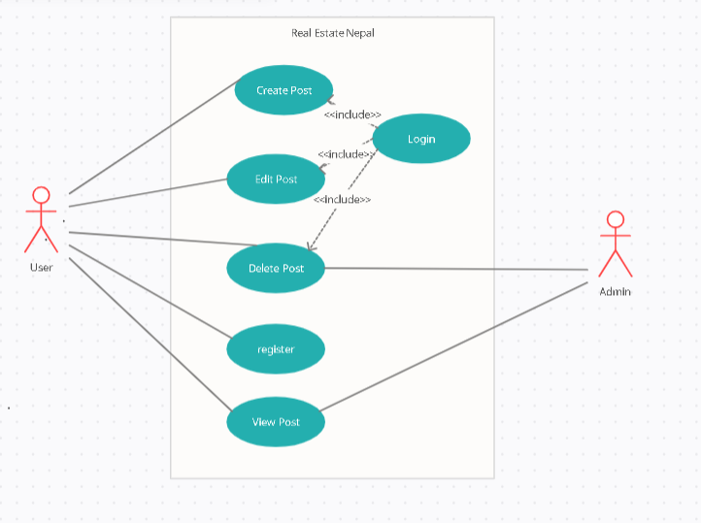

**Figure 1 Use Case Diagram Real Estate Nepal**

Use case diagram aids in identifying, validating, and documenting project specifications. The user must use a valid username (i.e. phone number) and password to access the system. The user and admin are the actors in this application. Customers can be specialized into registered users and unregistered customers. The registered and unregistered customers have some similar processes and some distinct ones. Both registered and unregistered customers can view the web application but registered only have access of posting, editing and deleting the post. The admin can verify and authenticate the customers and the post.

**ii. Non-functional Requirements**

A non-functional requirement is a specification that describes the system’s operation capabilities that enhance its functionality.

**a) Easy Access**

Real Estate Nepal can be accessed anywhere with internet access.

#### b) Reliability

The content on the website was gathered from reputable sources and double-checked before being posted on our site.

**c) User Friendly**

The web application has a clean user interface.

#### d) Application Speed

With normal internet connectivity and device, web application will run smoothly.

### 3.1.2 Feasibility Analysis

A feasibility study is an examination that considers all aspects of a project in order to determine the chances of completing it effectively. This application underwent a feasibility assessment, which is detailed below:

##### i. Technical Feasibility

The proposed project consists of algorithm implementation, data processing, and an application built in Python. HTML, CSS, JavaScript and Next.js (React Framework) are used to create the user interface. The software and hardware requirements for this application are based on a free and open-source framework. This application requires a high-performance programming language. The libraries in the project are capable of achieving the desired result.

##### ii. Economy Feasibility

It has been economically feasible to develop this project up to this point because the tools and resources are resource-free and open-source frameworks.

##### iii. Operational Feasibility

The proposed program is intended to be user-friendly, with a simple yet appealing interface that allows users to easily operate the application. This application helps the user to check the price, and compare it with other properties.

##### iv. Schedule Feasibility

The proposed system is completed based on the proposed time of the system. A time schedule/ Gantt Chart according to the methodology is used for the development. The project was subdivided into different phases. Most of the phases were completed according to the time scheduled for the project and some are still to be completed.

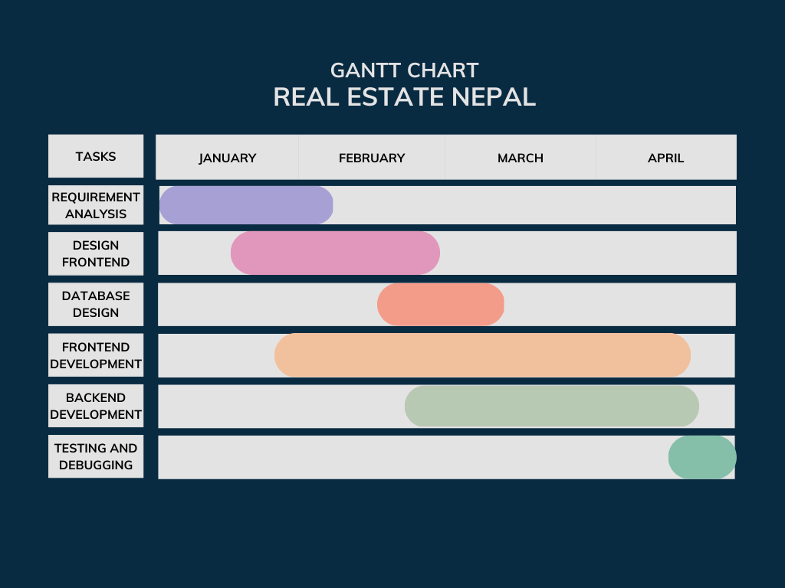

**Figure 2 Gantt chart of REN**

### 3.1.3 Analysis

In order to incorporate both data and process, we employed an object-oriented approach to concentrate on encapsulating the structure and behavior of information systems into tiny models. By making the system easier to use, the fundamental goal of employing an objectoriented approach was to increase the quality and productivity of our system analysis and design.

# CHAPTER 4: SYSTEM DESIGN

## 4.1 Designing System

In order to create our application utilizing an object-oriented technique, we employed an object-oriented design. We were able to develop the software solution based on the principles of objects thanks to this design technique. The object-oriented programming lifecycle or process included object-oriented design as a step. The accompanying class diagram, sequence diagram, and activity diagram serve as the foundation for developing the system.

### 4.1.1 Class Diagram

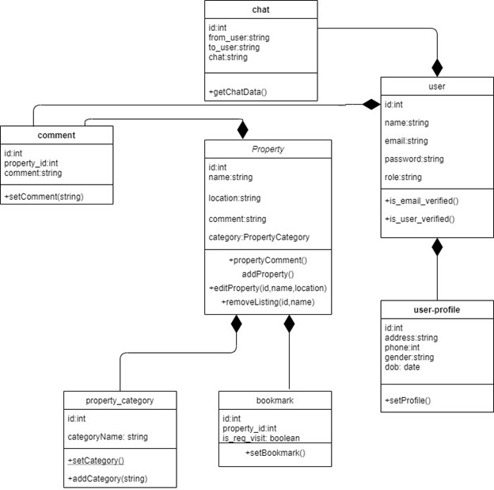

**Figure 3Class Diagram of REN**

#### 

### 4.1.2 Sequence Diagram

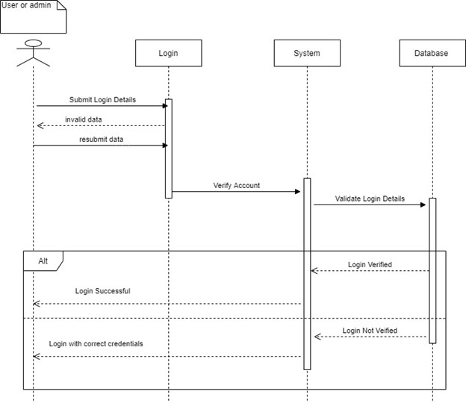

**Figure 4Sequence Diagram of REN**

## 4.2 Algorithm

A recommendation algorithm is a computer program that analyzes data and makes recommendations based on that data. In the context of our project, a recommendation algorithm will be used to suggest properties to users based on their search history and preferences.

There are several approaches that could be used to implement a recommendation algorithm for a real estate web application. Here are a few examples:

Collaborative filtering: This approach involves analyzing the preferences and behaviors of users who have similar interests and recommending properties based on their preferences. For example, if two users have searched for properties with similar features (such as location and price range), the algorithm may recommend properties to one user that the other user has shown interest in.

Content-based filtering: This approach involves analyzing the characteristics of properties and recommending properties that match a user's preferences. For example, if a user has consistently searched for properties with a certain number of bedrooms and a certain price range, the algorithm may recommend properties with similar characteristics.

Hybrid approach: A combination of collaborative filtering and content-based filtering may be used to provide more accurate recommendations. For example, the algorithm could take into account both the preferences of similar users and the characteristics of properties when making recommendations.

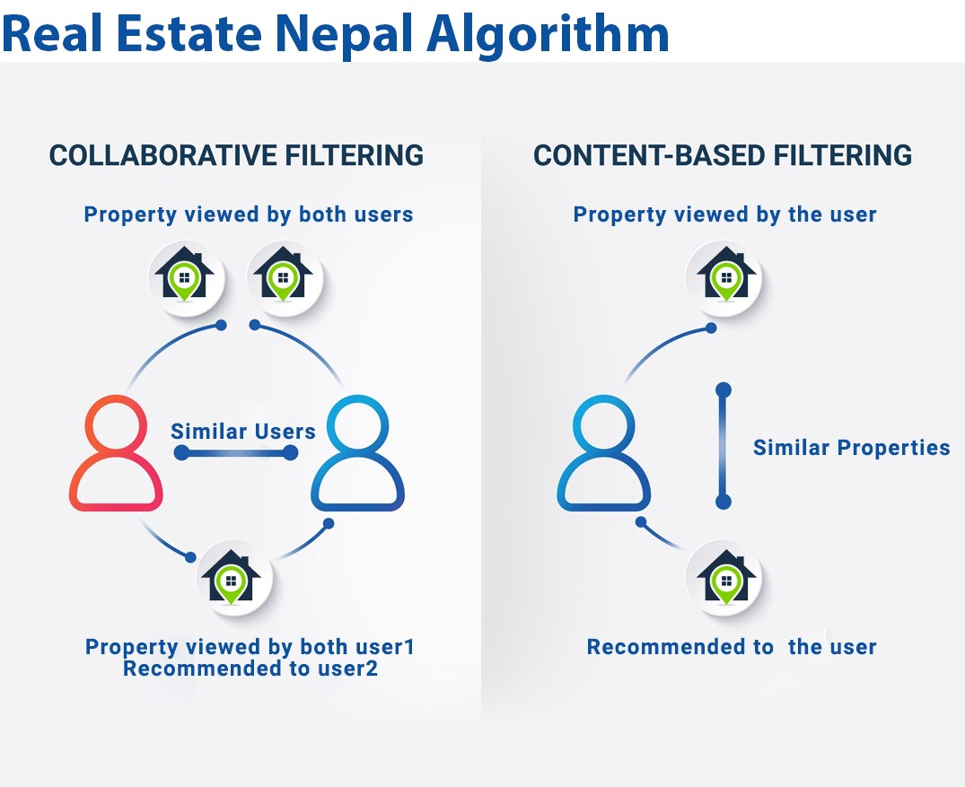

**Figure 5 Algorithm Diagram of REN**

to achieve collaborating filtering and content-based filtering KNN is used. To implement the k-nearest neighbors (k-NN) algorithm in our real estate web application, we would first need to collect data about the properties listed on our website. This might involve scraping data from real estate websites or collecting data from real estate agents who list properties on our website.

Once we have collected the data, we would need to preprocess it to ensure that it is in a format that can be used by the k-NN algorithm. This might involve normalizing the data or transforming it into a distance metric.

Next, we would need to choose a similarity metric to determine which properties are most similar to each other. In the case of a real estate web application, a suitable similarity metric might be the Euclidean distance between properties based on their location, price, and other features.

With the data preprocessed and a similarity metric chosen, we can implement the k-NN algorithm. When a user performs a search on our website, we can use the k-NN algorithm to identify the k-nearest properties to their search query based on the similarity metric we have chosen.

Once we have identified the k-nearest properties, we can provide recommendations to the user based on these results. We might display a list of similar properties on the search results page or provide personalized recommendations to the user based on their search history.

As users interact with our website and provide feedback on the recommendations, we can use this information to update the k-NN model and provide even more personalized recommendations in the future.

Overall, implementing the k-NN algorithm in our real estate web application can help to improve the user experience by providing personalized and relevant recommendations to users based on their preferences and search history.

KNN (K-Nearest Neighbors) is a machine learning algorithm that can be used in a real estate web application in Nepal for several purposes, such as:

* Identifying Similar Properties: KNN algorithm can be used to identify similar properties based on various attributes such as location, size, amenities, and price. This can help buyers to find properties that match their preferences and requirements.
* Personalizing Property Recommendations: KNN algorithm can be used to personalize property recommendations for buyers based on their search history, saved properties, and preferences. This can help to improve the user experience and increase the chances of a successful transaction.
* Identifying Potential Buyers: KNN algorithm can be used to identify potential buyers for a property based on their search history and preferences. This can help real estate agents to target their marketing efforts more effectively and increase the chances of a successful sale.

# CHAPTER 5: IMPLEMENTATION AND TESTING

**5.1 Implementation**

The software implementation stage involved the transformation of the software technical data package into one or more fabricated, integrated and tested software configuration items that were ready for software testing.

### 5.1.1. Tools Used

#### a. Frontend

We implemented the frontend section of our real estate web application using Tailwind CSS and React.js. Tailwind CSS was used to create a highly customizable and responsive design system, while React.js was used to improve the performance and development experience of the application. Using Tailwind CSS, we defined a custom configuration file that defined the design system for our application. We then created reusable components using Tailwind CSS classes, allowing us to easily apply styles to HTML elements using a set of pre-defined utilities.

#### b. Backend

We used Django REST Framework to create the API for our real estate web application's backend. Django REST Framework is a powerful and flexible toolkit for building Web APIs.

With Django REST Framework, we were able to quickly and easily create a RESTful API that could be consumed by our frontend application. We defined models to represent our data and used Django's built-in ORM to manage the database. We then created serializers to convert our model instances to JSON format, making it easy to transfer data between the frontend and backend.

Django REST Framework also provided a range of useful features, such as authentication and authorization, pagination, filtering, and caching. This allowed us to secure our API and ensure that only authorized users could access sensitive data.

To optimize performance, we used Django REST Framework's built-in caching system to cache frequently accessed data. This reduced the load on the server and improved the responsiveness of the application.

Overall, Django REST Framework provided a powerful and flexible platform for building our API, allowing us to create a high-performance and secure backend for our real estate web application.

##### c. Other tools

We utilized various other tools such as Draw.io to create the ERD diagram, class diagram, state diagram, sequence diagram, and MS Word for documentation and report. These tools helped us to effectively plan and visualize our application, as well as to document and communicate our progress and findings.

## 5.2 Testing

Testing is the final verification and validation activity within the organization itself. In the testing stage following goals are to achieve:-

● To find and eliminate any residual errors from previous stages

● To validate the software or web application as a solution to the original problem.

|  |  |  |  |  |  |
| --- | --- | --- | --- | --- | --- |
| Test Id | Component Tested | Test Cases | Expected Results | Actual Results | Pass/Fail |
| 1. | Property Listing Component | Verify that properties are listed correctly with all necessary details. | Properties are listed correctly with correct details displayed. | All properties are listed correctly with correct details displayed. | Pass |
| 2. | Search Component | Verify that properties are filtered correctly based on the search criteria. | Only properties that match the selected location and property type are displayed. | Properties are correctly filtered based on selected location and property type. | Pass |
| 3. | User Authentication Component | Verify that users can successfully register, login, and logout of the application. | Users can successfully register, login, and logout. User roles are correctly assigned. Unauthorized access is prevented. | Users are able to register, login, and logout. User roles are correctly assigned. Unauthorized access is prevented. | Pass |
| 4. | Property Details Component | Verify that all necessary details of the property such as images, videos, floor plans, and virtual tours are correctly displayed. | All necessary details are correctly displayed. | All necessary details are correctly displayed. | Pass |
| 5. | Favorites Component | Verify that users can save properties to their favorites list and that the properties can be retrieved and displayed correctly. | Users can save properties to their favorites list. Properties can be retrieved and displayed correctly. | Users are able to save properties to their favorites list. Properties are correctly retrieved and displayed. | Pass |

In this table format, each component tested is listed in the first column, and the test cases for that component are listed in the second column. The third column lists the expected results for each test case, and the fourth column lists the actual results obtained during testing. The final column indicates whether the test case passed or failed.

# CHAPTER 6: CONCLUSION AND RECOMMENDATIONS

## 6.1 Conclusion

In conclusion, a real estate web application can be a valuable tool for buyers, sellers, and real estate agents in Nepal. It can provide a centralized platform for property listings, searches, and communication, making the buying and selling process more efficient and accessible. However, to be successful, the web application must address the unique challenges and considerations of the Nepalese real estate market, including limited access to the internet and technology in certain areas, language barriers, and cultural differences in buying and selling practices. In addition, the web application must prioritize user experience and security, ensuring that users can easily navigate the platform and that their personal information is protected.

Overall, a well-designed and culturally sensitive real estate web application can have significant potential to benefit the Nepalese real estate industry and its stakeholders.

# REFERENCES

* Kumar, R. (n.d.). *Kathmandu s unreal real estate prices*. Nepali Times.
* https://www.nepalitimes.com/banner/kathmandus-unreal-real-estate-prices/
* Chandana, D. (2022, January 6). *E-Commerce Recommendation Engine with Collaborative Filtering*. Medium. https://medium.com/web-mining-is688-spring-2021/ecommerce-recommendation-engine-with-collaborative-filtering-cb19cd542c18
* Wikipedia contributors. (2022, December 31). *Real estate*. Wikipedia.
* https://en.wikipedia.org/wiki/Real_estate
* *What is the k-nearest neighbors algorithm? | IBM*. (n.d.-c).
* https://www.ibm.com/topics/knn