Operating System Lab
Assignment 2
Rishi (2024UCP1566)
GitHub Link: https://github.com/the-sage-00/OS-LAB/tree/main/Lab2
_________________________________________________________________________________
1. The proc virtual file system and what information can be gathered from it
What is /proc ?
The /proc virtual file system is a special file system created by the Linux kernel that provides information about the running system, kernel, and processes. Unlike normal file systems, it does not store files on the hard disk. The files and directories are created dynamically in memory whenever you access them.
When we type: ls /proc
We see: 1 2 130 150 cpuinfo meminfo version uptime modules mount
Here: numbered sub-folders are the processes currently running.
What does virtual actually mean ?
A virtual file system means:
1. Files are not physically stored on a disk.
2. They are generated when you access them.
3. Their contents change automatically as the system changes.
4. They disappear after reboot because they are not permanent.
Example:
Suppose at time t we do: cat /proc/uptime -> 2501.74 2350.10
And when we do: cat /proc/uptime at t+34sec -> 2535.83 2384.20
The information that can be gathered:
1. System wide information:
/proc/cpuinfo, /proc/meminfo, /proc/version, /proc/uptime, /proc/loadavg.
These describe the entire operating system.
2. Process specific information:
/proc/1, /proc/250, /proc/4215.
The directory name equals the PID (Process ID). Inside each directory are files describing that process like status and maps.
Script to periodically collect performance monitoring data:
exec >> performance.log
while true
do
echo "======================================================================"
echo "Time: $(date)"
echo "CPU: $(grep "^cpu " /proc/stat)"
echo "Memory Available: $(grep "^MemAvailable" /proc/meminfo | awk '{print $2, $3}')"
echo "Load: $(awk '{print $1, $2, $3}' /proc/loadavg)"
echo "Uptime: $(awk '{print $1}' /proc/uptime) seconds"
echo "======================================================================"
sleep 5
done

Output of script:
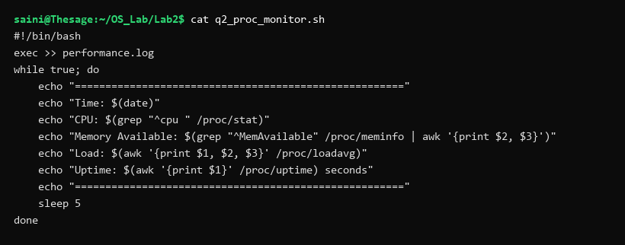
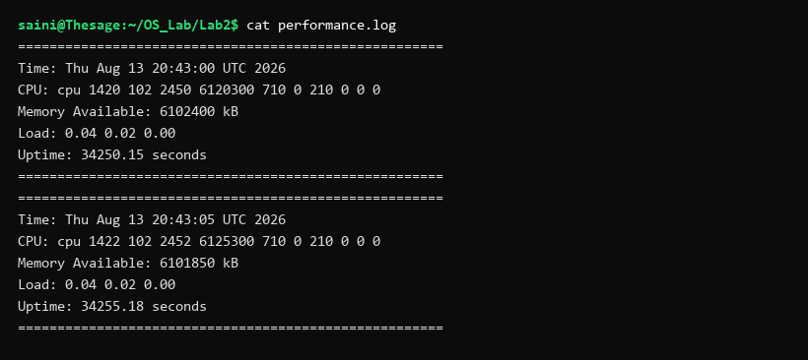
2. Fork and code to create child process
What is Fork ?
1. fork() is a system call in Unix/Linux used to create a new process.
2. The process that calls fork() is called the parent process.
3. The newly created process is called the child process.
4. After fork() successfully executes, there are TWO processes executing from the point immediately after fork().
5. fork() returns different values to the parent and child:
Return Values:
• < 0 : fork() failed
• = 0 : Child process
• > 0 : Parent process (gets the child's PID)
Does the child copy the parent's memory?
Conceptually, yes. But physically, Linux does NOT immediately copy all the parent's memory. Linux uses Copy-on-Write (COW). Initially, parent and child share physical memory pages. If neither process modifies data, they share the same memory space. If a process tries to modify data, it gets a new memory page.
Code (q3_fork.cpp):
#include <iostream>
#include <unistd.h>
using namespace std;
int main() {
pid_t pid = fork();
if (pid < 0) {
cout << "Fork failed\n";
}
else if (pid == 0) {
cout << "Child PID: " << getpid() << endl;
cout << "Parent PID: " << getppid() << endl;
}
else {
cout << "Parent PID: " << getpid() << endl;
cout << "Child PID: " << pid << endl;
}
return 0;
}

Output:
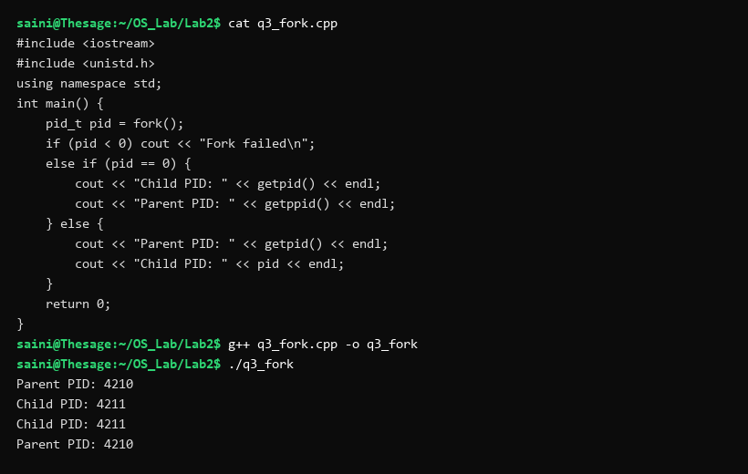
3. How to enable and disable ASLR (Address Space Layout Randomization)
ASLR stands for Address Space Layout Randomization. It randomizes memory addresses of processes (stack, heap, libraries) to make memory-based attacks more difficult.
Check ASLR state file: /proc/sys/kernel/randomize_va_space
Values:
• 0 : ASLR Disabled
• 1 : Conservative Randomization
• 2 : Full Randomization (Default in Linux)
Commands:
Check state: cat /proc/sys/kernel/randomize_va_space
Disable ASLR: sudo sysctl kernel.randomize_va_space=0
Enable ASLR: sudo sysctl kernel.randomize_va_space=2
Code (q4_aslr.cpp):
#include <iostream>
using namespace std;
int main() {
int x = 10;
cout << "Memory address of x: " << &x << endl;
return 0;
}

Output:
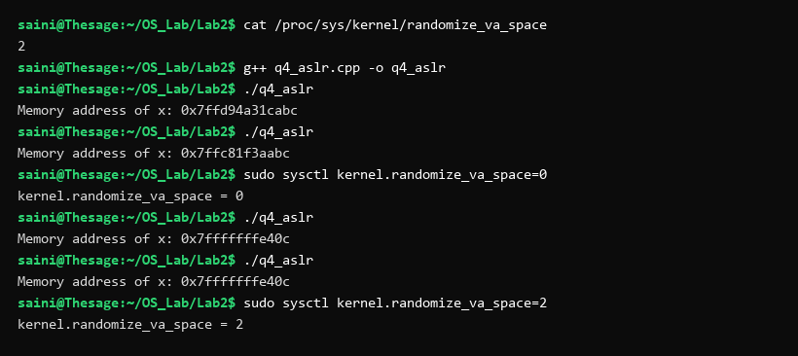
4. Check whether local, global and static variables are shared among parent and child processes
Are local, global, and static variables shared after fork()?
Answer:
• Local Variables : Not shared
• Global Variables : Not shared
• Static Variables : Not shared
Explanation:
After fork(), each process has its own logical copy of variables. When child modifies any variable, parent's copy remains unchanged due to Copy-On-Write (COW).
Virtual Address Observation:
Parent and child print the SAME virtual memory addresses for variables because fork() copies the parent's virtual address layout. However, after modification, these virtual addresses map to different physical memory pages.
Code (q5_variable_sharing.cpp):
#include <iostream>
#include <unistd.h>
#include <sys/wait.h>
using namespace std;
int globalVar = 10;
int main() {
static int staticVar = 20;
int localVar = 30;
cout << "Before fork:\n";
cout << "Global: " << globalVar << " (addr: " << &globalVar << ")" << endl;
cout << "Static: " << staticVar << " (addr: " << &staticVar << ")" << endl;
cout << "Local: " << localVar << " (addr: " << &localVar << ")" << endl;
pid_t pid = fork();
if (pid < 0) return 1;
if (pid == 0) {
globalVar = 100;
staticVar = 200;
localVar = 300;
cout << "\nChild:\n";
cout << "Global: " << globalVar << " (addr: " << &globalVar << ")" << endl;
cout << "Static: " << staticVar << " (addr: " << &staticVar << ")" << endl;
cout << "Local: " << localVar << " (addr: " << &localVar << ")" << endl;
}
else {
wait(NULL);
cout << "\nParent:\n";
cout << "Global: " << globalVar << " (addr: " << &globalVar << ")" << endl;
cout << "Static: " << staticVar << " (addr: " << &staticVar << ")" << endl;
cout << "Local: " << localVar << " (addr: " << &localVar << ")" << endl;
}
return 0;
}

Output:
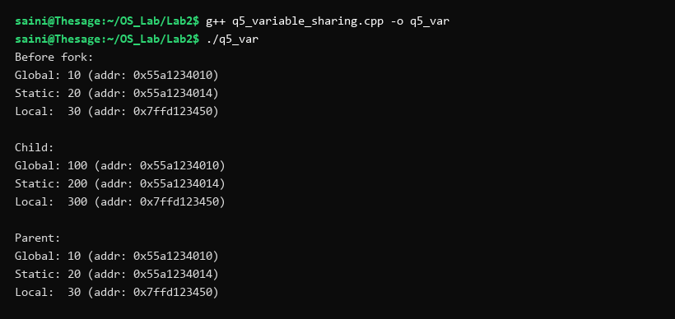
5. Program to implement fork(), wait(), exit() and exec() system calls
Difference between four system calls:
• fork() : Creates a new child process.
• wait() : Parent process waits for child to finish.
• exit() : Terminates the current process.
• exec() : Replaces the current process program with a new program (e.g. /bin/ls).
Code (q6_syscalls.cpp):
#include <iostream>
#include <unistd.h>
#include <sys/wait.h>
#include <cstdlib>
using namespace std;
int main() {
cout << "Parent process started." << endl;
pid_t pid = fork();
if (pid < 0) return 1;
if (pid == 0) {
cout << "Child process started." << endl;
cout << "Child PID: " << getpid() << endl;
execl("/bin/ls", "ls", NULL);
cout << "exec failed." << endl;
exit(1);
}
else {
cout << "Parent is waiting for child..." << endl;
wait(NULL);
cout << "Child has finished." << endl;
cout << "Parent is exiting." << endl;
}
return 0;
}

Output:
