Operating System Lab
Assignment 1
Rishi (2024UCP1566)
________________________________________________________________________________
Section A: Introduction to Linux
Important points:
1) Linux architecture: Hardware -> Kernel -> Shell -> Applications. The kernel manages everything, the shell is where we type commands.
2) Shell: A command-line program that takes our commands and tells the kernel what to do.
3) Types of shell: bash (default in Ubuntu), sh (original shell), csh (C-like syntax), ksh (Korn shell), zsh (modern shell with plugins).
4) Command structure: command [options] [arguments], for example ls -la /home.
5) apt-get: Package manager of Ubuntu: sudo apt-get update, install <pkg>, upgrade, remove <pkg>.
Command | What it does
sudo | Run a command as admin
ls / pwd | List files / show current folder
mkdir / rmdir | Make a folder / remove an empty folder
rm / cp / mv | Delete / copy / move or rename files
cd | Change folder
wc / cmp | Count words and lines / compare two files
who / uname / passwd | Logged in users / system info / change password

Section B: Command Execution (Ubuntu on WSL 2)
B.1 Directory Commands
Command | What it does
pwd | Show current directory
mkdir / rmdir | Create / remove a folder
ls -la | List all files with details
cd | Change directory
tree | Show folder structure as a tree

Output:
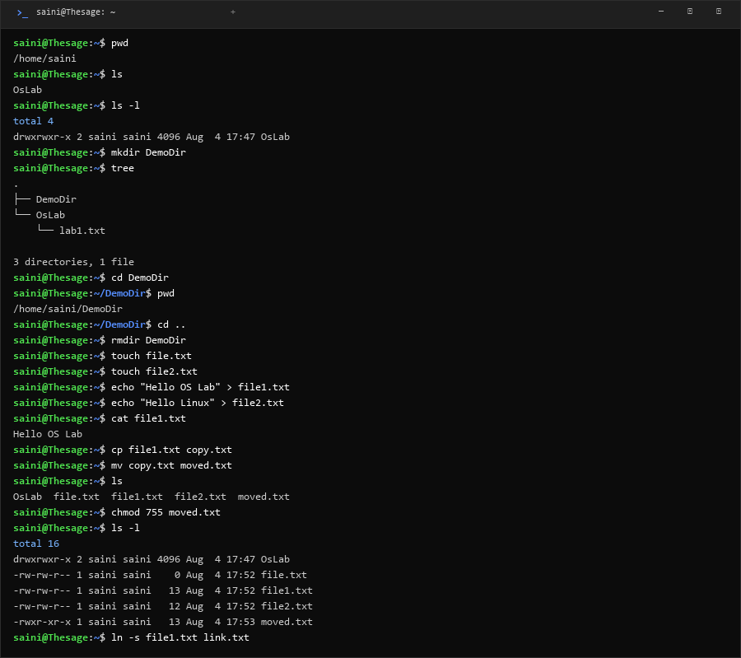
B.2 File Commands
Command | What it does
cat | Show file content
cp / mv / rm | Copy / move / delete a file
ln -s | Create a shortcut link
head / tail | Show first / last lines
grep / find | Search text in a file / search for files
cmp / diff | Compare files
chmod | Change file permissions
wc | Count lines and words
dd | Copy raw data

Output:
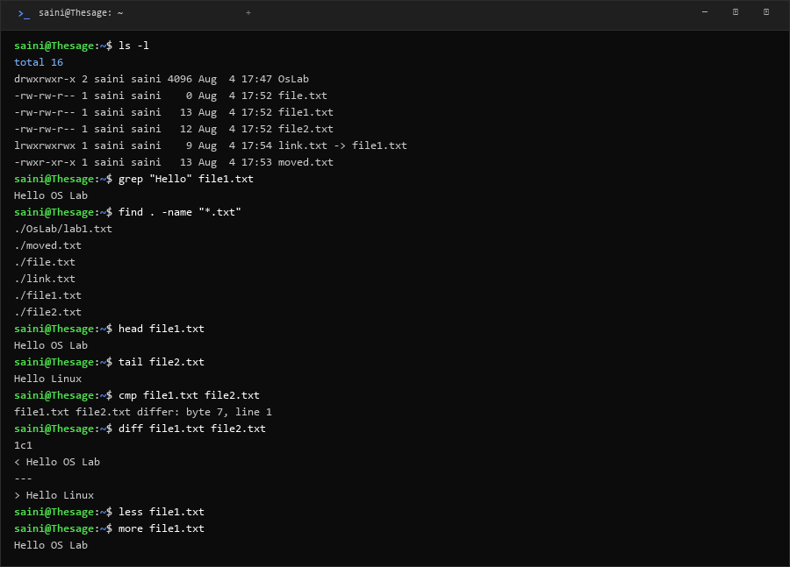
B.3 Process Commands
Command | What it does
ps aux / ps -ef | Show running processes
top | Live process monitor
nice | Run with a different priority
touch | Create an empty file
kill | Stop a process

Output:
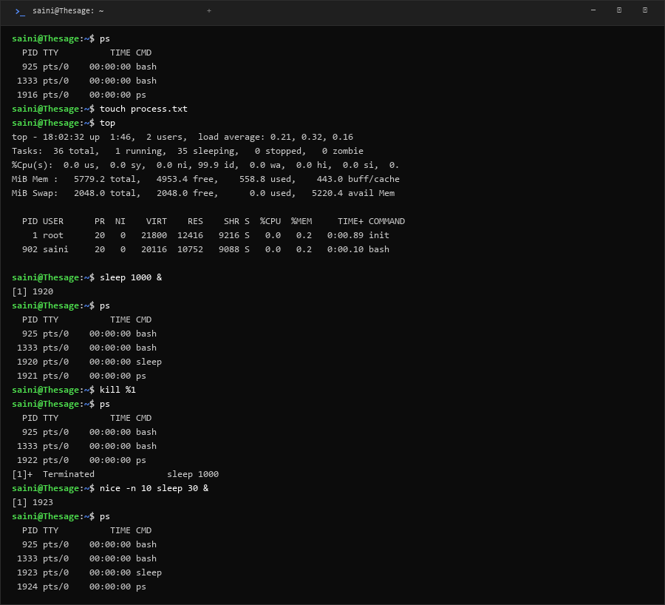
B.4 Network Commands
Command | What it does
ifconfig | Show network info
ping | Test if a server is reachable
traceroute | Show path to a server
curl / wget | Get web page headers / download files
nslookup | Find IP of a domain
netstat | Show open ports

Output:
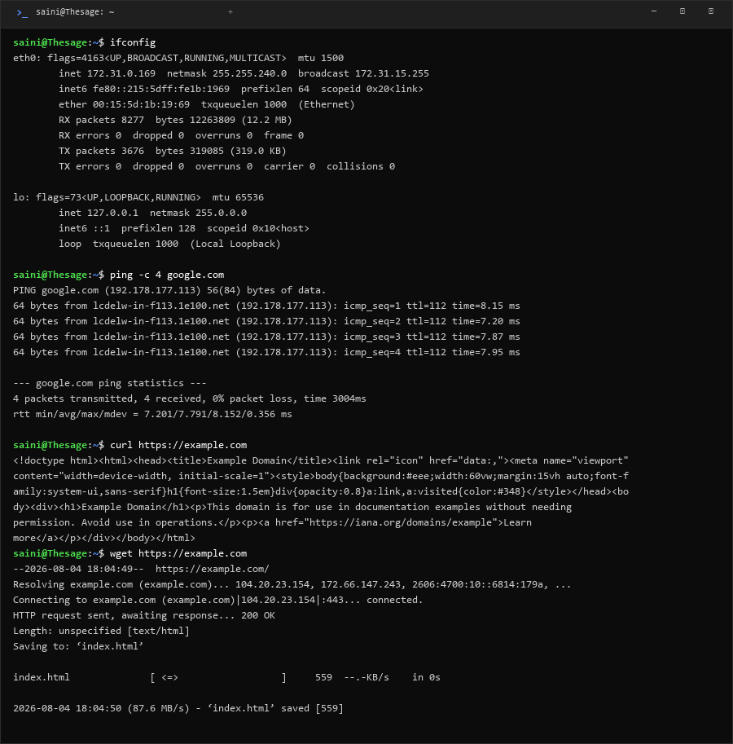
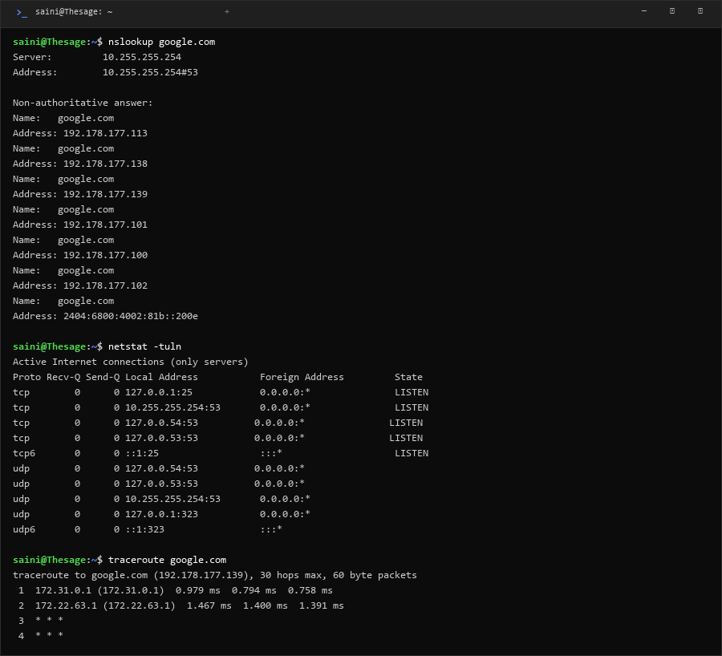
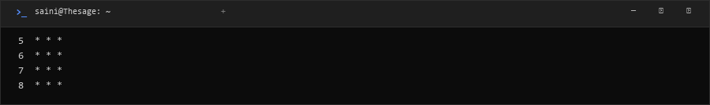
B.5 System Commands
Command | What it does
whoami | Show current username
uname -a | Show OS and kernel info
whereis / which | Find where a program is
systemctl / service | Manage services
ssh -V | Show SSH version
passwd | Change password

Output:
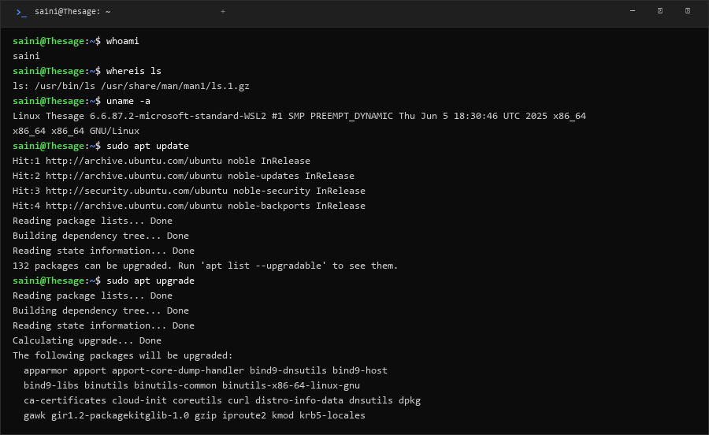
B.6 Disk Commands
Command | What it does
du -sh | Show folder size
df -h | Show disk space
fdisk -l | Show disk partitions

Output:
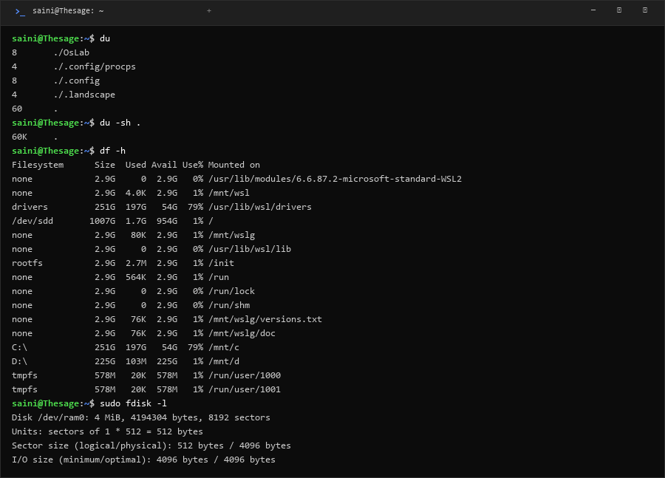
B.7 Miscellaneous Commands
Command | What it does
echo / clear | Print text / clear the terminal
tar | Compress or extract files
man | Open the manual of a command
mount | Show mounted drives
| > >> | Pipe output / write output to a file / append

Output:
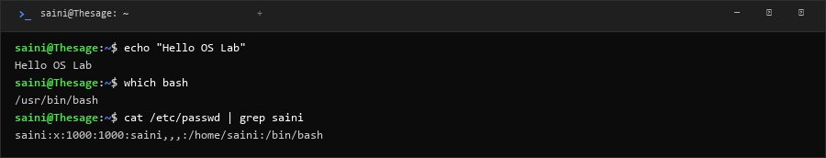
B.8 /proc Virtual Filesystem
Command | What it does
/proc/cpuinfo | CPU details
/proc/meminfo | Memory details
/proc/version | Kernel version
/proc/uptime | System uptime
/proc/self/status | Current process info

Output:
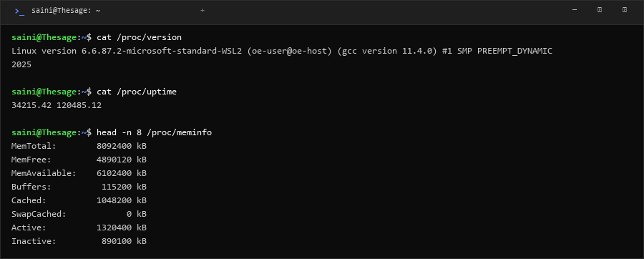
Section C: GCC / G++ Compiler Options
Option | What it does
-o <name> | Set name of the output file
-c | Compile only, do not link
-g | Add debug info
-Wall | Show all warnings
-O0 / -O1 / -O2 | Optimization level
-E | Run the preprocessor only
-S | Generate assembly code
-l <lib> | Link a library
-std=c++17 | Use a specific C++ standard

Example: g++ -o myprogram main.cpp g++ -Wall -g main.cpp -o test
Section D: OSTEP Code (p1 to p4)
These programs from the OSTEP book show how fork(), wait() and exec() work.
p1.cpp: fork()
Parent and child run at the same time. Which one prints first depends on the scheduler.
Code (p1.cpp):
#include <iostream>
#include <unistd.h>
#include <cstdlib>
int main(int argc, char *argv[]) {
std::cout << "hello world (pid:" << getpid() << ")" << std::endl;
int rc = fork();
if (rc < 0) {
std::cerr << "fork failed" << std::endl;
exit(1);
} else if (rc == 0) {
std::cout << "hello, I am child (pid:" << getpid() << ")" << std::endl;
} else {
std::cout << "hello, I am parent of " << rc << " (pid:" << getpid() << ")" << std::endl;
}
return 0;
}
Output:
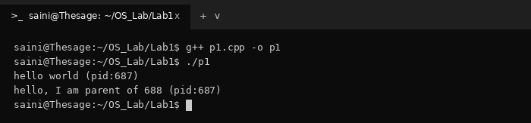
p2.cpp: fork() + wait()
Parent waits for the child with wait(), so the child always prints first.
Code (p2.cpp):
#include <iostream>
#include <unistd.h>
#include <cstdlib>
#include <sys/wait.h>
int main(int argc, char *argv[]) {
std::cout << "hello world (pid:" << getpid() << ")" << std::endl;
int rc = fork();
if (rc < 0) {
std::cerr << "fork failed" << std::endl;
exit(1);
} else if (rc == 0) {
std::cout << "hello, I am child (pid:" << getpid() << ")" << std::endl;
} else {
int wc = wait(NULL);
std::cout << "hello, I am parent of " << rc << " (wc:" << wc << ") (pid:" << getpid() << ")" << std::endl;
}
return 0;
}
Output:
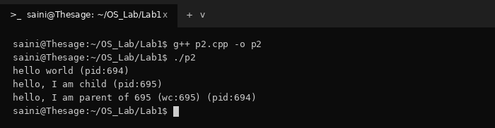
p3.cpp: fork() + exec()
The child replaces itself with the wc program using execvp(). The code after exec never runs.
Code (p3.cpp):
#include <iostream>
#include <unistd.h>
#include <cstdlib>
#include <cstring>
#include <sys/wait.h>
int main(int argc, char *argv[]) {
std::cout << "hello world (pid:" << getpid() << ")" << std::endl;
int rc = fork();
if (rc < 0) {
std::cerr << "fork failed" << std::endl;
exit(1);
} else if (rc == 0) {
std::cout << "hello, I am child (pid:" << getpid() << ")" << std::endl;
char *myargs[3];
myargs[0] = strdup("wc");
myargs[1] = strdup("p3.cpp");
myargs[2] = NULL;
execvp(myargs[0], myargs);
std::cout << "this shouldn't print out" << std::endl;
} else {
int wc = wait(NULL);
std::cout << "hello, I am parent of " << rc << " (wc:" << wc << ") (pid:" << getpid() << ")" << std::endl;
}
return 0;
}
Output:
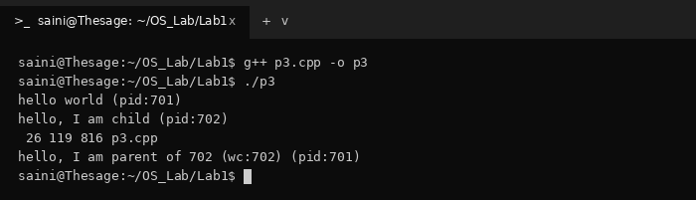
p4.cpp: output redirection
The child closes stdout and opens a file, so the output of wc goes into p4.output. This is how > works in the shell.
Code (p4.cpp):
#include <iostream>
#include <unistd.h>
#include <cstdlib>
#include <cstring>
#include <fcntl.h>
#include <sys/wait.h>
int main(int argc, char *argv[]) {
int rc = fork();
if (rc < 0) {
std::cerr << "fork failed" << std::endl;
exit(1);
} else if (rc == 0) {
close(STDOUT_FILENO);
open("./p4.output", O_CREAT|O_WRONLY|O_TRUNC, S_IRWXU);
char *myargs[3];
myargs[0] = strdup("wc");
myargs[1] = strdup("p4.cpp");
myargs[2] = NULL;
execvp(myargs[0], myargs);
} else {
int wc = wait(NULL);
}
return 0;
}
Output:
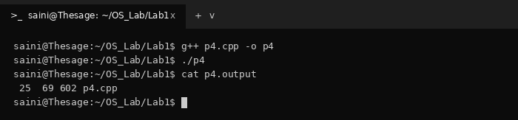
Section E: Booting Process
Steps:
1) POST: Computer checks that hardware (RAM, CPU, keyboard) is working.
2) BIOS/UEFI: Firmware on the motherboard finds the disk and loads the boot loader.
3) GRUB: Boot loader shows the OS menu and loads the Linux kernel into memory.
4) Kernel: Sets up memory, loads drivers and mounts the file system.
5) Systemd (PID 1): First process; starts all other services and shows the login screen.
Bootstrap program: first code that runs at power on. It is stored in ROM, finds the kernel and loads it into RAM.
Flow: Power ON -> POST -> BIOS -> GRUB -> Kernel -> Systemd -> Login

