Operating System Lab
Assignment 2
Rishi (2024UCP1566)
________________________________________________________________________________
Q1. Explain the /proc virtual file system and what information can be gathered from it. Write a script that collects performance data periodically.
Important points:
1) Virtual: /proc is created by the kernel in memory. Nothing is stored on disk, content changes by itself and it disappears after reboot.
2) System wide files: /proc/cpuinfo, /proc/meminfo, /proc/version, /proc/uptime, /proc/loadavg.
3) Process files: Numbered folders like /proc/1 or /proc/4215. The number is the PID and the files inside (status, maps) describe that process.
Code (q2_proc_monitor.sh):
#!/bin/bash
# Question 2: Collect performance monitoring data periodically from /proc
exec >> performance.log
while true
do
echo "======================================================================"
echo "Time: $(date)"
echo "CPU: $(grep "^cpu " /proc/stat)"
echo "Memory Available: $(grep "^MemAvailable" /proc/meminfo | awk '{print $2, $3}')"
echo "Load: $(awk '{print $1, $2, $3}' /proc/loadavg)"
echo "Uptime: $(awk '{print $1}' /proc/uptime) seconds"
echo "======================================================================"
sleep 5
done
Output:
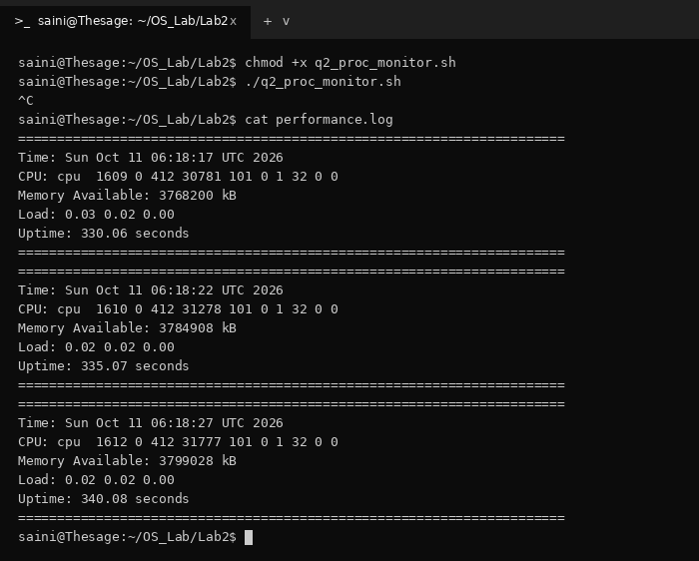
Q2. Write a program to create a child process using fork().
Important points:
1) fork(): Creates a new process. The caller is the parent and the new one is the child, and both continue after fork().
2) Return value: less than 0: fork failed, 0: in the child, greater than 0: in the parent (value is the child PID).
3) Copy-on-Write: Memory is not copied at once. Parent and child share pages until one of them changes data.
Code (q3_fork.cpp):
#include <iostream>
#include <unistd.h>
using namespace std;
int main() {
pid_t pid = fork();
if (pid < 0) {
cout << "Fork failed\n";
}
else if (pid == 0) {
cout << "Child PID: " << getpid() << endl;
cout << "Parent PID: " << getppid() << endl;
}
else {
cout << "Parent PID: " << getpid() << endl;
cout << "Child PID: " << pid << endl;
}
return 0;
}
Output:
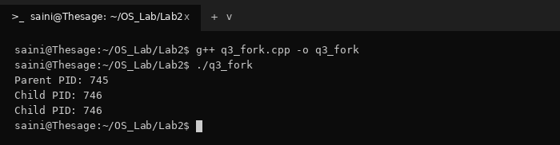
Q3. How to enable and disable ASLR (Address Space Layout Randomization)?
Important points:
1) ASLR: Randomizes the addresses of stack, heap and libraries so memory based attacks are harder.
2) State file: /proc/sys/kernel/randomize_va_space. 0: disabled, 1: partial, 2: full (default).
3) Commands: Disable: sudo sysctl kernel.randomize_va_space=0. Enable: sudo sysctl kernel.randomize_va_space=2.
Code (q4_aslr.cpp):
#include <iostream>
using namespace std;
int main() {
int x = 10;
cout << "Memory address of x: " << &x << endl;
return 0;
}
Output:
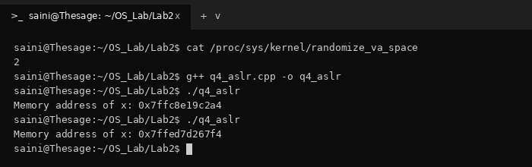
Q4. Check whether local, global and static variables are shared between parent and child after fork().
Important points:
1) Answer: None of them are shared. After fork() each process works on its own copy.
2) Same addresses: Parent and child print the same virtual addresses, but after a change they point to different physical pages (Copy-on-Write).
Code (q5_variable_sharing.cpp):
#include <iostream>
#include <unistd.h>
#include <sys/wait.h>
using namespace std;
int globalVar = 10;
int main() {
static int staticVar = 20;
int localVar = 30;
cout << "Before fork:\n";
cout << "Global: " << globalVar << " (addr: " << &globalVar << ")" << endl;
cout << "Static: " << staticVar << " (addr: " << &staticVar << ")" << endl;
cout << "Local: " << localVar << " (addr: " << &localVar << ")" << endl;
pid_t pid = fork();
if (pid < 0) {
cout << "Fork failed\n";
return 1;
}
if (pid == 0) {
// Child modifies all variables
globalVar = 100;
staticVar = 200;
localVar = 300;
cout << "\nChild:\n";
cout << "Global: " << globalVar << " (addr: " << &globalVar << ")" << endl;
cout << "Static: " << staticVar << " (addr: " << &staticVar << ")" << endl;
cout << "Local: " << localVar << " (addr: " << &localVar << ")" << endl;
}
else {
wait(NULL);
cout << "\nParent:\n";
cout << "Global: " << globalVar << " (addr: " << &globalVar << ")" << endl;
cout << "Static: " << staticVar << " (addr: " << &staticVar << ")" << endl;
cout << "Local: " << localVar << " (addr: " << &localVar << ")" << endl;
}
return 0;
}
Output:
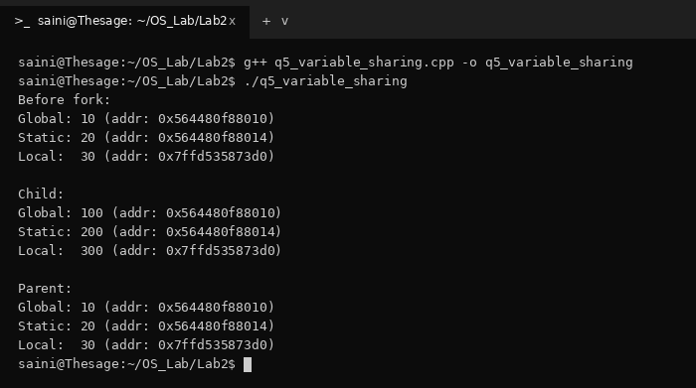
Q5. Write a program to implement the fork(), wait(), exit() and exec() system calls.
Important points:
1) fork(): Creates a child process.
2) wait(): Parent waits for the child to finish.
3) exit(): Ends the current process.
4) exec(): Replaces the current program with a new one (here /bin/ls).
Code (q6_syscalls.cpp):
#include <iostream>
#include <unistd.h>
#include <sys/wait.h>
#include <cstdlib>
using namespace std;
int main() {
cout << "Parent process started." << endl;
pid_t pid = fork();
if (pid < 0) {
cout << "Fork failed." << endl;
return 1;
}
if (pid == 0) {
// Child process
cout << "Child process started." << endl;
cout << "Child PID: " << getpid() << endl;
// Replace child program with ls
execl("/bin/ls", "ls", NULL);
// This executes only if exec fails
cout << "exec failed." << endl;
exit(1);
}
else {
// Parent process
cout << "Parent is waiting for child..." << endl;
wait(NULL);
cout << "Child has finished." << endl;
cout << "Parent is exiting." << endl;
}
return 0;
}
Output:
