Operating System Lab
Assignment 3
Rishi (2024UCP1566)
________________________________________________________________________________
(A) Write a program that takes a file name as input and shows details such as name, size and modification date of the file.
Important commands learned:
1) Reading input: $1 is the first argument given to the script.
2) File check: if [ -e "$FILE" ]; then ... else ... fi checks if the file exists (-f only for regular files).
3) Store output: output=$(command) saves the output of a command in a variable.
Code (file_info.sh):
#!/bin/sh
# Question A: Display file information
if [ $# -eq 0 ]; then
echo "Usage: ./file_info.sh <filename>"
exit 1
fi
FILE="$1"
if [ ! -e "$FILE" ]; then
echo "Error: File '$FILE' does not exist."
exit 1
fi
echo "File Information for: $FILE"
echo "-------------------------------"
echo "Size: $(stat -c '%s' "$FILE") bytes"
echo "Permissions: $(stat -c '%A' "$FILE")"
echo "Owner: $(stat -c '%U' "$FILE")"
echo "Last Modified: $(stat -c '%y' "$FILE")"
echo "File Type: $(stat -c '%F' "$FILE")"
echo "-------------------------------"
Output:
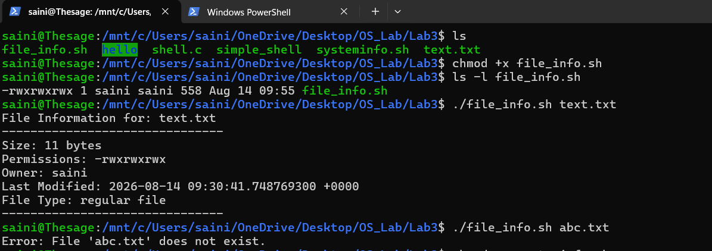
(B) Create a script that shows information about the system such as version, memory and disk utilization.
Important commands learned:
1) Disk usage: df -h shows disk space, df -h . | awk 'NR==2 {print $5}' gives only the used percent.
2) IP address: hostname -I
3) Default gateway: ip route | grep default
Code (systeminfo.sh):
#!/bin/bash
echo "===== SYSTEM INFORMATION ====="
echo
echo "OS Version:"
cat /etc/os-release | grep PRETTY_NAME
echo
echo "Kernel Version:"
uname -r
echo
echo "CPU Information:"
lscpu | grep "Model name"
echo
echo "Memory Information:"
free -h
echo
echo "Disk Usage:"
df -h
echo
echo "Network Information:"
ip addr
Output:
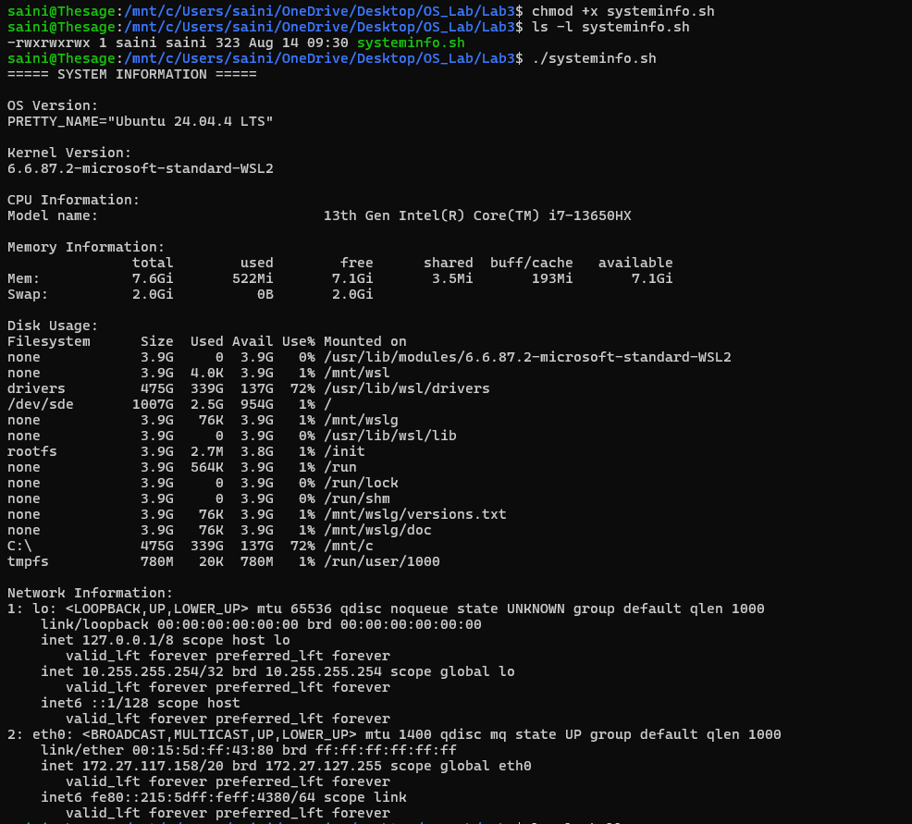
(C) Write code for a very simple shell.
Important concept learned:
1) Steps: Show prompt, read command, parse it with strtok(), fork(), run it with execvp() in the child, wait() in the parent, repeat. exit stops the shell.
Function | Arguments | Searches PATH? | Example
execl | List | No (full path) | execl("/bin/ls", "ls", "-l", NULL)
execlp | List | Yes | execlp("ls", "ls", "-l", NULL)
execvp | Array | Yes | execvp("ls", args_array)

Code (shell.c):
#include <stdio.h>
#include <stdlib.h>
#include <string.h>
#include <unistd.h>
#include <sys/wait.h>
#define MAX_INPUT 100
#define MAX_ARGS 20
int main()
{
char input[MAX_INPUT];
while (1)
{
// 1. Print shell prompt
printf("MyShell>>> ");
fflush(stdout);
// 2. Read command from user
if (!fgets(input, MAX_INPUT, stdin))
break;
// Remove newline character
input[strcspn(input, "\n")] = '\0';
// 8. Exit the shell
if (strcmp(input, "exit") == 0)
{
printf("Shell terminated.\n");
break;
}
// If user presses Enter without a command
if (strlen(input) == 0)
{
continue;
}
// 3. Parse command and arguments
char *args[MAX_ARGS];
int count = 0;
char *token = strtok(input, " ");
while (token != NULL)
{
args[count] = token;
count++;
token = strtok(NULL, " ");
}
// execvp() requires NULL at the end
args[count] = NULL;
// 4. Create child process
pid_t pid = fork();
if (pid < 0)
{
perror("fork failed");
continue;
}
// 5. Child process
if (pid == 0)
{
execvp(args[0], args);
// execvp() reaches here only if execution fails
perror("exec failed");
exit(1);
}
// 6. Parent process
else
{
wait(NULL);
}
// 7. Loop automatically goes back to the prompt
}
return 0;
}
Output:
