Operating System Lab
Assignment 4
Rishi (2024UCP1566)
________________________________________________________________________________
(A) Write a C/C++ program to implement CPU scheduling. Read the process data from proc.dat and simulate FCFS, SJF (preemptive), Priority (preemptive) and Round Robin.
Important concepts learned:
1) proc.dat: First line is the number of processes N. Then each line has PID, priority, arrival time and CPU/IO bursts one after another, ending with -1. The last line is the quantum.
2) CPU and IO bursts: Odd positions are CPU bursts and even positions are IO bursts. While one process does IO, another can use the CPU.
3) Status history: C = running on CPU, W = waiting, R = doing IO, . = not arrived.
4) Algorithms: FCFS: earliest arrival. SJF (preemptive): smallest remaining burst. Priority (preemptive): smallest priority number. Round Robin: fixed time quantum in circular order.
Input file (proc.dat):
4
1,2,0,5,2,4,3,-1
2,3,1,3,2,4,-1
3,1,2,4,3,-1
4,4,3,2,2,3,-1
2
Code (q1.cpp):
#include <iostream>
#include <fstream>
#include <vector>
#include <sstream>
#include <iomanip>
using namespace std;
struct Process
{
int id, priority, arrival;
vector<int> burst;
int index, remaining;
string history;
};
vector<Process> original;
int n, quantum = 1;
// ============================================================
// READ proc.dat AND PRINT INPUT CLEARLY
// ============================================================
void readFile()
{
ifstream file("proc.dat");
if (!file) { cout << "Error: proc.dat not found!\n"; return; }
file >> n;
file.ignore();
original.resize(n);
cout << "--------------------------------------------\n";
cout << " INPUT (read from proc.dat)\n";
cout << "--------------------------------------------\n";
cout << left
<< setw(6) << "PID"
<< setw(10) << "Priority"
<< setw(10) << "Arrival"
<< "Bursts (CPU then IO alternating)\n";
cout << "--------------------------------------------\n";
for (int i = 0; i < n; i++)
{
string line;
getline(file, line);
stringstream ss(line);
string x;
vector<int> v;
while (getline(ss, x, ','))
{
int val = stoi(x);
if (val == -1) break;
v.push_back(val);
}
original[i].id = v[0];
original[i].priority = v[1];
original[i].arrival = v[2];
for (int j = 3; j < (int)v.size(); j++)
original[i].burst.push_back(v[j]);
original[i].index = 0;
original[i].remaining = original[i].burst[0];
original[i].history = "";
cout << left
<< setw(6) << ("P" + to_string(v[0]))
<< setw(10) << v[1]
<< setw(10) << v[2];
bool isCPU = true;
for (int j = 3; j < (int)v.size(); j++)
{
cout << (isCPU ? "CPU=" : " IO=") << v[j] << " ";
isCPU = !isCPU;
}
cout << "\n";
}
if (!(file >> quantum)) quantum = 1;
cout << "\nQuantum = " << quantum << "\n";
cout << "--------------------------------------------\n";
}
// ============================================================
// HELPERS
// ============================================================
bool finished(Process &p) { return p.index >= (int)p.burst.size(); }
bool ready(Process &p, int t)
{
return !finished(p) && t >= p.arrival && p.index % 2 == 0;
}
void runIO(vector<Process> &p)
{
for (int i = 0; i < n; i++)
if (!finished(p[i]) && p[i].index % 2 == 1)
{
p[i].remaining--;
if (p[i].remaining == 0)
{
p[i].index++;
if (!finished(p[i]))
p[i].remaining = p[i].burst[p[i].index];
}
}
}
// Add one char to each process history for this time unit
void addHistory(vector<Process> &p, int cur, int t)
{
for (int i = 0; i < n; i++)
{
if (i == cur) p[i].history += 'C';
else if (!finished(p[i]) && p[i].index % 2 == 1) p[i].history += 'R';
else if (ready(p[i], t)) p[i].history += 'W';
else if (p[i].arrival <= t && !finished(p[i])) p[i].history += 'B';
else if (finished(p[i])) p[i].history += ' ';
else p[i].history += '.';
}
}
// ============================================================
// PRINT RESULT — clean table with time ruler
// ============================================================
void printResult(string name, vector<Process> &p)
{
// Trim to actual end time
int len = 0;
for (int i = 0; i < n; i++)
{
int end = (int)p[i].history.size();
while (end > 0 && (p[i].history[end-1]==' ' || p[i].history[end-1]=='.'))
end--;
if (end > len) len = end;
}
cout << "\n============================================\n";
cout << " " << name << "\n";
cout << "============================================\n";
cout << "C=CPU W=Waiting R=IO B=Blocked .=Not arrived\n\n";
// Time index ruler
cout << left << setw(16) << "Process";
for (int t = 0; t < len; t++) cout << (t % 10);
cout << "\n" << string(16 + len, '-') << "\n";
// One row per process
for (int i = 0; i < n; i++)
{
string label = "P" + to_string(p[i].id)
+ "(arr=" + to_string(p[i].arrival)
+ " pri=" + to_string(p[i].priority) + ")";
cout << left << setw(16) << label;
cout << p[i].history.substr(0, len) << "\n";
}
// Summary table
cout << "\n" << left
<< setw(8) << "Process"
<< setw(12) << "CPU units"
<< setw(10) << "IO units"
<< setw(12) << "Wait units" << "\n";
cout << string(42, '-') << "\n";
for (int i = 0; i < n; i++)
{
int cpu=0, io=0, wait=0;
for (char c : p[i].history)
{
if (c == 'C') cpu++;
else if (c == 'R') io++;
else if (c == 'W') wait++;
}
cout << left
<< setw(8) << ("P" + to_string(p[i].id))
<< setw(12) << cpu
<< setw(10) << io
<< setw(12) << wait << "\n";
}
}
// ============================================================
// FCFS
// ============================================================
void FCFS()
{
vector<Process> p = original;
int time=0, completed=0, current=-1;
int limit = 500; // safety cap
while (completed < n && time < limit)
{
if (current == -1)
{
int best = -1;
for (int i = 0; i < n; i++)
if (ready(p[i], time) && (best==-1 || p[i].arrival < p[best].arrival))
best = i;
current = best;
}
addHistory(p, current, time);
if (current != -1)
{
p[current].remaining--;
if (p[current].remaining == 0)
{
p[current].index++;
if (finished(p[current])) completed++;
else p[current].remaining = p[current].burst[p[current].index];
current = -1;
}
}
runIO(p);
time++;
}
printResult("FCFS", p);
}
// ============================================================
// SJF PREEMPTIVE
// ============================================================
void SJF()
{
vector<Process> p = original;
int time=0, completed=0;
int limit = 500;
while (completed < n && time < limit)
{
int cur = -1;
for (int i = 0; i < n; i++)
if (ready(p[i], time) && (cur==-1 || p[i].remaining < p[cur].remaining))
cur = i;
addHistory(p, cur, time);
if (cur != -1)
{
p[cur].remaining--;
if (p[cur].remaining == 0)
{
p[cur].index++;
if (finished(p[cur])) completed++;
else p[cur].remaining = p[cur].burst[p[cur].index];
}
}
runIO(p);
time++;
}
printResult("SJF (Preemptive)", p);
}
// ============================================================
// PRIORITY PREEMPTIVE
// ============================================================
void Priority()
{
vector<Process> p = original;
int time=0, completed=0;
int limit = 500;
while (completed < n && time < limit)
{
int cur = -1;
for (int i = 0; i < n; i++)
if (ready(p[i], time) && (cur==-1 || p[i].priority < p[cur].priority))
cur = i;
addHistory(p, cur, time);
if (cur != -1)
{
p[cur].remaining--;
if (p[cur].remaining == 0)
{
p[cur].index++;
if (finished(p[cur])) completed++;
else p[cur].remaining = p[cur].burst[p[cur].index];
}
}
runIO(p);
time++;
}
printResult("Priority (Preemptive)", p);
}
// ============================================================
// ROUND ROBIN
// ============================================================
void RoundRobin()
{
vector<Process> p = original;
int time=0, completed=0, current=-1, used=0;
int limit = 500;
while (completed < n && time < limit)
{
if (current == -1)
{
int best = -1;
for (int i = 0; i < n; i++)
if (ready(p[i], time) && (best==-1 || p[i].arrival < p[best].arrival))
best = i;
current = best;
used = 0;
}
addHistory(p, current, time);
if (current != -1)
{
p[current].remaining--;
used++;
if (p[current].remaining == 0)
{
p[current].index++;
if (finished(p[current])) completed++;
else p[current].remaining = p[current].burst[p[current].index];
current = -1; used = 0;
}
else if (used == quantum)
{
current = -1; used = 0;
}
}
runIO(p);
time++;
}
printResult("Round Robin (Quantum=" + to_string(quantum) + ")", p);
}
// ============================================================
// MAIN
// ============================================================
int main()
{
cout << "============================================\n";
cout << " CPU SCHEDULING SIMULATOR\n";
cout << "============================================\n\n";
readFile();
FCFS();
SJF();
Priority();
RoundRobin();
return 0;
}
Output:
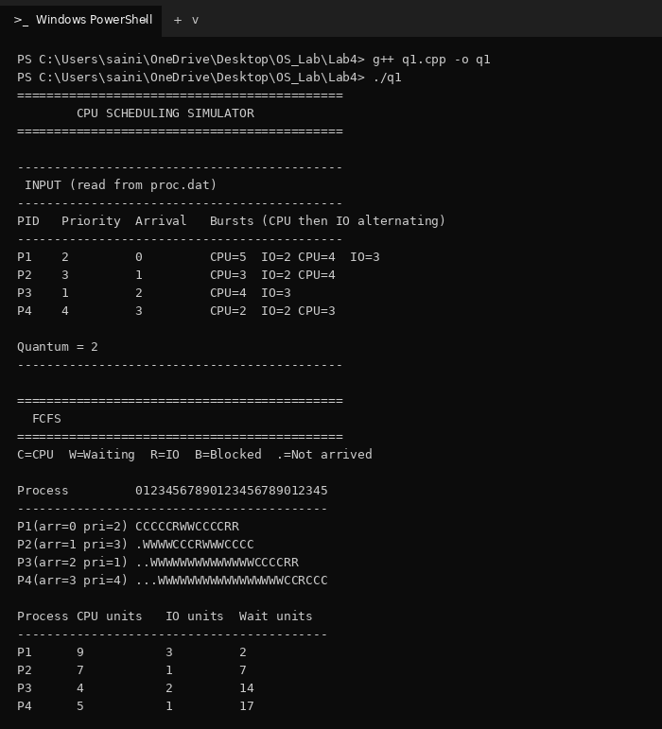
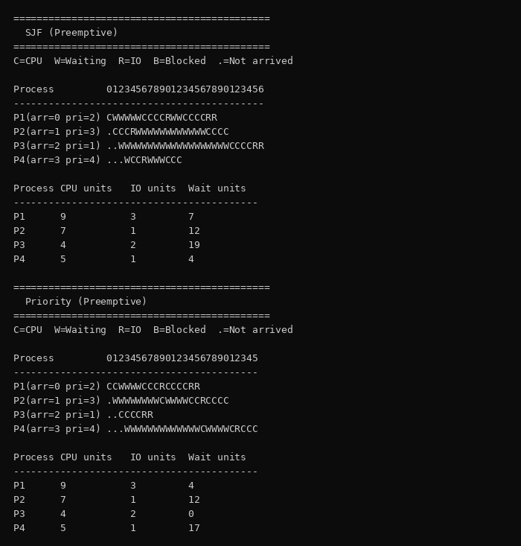
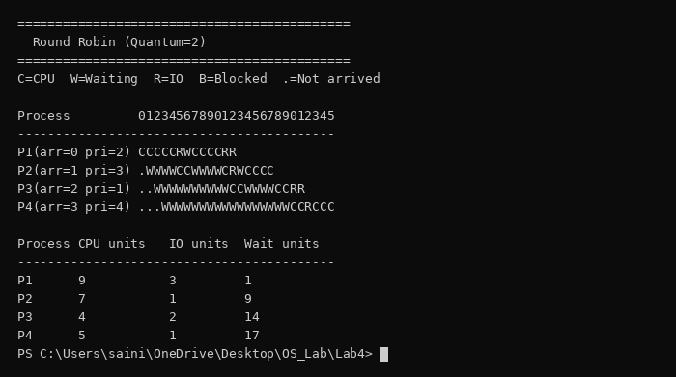
(B) Write a program in C/C++ to simulate FCFS and SJF (non-preemptive and preemptive).
Important concepts learned:
1) FCFS: Processes run in the order of arrival. A long job in front delays the others (convoy effect).
2) SJF non-preemptive: Picks the shortest burst among arrived processes and runs it till the end.
3) SJF preemptive (SRTF): A newly arrived shorter job can interrupt the running one.
4) Formula: Waiting time = Completion time - Arrival time - Burst time. Average waiting time = sum of waiting times / N.
Code (q2.cpp):
#include <iostream>
#include <vector>
#include <iomanip>
using namespace std;
struct Process
{
int id;
int arrival;
int burst;
int remaining;
int waiting;
int completion;
bool done;
};
int main()
{
int n;
cout << "========================================\n";
cout << " CPU SCHEDULING - PART B\n";
cout << "========================================\n";
cout << "\nEnter number of processes: ";
cin >> n;
vector<Process> p(n);
cout << "\nEnter process details\n";
cout << "-------------------------\n";
for (int i = 0; i < n; i++)
{
p[i].id = i + 1;
cout << "\nProcess P" << i + 1 << "\n";
cout << "Arrival Time: ";
cin >> p[i].arrival;
cout << "CPU Burst: ";
cin >> p[i].burst;
p[i].remaining = p[i].burst;
p[i].waiting = 0;
p[i].completion = 0;
p[i].done = false;
}
int choice;
cout << "\n========================================\n";
cout << "Select Scheduling Algorithm\n";
cout << "========================================\n";
cout << "1. FCFS\n";
cout << "2. SJF Non-Preemptive\n";
cout << "3. SJF Preemptive\n";
cout << "Enter choice: ";
cin >> choice;
vector<int> sequence;
/* ---------------- FCFS ---------------- */
if (choice == 1)
{
int time = 0;
int completed = 0;
while (completed < n)
{
int index = -1;
// Find earliest arrived process
for (int i = 0; i < n; i++)
{
if (!p[i].done && p[i].arrival <= time)
{
if (index == -1 ||
p[i].arrival < p[index].arrival)
{
index = i;
}
}
}
// CPU is idle
if (index == -1)
{
time++;
continue;
}
p[index].waiting = time - p[index].arrival;
time += p[index].burst;
p[index].completion = time;
p[index].done = true;
sequence.push_back(p[index].id);
completed++;
}
}
/* ------------ SJF NON-PREEMPTIVE ------------ */
else if (choice == 2)
{
int time = 0;
int completed = 0;
while (completed < n)
{
int index = -1;
// Find shortest burst among arrived processes
for (int i = 0; i < n; i++)
{
if (!p[i].done && p[i].arrival <= time)
{
if (index == -1 ||
p[i].burst < p[index].burst)
{
index = i;
}
}
}
if (index == -1)
{
time++;
continue;
}
p[index].waiting = time - p[index].arrival;
time += p[index].burst;
p[index].completion = time;
p[index].done = true;
sequence.push_back(p[index].id);
completed++;
}
}
/* ------------ SJF PREEMPTIVE ------------ */
else if (choice == 3)
{
int time = 0;
int completed = 0;
int last = -1;
while (completed < n)
{
int index = -1;
// Find process with smallest remaining time
for (int i = 0; i < n; i++)
{
if (!p[i].done && p[i].arrival <= time)
{
if (index == -1 ||
p[i].remaining < p[index].remaining)
{
index = i;
}
}
}
if (index == -1)
{
time++;
continue;
}
// Add process to sequence only when CPU changes
if (last != index)
{
sequence.push_back(p[index].id);
last = index;
}
p[index].remaining--;
time++;
// Process finished
if (p[index].remaining == 0)
{
p[index].done = true;
p[index].completion = time;
// Waiting Time =
// Completion - Arrival - Burst
p[index].waiting =
p[index].completion - p[index].arrival - p[index].burst;
completed++;
}
}
}
else
{
cout << "\nInvalid choice!\n";
return 0;
}
/* ---------------- OUTPUT ---------------- */
double average = 0;
cout << "\n\n========================================\n";
cout << " RESULT\n";
cout << "========================================\n";
cout << left
<< setw(8) << "PID"
<< setw(12) << "Arrival"
<< setw(12) << "Burst"
<< setw(12) << "Waiting"
<< setw(12) << "Completion"
<< "\n";
cout << "----------------------------------------\n";
for (int i = 0; i < n; i++)
{
cout << left
<< setw(8) << ("P" + to_string(p[i].id))
<< setw(12) << p[i].arrival
<< setw(12) << p[i].burst
<< setw(12) << p[i].waiting
<< setw(12) << p[i].completion
<< "\n";
average += p[i].waiting;
}
average /= n;
cout << "\nAverage Waiting Time = "
<< fixed << setprecision(2)
<< average << "\n";
cout << "\nExecution Sequence:\n";
for (int i = 0; i < sequence.size(); i++)
{
cout << "P" << sequence[i];
if (i != sequence.size() - 1)
cout << " -> ";
}
cout << "\n";
return 0;
}
Output 1 (FCFS, choice 1):
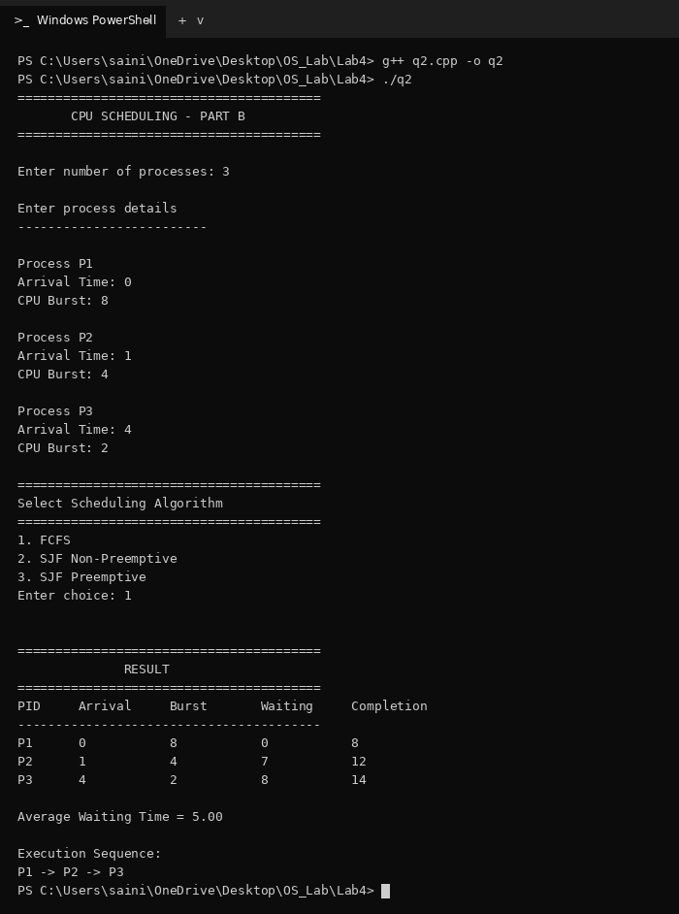
Output 2 (SJF non-preemptive, choice 2):
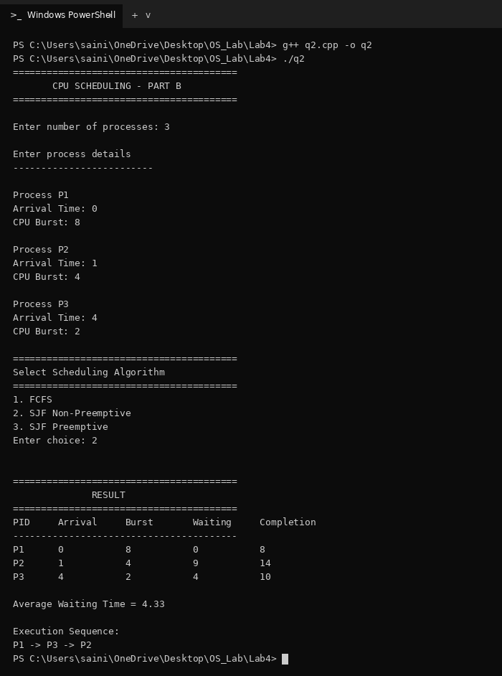
Output 3 (SJF preemptive, choice 3):
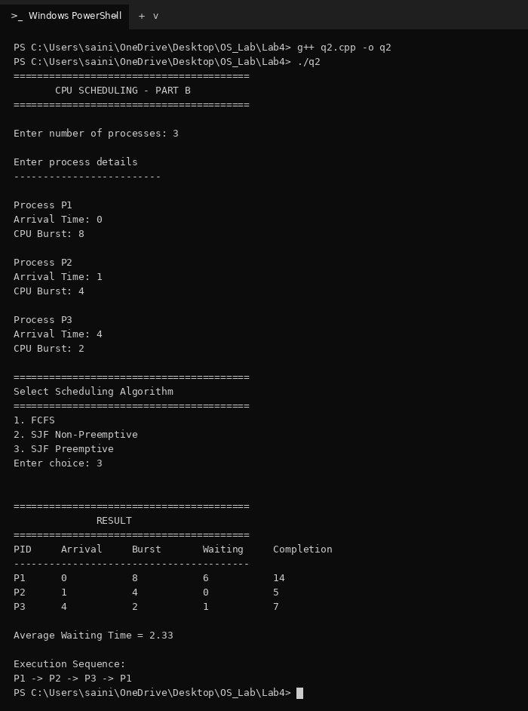
(C) Write a program in C/C++ to simulate Priority scheduling (non-preemptive and preemptive) and Round Robin.
Important concepts learned:
1) Priority: Smaller number means higher priority. Non-preemptive: the running process finishes first. Preemptive: a higher priority process takes the CPU as soon as it arrives.
2) Round Robin: Ready queue is FIFO. Each process runs for at most one quantum and then goes to the end of the queue if it is not finished.
Code (q3.cpp):
#include <iostream>
#include <vector>
#include <iomanip>
using namespace std;
struct Process
{
int id;
int arrival;
int burst;
int remaining;
int priority;
int waiting;
int completion;
bool done;
};
int main()
{
int n;
cout << "========================================\n";
cout << " CPU SCHEDULING - PART C\n";
cout << "========================================\n";
cout << "\nEnter number of processes: ";
cin >> n;
vector<Process> p(n);
cout << "\nEnter process details\n";
cout << "-------------------------\n";
for (int i = 0; i < n; i++)
{
p[i].id = i + 1;
cout << "\nProcess P" << i + 1 << "\n";
cout << "Arrival Time: ";
cin >> p[i].arrival;
cout << "CPU Burst: ";
cin >> p[i].burst;
p[i].remaining = p[i].burst;
p[i].waiting = 0;
p[i].completion = 0;
p[i].done = false;
}
int choice;
cout << "\n========================================\n";
cout << "Select Algorithm\n";
cout << "========================================\n";
cout << "1. Priority Non-Preemptive\n";
cout << "2. Priority Preemptive\n";
cout << "3. Round Robin\n";
cout << "Enter choice: ";
cin >> choice;
// Priority is needed only for priority scheduling
if (choice == 1 || choice == 2)
{
cout << "\nEnter priority for each process\n";
cout << "(Smaller number = Higher priority)\n";
for (int i = 0; i < n; i++)
{
cout << "Priority of P" << i + 1 << ": ";
cin >> p[i].priority;
}
}
int quantum = 1;
if (choice == 3)
{
cout << "\nEnter Quantum: ";
cin >> quantum;
}
vector<int> sequence;
/* =====================================
PRIORITY NON-PREEMPTIVE
===================================== */
if (choice == 1)
{
int time = 0;
int completed = 0;
while (completed < n)
{
int index = -1;
for (int i = 0; i < n; i++)
{
if (!p[i].done && p[i].arrival <= time)
{
if (index == -1 ||
p[i].priority < p[index].priority)
{
index = i;
}
}
}
if (index == -1)
{
time++;
continue;
}
p[index].waiting =
time - p[index].arrival;
time += p[index].burst;
p[index].completion = time;
p[index].done = true;
sequence.push_back(p[index].id);
completed++;
}
}
/* =====================================
PRIORITY PREEMPTIVE
===================================== */
else if (choice == 2)
{
int time = 0;
int completed = 0;
int last = -1;
while (completed < n)
{
int index = -1;
for (int i = 0; i < n; i++)
{
if (!p[i].done && p[i].arrival <= time)
{
if (index == -1 ||
p[i].priority < p[index].priority)
{
index = i;
}
}
}
if (index == -1)
{
time++;
continue;
}
// Add only when CPU changes process
if (last != index)
{
sequence.push_back(p[index].id);
last = index;
}
p[index].remaining--;
time++;
if (p[index].remaining == 0)
{
p[index].done = true;
p[index].completion = time;
p[index].waiting =
p[index].completion - p[index].arrival - p[index].burst;
completed++;
}
}
}
/* =====================================
ROUND ROBIN
===================================== */
else if (choice == 3)
{
vector<int> queue;
int front = 0;
int time = 0;
int completed = 0;
// Add processes that arrive at time 0
for (int i = 0; i < n; i++)
{
if (p[i].arrival == 0)
queue.push_back(i);
}
while (completed < n)
{
// If queue is empty, move time forward
if (front >= queue.size())
{
bool found = false;
for (int i = 0; i < n; i++)
{
if (!p[i].done &&
p[i].arrival > time)
{
time = p[i].arrival;
queue.push_back(i);
found = true;
break;
}
}
if (!found)
break;
continue;
}
int index = queue[front];
front++;
// If process has not arrived yet
if (p[index].arrival > time)
{
time = p[index].arrival;
}
sequence.push_back(p[index].id);
int run = quantum;
if (p[index].remaining < quantum)
run = p[index].remaining;
// Run process
for (int j = 0; j < run; j++)
{
p[index].remaining--;
time++;
// Add newly arrived processes
for (int k = 0; k < n; k++)
{
if (!p[k].done &&
p[k].arrival == time &&
k != index)
{
queue.push_back(k);
}
}
if (p[index].remaining == 0)
break;
}
// Process finished
if (p[index].remaining == 0)
{
p[index].done = true;
p[index].completion = time;
p[index].waiting =
p[index].completion - p[index].arrival - p[index].burst;
completed++;
}
else
{
// Put process at end of queue
queue.push_back(index);
}
}
}
else
{
cout << "\nInvalid choice!\n";
return 0;
}
/* =====================================
OUTPUT
===================================== */
double average = 0;
cout << "\n\n========================================\n";
cout << " RESULT\n";
cout << "========================================\n";
cout << left
<< setw(8) << "PID"
<< setw(12) << "Arrival"
<< setw(12) << "Burst";
if (choice == 1 || choice == 2)
cout << setw(12) << "Priority";
cout << setw(12) << "Waiting"
<< setw(12) << "Completion"
<< "\n";
cout << "----------------------------------------\n";
for (int i = 0; i < n; i++)
{
cout << left
<< setw(8) << ("P" + to_string(p[i].id))
<< setw(12) << p[i].arrival
<< setw(12) << p[i].burst;
if (choice == 1 || choice == 2)
cout << setw(12) << p[i].priority;
cout << setw(12) << p[i].waiting
<< setw(12) << p[i].completion
<< "\n";
average += p[i].waiting;
}
average /= n;
cout << "\nAverage Waiting Time = "
<< fixed << setprecision(2)
<< average << "\n";
if (choice == 3)
cout << "Quantum = " << quantum << "\n";
cout << "\nExecution Sequence:\n";
for (int i = 0; i < sequence.size(); i++)
{
cout << "P" << sequence[i];
if (i != sequence.size() - 1)
cout << " -> ";
}
cout << "\n";
return 0;
}
Output 1 (Priority non-preemptive, choice 1):
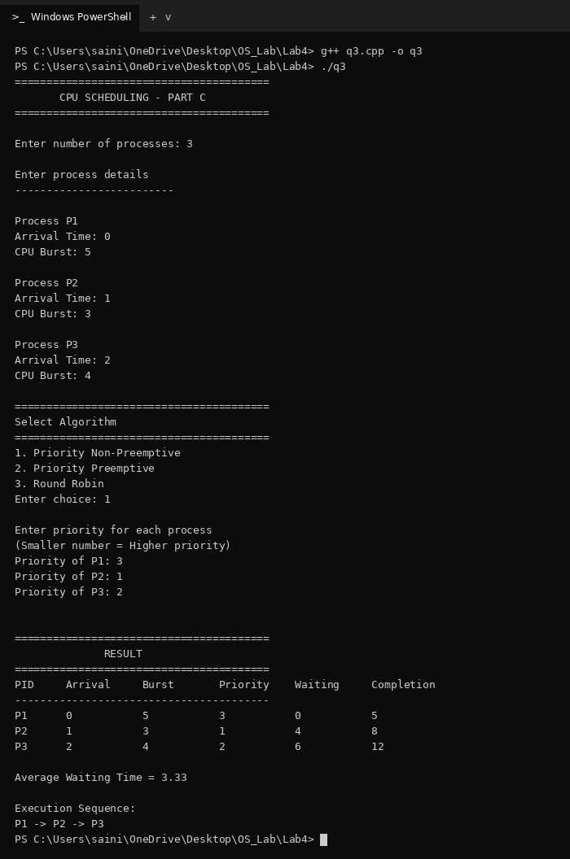
Output 2 (Priority preemptive, choice 2):
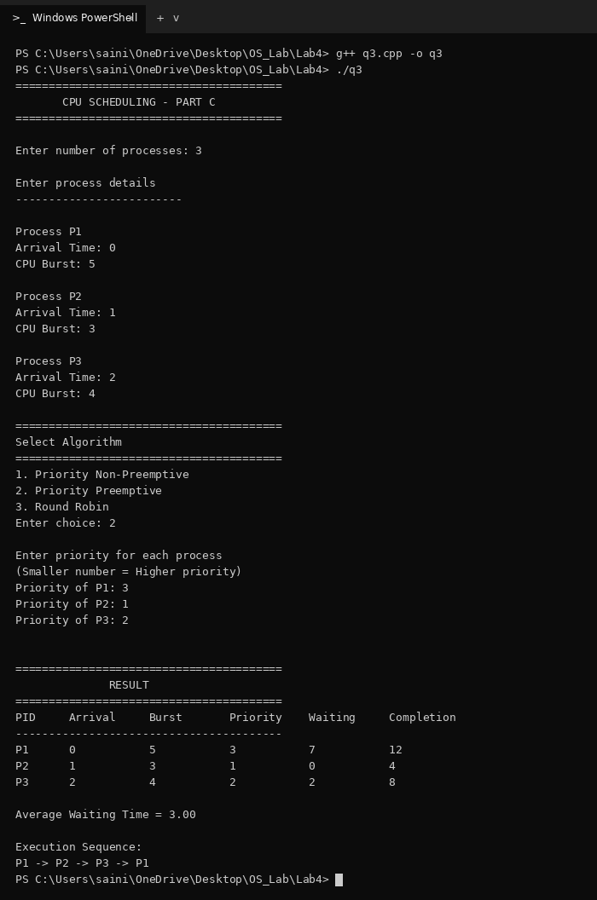
Output 3 (Round Robin, choice 3, quantum = 2):
