Operating System Lab
Assignment 6
Rishi (2024UCP1566)
________________________________________________________________________________
Q1. Simulate the Producer-Consumer problem using shared memory with Dekker's, Lamport's Bakery and Peterson's algorithms.
Important points:
1) Shared memory (mmap): producer and consumer processes share the buffer and flags using MAP_SHARED.
2) Critical section: buffer, in, out and count are used by one process at a time.
3) Dekker's: uses flags and turn, with back-off to avoid deadlock.
4) Lamport's Bakery: each process takes a ticket number, smallest number enters first.
5) Peterson's: uses flag[2] and turn; gives mutual exclusion, progress and bounded waiting.
Code (q1.c):
#include <stdio.h>
#include <stdlib.h>
#include <unistd.h>
#include <sys/mman.h>
#include <sys/wait.h>
#define BUFFER_SIZE 5
#define TOTAL_ITEMS 6
typedef struct {
int buffer[BUFFER_SIZE];
int in, out, count;
// Dekker's variables
int dekker_flag[2];
int dekker_turn;
// Lamport's Bakery variables
int choosing[2];
int number[2];
// Peterson's variables
int peterson_flag[2];
int peterson_turn;
} SharedData;
// ============================================================
// 1. DEKKER'S ALGORITHM
// ============================================================
void dekker_entry(SharedData *s, int i) {
int j = 1 - i;
s->dekker_flag[i] = 1;
while (s->dekker_flag[j]) {
if (s->dekker_turn != i) {
s->dekker_flag[i] = 0; // Back off
while (s->dekker_turn != i) { // Wait for turn
usleep(100);
}
s->dekker_flag[i] = 1; // Re-try
}
}
}
void dekker_exit(SharedData *s, int i) {
int j = 1 - i;
s->dekker_turn = j; // Pass turn to other
s->dekker_flag[i] = 0;
}
// ============================================================
// 2. LAMPORT'S BAKERY ALGORITHM
// ============================================================
void lamport_entry(SharedData *s, int i) {
int j = 1 - i;
s->choosing[i] = 1;
int max_num = (s->number[0] > s->number[1]) ? s->number[0] : s->number[1];
s->number[i] = max_num + 1;
s->choosing[i] = 0;
while (s->choosing[j]) usleep(100);
while (s->number[j] != 0 && (s->number[j] < s->number[i] ||
(s->number[j] == s->number[i] && j < i))) {
usleep(100);
}
}
void lamport_exit(SharedData *s, int i) {
s->number[i] = 0;
}
// ============================================================
// 3. PETERSON'S ALGORITHM
// ============================================================
void peterson_entry(SharedData *s, int i) {
int j = 1 - i;
s->peterson_flag[i] = 1;
s->peterson_turn = j;
while (s->peterson_flag[j] && s->peterson_turn == j) {
usleep(100);
}
}
void peterson_exit(SharedData *s, int i) {
s->peterson_flag[i] = 0;
}
// ============================================================
// SIMULATION FUNCTION
// ============================================================
void run_simulation(int choice) {
SharedData *s = mmap(NULL, sizeof(SharedData),
PROT_READ | PROT_WRITE,
MAP_SHARED | MAP_ANONYMOUS, -1, 0);
s->in = 0; s->out = 0; s->count = 0;
s->dekker_flag[0] = 0; s->dekker_flag[1] = 0; s->dekker_turn = 0;
s->choosing[0] = 0; s->choosing[1] = 0; s->number[0] = 0; s->number[1] = 0;
s->peterson_flag[0] = 0; s->peterson_flag[1] = 0; s->peterson_turn = 0;
const char *algo_name = (choice == 1) ? "Dekker's Algorithm" :
(choice == 2) ? "Lamport's Bakery Algorithm" :
"Peterson's Algorithm";
printf("\n====================================================\n");
printf(" SIMULATING PRODUCER-CONSUMER USING: %s\n", algo_name);
printf(" Buffer Size = %d | Total Items = %d\n", BUFFER_SIZE, TOTAL_ITEMS);
printf("====================================================\n");
fflush(stdout);
pid_t pid = fork();
if (pid == 0) {
// Consumer Process (ID = 1)
for (int i = 1; i <= TOTAL_ITEMS; i++) {
while (s->count == 0) usleep(500); // Wait if empty
if (choice == 1) dekker_entry(s, 1);
else if (choice == 2) lamport_entry(s, 1);
else if (choice == 3) peterson_entry(s, 1);
int item = s->buffer[s->out];
printf(" [Consumer] Consumed: %d from buffer[%d] | Buffer Items: %d\n",
item, s->out, s->count - 1);
s->out = (s->out + 1) % BUFFER_SIZE;
s->count--;
fflush(stdout);
if (choice == 1) dekker_exit(s, 1);
else if (choice == 2) lamport_exit(s, 1);
else if (choice == 3) peterson_exit(s, 1);
usleep(25000);
}
exit(0);
} else {
// Producer Process (ID = 0)
for (int i = 1; i <= TOTAL_ITEMS; i++) {
while (s->count == BUFFER_SIZE) usleep(500); // Wait if full
if (choice == 1) dekker_entry(s, 0);
else if (choice == 2) lamport_entry(s, 0);
else if (choice == 3) peterson_entry(s, 0);
s->buffer[s->in] = i * 10;
printf("[Producer] Produced: %d at buffer[%d] | Buffer Items: %d\n",
i * 10, s->in, s->count + 1);
s->in = (s->in + 1) % BUFFER_SIZE;
s->count++;
fflush(stdout);
if (choice == 1) dekker_exit(s, 0);
else if (choice == 2) lamport_exit(s, 0);
else if (choice == 3) peterson_exit(s, 0);
usleep(15000);
}
wait(NULL);
printf("----------------------------------------------------\n");
printf("Simulation finished successfully for %s!\n\n", algo_name);
fflush(stdout);
munmap(s, sizeof(SharedData));
}
}
int main() {
printf("====================================================\n");
printf(" ASSIGNMENT 6 - QUESTION 1: SHARED MEMORY IPC\n");
printf("====================================================\n");
printf("Select Synchronization Algorithm:\n");
printf("1. Dekker's Algorithm\n");
printf("2. Lamport's Bakery Algorithm\n");
printf("3. Peterson's Algorithm\n");
printf("4. Run All Three Algorithms\n");
printf("Enter choice: ");
fflush(stdout);
int choice;
if (scanf("%d", &choice) != 1) choice = 4;
if (choice >= 1 && choice <= 3) {
run_simulation(choice);
} else {
run_simulation(1);
run_simulation(2);
run_simulation(3);
}
return 0;
}
Output (Simulation of Dekker, Lamport, and Peterson):
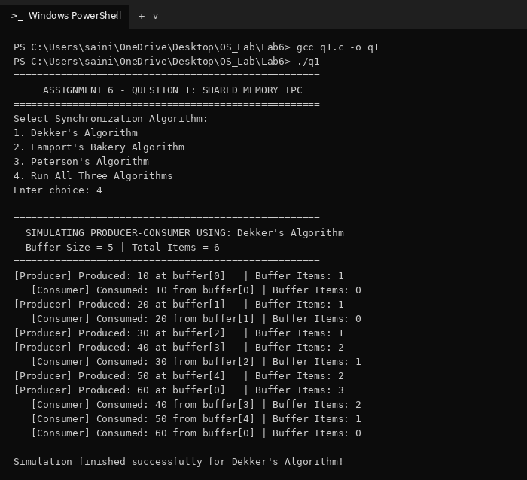
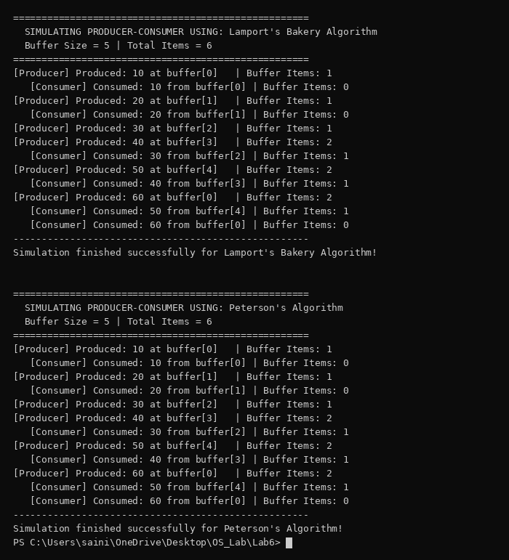
Q2. Implement the Producer-Consumer problem with a finite buffer using Peterson's algorithm for: (1) Single Producer - Single Consumer (2) Single Producer - Multiple Consumers (3) Multiple Producers - Single Consumer (4) Multiple Producers - Multiple Consumers.
Important points:
1) Peterson's algorithm: uses flag and turn for 2 threads; for more threads each thread passes n-1 levels (level[] works as flag, victim[] as turn).
2) Finite buffer: circular buffer; producer waits when it is full and consumer waits when it is empty.
3) Four versions: same code, only the number of producer and consumer threads changes.
4) __sync_synchronize(): stops the CPU from reordering the flag and turn writes.
Code (q2.c):
#include <stdio.h>
#include <pthread.h>
#include <unistd.h>
#define SIZE 3
#define ITEMS 2
int buffer[SIZE];
int in = 0, out = 0, count = 0;
int consumed = 0, total = 0;
volatile int level[10];
volatile int victim[10];
int n, np;
int someone_ahead(int id, int L) {
for (int k = 0; k < n; k++)
if (k != id && level[k] >= L) return 1;
return 0;
}
// peterson's algorithm for n threads (for n = 2 it is the normal one)
void enter(int id) {
for (int L = 1; L < n; L++) {
level[id] = L;
victim[L] = id;
__sync_synchronize();
while (victim[L] == id && someone_ahead(id, L))
usleep(50);
}
}
void leave(int id) {
level[id] = 0;
}
void *producer(void *arg) {
int id = *(int *)arg;
for (int i = 1; i <= ITEMS; i++) {
int done = 0;
while (!done) {
enter(id);
if (count < SIZE) {
buffer[in] = (id + 1) * 100 + i;
printf("Producer %d produced %d\n", id + 1, buffer[in]);
in = (in + 1) % SIZE;
count++;
done = 1;
}
leave(id);
usleep(1000);
}
}
return NULL;
}
void *consumer(void *arg) {
int id = *(int *)arg;
while (1) {
enter(id);
if (consumed == total) {
leave(id);
break;
}
if (count > 0) {
printf(" Consumer %d consumed %d\n", id - np + 1, buffer[out]);
out = (out + 1) % SIZE;
count--;
consumed++;
}
leave(id);
usleep(6000);
}
return NULL;
}
void run(int p, int c) {
pthread_t t[10];
int id[10];
n = p + c;
np = p;
total = p * ITEMS;
in = out = count = consumed = 0;
for (int i = 0; i < 10; i++) level[i] = victim[i] = 0;
for (int i = 0; i < n; i++) {
id[i] = i;
if (i < p) pthread_create(&t[i], NULL, producer, &id[i]);
else pthread_create(&t[i], NULL, consumer, &id[i]);
}
for (int i = 0; i < n; i++)
pthread_join(t[i], NULL);
}
int main() {
printf("1) Single Producer - Single Consumer\n");
run(1, 1);
printf("\n2) Single Producer - Multiple Consumers\n");
run(1, 3);
printf("\n3) Multiple Producers - Single Consumer\n");
run(3, 1);
printf("\n4) Multiple Producers - Multiple Consumers\n");
run(3, 3);
return 0;
}
Output:
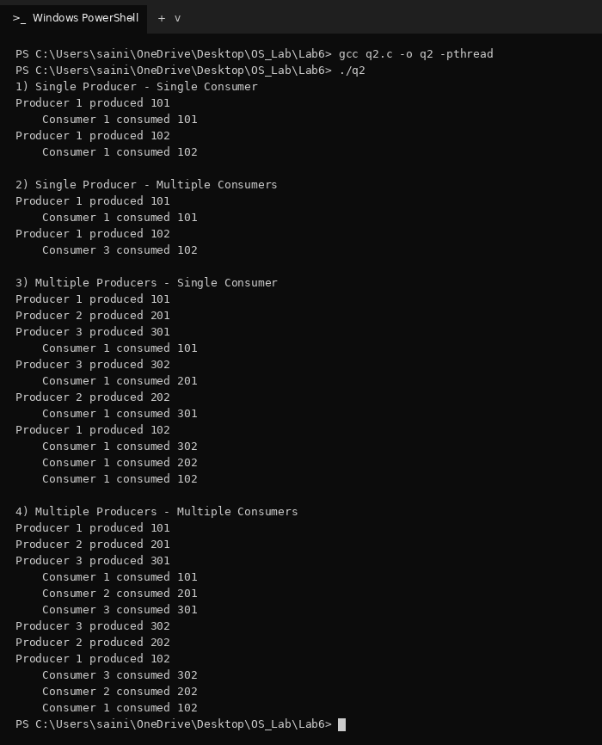
Q3. Simulate a simple bank with multiple accounts where clients do deposits (thread 1) and withdrawals (thread 2) at the same time. Keep balances consistent using mutex locks.
Important points:
1) Race condition: a deposit and a withdrawal on the same account at the same time can give a wrong balance.
2) Mutex lock: one lock per account; lock before changing the balance and unlock after.
3) Check: final balance = 1000 + deposited - withdrawn for every account.
Code (q3.c):
#include <stdio.h>
#include <pthread.h>
#include <unistd.h>
#define ACCOUNTS 3
int balance[ACCOUNTS] = {1000, 1000, 1000};
int deposited[ACCOUNTS], withdrawn[ACCOUNTS];
pthread_mutex_t lock[ACCOUNTS];
void *deposit(void *arg) {
int id = *(int *)arg;
for (int i = 0; i < 4; i++) {
int acc = (id + i) % ACCOUNTS;
int amt = 100 * (id + i);
pthread_mutex_lock(&lock[acc]);
balance[acc] += amt;
deposited[acc] += amt;
printf("Client %d deposited %d in account %d, balance = %d\n",
id, amt, acc + 1, balance[acc]);
pthread_mutex_unlock(&lock[acc]);
usleep(2000);
}
return NULL;
}
void *withdraw(void *arg) {
int id = *(int *)arg;
for (int i = 0; i < 4; i++) {
int acc = (id + 2 * i) % ACCOUNTS;
int amt = 200 * (i + 1);
pthread_mutex_lock(&lock[acc]);
if (balance[acc] >= amt) {
balance[acc] -= amt;
withdrawn[acc] += amt;
printf("Client %d withdrew %d from account %d, balance = %d\n",
id, amt, acc + 1, balance[acc]);
} else {
printf("Client %d failed to withdraw %d from account %d (low balance)\n",
id, amt, acc + 1);
}
pthread_mutex_unlock(&lock[acc]);
usleep(2000);
}
return NULL;
}
int main() {
pthread_t t1[2], t2[2];
int id[2] = {1, 2};
for (int i = 0; i < ACCOUNTS; i++)
pthread_mutex_init(&lock[i], NULL);
for (int i = 0; i < 2; i++) {
pthread_create(&t1[i], NULL, deposit, &id[i]);
pthread_create(&t2[i], NULL, withdraw, &id[i]);
}
for (int i = 0; i < 2; i++) {
pthread_join(t1[i], NULL);
pthread_join(t2[i], NULL);
}
printf("\n");
for (int i = 0; i < ACCOUNTS; i++) {
int expected = 1000 + deposited[i] - withdrawn[i];
printf("Account %d: final = %d, expected = %d\n", i + 1, balance[i], expected);
}
return 0;
}
Output:
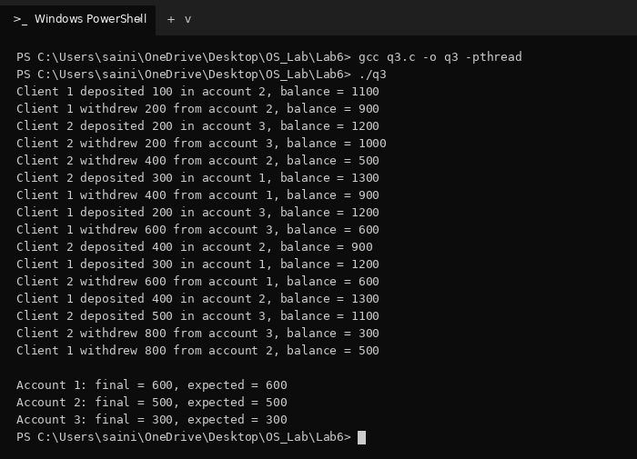
Q4. Create a child process using fork(). Parent and child share int VAR = 10; parent increments it by 2 and child decrements it by 2. Use a semaphore so that the child always executes before the parent.
Important points:
1) Shared memory: after fork() the child has its own copy of memory, so VAR and the semaphore are kept in mmap shared memory.
2) Semaphore: starts at 0; parent waits in sem_wait() until the child calls sem_post(), so the child runs first.
Code (q4.c):
#include <stdio.h>
#include <stdlib.h>
#include <unistd.h>
#include <semaphore.h>
#include <sys/mman.h>
#include <sys/wait.h>
struct shared {
int VAR;
sem_t sem;
};
int main() {
struct shared *s = mmap(NULL, sizeof(struct shared), PROT_READ | PROT_WRITE,
MAP_SHARED | MAP_ANONYMOUS, -1, 0);
s->VAR = 10;
sem_init(&s->sem, 1, 0);
printf("VAR = %d\n", s->VAR);
fflush(stdout);
if (fork() == 0) {
s->VAR = s->VAR - 2;
printf("Child: VAR = %d\n", s->VAR);
sem_post(&s->sem);
exit(0);
} else {
sem_wait(&s->sem);
s->VAR = s->VAR + 2;
printf("Parent: VAR = %d\n", s->VAR);
wait(NULL);
}
return 0;
}
Output:
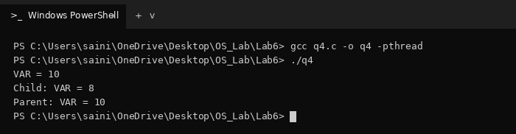
Q5. Write a C program with three threads on shared data int data[10]: first thread finds the sum, second finds the maximum and third finds the minimum. Main thread waits for them and prints the results.
Important points:
1) Threads: created with pthread_create() and all work on the same array data[10].
2) pthread_join(): main waits for all three threads before printing.
3) No mutex needed: threads only read the array and each writes its own variable.
Code (q5.c):
#include <stdio.h>
#include <pthread.h>
int data[10] = {24, 67, 13, 89, 45, 7, 92, 38, 56, 31};
int sum = 0, max, min;
void *find_sum(void *arg) {
for (int i = 0; i < 10; i++)
sum += data[i];
return NULL;
}
void *find_max(void *arg) {
max = data[0];
for (int i = 1; i < 10; i++)
if (data[i] > max) max = data[i];
return NULL;
}
void *find_min(void *arg) {
min = data[0];
for (int i = 1; i < 10; i++)
if (data[i] < min) min = data[i];
return NULL;
}
int main() {
pthread_t t1, t2, t3;
pthread_create(&t1, NULL, find_sum, NULL);
pthread_create(&t2, NULL, find_max, NULL);
pthread_create(&t3, NULL, find_min, NULL);
pthread_join(t1, NULL);
pthread_join(t2, NULL);
pthread_join(t3, NULL);
printf("Sum = %d\n", sum);
printf("Max = %d\n", max);
printf("Min = %d\n", min);
return 0;
}
Output:
