Operating System Lab
Assignment 7
Rishi (2024UCP1566)
________________________________________________________________________________
Q1. Write a C++ program for the producer-consumer problem using semaphores. The buffer size is taken from the command line and the producer produces a non-decreasing integer sequence. Avoid race condition, buffer overflow, buffer underflow and deadlock.
Important points:
1) Semaphores: empty_slots starts at buffer size, full_slots starts at 0 and mutex_lock starts at 1.
2) Overflow and underflow: producer waits on empty_slots and consumer waits on full_slots, so nothing is added to a full buffer or removed from an empty one.
3) Race condition: mutex_lock lets only one thread change the buffer, in and out at a time.
4) Deadlock: empty_slots / full_slots is waited before mutex_lock, so no thread holds the lock while waiting.
5) Processes: buffer and semaphores are kept in mmap shared memory and the semaphores are initialised with pshared = 1.
6) Exactly once: every consumer gets a fixed number of items to consume, so each item is consumed once and all threads finish.
(1) Producer and consumer as threads of the same process
Code (p1.cpp):
#include <iostream>
#include <string>
#include <thread>
#include <cstdlib>
#include <semaphore.h>
#include <unistd.h>
using namespace std;
int *buffer;
int n, in = 0, out = 0;
sem_t empty_slots, full_slots;
void producer() {
for (int x = 1; x <= 10; x++) {
sem_wait(&empty_slots);
buffer[in] = x;
in = (in + 1) % n;
cout << "Item " + to_string(x) + " produced\n" << flush;
sem_post(&full_slots);
usleep(1000);
}
}
void consumer() {
for (int i = 0; i < 10; i++) {
sem_wait(&full_slots);
int x = buffer[out];
out = (out + 1) % n;
cout << "Item " + to_string(x) + " consumed\n" << flush;
sem_post(&empty_slots);
usleep(5000);
}
}
int main(int argc, char *argv[]) {
if (argc < 2) {
cout << "Usage: ./p1 <buffer size>\n";
return 1;
}
n = atoi(argv[1]);
buffer = new int[n];
sem_init(&empty_slots, 0, n);
sem_init(&full_slots, 0, 0);
thread t1(producer);
thread t2(consumer);
t1.join();
t2.join();
return 0;
}
Output (./p1 3):
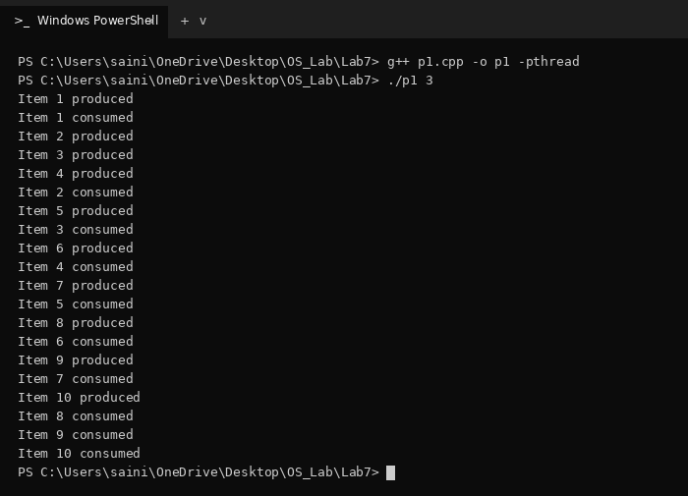
(2) Producer and consumer as independent processes
Code (p2.cpp):
#include <iostream>
#include <string>
#include <cstdlib>
#include <semaphore.h>
#include <sys/mman.h>
#include <sys/wait.h>
#include <unistd.h>
using namespace std;
struct Shared {
int in, out;
sem_t empty_slots, full_slots;
};
int main(int argc, char *argv[]) {
if (argc < 2) {
cout << "Usage: ./p2 <buffer size>\n";
return 1;
}
int n = atoi(argv[1]);
Shared *s = (Shared *)mmap(NULL, sizeof(Shared), PROT_READ | PROT_WRITE,
MAP_SHARED | MAP_ANONYMOUS, -1, 0);
int *buffer = (int *)mmap(NULL, n * sizeof(int), PROT_READ | PROT_WRITE,
MAP_SHARED | MAP_ANONYMOUS, -1, 0);
s->in = 0;
s->out = 0;
sem_init(&s->empty_slots, 1, n);
sem_init(&s->full_slots, 1, 0);
if (fork() == 0) {
for (int x = 1; x <= 10; x++) {
sem_wait(&s->empty_slots);
buffer[s->in] = x;
s->in = (s->in + 1) % n;
cout << "Item " + to_string(x) + " produced\n" << flush;
sem_post(&s->full_slots);
usleep(1000);
}
exit(0);
}
if (fork() == 0) {
for (int i = 0; i < 10; i++) {
sem_wait(&s->full_slots);
int x = buffer[s->out];
s->out = (s->out + 1) % n;
cout << "Item " + to_string(x) + " consumed\n" << flush;
sem_post(&s->empty_slots);
usleep(5000);
}
exit(0);
}
wait(NULL);
wait(NULL);
return 0;
}
Output (./p2 3):
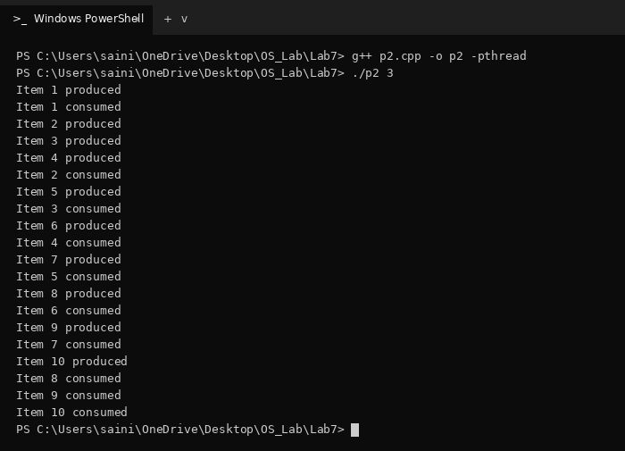
(3) Multiple producers and multiple consumers (buffer size, producers and consumers from command line, item printed as p.x)
Code (p3.cpp):
#include <iostream>
#include <string>
#include <thread>
#include <vector>
#include <cstdlib>
#include <semaphore.h>
#include <unistd.h>
using namespace std;
const int ITEMS = 5;
int *prod_id, *item_no;
int n, in = 0, out = 0;
sem_t empty_slots, full_slots, mutex_lock;
void producer(int id) {
for (int x = 1; x <= ITEMS; x++) {
sem_wait(&empty_slots);
sem_wait(&mutex_lock);
prod_id[in] = id;
item_no[in] = x;
in = (in + 1) % n;
cout << "Producer " + to_string(id) + ": item " + to_string(id) + "." +
to_string(x) + " produced\n" << flush;
sem_post(&mutex_lock);
sem_post(&full_slots);
usleep(1000);
}
}
void consumer(int id, int count) {
for (int i = 0; i < count; i++) {
sem_wait(&full_slots);
sem_wait(&mutex_lock);
int p = prod_id[out];
int x = item_no[out];
out = (out + 1) % n;
cout << " Consumer " + to_string(id) + ": item " + to_string(p) + "." +
to_string(x) + " consumed\n" << flush;
sem_post(&mutex_lock);
sem_post(&empty_slots);
usleep(3000);
}
}
int main(int argc, char *argv[]) {
if (argc < 4) {
cout << "Usage: ./p3 <buffer size> <producers> <consumers>\n";
return 1;
}
n = atoi(argv[1]);
int np = atoi(argv[2]);
int nc = atoi(argv[3]);
prod_id = new int[n];
item_no = new int[n];
sem_init(&empty_slots, 0, n);
sem_init(&full_slots, 0, 0);
sem_init(&mutex_lock, 0, 1);
int total = np * ITEMS;
vector<thread> threads;
for (int i = 1; i <= np; i++)
threads.push_back(thread(producer, i));
for (int i = 1; i <= nc; i++) {
int count = total / nc + (i <= total % nc ? 1 : 0);
threads.push_back(thread(consumer, i, count));
}
for (auto &t : threads)
t.join();
return 0;
}
Output (./p3 4 3 2):
