Operating System Lab
Assignment 8
Rishi (2024UCP1566)
________________________________________________________________________________
Q1. Write a program to simulate the Banker's algorithm for deadlock avoidance with 5 processes and 4 resource classes. Show one case where a safe sequence exists and one case where it does not.
Important points:
1) Need: Need = Max - Allocation for every process.
2) Safety check: a process can finish if its Need is less than or equal to Work (starts as Available); when it finishes it returns its Allocation to Work. If all processes can finish in some order, that order is the safe sequence.
3) Request: check request <= Need and request <= Available, pretend to allocate it and run the safety check. If the state is safe the request is granted, otherwise it is rolled back and the process waits.
4) Two cases: same system; P1 requesting 1 0 2 0 keeps the system safe, P0 requesting 0 0 2 0 leaves no safe sequence.
Code (q1.cpp):
#include <iostream>
using namespace std;
const int P = 5, R = 4;
bool isSafe(int avail[], int alloc[][R], int need[][R], int seq[]) {
int work[R];
bool done[P] = {false};
int count = 0;
for (int j = 0; j < R; j++)
work[j] = avail[j];
while (count < P) {
bool found = false;
for (int i = 0; i < P; i++) {
if (done[i]) continue;
bool ok = true;
for (int j = 0; j < R; j++)
if (need[i][j] > work[j]) ok = false;
if (ok) {
for (int j = 0; j < R; j++)
work[j] += alloc[i][j];
done[i] = true;
seq[count++] = i;
found = true;
}
}
if (!found) return false;
}
return true;
}
void banker(int avail[], int alloc[][R], int maxm[][R], int p, int request[]) {
int need[P][R], seq[P];
for (int i = 0; i < P; i++)
for (int j = 0; j < R; j++)
need[i][j] = maxm[i][j] - alloc[i][j];
cout << "Process Allocation Max Need\n";
for (int i = 0; i < P; i++) {
cout << "P" << i << " ";
for (int j = 0; j < R; j++) cout << alloc[i][j] << " ";
cout << " ";
for (int j = 0; j < R; j++) cout << maxm[i][j] << " ";
cout << " ";
for (int j = 0; j < R; j++) cout << need[i][j] << " ";
cout << "\n";
}
cout << "Available: ";
for (int j = 0; j < R; j++) cout << avail[j] << " ";
cout << "\n";
cout << "\nP" << p << " requests: ";
for (int j = 0; j < R; j++) cout << request[j] << " ";
cout << "\n";
for (int j = 0; j < R; j++) {
if (request[j] > need[p][j]) {
cout << "Error: process has exceeded its maximum claim\n";
return;
}
}
for (int j = 0; j < R; j++) {
if (request[j] > avail[j]) {
cout << "Resources not available, P" << p << " must wait\n";
return;
}
}
for (int j = 0; j < R; j++) {
avail[j] -= request[j];
alloc[p][j] += request[j];
need[p][j] -= request[j];
}
if (isSafe(avail, alloc, need, seq)) {
cout << "Request can be granted. Safe sequence: ";
for (int i = 0; i < P; i++) {
cout << "P" << seq[i];
if (i < P - 1) cout << " -> ";
}
cout << "\n";
} else {
cout << "Request cannot be granted. No safe sequence exists, system would be unsafe\n";
for (int j = 0; j < R; j++) {
avail[j] += request[j];
alloc[p][j] -= request[j];
need[p][j] += request[j];
}
}
}
int main() {
int maxm[P][R] = {{7, 5, 3, 2}, {3, 2, 2, 2}, {9, 0, 2, 2}, {2, 2, 2, 2}, {4, 3, 3, 2}};
int alloc1[P][R] = {{0, 1, 0, 0}, {2, 0, 0, 1}, {3, 0, 2, 0}, {2, 1, 1, 1}, {0, 0, 2, 0}};
int avail1[R] = {3, 3, 2, 1};
int req1[R] = {1, 0, 2, 0};
cout << "CASE 1: Safe sequence exists\n";
banker(avail1, alloc1, maxm, 1, req1);
int alloc2[P][R] = {{0, 1, 0, 0}, {2, 0, 0, 1}, {3, 0, 2, 0}, {2, 1, 1, 1}, {0, 0, 2, 0}};
int avail2[R] = {3, 3, 2, 1};
int req2[R] = {0, 0, 2, 0};
cout << "\nCASE 2: Safe sequence does not exist\n";
banker(avail2, alloc2, maxm, 0, req2);
return 0;
}
Output (Banker's algorithm):
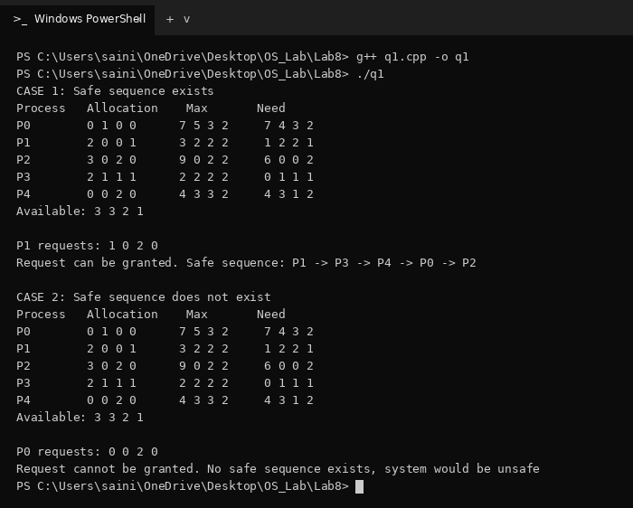
Q2. Write a simulator for variable partition memory allocation using First Fit, Best Fit and Worst Fit. Read the input from alloc.dat (memory size, then process id, arrival time, block size and duration, ending with -1 -1 -1). Keep requests in a waiting queue until they are allocated and report the success percentage, external fragmentation and internal fragmentation after every 10 requests.
Important points:
1) Waiting queue: every request is added to the queue and tried in order. A block is freed at arrival time + duration and neighbouring free blocks are merged.
2) Strategies: First Fit takes the first hole that is big enough, Best Fit the smallest one and Worst Fit the largest one.
3) Success %: allocated requests / requests considered so far * 100.
4) External fragmentation: (total free memory - largest free hole) / memory size * 100.
5) Internal fragmentation: if the leftover of a hole is less than 3 KB, the whole hole is given to the process; the wasted part / memory size * 100.
6) Strategies listed: the question says four strategies but lists three, so First, Best and Worst Fit are implemented.
Input file (alloc.dat):
100
1 1 37 12
2 3 20 7
3 5 38 14
4 5 14 12
5 6 17 6
6 8 10 14
7 9 36 14
8 11 18 14
9 11 12 5
10 11 20 8
11 13 9 12
12 14 36 14
13 14 22 9
14 15 8 6
15 16 25 11
16 18 13 9
17 19 22 13
18 20 9 6
19 22 14 11
20 22 26 11
21 22 9 5
22 22 21 5
23 23 32 11
24 24 12 14
25 26 20 9
26 27 13 9
27 28 8 11
28 28 16 8
29 30 14 5
30 30 37 12
-1 -1 -1
Code (q2.cpp):
#include <iostream>
#include <fstream>
#include <vector>
#include <algorithm>
#include <iomanip>
using namespace std;
struct Request {
int pid, arrival, size, duration;
};
struct Block {
int start, size;
bool free;
int end, used;
};
int memory;
vector<Request> requests;
const int MIN_LEFT = 3;
int findHole(vector<Block> &mem, int size, int type) {
int pick = -1;
for (int i = 0; i < mem.size(); i++) {
if (!mem[i].free || mem[i].size < size) continue;
if (pick == -1) pick = i;
else if (type == 2 && mem[i].size < mem[pick].size) pick = i;
else if (type == 3 && mem[i].size > mem[pick].size) pick = i;
if (type == 1) break;
}
return pick;
}
bool allocate(vector<Block> &mem, Request r, int t, int type) {
int i = findHole(mem, r.size, type);
if (i == -1) return false;
int left = mem[i].size - r.size;
mem[i].free = false;
mem[i].used = r.size;
mem[i].end = t + r.duration;
if (left >= MIN_LEFT) {
Block rest = {mem[i].start + r.size, left, true, 0, 0};
mem[i].size = r.size;
mem.insert(mem.begin() + i + 1, rest);
}
return true;
}
void freeBlocks(vector<Block> &mem, int t) {
for (int i = 0; i < mem.size(); i++)
if (!mem[i].free && mem[i].end <= t)
mem[i].free = true;
for (int i = 0; i + 1 < mem.size(); ) {
if (mem[i].free && mem[i + 1].free) {
mem[i].size += mem[i + 1].size;
mem.erase(mem.begin() + i + 1);
} else {
i++;
}
}
}
void report(vector<Block> &mem, int total, int done) {
int freeMem = 0, biggest = 0, internal = 0;
for (int i = 0; i < mem.size(); i++) {
if (mem[i].free) {
freeMem += mem[i].size;
biggest = max(biggest, mem[i].size);
} else {
internal += mem[i].size - mem[i].used;
}
}
double success = done * 100.0 / total;
double external = (freeMem - biggest) * 100.0 / memory;
double inter = internal * 100.0 / memory;
cout << fixed << setprecision(2);
cout << "After " << setw(2) << total << " requests: Success = " << setw(6) << success
<< "% External = " << setw(5) << external
<< "% Internal = " << setw(4) << inter << "%\n";
}
void simulate(int type, string name) {
vector<Block> mem;
mem.push_back({0, memory, true, 0, 0});
vector<Request> waiting;
int next = 0, arrived = 0, done = 0;
cout << name << "\n";
for (int t = 0; ; t++) {
freeBlocks(mem, t);
for (int i = 0; i < waiting.size(); ) {
if (allocate(mem, waiting[i], t, type)) {
done++;
waiting.erase(waiting.begin() + i);
} else {
i++;
}
}
while (next < requests.size() && requests[next].arrival <= t) {
arrived++;
if (requests[next].size <= memory)
waiting.push_back(requests[next]);
next++;
for (int i = 0; i < waiting.size(); ) {
if (allocate(mem, waiting[i], t, type)) {
done++;
waiting.erase(waiting.begin() + i);
} else {
i++;
}
}
if (arrived % 10 == 0)
report(mem, arrived, done);
}
if (next == requests.size() && waiting.empty())
break;
}
cout << "Total allocated: " << done << " of " << arrived << "\n\n";
}
int main() {
ifstream file("alloc.dat");
if (!file) {
cout << "Cannot open alloc.dat\n";
return 1;
}
file >> memory;
Request r;
while (file >> r.pid && r.pid != -1) {
file >> r.arrival >> r.size >> r.duration;
requests.push_back(r);
}
stable_sort(requests.begin(), requests.end(),
[](Request a, Request b) { return a.arrival < b.arrival; });
simulate(1, "FIRST FIT");
simulate(2, "BEST FIT");
simulate(3, "WORST FIT");
return 0;
}
Output (Memory allocation simulator):
