Malaviya National Institute of Technology, Jaipur

Operating System Lab
Assignment 1

Submitted by: Rishi
Student ID: 2024UCP1566
Submitted to: Prof. Sonu Lamba
Date: August 2026

Section A: Introduction to Linux

A.1 Linux Architecture
Linux has a layered structure. At the bottom is hardware. Above it is the kernel which manages everything. Then comes the shell where we type commands. And on top are the applications we use daily like editors and browsers.
Flow: User → Shell → Kernel → Hardware

A.2 What is Shell?
Shell is a command-line program. We type commands in it and it tells the kernel what to do. It is like a translator between us and the operating system.

A.3 Types of Shell
Command | What it does
bash | Default shell in Ubuntu. Most commonly used.
sh | The original basic shell.
csh | Shell with C-like syntax.
ksh | Korn shell. Combines features of sh and csh.
zsh | Modern shell with auto-complete and plugins.

A.4 Command Structure
command [options] [arguments]
Example: ls -la /home — 'ls' is command, '-la' is option, '/home' is argument.

A.5 Basic Commands
Command | What it does
sudo | Run command as admin.
ls | List files in a folder.
pwd | Show current folder path.
mkdir | Make a new folder.
rmdir | Remove empty folder.
rm | Delete a file.
cd | Change folder.
cp | Copy files.
mv | Move or rename files.
wc | Count words/lines in file.
cmp | Compare two files.
passwd | Change password.
who | Show logged in users.
uname | Show system info.

A.6 apt-get (Package Manager)
apt-get is how we install and update software in Ubuntu.
Command | What it does
sudo apt-get update | Update package list.
sudo apt-get install <pkg> | Install new software.
sudo apt-get upgrade | Upgrade all software.
sudo apt-get remove <pkg> | Remove software.

Section B: Command Execution
I ran the following commands on Ubuntu terminal (WSL 2). Screenshots of the output are shown below each section.

B.1 Directory Commands
Command | What it does
pwd | Show current directory.
mkdir | Create new folder.
ls -la | List all files with details.
cd | Change directory.
rmdir | Remove empty folder.
tree | Show folder structure as tree.

Output:
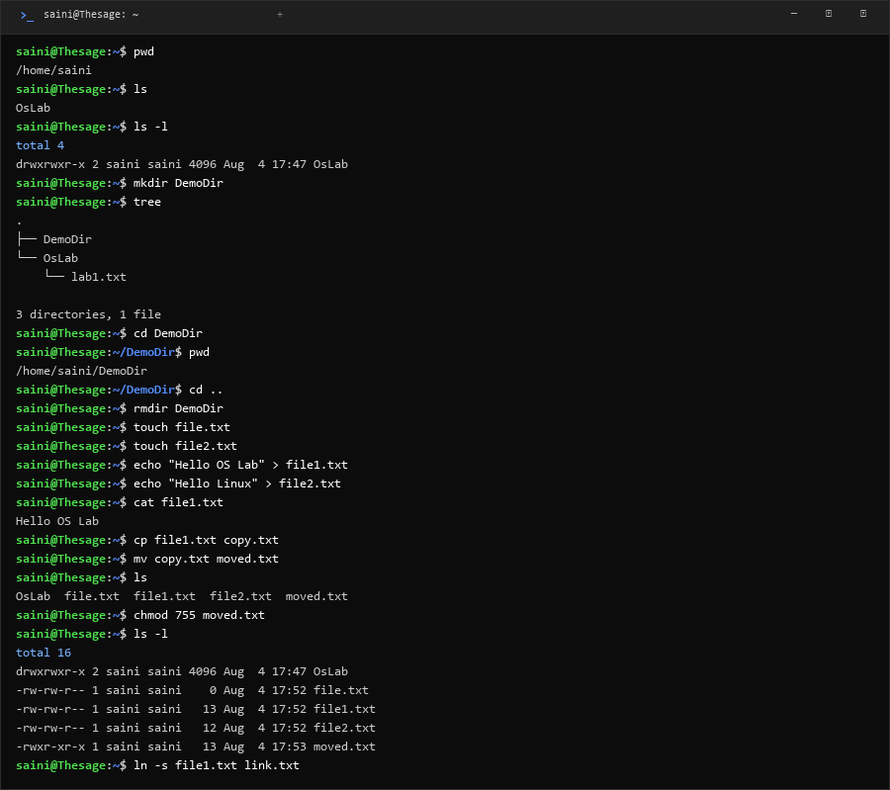

B.2 File Commands
Command | What it does
cat | Show file content.
cp | Copy file.
mv | Move or rename file.
ln -s | Create shortcut link.
head / tail | Show first/last lines of file.
grep | Search text in file.
find | Search for files.
cmp / diff | Compare two files.
chmod | Change file permissions.
wc | Count lines and words.
dd | Copy raw data.
rm | Delete file.

Output:
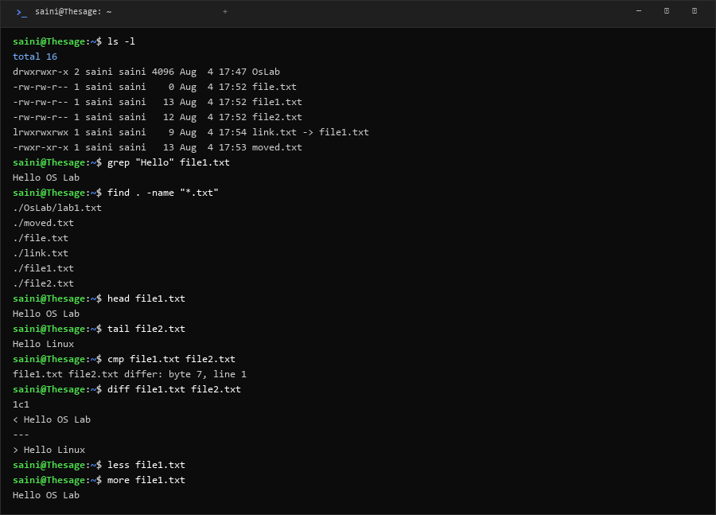

B.3 Process Commands
Command | What it does
ps aux / ps -ef | Show running processes.
top | Live process monitor.
nice | Run with different priority.
touch | Create empty file.
kill | Stop a process.
fork() in C++ | Create child process.

Output:
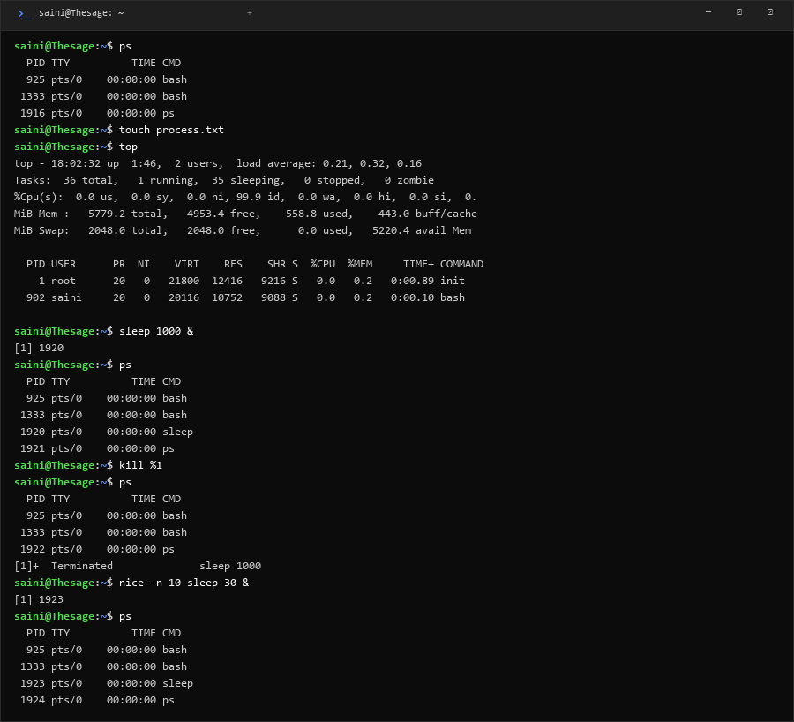

B.4 Network Commands
Command | What it does
ifconfig | Show network info.
ping | Test if server is reachable.
traceroute | Show path to server.
curl | Get web page headers.
wget | Download files.
nslookup | Find IP of a domain.
netstat | Show open ports.

Output:
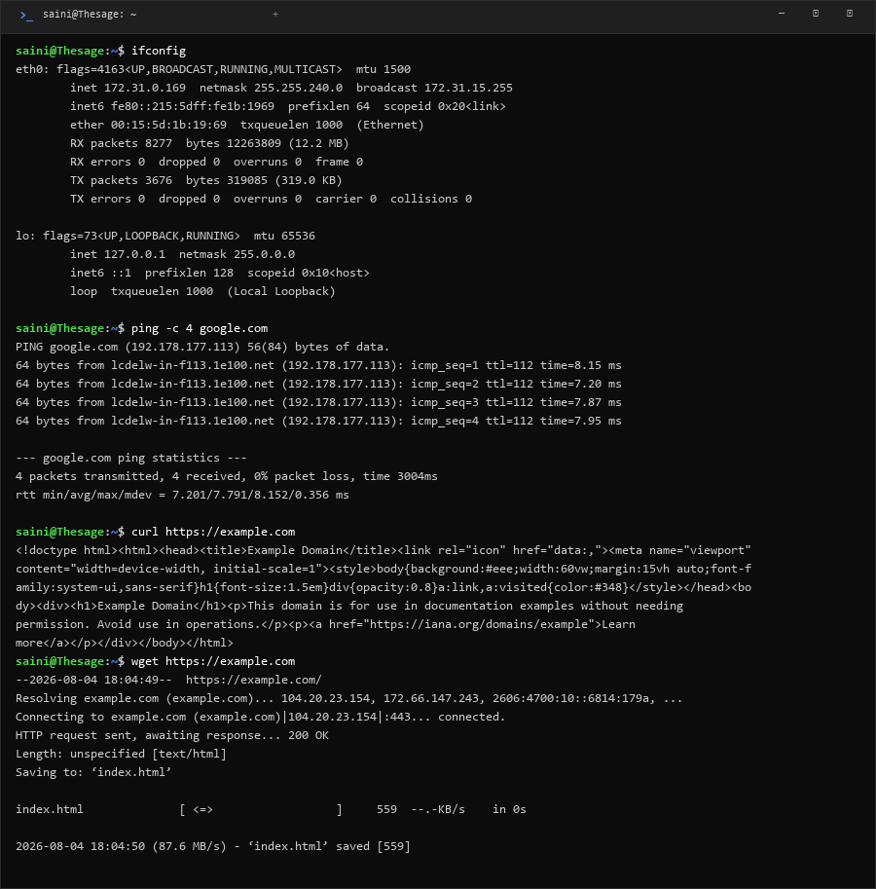
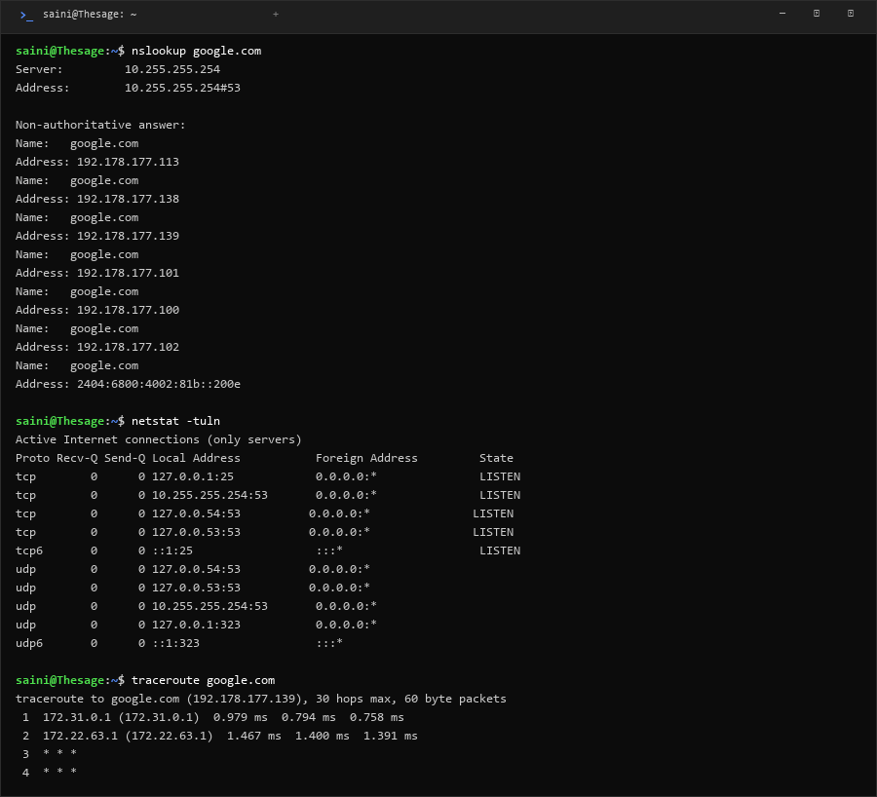
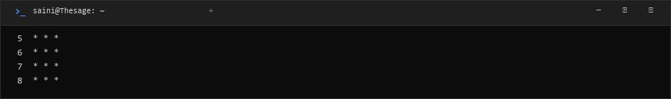

B.5 System Commands
Command | What it does
whoami | Show current username.
uname -a | Show OS and kernel info.
whereis / which | Find where a program is.
sudo apt-get update | Update packages.
systemctl / service | Manage services.
ssh -V | Show SSH version.
passwd | Change password.

Output:
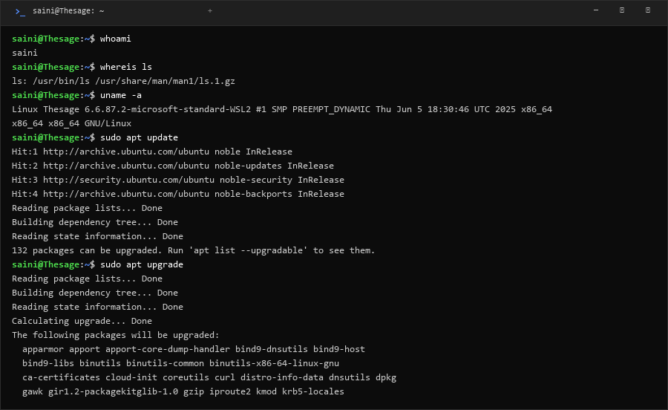

B.6 Disk Commands
Command | What it does
du -sh | Show folder size.
df -h | Show disk space.
fdisk -l | Show disk partitions.

Output:
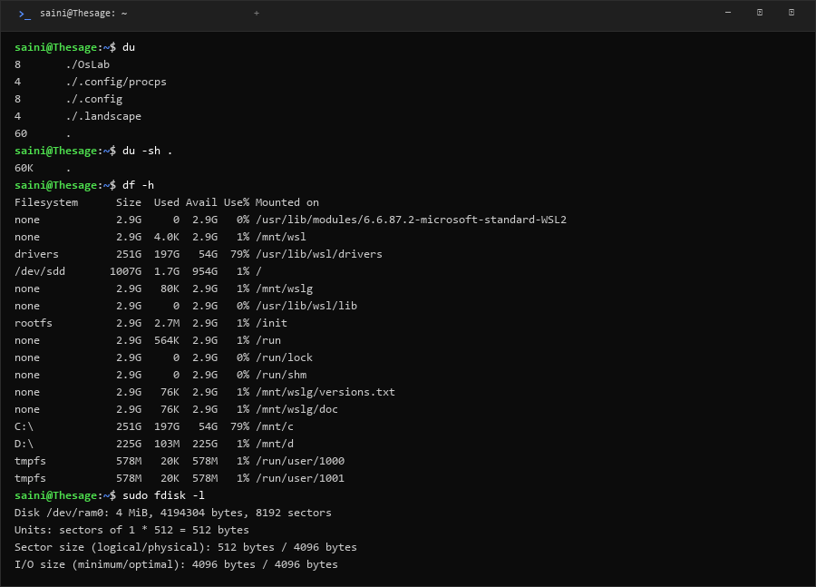

B.7 Miscellaneous Commands
Command | What it does
echo | Print text.
clear | Clear terminal.
tar | Compress/extract files.
which | Find command location.
man | Open manual of command.
mount | Show mounted drives.
| (pipe) | Send output to next command.
> and >> | Write/append output to file.

Output:
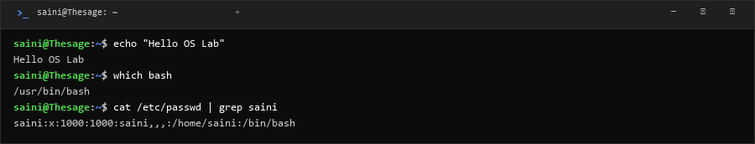

B.8 /proc Virtual Filesystem
Command | What it does
/proc/cpuinfo | CPU details.
/proc/meminfo | Memory details.
/proc/version | Kernel version.
/proc/uptime | System uptime.
/proc/self/status | Current process info.

Output:
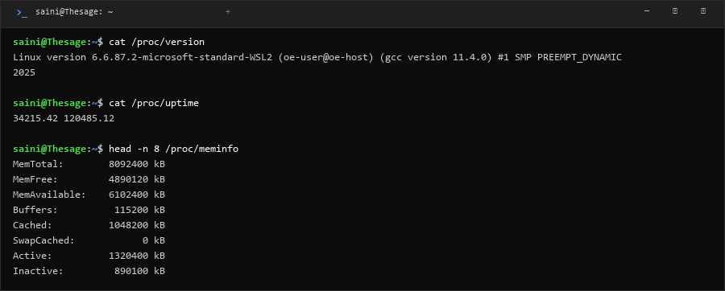

Section C: GCC/G++ Compiler Options
GCC (for C) and G++ (for C++) are the compilers we use to compile programs in Linux.
Command | What it does
-o <name> | Set name of output file.
-c | Compile only, don't link.
-g | Add debug info.
-Wall | Show all warnings.
-O0 / -O1 / -O2 | Optimization level.
-E | Run preprocessor only.
-S | Generate assembly code.
-l <lib> | Link a library.
-std=c++17 | Use specific C++ standard.

Example: g++ -o myprogram main.cpp
Example: g++ -Wall -g main.cpp -o test

Section D: OSTEP Code (p1-p4)
These programs from the OSTEP textbook show how fork(), wait(), and exec() work in Linux.

p1.cpp — fork()
Code:
#include <iostream>
#include <unistd.h>
#include <cstdlib>
int main(int argc, char *argv[]) {
std::cout << "hello world (pid:" << getpid() << ")" << std::endl;
int rc = fork();
if (rc < 0) {
std::cerr << "fork failed" << std::endl;
exit(1);
} else if (rc == 0) {
std::cout << "hello, I am child (pid:" << getpid() << ")" << std::endl;
} else {
std::cout << "hello, I am parent of " << rc << " (pid:" << getpid() << ")" << std::endl;
}
return 0;
}
What happens:
This program creates a child process using fork(). Both parent and child run at the same time. Which one prints first depends on the scheduler.

p2.cpp — fork() + wait()
Code:
#include <iostream>
#include <unistd.h>
#include <cstdlib>
#include <sys/wait.h>
int main(int argc, char *argv[]) {
std::cout << "hello world (pid:" << getpid() << ")" << std::endl;
int rc = fork();
if (rc < 0) {
std::cerr << "fork failed" << std::endl;
exit(1);
} else if (rc == 0) {
std::cout << "hello, I am child (pid:" << getpid() << ")" << std::endl;
} else {
int wc = wait(NULL);
std::cout << "hello, I am parent of " << rc << " (wc:" << wc << ") (pid:" << getpid() << ")" << std::endl;
}
return 0;
}
What happens:
Here the parent waits for the child to finish first using wait(). So child always prints before parent.

p3.cpp — fork() + exec()
Code:
#include <iostream>
#include <unistd.h>
#include <cstdlib>
#include <cstring>
#include <sys/wait.h>
int main(int argc, char *argv[]) {
std::cout << "hello world (pid:" << getpid() << ")" << std::endl;
int rc = fork();
if (rc < 0) {
std::cerr << "fork failed" << std::endl;
exit(1);
} else if (rc == 0) {
std::cout << "hello, I am child (pid:" << getpid() << ")" << std::endl;
char *myargs[3];
myargs[0] = strdup("wc");
myargs[1] = strdup("p3.cpp");
myargs[2] = NULL;
execvp(myargs[0], myargs);
std::cout << "this shouldn't print out" << std::endl;
} else {
int wc = wait(NULL);
std::cout << "hello, I am parent of " << rc << " (wc:" << wc << ") (pid:" << getpid() << ")" << std::endl;
}
return 0;
}
What happens:
The child replaces itself with the 'wc' program using exec(). After exec(), the original code is gone.

p4.cpp — Output redirection
Code:
#include <iostream>
#include <unistd.h>
#include <cstdlib>
#include <cstring>
#include <fcntl.h>
#include <sys/wait.h>
int main(int argc, char *argv[]) {
int rc = fork();
if (rc < 0) {
std::cerr << "fork failed" << std::endl;
exit(1);
} else if (rc == 0) {
close(STDOUT_FILENO);
open("./p4.output", O_CREAT|O_WRONLY|O_TRUNC, S_IRWXU);
char *myargs[3];
myargs[0] = strdup("wc");
myargs[1] = strdup("p4.cpp");
myargs[2] = NULL;
execvp(myargs[0], myargs);
} else {
int wc = wait(NULL);
}
return 0;
}
What happens:
The child closes stdout and opens a file. So wc output goes to file instead of screen. This is how '>' works in shell.

Terminal Output:
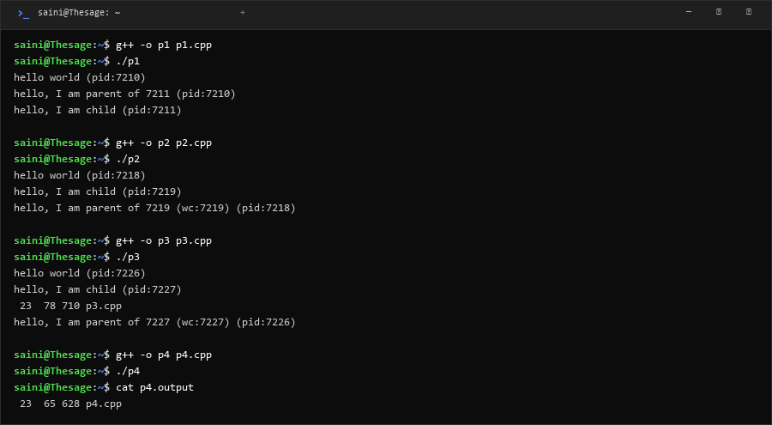

Section E: Booting Process
When we turn on the computer, it goes through these steps:
1. POST
Computer checks if hardware (RAM, CPU, keyboard) is working.
2. BIOS/UEFI
Firmware on motherboard finds the hard disk and loads the boot loader.
3. GRUB (Boot Loader)
Shows menu to select OS. Loads Linux kernel into memory.
4. Kernel
Kernel starts, sets up memory, loads drivers, mounts file system.
5. Systemd (PID 1)
First process starts. It starts all other services and shows login screen.

Bootstrap Program
Bootstrap program is the first code that runs when computer starts. It is stored in ROM on the motherboard. It finds the OS kernel and loads it into RAM.
Flow: Power ON → POST → BIOS → GRUB → Kernel → Systemd → Login

