WHITE BAND ASSOCIATES
CYBER SECURITY SUMMER INTERNSHIP

Linux Task No. 03: Process Management, System Monitoring & Basic Shell Scripting

Name: Sayali Dattatray Kute
Date: 13/06/2026

Part A: Process Monitoring

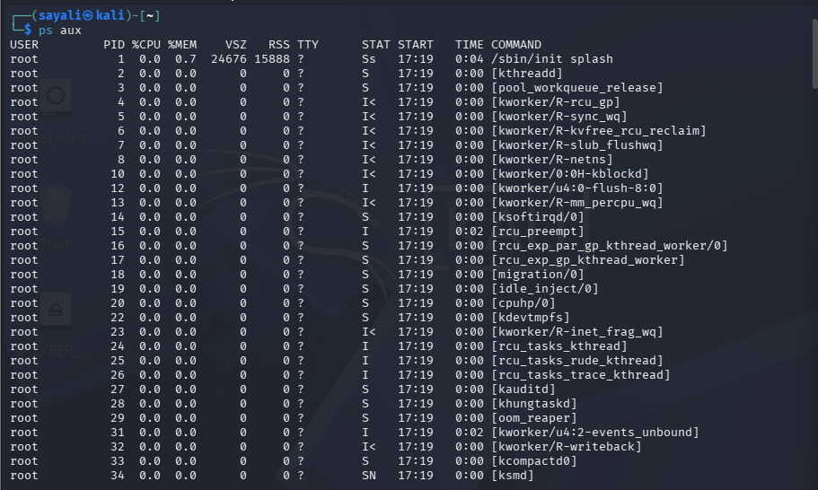
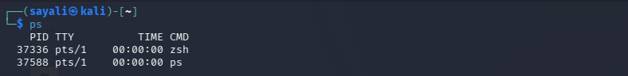
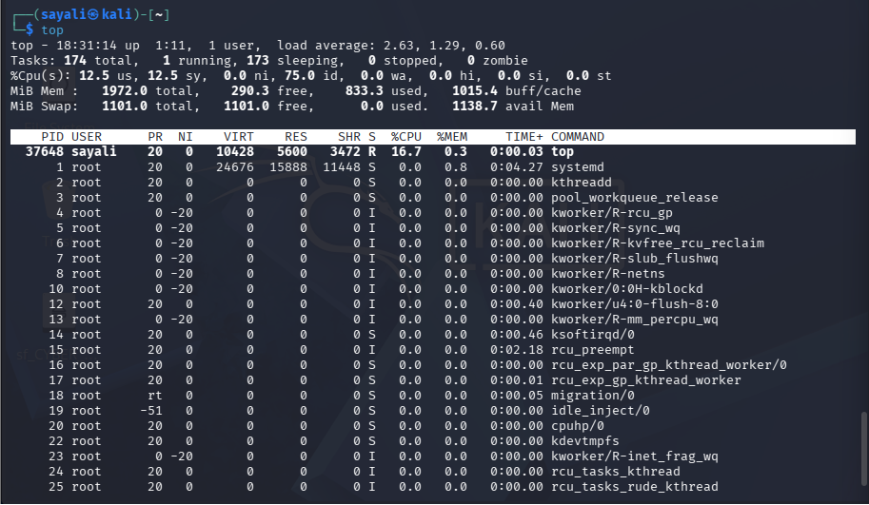
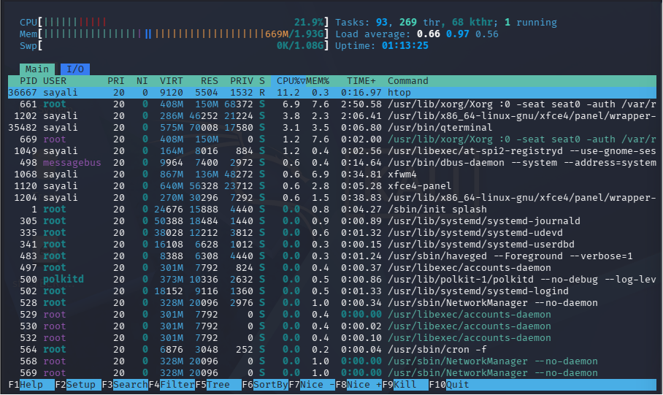
Q1. What is a Process?
Ans: A process is a running instance of a program.
Q2. What is a PID?
Ans: PID (Process ID) is a unique number assigned to each running process.
Q3. Which process uses most CPU?
Ans: Check the first process in TOP/HTOP CPU column.
Q4. Which process uses most Memory?
Ans: Check the first process in Memory column.

Part B: Process Management

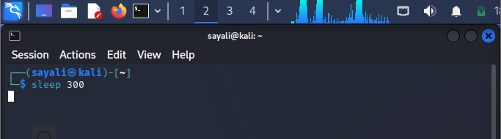
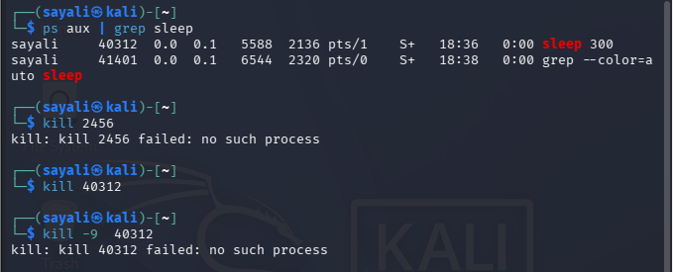

Part C: System Monitoring

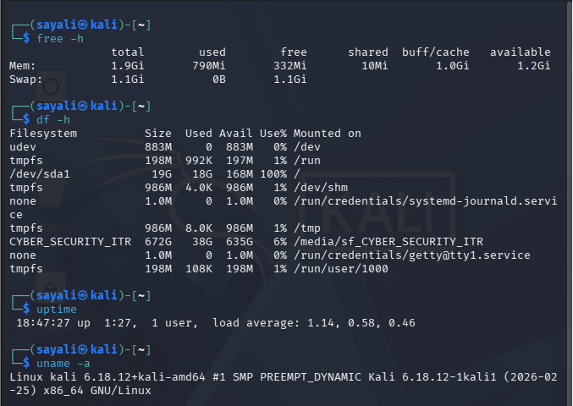
Total RAM: 1.9 GiB
Available RAM: 1.2 GiB
Disk Usage: 19 GB Total, 18 GB Used, 168 MB Available (100% Used)
System Uptime: 1 hour 27 minutes
Kernal Version: Linux kali 6.18.12+kali-amd64 #1 SMP PREEMPT_DYNAMIC Kali 6.18.12-1kali1 (2026-02-25) x86_64 GNU/Linux

Part D: Service Monitoring

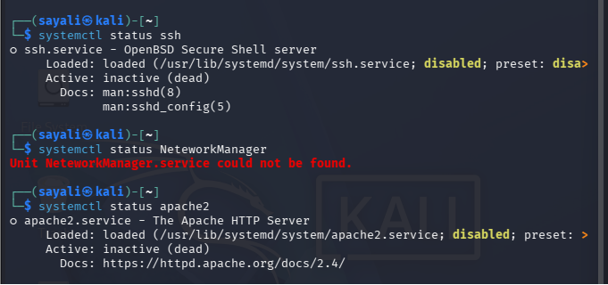
Q1. What is a Service?
Ans: A service is a background process that performs specific tasks for the operating system or applications.
Q2. Why are services important?
Ans: Services provide essential functionality such as networking, web hosting, remote access, printing, and system management.
Q3. How can a stopped service affect a system?
Ans: A stopped service can cause applications or system functions to stop working. For example, if the SSH service stops, remote login will no longer be available.

Part E: Shell Scripting

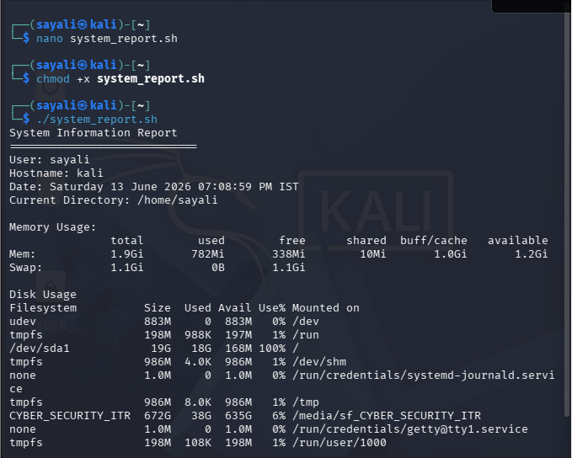

Part F: Security Monitoring Challenge

. netstat
Purpose:
Displays network connections, routing tables, and listening ports.
Example Output:
tcp 0 0 127.0.0.1:80 LISTEN
Security Use Case:
Used to identify suspicious network connections and open ports.

ss
Purpose:
Displays socket statistics and active connections.
Example Output:
LISTEN 0 128 *:22
Security Use Case:
Used to identify listening services and network activity.

who
Purpose:
Shows currently logged-in users.
Example Output:
sayali pts/0
Security Use Case:
Used to identify active user sessions.

w
Purpose:
Displays logged-in users and their activities.
Example Output:
USER TTY FROM LOGIN@ IDLE
Security Use Case:
Used to monitor user activity.

last
Purpose:
Shows login history.
Example Output:
sayali pts/0
Security Use Case:
Used to investigate suspicious logins and security incidents.

Part G: Mini SOC Activity

If a Linux system is running slowly, I would first use top or htop to identify processes consuming excessive CPU or memory resources.
To determine whether a process is suspicious, I would check the process name, PID, resource consumption, executable path, and the user running the process.
Before terminating a process, I would collect important information including PID, CPU usage, memory usage, process owner, command path, and whether the process is associated with a critical service.
Collecting this information helps prevent accidental termination of legitimate system processes while identifying potential threats.

