WHITE BAND ASSOCIATES
CYBER SECURITY SUMMER INTERNSHIP

Linux Task No. 01: Linux Environment Setup & Essential Commands
Name: Sayali Dattatray Kute
Date: 09/06/2026

Part A: Linux Installation & Verification

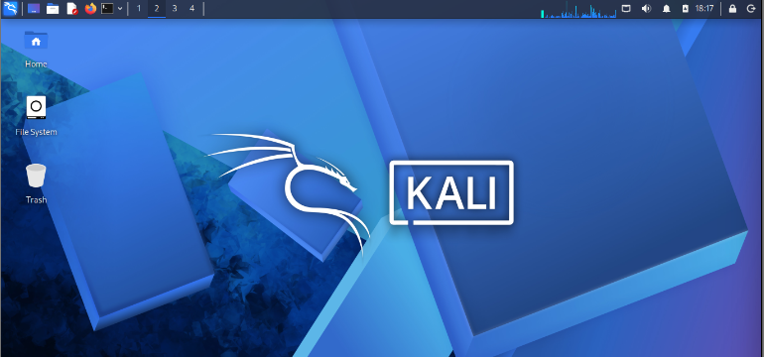
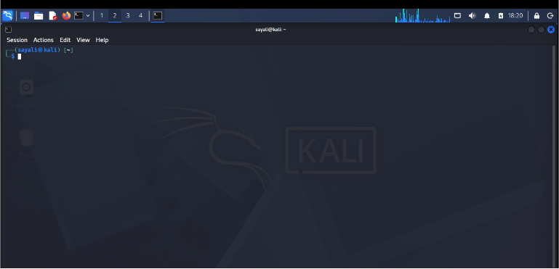
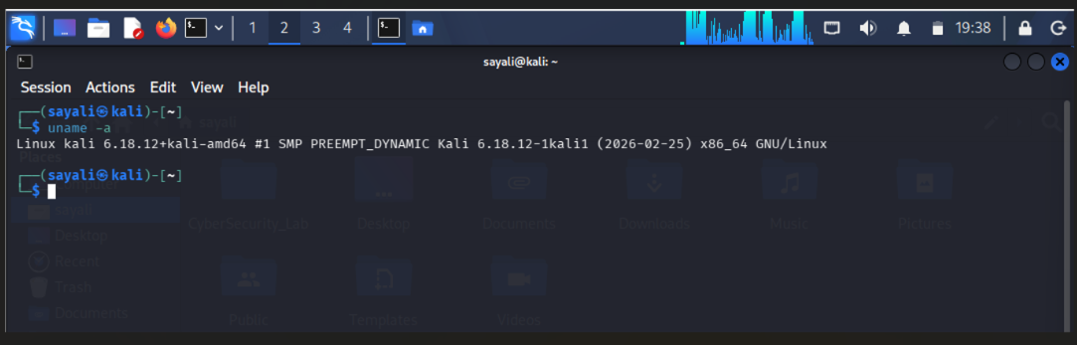

Part B: Basic Navigation Command

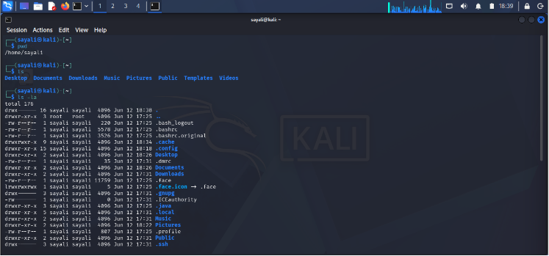
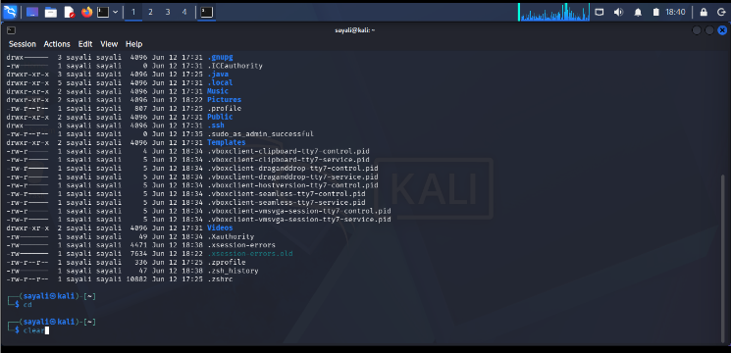

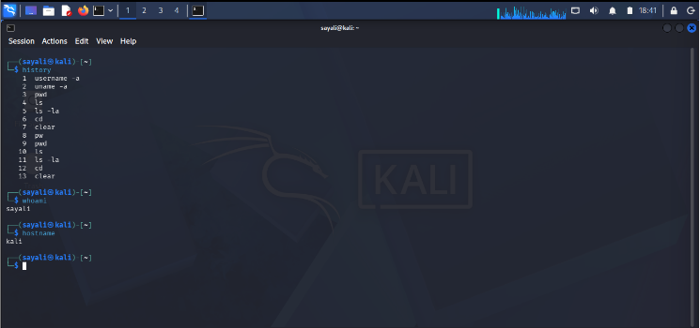

Command | Purpose
pwd | Shows current directory path
ls | Lists files and folders
ls -la | Lists all files including hidden files
cd | Changes directory
clear | Clears terminal screen
history | Shows previously executed commands
whoami | Displays current username
hostname | Displays computer name

Part C: Directory Management

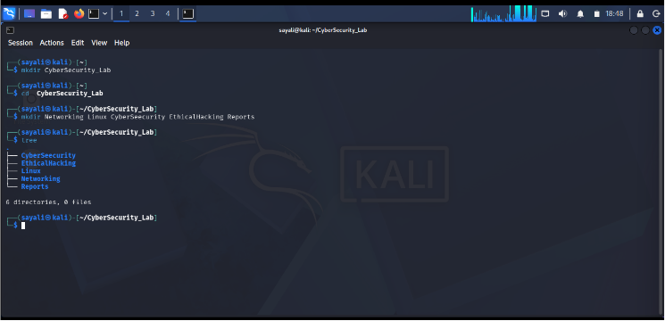

Part D: File Management

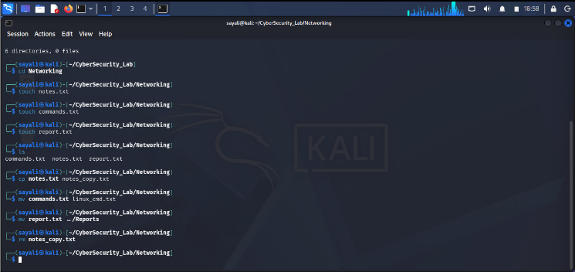
Command | Purpose
touch | Creates file
cp | Copies file
mv | Moves or renames file
rm | Deletes file

Part E: System Information Collection

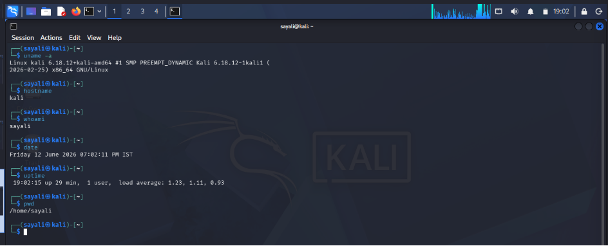
Item | Value
Kernel Version | Linux kali 6.18.12+kali-amd64
Username | kali
Current Directory | /home/sayali
Date & Time | Friday 12 June 2026 07:02:11 PM IST
System Uptime | 19:02:15 up 29 min, 1 user, load average: 1.23, 1.11, 0.93

Part E: Linux Research Activity

Q1. What is Linux?
Ans: Linux is an open-source operating system used on servers, desktops, cloud platforms, and cybersecurity systems.

Q2. Why is Linux Important in Cyber Security?
Ans: Most security tools, servers, and penetration-testing environments run on Linux. It provides flexibility, security, and powerful command-line utilities.

Q3. Difference Between Linux and Windows

Linux | Windows
Open Source | Proprietary
More secure | More targeted by malware
Command-line focused | GUI focused
Free | Usually licensed

Q4. What is a Linux Distribution?
Ans: A Linux distribution is a version of Linux bundled with software and tools, such as Ubuntu, Kali Linux, and Parrot OS.

Q5.Why Do Ethical Hackers Prefer Linux?
Ans: Ethical hackers prefer Linux because it includes powerful security tools, offers greater control, and is widely used in cybersecurity environments.

