WHITE BAND ASSOCIATES
CYBER SECURITY SUMMER INTERNSHIP

Networking Task No. 01: Understanding your network environment.
Name: Sayali Dattatray Kute
Date: 02/06/2026

Part A: Network Information
Parameter | Value
Hostname(Device Name) | SAYALI
IPv4 Address | 10.36.29.107
MAC Address | 5C-BA-EF-8E-59-7F
Default Gateway | fe80::f0ba:74ff:febe:c8f4%4  10:36:29:72
DNS Server | 10.36.29.72

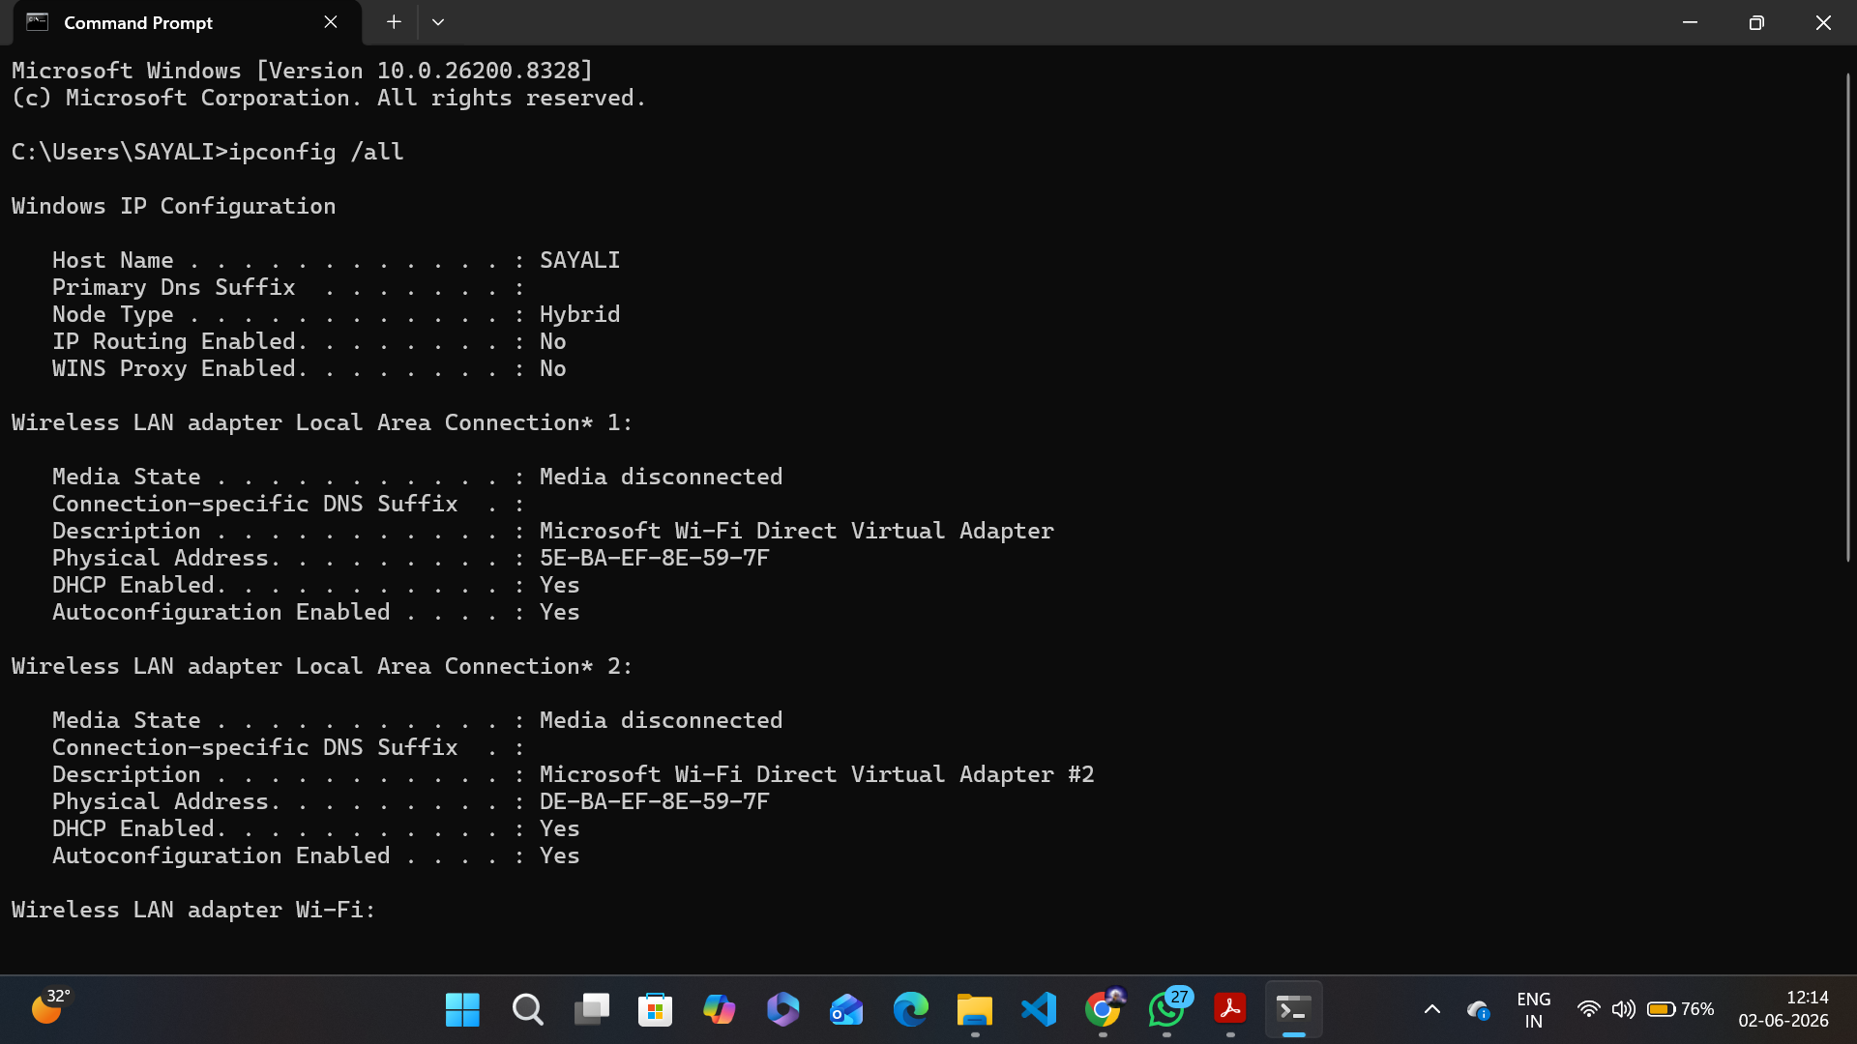
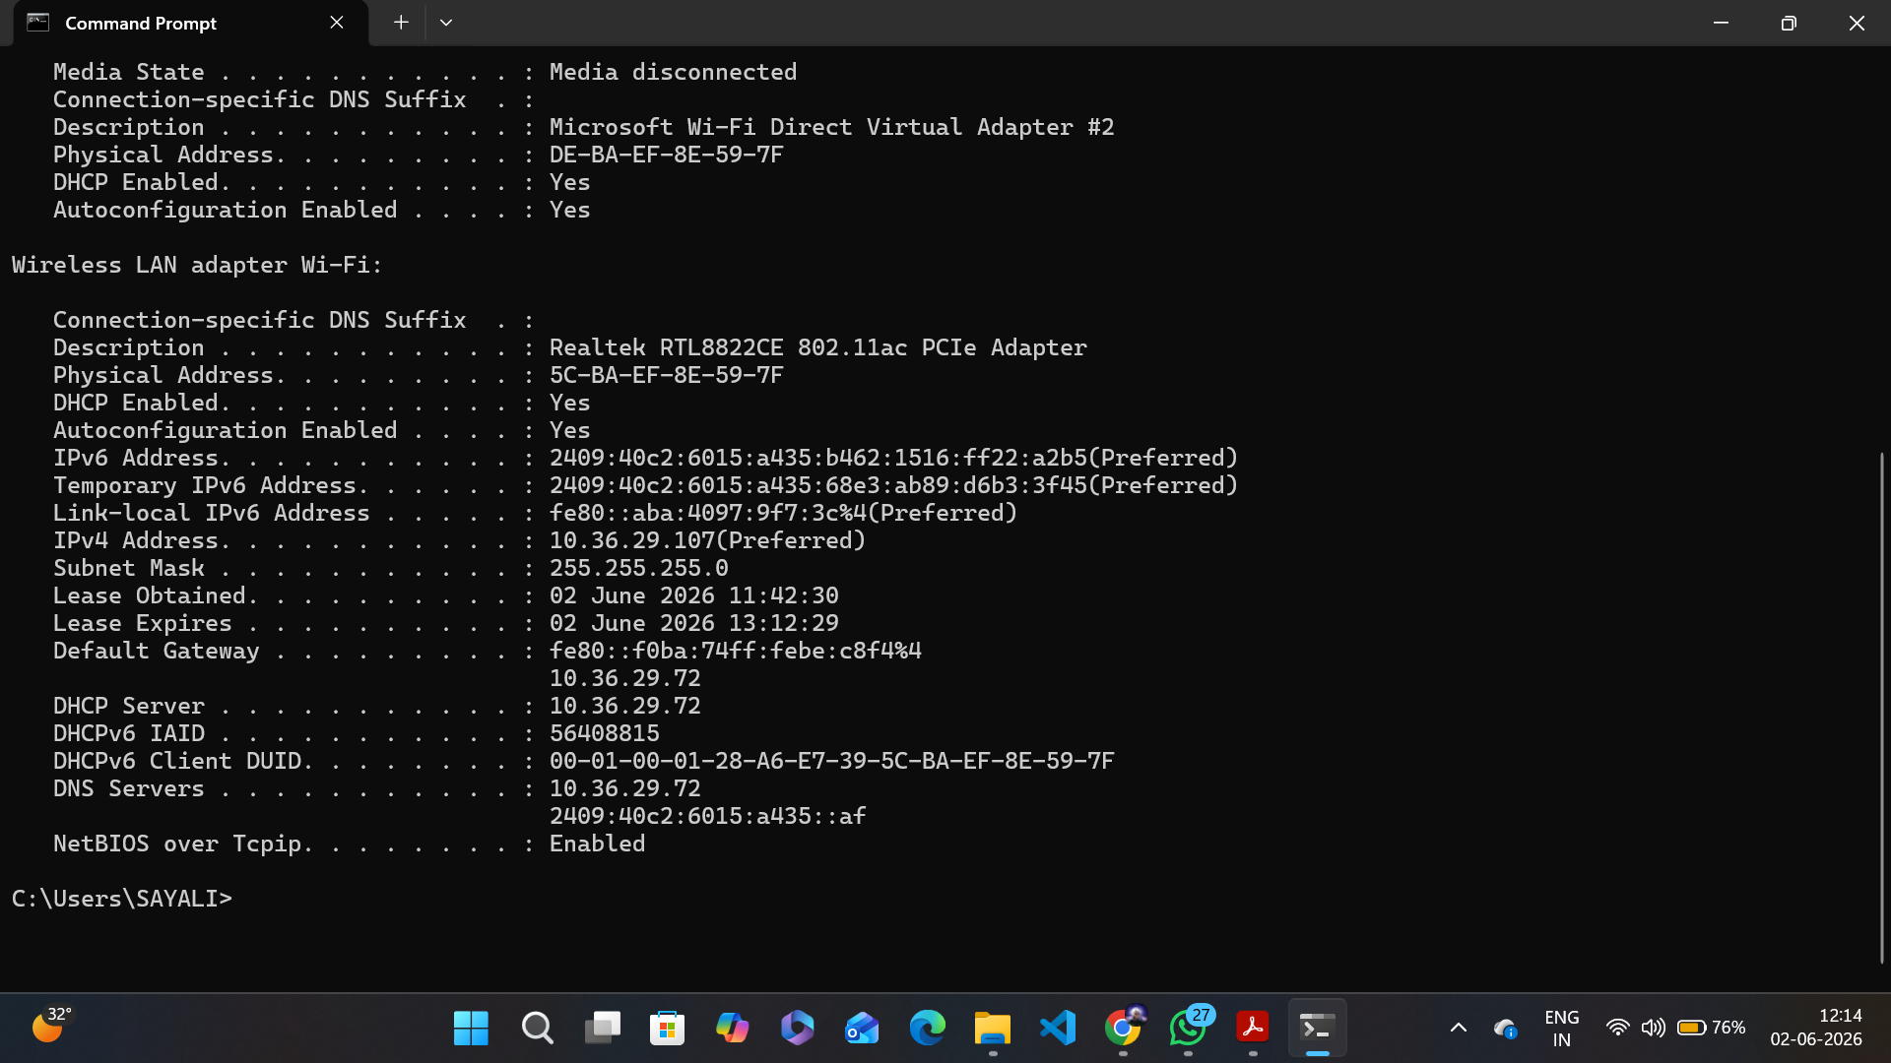

Part B: Basic Networking Concepts
Q1. What is an IP Address?
Ans: An IP (Internet Protocol) Address is a unique digital label assigned to every device connected to a computer network. It helps devices identify and communicate with each other over the internet or local network.
Ex: 192.168.1.1 (IPv4) or 2001:db8::ff00:42:8329 (IPv6).
Q2. What is a MAC Address?
Ans: A MAC (Media Access Control) Address is a unique hardware identifier assigned to a network adapter. It is used for communication within a local network. MAC address never changes, no matter what network you connect to. It is used to identify your specific device among other devices on the exact same local network.
Ex: 00:1A:2B:3C:4D:5E.

Q3. What is a Default Gateway?
Ans: A Default Gateway is the "exit door" your local network uses to connect to the internet. In most home networks, your router is the default gateway. When your device wants to send data, it checks if the destination is local network. If it isn't, your device doesn't know where to go next, so it passes the data to the Default Gateway, which knows how to route it out to the broader internet.

Q4. What is DNS?
Ans: DNS (Domain Name System) converts domain names like google.com into IP addresses so computers can locate websites. Without DNS, you would have to memorize a string of numbers for every website you want to visit.

Q5. Difference between Public IP and Private IP
Ans:
Private IP Address | Public IP Address
Used within a local or private network | Used for communication over the internet
Not routable on the public internet | Routable on the public internet
Scope is limited to the local network | Scope is global
Assigned by router or DHCP server | Assigned by ISP
Unique within a local network | Globally unique
Freely usable inside networks | May involve additional ISP cost
Example: 192.168.1.10 | Example: 203.0.113.10

Part C: Create a Basic Network Diagram

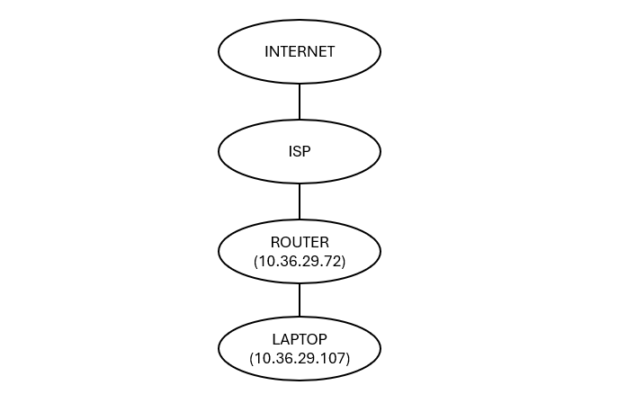

Part D: Network Connectivity Test

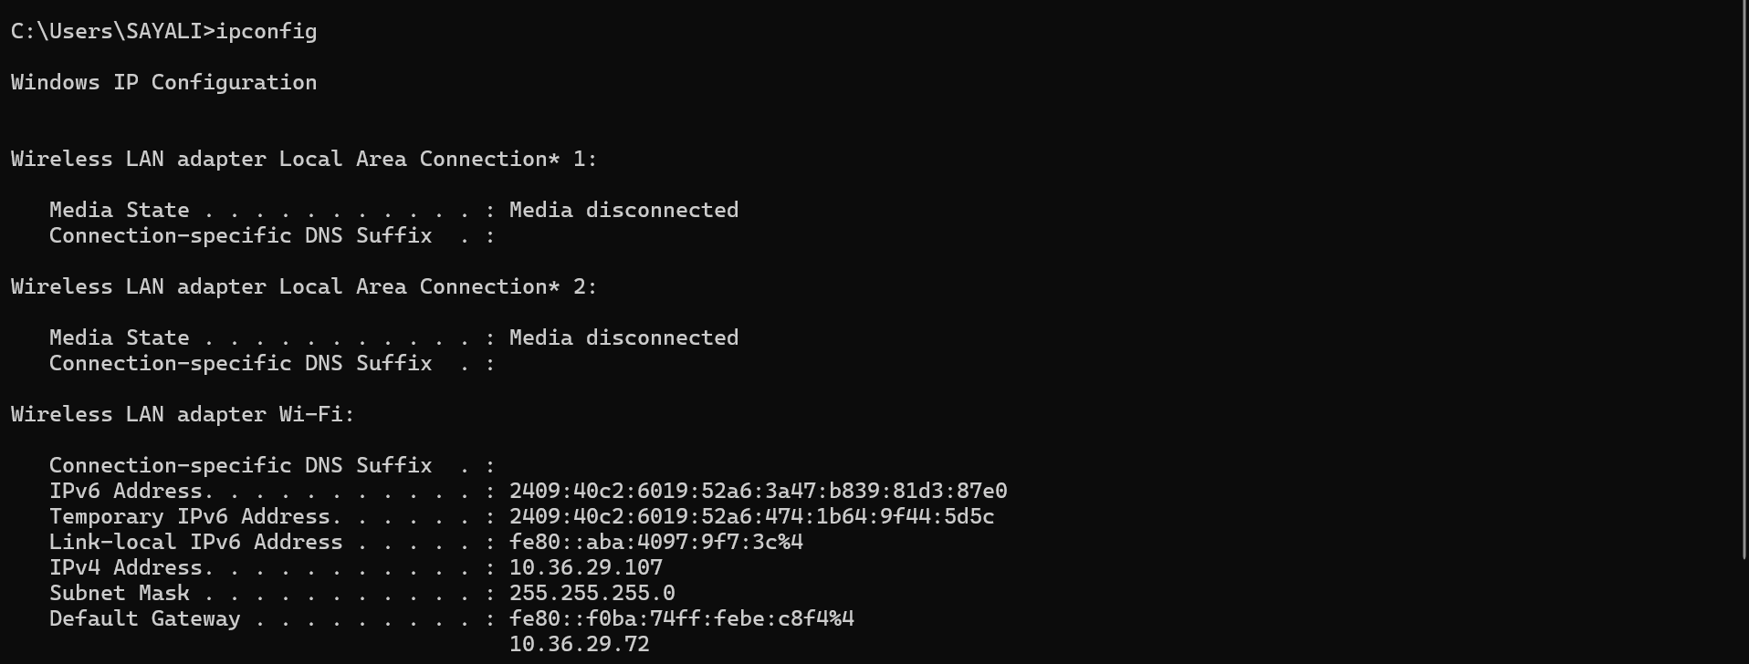

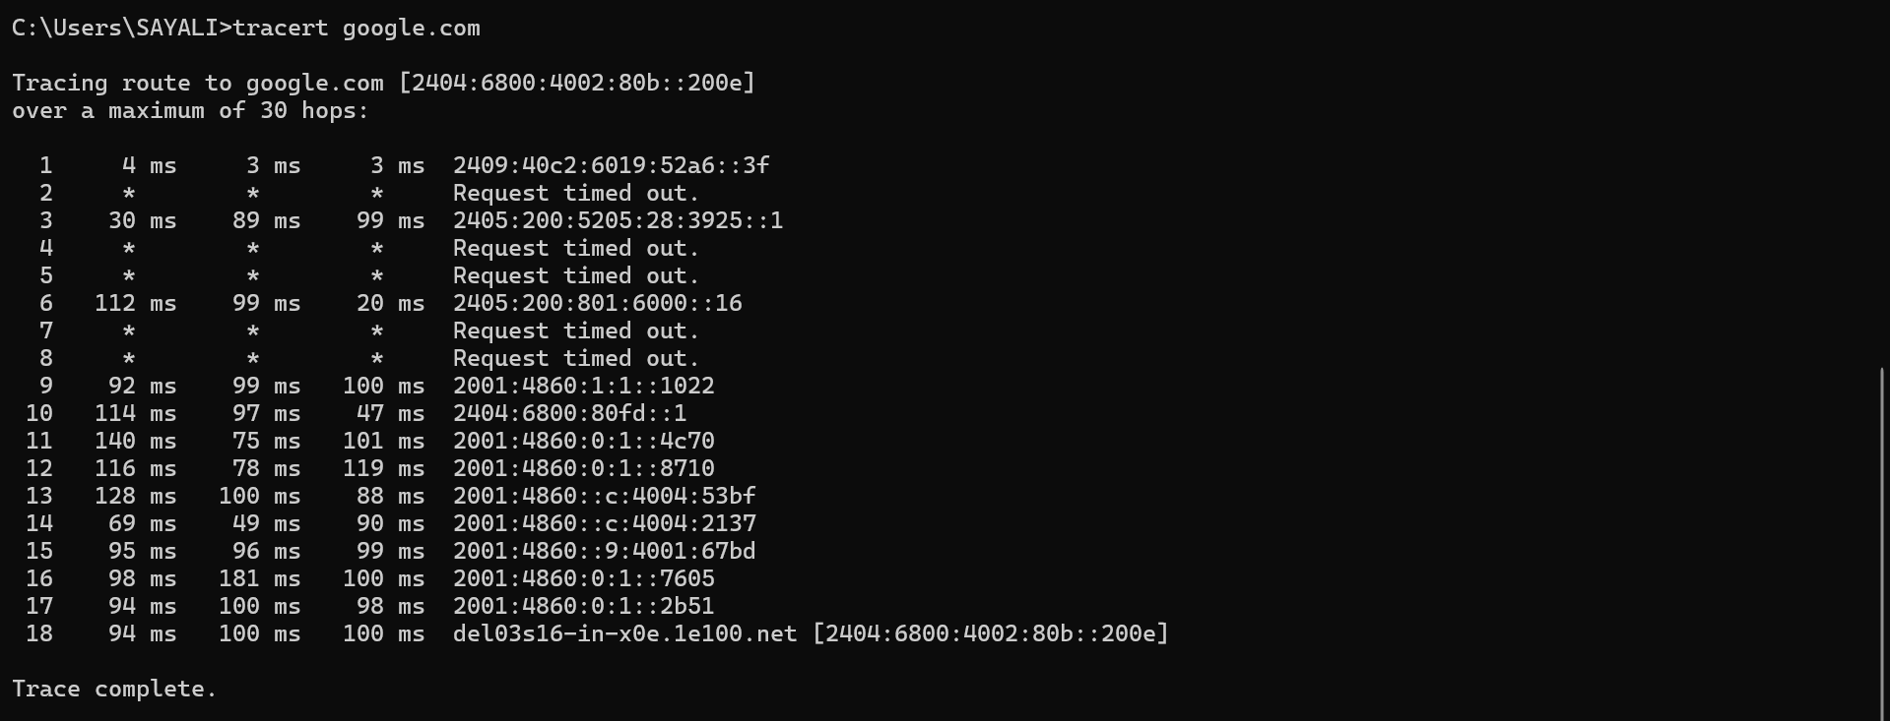

Q1. Was the ping successful?
Ans: Yes, the ping was successful. All 4 packets were received with 0% packet loss.

Q2. How many hops were shown?
Ans: 18 hops were shown in the traceroute result.

Q3. What is the purpose of traceroute?
Ans: Traceroute is a network diagnostic tool that shows the path (route) taken by data packets from your device to a destination server. It displays each hop along the route and helps identify network delays or connectivity issues.

