WHITE BAND ASSOCIATES
CYBER SECURITY SUMMER INTERNSHIP

Networking Task No. 02: Network Devices & IP Addressing
Name: Sayali Dattatray Kute
Date: 04/06/2026

Part A: Network Device Research
- Router
- Purpose: Connects multiple networks together (e.g., your home network to the internet) and directs data packets to their exact destinations.
- How it works: It reads the destination IP address of incoming data and consults a routing table to determine the most efficient and fastest path to send that data along.
- Real-world usage: Used at home to link your devices to your ISP, and by large organizations to connect different branch offices across cities.

- Switch
- Purpose: Connects various devices (like computers, printers, and servers) together to form a Local Area Network (LAN).
- How it works: Unlike older devices, a switch keeps a table of device addresses (MAC addresses). It sends incoming data only to the specific device it is meant for, rather than broadcasting it to everyone.
- Real-world usage: Used in office buildings, schools, and homes to securely link multiple wired devices together for fast, uninterrupted communication.

- Hub
- Purpose: A basic, legacy hardware device used to connect multiple computers together in a single LAN segment.
- How it works: It acts as a "dumb" repeater. When it receives data on one port, it broadcasts that data to all other connected ports, regardless of who the intended recipient is.
- Real-world usage: Rarely used today because its constant broadcasting causes network congestion and security flaws. You might only see them in very old legacy systems or as novelty setups.

- Access Point (AP)
- Purpose: Allows wireless devices to connect to a wired network.
- How it works: It takes a wired Ethernet connection, converts it into radio waves, and broadcasts a Wi-Fi signal so wireless gadgets (phones, laptops, smart TVs) can communicate with the network.
- Real-world usage: Found everywhere—from your home wireless router to large-scale ceiling-mounted units in coffee shops, airports, and corporate offices.

- Firewall
- Purpose: Acts as a security barrier to monitor and control all incoming and outgoing network traffic.
- How it works: It evaluates data against a predefined set of security rules, blocking suspicious, unauthorized, or malicious traffic from entering your private network.
- Real-world usage: Actively protecting home networks from hackers and securing corporate infrastructure from external cyber threats and data breaches.

- Modem
- Purpose: Modulator/Demodulator. It bridges your local network with the outside world by translating signals.
- How it works: It translates the analog signals from your Internet Service Provider (via cable, fiber, or telephone lines) into digital data that your computer can understand, and vice versa.
- Real-world usage: Plugs directly into the wall on one end and your router on the other, bringing the internet connection into your home or office.

Part B: IP Address Classification

IP Address | Public/Private | Reason
192.168.1.10 | Private | Falls in 192.168.0.0 – 192.168.255.255 range
10.0.0.5 | Private | Falls in 10.0.0.0 – 10.255.255.255 range
172.16.5.20 | Private | Falls in 172.16.0.0 – 172.31.255.255 range
8.8.8.8 | Public | Google's public DNS
1.1.1.1 | Public | Cloudflare's public DNS
192.168.100.1 | Private | Falls in private IP range

Part C: Understand Your Network

Parameter | Value
IPv4 Address | 10.36.29.107
Default Gateway | 10.36.29.72
DNS Server | 10.36.29.72

Q1. Which IP range does your device belong to?
Ans: My device belongs to the 10.x.x.x private IP range.

Q2. Is it Public or Private?
Ans: It is a Private IP Address because it falls within the 10.0.0.0 – 10.255.255.255 private address range.

Q3. What role does your router play?
Ans: The router connects my local network to the internet and forwards data between devices and external networks.

Q4. What would happen if DNS stopped working?
Ans: Websites could not be accessed using domain names. Users would need to enter IP addresses manually.
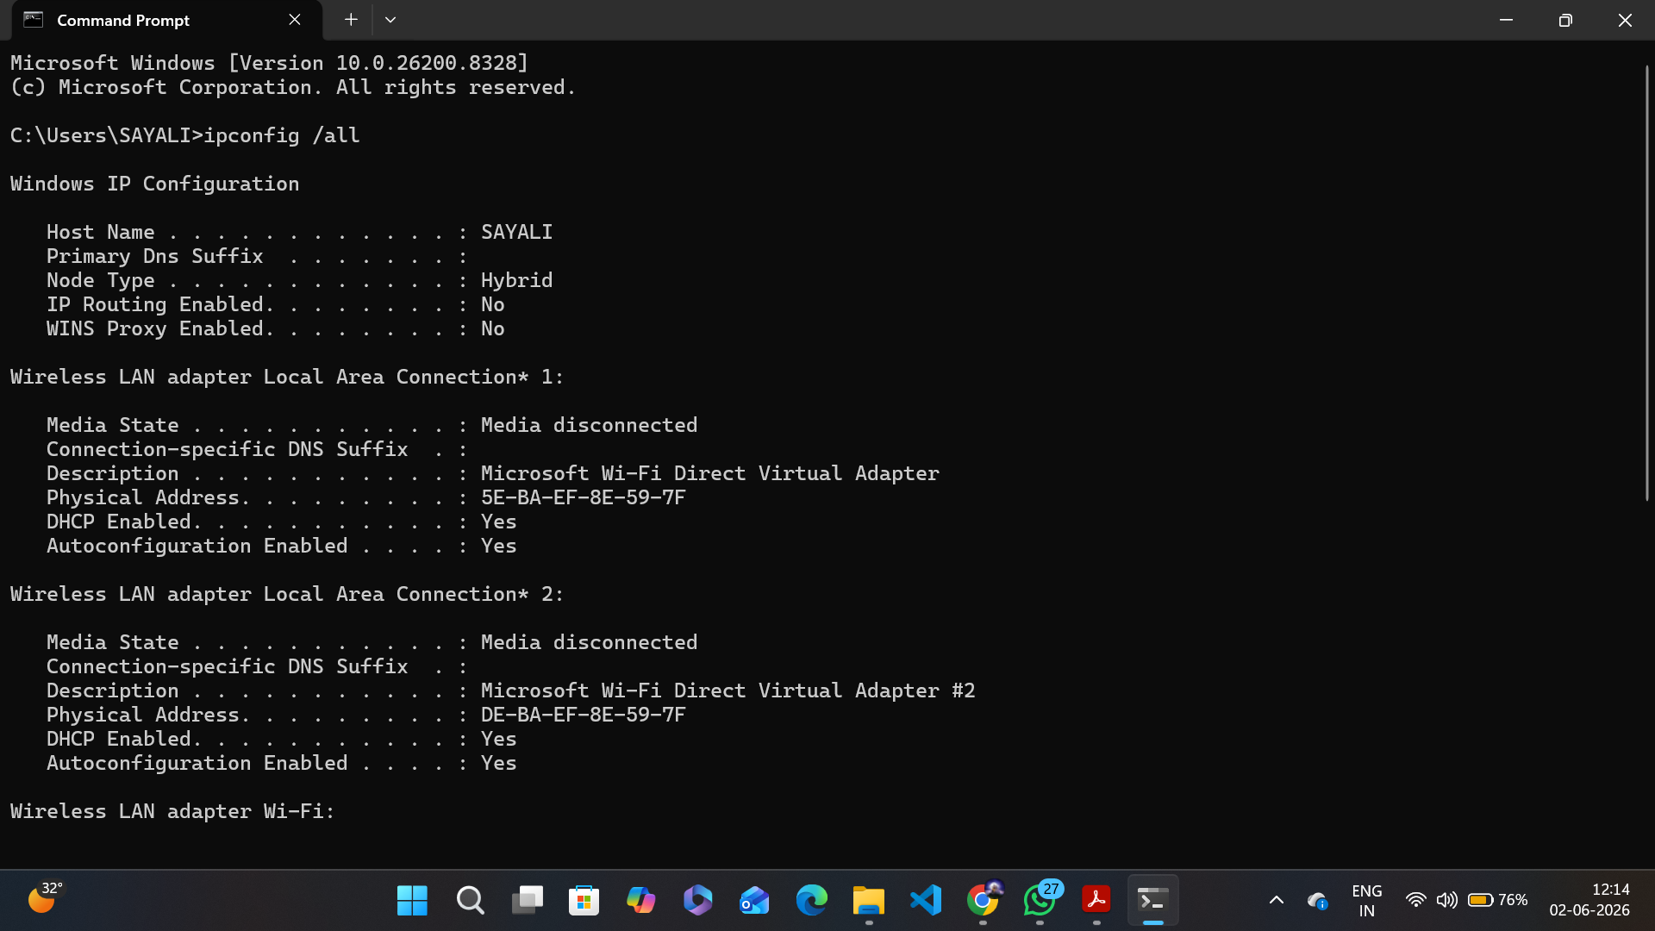
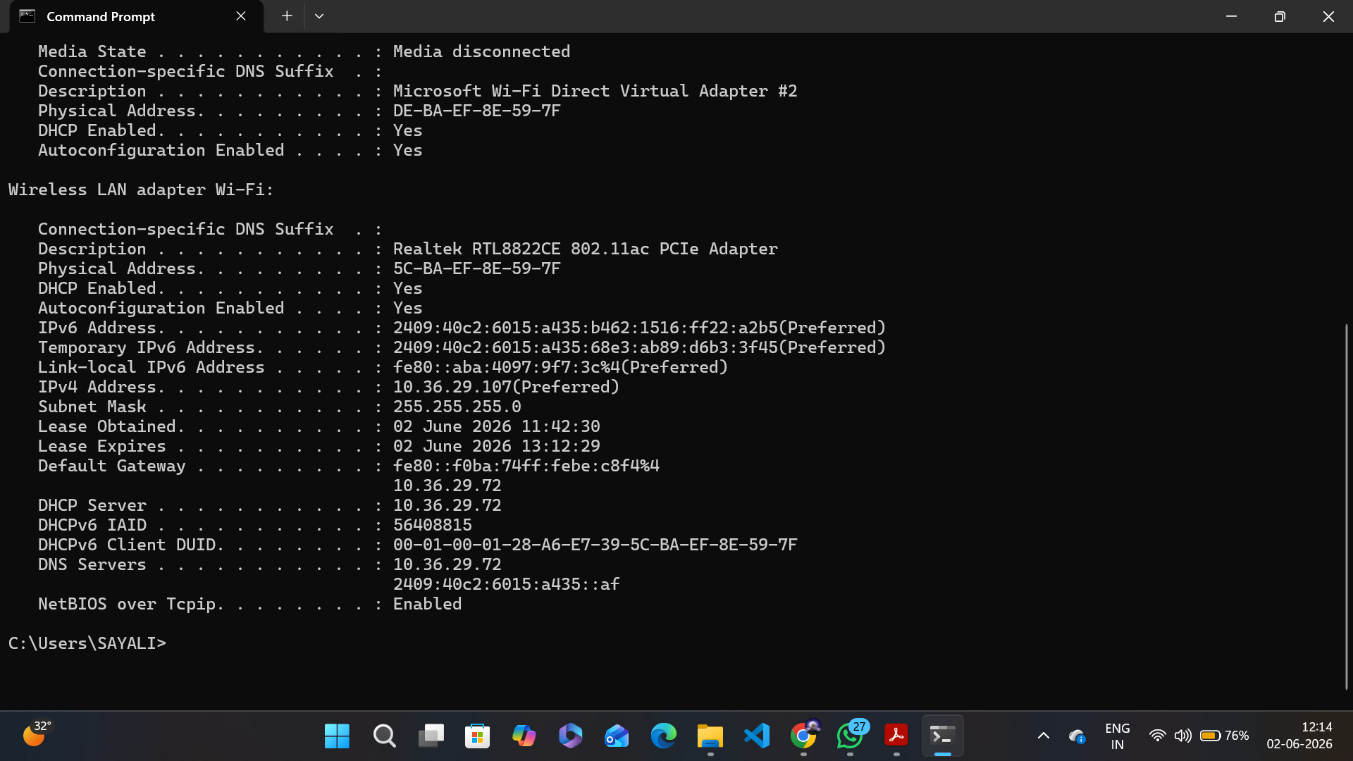

Part D: Network Communication Flow

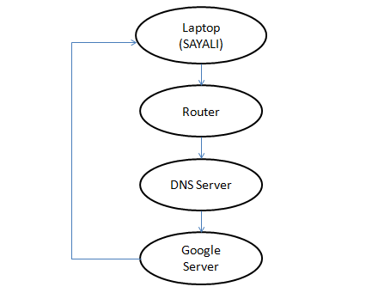

Step 1 :
The user enters www.google.com into a web browser.

Step 2 :
The request is sent to the router, which forwards it to the DNS server.

Step 3 :
The DNS server translates www.google.com into an IP address.

Step 4 :
The browser sends a request to Google's server using the IP address.

Step 5 :
Google's server processes the request and sends the webpage data back.

Step 6 :
The webpage is displayed on the user's device.

Part E: Practice Command Exercise




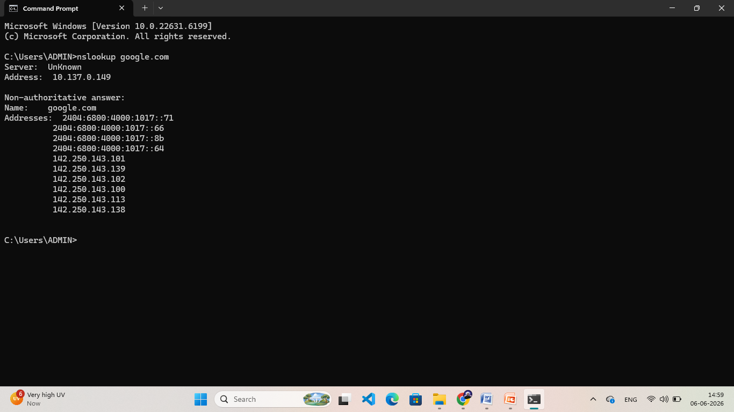

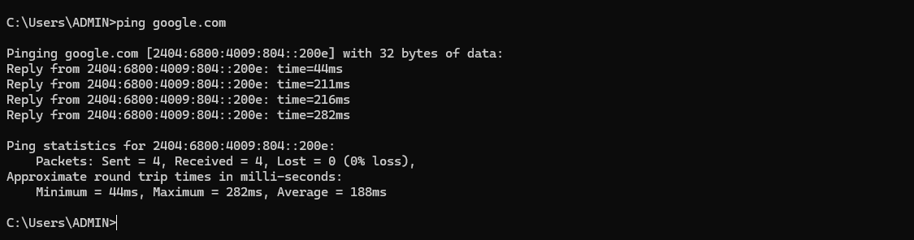

Q1. What IP address did DNS return for Google?

Ans: The DNS server returned multiple IP addresses for Google:
IPv4 Addresses:
142.250.143.101
142.250.143.139
142.250.143.102
142.250.143.100
142.250.143.113
142.250.143.138
IPv6 Addresses:
2404:6800:4000:1017::71
2404:6800:4000:1017::66
2404:6800:4000:1017::8b
2404:6800:4000:1017::64

Q2. Was the ping successful?
Ans: Yes, the ping was successful.

Q3. Why is DNS important before communication begins?
Ans: DNS is important because it translates human-readable domain names (such as google.com) into IP addresses that computers can understand. Without DNS, users would need to remember and enter IP addresses instead of website names.

