WHITE BAND ASSOCIATES
CYBER SECURITY SUMMER INTERNSHIP

Linux Task No. 02: Users, Groups & File Permissions

Name: Sayali Dattatray Kute
Date: 09/06/2026

Part A: Understanding Users

Q1. What is your current username?
Ans: My current username is sayali.

Q2. What is UID?
Ans: UID (User Identifier) is a unique numerical value assigned to each user account in Linux.

Q3. What is GID?
Ans: GID (Group Identifier) is a unique numerical value assigned to a user group in Linux.

Q4. What information does /etc/passwd contain?
Ans: The /etc/passwd file stores information about user accounts including username, UID, GID, home directory, shell information, and account details.
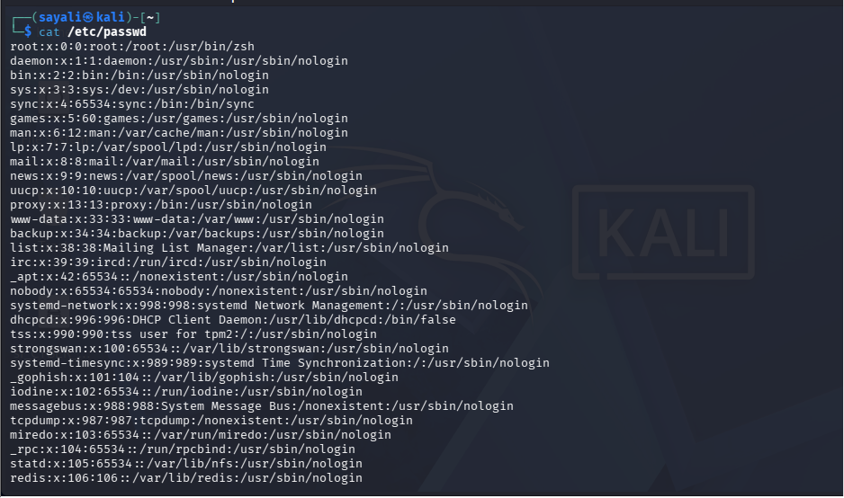
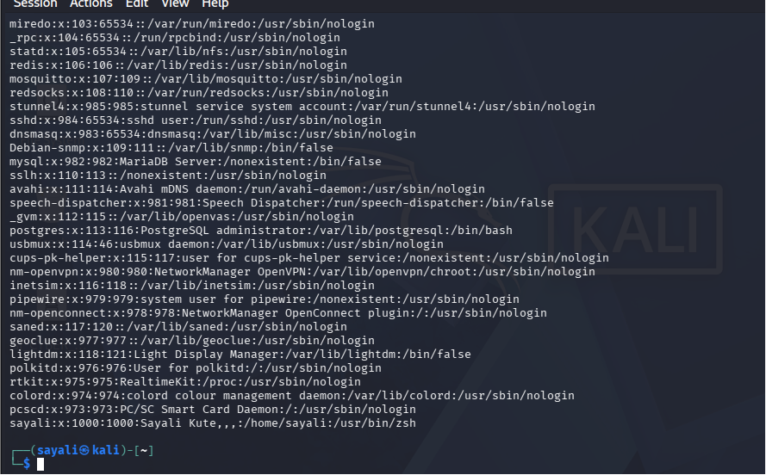
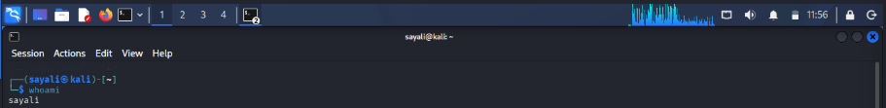

Part B: Create Users & Groups

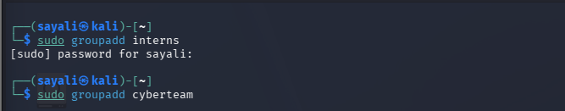
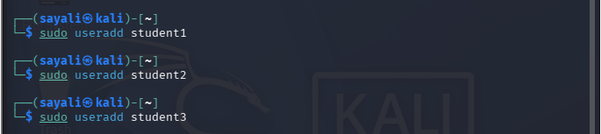
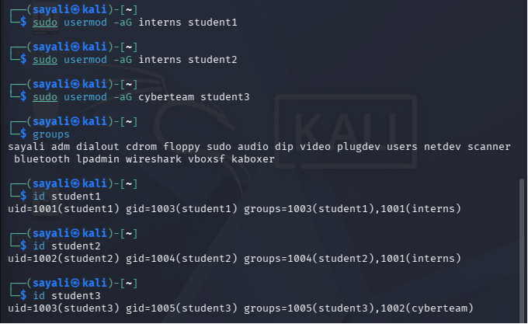
Part C: File Ownership

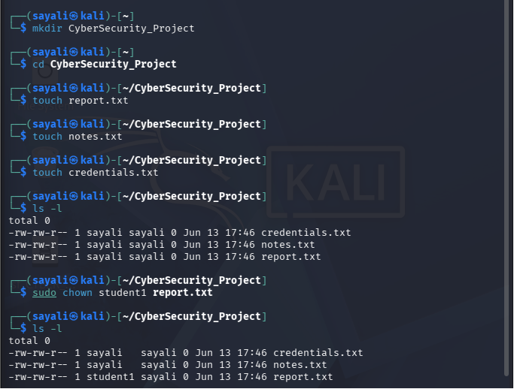

Original Owner : sayali

New Owner : student1

Command Used : sudo chown student1 report.txt

Purpose: The chown command is used to change the ownership of a file or directory. This allows administrators to control access and file management responsibilities.

Part D: File Permissions

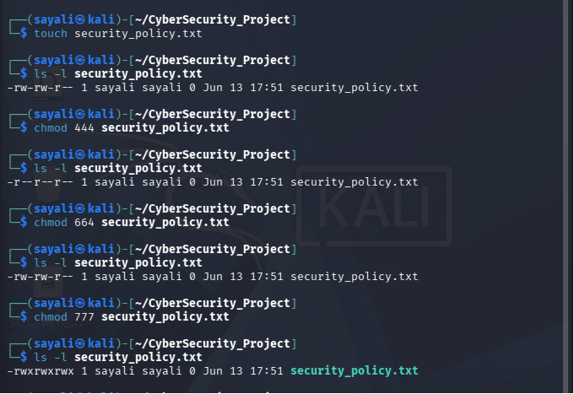

Part E: Permission Analysis

Permission 755
Owner Rights: Read, Write, Execute
Group Rights: Read, Execute
Other Users: Read, Execute
Use Case: Web server directories and executable scripts.

Permission 644
Owner Rights: Read, Write
Group Rights: Read
Other Users: Read
Use Case: Configuration files and documents.

Permission 777
Owner Rights: Read, Write, Execute
Group Rights: Read, Write, Execute
Other Users: Read, Write, Execute
Use Case: Rarely recommended because it allows everyone full access.

Permission 600
Owner Rights: Read, Write
Group Rights: No Access
Other Users: No Access
Use Case: Passwords, SSH keys, and confidential files.

Permission 700
Owner Rights: Read, Write, Execute
Group Rights: No Access
Other Users: No Access
Use Case: Private directories and administrative scripts.

Part F: Security Challenge

File | Recommended Permission | Reason
password_backup.txt | 600 | Contains sensitive credentials and should only be accessible by the owner
public_notice.txt | 644 | Everyone can read it but only the owner can modify it
system_log.txt | 640 | Administrators can read logs while preventing public access
personal_notes.txt | 600 | Personal information should remain private

Explanation:
Sensitive files such as password backups and personal notes should have restricted permissions to prevent unauthorized access.
Public information should be readable by all users but only modifiable by authorized personnel.
System logs should be protected to prevent tampering while remaining accessible to administrators.

Part G: Linux Security Research

Q1. Why are file permissions important?
Ans: File permissions control who can read, write, or execute files. They help protect sensitive information and maintain system security.

Q2. What happens if sensitive files are given 777 permissions?
Ans: Any user can read, modify, or delete the files. This creates a major security risk and can lead to data breaches or system compromise.

Q3. What is the Principle of Least Privilege?
Ans: The Principle of Least Privilege states that users should only receive the minimum permissions required to perform their tasks.

Q4. Why do organizations restrict user access?
Ans: Organizations restrict access to protect sensitive data, prevent unauthorized changes, reduce insider threats, and maintain system integrity.

