Name: Seshasai.PB Reg_N0: 21MIA1005

Image and Video Analytics Assignment 2

**Lab Task 1: Setup and Basic Extraction**

**Objective:**

Install the necessary tools and libraries, and extract frame information from a video.

**Steps:**

1. **Install ffmpeg and ffmpeg-python**:
   * Install the ffmpeg tool and the ffmpeg-python library.
2. **Extract Frame Information**:
   * Extract frame information from a sample video.

Code:

import sys

import ffmpeg

sys.path.append(r'C:\ffmpeg')

input_file = 'in.mp4'

output_pattern = 'frames/frame_%04d.jpeg'

ffmpeg.input(input_file).output(output_pattern).run()

****my spyder console is not recognizing **‘ffmpeg’** I’m running it in **‘command prompt’**

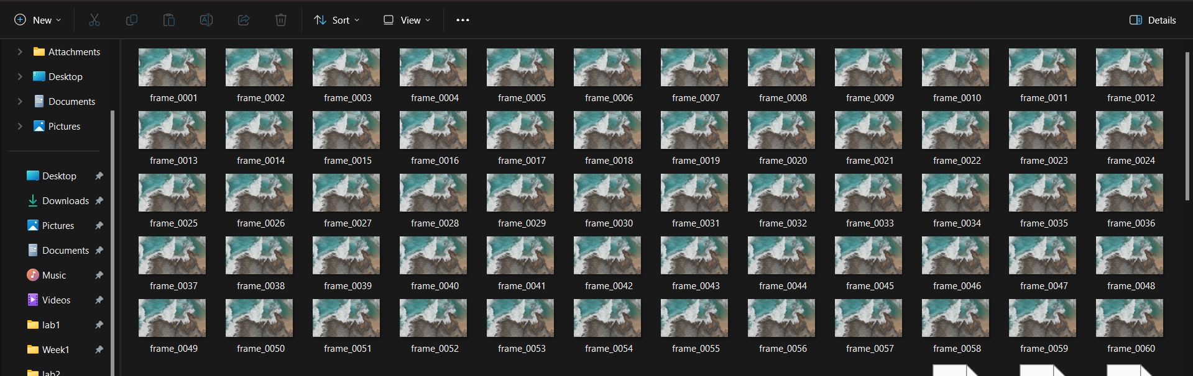So after running this we get our frames

To get information about each frame we can run this prompt in cmd

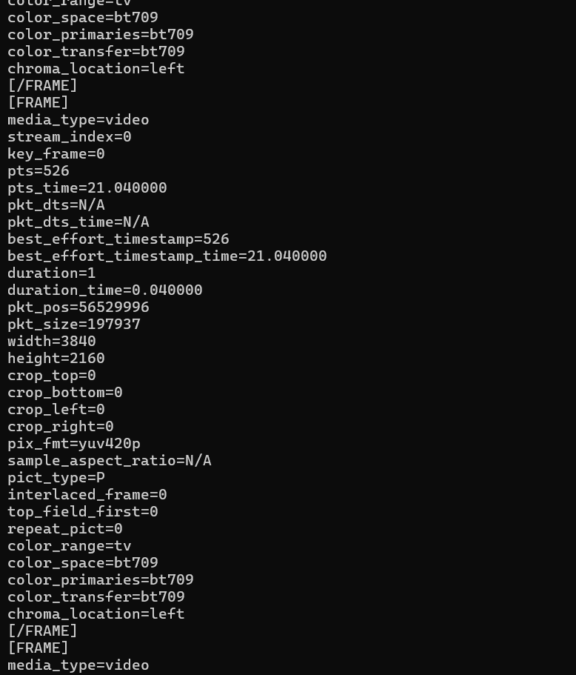This will display information about each frame

**Lab Task 2: Frame Type Analysis**

**Objective:**

Analyze the extracted frame information to understand the distribution of I, P, and B frames in a video.

**Steps:**

1. **Modify the Script**:
   * Count the number of I, P, and B frames.
   * Calculate the percentage of each frame type in the video.
2. **Analyze Frame Distribution**:
   * Plot the distribution of frame types using a library like matplotlib.
   * Plot a pie chart or bar graph showing the distribution of frame types using matplotlib.

To get type of frame information, Enter

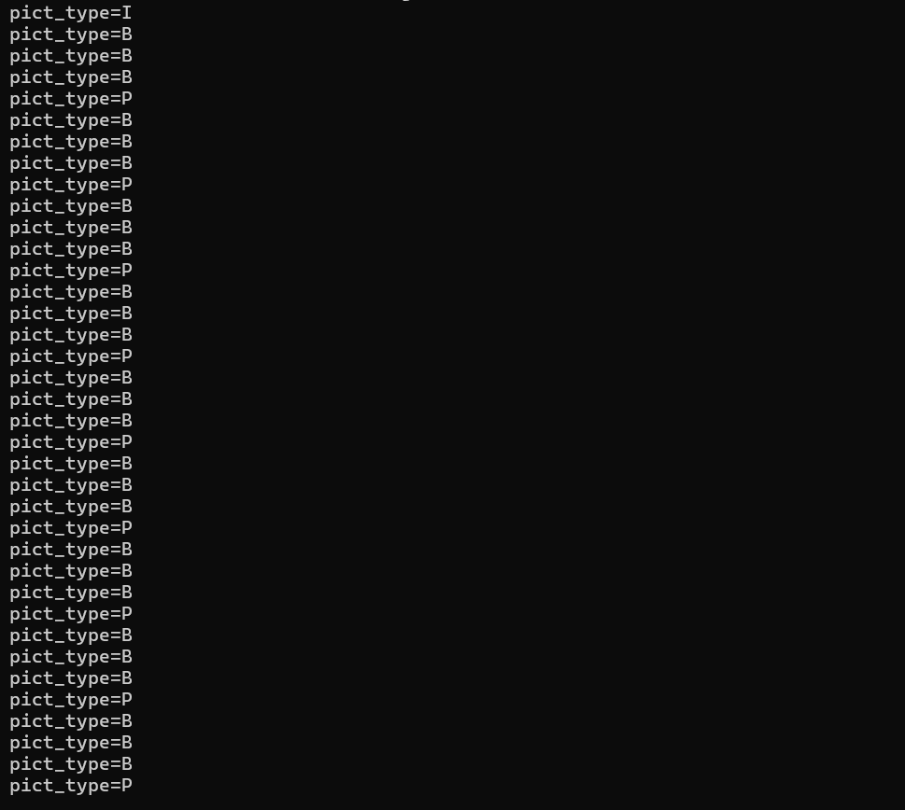This will display type of each frame

We can extract this and information to analyse and visualize the frames to get information

**Code:**

frame_types =["I"

,"B"

,"B"

,"B"

,"P"

,"B"

,"B"

,"B"

,"P"

,"B"

,"B"

,"B"

,"P"

,"B"

,"B"

,"B"

,"P"

,"B"

,"B"

,"B"

,"P"

,"B"

,"B"

,"B"

,"P"

,"B"

,"B"

,"B"

,"P"

,"B"

,"B"

,"B"

,"P"

,"B"

,"B"

,"B"

,"P"

,"B"

,"B"

,"B"

,"P"

,"B"

,"B"

,"P"

,"B"

,"B"

,"B"

,"P"

,"B"

,"B"

,"B"

,"P"

,"B"

,"B"

,"B"

,"P"

,"B"

,"B"

,"B"

,"P"

,"B"

,"B"

,"B"

,"P"

,"B"

,"B"

,"B"

,"P"

,"B"

,"B"

,"B"

,"P"

,"B"

,"B"

,"B"

,"P"

,"I"

,"B"

,"B"

,"B"

,"P"

,"B"

,"B"

,"B"

,"P"

,"B"

,"B"

,"B"

,"P"

,"B"

,"B"

,"B"

,"P"

,"B"

,"B"

,"B"

,"P"

,"B"

,"B"

,"B"

,"P"

,"B"

,"B"

,"B"

,"P"

,"B"

,"B"

,"B"

,"P"

,"B"

,"B"

,"B"

,"P"

,"B"

,"B"

,"B"

,"P"

,"B"

,"B"

,"B"

,"P"

,"B"

,"B"

,"B"

,"P"

,"B"

,"B"

,"B"

,"P"

,"B"

,"B"

,"B"

,"P"

,"B"

,"B"

,"B"

,"P"

,"B"

,"B"

,"P"

,"B"

,"B"

,"B"

,"P"

,"B"

,"B"

,"B"

,"P"

,"B"

,"B"

,"B"

,"P"

,"I"

,"B"

,"B"

,"P"

,"B"

,"B"

,"B"

,"P"

,"B"

,"B"

,"B"

,"P"

,"B"

,"B"

,"B"

,"P"

,"B"

,"B"

,"B"

,"P"

,"B"

,"B"

,"B"

,"P"

,"B"

,"B"

,"P"

,"B"

,"B"

,"B"

,"P"

,"B"

,"B"

,"B"

,"P"

,"B"

,"B"

,"B"

,"P"

,"B"

,"B"

,"B"

,"P"

,"B"

,"B"

,"B"

,"P"

,"B"

,"B"

,"B"

,"P"

,"B"

,"B"

,"B"

,"P"

,"B"

,"B"

,"B"

,"P"

,"B"

,"B"

,"B"

,"P"

,"B"

,"B"

,"B"

,"P"

,"B"

,"B"

,"B"

,"P"

,"P"

,"B"

,"B"

,"B"

,"P"

,"I"

,"B"

,"B"

,"B"

,"P"

,"B"

,"B"

,"B"

,"P"

,"B"

,"B"

,"B"

,"P"

,"B"

,"B"

,"B"

,"P"

,"B"

,"B"

,"B"

,"P"

,"B"

,"B"

,"B"

,"P"

,"B"

,"B"

,"B"

,"P"

,"B"

,"B"

,"B"

,"P"

,"B"

,"B"

,"B"

,"P"

,"B"

,"B"

,"P"

,"B"

,"B"

,"B"

,"P"

,"B"

,"B"

,"B"

,"P"

,"B"

,"B"

,"B"

,"P"

,"B"

,"B"

,"B"

,"P"

,"B"

,"B"

,"B"

,"P"

,"B"

,"B"

,"B"

,"P"

,"B"

,"B"

,"B"

,"P"

,"B"

,"B"

,"B"

,"P"

,"B"

,"B"

,"B"

,"P"

,"I"

,"B"

,"B"

,"B"

,"P"

,"B"

,"B"

,"B"

,"P"

,"P"

,"B"

,"B"

,"B"

,"P"

,"B"

,"B"

,"B"

,"P"

,"B"

,"B"

,"B"

,"P"

,"B"

,"B"

,"B"

,"P"

,"B"

,"B"

,"B"

,"P"

,"B"

,"B"

,"B"

,"P"

,"B"

,"B"

,"B"

,"P"

,"B"

,"B"

,"B"

,"P"

,"B"

,"B"

,"B"

,"P"

,"B"

,"B"

,"B"

,"P"

,"B"

,"B"

,"P"

,"B"

,"B"

,"B"

,"P"

,"B"

,"B"

,"B"

,"P"

,"B"

,"B"

,"B"

,"P"

,"B"

,"B"

,"P"

,"B"

,"B"

,"B"

,"P"

,"B"

,"B"

,"B"

,"P"

,"I"

,"B"

,"B"

,"B"

,"P"

,"B"

,"B"

,"B"

,"P"

,"B"

,"B"

,"B"

,"P"

,"B"

,"B"

,"B"

,"P"

,"B"

,"B"

,"B"

,"P"

,"B"

,"B"

,"B"

,"P"

,"B"

,"B"

,"P"

,"B"

,"B"

,"B"

,"P"

,"B"

,"B"

,"B"

,"P"

,"B"

,"B"

,"B"

,"P"

,"B"

,"B"

,"B"

,"P"

,"B"

,"B"

,"B"

,"P"

,"B"

,"B"

,"B"

,"P"

,"B"

,"B"

,"B"

,"P"

,"B"

,"B"

,"B"

,"P"

,"B"

,"B"

,"B"

,"P"

,"B"

,"B"

,"B"

,"P"

,"B"

,"B"

,"B"

,"P"

,"B"

,"B"

,"B"

,"P"

,"I"

,"B"

,"B"

,"B"

,"P"

,"B"

,"B"

,"B"

,"P"

,"B"

,"B"

,"B"

,"P"

,"B"

,"B"

,"B"

,"P"

,"B"

,"B"

,"B"

,"P"

,"B"

,"B"

,"B"

,"P"

,"B"

,"B"

,"B"

,"P"

,"B"

,"B"

,"B"

,"P"

,"B"

,"B"

,"P"

,"B"

,"B"

,"B"

,"P"

,"B"

,"B"

,"B"

,"P"

,"B"

,"B"

,"B"

,"P"

,"B"

,"B"

,"B"

,"P"

,"B"

,"B"

,"B"

,"P"

,"B"

,"B"

,"B"

,"P"

,"B"

,"B"

,"B"

,"P"

,"B"

,"B"

,"B"

,"P"

,"B"

,"B"

,"P"

,"P"]

# Count the number of each frame type

frame_counts = {'I': 0, 'P': 0, 'B': 0}

for frame_type in frame_types:

    if frame_type in frame_counts:

        frame_counts[frame_type] += 1

# Calculate total frames

total_frames = len(frame_types)

# Calculate percentage of each frame type

frame_percentages = {ftype: (count / total_frames) * 100 for ftype, count in frame_counts.items()}

# Print the results

print(f"Frame Counts: {frame_counts}")

print(f"Frame Percentages: {frame_percentages}")

import matplotlib.pyplot as plt

def plot_distribution(frame_counts, frame_percentages):

    # Plotting the Pie Chart

    plt.figure(figsize=(12, 6))

    plt.subplot(1, 2, 1)

    plt.pie(frame_counts.values(), labels=frame_counts.keys(), autopct='%1.1f%%')

    plt.title('Frame Type Distribution (Pie Chart)')

    # Plotting the Bar Graph

    plt.subplot(1, 2, 2)

    plt.bar(frame_counts.keys(), frame_counts.values(), color=['red', 'green', 'blue'])

    plt.xlabel('Frame Type')

    plt.ylabel('Count')

    plt.title('Frame Type Distribution (Bar Graph)')

    plt.tight_layout()

    plt.show()

plot_distribution(frame_counts, frame_percentages)

**Output:**

Frame Counts: {'I': 7, 'P': 135, 'B': 386}

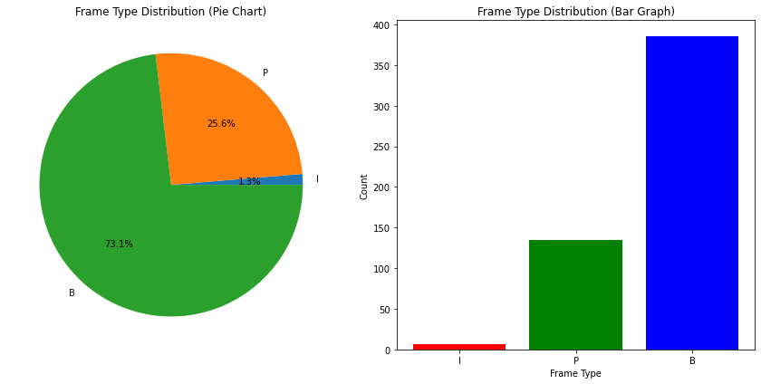Frame Percentages: {'I': 1.3257575757575757, 'P': 25.568181818181817, 'B': 73.10606060606061}

**Lab Task 3: Visualizing Frames**

**Objective:**

Extract actual frames from the video and display them using Python.

**Steps:**

1. **Extract Frames**:
   * Use ffmpeg to extract individual I, P, and B frames from the video.
   * Save these frames as image files.
2. **Display Frames**:
   * Use a library like PIL (Pillow) or opencv-python to display the extracted frames.

**Tasks:**

1. Save I, P, and B frames as separate image files using ffmpeg.
2. Use PIL or opencv-python to load and display these frames in a Python script.
3. Compare the visual quality of I, P, and B frames.

**Code:**

import os

# Path to frames directory

frames_dir = './frames/'  # Adjust this path as needed

# Rename frames

for i, frame_type in enumerate(frame_types):

    original_filename = f"frame_{i+1:04d}.jpeg"

    new_filename = f"{frame_type}_frame_{i+1:04d}.jpeg"

    original_path = os.path.join(frames_dir, original_filename)

    new_path = os.path.join(frames_dir, new_filename)

    if os.path.exists(original_path):

        os.rename(original_path, new_path)

    else:

        print(f"File {original_filename} does not exist in the directory.")

import cv2

import matplotlib.pyplot as plt

# Define a function to display images using OpenCV

def display_frames(frame_paths):

    for path in frame_paths:

        # Load the image

        image = cv2.imread(path)

        # Convert BGR to RGB for displaying using matplotlib

        image_rgb = cv2.cvtColor(image, cv2.COLOR_BGR2RGB)

        plt.imshow(image_rgb)

        plt.title(f"Frame: {os.path.basename(path)}")

        plt.axis('off')

        plt.show()

# Example paths (Replace with actual paths after renaming)

example_I_frame = os.path.join(frames_dir, 'I_frame_0001.jpeg')

example_P_frame = os.path.join(frames_dir, 'P_frame_0005.jpeg')

example_B_frame = os.path.join(frames_dir, 'B_frame_0002.jpeg')

# Displaying example frames

display_frames([example_I_frame, example_P_frame, example_B_frame])

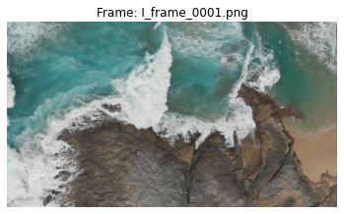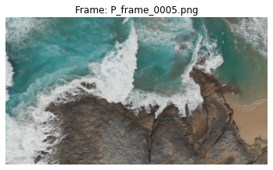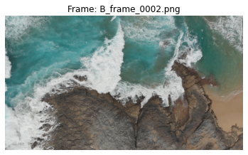**Quality comparison of different image types:**

**Lab Task 4: Frame Compression Analysis**

**Objective:**

Analyze the compression efficiency of I, P, and B frames.

**Steps:**

1. **Calculate Frame Sizes**:
   * Calculate the file sizes of extracted I, P, and B frames.
   * Compare the average file sizes of each frame type.
2. **Compression Efficiency**:
   * Discuss the role of each frame type in video compression.
   * Analyze why P and B frames are generally smaller than I frames.

**Code:**

import os

# Directory containing the renamed frames

frames_dir = './frames/'

# Initialize dictionaries to store sizes and counts

frame_sizes = {'I': [], 'P': [], 'B': []}

# Calculate the file sizes

for filename in os.listdir(frames_dir):

    if filename.startswith('I_') or filename.startswith('P_') or filename.startswith('B_'):

        frame_type = filename.split('_')[0]

        file_path = os.path.join(frames_dir, filename)

        file_size = os.path.getsize(file_path)

        frame_sizes[frame_type].append(file_size)

# Calculate average sizes

average_sizes = {frame_type: sum(sizes) / len(sizes) if sizes else 0 for frame_type, sizes in frame_sizes.items()}

# Print out the results

print("Average File Sizes (bytes):")

for frame_type, avg_size in average_sizes.items():

    print(f"{frame_type}: {avg_size:.2f} bytes")

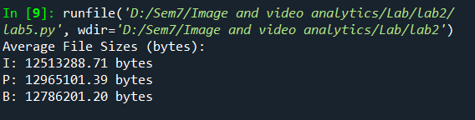

• **Unexpected Size Distribution**:

* Normally, I-frames are the largest because they store a complete picture, while P-frames and B-frames are smaller since they store only the differences relative to other frames. The given sizes indicate that the P and B frames are unexpectedly larger than the I frames.

• **Possible Reasons**:

* **Uncompressed Frame Files**: If the extracted frames are saved as uncompressed images (e.g., PNG), the differences in compression do not apply, and the file size will depend mainly on the image resolution and color depth. In this scenario, even though the frames are labeled as I, P, and B, they all contain full image data, thus resulting in similar sizes.
* **Frame Extraction Process**: The tool or method used to extract these frames might not account for the compressed nature of P and B frames in the original video stream. When frames are extracted and saved as images, each frame is saved as a full image, which negates the compression differences.

**Lab Task 5: Advanced Frame Extraction**

**Objective:**

Extract frames from a video and reconstruct a part of the video using only I frames.

**Steps:**

1. **Extract and Save I Frames**:
   * Extract I frames from the video and save them as separate image files.
2. **Reconstruct Video**:
   * Use the extracted I frames to reconstruct a portion of the video.
   * Create a new video using these I frames with a reduced frame rate.