Name: Seshasai.PB Reg_N0: 21MIA1005

Image and Video Analytics Assignment 2

**Lab Task 1: Setup and Basic Extraction**

**Objective:**

Install the necessary tools and libraries, and extract frame information from a video.

**Steps:**

1. **Install ffmpeg and ffmpeg-python**:
   * Install the ffmpeg tool and the ffmpeg-python library.
2. **Extract Frame Information**:
   * Extract frame information from a sample video.

Code:

import sys

import ffmpeg

sys.path.append(r'C:\ffmpeg')

input_file = 'in.mp4'

output_pattern = 'frames/frame_%04d.jpeg'

ffmpeg.input(input_file).output(output_pattern).run()

****my spyder console is not recognizing **‘ffmpeg’** I’m running it in **‘command prompt’**

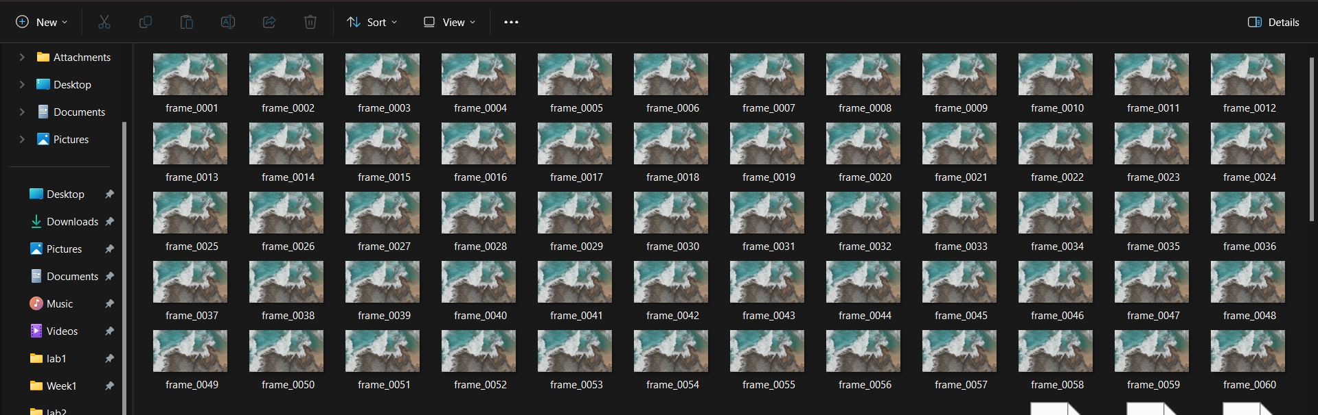So after running this we get our frames

To get information about each frame we can run this prompt in cmd

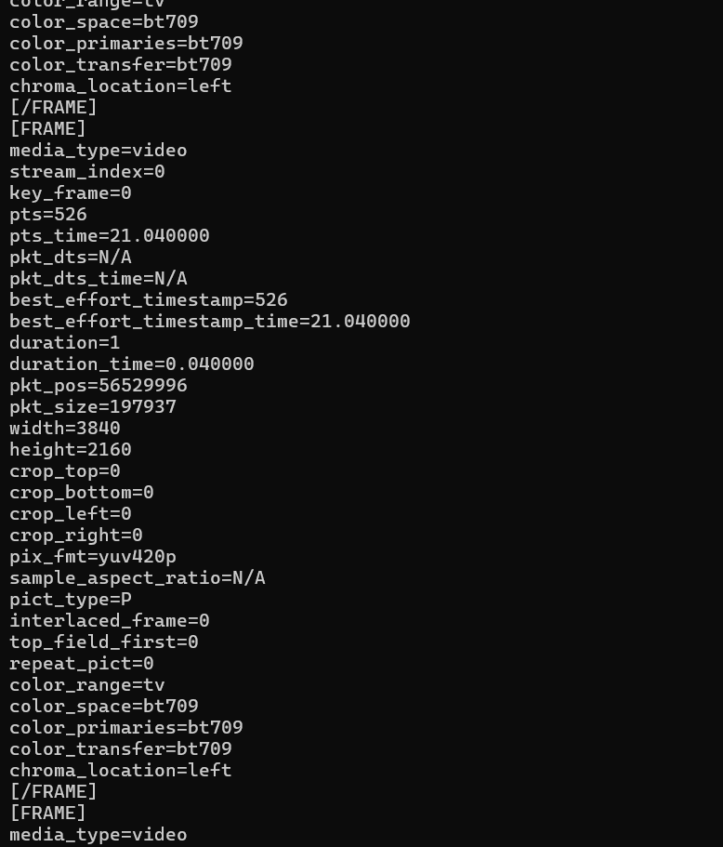This will display information about each frame

**Lab Task 2: Frame Type Analysis**

**Objective:**

Analyze the extracted frame information to understand the distribution of I, P, and B frames in a video.

**Steps:**

1. **Modify the Script**:
   * Count the number of I, P, and B frames.
   * Calculate the percentage of each frame type in the video.
2. **Analyze Frame Distribution**:
   * Plot the distribution of frame types using a library like matplotlib.
   * Plot a pie chart or bar graph showing the distribution of frame types using matplotlib.

To get type of frame information, Enter

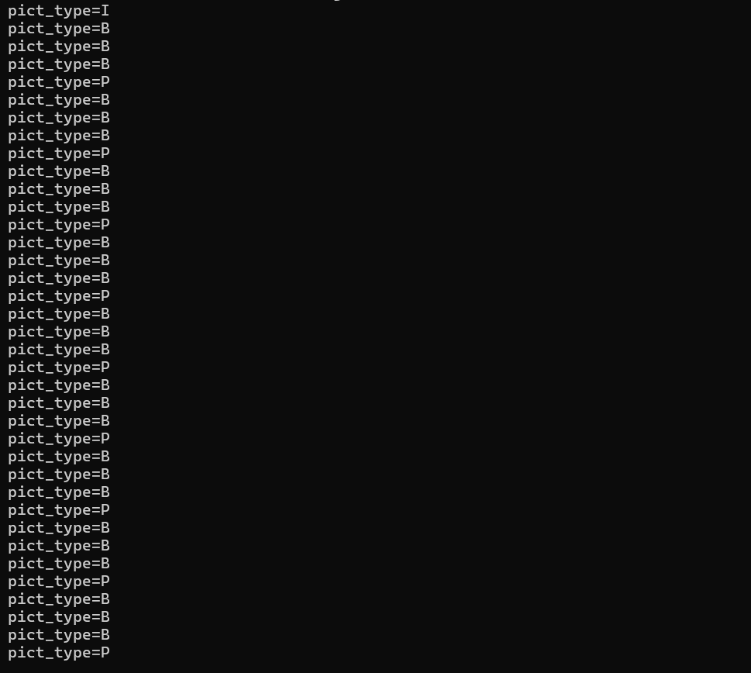This will display type of each frame

We can extract this and information to analyse and visualize the frames to get information

**Code:**

frame_types =["I"

,"B"

,"B"

,"B"

,"P"

,"B"

,"B"

,"B"

,"P"

,"B"

,"B"

,"B"

,"P"

,"B"

,"B"

,"B"

,"P"

,"B"

,"B"

,"B"

,"P"

,"B"

,"B"

,"B"

,"P"

,"B"

,"B"

,"B"

,"P"

,"B"

,"B"

,"B"

,"P"

,"B"

,"B"

,"B"

,"P"

,"B"

,"B"

,"B"

,"P"

,"B"

,"B"

,"P"

,"B"

,"B"

,"B"

,"P"

,"B"

,"B"

,"B"

,"P"

,"B"

,"B"

,"B"

,"P"

,"B"

,"B"

,"B"

,"P"

,"B"

,"B"

,"B"

,"P"

,"B"

,"B"

,"B"

,"P"

,"B"

,"B"

,"B"

,"P"

,"B"

,"B"

,"B"

,"P"

,"I"

,"B"

,"B"

,"B"

,"P"

,"B"

,"B"

,"B"

,"P"

,"B"

,"B"

,"B"

,"P"

,"B"

,"B"

,"B"

,"P"

,"B"

,"B"

,"B"

,"P"

,"B"

,"B"

,"B"

,"P"

,"B"

,"B"

,"B"

,"P"

,"B"

,"B"

,"B"

,"P"

,"B"

,"B"

,"B"

,"P"

,"B"

,"B"

,"B"

,"P"

,"B"

,"B"

,"B"

,"P"

,"B"

,"B"

,"B"

,"P"

,"B"

,"B"

,"B"

,"P"

,"B"

,"B"

,"B"

,"P"

,"B"

,"B"

,"B"

,"P"

,"B"

,"B"

,"P"

,"B"

,"B"

,"B"

,"P"

,"B"

,"B"

,"B"

,"P"

,"B"

,"B"

,"B"

,"P"

,"I"

,"B"

,"B"

,"P"

,"B"

,"B"

,"B"

,"P"

,"B"

,"B"

,"B"

,"P"

,"B"

,"B"

,"B"

,"P"

,"B"

,"B"

,"B"

,"P"

,"B"

,"B"

,"B"

,"P"

,"B"

,"B"

,"P"

,"B"

,"B"

,"B"

,"P"

,"B"

,"B"

,"B"

,"P"

,"B"

,"B"

,"B"

,"P"

,"B"

,"B"

,"B"

,"P"

,"B"

,"B"

,"B"

,"P"

,"B"

,"B"

,"B"

,"P"

,"B"

,"B"

,"B"

,"P"

,"B"

,"B"

,"B"

,"P"

,"B"

,"B"

,"B"

,"P"

,"B"

,"B"

,"B"

,"P"

,"B"

,"B"

,"B"

,"P"

,"P"

,"B"

,"B"

,"B"

,"P"

,"I"

,"B"

,"B"

,"B"

,"P"

,"B"

,"B"

,"B"

,"P"

,"B"

,"B"

,"B"

,"P"

,"B"

,"B"

,"B"

,"P"

,"B"

,"B"

,"B"

,"P"

,"B"

,"B"

,"B"

,"P"

,"B"

,"B"

,"B"

,"P"

,"B"

,"B"

,"B"

,"P"

,"B"

,"B"

,"B"

,"P"

,"B"

,"B"

,"P"

,"B"

,"B"

,"B"

,"P"

,"B"

,"B"

,"B"

,"P"

,"B"

,"B"

,"B"

,"P"

,"B"

,"B"

,"B"

,"P"

,"B"

,"B"

,"B"

,"P"

,"B"

,"B"

,"B"

,"P"

,"B"

,"B"

,"B"

,"P"

,"B"

,"B"

,"B"

,"P"

,"B"

,"B"

,"B"

,"P"

,"I"

,"B"

,"B"

,"B"

,"P"

,"B"

,"B"

,"B"

,"P"

,"P"

,"B"

,"B"

,"B"

,"P"

,"B"

,"B"

,"B"

,"P"

,"B"

,"B"

,"B"

,"P"

,"B"

,"B"

,"B"

,"P"

,"B"

,"B"

,"B"

,"P"

,"B"

,"B"

,"B"

,"P"

,"B"

,"B"

,"B"

,"P"

,"B"

,"B"

,"B"

,"P"

,"B"

,"B"

,"B"

,"P"

,"B"

,"B"

,"B"

,"P"

,"B"

,"B"

,"P"

,"B"

,"B"

,"B"

,"P"

,"B"

,"B"

,"B"

,"P"

,"B"

,"B"

,"B"

,"P"

,"B"

,"B"

,"P"

,"B"

,"B"

,"B"

,"P"

,"B"

,"B"

,"B"

,"P"

,"I"

,"B"

,"B"

,"B"

,"P"

,"B"

,"B"

,"B"

,"P"

,"B"

,"B"

,"B"

,"P"

,"B"

,"B"

,"B"

,"P"

,"B"

,"B"

,"B"

,"P"

,"B"

,"B"

,"B"

,"P"

,"B"

,"B"

,"P"

,"B"

,"B"

,"B"

,"P"

,"B"

,"B"

,"B"

,"P"

,"B"

,"B"

,"B"

,"P"

,"B"

,"B"

,"B"

,"P"

,"B"

,"B"

,"B"

,"P"

,"B"

,"B"

,"B"

,"P"

,"B"

,"B"

,"B"

,"P"

,"B"

,"B"

,"B"

,"P"

,"B"

,"B"

,"B"

,"P"

,"B"

,"B"

,"B"

,"P"

,"B"

,"B"

,"B"

,"P"

,"B"

,"B"

,"B"

,"P"

,"I"

,"B"

,"B"

,"B"

,"P"

,"B"

,"B"

,"B"

,"P"

,"B"

,"B"

,"B"

,"P"

,"B"

,"B"

,"B"

,"P"

,"B"

,"B"

,"B"

,"P"

,"B"

,"B"

,"B"

,"P"

,"B"

,"B"

,"B"

,"P"

,"B"

,"B"

,"B"

,"P"

,"B"

,"B"

,"P"

,"B"

,"B"

,"B"

,"P"

,"B"

,"B"

,"B"

,"P"

,"B"

,"B"

,"B"

,"P"

,"B"

,"B"

,"B"

,"P"

,"B"

,"B"

,"B"

,"P"

,"B"

,"B"

,"B"

,"P"

,"B"

,"B"

,"B"

,"P"

,"B"

,"B"

,"B"

,"P"

,"B"

,"B"

,"P"

,"P"]

# Count the number of each frame type

frame_counts = {'I': 0, 'P': 0, 'B': 0}

for frame_type in frame_types:

    if frame_type in frame_counts:

        frame_counts[frame_type] += 1

# Calculate total frames

total_frames = len(frame_types)

# Calculate percentage of each frame type

frame_percentages = {ftype: (count / total_frames) * 100 for ftype, count in frame_counts.items()}

# Print the results

print(f"Frame Counts: {frame_counts}")

print(f"Frame Percentages: {frame_percentages}")

import matplotlib.pyplot as plt

def plot_distribution(frame_counts, frame_percentages):

    # Plotting the Pie Chart

    plt.figure(figsize=(12, 6))

    plt.subplot(1, 2, 1)

    plt.pie(frame_counts.values(), labels=frame_counts.keys(), autopct='%1.1f%%')

    plt.title('Frame Type Distribution (Pie Chart)')

    # Plotting the Bar Graph

    plt.subplot(1, 2, 2)

    plt.bar(frame_counts.keys(), frame_counts.values(), color=['red', 'green', 'blue'])

    plt.xlabel('Frame Type')

    plt.ylabel('Count')

    plt.title('Frame Type Distribution (Bar Graph)')

    plt.tight_layout()

    plt.show()

plot_distribution(frame_counts, frame_percentages)

**Output:**

Frame Counts: {'I': 7, 'P': 135, 'B': 386}

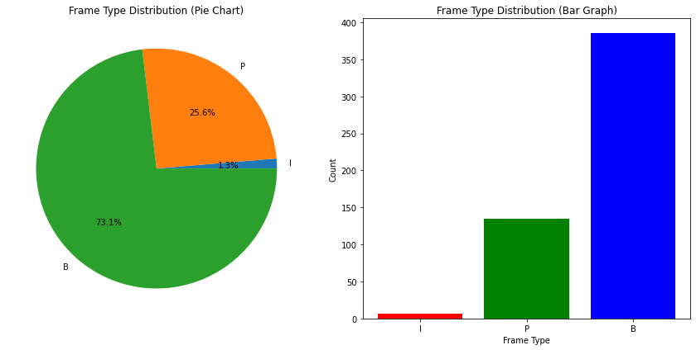Frame Percentages: {'I': 1.3257575757575757, 'P': 25.568181818181817, 'B': 73.10606060606061}

**Lab Task 3: Visualizing Frames**

**Objective:**

Extract actual frames from the video and display them using Python.

**Steps:**

1. **Extract Frames**:
   * Use ffmpeg to extract individual I, P, and B frames from the video.
   * Save these frames as image files.
2. **Display Frames**:
   * Use a library like PIL (Pillow) or opencv-python to display the extracted frames.

**Tasks:**

1. Save I, P, and B frames as separate image files using ffmpeg.
2. Use PIL or opencv-python to load and display these frames in a Python script.
3. Compare the visual quality of I, P, and B frames.

**Code:**

import os

# Path to frames directory

frames_dir = './frames/'  # Adjust this path as needed

# Rename frames

for i, frame_type in enumerate(frame_types):

    original_filename = f"frame_{i+1:04d}.jpeg"

    new_filename = f"{frame_type}_frame_{i+1:04d}.jpeg"

    original_path = os.path.join(frames_dir, original_filename)

    new_path = os.path.join(frames_dir, new_filename)

    if os.path.exists(original_path):

        os.rename(original_path, new_path)

    else:

        print(f"File {original_filename} does not exist in the directory.")

import cv2

import matplotlib.pyplot as plt

# Define a function to display images using OpenCV

def display_frames(frame_paths):

    for path in frame_paths:

        # Load the image

        image = cv2.imread(path)

        # Convert BGR to RGB for displaying using matplotlib

        image_rgb = cv2.cvtColor(image, cv2.COLOR_BGR2RGB)

        plt.imshow(image_rgb)

        plt.title(f"Frame: {os.path.basename(path)}")

        plt.axis('off')

        plt.show()

# Example paths (Replace with actual paths after renaming)

example_I_frame = os.path.join(frames_dir, 'I_frame_0001.jpeg')

example_P_frame = os.path.join(frames_dir, 'P_frame_0005.jpeg')

example_B_frame = os.path.join(frames_dir, 'B_frame_0002.jpeg')

# Displaying example frames

display_frames([example_I_frame, example_P_frame, example_B_frame])

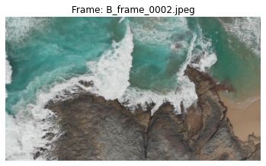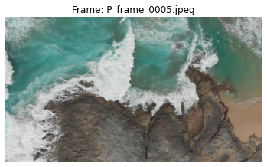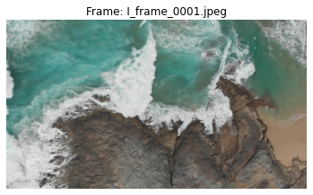**Quality comparison of different image types:**

**Lab Task 4: Frame Compression Analysis**

**Objective:**

Analyze the compression efficiency of I, P, and B frames.

**Steps:**

1. **Calculate Frame Sizes**:
   * Calculate the file sizes of extracted I, P, and B frames.
   * Compare the average file sizes of each frame type.
2. **Compression Efficiency**:
   * Discuss the role of each frame type in video compression.
   * Analyze why P and B frames are generally smaller than I frames.

**Code:**

import os

# Directory containing the renamed frames

frames_dir = './frames/'

# Initialize dictionaries to store sizes and counts

frame_sizes = {'I': [], 'P': [], 'B': []}

# Calculate the file sizes

for filename in os.listdir(frames_dir):

    if filename.startswith('I_') or filename.startswith('P_') or filename.startswith('B_'):

        frame_type = filename.split('_')[0]

        file_path = os.path.join(frames_dir, filename)

        file_size = os.path.getsize(file_path)

        frame_sizes[frame_type].append(file_size)

# Calculate average sizes

average_sizes = {frame_type: sum(sizes) / len(sizes) if sizes else 0 for frame_type, sizes in frame_sizes.items()}

# Print out the results

print("Average File Sizes (bytes):")

for frame_type, avg_size in average_sizes.items():

    print(f"{frame_type}: {avg_size:.2f} bytes")

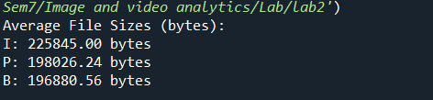**Output:**

**Analysis**

These results align more closely with typical expectations, where I-frames are larger than P-frames and B-frames:

1. **I-Frames** are expected to be larger because they store a complete image without reference to other frames.
2. **P-Frames** are smaller than I-frames as they only store differences from previous frames, using predictive coding.
3. **B-Frames** are usually the smallest, leveraging both past and future frames to encode differences with high efficiency.

**Lab Task 5: Advanced Frame Extraction**

**Objective:**

Extract frames from a video and reconstruct a part of the video using only I frames.

**Steps:**

1. **Extract and Save I Frames**:
   * Extract I frames from the video and save them as separate image files.
2. **Reconstruct Video**:
   * Use the extracted I frames to reconstruct a portion of the video.
   * Create a new video using these I frames with a reduced frame rate.

**Code:**

import cv2

import os

# Path to the directory containing I frames

i_frame_dir = './I_frames/'  # Update this path as needed

output_video_path = 'reconstructed.mp4'  # Output path for the reconstructed video

# Define frame rate (we'll use 3.5 fps for at least 2 seconds duration)

frame_rate = 3.5

num_frames = 7

# Get the list of frame file names

frame_files = [f for f in sorted(os.listdir(i_frame_dir)) if f.startswith('I_frame_')]

# Check if the number of frames matches the expected count

if len(frame_files) != num_frames:

    print(f"Error: Expected {num_frames} frames, found {len(frame_files)}.")

else:

    # Load the first frame to get the frame size

    first_frame = cv2.imread(os.path.join(i_frame_dir, frame_files[0]))

    height, width, layers = first_frame.shape

    # Define the codec and create VideoWriter object

    fourcc = cv2.VideoWriter_fourcc(*'mp4v')  # Codec for .mp4 files

    video_writer = cv2.VideoWriter(output_video_path, fourcc, frame_rate, (width, height))

    # Write each frame to the video

    for frame_file in frame_files:

        frame_path = os.path.join(i_frame_dir, frame_file)

        frame = cv2.imread(frame_path)

        video_writer.write(frame)

    # Release the video writer

    video_writer.release()

    print(f"Video created successfully and saved as {output_video_path}")

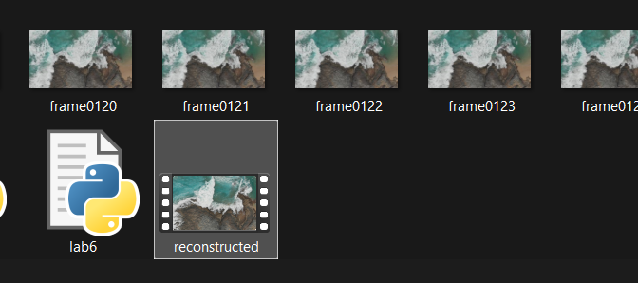**Output:**

**Lab Task 6: Compare the quality of images using PSNR, SSIM, MSE**

**PSNR**

**Code:**

from math import log10, sqrt

import cv2

import numpy as np

def PSNR(original, compressed):

  mse = np.mean((original - compressed) ** 2)

  if(mse == 0):

    return 100

  max_pixel = 255.0

  psnr = 20 * log10(max_pixel / sqrt(mse))

  return psnr

def main():

  original = cv2.imread("./frames/I_frame_0001.jpeg")

  compressed = cv2.imread("./frames/B_frame_0002.jpeg", 1)

  value = PSNR(original, compressed)

  print(f"PSNR value is {value} dB")

if __name__ == "__main__":

  main()

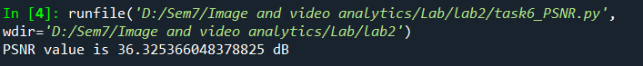Output:

**SSIM**

import torch

import torch.nn.functional as F

import numpy as np

import math

from PIL import Image

import cv2

def gaussian(window_size, sigma):

    """

    Generates a list of Tensor values drawn from a gaussian distribution with standard

    diviation = sigma and sum of all elements = 1.

    Length of list = window_size

    """

    gauss =  torch.Tensor([math.exp(-(x - window_size//2)**2/float(2*sigma**2)) for x in range(window_size)])

    return gauss/gauss.sum()

gauss_dis = gaussian(11, 1.5)

print("Distribution: ", gauss_dis)

print("Sum of Gauss Distribution:", torch.sum(gauss_dis))

def create_window(window_size, channel=1):

    # Generate an 1D tensor containing values sampled from a gaussian distribution

    _1d_window = gaussian(window_size=window_size, sigma=1.5).unsqueeze(1)

    # Converting to 2D

    _2d_window = _1d_window.mm(_1d_window.t()).float().unsqueeze(0).unsqueeze(0)

    window = torch.Tensor(_2d_window.expand(channel, 1, window_size, window_size).contiguous())

    return window

window = create_window(11, 3)

print("Shape of gaussian window:", window.shape)

def ssim(img1, img2, val_range, window_size=11, window=None, size_average=True, full=False):

    L = val_range # L is the dynamic range of the pixel values (255 for 8-bit grayscale images),

    pad = window_size // 2

    try:

        _, channels, height, width = img1.size()

    except:

        channels, height, width = img1.size()

    # if window is not provided, init one

    if window is None:

        real_size = min(window_size, height, width) # window should be atleast 11x11

        window = create_window(real_size, channel=channels).to(img1.device)

    # calculating the mu parameter (locally) for both images using a gaussian filter

    # calculates the luminosity params

    mu1 = F.conv2d(img1, window, padding=pad, groups=channels)

    mu2 = F.conv2d(img2, window, padding=pad, groups=channels)

    mu1_sq = mu1 ** 2

    mu2_sq = mu2 ** 2

    mu12 = mu1 * mu2

    # now we calculate the sigma square parameter

    # Sigma deals with the contrast component

    sigma1_sq = F.conv2d(img1 * img1, window, padding=pad, groups=channels) - mu1_sq

    sigma2_sq = F.conv2d(img2 * img2, window, padding=pad, groups=channels) - mu2_sq

    sigma12 =  F.conv2d(img1 * img2, window, padding=pad, groups=channels) - mu12

    # Some constants for stability

    C1 = (0.01 ) ** 2  # NOTE: Removed L from here (ref PT implementation)

    C2 = (0.03 ) ** 2

    contrast_metric = (2.0 * sigma12 + C2) / (sigma1_sq + sigma2_sq + C2)

    contrast_metric = torch.mean(contrast_metric)

    numerator1 = 2 * mu12 + C1

    numerator2 = 2 * sigma12 + C2

    denominator1 = mu1_sq + mu2_sq + C1

    denominator2 = sigma1_sq + sigma2_sq + C2

    ssim_score = (numerator1 * numerator2) / (denominator1 * denominator2)

    if size_average:

        ret = ssim_score.mean()

    else:

        ret = ssim_score.mean(1).mean(1).mean(1)

    if full:

        return ret, contrast_metric

    return ret

# helper function to load images

load_images = lambda x: np.asarray(Image.open(x).resize((480, 640)))

# Helper functions to convert to Tensors

tensorify = lambda x: torch.Tensor(x.transpose((2, 0, 1))).unsqueeze(0).float().div(255.0)

def display_imgs(x, transpose=True, resize=True):

    if resize:

        x = cv2.resize(x, (400, 400))

    if transpose:

        x = cv2.cvtColor(x, cv2.COLOR_BGR2RGB)

    cv2.imshow('Image', x)

    cv2.waitKey(0)

    cv2.destroyAllWindows()

# The true reference Image

img1 = load_images("./frames/I_frame_0001.jpeg")

# The False image

img2 = load_images("./frames/B_frame_0002.jpeg")

# The noised true image

noise = np.random.randint(0, 255, (640, 480, 3)).astype(np.float32)

noisy_img = img1 + noise

_img1 = tensorify(img1)

_img2 = tensorify(img2)

true_vs_false = ssim(_img1, _img2, val_range=255)

print("True vs False Image SSIM Score:", true_vs_false)

# Check SSIM score of True image vs Noised_true Image

_img1 = tensorify(img1)

_img2 = tensorify(noisy_img)

true_vs_false = ssim(_img1, _img2, val_range=255)

print("True vs Noisy True Image SSIM Score:", true_vs_false)

# Check SSIM score of True image vs True Image

_img1 = tensorify(img1)

true_vs_false = ssim(_img1, _img1, val_range=255)

print("True vs True Image SSIM Score:", true_vs_false)

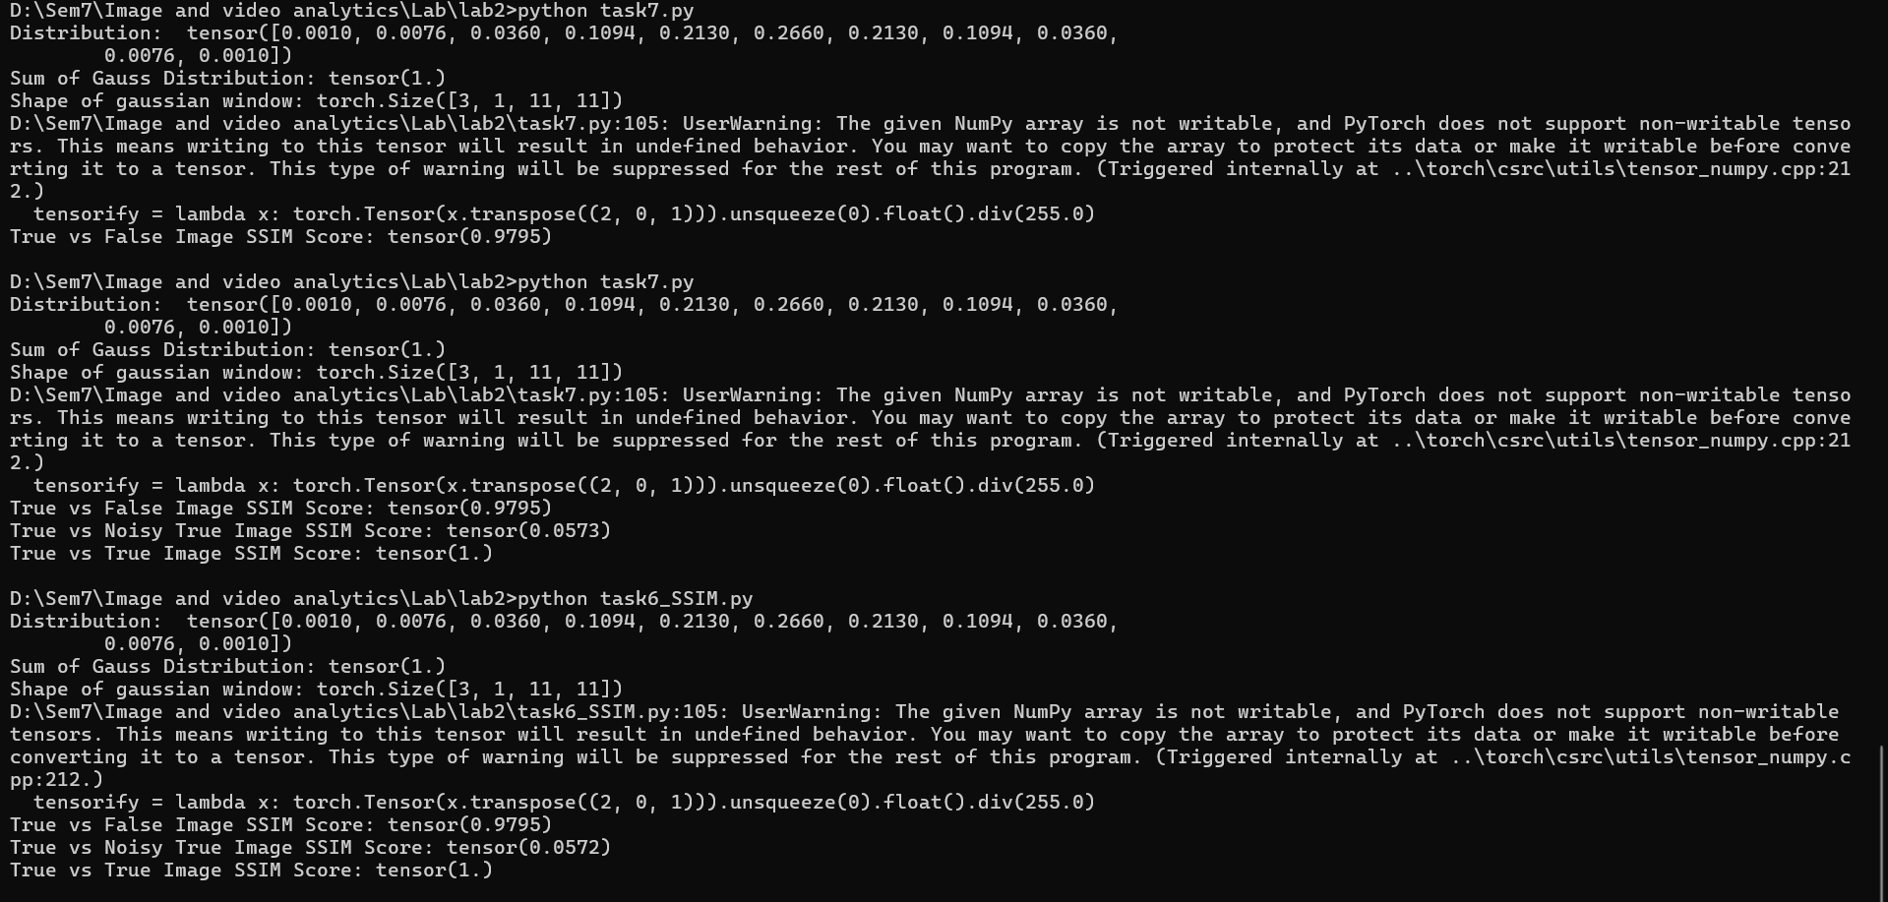**Output:**

**MSE:**

import numpy as np

from PIL import Image

import cv2

def mse(imageA, imageB):

    # Ensure the images are numpy arrays

    imageA = np.array(imageA)

    imageB = np.array(imageB)

    # Check if the images have the same shape

    if imageA.shape != imageB.shape:

        raise ValueError("Input images must have the same dimensions.")

    # Compute the MSE

    err = np.sum((imageA.astype("float") - imageB.astype("float")) ** 2)

    err /= float(imageA.shape[0] * imageA.shape[1] * imageA.shape[2])

    return err

# Load images using the provided helper functions or directly with cv2 or PIL

img1 = cv2.imread("./frames/I_frame_0381.jpeg")

img2 = cv2.imread("./frames/B_frame_0002.jpeg")

# Calculate MSE

mse_value = mse(img1, img2)

print(f"MSE between the images: {mse_value}")

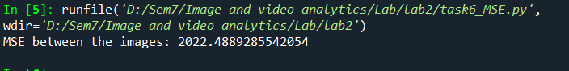**Output:**